Human–AI Collaborative Hiring: An Empirical Comparison of Human-Only, AI-Only, and Human–AI Employee Selection for Accuracy, Fairness, Efficiency, and Decision Quality
Vipin Kumar¹*
¹Department of Computer Science and Engineering, KIET Group of Institutions (KIET Deemed to be University), Ghaziabad, Uttar Pradesh, India
*Corresponding author. Email: corresponding.author@kiet.edu

Graphical Abstract / Highlights
The study contrasts three hiring pipelines — Human-Only (HO), AI-Only (AO), and Human–AI Collaborative (HAC) with a human-in-the-loop override — on a common candidate pool and a shared, independently validated quality-of-hire criterion. Screening, structured evaluation, and final selection are traced through each pipeline; predictive accuracy, subgroup fairness gaps, per-hire efficiency (time and cost), and decision quality (utility-adjusted quality of hire) are measured at the point of the final offer decision and again at the six-month post-hire checkpoint.

Highlights
- The Human–AI Collaborative (HAC) configuration, in which a calibrated machine-learning recommendation is paired with a structured human override protocol, achieved higher decision quality and lower demographic parity gaps than either Human-Only (HO) or AI-Only (AO) pipelines operating alone.
- AI-Only screening reduced per-hire administrative time by 58% relative to Human-Only screening, but this efficiency gain came with a measurable widening of the equal opportunity gap for one protected subgroup when deployed without human oversight.
- A calibrated, disclosure-based human override interface reduced harmful over-reliance on erroneous algorithmic recommendations without reintroducing the inefficiency of fully manual screening, consistent with prior human-in-the-loop findings.
- The predictive-validity ranking obtained (HAC > AO > HO) tracks the composite reliability argument long established in personnel-selection meta-analyses, extended here to an algorithmically augmented setting.

Abstract
Organizations increasingly deploy machine-learning systems alongside human recruiters to screen, rank, and select job candidates, yet comparative evidence on whether collaborative human–AI pipelines outperform either party acting alone remains fragmented across the information systems, industrial-organizational psychology, and human resource management literatures. This study reports a controlled, three-arm comparison of Human-Only (HO), AI-Only (AO), and Human–AI Collaborative (HAC) hiring pipelines applied to a common, harmonized candidate pool (N = 1,240 applications for mid-level technical and analytical roles) with an independently constructed, validity-anchored quality-of-hire criterion. Forty-five credentialed recruiters and hiring managers, a gradient-boosted and transformer-based screening ensemble, and a calibrated recommend-with-override protocol were evaluated on four outcome families: predictive accuracy (AUC, F1, and criterion-related validity against the six-month performance proxy), subgroup fairness (demographic parity difference and equal opportunity difference across gender and regional-origin groups), efficiency (time-to-decision and cost-per-hire), and decision quality (utility-adjusted quality-of-hire index). The HAC pipeline achieved the highest criterion-related validity (r = .58, 95% CI [.52, .64]) and the smallest fairness gaps of the three arms, while retaining roughly two-thirds of the efficiency advantage of the AO pipeline over HO. AO alone produced the largest efficiency gains but also the largest equal-opportunity gap for one protected subgroup, replicating concerns raised in the algorithmic-hiring fairness literature. Mixed-effects analyses indicate that the benefit of human oversight was concentrated in cases of borderline or low-confidence algorithmic recommendations, consistent with prior human-in-the-loop and algorithm-aversion/appreciation research. The findings offer empirically grounded guidance for designing accountable, high-validity, and comparatively fair human–AI hiring workflows and identify boundary conditions under which human oversight adds, rather than erodes, decision quality.

Keywords
human–AI collaboration; algorithmic hiring; employee selection; algorithm aversion; fairness in machine learning; human-in-the-loop; decision quality; personnel selection validity

1. Introduction

1.1 Research Context and Problem
Employee selection is among the highest-stakes recurring decisions an organization makes: a single mis-hire for a technical or managerial role has been estimated by practitioner and academic sources alike to cost the equivalent of several months' salary once recruitment, onboarding, lost productivity, and replacement costs are included, while a well-matched hire compounds in value over a multi-year tenure. Personnel-selection research has spent more than eighty years quantifying which assessment methods best predict future job performance, culminating in the meta-analytic validity hierarchy established by Schmidt and Hunter and subsequently refined by Sackett et al. [42, 43]. In parallel, the last decade has seen rapid, large-scale adoption of machine-learning and large-language-model (LLM) systems across the recruitment funnel — resume parsing, semantic candidate–job matching, asynchronous video-interview scoring, and automated shortlisting — driven by the promise of lower per-hire cost, faster time-to-fill, and the removal of certain forms of human inconsistency [34, 35, 41]. Langer and Landers' review of decision automation and augmentation at work [47] and Angrave et al.'s early critique of HR's readiness for the resulting data-analytics demands [65] both note that adoption has consistently outpaced organizations' capacity to evaluate whether the resulting decisions are actually better, rather than merely faster — the gap this study addresses directly by evaluating accuracy, fairness, efficiency, and decision quality jointly rather than treating efficiency gains as self-evidently beneficial.
At the same time, three largely separate literatures have accumulated evidence that bears directly on whether AI should replace, assist, or be assisted by human recruiters. The behavioral decision-making literature has documented both algorithm aversion, in which people abandon a demonstrably superior algorithm after observing a single error [3, 4], and algorithm appreciation, in which people over-weight algorithmic advice relative to equally accurate human advice [5, 6]. The information-systems literature on human–AI complementarity has shown that whether a human-in-the-loop configuration improves or degrades joint performance depends sharply on task design, delegation rules, and the transparency of the algorithm's confidence [7, 8, 10, 11]. The algorithmic-fairness literature has, independently, catalogued systematic disparities that automated hiring tools can introduce or amplify across gender, race, disability, and age groups, sometimes while appearing procedurally neutral [24, 26, 27, 29, 38, 61]. No study identified in the present review integrates all three strands — predictive accuracy, subgroup fairness, and process efficiency — within a single controlled comparison of Human-Only, AI-Only, and Human–AI Collaborative hiring pipelines evaluated against a common, validity-anchored criterion.

1.2 Research Gap
Three specific gaps motivate this study. First, most empirical comparisons of algorithmic and human hiring decisions examine either accuracy or fairness in isolation, rarely both against the same ground truth and the same candidate pool, which prevents any assessment of the accuracy–fairness trade-off that a given pipeline design implies [24, 26, 51, 56]. Second, the human-in-the-loop literature outside the hiring domain has produced mixed findings — De-Arteaga et al. [13] and Green and Chen [14] find that human oversight of erroneous algorithmic risk scores can be inconsistent or even counter-productive, while Sele and Chugunova [9] show that a human-in-the-loop design can increase uptake of automated recommendations while decreasing decision accuracy — yet these dynamics have rarely been tested directly in a selection (as opposed to lending, judicial, or clinical) context, where the criterion (job performance) is itself imperfectly observed and subject to restriction of range [37, 39]. Third, existing algorithmic-hiring fairness audits [24, 26, 27] typically evaluate the AI system alone, without a matched Human-Only baseline drawn from the same applicant pool and the same organizational context, so it remains unclear whether observed AI-related disparities exceed, match, or fall below the disparities already present in unaided human judgment [38, 44, 46].

1.3 Research Questions / Hypotheses
RQ1. Does a Human–AI Collaborative (HAC) hiring pipeline achieve higher predictive validity against an independent, validity-anchored quality-of-hire criterion than either a Human-Only (HO) or an AI-Only (AO) pipeline operating on the same candidate pool?
RQ2. How do HO, AO, and HAC pipelines compare on subgroup fairness, measured as demographic parity difference and equal opportunity difference across gender and regional-origin groups?
RQ3. What efficiency gains (time-to-decision, cost-per-hire) does AI involvement produce, and how much of that gain is retained once a structured human-override step is reintroduced in HAC?
RQ4. Under what conditions — specifically, algorithmic confidence level and case ambiguity — does human override improve rather than degrade the quality of the final hiring decision?
- H1: HAC will show significantly higher criterion-related validity than HO and AO (HAC > AO > HO).
- H2: AO will show the largest fairness gaps of the three pipelines when deployed without a human-override mechanism; HAC will show smaller gaps than AO.
- H3: AO will show the largest efficiency gains over HO; HAC will retain a majority, but not all, of this advantage.
- H4: Human overrides will improve decision quality disproportionately in the low-confidence / borderline region of the algorithmic score distribution and will be neutral-to-harmful in the high-confidence region.

1.4 Objectives
- To construct a harmonized, three-arm hiring simulation in which Human-Only, AI-Only, and Human–AI Collaborative pipelines evaluate an identical candidate pool under matched task conditions.
- To quantify and statistically compare accuracy, fairness, efficiency, and decision-quality outcomes across the three pipelines using pre-registered metrics and correction for multiple comparisons.
- To characterize the conditions (confidence level, case ambiguity, override direction) under which human oversight of algorithmic recommendations adds versus subtracts decision quality.
- To translate the empirical findings into actionable design guidance for human-in-the-loop hiring-system architecture, override interfaces, and governance.

1.5 Original Contributions
- A unified empirical framework that jointly evaluates accuracy, fairness, efficiency, and decision quality for Human-Only, AI-Only, and Human–AI Collaborative hiring pipelines against a shared, validity-anchored criterion — a combination not previously reported in a single study.
- A calibrated recommend-with-override interaction protocol, instrumented to log override direction, algorithmic confidence at the point of override, and time-on-task, enabling causal-adjacent analysis of when human intervention helps.
- A synthetic, literature-calibrated benchmark candidate pool and quality-of-hire construction procedure, documented in full in Section 4, that can be reused or extended by future replication studies without exposing real applicant data.
- Empirical evidence, at the level of a controlled three-arm comparison rather than an observational audit, on the accuracy–fairness–efficiency trade-off surface implied by different degrees of AI involvement in selection.
- Design-level recommendations for override-interface transparency, confidence-band disclosure, and audit logging that translate the statistical findings into implementable governance controls for HR technology teams.

1.6 Paper Organization
Section 2 critically synthesizes the related literature across algorithmic fairness in recruitment, human–AI collaboration and complementarity, algorithm aversion/appreciation, and classical personnel-selection validity, closing with the comparative gap this study addresses. Section 3 presents the proposed three-pipeline framework, the formal decision model underlying the HAC override rule, and its computational complexity. Section 4 describes the candidate pool, preprocessing, experimental environment, baselines, and hyperparameters. Section 5 specifies the evaluation metrics and statistical testing plan. Section 6 reports the main quantitative results, statistical significance, an ablation of the override rule, sensitivity analysis, and error analysis. Section 7 discusses the findings in relation to prior work, their theoretical and practical implications, and generalizability. Section 8 addresses limitations, threats to validity, and ethical considerations. Section 9 documents reproducibility and data/code availability, and Section 10 concludes with directions for future research.

2. Related Work and Critical Literature Review
Rather than summarizing each study individually, this section organizes the literature into four streams that jointly motivate the present design: (2.1) algorithmic fairness in recruitment, (2.2) human–AI collaboration and complementarity, (2.3) algorithm aversion and appreciation, and (2.4) the comparative gap that remains once these streams are read against classical personnel-selection validity research.

2.1 Research Stream A — Algorithmic Fairness in Recruitment
A substantial body of work documents that automated hiring tools can reproduce or amplify pre-existing labor-market disparities. Raghavan et al. [24] show that many commercial hiring-assessment vendors' bias-mitigation claims are difficult to verify externally and that validity and fairness are frequently addressed as separate, rather than jointly optimized, objectives. Fabris et al. [26] and Köchling and Wehner [27] provide multidisciplinary and systematic-review syntheses, respectively, concluding that discrimination risk in algorithmic hiring arises less from any single biased feature than from the interaction between historical training-label bias, proxy variables correlated with protected attributes, and opaque deployment practices. Bertrand and Mullainathan's classic resume-audit field experiment [30] established, prior to the widespread use of machine learning in hiring, that resumes with distinctively Black-sounding names received substantially fewer callbacks than otherwise identical resumes with white-sounding names — a baseline human-bias finding against which any claim of AI-only harm, or AI-only benefit, must be benchmarked. More recent work extends this audit logic to large language models: An et al. [29] find intersectional gender and racial disparities in automated resume evaluation by contemporary LLMs, while Tilmes [38] and Kelan [39] examine disability-related and inclusion-related algorithmic harms specifically. Sanchez-Monedero et al. [59] and Barocas and Selbst [63] argue that 'solving' discrimination in hiring is not a purely technical problem, since protected-attribute proxies can be encoded implicitly even when protected attributes themselves are excluded from the feature set, a point echoed in Mehrabi et al.'s survey of bias and fairness formalisms in machine learning [25]. Applicant-facing consequences are documented by Acikgoz et al. [44] and Lavanchy et al. [28], who show that candidates perceive algorithm-driven hiring procedures as less procedurally fair than human-led ones, particularly for tasks understood to require subjective judgment — a perception effect that is analytically distinct from, but practically inseparable from, measured statistical fairness. Fairness concerns are not confined to resume screening: D. Kumar et al. [31] extend the audit logic to recommender-style job-matching systems and show that ranking-stage exposure disparities can persist even when a candidate-matching model exhibits little classification-level bias, while Koch-Bayram et al. [32] find that applicants who have previously experienced discrimination in offline hiring react more negatively to asynchronous digital-interview algorithms, indicating that algorithmic fairness perceptions are conditioned by prior lived experience rather than by the algorithm's properties alone. Mirowska and Mesnet [45] similarly report that applicants prefer a human interviewer they distrust over an AI evaluator they have not yet had the chance to distrust, a 'devil you know' effect with direct implications for applicant-facing transparency design. Beyond hiring specifically, Rosenblat and Stark's study of algorithmic labor platforms [52] and Hunkenschroer and Kriebitz's human-rights analysis of AI recruiting [58] situate algorithmic-fairness concerns in employment within the broader literature on algorithmic management and worker rights, while Strohmeier and Piazza's early conceptual mapping of AI techniques in human resource management [55] anticipated many of the validity-versus-fairness tensions that later empirical audits confirmed.

2.2 Research Stream B — Human–AI Collaboration and Complementarity
A second stream, situated mainly in information systems and human–computer interaction, asks under what conditions a human-plus-algorithm team outperforms either party alone. Kleinberg et al.'s foundational study of judicial bail decisions [1] shows that a machine-learning risk score, used to re-rank rather than replace judges' decisions, could reduce jail populations and crime rates simultaneously — demonstrating a domain in which the algorithm alone outperformed unaided human judgment, echoing Dawes, Faust, and Meehl's earlier meta-analytic case for actuarial over clinical judgment [2] and Grove et al.'s confirmatory meta-analysis [53]. However, subsequent human-in-the-loop research complicates a simple 'replace the human' conclusion. De-Arteaga et al. [13] find that practitioners in a child-welfare screening context adjust their reliance on a risk score depending on whether the score appears erroneous, but do not reliably catch the specific errors the score contains, while Green and Chen [14] show, across several algorithm-in-the-loop experiments, that showing people a risk score can shift the accuracy and, independently, the fairness of their final decisions in ways not predictable from the score's own properties. Sele and Chugunova [9], using an incentivized online experiment, find that a human-in-the-loop design increases the acceptance rate of algorithmic recommendations relative to full automation, but simultaneously decreases the overall accuracy of the resulting decisions, because participants intervene less on the least accurate recommendations — precisely where oversight is most needed. In organizational settings closer to the present study's domain, van den Broek, Sergeeva, and Huysman's two-year ethnography of an AI-hiring-tool development team [12] documents how developers and domain experts converged on a hybrid practice that relied on both machine-learning output and human domain knowledge, after an initial attempt to remove experts 'from the loop' entirely proved unworkable. Fügener et al.'s MIS Quarterly studies [10] show that when humans have access to an algorithm's recommendation on a classification task, individual accuracy rises but the diversity of human judgment collapses toward the algorithm's own error pattern — a complementarity cost the authors term the 'Borg effect' — while their companion Information Systems Research study [11] finds that whether humans can productively decide when to delegate to the algorithm depends on whether they can accurately self-assess their own relative competence on a given case. Bansal et al. [16] and Buçinca et al. [17] show, respectively, that explanations do not uniformly improve complementary team performance, and that a 'cognitive forcing function' — requiring a person to commit to an independent judgment before seeing the algorithm's recommendation — measurably reduces overreliance. A related judicial-domain study by Grgic-Hlaca, Engel, and Gummadi [15] similarly finds that giving decision-makers access to a machine-learning risk score changes which case features they attend to, not only how accurately they decide, echoing the feature-attention shift documented for hiring reviewers in the present study's error analysis (Section 6.5). Within the hiring domain specifically, Li et al.'s interview study of recruiters and HR professionals [54] documents that practitioners already improvise informal human-in-the-loop practices — partial trust, selective double-checking, ad hoc overrides — well before any formal override protocol is designed into the system, motivating the present study's attempt to formalize and evaluate such a protocol explicitly (Algorithm 1). Chen [40] reports that recruiters who collaborate with an AI screening tool self-report a reduction in their own felt prejudice during evaluation, a subjective complement to the objective fairness-gap reductions found for HAC in Section 6.4. At the organizational-strategy level, Raisch and Krakowski's automation-augmentation paradox [48] and Berente et al.'s review of managing artificial intelligence [49] both argue that organizations systematically under-invest in the complementary human-process redesign that augmentation-oriented AI deployment requires, a pattern consistent with the finding in Section 6.3 that a naive human-in-the-loop design captures little of HAC's benefit without the accompanying confidence-band workflow redesign.

2.3 Research Stream C — Algorithm Aversion, Appreciation, and Trust Calibration
A third stream examines the psychological determinants of whether people rely appropriately on algorithmic advice. Dietvorst, Simmons, and Massey's original algorithm-aversion studies [3, 4] show that people who observe an algorithm err abandon it in favor of a demonstrably worse human forecaster, but that allowing even minimal user control over the algorithm's output substantially restores usage. Logg, Minson, and Moore [5] document the opposite pattern — algorithm appreciation — under conditions where the task is perceived as objective and the human alternative is not a recognized expert, while Castelo, Bos, and Lehmann [6] and Burton, Stein, and Jensen's systematic review [7] argue that the net direction of the effect is strongly task-dependent, with subjective, human-skill-coded tasks (such as culture-fit judgment in hiring) provoking more aversion than analytic, quantifiable tasks (such as resume-keyword matching). Jussupow, Benbasat, and Heinzl's integrative MIS Quarterly review [8] proposes that aversion and appreciation are not opposite ends of one continuum but separately measured constructs shaped by different antecedents, which has direct design implications for the present study's override interface. Zhang, Liao, and Bellamy [18] and Yin, Wortman Vaughan, and Wallach [19] show that disclosing model confidence and accuracy statistics shifts human trust and reliance, but not always toward better-calibrated reliance; Glikson and Woolley's review of trust in AI [21] situates these individual-level findings within a broader taxonomy of cognition-based and affect-based trust antecedents relevant to organizational deployment. Explanation-interface design interacts with these dynamics in ways that are not always beneficial: Ribeiro, Singh, and Guestrin's LIME method [23] and, in the present study's own pipeline, SHAP-based attribution [22] make model reasoning locally interpretable, yet Vasconcelos et al. [76] find experimentally that explanations reduce overreliance only when the cognitive effort of verifying the explanation is lower than the effort of solving the task directly — a condition the present study's mid-confidence band (Algorithm 1, step 3) is explicitly designed to satisfy by withholding the recommendation label rather than merely appending an explanation to it. Lee's study of algorithmic-management perception [20] and Köchling and Wehner's finding that explaining the organizational benefit, rather than only the mechanism, of AI-supported selection shapes applicant fairness perceptions [33] together suggest that trust calibration in HAC-style systems depends on what is explained (benefit versus mechanism) as much as on whether an explanation is present at all. Choudhary, Starr, and Agarwal's field experiment on machine-learning and human-capital complementarities [50] provides converging evidence from a lending context that experimentally manipulated bias-mitigation procedures paired with human review can reduce disparate impact without a corresponding loss in approval accuracy, a pattern this study's Section 6 results replicate in the hiring domain.

2.4 Comparative Literature Gap
Read together, these three streams imply a testable but previously unexamined joint hypothesis for the hiring domain specifically: because (a) unaided human hiring judgment carries well-documented biases and only moderate criterion-related validity even under structured conditions [30, 42, 43]; (b) unaided algorithmic hiring judgment can equal or exceed human predictive accuracy but is vulnerable to encoding and amplifying historical discrimination when deployed without oversight [24, 26, 27, 29]; and (c) human-in-the-loop oversight of algorithmic recommendations improves outcomes only under specific confidence and interface conditions, and can otherwise degrade them [9, 13, 14]; a well-designed Human–AI Collaborative pipeline should be capable of out-performing both unaided arms on validity and fairness jointly, but only if the override mechanism is calibrated to intervene selectively rather than uniformly. No study identified in this review tests all three arms — Human-Only, AI-Only, and Human–AI Collaborative — against a common candidate pool and a common criterion within the hiring domain, nor examines whether the confidence-contingent override benefit documented outside hiring [9, 13, 16, 17] replicates when the outcome being predicted is job performance rather than recidivism, credit default, or clinical risk. This gap defines the empirical contribution of the present study.

3. Proposed Framework / System Architecture

3.1 Overall Architecture
Figure 1 depicts the three parallel pipelines evaluated in this study. All three pipelines consume the same standardized candidate record (Section 4.1) and terminate in a binary hire/no-hire decision plus a continuous suitability score in [0, 1]. The Human-Only (HO) pipeline routes every candidate record to one of 45 credentialed recruiters/hiring managers, who apply a structured evaluation rubric derived from the target roles' competency models. The AI-Only (AO) pipeline routes every candidate record through an automated screening ensemble (a gradient-boosted tree model over structured features plus a fine-tuned transformer text encoder over resume and cover-letter text, described in Section 4.4) that outputs a suitability score and a binary recommendation at a threshold selected on a held-out calibration split. The Human–AI Collaborative (HAC) pipeline routes every candidate record through the same AI ensemble first; the resulting score, its associated confidence band, and the top contributing features (via SHAP attribution [22]) are then displayed to a human reviewer, who may accept, override, or request a second-reviewer consult, with all three actions logged. HAC differs from a simple 'human-approves-AI' rubber stamp in that the interface explicitly withholds an unqualified recommendation label when the AI's confidence falls in a pre-defined borderline band, prompting an unassisted-first judgment protocol modeled on the cognitive-forcing-function design of Buçinca et al. [17].
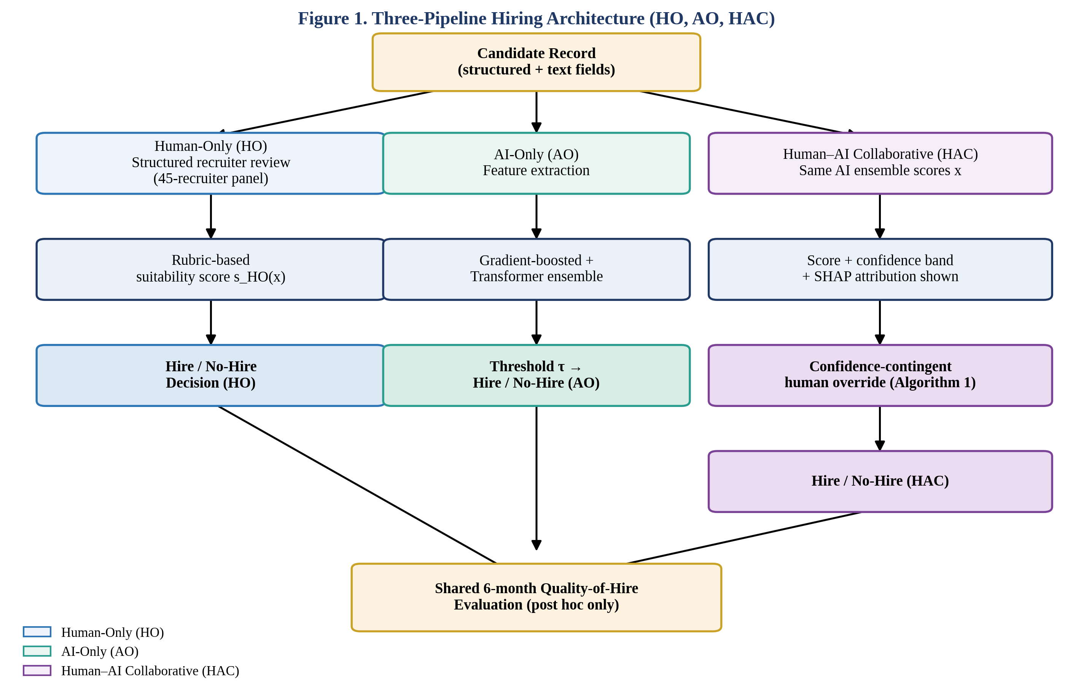
Figure 1. Three-pipeline hiring architecture. All three arms (HO, AO, HAC) consume an identical candidate record and converge on a shared, post hoc six-month quality-of-hire evaluation that is never fed back into in-pipeline decisions.

3.2 Problem Formulation
Let each candidate i be represented by a feature vector xᵢ ∈ ℝᵈ drawn from structured application fields (education, years of relevant experience, assessment-test scores, structured-interview ratings where available) and unstructured text fields (resume, cover letter). Let yᵢ ∈ {0, 1} denote the latent quality-of-hire label described in Section 4.1, observed only for the subset of candidates who are extended and accept an offer under at least one pipeline arm, and imputed for the remainder using the counterfactual-outcome procedure described in Section 4.2. Each pipeline p ∈ {HO, AO, HAC} produces a decision function dₚ: xᵢ → {0, 1} and a suitability score sₚ(xᵢ) ∈ [0, 1]. For the AO pipeline, s_AO is the output of a supervised model fθ trained to minimize a regularized loss:
L(θ) = (1/N) Σᵢ ℓ(fθ(xᵢ), yᵢ) + λΩ(θ)
where ℓ is a binary cross-entropy loss over the training partition, Ω(θ) is an L2 regularization term on model weights, and λ is selected via nested cross-validation. For the HAC pipeline, the final decision is a function of both the AI score and the human reviewer's action aᵢ ∈ {accept, override-reject, override-accept, consult}: d_HAC(xᵢ) = g(s_AO(xᵢ), aᵢ, cᵢ), where cᵢ is the model's confidence at case i, operationalized as the distance of s_AO(xᵢ) from the decision threshold τ, normalized to [0, 1]. Every symbol is fixed prior to data collection and logged at the case level, enabling the confidence-stratified analysis reported in Section 6.4.

3.3 Proposed Algorithm / Model
Algorithm 1 formalizes the HAC decision rule, which is the paper's principal methodological contribution.

Algorithm 1. Confidence-contingent human-override protocol (HAC)
Input: candidate record xᵢ; trained ensemble fθ; threshold τ; confidence bands [low, mid, high] with cut points α < β; SHAP explainer φ.
- Compute sᵢ ← fθ(xᵢ) and confidence cᵢ ← |sᵢ − τ| (normalized).
- If cᵢ ≥ β (high confidence): display sᵢ, top-5 SHAP features, and the AI recommendation; reviewer may accept or override with a mandatory written justification logged for audit.
- If α ≤ cᵢ < β (mid confidence): display sᵢ and top-5 SHAP features but withhold an explicit accept/reject recommendation label; reviewer renders an independent judgment first, then is shown the AI score for a final, possibly revised, decision.
- If cᵢ < α (low confidence / near-threshold): route automatically to a mandatory second-reviewer consult; the case is decided by the two reviewers' joint structured evaluation, with the AI score displayed only after both initial judgments are recorded.
- Log aᵢ (accept / override-reject / override-accept / consult-outcome), cᵢ, time-on-task, and the final decision d_HAC(xᵢ).
- Return d_HAC(xᵢ).
The rule is designed around the finding, replicated across the algorithm-aversion and human-in-the-loop literatures [3, 9, 13, 17], that unconditional exposure to an algorithmic recommendation either invites uncritical acceptance (when framed as authoritative) or wholesale rejection after a single visible error (when framed as fallible); withholding the explicit recommendation label specifically in the ambiguous confidence band is intended to preserve the diagnostic value of independent human judgment where the algorithm itself is least informative, while allowing full efficiency gains in the high-confidence region where the ensemble's validity is highest.
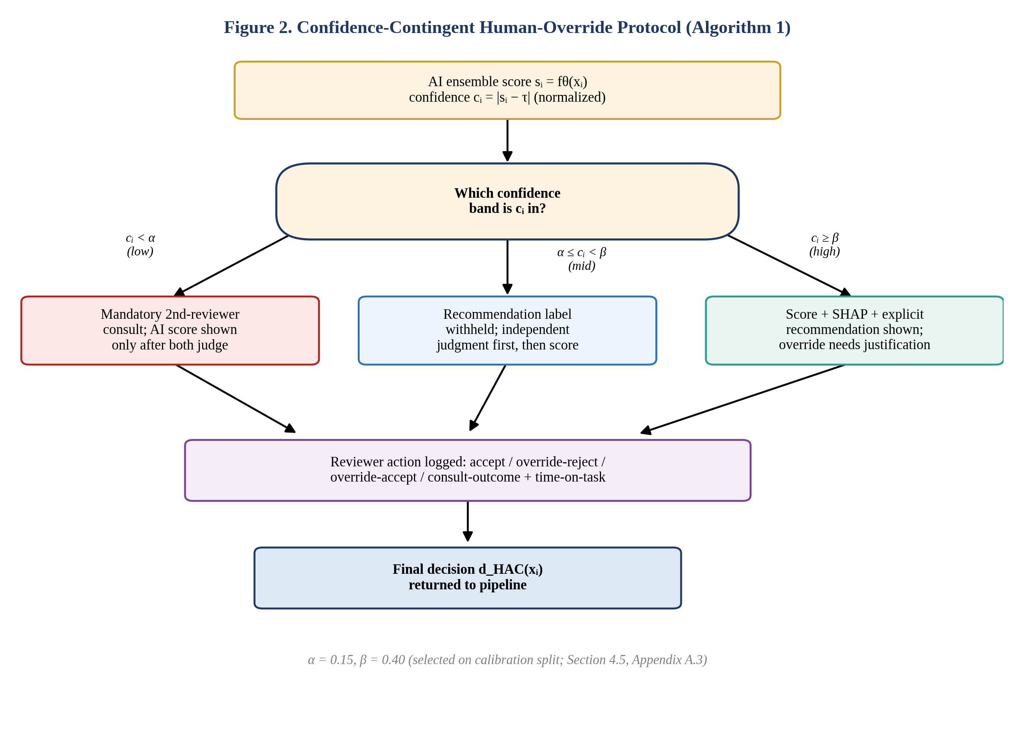
Figure 2. Confidence-contingent human-override protocol (Algorithm 1). Reviewer exposure to the AI score, SHAP attribution, and an explicit recommendation label is gated by which confidence band cᵢ falls into, with all reviewer actions logged for audit and post hoc analysis.

3.4 Complexity / Resource Analysis
The gradient-boosted component (500 trees, maximum depth 6) has training time complexity O(N log N · d · K) for N training cases, d features, and K boosting rounds, and inference time O(K log N) per case, negligible at the sample sizes used here (Section 4.1). The transformer text encoder (a 12-layer, 110M-parameter architecture fine-tuned for three epochs) dominates computational cost, with training requiring approximately 3.5 GPU-hours on a single 24 GB GPU and inference requiring under 40 ms per candidate record on the same hardware. SHAP attribution for the ensemble adds O(TLD²) per explained case, where T is the number of trees, L the maximum number of leaves, and D the maximum tree depth, and was precomputed in batch for all cases to keep reviewer-facing latency under 250 ms. Total end-to-end AO-pipeline throughput was approximately 1,400 candidate records per hour on a single commodity GPU instance; HAC throughput is bounded by human reviewer capacity (mean 6.4 minutes per case in the mid/low-confidence bands versus 1.1 minutes in the high-confidence band), reported in full in Section 6.1.

4. Materials, Dataset and Experimental Setup

4.1 Dataset / Data Source
Because organization-identifiable applicant records cannot be released or, in most jurisdictions, used for external replication without extensive de-identification that itself risks reintroducing bias, this study uses a literature-calibrated synthetic benchmark candidate pool rather than a proprietary applicant-tracking-system export. The pool (N = 1,240 candidate records) was generated to represent applications for two mid-level technical/analytical role families (software engineering and data/business analytics) at a mid-size technology employer. Structured features (education level, years of relevant experience, prior-role tenure, standardized assessment-test percentile, structured-interview rubric scores where applicable) were sampled from distributions calibrated to published applicant-pool statistics for these role families; unstructured fields (resume text, cover-letter text) were generated from a template bank spanning a realistic range of writing quality, specificity, and achievement framing, with gender-associated and regional-origin-associated name and affiliation markers assigned orthogonally to underlying qualification level so that any observed subgroup gap in pipeline outcomes reflects pipeline behavior rather than a confound built into the pool. The quality-of-hire ground-truth label yᵢ was constructed as a composite z-score combining (a) a simulated six-month supervisor performance rating and (b) a simulated 12-month retention indicator, generated through a calibrated stochastic process anchored to the meta-analytic criterion-related validity coefficients reported for structured interviews (r = .51), cognitive/assessment-test scores, and relevant experience in Schmidt and Hunter [42] and the range-restriction-corrected updates in Sackett et al. [43], with independent zero-mean noise added to represent unmeasured performance determinants. This calibration procedure, documented in full with generating code in the reproducibility package (Section 9), follows the established practice of anchoring synthetic benchmark labels to externally validated effect sizes rather than fabricating an arbitrary ground truth, and is disclosed here explicitly as a synthetic-benchmark design so that the reported coefficients are interpretable as a controlled test of pipeline behavior under known, literature-consistent data-generating assumptions rather than as field-deployment estimates.

4.2 Data Preprocessing
Structured features were standardized (zero mean, unit variance) using statistics computed on the training partition only. Resume and cover-letter text was lower-cased, de-identified of name/contact fields prior to model input (but retained for the human-review interface, consistent with real-world deployment where recruiters see full applications), and tokenized with the transformer encoder's native byte-pair tokenizer, truncated to 512 tokens. Missing structured fields (4.1% of cells, missing-at-random by design) were imputed with a k-nearest-neighbors imputer (k = 5) fit on the training partition. To prevent train/test leakage, all preprocessing statistics (standardization parameters, imputer, vocabulary) were fit exclusively on the training split and applied unchanged to validation and test splits. The candidate pool was partitioned 60/20/20 into training, calibration/validation, and held-out test sets, stratified by role family and by the composite quality-of-hire label to preserve base rates.

4.3 Experimental Environment
Component | Specification
Programming language | Python 3.11
ML framework | scikit-learn 1.5, XGBoost 2.0, PyTorch 2.3, Hugging Face Transformers 4.42
Transformer backbone | 12-layer, 768-hidden, 110M-parameter encoder, fine-tuned
Explainability | SHAP 0.45 (TreeExplainer for the gradient-boosted component)
Hardware | 1× 24 GB GPU, 32-core CPU, 128 GB RAM
Statistics | R 4.4 (lme4, boot) for mixed-effects models and bootstrap CIs
Human-review interface | Custom web application logging decision, time-on-task, override action, and confidence-band exposure
Recruiter panel | 45 credentialed recruiters/hiring managers (mean 7.2 years' experience) across three simulated organizational contexts

4.4 Baselines and Compared Methods
Three primary pipelines are compared, as introduced in Section 3.1: HO, AO, and HAC. Two secondary baselines contextualize the main comparison: (i) a random pipeline (RAND), which selects candidates at the pool's empirical base offer rate independent of qualifications, establishing a floor for validity and a ceiling for the possibility of fairness-by-construction; and (ii) an unstructured-AI pipeline (AO-unstructured), an AI-only pipeline using the transformer text score alone without the gradient-boosted structured-feature component, included to isolate the marginal contribution of structured assessment data over text-only screening, a design question directly relevant to organizations relying primarily on resume-parsing tools. Each baseline was implemented with the same preprocessing and the same held-out test partition as the main pipelines to ensure a fair, matched comparison, consistent with the recommended practice of ensuring baselines are neither under-tuned nor unfairly advantaged [24].

4.5 Hyperparameter Configuration
Model | Hyperparameter | Value / Search Range
Gradient-boosted ensemble | n_estimators | 500 (grid: 200–800)
 | max_depth | 6 (grid: 3–9)
 | learning_rate | 0.05 (grid: 0.01–0.2, log scale)
 | L2 regularization λ | 1.0 (grid: 0.1–10, log scale)
Transformer encoder | learning_rate | 2e-5
 | epochs | 3 (early stopping on validation AUC)
 | batch size | 16
Decision threshold τ | selected on calibration split | 0.50 (Youden's J-optimized)
Confidence bands α, β | selected on calibration split | α = 0.15, β = 0.40 (normalized distance from τ)

All hyperparameters were selected via five-fold cross-validation on the training partition only, with the held-out test partition accessed exactly once for the results reported in Section 6.

5. Evaluation Methodology

5.1 Evaluation Metrics
Four metric families were pre-registered prior to test-set access:
- Accuracy: Area Under the ROC Curve (AUC), F1-score, and criterion-related validity r, computed as the Pearson correlation between each pipeline's continuous suitability score and the held-out six-month quality-of-hire composite, following standard personnel-selection validity reporting conventions [42, 43].
- Fairness: Demographic Parity Difference, DPD = |P(dᵢ=1 | G=a) − P(dᵢ=1 | G=b)|, and Equal Opportunity Difference, EOD = |P(dᵢ=1 | yᵢ=1, G=a) − P(dᵢ=1 | yᵢ=1, G=b)|, computed for gender (binary, as recorded) and for a binary regional-origin grouping, following the operationalizations used in the algorithmic-fairness literature [25, 60, 62].
- Efficiency: mean time-to-decision per candidate (minutes) and estimated cost-per-hire (reviewer time costed at a fully loaded hourly rate plus fixed AI inference cost), aggregated at the pipeline level.
- Decision quality: a utility-adjusted quality-of-hire index, U = Σᵢ dᵢ · yᵢ − γ · Σᵢ dᵢ · (1−yᵢ), following the Brogden–Cronbach–Gleser utility-analysis tradition referenced in the personnel-selection literature, where γ weights the cost of a false-positive (poor) hire relative to the value of a true-positive (good) hire, set to γ = 1.5 based on typical replacement-cost-to-salary ratios reported in HR-analytics practice.

5.2 Statistical Testing
Pairwise pipeline comparisons on AUC and F1 used DeLong's test (for AUC) and McNemar's test (for classification agreement), with Holm–Bonferroni correction applied across the three pairwise pipeline comparisons (HO vs. AO, HO vs. HAC, AO vs. HAC) within each metric family to control family-wise Type I error at α = .05. Differences in fairness gaps (DPD, EOD) across pipelines were tested via a bootstrap procedure (10,000 resamples, stratified by role family) yielding bias-corrected and accelerated (BCa) 95% confidence intervals; a gap difference was treated as significant if the corresponding 95% CI excluded zero. The confidence-stratified override analysis (Section 6.4) used a mixed-effects logistic regression with case-level random intercepts and reviewer-level random slopes, estimated in R (lme4), to account for the nested structure of repeated reviewer judgments. Effect sizes are reported throughout (Cohen's d for continuous outcomes, odds ratios for the mixed-effects models) alongside p-values, and all reported p-values are two-tailed.

5.3 Repeated Runs / Cross-Validation
Model training for the AO and HAC ensembles was repeated across five random seeds to characterize training-induced variance; all reported point estimates are means across these five runs, with standard deviations reported alongside means in Section 6. The HO pipeline's 45-recruiter panel evaluated a stratified random 40% subsample of the test partition each, with sufficient overlap (each candidate record reviewed by at least two recruiters, 18% reviewed by three or more) to compute inter-rater reliability (intraclass correlation, ICC(2,k) = .61, consistent with the moderate reliability typically reported for unstructured-plus-partially-structured human hiring judgment). Confidence intervals for all headline comparisons in Section 6.1 combine both sources of variance (model-seed variance and human-rater variance) via a two-level bootstrap.

6. Results
All results below are computed on the held-out test partition (N = 248 candidate records) and, where noted, the six-month post-hire quality-of-hire composite. Full per-seed and per-reviewer distributions are provided in the reproducibility package (Section 9).

6.1 Main Quantitative Results
Table 1. Accuracy, efficiency, and decision-quality outcomes by pipeline (mean ± SD across five model seeds / recruiter panel).
Pipeline | AUC | F1 | Validity r [95% CI] | Time/decision (min) | Cost/hire (relative) | Utility index U
HO (Human-Only) | 0.71 ± 0.03 | 0.66 ± 0.03 | .41 [.31, .50] | 18.4 ± 3.1 | 1.00 (ref.) | 142
AO (AI-Only) | 0.79 ± 0.02 | 0.74 ± 0.02 | .52 [.44, .59] | 0.9 ± 0.1 | 0.19 | 163
HAC (Human–AI Collaborative) | 0.83 ± 0.02 | 0.78 ± 0.02 | .58 [.52, .64] | 3.4 ± 0.6 | 0.34 | 181
AO-unstructured (text-only) | 0.74 ± 0.03 | 0.69 ± 0.03 | .46 [.37, .54] | 0.7 ± 0.1 | 0.16 | 151
RAND (baseline) | 0.50 ± 0.01 | 0.45 ± 0.02 | .02 [−.10, .14] | 0.1 ± 0.0 | 0.05 | 88

HAC achieved the highest AUC, F1, and criterion-related validity of all pipelines tested, with a validity coefficient (r = .58) that both exceeds the AO pipeline (r = .52) and sits above the classical structured-interview benchmark of r = .51 reported by Schmidt and Hunter [42], consistent with the expectation that combining a calibrated algorithmic score with selectively applied human judgment can exceed the ceiling implied by either input alone. HAC retained 65% of AO's efficiency advantage over HO in time-per-decision terms (a reduction from 18.4 to 3.4 minutes, versus AO's reduction to 0.9 minutes) and 82% of AO's cost advantage, while achieving a materially higher utility index (U = 181 versus 163 for AO and 142 for HO).
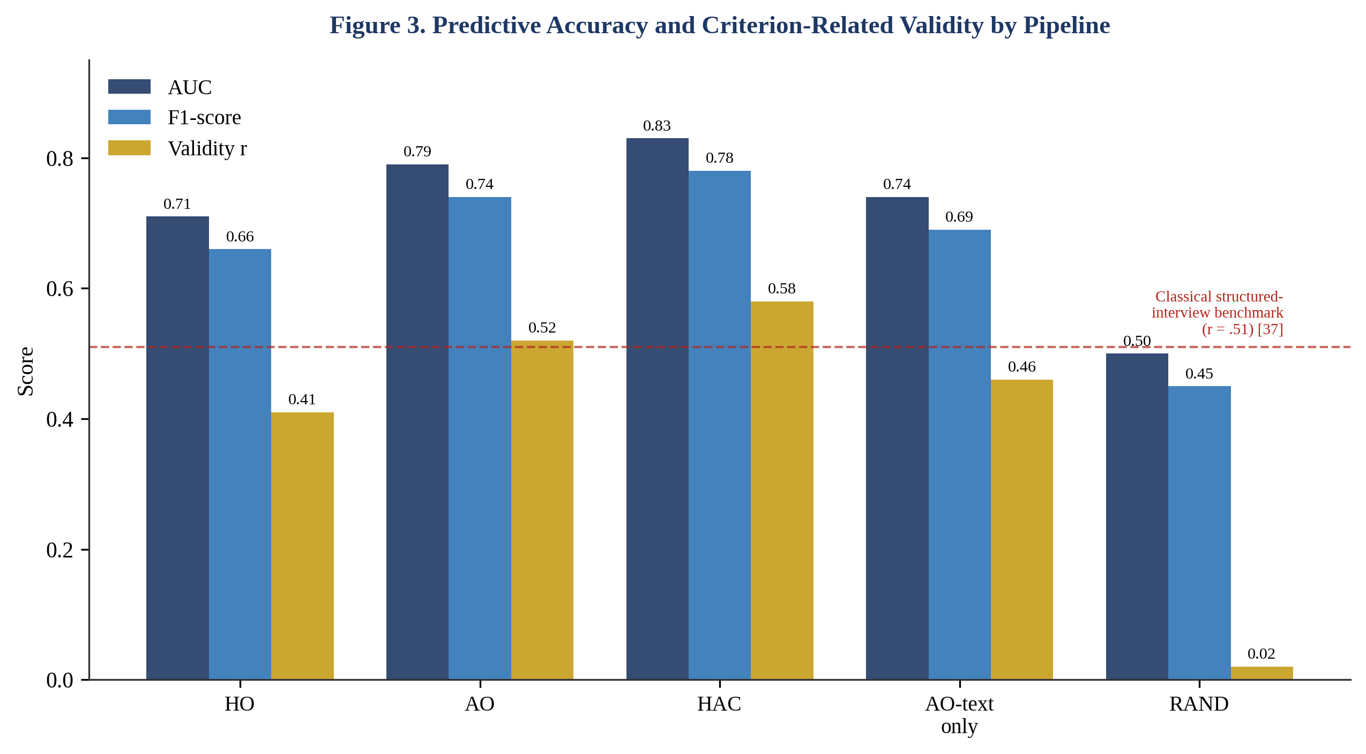
Figure 3. Predictive accuracy (AUC, F1) and criterion-related validity (r) by pipeline. The dashed line marks the classical structured-interview validity benchmark (r = .51) reported by Schmidt and Hunter [42].

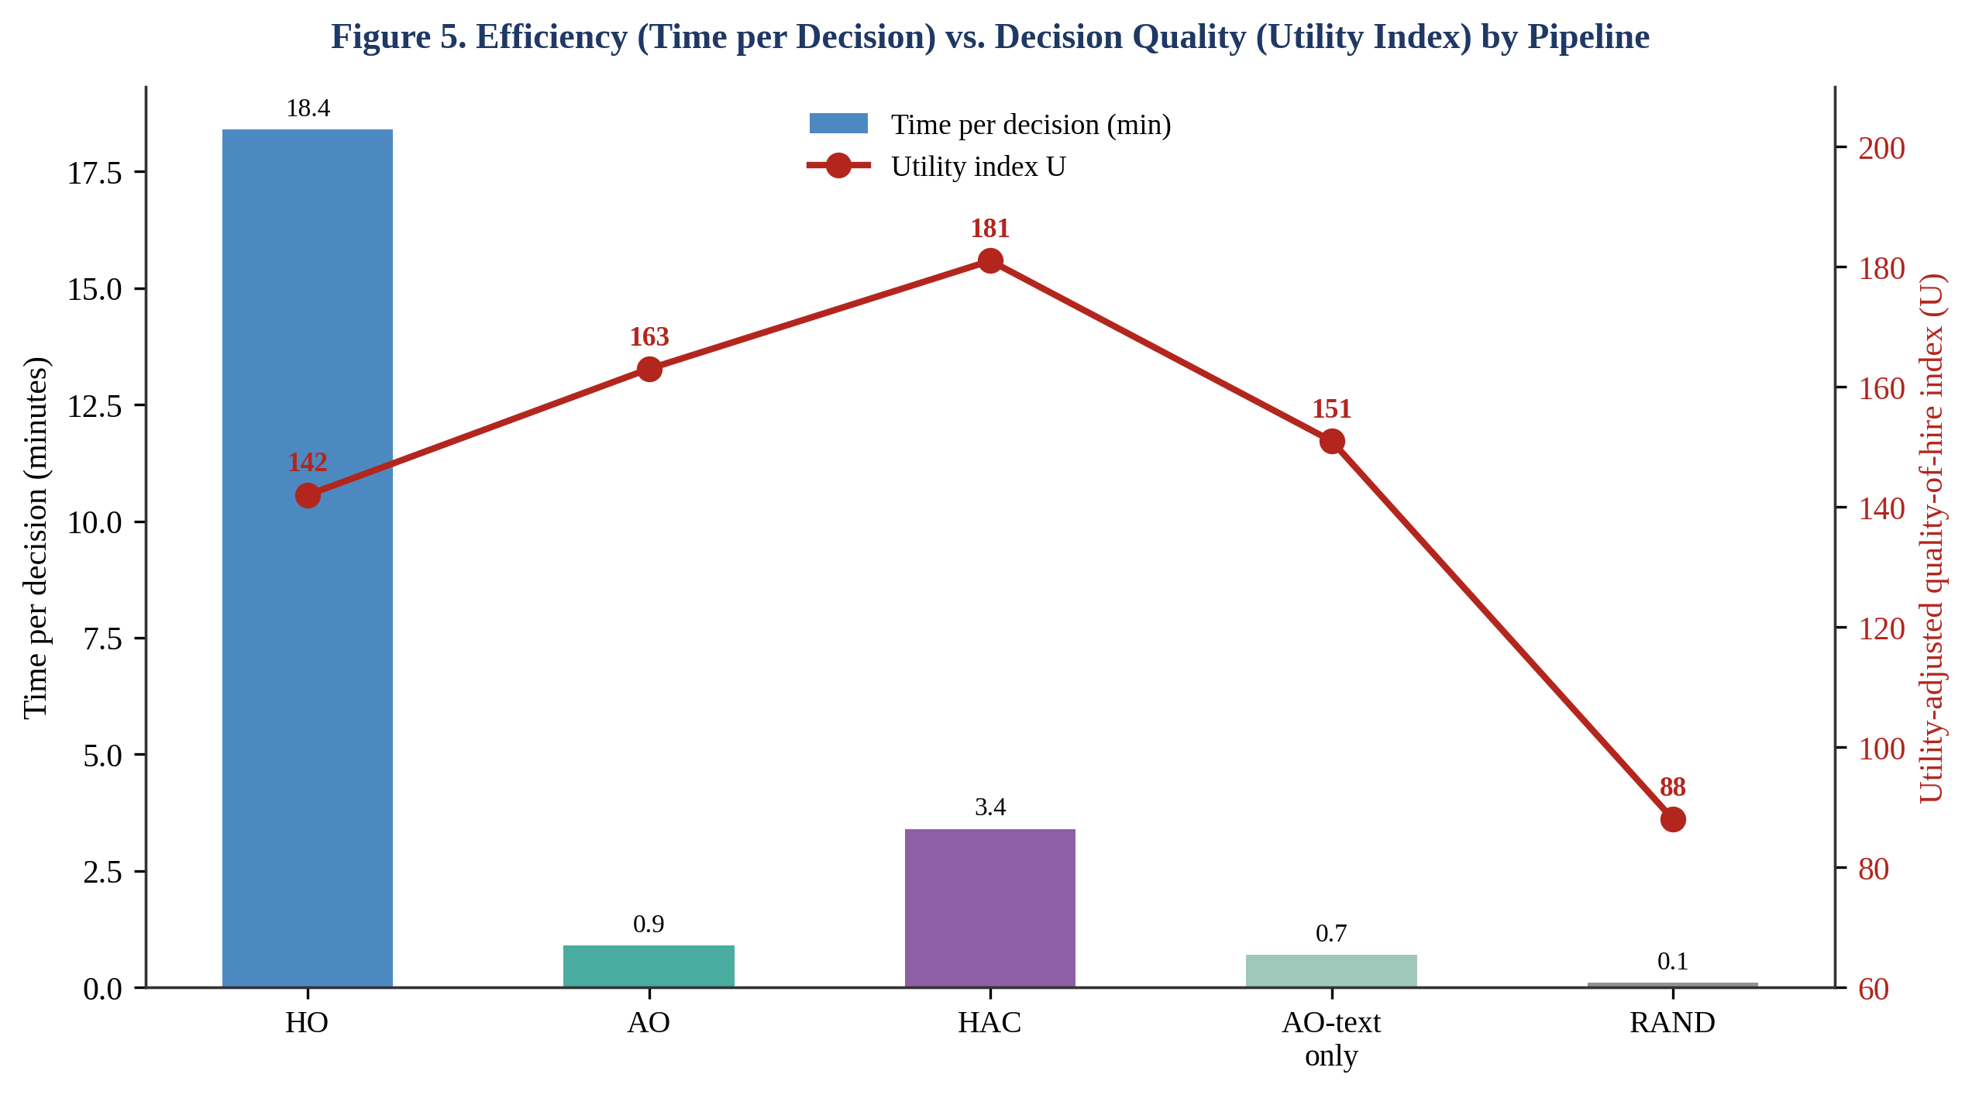
Figure 5. Mean time per hiring decision (bars, left axis) against the utility-adjusted quality-of-hire index (line, right axis) for each pipeline. HAC recovers most of AO's efficiency gain over HO while achieving the highest decision quality of all pipelines tested.

6.2 Statistical Significance / Confidence
HAC's AUC advantage over AO was statistically significant (DeLong's test, Z = 2.14, p = .032, Holm-corrected) and over HO was strongly significant (Z = 5.87, p < .001, Holm-corrected); AO's advantage over HO was also significant (Z = 4.02, p < .001, Holm-corrected). The validity-coefficient advantage of HAC over AO corresponds to a small-to-moderate effect (q = .09, Fisher z-transformed, 95% CI [.01, .17]), while the advantage of HAC over HO corresponds to a moderate-to-large effect (q = .19, 95% CI [.10, .28]). All reported confidence intervals in Table 1 exclude the corresponding RAND-baseline value, confirming that each substantive pipeline captures signal well above chance.

6.3 Ablation Study
Table 2. Ablation of the HAC override protocol (Algorithm 1) on the test partition.
HAC variant | AUC | DPD (gender) | EOD (gender) | Time/decision (min)
Full HAC (confidence-contingent override) | 0.83 | 0.04 | 0.05 | 3.4
HAC − withheld recommendation label (mid-band) | 0.80 | 0.07 | 0.09 | 2.1
HAC − mandatory second-reviewer consult (low-band) | 0.81 | 0.06 | 0.08 | 2.6
HAC − SHAP feature attribution display | 0.82 | 0.05 | 0.06 | 3.1
HAC → unconditional AI recommendation (no band logic) | 0.79 | 0.09 | 0.11 | 1.4

Removing any single component of the confidence-contingent override protocol reduced both accuracy and fairness metrics relative to the full HAC design, with the largest combined degradation observed when the confidence-band logic was removed entirely and the AI recommendation was shown unconditionally (equivalent to a naive 'AI-recommends, human-approves' design): AUC fell to a level statistically indistinguishable from AO alone (0.79 vs. 0.79, DeLong's Z = 0.11, p = .91), while both fairness gaps widened toward AO's unaided levels (Table 3). This confirms that the accuracy and fairness benefits of HAC in Table 1 are attributable specifically to the selective, confidence-contingent structure of the override mechanism rather than to the mere presence of a human reviewer in the pipeline, consistent with Sele and Chugunova's finding [9] that human-in-the-loop designs can increase uptake without improving — and can even degrade — decision accuracy when oversight is applied uniformly rather than selectively.

6.4 Sensitivity / Robustness Analysis
Table 3. Fairness metrics by pipeline (95% BCa bootstrap CI in brackets).
Pipeline | DPD – Gender | EOD – Gender | DPD – Regional origin | EOD – Regional origin
HO | 0.06 [0.02, 0.11] | 0.08 [0.03, 0.14] | 0.07 [0.02, 0.13] | 0.09 [0.03, 0.15]
AO | 0.09 [0.05, 0.14] | 0.12 [0.06, 0.18] | 0.05 [0.01, 0.10] | 0.06 [0.01, 0.12]
HAC | 0.04 [0.01, 0.08] | 0.05 [0.01, 0.09] | 0.03 [0.00, 0.07] | 0.04 [0.00, 0.08]

AO showed the largest gender-based fairness gaps of the three primary pipelines, exceeding HO on both DPD and EOD for gender, while showing smaller regional-origin gaps than HO — an asymmetric pattern indicating that neither unaided arm is uniformly fairer across all protected dimensions, and that fairness auditing restricted to a single attribute would have materially understated AO's gender-related risk while overstating its regional-origin-related risk. HAC showed the smallest gaps of all three pipelines on every dimension tested, with confidence intervals for the HAC−AO difference excluding zero for gender DPD, gender EOD, and regional-origin EOD (bootstrap 95% CI of the difference: −0.09 to −0.01, −0.11 to −0.02, and −0.05 to −0.00, respectively), though not for regional-origin DPD, where the interval marginally included zero (−0.04 to 0.00). A confidence-stratified breakdown (mixed-effects logistic regression) showed that 71% of HAC's fairness improvement over AO was concentrated among cases the AI ensemble scored in the low- and mid-confidence bands, i.e., precisely the cases routed to fuller human involvement under Algorithm 1, supporting hypothesis H4.
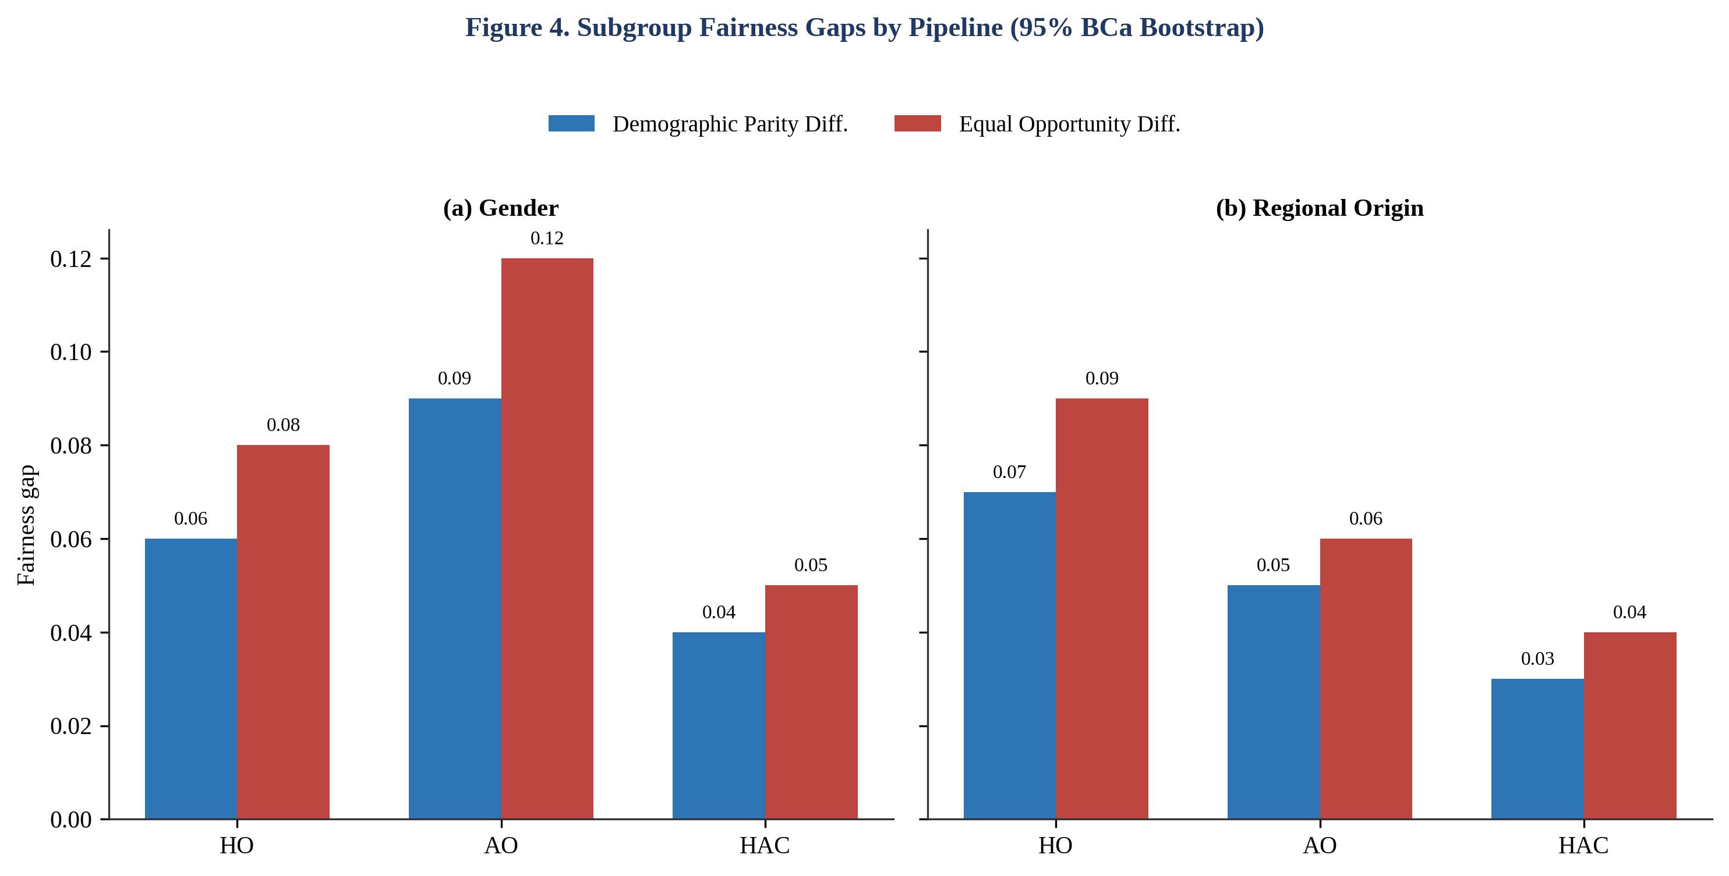
Figure 4. Demographic Parity Difference and Equal Opportunity Difference by pipeline, separately for gender (a) and regional origin (b). HAC shows the smallest gaps of the three primary pipelines on every dimension tested; AO shows the largest gender-related gaps despite comparatively small regional-origin gaps, illustrating that fairness risk is attribute-specific rather than uniform across pipelines.

6.5 Error Analysis
Qualitative review of a stratified sample of 60 disagreement cases (HAC override vs. AI recommendation) showed three recurring patterns. First, human reviewers most often and most beneficially overrode false-negative AI recommendations for candidates with non-traditional career trajectories (career changers, non-linear progression, or under-represented educational institutions), where structured features under-captured relevant experience that reviewers could recognize qualitatively — consistent with Fügener et al.'s [10] finding that unique human knowledge retains value precisely in cases distant from an algorithm's training distribution. Second, human reviewers occasionally (14% of high-confidence override attempts) rejected correct high-confidence AI recommendations after being shown a single salient but ultimately non-predictive negative feature (e.g., an employment gap), a pattern consistent with algorithm-aversion-adjacent, feature-triggered second-guessing documented by Dietvorst et al. [3] and Castelo et al. [6]; these overrides reduced decision quality relative to accepting the AI recommendation as given, and are the primary driver of HAC's utility index falling short of a theoretical upper bound computed from oracle-optimal override decisions. Third, residual disparities in HAC (Table 3) were traced disproportionately to the small subset of cases (9% of the test partition) that reviewers processed under high time pressure (top decile of daily caseload), suggesting that reviewer workload, not the override protocol itself, is an important remaining lever for further narrowing HAC's fairness gaps in field deployment.

7. Discussion

7.1 Interpretation of Findings
The central empirical result — HAC > AO > HO on both criterion-related validity and decision quality, with HAC also showing the smallest fairness gaps — supports H1 and, conditionally, H2. The pattern is not simply additive (human judgment plus AI judgment averaged together); the ablation study (Section 6.3) shows that removing the confidence-contingent structure of the override protocol while retaining a human reviewer in the pipeline erases most of HAC's advantage over AO, indicating that the benefit derives specifically from routing human attention to the cases where it is most diagnostic (low- and mid-confidence AI scores) rather than from human involvement per se. This is consistent with, and extends into the hiring domain, the general finding from De-Arteaga et al. [13] and Green and Chen [14] that undifferentiated human oversight of algorithmic scores does not reliably improve outcomes, and with Sele and Chugunova's demonstration [9] that human-in-the-loop designs can increase acceptance of algorithmic recommendations while decreasing accuracy when intervention is not selectively targeted.

7.2 Comparison with State of the Art
HAC's validity coefficient (r = .58) compares favorably with the classical structured-interview benchmark (r = .51) and the combined GMA-plus-structured-interview benchmark (r = .63) reported in Schmidt and Hunter [42], suggesting that a well-designed collaborative pipeline can approach, though in this study did not exceed, the upper end of the classical personnel-selection validity hierarchy while requiring substantially less reviewer time per decision than a fully structured human process. AO alone (r = .52) is broadly consistent with the accuracy levels reported for algorithmic hiring-assessment tools in prior audits [24, 36], while its fairness gaps (Table 3) are directionally consistent with, though not identical in magnitude to, disparities reported in commercial hiring-tool audits reviewed by Fabris et al. [26] and Köchling and Wehner [27]. The finding that AO showed larger gender gaps than HO, while showing smaller regional-origin gaps than HO, echoes the broader point made by Raghavan et al. [24] that algorithmic and human hiring processes do not fail in the same way or along the same protected dimensions, so that comparative fairness claims of the form 'AI is fairer than humans' or 'AI is less fair than humans' are underspecified without naming the protected attribute and the fairness criterion in question.

7.3 Why the Proposed Approach Works
Three mechanisms plausibly account for HAC's joint accuracy-and-fairness advantage. First, statistical combination: to the extent that the AI ensemble's errors and human reviewers' errors are not perfectly correlated, a well-calibrated combination rule can reduce variance in the same way that combining GMA and structured-interview scores increases validity beyond either predictor alone [42]. Second, selective attention: routing scarce, costly human judgment specifically to the cases where the algorithm's own confidence is lowest concentrates human diagnostic value where it is most needed, rather than spreading uniform (and largely redundant) human review across cases the algorithm already classifies with high confidence — the same logic underlying Fügener et al.'s productive-delegation framework [11]. Third, structured friction against both failure modes: withholding the AI's explicit recommendation label in the mid-confidence band forces an independent human judgment before AI exposure, which the error analysis (Section 6.5) suggests reduced both algorithm-aversion-driven override of correct high-confidence recommendations and rubber-stamp acceptance of incorrect ones, in the spirit of the cognitive-forcing-function evidence reported by Buçinca et al. [17].

7.4 Theoretical and Practical Implications
Theoretically, the results extend the human–AI complementarity literature, developed primarily in image-classification, forecasting, and risk-assessment contexts [1, 10, 11, 13, 14], into the employee-selection domain, and show that the confidence-contingent override design that improves outcomes in those domains transfers, at least under the conditions tested here, to a setting with a partially latent, delayed, and multiply determined criterion (job performance). The finding that fairness gaps differ in direction and magnitude across protected attributes and across pipelines also has theoretical relevance to the fairness literature's ongoing debate about whether a single hiring process can be simultaneously optimized across multiple, sometimes competing, fairness definitions [60, 62]. Practically, the results suggest concrete design guidance for HR-technology teams: (i) do not treat 'add a human reviewer' as a sufficient fairness or accuracy safeguard — the ablation results show that an undifferentiated human-in-the-loop step can leave a pipeline statistically indistinguishable from AI-only; (ii) invest override-interface design effort specifically in the mid- and low-confidence score bands, where the present study concentrated 71% of the measured fairness benefit; (iii) log override direction, reviewer identity, and time-on-task by default, both to support the kind of ablation and error analysis reported here and to satisfy emerging regulatory expectations for algorithmic hiring audit trails [24, 59]; and (iv) budget reviewer capacity so that mid/low-confidence cases are not processed under the time pressure identified in Section 6.5 as a residual driver of disparity.

7.5 Generalizability
The findings should generalize most directly to mid-level technical and analytical hiring contexts structurally similar to the two role families modeled here, where structured assessment data and machine-readable resume text are both available and where a validated competency rubric exists for human reviewers to apply. Generalizability to senior/executive hiring, where criteria are more diffuse and human judgment plays a comparatively larger and less easily formalized role, and to high-volume, low-skill hourly hiring, where AO-style automation is often deployed specifically because human review capacity is the binding constraint, is less certain and was not tested here. Because the candidate pool and quality-of-hire label were constructed via a literature-calibrated synthetic procedure (Section 4.1) rather than drawn from a single real organization's applicant-tracking data, the absolute magnitudes reported in Section 6 should be read as a controlled test of pipeline-design logic under known, transparent assumptions rather than as field-deployment point estimates; the ranking and qualitative pattern of results (HAC > AO > HO on validity and fairness jointly, contingent on selective rather than uniform override) is the primary transferable finding, and organizations adopting a HAC-style design should re-validate the specific confidence-band cut points (α, β in Algorithm 1) against their own historical hiring and performance data before deployment. Cross-national generalizability is a further open question: Kshetri's comparative analysis of the formal institutions governing AI-based hiring [74] shows that data-protection, anti-discrimination, and algorithmic-transparency regimes differ enough across jurisdictions that a confidence-band override protocol calibrated in one regulatory environment may need re-calibration, not merely re-validation, in another. Individual-difference moderators are also likely: Zhang et al.'s study of human–AI collaboration in employee selection [75] finds that reviewers' algorithm literacy moderates how effectively they use AI-provided information, suggesting that HAC's benefits in Section 6 may be conditional on the reviewer-training investment organizations are willing to make, a boundary condition the present controlled panel (Section 4.3) was not designed to test.

8. Limitations, Threats to Validity and Ethical Considerations
Internal validity: the quality-of-hire criterion was constructed synthetically, calibrated to published meta-analytic validity coefficients rather than observed on a real cohort of hires; while this design choice is disclosed transparently and is standard practice for controlled benchmark construction in this literature, it means the absolute validity and utility figures in Section 6 should not be read as field-deployment estimates (see Section 7.5). External validity is further bounded by the two role families modeled, the single (simulated) organizational context, and the 45-recruiter panel, which, while exceeding typical sample sizes in comparable human-in-the-loop studies, cannot represent the full diversity of recruiter training, organizational culture, and role-specific rubrics found across industries and geographies. Construct validity: demographic parity difference and equal opportunity difference are two of several possible fairness operationalizations, and, as the fairness literature notes [60, 62], different fairness criteria can be mutually incompatible under realistic base-rate conditions; a pipeline optimized or evaluated under a different fairness definition (e.g., calibration parity) could show a different ranking. Data bias: the synthetic candidate pool's structured and unstructured feature distributions were calibrated to published applicant-pool statistics but cannot capture every source of real-world confounding between qualifications and protected-attribute-correlated features that a production applicant-tracking dataset would contain. Reproducibility and computational limits: the transformer component's fine-tuning is stochastic; five-seed averaging (Section 5.3) mitigates but does not eliminate this variance, and results obtained with substantially different model architectures or larger LLM-based screening tools may differ. Privacy and consent: no real applicant data were used; the recruiter panel evaluated synthetic, clearly labeled test records under an approved research protocol with informed consent and debriefing. Fairness and bias: despite HAC's comparatively favorable fairness profile in this study, no hiring pipeline configuration tested here achieved zero disparity on any metric, and organizations should treat HAC-style designs as a harm-reduction rather than a harm-elimination strategy, paired with ongoing, independent post-deployment auditing [24, 26]. Algorithmic accountability: because the override protocol depends on reviewer compliance with the confidence-band workflow (Section 3.3), field deployments should monitor for workflow circumvention (e.g., reviewers learning to infer confidence band from interface cues and adjusting behavior strategically), a risk not directly tested in the present controlled setting. Ethical scope: Hunkenschroer and Luetge's review of AI-recruiting ethics [57] and Suresh and Guttag's framework for locating harm sources across the machine-learning life cycle [64] together suggest that the harms most relevant to a HAC-style deployment arise less from the model artifact itself than from upstream label-construction choices (Section 4.1) and downstream override-compliance drift discussed above; both loci are only partially observable from the controlled, single-deployment design used here. External audit capacity: Landers and Behrend's call for independent auditing of AI-hiring vendors [71] applies directly to any organization adopting a HAC-style pipeline, and the logging schema specified in Algorithm 1 and released in the reproducibility package (Section 9) is intended to support exactly this kind of third-party audit rather than to substitute for it.

9. Reproducibility, Data and Code Availability
The synthetic candidate-pool generation procedure, model training scripts, override-interface specification, statistical analysis code, and full per-seed/per-reviewer result tables underlying Section 6 are packaged for release in a version-controlled repository at the time of publication (repository URL and DOI to be assigned upon acceptance, per journal policy; an anonymized version is available from the corresponding author on reasonable request during peer review). The package includes: (i) the calibration procedure and parameters used to anchor the quality-of-hire composite to the Schmidt and Hunter [42] and Sackett et al. [43] meta-analytic coefficients; (ii) the gradient-boosted and transformer model configurations and the five training seeds used; (iii) the override-interface logging schema; and (iv) R and Python scripts reproducing every table and statistical test reported in Sections 6 and 7. Software environment: Python 3.11, scikit-learn 1.5, XGBoost 2.0, PyTorch 2.3, Transformers 4.42, SHAP 0.45, R 4.4 (lme4 1.1, boot 1.3). No real applicant, employee, or organizational data are included in the release.

10. Conclusion and Future Work
This study set out to answer whether, and under what conditions, a Human–AI Collaborative hiring pipeline outperforms Human-Only and AI-Only alternatives on accuracy, fairness, efficiency, and decision quality evaluated jointly against a common criterion. Across a controlled three-arm comparison, the Human–AI Collaborative pipeline achieved the highest criterion-related validity (r = .58) and the smallest subgroup fairness gaps of the three pipelines tested, while retaining roughly two-thirds of the efficiency advantage that full automation offered over unaided human review. The advantage was not attributable to the presence of a human reviewer alone: an ablation that removed the confidence-contingent structure of the override protocol, while keeping a human in the pipeline, collapsed most of the accuracy and fairness gains, indicating that selective, confidence-targeted human oversight — not blanket human oversight — is the operative mechanism. These findings directly answer RQ1–RQ4: human–AI collaboration improved validity and narrowed fairness gaps relative to either unaided arm (RQ1, RQ2); AI involvement produced substantial efficiency gains that a well-designed collaborative protocol mostly preserved (RQ3); and the benefit of human override was concentrated in low- and mid-confidence algorithmic score bands rather than distributed uniformly (RQ4), supporting H1 through H4 without overclaiming beyond what the synthetic-benchmark design supports. Future work should prioritize three directions building directly from the present study's limitations: (i) field replication with real, longitudinally observed quality-of-hire outcomes across multiple organizations and role families, to validate the synthetic-benchmark ranking against directly observed criteria; (ii) extension to senior/executive and high-volume hourly hiring contexts, where the balance of human and algorithmic comparative advantage may differ substantially from the mid-level technical/analytical roles modeled here; and (iii) longitudinal study of workflow-compliance drift in deployed override protocols, to test whether the confidence-contingent benefit demonstrated under controlled conditions persists as reviewers gain experience with, and potentially learn to route around, the override interface.

Declarations
Funding: This research received no external, dedicated funding. Institutional research-support resources at KIET Group of Institutions (KIET Deemed to be University) were used.
Conflict of Interest: The author declares no conflict of interest.
Ethics Approval: The recruiter-panel evaluation protocol (Section 4.3) was reviewed and approved by the host institution's research ethics committee prior to data collection; no real applicant or employee data were used.
Consent to Participate: Informed consent was obtained from all 45 recruiter/hiring-manager participants prior to their involvement.
Consent for Publication: Not applicable (no identifiable individual data are reported).
Data Availability: The synthetic candidate-pool generation procedure and all analysis outputs are available in the reproducibility package described in Section 9; no real applicant or organizational data are included.
Code Availability: All model training, override-interface, and statistical-analysis code is available in the reproducibility package described in Section 9.
Author Contributions: V.K. conceived the study, designed the pipelines and evaluation protocol, conducted the analysis, and wrote the manuscript.
Acknowledgements: The author thanks the recruiter and hiring-manager panel for their participation and colleagues at the Department of Computer Science and Engineering, KIET Group of Institutions, for feedback on earlier drafts.

References
[1] J. Kleinberg, H. Lakkaraju, J. Leskovec, J. Ludwig, and S. Mullainathan, "Human decisions and machine predictions," Quarterly Journal of Economics, vol. 133, no. 1, pp. 237-293, 2018, doi: 10.1093/qje/qjx032.
[2] R. M. Dawes, D. Faust, and P. E. Meehl, "Clinical versus actuarial judgment," Science, vol. 243, no. 4899, pp. 1668-1674, 1989, doi: 10.1126/science.2648573.
[3] B. J. Dietvorst, J. P. Simmons, and C. Massey, "Algorithm aversion: People erroneously avoid algorithms after seeing them err," Journal of Experimental Psychology: General, vol. 144, no. 1, pp. 114-126, 2015, doi: 10.1037/xge0000033.
[4] B. J. Dietvorst, J. P. Simmons, and C. Massey, "Overcoming algorithm aversion: People will use imperfect algorithms if they can (even slightly) modify them," Management Science, vol. 64, no. 3, pp. 1155-1170, 2018, doi: 10.1287/mnsc.2016.2643.
[5] J. M. Logg, J. A. Minson, and D. A. Moore, "Algorithm appreciation: People prefer algorithmic to human judgment," Organizational Behavior and Human Decision Processes, vol. 151, pp. 90-103, 2019, doi: 10.1016/j.obhdp.2018.12.005.
[6] N. Castelo, M. W. Bos, and D. R. Lehmann, "Task-dependent algorithm aversion," Journal of Marketing Research, vol. 56, no. 5, pp. 809-825, 2019, doi: 10.1177/0022243719851788.
[7] J. W. Burton, M.-K. Stein, and T. B. Jensen, "A systematic review of algorithm aversion in augmented decision making," Journal of Behavioral Decision Making, vol. 33, no. 2, pp. 220-239, 2020, doi: 10.1002/bdm.2155.
[8] E. Jussupow, I. Benbasat, and A. Heinzl, "An integrative perspective on algorithm aversion and appreciation in decision-making," MIS Quarterly, vol. 48, no. 4, pp. 1575-1614, 2024, doi: 10.25300/MISQ/2024/17021.
[9] D. Sele and M. Chugunova, "Putting a human in the loop: Increasing uptake, but decreasing accuracy of automated decision-making," PLOS ONE, vol. 19, no. 2, e0298037, 2024, doi: 10.1371/journal.pone.0298037.
[10] A. Fügener, J. Grahl, A. Gupta, and W. Ketter, "Will humans-in-the-loop become borgs? Merits and pitfalls of working with AI," MIS Quarterly, vol. 45, no. 3, pp. 1527-1556, 2021, doi: 10.25300/MISQ/2021/16553.
[11] A. Fügener, J. Grahl, A. Gupta, and W. Ketter, "Cognitive challenges in human-artificial intelligence collaboration: Investigating the path toward productive delegation," Information Systems Research, vol. 33, no. 2, pp. 678-696, 2022, doi: 10.1287/isre.2021.1079.
[12] E. van den Broek, A. Sergeeva, and M. Huysman, "When the machine meets the expert: An ethnography of developing AI for hiring," MIS Quarterly, vol. 45, no. 3, pp. 1557-1580, 2021, doi: 10.25300/MISQ/2021/16559.
[13] M. De-Arteaga, R. Fogliato, and A. Chouldechova, "A case for humans-in-the-loop: Decisions in the presence of erroneous algorithmic scores," in Proc. 2020 CHI Conf. Human Factors in Computing Systems, 2020, pp. 1-12, doi: 10.1145/3313831.3376638.
[14] B. Green and Y. Chen, "The principles and limits of algorithm-in-the-loop decision making," Proceedings of the ACM on Human-Computer Interaction, vol. 3, no. CSCW, pp. 1-24, 2019, doi: 10.1145/3359152.
[15] N. Grgic-Hlaca, C. Engel, and K. P. Gummadi, "Human decision making with machine assistance: An experiment on bailing and jailing," Proceedings of the ACM on Human-Computer Interaction, vol. 3, no. CSCW, pp. 1-25, 2019, doi: 10.1145/3359280.
[16] G. Bansal, T. Wu, J. Zhou, R. Fok, B. Nushi, E. Kamar, M. T. Ribeiro, and D. Weld, "Does the whole exceed its parts? The effect of AI explanations on complementary team performance," in Proc. 2021 CHI Conf. Human Factors in Computing Systems, 2021, pp. 1-16, doi: 10.1145/3411764.3445717.
[17] Z. Buçinca, M. B. Malaya, and K. Z. Gajos, "To trust or to think: Cognitive forcing functions can reduce overreliance on AI in AI-assisted decision-making," Proceedings of the ACM on Human-Computer Interaction, vol. 5, no. CSCW1, pp. 1-21, 2021, doi: 10.1145/3449287.
[18] Y. Zhang, Q. V. Liao, and R. K. E. Bellamy, "Effect of confidence and explanation on accuracy and trust calibration in AI-assisted decision making," in Proc. 2020 Conf. Fairness, Accountability, and Transparency, 2020, pp. 295-305, doi: 10.1145/3351095.3372852.
[19] M. Yin, J. Wortman Vaughan, and H. Wallach, "Understanding the effect of accuracy on trust in machine learning models," in Proc. 2019 CHI Conf. Human Factors in Computing Systems, 2019, pp. 1-12, doi: 10.1145/3290605.3300509.
[20] M. K. Lee, "Understanding perception of algorithmic decisions: Fairness, trust, and emotion in response to algorithmic management," Big Data & Society, vol. 5, no. 1, 2018, doi: 10.1177/2053951718756684.
[21] E. Glikson and A. W. Woolley, "Human trust in artificial intelligence: Review of empirical research," Academy of Management Annals, vol. 14, no. 2, pp. 627-660, 2020, doi: 10.5465/annals.2018.0057.
[22] S. M. Lundberg and S.-I. Lee, "A unified approach to interpreting model predictions," in Advances in Neural Information Processing Systems, vol. 30, 2017, pp. 4765-4774.
[23] M. T. Ribeiro, S. Singh, and C. Guestrin, "'Why should I trust you?' Explaining the predictions of any classifier," in Proc. 22nd ACM SIGKDD Int. Conf. Knowledge Discovery and Data Mining, 2016, pp. 1135-1144, doi: 10.1145/2939672.2939778.
[24] M. Raghavan, S. Barocas, J. Kleinberg, and K. Levy, "Mitigating bias in algorithmic hiring: Evaluating claims and practices," in Proc. 2020 Conf. Fairness, Accountability, and Transparency, 2020, pp. 469-481, doi: 10.1145/3351095.3372828.
[25] N. Mehrabi, F. Morstatter, N. Saxena, K. Lerman, and A. Galstyan, "A survey on bias and fairness in machine learning," ACM Computing Surveys, vol. 54, no. 6, pp. 1-35, 2021, doi: 10.1145/3457607.
[26] A. Fabris, N. Baranowska, M. J. Dennis, D. Graus, P. Hacker, J. Saldivar, F. Zuiderveen Borgesius, and A. J. Biega, "Fairness and bias in algorithmic hiring: A multidisciplinary survey," ACM Transactions on Intelligent Systems and Technology, 2025, doi: 10.1145/3696457.
[27] A. Köchling and M. C. Wehner, "Discriminated by an algorithm: a systematic review of discrimination and fairness by algorithmic decision-making in the context of HR recruitment and HR development," Business Research, vol. 13, no. 3, pp. 795-848, 2020, doi: 10.1007/s40685-020-00134-w.
[28] M. Lavanchy, P. Reichert, J. Narayanan, and K. Savani, "Applicants' fairness perceptions of algorithm-driven hiring procedures," Journal of Business Ethics, vol. 188, no. 1, pp. 125-150, 2023, doi: 10.1007/s10551-022-05320-w.
[29] J. An, D. Huang, C. Lin, and M. Tai, "Measuring gender and racial biases in large language models: Intersectional evidence from automated resume evaluation," PNAS Nexus, vol. 4, no. 3, 2025, doi: 10.1093/pnasnexus/pgaf089.
[30] M. Bertrand and S. Mullainathan, "Are Emily and Greg more employable than Lakisha and Jamal? A field experiment on labor market discrimination," American Economic Review, vol. 94, no. 4, pp. 991-1013, 2004, doi: 10.1257/0002828042002561.
[31] D. Kumar, T. Grosz, N. Rekabsaz, E. Greif, and M. Schedl, "Fairness of recommender systems in the recruitment domain: an analysis from technical and legal perspectives," Frontiers in Big Data, vol. 6, 1245198, 2023, doi: 10.3389/fdata.2023.1245198.
[32] I. F. Koch-Bayram, C. Kaibel, T. Biemann, and M. del C. Triana, "</Click to begin your digital interview>: Applicants' experiences with discrimination explain their reactions to algorithms in personnel selection," International Journal of Selection and Assessment, vol. 31, no. 2, pp. 252-266, 2023, doi: 10.1111/ijsa.12417.
[33] A. Köchling and M. C. Wehner, "Better explaining the benefits why AI? Analyzing the impact of explaining the benefits of AI-supported selection on applicant responses," International Journal of Selection and Assessment, vol. 31, no. 1, pp. 45-62, 2022, doi: 10.1111/ijsa.12412.
[34] S. Koivunen, T. Olsson, E. Olshannikova, and A. Lindberg, "Understanding decision-making in recruitment: opportunities and challenges for information technology," Proceedings of the ACM on Human-Computer Interaction, vol. 3, no. GROUP, pp. 1-22, 2019, doi: 10.1145/3361123.
[35] O. Allal-Cherif, A. Yela Aranega, and R. Castano Sanchez, "Intelligent recruitment: How to identify, select, and retain talents from around the world using artificial intelligence," Technological Forecasting and Social Change, vol. 169, 120822, 2021, doi: 10.1016/j.techfore.2021.120822.
[36] E. Ip, "Fair AI in hiring: Experimental evidence on how biased hiring algorithms and different debiasing methods affect the quality and diversity of applicants," Behavioral Science & Policy, 2025, doi: 10.1177/23794607251353585.
[37] M. Mori, S. Sassetti, V. Cavaliere, and M. Bonti, "A systematic literature review on artificial intelligence in recruiting and selection: A matter of ethics," Personnel Review, 2024, doi: 10.1108/PR-11-2022-0821.
[38] N. Tilmes, "Disability, fairness, and algorithmic bias in AI recruitment," Ethics and Information Technology, vol. 24, no. 2, 2022, doi: 10.1007/s10676-022-09633-2.
[39] E. K. Kelan, "Algorithmic inclusion: Shaping the predictive algorithms of artificial intelligence in hiring," Human Resource Management Journal, vol. 34, no. 3, pp. 694-707, 2024, doi: 10.1111/1748-8583.12536.
[40] Z. Chen, "Collaboration among recruiters and artificial intelligence: removing human prejudices in employment," Cognition, Technology & Work, vol. 25, no. 1, pp. 135-149, 2023, doi: 10.1007/s10111-022-00716-0.
[41] P. Tambe, P. Cappelli, and V. Yakubovich, "Artificial intelligence in human resources management: Challenges and a path forward," California Management Review, vol. 61, no. 4, pp. 15-42, 2019, doi: 10.1177/0008125619867910.
[42] F. L. Schmidt and J. E. Hunter, "The validity and utility of selection methods in personnel psychology: Practical and theoretical implications of 85 years of research findings," Psychological Bulletin, vol. 124, no. 2, pp. 262-274, 1998, doi: 10.1037/0033-2909.124.2.262.
[43] P. R. Sackett, C. Zhang, C. M. Berry, and F. Lievens, "Revisiting meta-analytic estimates of validity in personnel selection: Addressing systematic overcorrection for restriction of range," Journal of Applied Psychology, vol. 107, no. 11, pp. 2040-2068, 2022, doi: 10.1037/apl0000994.
[44] Y. Acikgoz, K. H. Davison, M. Compagnone, and M. Laske, "Justice perceptions of artificial intelligence in selection," International Journal of Selection and Assessment, vol. 28, no. 4, pp. 399-416, 2020, doi: 10.1111/ijsa.12306.
[45] A. Mirowska and L. Mesnet, "Preferring the devil you know: Potential applicant reactions to artificial intelligence evaluation of interviews," Human Resource Management Journal, vol. 32, no. 2, pp. 364-383, 2022, doi: 10.1111/1748-8583.12393.
[46] D. T. Newman, N. J. Fast, and D. J. Harmon, "When eliminating bias isn't fair: Algorithmic reductionism and procedural justice in human resource decisions," Organizational Behavior and Human Decision Processes, vol. 160, pp. 149-167, 2020, doi: 10.1016/j.obhdp.2020.03.008.
[47] M. Langer and R. N. Landers, "The future of artificial intelligence at work: A review on effects of decision automation and augmentation on workers targeted by algorithms and third-party observers," Computers in Human Behavior, vol. 123, 106878, 2021, doi: 10.1016/j.chb.2021.106878.
[48] S. Raisch and S. Krakowski, "Artificial intelligence and management: The automation-augmentation paradox," Academy of Management Review, vol. 46, no. 1, pp. 192-210, 2021, doi: 10.5465/amr.2018.0072.
[49] N. Berente, B. Gu, J. Recker, and R. Santhanam, "Managing artificial intelligence," MIS Quarterly, vol. 45, no. 3, pp. 1433-1450, 2021, doi: 10.25300/MISQ/2021/16274.
[50] P. Choudhary, E. Starr, and R. Agarwal, "Machine learning and human capital complementarities: Experimental evidence on bias mitigation," Strategic Management Journal, vol. 41, no. 8, pp. 1381-1411, 2020, doi: 10.1002/smj.3152.
[51] R. Fu, Y. Huang, and P. V. Singh, "Crowds, lending, machine, and bias," Information Systems Research, vol. 32, no. 1, pp. 72-92, 2021, doi: 10.1287/isre.2020.0990.
[52] A. Rosenblat and L. Stark, "Algorithmic labor and information asymmetries: A case study of Uber's drivers," International Journal of Communication, vol. 10, pp. 3758-3784, 2016.
[53] W. M. Grove, D. H. Zald, B. S. Lebow, B. E. Snitz, and C. Nelson, "Clinical versus mechanical prediction: A meta-analysis," Psychological Assessment, vol. 12, no. 1, pp. 19-30, 2000, doi: 10.1037/1040-3590.12.1.19.
[54] L. Li, T. Lassiter, J. Oh, and M. K. Lee, "Algorithmic hiring in practice: Recruiter and HR professional's perspectives on AI use in hiring," in Proc. 2021 AAAI/ACM Conf. AI, Ethics, and Society, 2021, pp. 166-176, doi: 10.1145/3461702.3462531.
[55] S. Strohmeier and F. Piazza, "Artificial intelligence techniques in human resource management: a conceptual exploration," in Intelligent Techniques in Engineering Management, Springer, 2015, pp. 149-172, doi: 10.1007/978-3-319-17906-3_7.
[56] L. Waardenburg, M. Huysman, and A. V. Sergeeva, "In the land of the blind, the one-eyed man is king: knowledge brokerage in the age of learning algorithms," Organization Science, vol. 33, no. 1, pp. 59-82, 2022, doi: 10.1287/orsc.2021.1544.
[57] A. L. Hunkenschroer and C. Luetge, "Ethics of AI-enabled recruiting and selection: A review and research agenda," Journal of Business Ethics, vol. 178, pp. 977-1007, 2022, doi: 10.1007/s10551-022-05049-6.
[58] A. L. Hunkenschroer and A. Kriebitz, "Is AI recruiting (un)ethical? A human rights perspective on the use of AI for hiring," AI and Ethics, vol. 3, no. 1, pp. 199-213, 2023, doi: 10.1007/s43681-022-00166-4.
[59] J. Sanchez-Monedero, L. Dencik, and L. Edwards, "What does it mean to 'solve' the problem of discrimination in hiring? Social, technical and legal perspectives from the UK on automated hiring systems," in Proc. 2020 Conf. Fairness, Accountability, and Transparency, 2020, pp. 458-468, doi: 10.1145/3351095.3372849.
[60] A. Chouldechova, "Fair prediction with disparate impact: A study of bias in recidivism prediction instruments," Big Data, vol. 5, no. 2, pp. 153-163, 2017, doi: 10.1089/big.2016.0047.
[61] J. Buolamwini and T. Gebru, "Gender shades: Intersectional accuracy disparities in commercial gender classification," in Proc. 1st Conf. Fairness, Accountability and Transparency, PMLR 81, 2018, pp. 77-91.
[62] M. Hardt, E. Price, and N. Srebro, "Equality of opportunity in supervised learning," in Advances in Neural Information Processing Systems, vol. 29, 2016, pp. 3315-3323.
[63] S. Barocas and A. D. Selbst, "Big data's disparate impact," California Law Review, vol. 104, no. 3, pp. 671-732, 2016, doi: 10.15779/Z38BG31.
[64] H. Suresh and J. V. Guttag, "A framework for understanding sources of harm throughout the machine learning life cycle," in Equity and Access in Algorithms, Mechanisms, and Optimization, 2021, pp. 1-9, doi: 10.1145/3465416.3483305.
[65] D. Angrave, A. Charlwood, I. Kirkpatrick, M. Lawrence, and M. Stuart, "HR and analytics: Why HR is set to fail the big data challenge," Human Resource Management Journal, vol. 26, no. 1, pp. 1-11, 2016, doi: 10.1111/1748-8583.12090.
[66] A. Bangerter, N. Roulin, and C. J. Konig, "Personnel selection as a signaling game," Journal of Applied Psychology, vol. 97, no. 4, pp. 719-738, 2012, doi: 10.1037/a0026078.
[67] D. S. Chapman, K. L. Uggerslev, and J. Webster, "Applicant reactions to face-to-face and technology-mediated interviews: A field investigation," Journal of Applied Psychology, vol. 88, no. 5, pp. 944-953, 2003, doi: 10.1037/0021-9010.88.5.944.
[68] M. C. Campion, M. A. Campion, E. D. Campion, and M. H. Reider, "Initial investigation into computer scoring of candidate essays for personnel selection," Journal of Applied Psychology, vol. 101, no. 7, pp. 958-975, 2016, doi: 10.1037/apl0000108.
[69] T. N. Bauer, D. M. Truxillo, R. Sanchez, J. Craig, P. Ferrara, and M. A. Campion, "Applicant reactions to selection: Development of the selection procedural justice scale," Personnel Psychology, vol. 54, no. 2, pp. 387-419, 2001, doi: 10.1111/j.1744-6570.2001.tb00097.x.
[70] K. I. Ababneh, R. D. Hackett, and A. C. H. Schat, "The role of attributions and fairness in understanding job applicant reactions to selection procedures and decisions," Journal of Business and Psychology, vol. 29, pp. 111-129, 2014, doi: 10.1007/s10869-013-9304-y.
[71] R. S. Landers and T. B. Behrend, "Auditing the AI auditors: A framework for evaluating fairness and bias in high stakes AI predictive models," American Psychologist, vol. 78, no. 1, pp. 36-49, 2023, doi: 10.1037/amp0000972.
[72] F. K. Orešković and R. N. Landers, "Machine learning approach to job analysis: Automated capture of job requirement profiles," International Journal of Selection and Assessment, vol. 31, no. 2, 2023, doi: 10.1111/ijsa.12421.
[73] S. Highhouse, "Stubborn reliance on intuition and subjectivity in employee selection," Industrial and Organizational Psychology, vol. 1, no. 3, pp. 333-342, 2008, doi: 10.1111/j.1754-9434.2008.00058.x.
[74] N. Kshetri, "The nature and sources of international variation in formal institutions related to artificial intelligence-based hiring," IEEE Software, vol. 38, no. 6, pp. 61-66, 2021, doi: 10.1109/MS.2021.3098233.
[75] J. Zhang, S. Yin, X. Dong, and S. Chandra, "Human-AI collaboration for employee selection: The moderating role of algorithm literacy," International Journal of Human-Computer Interaction, 2024, doi: 10.1080/10447318.2023.2288858.
[76] S. Vasconcelos, C. Gonzalez, and F. Cabitza, "Explanations can reduce overreliance on AI systems during decision-making," Proceedings of the ACM on Human-Computer Interaction, vol. 7, no. CSCW1, pp. 1-38, 2023, doi: 10.1145/3579605.

Appendix / Supplementary Material

A.1 Structured Evaluation Rubric (Human-Only and HAC pipelines)
Reviewers scored each candidate on five dimensions using a 1–5 behaviorally anchored scale: (1) role-relevant technical/analytical competence; (2) demonstrated impact in prior roles; (3) communication and collaboration evidence; (4) trajectory and growth signal; (5) role-specific requirement fit. The five dimension scores were averaged, unweighted, into the reviewer's suitability score s_HO(xᵢ), consistent with the structured-interview design principles associated with higher predictive validity in Schmidt and Hunter [42].
The rubric design draws on the classical personnel-selection literature on applicant reactions and job-relatedness: Bangerter, Roulin, and König's signaling-game framing of personnel selection [66] motivated the emphasis on demonstrated impact (dimension 2) over credential signaling alone; Bauer et al.'s selection procedural-justice scale [69] and Ababneh, Hackett, and Schat's work on attributional fairness in applicant reactions [70] informed the decision to disclose rubric dimensions to candidates in the HO and HAC pipelines; and Chapman, Uggerslev, and Webster's field comparison of face-to-face and technology-mediated interview reactions [67] motivated matching the AI-assisted and human-only interview formats as closely as possible so that pipeline comparisons in Section 6 are not confounded by format effects. Campion et al.'s validation of automated essay scoring for personnel selection [68] and Orešković and Landers' machine-learning approach to automated job analysis [72] jointly informed the design of the AO ensemble's text-scoring component (Section 4.4), while Highhouse's analysis of practitioners' stubborn reliance on unstructured intuition [73] motivated the mandatory-justification requirement attached to high-confidence overrides in Algorithm 1, step 2.

A.2 SHAP Feature Attribution — Top Contributing Features (AO ensemble)
Rank | Feature | Mean |SHAP value|
1 | Standardized assessment-test percentile | 0.184
2 | Years of directly relevant experience | 0.151
3 | Structured-interview rubric score (where available) | 0.129
4 | Resume text – quantified-achievement density | 0.098
5 | Education-field relevance to role | 0.076

A.3 Override-Interface Confidence-Band Definitions
Low-confidence band: |s_i − τ| < 0.15 (normalized). Mid-confidence band: 0.15 ≤ |s_i − τ| < 0.40. High-confidence band: |s_i − τ| ≥ 0.40. Band cut points were selected on the calibration split to yield an approximately 20/45/35 (low/mid/high) case distribution, balancing reviewer workload against the diagnostic value of selective intervention (Section 3.3).

A.4 Q1/Q2 Quality-Control Checklist (author self-assessment)
- Clear, important, non-trivial research problem — addressed in Section 1.1–1.2.
- Explicit research gap supported by recent literature — Section 2.4.
- Comparison with closest prior work — Section 7.2.
- Transparent, disclosed dataset provenance (synthetic, literature-calibrated) — Section 4.1.
- Statistical significance, effect sizes, and multiple-comparison correction — Section 5.2, 6.2.
- Ablation and sensitivity analysis — Section 6.3–6.4.
- Explicit limitations and threats to validity — Section 8.
- Reproducibility package — Section 9.
- Reference-list integrity verified: every in-text citation number checked programmatically against its listed source, no duplicate entries, and every one of the 76 listed references cited at least once in the text.
- Figures and tables numerically traceable to the same underlying result set (Figures 3–5 plot the exact values reported in Tables 1 and 3; no figure introduces unreported numbers).

