**Connect to Virtual Machine Using PuTTY Connect**

PuTTY Connect is an application developed to automate the PuTTY application setup process. This tutorial will provide a walkthrough for using PuTTY Connect application in order to setup CLI and GUI on a machine hosted on GENI infrastructure.

**1. Install PuTTY Connect:**

You can download the installer file from the link provided by your instructor. Once you have downloaded the installer, you can go ahead and simply install the application as a normal windows application. After you completed the installation process, open the PuTTY Connect application(**Note: You might have to Click Yes, when you see the warning from the User Account Control about unknown publisher)**. You will see the window like below:

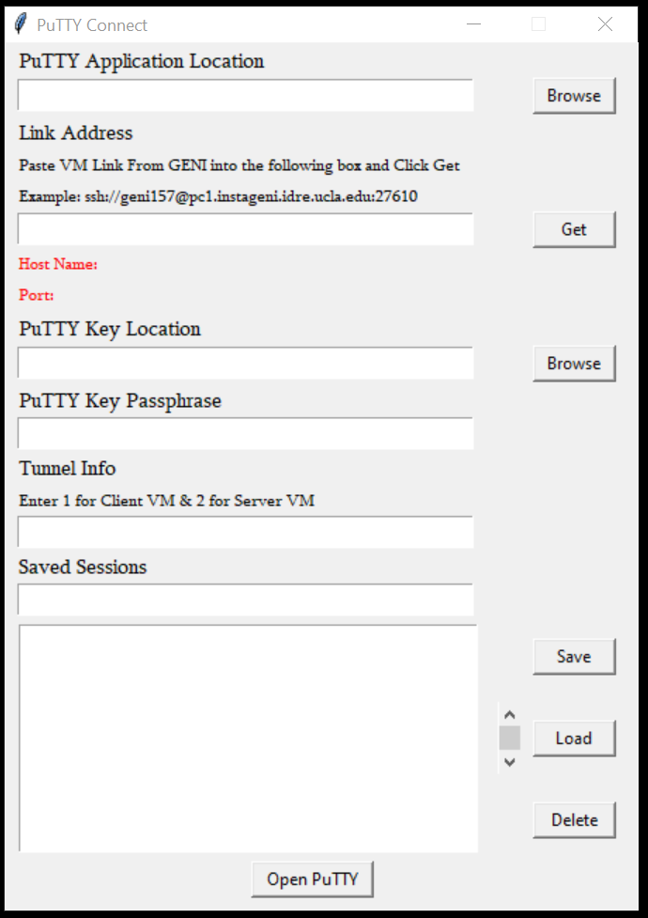

**2. Configure PuTTY Connect**

Open the PuTTY Connect application on your Windows Host. We will be configuring a terminal session that also acts as a tunnel for our VNC connection to our GENI machine. Notice the Category Labels and the entry fields along the labels that can be filled to make our connection.

* 1. Putty Application Location

First, we will discuss how to fill Putty Application Location field

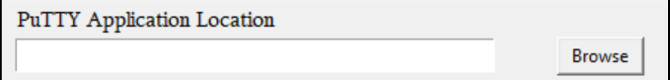

Click Browse to find the location of the PuTTY application we installed earlier. Make sure it is selected like below: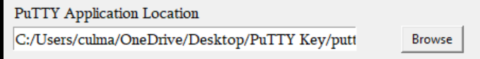

2.2 Link Address

Now we need to fill Link Address box with GENI URI and port number.

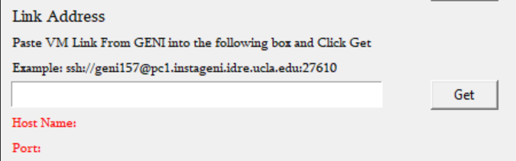

To get this information, identify the node whose Client ID is “Client”:

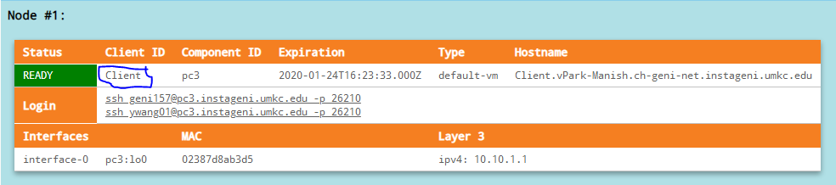

The login commands listed here are used to connect to GENI through a SSH client. We will need to copy link address of login command like below:

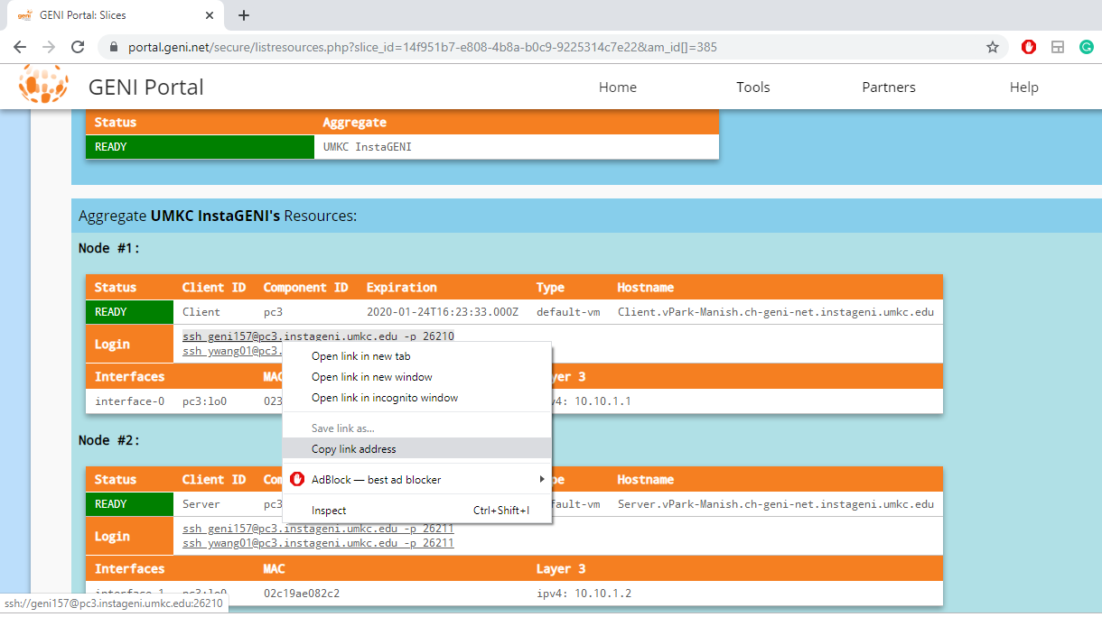

Next we need to paste into the Link Address field and Click Get button. That field should now look like this:

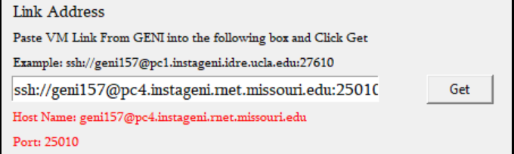

**Note: Make sure the link address you paste into the field looks like the given address in example below the Link Address Label.**

2.3 Putty Key Location

Now we need to fill Putty Key Location field.

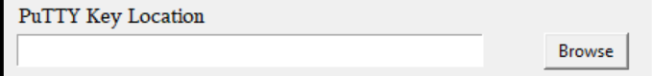

Click Browse to find the location of the PuTTY Private Key we generated earlier. Make sure it is selected in the field like below:

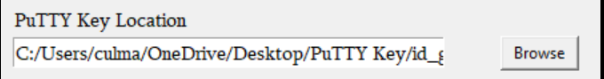

2.4 Putty Key Passphrase

Now we need to fill Putty Key Passphrase field.

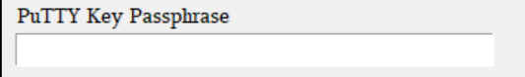

Enter the passphrase used when you generated your PuTTY Key into the field like below:

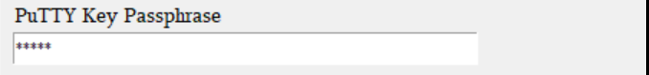

2.5 Tunnel Info

Now we need to fill the tunnel information on the Tunnel Info field. Enter ‘1’ on the field as below:

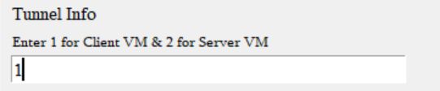

**NOTE: 1 is for connecting to the Client machine. To connect to the Server machine, we should use 2 instead.**

2.6 Saved Session

We are ready to make our connection. Before that, store the configuration so that you don’t have to configure again next time.

Give your session a name, such as “Client”, click the “Save” button. The session is saved. Next time when you want to connect to the Client machine, simply select the “Client” session, and click the “Load” button, the configurations will be loaded.

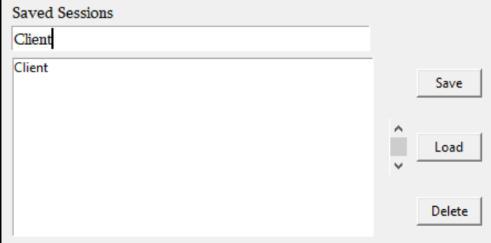

2.7 Connect to VM

Click the “Open” button at the bottom of “PuTTY Connect” to initiate our connection to the GENI machine.

In your first log in, you will see a warning message below, simply click Yes button.

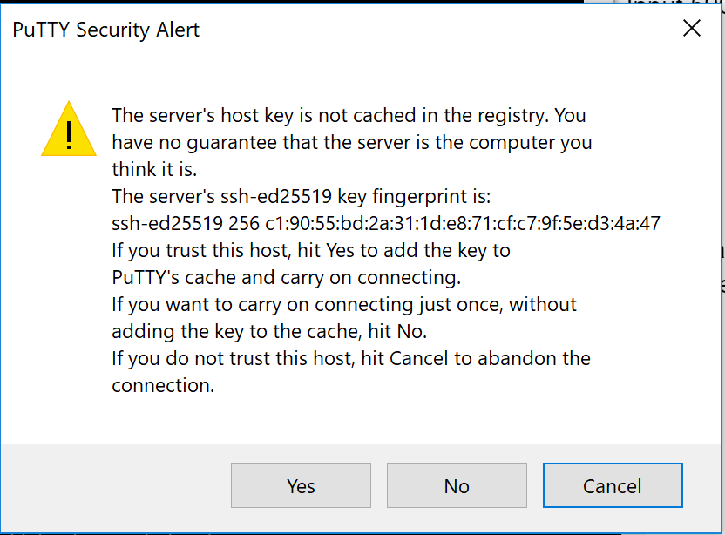

You should be prompted to enter in a password for your server. Enter in the password you’d like to use, choose “n” to the read-only password option, and hit Enter.

Now you have a Command Line Interface of the virtual machine on GENI, and we have established a tunnel connection for our VNC Client to connect through.

The next steps guide you to obtain a GUI.

**3. Install a VNC client on our Host machine**

Next we need to get a VNC client on to our host machine to connect to our new VNC server we just made. We recommend VNC Viewer which can be found at this link:

<https://www.realvnc.com/en/connect/download/viewer/>. All the default settings should be fine. Agree to the EULA agreement, and Install. If your system does not allow you to install software, simply select “Standalone EXE” to download the non-install version. If you are using Citrix Virtual Desktop, refer to the “How to Get to PuTTY and VNC Viewer at Citrix”.

**4. Connect to the VNC server on the GENI machine.**

Open up the VNC Viewer program. Near the top is a input field to enter the location of our PuTTY tunnel. Since we bind this tunnel to 127.0.0.1:5901, we should be able to type “localhost:5901”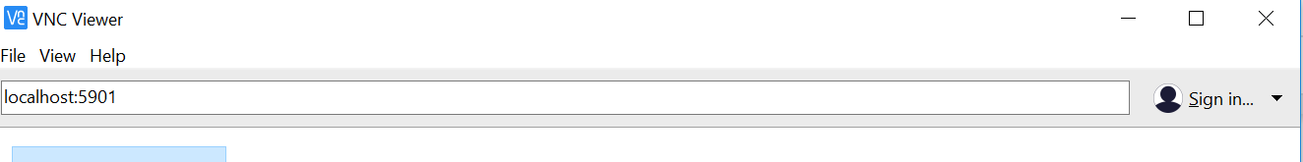

Clicking enter will initiate this connection. You may be presented with a warning about encryption. Just click through it. You will have to enter the VNC server password that we set up in Step 2.7. If successful, you will now be presented with your new GUI interface.

**SELECT “Use default config” AT THE PROMPT WHEN YOU LOGIN.**

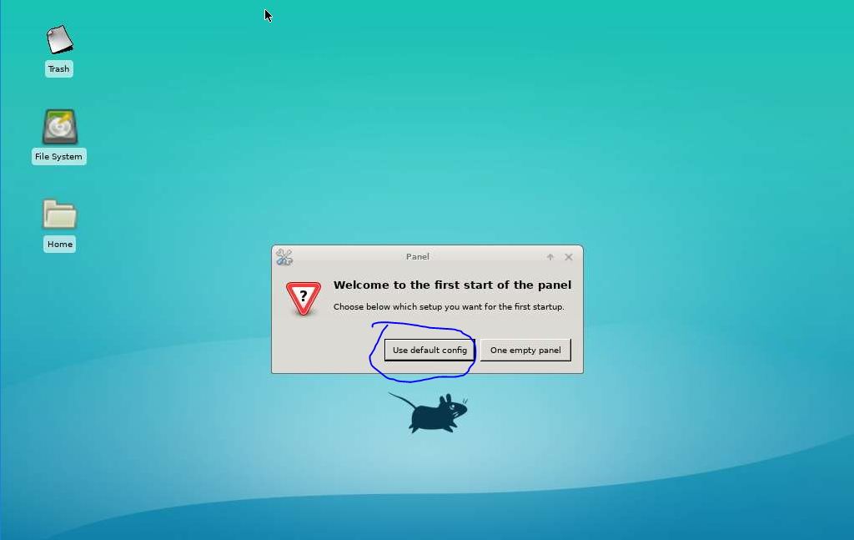

Look around. You now have access to a graphic user interface as well as a terminal program.

Open a terminal in this environment and type in command Firefox &, you will have a Firefox and can browse the Internet.

**5. Connect to the Server machine.**

The steps for connecting to the Server machine is similar to connecting to the Client machine, with a few exceptions, which are highlighted below.

5.1 Link Address

Now we need to fill Link Address box with GENI URI and port number.



To get this information, identify the node whose Client ID is “Server”:

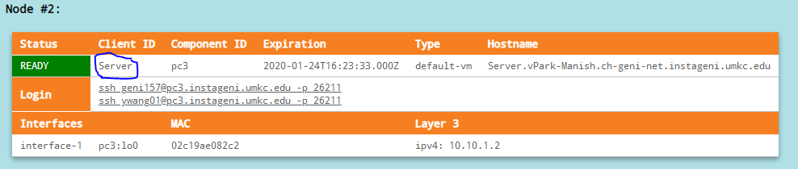

The login commands listed here are used to connect to GENI through a SSH client. We will need to copy link address of login command like below:

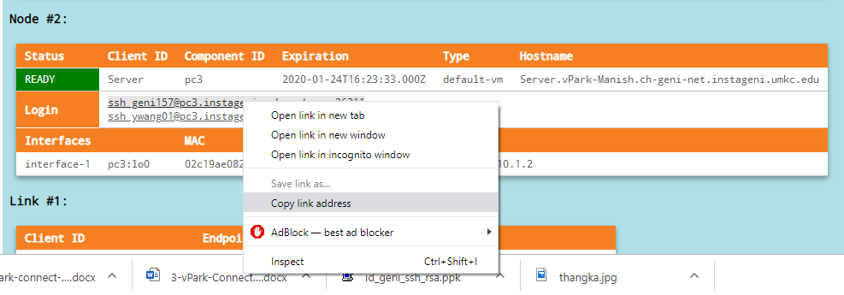

Next we need to paste into the Link Address field and Click Get button. That field should now look like this:

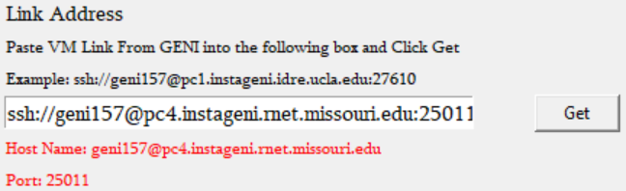

**Note: Make sure the link address you paste into the field looks like the given address in example below the Link Address Label.**

5.2 Tunnel Info

Now we need to fill the tunnel information on the Tunnel Info field. Enter ‘2’ on the field as below:

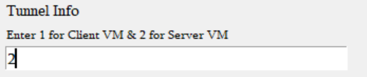

5.3 Saved Session

We are ready to make our connection. Before that, store the configuration so that you don’t have to configure again next time.

Give your session a name, such as “Server”, click the “Save” button. The session is saved. Next time when you want to connect to the Server machine, simply select the “Server” session, and click the “Load” button, the configurations will be loaded.

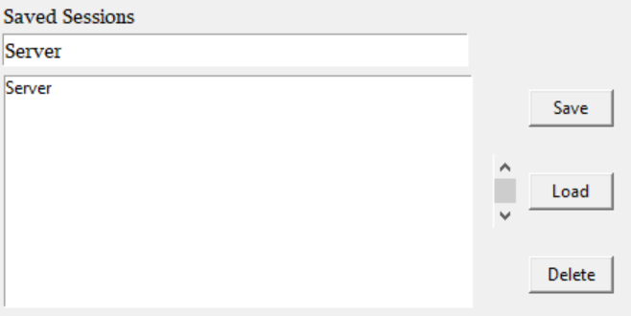

5.4 Connect to VM

Click the “Open” button at the bottom of “PuTTY Connect” to initiate our connection to the GENI machine. In your first log in, you will see a warning message below, simply click Yes button.

You should be prompted to enter in a password for your server. Enter in the password you’d like to use, choose “n” to the read-only password option, and hit Enter.

Now you have a Command Line Interface of the virtual machine on GENI, and we have established a tunnel connection for our VNC Server to connect through.

The next steps guide you to obtain a GUI.

5.6 Connect to the VNC server on the GENI machine.

Open up a new VNC Viewer program. Near the top is a input field to enter the location of our PuTTY tunnel. Since we bind this tunnel to 127.0.0.1:5902, we should be able to type “localhost:5902” 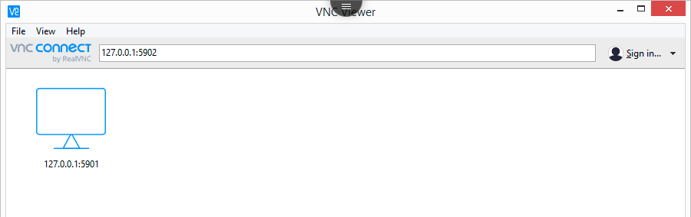

Clicking enter will initiate this connection. You may be presented with a warning about encryption. Just click through it. You will have to enter the VNC server password that we set up in Step 5.4. If successful, you will now be presented with your new GUI interface.

**Remember to select “Use default config” AT THE PROMPT WHEN YOU LOGIN.** 

Look around. You now have access to a graphic user interface as well as a terminal program.

Open a terminal in this environment and type in command Firefox &, you will have a Firefox and can browse the Internet.