Report 03 — Sentiment Construction
Information Transmission and Sectoral Asymmetry in the KSE-100 — Dr. Yasir Saeed, KUST

1. FinBERT tone scoring
Each relevant article is scored with FinBERT (ProsusAI/finbert; Araci 2019) on headline + first 2,000 body characters, truncated at 256 tokens (fp16, GPU, checkpointed batches). Output is converted to a signed tone score in [-1, +1].

2. Directional sign rules
Tone is not direction: a rate hike reads as decisive prose but is negative for equities. 35 channel-specific event rules supply the DIRECTION for KSE-100 equities; FinBERT confidence supplies the MAGNITUDE (0.5 default when FinBERT is neutral). Headline matches weigh 3x. When an article belongs to several channels, each channel applies its own rules — the same article can correctly carry different directional readings in different channels. Articles matching no rule fall back to the FinBERT score. Global crude-oil price moves carry no rule by design (sign ambiguous for the aggregate market).
channel | rule | sign for PSX | patterns
Monetary | rate_cut | + | 4
Monetary | rate_hike | - | 4
Monetary | inflation_up | - | 3
Monetary | inflation_down | + | 3
Monetary | rupee_down | - | 3
Monetary | rupee_up | + | 1
Monetary | reserves_up | + | 1
Monetary | reserves_down | - | 1
Fiscal | revenue_beat | + | 2
Fiscal | revenue_miss | - | 2
Fiscal | deficit_widens | - | 1
Fiscal | deficit_narrows | + | 2
Fiscal | new_taxes | - | 3
Fiscal | rating_downgrade | - | 2
Fiscal | rating_upgrade | + | 3
External | imf_positive | + | 4
External | imf_negative | - | 2
External | cad_widens | - | 1
External | cad_narrows | + | 2
External | remittances_up | + | 1
External | remittances_down | - | 1
External | fdi_up | + | 1
External | fdi_down | - | 1
External | default_risk | - | 3
External | bond_success | + | 1
Energy | tariff_hike | - | 2
Energy | tariff_cut | + | 3
Energy | fuel_price_up | - | 2
Energy | fuel_price_down | + | 2
Energy | circular_debt_up | - | 2
Energy | circular_debt_down | + | 1
Energy | outages | - | 4
Energy | supply_restored | + | 2

3. Combined series S_All
S_All aggregates ALL relevant articles, scored against the union of every rule — the overall news-sentiment measure paired with the combined market index r_Market in estimation.

4. Weekend and holiday news
News published on non-trading days cannot move prices until the next session. Every article is therefore assigned to the first PSX trading day on or after its publication date (trading calendar taken from the price data). Previously, weekend/holiday news was lost in the trading-day merge.

5. Daily aggregation
Word-count-weighted mean of article scores within each (trading day, channel) cell; days without articles in a channel carry the last observed value forward. Raw-FinBERT variants of all five series are produced in parallel as the robustness benchmark (Report 12).
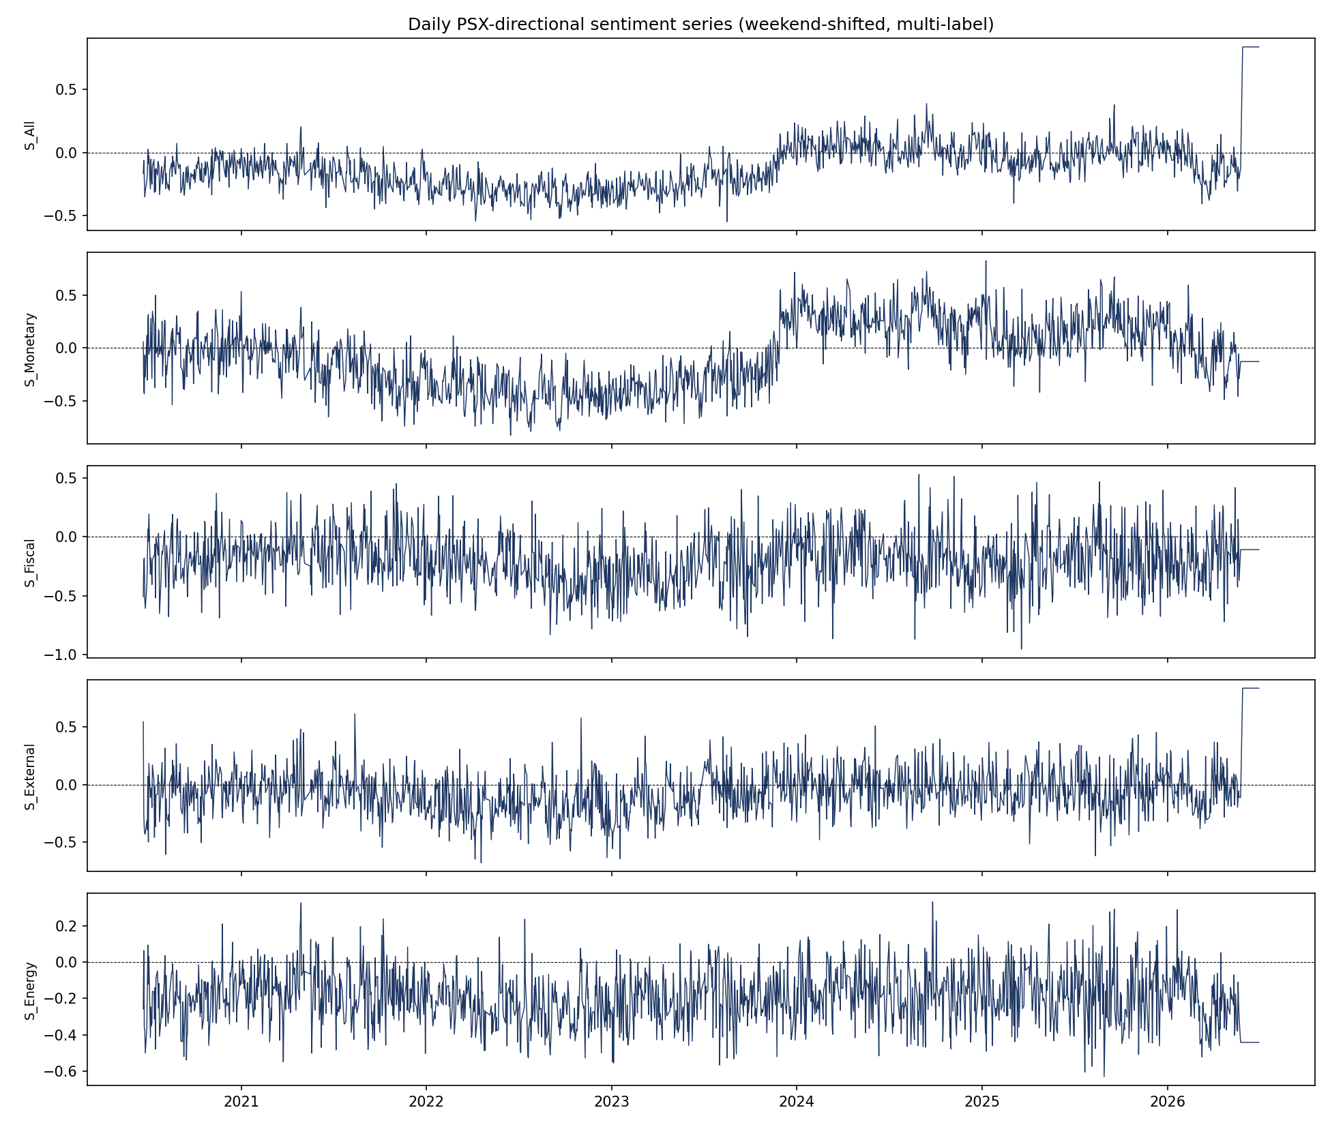
Daily PSX-directional sentiment series
Note: Sign-rule audit: Phase 2 Outputs/sign_rules_audit.xlsx. Article-channel level detail: Phase 2 Outputs/article_channel_scores.csv.

