Report 04 — Sector Universe and Return Construction
Information Transmission and Sectoral Asymmetry in the KSE-100 — Dr. Yasir Saeed, KUST

1. Eligibility criteria
- Equity securities only — debt instruments, ETFs, mutual funds and the 'Miscellaneous' grouping excluded from sector analysis.
- Stock-level screens: valid CLOSE and LDCP, |daily return| <= 25%, and >= 70% trading-day coverage in the study window.
- Sector quorum: >= 4 screened firms. Four (not five) preserves Oil & Gas Exploration — the KSE-100's second-largest sector has exactly four firms (OGDC, PPL, POL, MARI), all large caps.
- A sector-day requires >= 3 traded constituents.

2. Return definitions
Stock return: r = CLOSE / LDCP - 1, using the exchange's own adjusted previous close (robust to corporate actions). Sector return: equal-weighted mean over constituents that traded that day. Market return r_Market: equal-weighted mean over ALL screened equities (319 stocks, ~294 per day) — the combined-index proxy, as the price file contains no usable index series.

3. Eligible sectors
sector | column | core_firms | trading_days | mean_ret_bps | std_ret_pct | avg_stocks_per_day
AUTOMOBILE ASSEMBLER | r_Automobile_Assembler | 10 | 1492 | 14.01 | 1.719 | 9.8
AUTOMOBILE PARTS & ACCESSORIES | r_Automobile_Parts_Accessories | 8 | 1492 | 7.64 | 1.736 | 7.5
CABLE & ELECTRICAL GOODS | r_Cable_Electrical_Goods | 6 | 1491 | 8.37 | 1.88 | 5.6
CEMENT | r_Cement | 17 | 1492 | 14.6 | 1.894 | 16.5
CHEMICAL | r_Chemical | 19 | 1492 | 11.66 | 1.342 | 17.8
COMMERCIAL BANKS | r_Commercial_Banks | 20 | 1492 | 15.36 | 1.289 | 19.4
ENGINEERING | r_Engineering | 12 | 1492 | 7.91 | 1.915 | 11.6
FERTILIZER | r_Fertilizer | 7 | 1492 | 17.61 | 1.446 | 6.4
FOOD & PERSONAL CARE PRODUCTS | r_Food_Personal_Care_Products | 20 | 1492 | 9.45 | 1.394 | 18.7
GLASS & CERAMICS | r_Glass_Ceramics | 6 | 1492 | 10.11 | 1.829 | 6
INSURANCE | r_Insurance | 20 | 1492 | 13.03 | 1.375 | 17
INV. BANKS / INV. COS. / SECURITIES COS. | r_Inv_Banks_Inv_Cos_Securities_Cos | 21 | 1492 | 13.39 | 1.664 | 19.4
LEATHER & TANNERIES | r_Leather_Tanneries | 4 | 1340 | 15.47 | 1.957 | 3.7
MODARABAS | r_Modarabas | 8 | 1490 | 8.8 | 2.565 | 6.9
OIL & GAS EXPLORATION COMPANIES | r_Oil_Gas_Exploration_Companies | 4 | 1492 | 12.7 | 1.573 | 4
OIL & GAS MARKETING COMPANIES | r_Oil_Gas_Marketing_Companies | 10 | 1492 | 11.14 | 1.83 | 9.4
PAPER, BOARD & PACKAGING | r_Paper_Board_Packaging | 8 | 1492 | 6.88 | 1.571 | 7.9
PHARMACEUTICALS | r_Pharmaceuticals | 10 | 1492 | 8.18 | 1.574 | 9.3
POWER GENERATION & DISTRIBUTION | r_Power_Generation_Distribution | 14 | 1492 | 16.76 | 1.477 | 13.5
REFINERY | r_Refinery | 4 | 1492 | 13.65 | 2.728 | 4
SUGAR & ALLIED INDUSTRIES | r_Sugar_Allied_Industries | 16 | 1492 | 13.34 | 1.328 | 13.4
TECHNOLOGY & COMMUNICATION | r_Technology_Communication | 14 | 1492 | 11.79 | 2.097 | 13.4
TEXTILE COMPOSITE | r_Textile_Composite | 19 | 1492 | 14.72 | 1.501 | 16.7
TEXTILE SPINNING | r_Textile_Spinning | 20 | 1492 | 14.88 | 1.957 | 17.1
TRANSPORT | r_Transport | 4 | 1486 | 8.47 | 1.863 | 3.8

Note: Full eligibility table incl. rejected sectors: Phase 3 Inputs/sector_universe.xlsx.
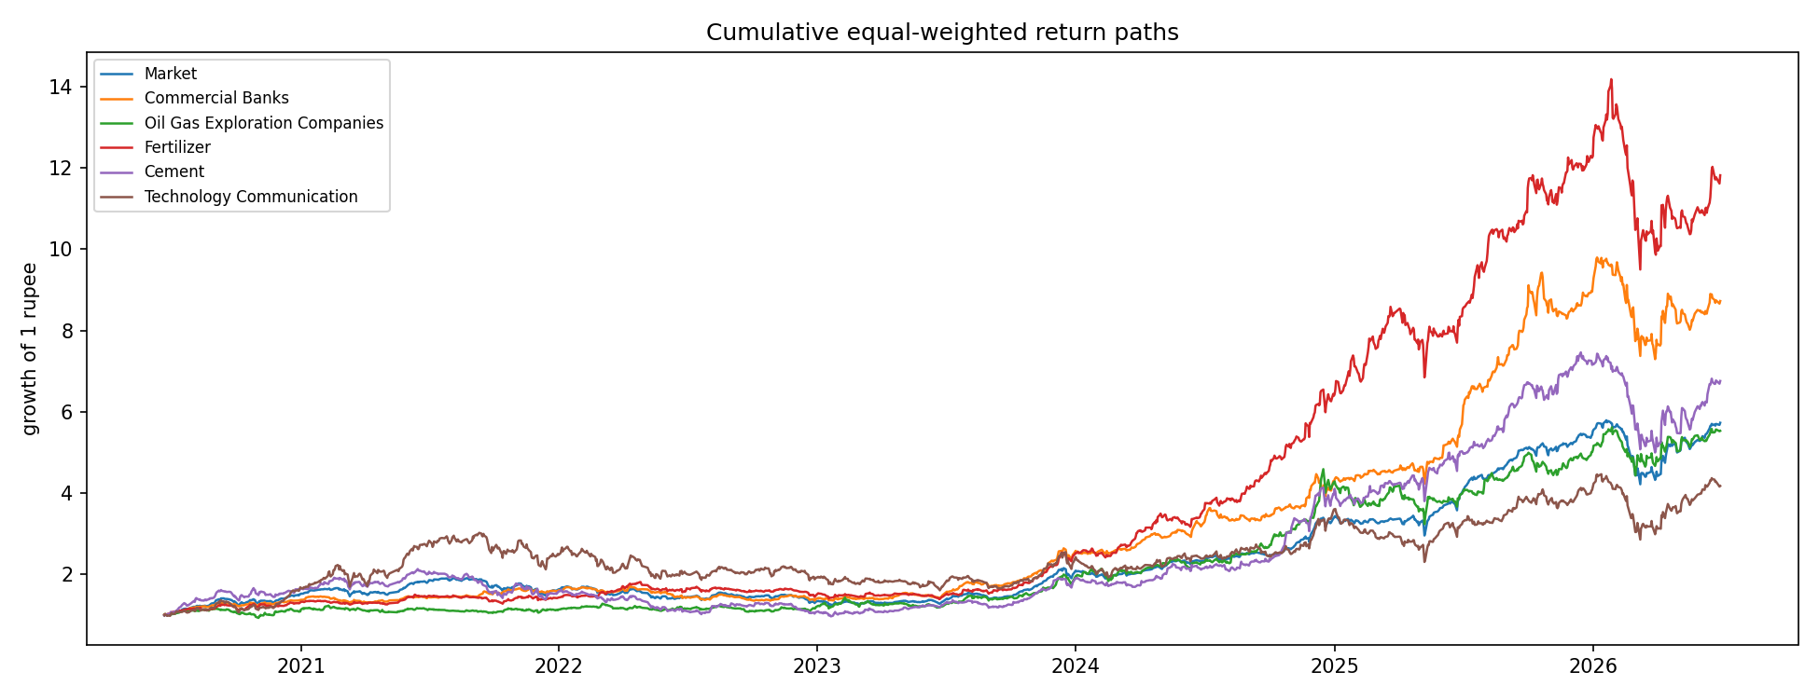
Cumulative return paths — market and the five focus sectors

