Report 05 — Descriptive Statistics
Information Transmission and Sectoral Asymmetry in the KSE-100 — Dr. Yasir Saeed, KUST

1. Sentiment series
series | N | mean | std | min | p25 | median | p75 | max | skewness | excess_kurtosis
S_All | 1492 | -0.1131 | 0.195 | -0.5471 | -0.244 | -0.1254 | -0.0057 | 0.8378 | 1.5591 | 6.0885
S_Monetary | 1492 | -0.0712 | 0.315 | -0.8303 | -0.3233 | -0.0707 | 0.1742 | 0.8283 | 0.0308 | -0.7825
S_Fiscal | 1492 | -0.1972 | 0.2269 | -0.9531 | -0.3519 | -0.1944 | -0.0606 | 0.5273 | 0.0694 | 0.1174
S_External | 1492 | -0.0516 | 0.2159 | -0.6781 | -0.1896 | -0.0632 | 0.0652 | 0.8378 | 0.9018 | 2.8909
S_Energy | 1492 | -0.193 | 0.1514 | -0.6308 | -0.2971 | -0.1935 | -0.0962 | 0.3317 | 0.1545 | -0.0412

2. Sector returns (%)
series | N | mean_pct | std_pct | min_pct | p25 | median | p75 | max_pct | skewness | excess_kurtosis
r_Market | 1492 | 0.1253 | 1.2753 | -9.2171 | -0.474 | 0.2056 | 0.7941 | 8.9703 | -0.413 | 7.4562
r_Automobile_Assembler | 1492 | 0.1401 | 1.7186 | -9.4439 | -0.7795 | 0.0914 | 1.0149 | 9.0253 | 0.0223 | 2.5537
r_Automobile_Parts_Accessories | 1492 | 0.0764 | 1.7362 | -9.8431 | -0.8621 | 0.057 | 0.9792 | 9.4642 | -0.0069 | 3.0867
r_Cable_Electrical_Goods | 1491 | 0.0837 | 1.8801 | -8.6503 | -1.0357 | 0.0047 | 1.2058 | 9.244 | 0.0219 | 1.5534
r_Cement | 1492 | 0.146 | 1.894 | -9.4781 | -0.8801 | 0.0675 | 1.0751 | 9.7927 | 0.2537 | 2.8554
r_Chemical | 1492 | 0.1166 | 1.3418 | -8.126 | -0.5941 | 0.1699 | 0.8713 | 9.2884 | -0.1895 | 4.7616
r_Commercial_Banks | 1492 | 0.1536 | 1.2886 | -9.7015 | -0.5285 | 0.1219 | 0.7261 | 9.0392 | 0.3684 | 7.9285
r_Engineering | 1492 | 0.0791 | 1.9153 | -11.4576 | -0.9919 | -0.0157 | 1.0358 | 10.4091 | 0.1212 | 3.2405
r_Fertilizer | 1492 | 0.1761 | 1.4457 | -9.9121 | -0.5735 | 0.1176 | 0.8971 | 9.9961 | 0.1963 | 6.7373
r_Food_Personal_Care_Products | 1492 | 0.0945 | 1.3937 | -8.3578 | -0.6048 | 0.1082 | 0.8538 | 9.2389 | -0.2965 | 4.8064
r_Glass_Ceramics | 1492 | 0.1011 | 1.8289 | -10.1321 | -0.883 | 0.0042 | 1.0598 | 10.0833 | 0.09 | 3.0255
r_Insurance | 1492 | 0.1303 | 1.3754 | -7.3673 | -0.6868 | 0.1652 | 0.954 | 7.543 | -0.0969 | 2.5441
r_Inv_Banks_Inv_Cos_Securities_Cos | 1492 | 0.1339 | 1.6639 | -11.3441 | -0.7827 | 0.1543 | 1.0855 | 8.918 | -0.2316 | 3.8086
r_Leather_Tanneries | 1340 | 0.1547 | 1.9569 | -9.361 | -1.0929 | 0.127 | 1.3561 | 8.4046 | 0.0065 | 0.9025
r_Modarabas | 1490 | 0.088 | 2.5648 | -11.6826 | -1.4077 | -0.0123 | 1.4535 | 11.2146 | 0.3183 | 1.7636
r_Oil_Gas_Exploration_Companies | 1492 | 0.127 | 1.5731 | -8.4922 | -0.7115 | -0.0118 | 0.8849 | 9.7698 | 0.4331 | 3.8634
r_Oil_Gas_Marketing_Companies | 1492 | 0.1114 | 1.8296 | -10.0854 | -0.9132 | 0.0815 | 1.1176 | 9.7307 | -0.0564 | 3.4105
r_Paper_Board_Packaging | 1492 | 0.0688 | 1.5708 | -9.8207 | -0.7793 | 0.016 | 0.8955 | 9.4203 | 0.004 | 4.9295
r_Pharmaceuticals | 1492 | 0.0818 | 1.5744 | -9.0065 | -0.732 | -0.0012 | 0.837 | 9.0306 | 0.2997 | 5.1144
r_Power_Generation_Distribution | 1492 | 0.1676 | 1.4768 | -9.6653 | -0.6383 | 0.1626 | 0.9402 | 9.7332 | 0.1077 | 4.6292
r_Refinery | 1492 | 0.1365 | 2.728 | -11.0213 | -1.2794 | -0.0755 | 1.4311 | 11.398 | 0.3081 | 1.6238
r_Sugar_Allied_Industries | 1492 | 0.1334 | 1.3283 | -6.4993 | -0.6058 | 0.092 | 0.8969 | 6.9815 | 0.0184 | 1.9345
r_Technology_Communication | 1492 | 0.1179 | 2.0968 | -10.904 | -0.9507 | 0.1038 | 1.2818 | 12.5432 | 0.0595 | 3.4032
r_Textile_Composite | 1492 | 0.1472 | 1.5013 | -7.9704 | -0.6876 | 0.1166 | 0.974 | 7.5989 | -0.1407 | 2.3891
r_Textile_Spinning | 1492 | 0.1488 | 1.9566 | -9.3312 | -0.9475 | 0.1178 | 1.2585 | 9.1055 | -0.0295 | 1.9934
r_Transport | 1486 | 0.0847 | 1.8634 | -8.3581 | -0.9826 | -0.0049 | 1.1229 | 9.6165 | 0.1063 | 1.8433

3. News flow over time
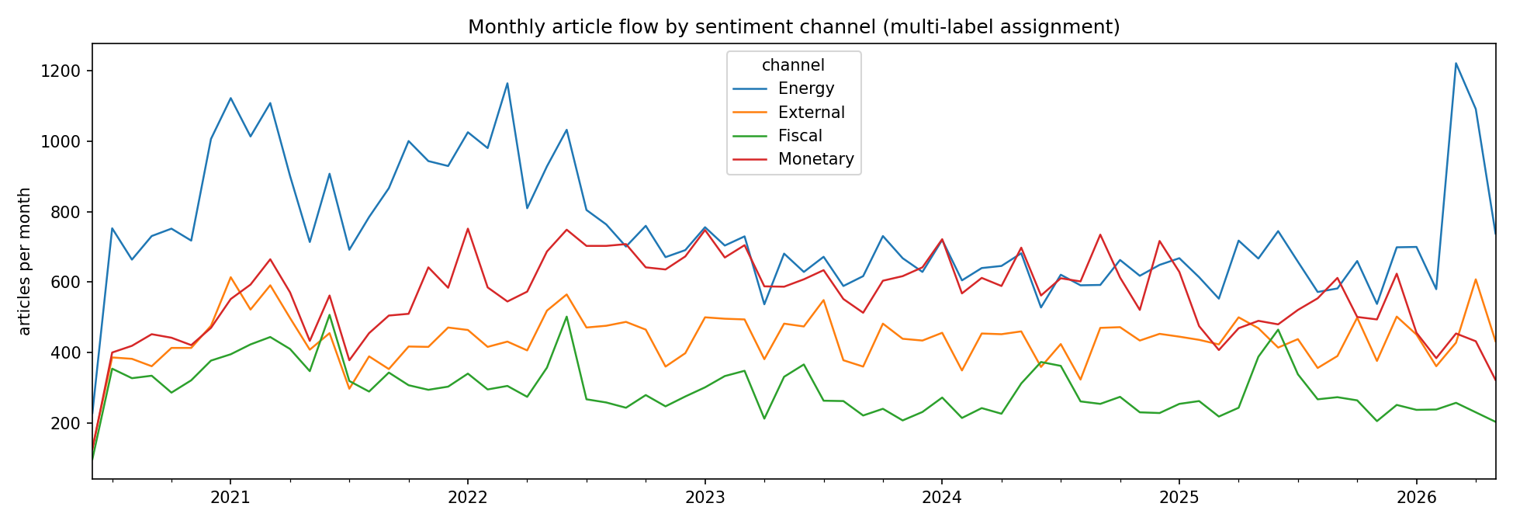
Monthly article counts by channel (multi-label)
Interpretation: article flow spikes track Pakistan's macro calendar — budget months (June), IMF programme milestones, and the 2022–23 stabilisation crisis — confirming the channels capture policy news intensity.

