Report 06 — Correlation Analysis
Information Transmission and Sectoral Asymmetry in the KSE-100 — Dr. Yasir Saeed, KUST
Contemporaneous correlations below; dynamic (lead-lag) relationships are treated in Reports 09–11.

1. Sentiment x sentiment
Unnamed: 0 | S_All | S_Monetary | S_Fiscal | S_External | S_Energy
S_All | 1 | 0.676 | 0.292 | 0.637 | 0.26
S_Monetary | 0.676 | 1 | 0.21 | 0.299 | 0.229
S_Fiscal | 0.292 | 0.21 | 1 | 0.311 | 0.292
S_External | 0.637 | 0.299 | 0.311 | 1 | 0.204
S_Energy | 0.26 | 0.229 | 0.292 | 0.204 | 1

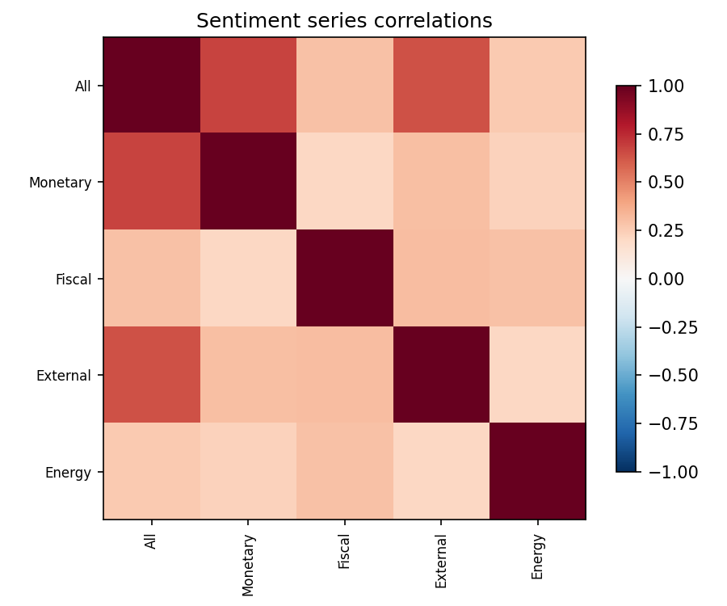

2. Returns x sentiment (contemporaneous)
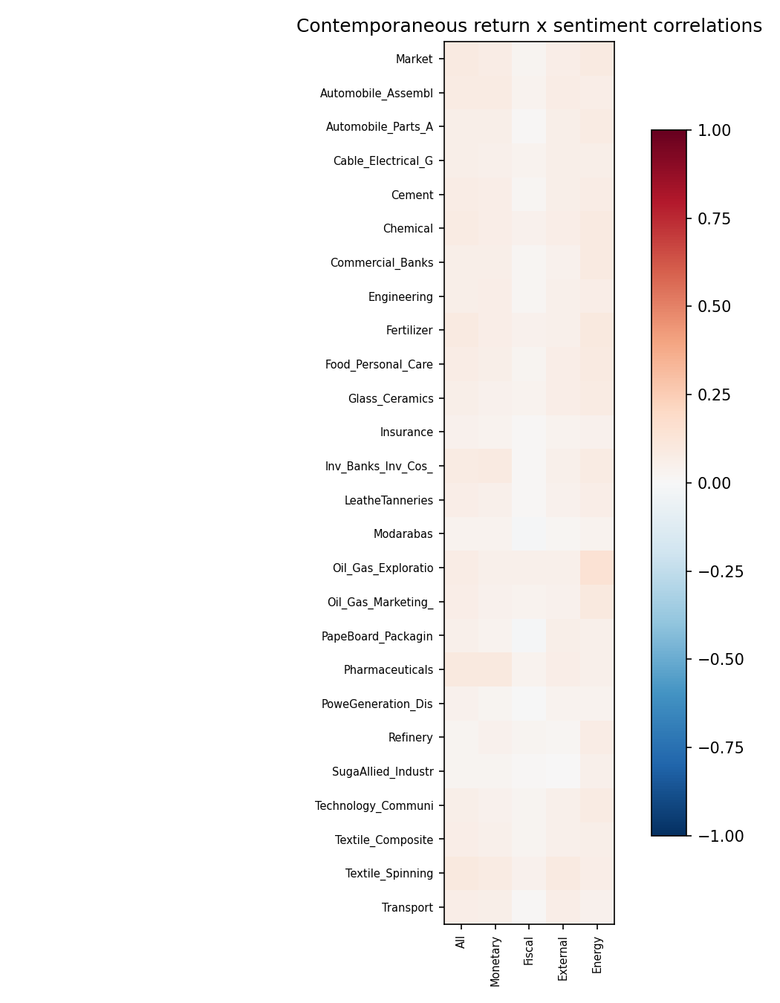

3. Returns x returns
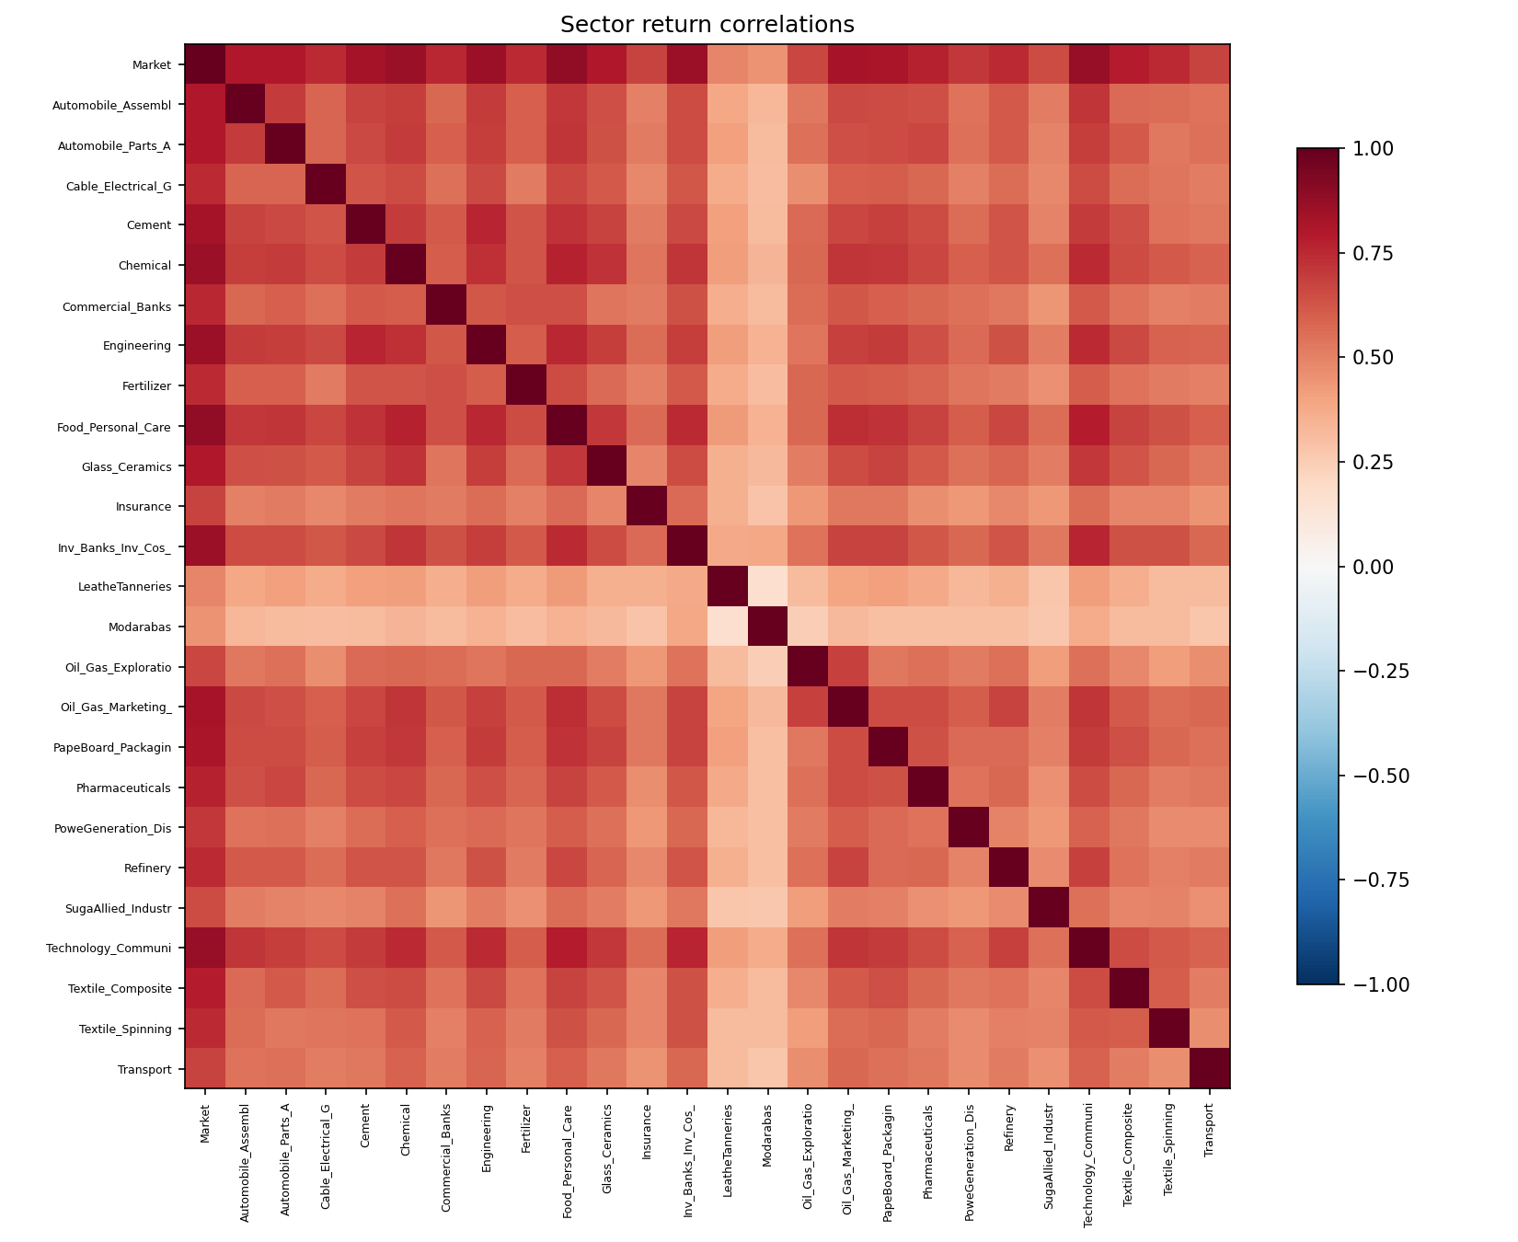
Note: Numeric matrices: Results/tables/06_correlations.xlsx.

