Report 10 — VAR IRF and FEVD
Information Transmission and Sectoral Asymmetry in the KSE-100 — Dr. Yasir Saeed, KUST

1. Market systems
system | aic_lag | stable | nobs
VAR A: r_Market + S_All | 5 | True | 1487
VAR B: r_Market + 4 channels | 10 | True | 1482

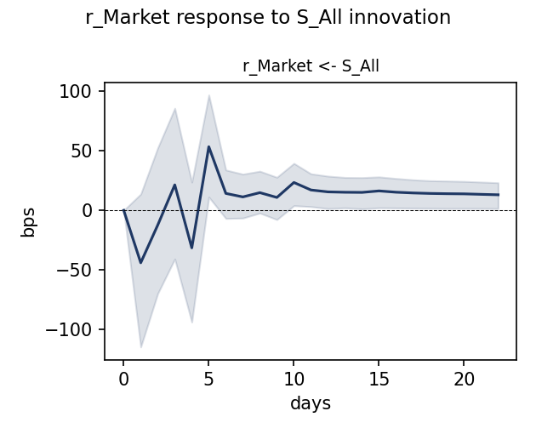
r_Market response to a unit S_All innovation (95% MC bands, 500 reps)
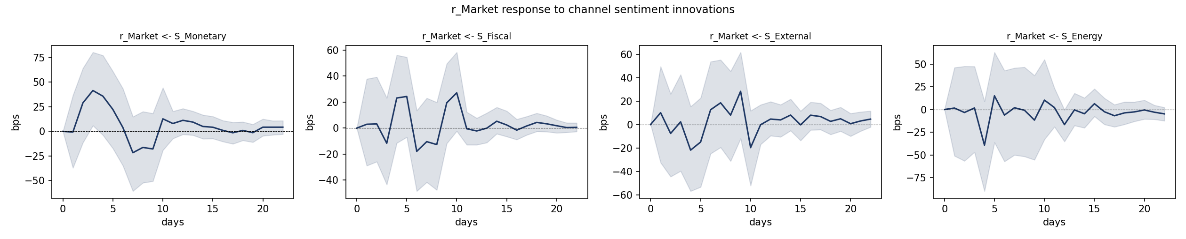
r_Market response to channel sentiment innovations

FEVD — market
target | source | FEVD_h1_pct | FEVD_h5_pct | FEVD_h22_pct
r_Market | S_All | 0 | 0.24 | 0.67
r_Market | S_Monetary | 0 | 0.629 | 0.986
r_Market | S_Fiscal | 0 | 0.086 | 0.71
r_Market | S_External | 0 | 0.166 | 0.5
r_Market | S_Energy | 0 | 0.171 | 0.266

IRF summary — market
target | shock | day1_bps | day3_bps | peak_day | peak_bps | cum22_bps
r_Market | S_All | -44.03 | 21.36 | 5 | 53.39 | 238.6
r_Market | S_Monetary | -0.68 | 41.51 | 3 | 41.51 | 138.7
r_Market | S_Fiscal | 2.97 | -11.65 | 10 | 27.16 | 63.5
r_Market | S_External | 10.08 | 2.31 | 9 | 28.35 | 62.7
r_Market | S_Energy | 1.58 | 1.68 | 4 | -39.23 | -68.1

2. All-sector sensitivity matrix
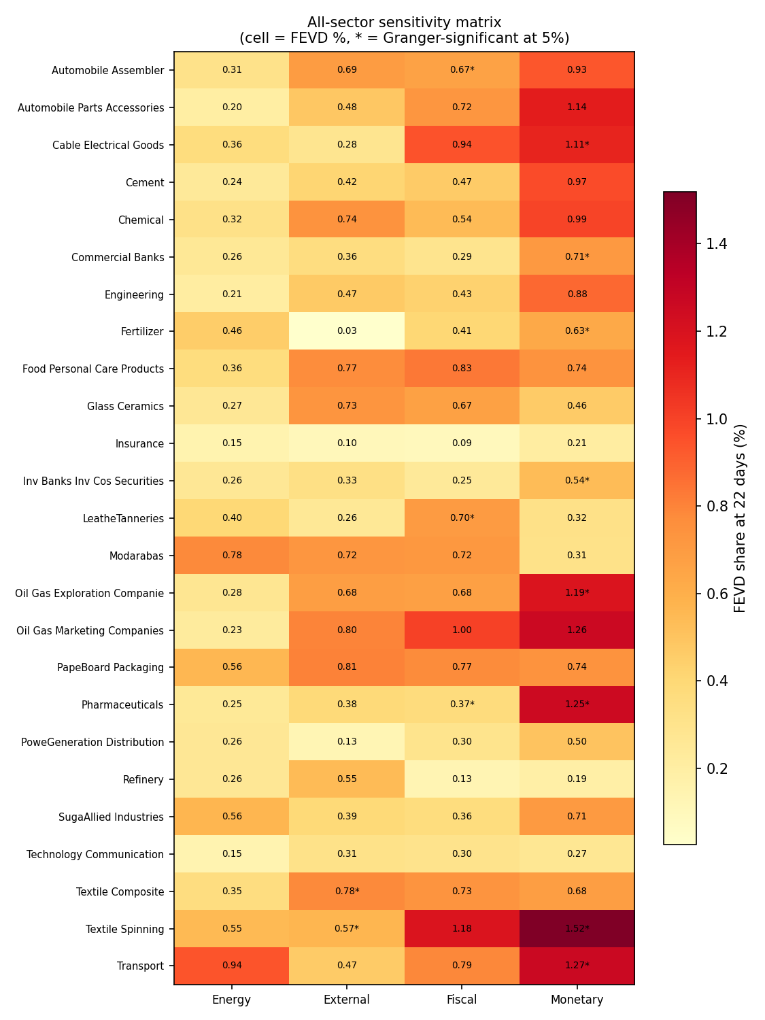
FEVD share (%) of each sector's 22-day return variance from each channel; * = Granger-significant at 5%

Sectoral IRF summary
target | shock | day1_bps | day3_bps | peak_day | peak_bps | cum22_bps
r_Automobile_Assembler | S_Monetary | -2.72 | 52.79 | 3 | 52.79 | 131.1
r_Automobile_Assembler | S_Fiscal | 30.24 | -26.19 | 4 | 32.55 | 26
r_Automobile_Assembler | S_External | 9.1 | 20.72 | 9 | 44.97 | 44.2
r_Automobile_Assembler | S_Energy | -1.01 | 6.16 | 5 | 40.16 | 12.2
r_Automobile_Parts_Accessories | S_Monetary | 16.19 | 58.99 | 3 | 58.99 | 162.2
r_Automobile_Parts_Accessories | S_Fiscal | 9.54 | -20.02 | 6 | -41.13 | 19.4
r_Automobile_Parts_Accessories | S_External | 20.12 | 5.01 | 10 | -35.86 | 93.8
r_Automobile_Parts_Accessories | S_Energy | -23.54 | 6.5 | 4 | -30.85 | -76.1
r_Cable_Electrical_Goods | S_Monetary | -2.98 | 37.23 | 2 | 62.46 | 173.8
r_Cable_Electrical_Goods | S_Fiscal | -7.81 | -3.91 | 4 | 42.59 | 109.4
r_Cable_Electrical_Goods | S_External | 21.25 | -6.55 | 6 | 24.16 | 123.7
r_Cable_Electrical_Goods | S_Energy | -14.24 | -7.34 | 4 | -60.41 | -56.6
r_Cement | S_Monetary | 10.92 | 45.37 | 3 | 45.37 | 169.8
r_Cement | S_Fiscal | -7.3 | -6.24 | 5 | 37.9 | 26.3
r_Cement | S_External | -2.66 | 20.16 | 7 | 42.21 | 106.6
r_Cement | S_Energy | -14.11 | 1.09 | 4 | -46.95 | -133.9
r_Chemical | S_Monetary | 3 | 49.8 | 3 | 49.8 | 121.6
r_Chemical | S_Fiscal | 6.3 | 0.39 | 10 | 28.18 | 72.3
r_Chemical | S_External | 8.34 | -1.67 | 9 | 39.16 | 92.7
r_Chemical | S_Energy | -5.25 | -7.25 | 4 | -42.2 | -50.8
r_Commercial_Banks | S_Monetary | -10.57 | 30.83 | 3 | 30.83 | 148.3
r_Commercial_Banks | S_Fiscal | 15.38 | -0.31 | 1 | 15.38 | 10.3
r_Commercial_Banks | S_External | -5.1 | -2.39 | 10 | -28.49 | -35.6
r_Commercial_Banks | S_Energy | -8.63 | 7.43 | 5 | 26.39 | 18.4
r_Engineering | S_Monetary | -30.41 | 51 | 3 | 51 | 113.6
r_Engineering | S_Fiscal | 9.97 | -12.18 | 10 | 31.27 | 76.1
r_Engineering | S_External | 12.86 | 27.46 | 10 | -48.56 | 54.1
r_Engineering | S_Energy | -5.29 | -19.81 | 4 | -53.86 | -73.6
r_Fertilizer | S_Monetary | -24.44 | 29.27 | 3 | 29.27 | 267
r_Fertilizer | S_Fiscal | 20.31 | -15.17 | 1 | 20.31 | -61.3
r_Fertilizer | S_External | 2.21 | -0.13 | 4 | 13.15 | -6.5
r_Fertilizer | S_Energy | 30.57 | 4.88 | 4 | -64.18 | -51.1
r_Food_Personal_Care_Products | S_Monetary | -4.26 | 40.23 | 3 | 40.23 | 144.3
r_Food_Personal_Care_Products | S_Fiscal | 10.56 | -3.65 | 5 | 35.2 | 41.2
r_Food_Personal_Care_Products | S_External | -7.55 | 8.51 | 9 | 39.56 | 38.4
r_Food_Personal_Care_Products | S_Energy | 10.09 | -32.59 | 3 | -32.59 | -95.9
r_Glass_Ceramics | S_Monetary | -0.65 | 39.3 | 2 | 40.39 | 80.2
r_Glass_Ceramics | S_Fiscal | -8.44 | -24.31 | 10 | 40.46 | 80.6
r_Glass_Ceramics | S_External | 37.77 | -5.6 | 9 | 61.65 | 45.9
r_Glass_Ceramics | S_Energy | 17.98 | -4.27 | 4 | -41.54 | 79
r_Insurance | S_Monetary | -0.92 | 18.1 | 4 | 19.46 | 140.9
r_Insurance | S_Fiscal | -4.66 | -9.89 | 5 | 18.03 | 9
r_Insurance | S_External | 11.4 | 4.27 | 4 | -15.98 | -18
r_Insurance | S_Energy | 1.78 | 7.43 | 4 | -36.3 | -8.9
r_Inv_Banks_Inv_Cos_Securities_Cos | S_Monetary | 0.36 | 15.87 | 4 | 47.38 | 280.6
r_Inv_Banks_Inv_Cos_Securities_Cos | S_Fiscal | -4.06 | -3.37 | 5 | 31.45 | 26.3
r_Inv_Banks_Inv_Cos_Securities_Cos | S_External | 21.61 | 14.58 | 4 | -35.15 | -23.9
r_Inv_Banks_Inv_Cos_Securities_Cos | S_Energy | 18.42 | -4.82 | 4 | -43.08 | 56.4
r_Leather_Tanneries | S_Monetary | 0.48 | 4.58 | 5 | 38.89 | 136
r_Leather_Tanneries | S_Fiscal | 10.56 | 13.45 | 4 | 77.29 | 169
r_Leather_Tanneries | S_External | -8.17 | 26.14 | 4 | -26.42 | 103.1
r_Leather_Tanneries | S_Energy | -14.39 | -10.65 | 4 | -59.63 | -236.4
r_Modarabas | S_Monetary | 14.8 | 44.5 | 10 | 50.89 | 193
r_Modarabas | S_Fiscal | -24.82 | -17.69 | 6 | -69.52 | -12.5
r_Modarabas | S_External | 46.41 | -37.98 | 6 | 63.52 | 22.1
r_Modarabas | S_Energy | 36.83 | 46.01 | 2 | -106.01 | -208.3
r_Oil_Gas_Exploration_Companies | S_Monetary | -25.95 | 70.74 | 3 | 70.74 | 145.7
r_Oil_Gas_Exploration_Companies | S_Fiscal | 4.49 | -42 | 3 | -42 | -29.9
r_Oil_Gas_Exploration_Companies | S_External | -20.86 | -20.16 | 2 | -54.01 | -85.2
r_Oil_Gas_Exploration_Companies | S_Energy | 4.63 | 11.57 | 7 | -31.09 | -2.4
r_Oil_Gas_Marketing_Companies | S_Monetary | -34.42 | 65.82 | 3 | 65.82 | 159.1
r_Oil_Gas_Marketing_Companies | S_Fiscal | 6.34 | -39.33 | 5 | 52.14 | 9.8
r_Oil_Gas_Marketing_Companies | S_External | 16.17 | 1.42 | 5 | -54.4 | 0.5
r_Oil_Gas_Marketing_Companies | S_Energy | -13.69 | -3 | 2 | -34.91 | -158
r_Paper_Board_Packaging | S_Monetary | 4.65 | 36.19 | 3 | 36.19 | 73.2
r_Paper_Board_Packaging | S_Fiscal | 6.4 | -20.02 | 4 | 41.02 | 138.6
r_Paper_Board_Packaging | S_External | 9.8 | 25.84 | 7 | 44.24 | 135.2
r_Paper_Board_Packaging | S_Energy | 5.2 | -1.93 | 7 | -40.37 | -228.5
r_Pharmaceuticals | S_Monetary | 42.93 | 32.19 | 4 | 47.06 | 250.5
r_Pharmaceuticals | S_Fiscal | 12.51 | 1.13 | 5 | 23.71 | 113.8
r_Pharmaceuticals | S_External | 14.62 | 6.49 | 5 | -29.57 | 106.1
r_Pharmaceuticals | S_Energy | -13.09 | 7.7 | 4 | -34.43 | -120.2
r_Power_Generation_Distribution | S_Monetary | 4.36 | 42.23 | 3 | 42.23 | 17.6
r_Power_Generation_Distribution | S_Fiscal | 11.82 | -31.28 | 3 | -31.28 | -6.7
r_Power_Generation_Distribution | S_External | 34.25 | -2.35 | 1 | 34.25 | 23
r_Power_Generation_Distribution | S_Energy | -36.92 | 18.43 | 1 | -36.92 | 14.1
r_Refinery | S_Monetary | -48.9 | 1.32 | 1 | -48.9 | 179.9
r_Refinery | S_Fiscal | 2.72 | -40.43 | 4 | 41.19 | 19.8
r_Refinery | S_External | 18.1 | 5.17 | 2 | -76.83 | -366.8
r_Refinery | S_Energy | -16.09 | 27.52 | 5 | 75.68 | 194.9
r_Sugar_Allied_Industries | S_Monetary | 3.14 | 21.42 | 8 | -33.95 | 66.8
r_Sugar_Allied_Industries | S_Fiscal | 11.48 | -9.89 | 5 | 22.68 | -1.4
r_Sugar_Allied_Industries | S_External | -15.75 | 3.49 | 8 | 28.82 | 103.4
r_Sugar_Allied_Industries | S_Energy | 11.38 | -14.33 | 4 | -50.07 | -22.8
r_Technology_Communication | S_Monetary | -30.82 | 11.76 | 2 | 43.47 | 184.7
r_Technology_Communication | S_Fiscal | 1.37 | 19.14 | 4 | 60.91 | 118.8
r_Technology_Communication | S_External | 23.2 | 0.15 | 4 | -52.32 | -119.3
r_Technology_Communication | S_Energy | 4.6 | -17.83 | 4 | -45.57 | -3.3
r_Textile_Composite | S_Monetary | 7.83 | 33.48 | 7 | -42.44 | 97.9
r_Textile_Composite | S_Fiscal | -10.81 | -16.84 | 4 | 35.87 | 43
r_Textile_Composite | S_External | 29.12 | -22.99 | 7 | 31.43 | 169.2
r_Textile_Composite | S_Energy | -4.09 | 11.05 | 4 | -47.58 | -66.7
r_Textile_Spinning | S_Monetary | 8.96 | 64.95 | 4 | 66.36 | 241.8
r_Textile_Spinning | S_Fiscal | 6.31 | -31.82 | 9 | 54.02 | 244.6
r_Textile_Spinning | S_External | 22.38 | 7.07 | 6 | 52.44 | 332.5
r_Textile_Spinning | S_Energy | 17.72 | -12.12 | 4 | -82.3 | -323.4
r_Transport | S_Monetary | -44.7 | 78.32 | 3 | 78.32 | 198.6
r_Transport | S_Fiscal | 16.12 | -40.87 | 3 | -40.87 | -73.6
r_Transport | S_External | -2.79 | 6.71 | 4 | -40.03 | 224
r_Transport | S_Energy | 19 | -30.46 | 2 | -63.18 | -235.7

Note: Full FEVD tables: Results/tables/10_var_irf_fevd.xlsx and 10b_sensitivity_matrix_all.xlsx.

