1. Create a new Database called “Zinema”

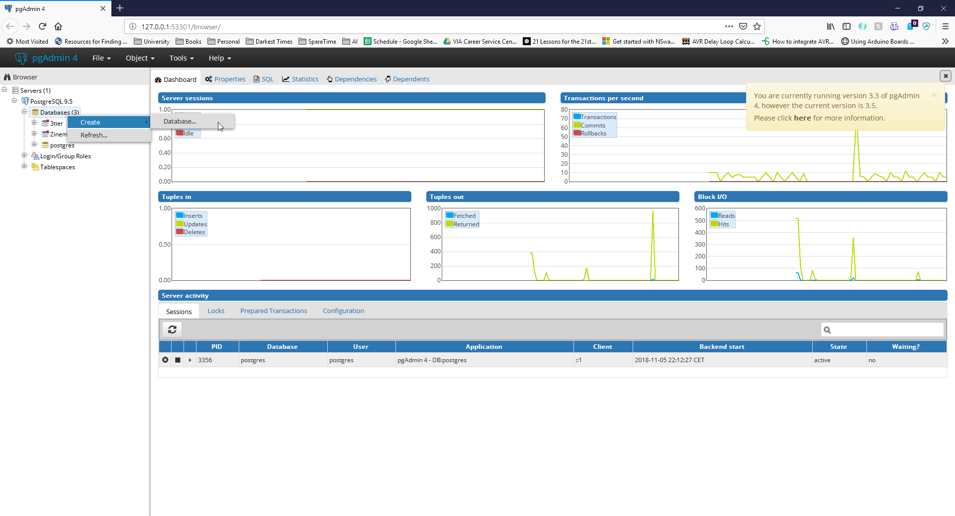

2. Go to Tools and select Query Tool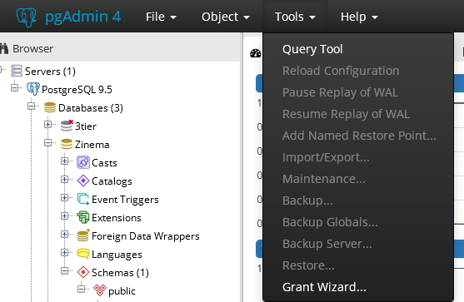

3. Run the following code

CREATE TABLE public."Movie"

(

title varchar(30) NOT NULL,

yearCreation varchar(14) NOT NULL,

releaseDate varchar(14) NOT NULL,

price decimal NOT NULL,

nameStudio varchar(20) NOT NULL,

nameDirector varchar(20) NOT NULL,

description varchar(50) NOT NULL,

nameMainActor varchar(20) NOT NULL,

PRIMARY KEY (title)

)

Notes:

To see the data in the table:

SELECT \* FROM public."Movie"

To remove data from table:

DELETE FROM public."Movie"

To insert data in table:

INSERT INTO public."Movie"(

title, yearcreation, releasedate, price, namestudio, namedirector, description, namemainactor)

VALUES ('Test', '2018', 'now2018', 40, 'TestStudio', 'TestDirector', 'TestDescription', 'TestActor');