1. Open Sql Server Configuration Manager

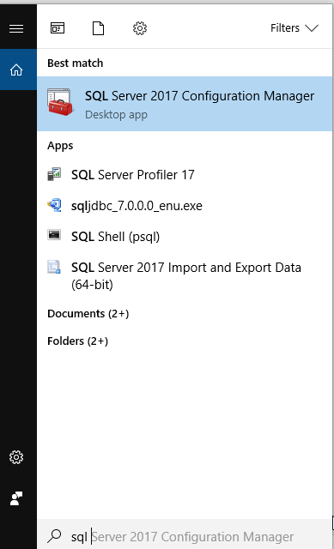

2.

Click Protocols for InstanceName, and then make sure TCP/IP is enabled in the right panel and double-click TCP/IP.

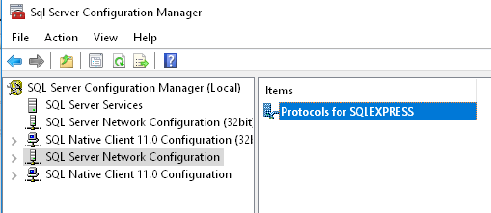

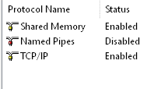

3. Click the IP Addresses tab: If the value of Listen All is yes, the TCP/IP port number for this instance of SQL Server is the value of the TCP Dynamic Ports item under IPAll. Make sure the port is 1433

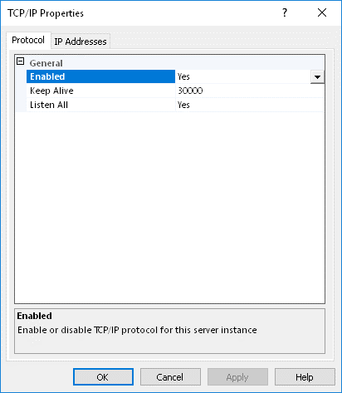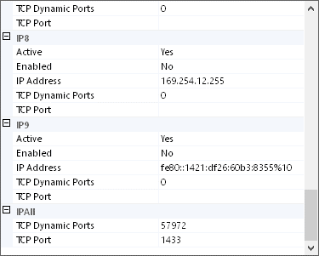

4. Make sure to restart the SQL Server. Press SQL Server Services. Select SQL Server on the right and restart.

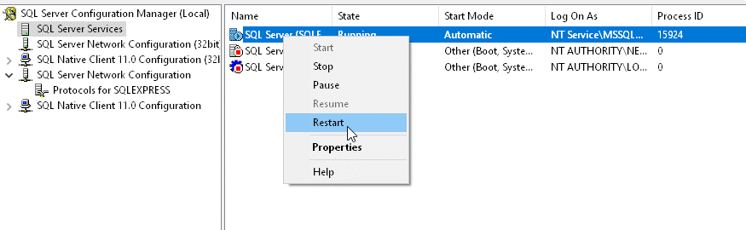

5. We go inside Microsoft SQL Server Management Studio. Select your server, select properties. Press on security and set to SQL Server and Windows Authentication

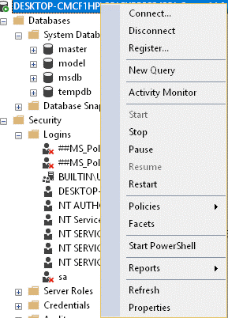

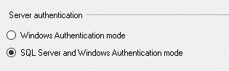

5. Now we need to make sure we can login to the database. 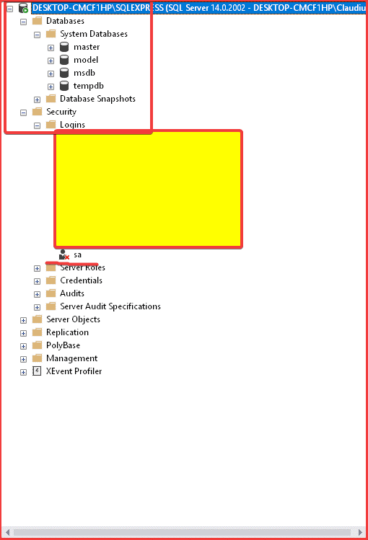

6. Time to change sa. First change the status of login to enabled 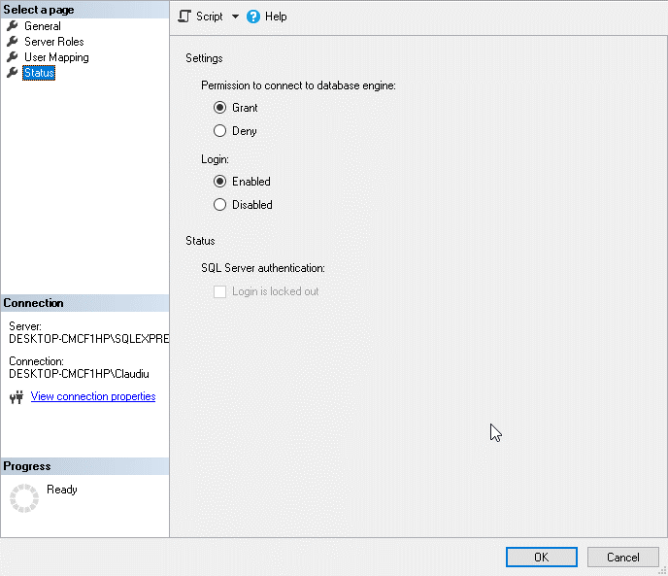

7.Then go to general and set whatever password you want. I recommend root because it is easy to remember, and we can all have the same password.

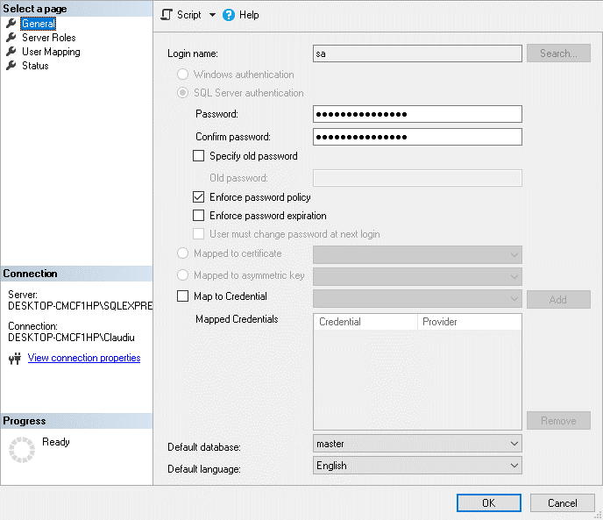

NOTE: I will upload a class, so you can test if it works for you or not

Now to set up our Movie table

1. Right click on Tables and click on Table… to start creating a new table

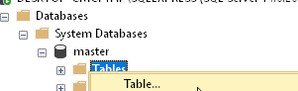

2. Enter the name and Data Type of every attribute the Movie Class has in our business model. After we are done, it should look like this

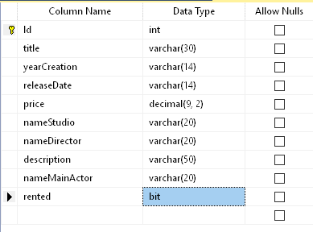

3. Right click on id and select it as primary key. Set is identity to yes and you should have seed 1 and increment 1

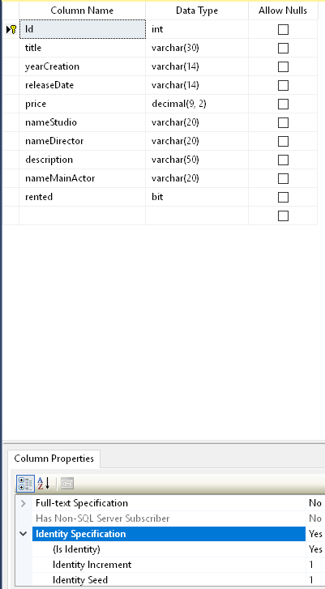

4. Set default value for rented in default value or binding. It should be 0

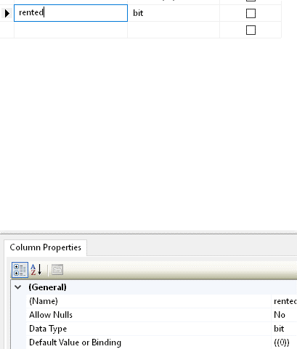

5. On the far right you should be able to change the name of the table to Movie from Table_1. Press ctrl+S to save the changes then right on master and defresh your master database and you are done.

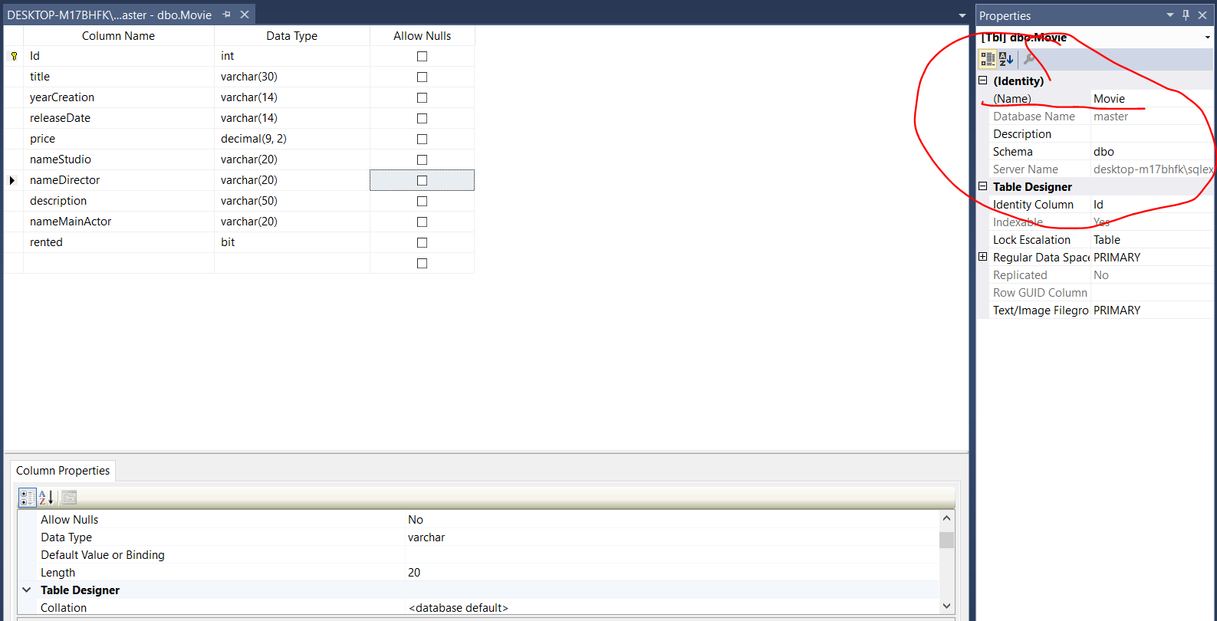

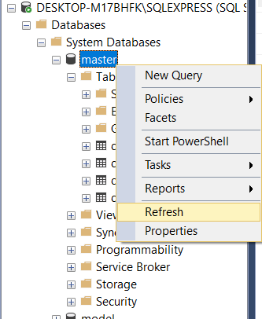

6. You can test it with this insert statement

INSERT INTO [Movie]

([title]

,[yearCreation]

,[releaseDate]

,[price]

,[nameStudio]

,[nameDirector]

,[description]

,[nameMainActor]

,[rented])

VALUES

('testAdd',

'13/11/2018',

'14/11/2018',

50,

'studioAdd',

'directorAdd',

'descriptionAdd',

'mainAdd',

0)

<https://docs.microsoft.com/en-us/sql/relational-databases/tables/create-tables-database-engine?view=sql-server-2017&fbclid=IwAR0H-pgl8EdI3VzF1G6FBCXOoEh-lKjsXJrB0H9j2y_-QtPJ2E7iGmPLS4g>

<https://docs.microsoft.com/en-us/sql/relational-databases/tables/specify-default-values-for-columns?view=sql-server-2017&fbclid=IwAR2b7Ub5xsLdGwTw2WN2wBF_WLxrKSyy-ROHPvb94OxshNvx_fYgG6PFjSc>

<https://www.codejava.net/java-se/jdbc/connect-to-microsoft-sql-server-via-jdbc?fbclid=IwAR2LOqN5iaTE5aIjowdZkHayw4DLyWJf-XzMJJqeBJiC6dAki5LNWzYFQaU>

<https://stackoverflow.com/questions/10991894/auto-increment-primary-key-in-sql-server-management-studio-2012?fbclid=IwAR2BR4xq1BopV5MYnJVaYkf5bmvY7J75rXs3duaYWJN-xYBB59dqV-E1ff8#10992074>

<https://docs.microsoft.com/en-us/sql/connect/jdbc/data-source-sample?view=sql-server-2017&fbclid=IwAR2BnOGR5Vqgb3oINfVC8yGfejezZlc3EUTkuHN6TK2bAWgyE8ZrJmGp5JI>

<https://stackoverflow.com/questions/2451892/how-do-i-connect-to-a-sql-server-2008-database-using-jdbc?fbclid=IwAR2b7Ub5xsLdGwTw2WN2wBF_WLxrKSyy-ROHPvb94OxshNvx_fYgG6PFjSc#14490004>

<https://docs.microsoft.com/en-us/sql/database-engine/configure-windows/enable-or-disable-a-server-network-protocol?view=sql-server-2017&fbclid=IwAR3WCkws63OdpagQ5gNNnni2vm0B7Ys2x2qUXi2jE8EfVO1KT9OiBA8nRuk>

<http://itproguru.com/expert/2014/09/how-to-fix-login-failed-for-user-microsoft-sql-server-error-18456-step-by-step-add-sql-administrator-to-sql-management-studio/?fbclid=IwAR0_MQ7ZuoUw57YEnzUIwPO9c27LDQMEeIR8xnEoo4lSuFhC3Bgn2U7oWWg>

<https://docs.microsoft.com/en-us/sql/connect/jdbc/data-source-sample?view=sql-server-2017&fbclid=IwAR2aqZRc2S1o7PunlUxxwzBfFbjXjS_PRnafGHTqtEvwrtAQZL5KRRyDpVk>