**PROCESS REPORT**

Zinema – Management Software

Distributed System

**Students**

Andrei Cioanca – 266105

Claudiu Rediu – 266129

Dominika Kubicz – 266148

Nikita Roskovs – 266900

Stefan Harabagiu – 266116

**Supervisors**

Jakob Knop Rasmussen

Jan Otto Munch Pedersen

**Acknowledgements**

The team wishes to formally acknowledge VIA University College’s active implication in the evolution and completion of this project work. All documents contained or referred to from this project are based on VIA University College’s templates and designs. All information present in this document, while original, could not have been made possible without VIA’s resources.

**Table of content**

1 Introduction 1

2 Group Description 3

2.1 Belbin Roles 3

2.2 SWOT Analysis 4

2.3 Cultural Difference 7

2.4 The Group 8

3 Project Initiation 9

4 Project Description 10

5 Project Execution 12

5.1 SCRUM 12

5.1.1 SCRUM Roles 12

5.1.2 Sprint Planning 12

5.1.3 Group Meetings 13

5.1.4 Sprint Backlogs 13

5.1.5 Burndown Chart 22

5.2 Unified Process 23

5.2.1 Inception 23

5.2.2 Elaboration 23

5.2.3 Construction 24

5.2.4 Transition 24

5.2.5 Distribution between effort and schedule 24

5.3 Tools 25

5.3.1 Git & GitHub 25

5.3 Tools 26

5.3.1 Git & GitHub 26

5.3.2 Swagger 28

5.3.2 Swagger 28

5.3.3 Treelo 30

6 Personal Reflections 31

7 Supervision 36

8 Conclusions 37

# Introduction

For this semester project we formed a group of five people, who agreed to work together in order to create a functional system. Three team members already worked on a project together before.

The idea for the project was ours to choose. We received the requirements that we had to meet. From the three concepts we had for the project we picked the one that fit us best, which was a cinema system.

Before we were able to work efficiently on the project we had to go through stages of team formation1, such as forming, storming, norming and preforming. Even though most of the team already knew how to work with each other, the new team member brought into the group new energy, which had to be accurately managed.

To properly organize the group work we used UP and the SCRUM framework. Claudiu Rediu was the SCRUM Master while Dominika Kubicz the Product Owner. We had before every sprint a planning meeting and after every sprint review and retrospective meetings. From the beginning of the project until the 5th of December we had daily SCRUM meeting once or twice a week, while during the project period the meetings were held on daily basis.

In order to evenly share the work, we used services provided by [www.trello.com2](http://www.trello.com2). All the tasks were posted there and assigned to certain group members. When a member fulfilled his responsibility, he updated the information on trello, so the other team mates were aware of the done tasks. Thanks to that website the whole team was able to keep track of the progression [1]of the project.

Because we sometimes lacked the knowledge to fulfill the requirements, we had a number of meetings with our supervisors. During that time, they helped us with our problems, so that we could continue with the work.

In conclusion, we spend during the past four months the total of 1350 hours on implementing and documenting the project. The group worked together in peace, united by the common goal of creating the possible best system for Zinema. After all the effort put in building the software and documenting the process, the whole operation turned out to be a success.

# Group Description

The group consists of five team members from three different nationalities.

## Belbin Roles[2]

According to Belbin team roles each member of a group shows a certain “tendency to behave” while cooperating with others.

**Claudiu Rediu** (Romania)

**Shaper** – keeps the team focused on the work and helps them stay motivated. The risk is that he might by accident offend someone’s feelings.

**Co-ordinator** – divides work between all group members and stays focused of the team’s goal. On the other hand, some people might see him as manipulative.

**Nikita Roskovs** (Latvia)

**Implementer** – feels most comfortable when his work is planned, and he can follow his strategy. It might be hard for him to adapt to new possibilities, or to change his plan.

**Complete finisher** – is the best at giving work a “final touch” and return it in the possible best condition. On the other hand, can get unduly careful with the details.

**Dominika Kubicz** (Poland)

**Complete finisher** – scrutinizes the teams work for errors and fixes them. Is known for being conscientious and anxious.

**Specialist** – brings knowledge and skills in a one specialized area. Has tendency to concentrate only on the one chosen area.

**Andrei Cioanca** (Romania)

**Shaper** – is good at challenging other members, thrives under pressure. On the other hand, he can be prone to provocation.

**Plant** – has unique ways of solving problems, is known for his creativity. Can be forgetful, and absent-minded.

**Stefan Harabagiu** (Romania)

**Monitor Evaluator** – has a logical eye on things, being able to make impartial judgment. Might be overly critical and lacks ability to inspire others.

**Plant** – has a tendency to solve upcoming problems in a creative way, comes up with a lot of different ideas for the project. May pay too much attention to communicate in the most effective way.

## SWOT Analysis

Each team member made a SWOT analysis of himself, so we could know each other better. Bellow we attached a diagram for each team member and also one for the whole team.

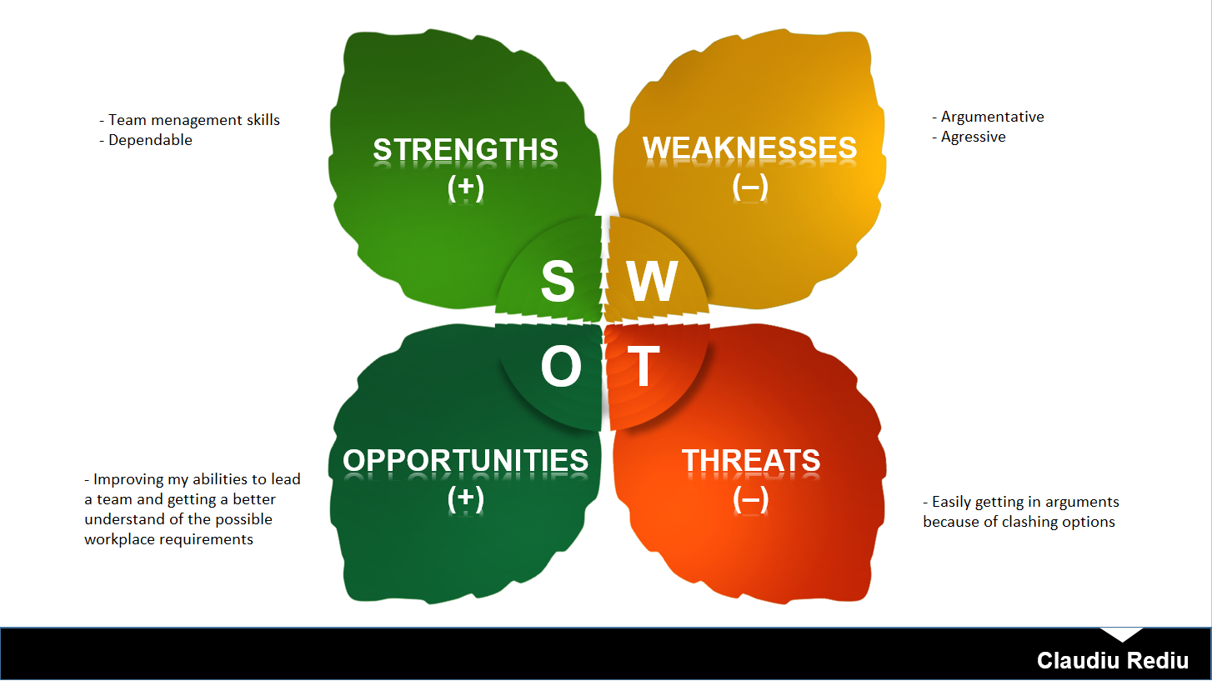

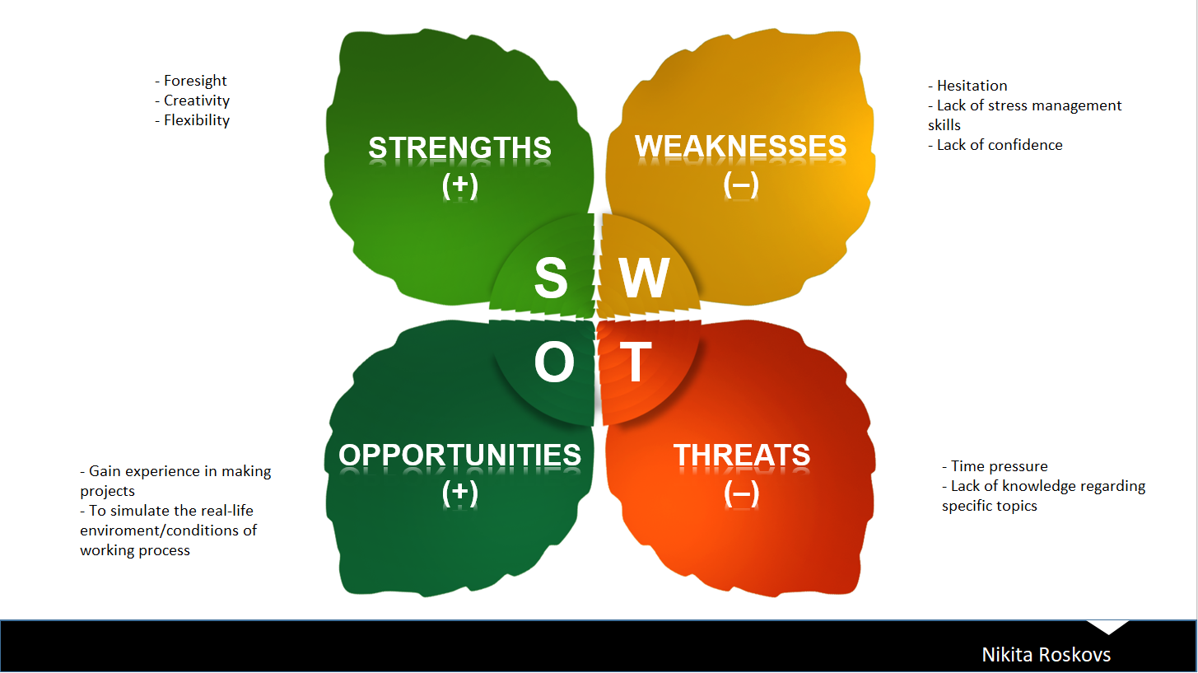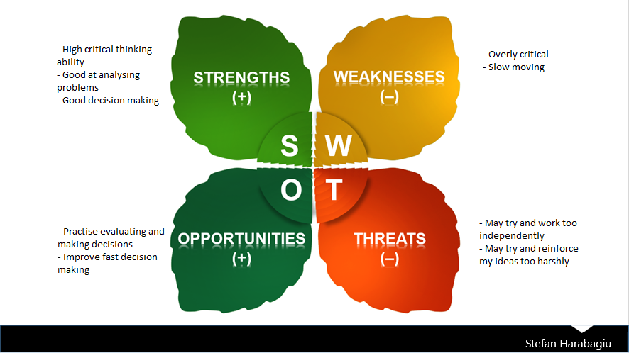

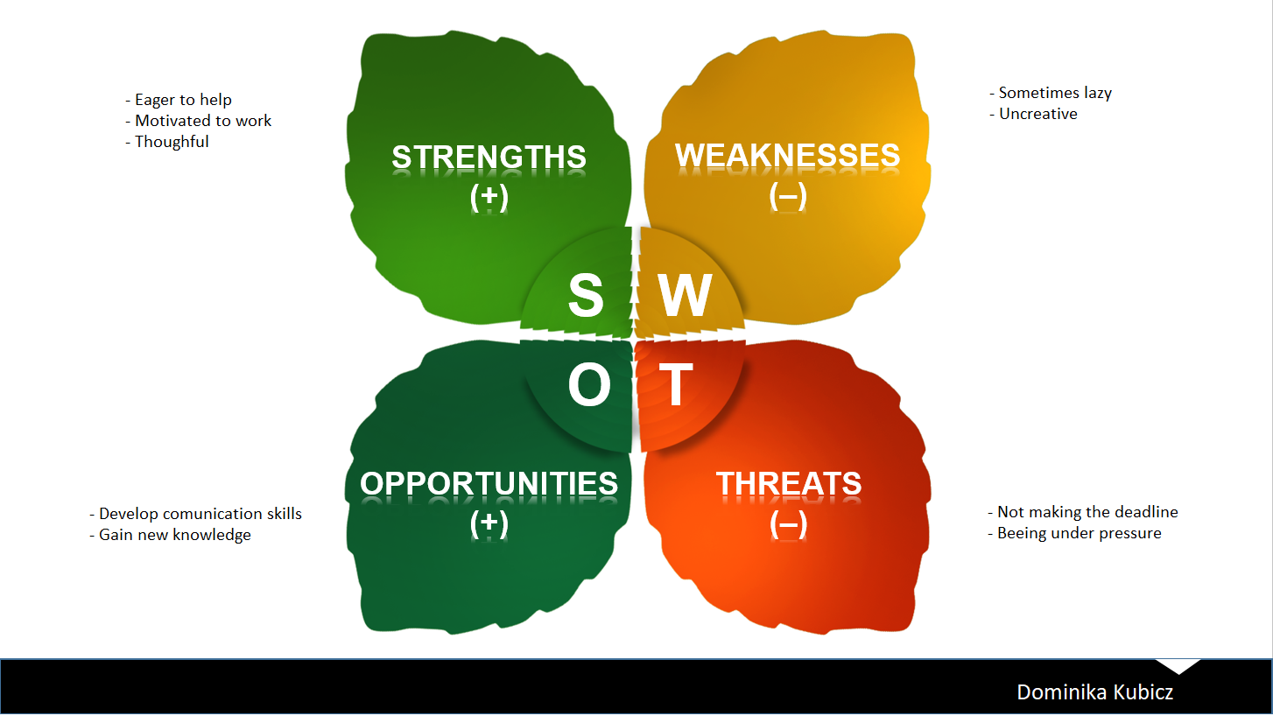

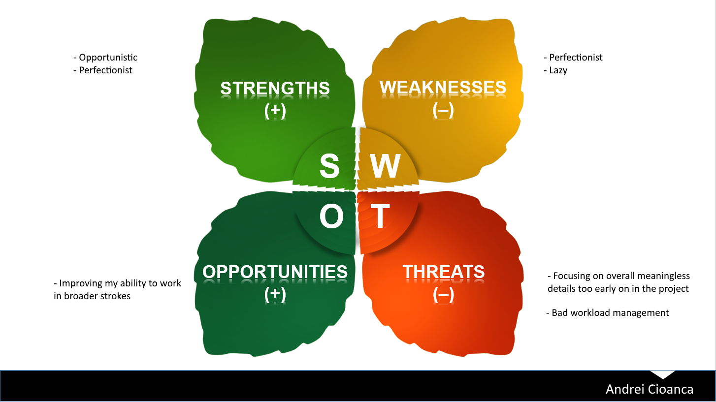

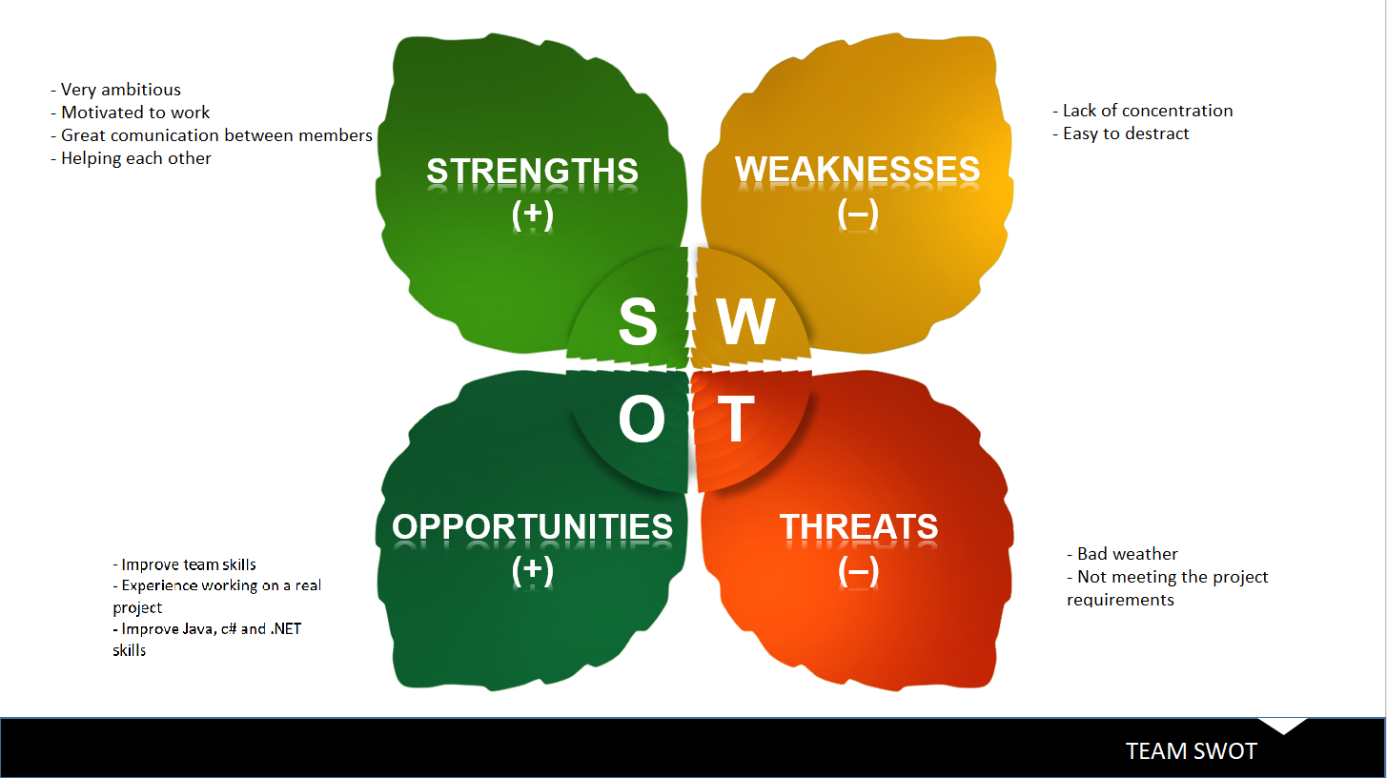

## Cultural Difference

Between all five team members we share the total of three different nationalities, such as Romania, Latvia and Poland. All countries scored a certain amount of points for different dimensions. The received scores are shown on the figure 1.

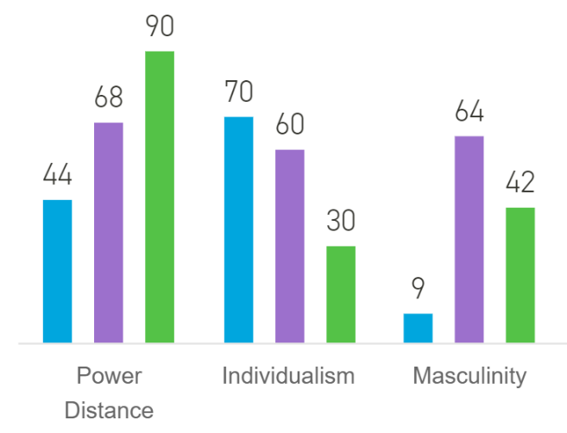

*Figure 1*

**Latvia**

In the power distance dimension Latvia scored lowest from all three countries. That means that Latvian people prefer to work as a team and with equality between the team members, although they still show respect towards the authorities.

Individualism is also very popular in Latvia. Children from the beginning are taught that it is important to take responsibility for their action. Also, they tend to speak their mind, and are very tolerant towards other.

Latvians motivation is that they do what they like. They don’t feel comfortable with praising and are very careful not to offend anybody. All of that is because they have very low masculinity.

**Romania**

Because Romania scored very high in the power distance dimension, that means that the people are used to a hierarchy and accept their place. They are used to others telling them what to do.

The score of individualism shows that in Romania there is a collectivistic society. That means that they take group responsibility very seriously, and they also take very serious relationships between group members.

Romania has a Feminine society, which means that people “work in order live”. They value equality and solidarity. The conflicts between them are solved very easily.

**Poland**

Just like Romanian society Poland also is a hierarchal society, because of its high power distance score. People agree to their place in the hierarchical order and are used to being told what to do.

In the Individualism dimension Poland scored quite high, meaning that they care about themselves and the closest family. In such society offence causes a loss in self-esteem and guilt. The promotions and hiring are based not on the relationship but on merit.

Poland is considered a Masculine society. That means that people “live in order to work”. The conflicts are settled by fighting them out.

## The Group

All team members have experienced group work in previous semesters. Nikita, Claudiu and Dominika worked together on a project last semester. All three of them accepted the new team members, which brought to the group new approach towards the project.

Even though our cultural backgrounds were different we managed to work together. The team members often challenged each other’s ideas in the process of striving for excellence. All decisions made during the meetings were talked through with all members. Everyone was aware of the progression of the project.

In our group we had members with Belbin roles from each of the following dimensions:

* Action Oriented Roles (Nikita – implementer, Andrei Cioanca - shaper)
* People Oriented Roles (Claudiu – Co-ordinator)
* Thought Oriented Roles (Dominika – specialist, Stefan – monitor evaluator)

Thanks to the fact that we had all the three dimensions covered, our work together was very pleasant and everyone had an important role to play. That caused our group to have a high performance rate.

# Project Initiation

The team we formed for this semester had some new members, which gave the group a new character. Everyone had to find their new position in the team. Because of that process we went through the four team formation stages, which are Forming, Storming, Norming, and Performing[3]. In the first stage all members were explained about the upcoming challenge and what was expected from them. Storming phase was quite noticeable. There were many discussions in the beginning of our work together. Members tried to implement their solution to the project, but in a polite way, without any fights. After that we finally reached the norming phase, which let us work together as a group. Preforming phase came quickly after norming and our progression was visible.

The most important document for us was the group contract. We established some ground rules we expected each other to follow. To prove our will to work on the project, everyone agreed to the rules from the contract and signed it. All team members through the duration of our work together did their best to respect the regulations.

All of our meetings were held at the university. There was a possibility of having meetings through the internet, but there was no need for that. Setting the meetings was quite challenging. Because all of the members had extra activities like a part-time job or some extra lessons, it was very hard to set a date that fits everyone. That is why on some of the meetings not everyone was present. Apart from couple of meetings with one or two members missing the attendance was very good.

At the very beginning of the semester the supervisors explained us what requirements they expect our project to fulfil. We could pick a case that was to our liking. We discussed three different ideas, such as a flight booking system, hotel booking system and a cinema system. After a voting, the majority of our team voted for a cinema system, which we proceeded to work with.

On order to organize our work in the best possible way we decided to use UP and SCRUM framework. We picked a SCRUM master and a product owner in order to respect all required roles of a SCRUM team. Claudu Rediu was the SCRUM master and Dominika Kubicz the product owner. The rest of the group members (Andrei, Stefan, Nikita) were the team. Through the duration of the project we had the appropriate meetings such as retrospective, planning, review and a daily SCRUM meeting during every sprint iteration.

# Project Description

We wrote the project description, so that we can share our vision of the project with other people. Thanks to our previous experience with other projects we worked on we were able to pass our idea for the system in a simple and understandable way.

First, we formulated the background description. We used reliable sources to support our project, so the readers were convinced of the need for our system. We included statistics showing the decrease in Danish cinema activity to show that the market needs a boost. Defining the purpose was challenging as usual. We did our best to pick the right words that catch the essence of our project. In the problem statement we stated couple of question we expected to answer while completing the project. Because we already had the idea in our heads it wasn’t hard to put these questions on paper. The delimitations include some features that at this point of our education we were not able to implement. To show how we plan to work on the project we established in the “Choice of models and methods” frameworks we were planning to use and explained why we decided on them. In the “Risk Assessment” we discussed about the possible risks that we might come across. To each risk we assigned one person to make sure that this exposure will not affect our project work. The goals we set up worked well for us. We managed to implement everything we wanted to. Because of the previous experience we knew our potential and we set goals suitable for our skills.

To conclude the Project Description phase went smoothly, without any big problems. Having had some previous experience, we were able to stand up to the challenge and do our best to properly introduce our project.

# Project Execution

## SCRUM

### SCRUM Roles

SCRUM Master: Claudiu Rediu

Product Owner: Dominika Kubicz

### Sprint Planning

1st Sprint:

8th of October – 12th of October

2nd Sprint:

22nd of October – 16th of October

3rd Sprint:

29th of October – 2nd of November

4th Sprint:

5th of November – 9th of November

5th Sprint:

12th of November – 16th of November

6th Sprint:

19th of November – 23rd of November

7th Sprint:

26th of November – 30th of November

8th Sprint:

3rd of December – 7th of December

9th Sprint:

10th of December – 14th of December

### Group Meetings

Group meetings will be on Fridays. They will consist of SCRUM Review and Retrospective. They will all be held at the university. There will be approximately 150 hours of work each sprint.

### Sprint Backlogs

1st Sprint

Sprint Review:

Work was split in multiple days as immediate priorities took held of our schedules. The meetings got heated because of arguments, but it didn’t impend the work pace. Due to planning, everything was achieved even before the term. The results of designing the system were satisfactory.

Sprint Retrospective:

WHAT WENT WELL:

- TEAMWORK

- WORK PACE

- FOCUS

WHAT COULD BE IMPROVED:

- COMMUNICATION

The way we planned our schedules worked properly to satisfy both personal and professional. Work pace and focus were centered on the work, but communication got heated because of arguments. They were solved but could’ve been avoided by a bit more tact. In future meetings situations like these will be dealt with a better approach.

2nd Sprint

Sprint Review:

The design is still the focus. Meetings took place to prepare for future sprints in which we will implement the system. The schedule for meetings was unaltered by external issues. In this sprint, the process evolved further in designing the system.

Sprint Retrospective:

WHAT WENT WELL:

- TEAMWORK

- WORK PACE

- COMMUNICATION

WHAT COULD BE IMPROVED:

- FOCUS

In comparison with the previous sprint, communication was on point. Arguments were dealt with a better attitude, especially openness. Focus started to fall off towards the end, but it didn’t affect the result as most of the work was already done. The working medium was a better environment for working and discussing.

3rd Sprint

Sprint Review:

The focus was designing the proof of concept. The common agreement was to work on the first component and have it working as intended, in order to demonstrate the feasibility of our system. The construction of the system also started with this sprint

Sprint Retrospective:

WHAT WENT WELL:

* TEAMWORK
* COMMUNICATION
* FOCUS

WHAT COULD BE IMPROVED:

* UNDERSTANDING THE REQUIREMENTS OF THE SYSTEM

As the designing and implementation began, doubts started to appear. This was mainly the only issue with this sprint. There is a need for a meeting with the supervisors to understand in a clearer manner what is expected. The working environment was satisfying in this sprint.

4th Sprint

(Add supervisor meeting with Jan during this sprint. He explained what designing our own protocols means and we remade our code using sockets)

Sprint Review:

After discussing with one of the supervisors and meeting to reflect on the evolution of the code, the design was improved as there was a lack in understanding of the requirements. This was one of the biggest steps until now for meeting the requirements.

Sprint Retrospective:

WHAT WENT WELL:

* ADDAPTIVENESS OF THE TEAM

WHAT COULD BE IMPROVED:

* COMMUNICATION
* TEAMWORK
* FOCUS
* WORK PACE

In comparison with previous sprints, the results of planning and splitting the tasks was not fruitful. It was not such a big issue as most of the code was scrapped. Looking forward to future sprints, plans should be made in such a way that the direction is clear and easy to follow.

5th Sprint

(Add supervisor meetings with Jakob and Jan. They both explained how we didn’t really respect the 3-tier model and would be a good idea to have the database server separate. We decided after this to code it in C# and communicate over sockets.)

Sprint Review:

The proof of concept created was reviewed by the supervisors. After the meeting, design was adjusted and tasks on how to improve it were done. Requirements were made clearer and the vision for the system is becoming clearer.

Sprint Retrospective:

WHAT WENT WELL:

-COMMUNICATION

-TEAMWORK

WHAT COULD BE IMPROVED:

-FOCUS

-WORK PACE

Comparing it to previous sprints, the vision for the final product became more defined. The pace should be improved as the number of sprints until the hand in are decreasing. The problem of members not communicating when in doubt started to become less of an issue. Use of tools like Github and Trello has improved.

6th Sprint

Sprint Review: The project advanced towards the most relevant components. The design now is complete for all components and the only thing to do is finish up on the implementation and finalize the details on the code made in previous sprints.

Sprint Retrospective:

WHAT WENT WELL:

-WORK PACE

-TEAMWORK

WHAT COULD BE IMPROVED:

-FOCUS

This was one of the better sprints in which a lot was achieved. The only thing that could be improved is bringing together in a better form each other’s working habits.

7th Sprint

Sprint Review:

Work on the final component has started. The pace is slower than expected, but there is enough time until the deadline to have everything done. The visual part on each component is almost done.

Sprint Retrospective:

WHAT WENT WELL:

-COMMUNICATION

WHAT COULD BE IMPROVED:

-WORKPACE

-FOCUS

In comparison with other sprints, there hasn’t been much done in the way of code. The focus is slowly shifting towards documentation in the closing sprints. Two more sprints should be more than enough to fulfill the requirements.

8th Sprint

Sprint Review:

The final component is finished. The part with advertisements has been removed from the plan, as it didn’t help in achieving the goals and took too much time for how much it was worth. Documentation and testing is the only focus now.

Sprint Retrospective:

WHAT WENT WELL:

-COMMUNICATION

-WORKPACE

-FOCUS

-TEAMWORK

WHAT COULD BE IMPROVED:

Putting into perspective the other sprints, this was the best one. The implementation has been finalized and splitting the work is going well. Teamwork and communication was great.

9th Sprint

Sprint Review:

All the requirements are achieved. The project was kept simple to ensure that everything worked as expected. Proofing everything that is already done and updating the documentation is the current strategy.  
  
Sprint Retrospective:

WHAT WENT WELL:

-COMMUNICATION

-WORKPACE

-FOCUS

-TEAMWORK

WHAT COULD BE IMPROVED:

This was also a great sprint by the general standards that were created for them. There weren’t any complaints and the tasks were achieved in due time.

### Burndown Chart

The burndown chart’s axes take into calculation the number of tasks and the sprint number. The first sprints were characterized by a focus on setting up the environment for the project and the initial documentation. Over the course of the next sprints, there were external projects and concerns that were not part of SEP that influenced the departure from the ideal tasks on each sprint. During the last sprints, work was done in the ideal manner. It helped in fulfilling the requirements on time and making the most helpful decisions.

## Unified Process

### Inception

During the Inception phase, focus was placed on preparing the working environment and formulating a scope of the project. Working together with SCRUM, this phase was mostly in the first sprints. It consisted of creating the project description, sprint planning and creating the product backlog. Project description was created to formulate a scope, introduce boundaries, a vision for the system and gain acceptance and estimate what the product should end up like. The requirements and the first use cases are created to guide the development of the system. SCRUM was used in this phase to estimate a schedule and delimit what the system should and should not do using the product backlog.

### Elaboration

During the Elaboration phase, the main activities were defining and refining the vision and architecture of the system, making sure that the risks are mitigated, ensuring the project is worth further advancement and planning for the construction phase. Possible risks are that the system is not maintainable, understandable or not respecting the requirements. The use cases were created to demonstrate that the system will support the requirements. It was ensured that they would reflect the system that will be developed. Elaboration phase is mostly characterized by the analysis and design of the system.

### Construction

During the Construction phase, the priority is constructing the system as rapidly and efficient as possible while having the analysis, design, implementation and testing complete. As each component is implemented, the system is proofed against the requirements and specifications then updated accordingly. Emphasis is put on the working process and its efficiency. The approach was that after each component was implemented, the system could be on its own a product that would work. In this way, the focus was to create it in a way that makes it maintainable and open to the adding of components with new features.

### Transition

During the Transition phase, the main goal was that documentation, the user guide and have it ready to present to the customer. By the end of this phase, bug fixing, and enhancements made to the system must be complete. User feedback should be considered for fine tuning the product. The system must be presented to the customer.

### Distribution between effort and schedule

|  |  |  |  |  |
| --- | --- | --- | --- | --- |
|  | Inception | Elaboration | Construction | Transition |
| Effort | 10% | 20% | 65% | 5% |
| Schedule | 11% | 22% | 56% | 11% |

This table was filled with values that resulted from the time spent in a sprint and all over the course of all sprints.

## Tools

### Git & GitHub

Git is a revision control system. A tool to manage the source code history of a project.

GitHub is the hosting service that was used for the Git repository created for the current project.

There were both used to ensure that the work was centralized.

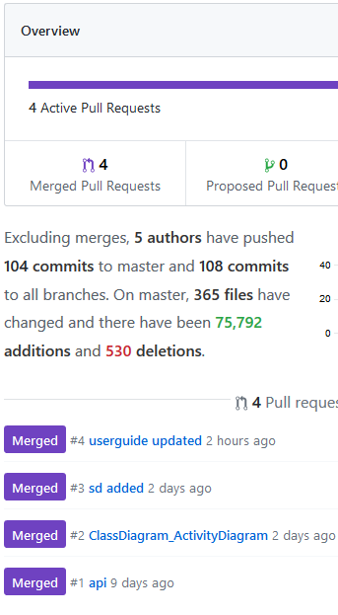

This is an example of the use of the pull request feature. A pull request announces that there are changes to be pushed, but before that they need to be checked and discussed.

# Another feature that was used and is worth mentioning is the branching inside a repository

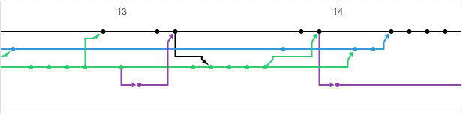

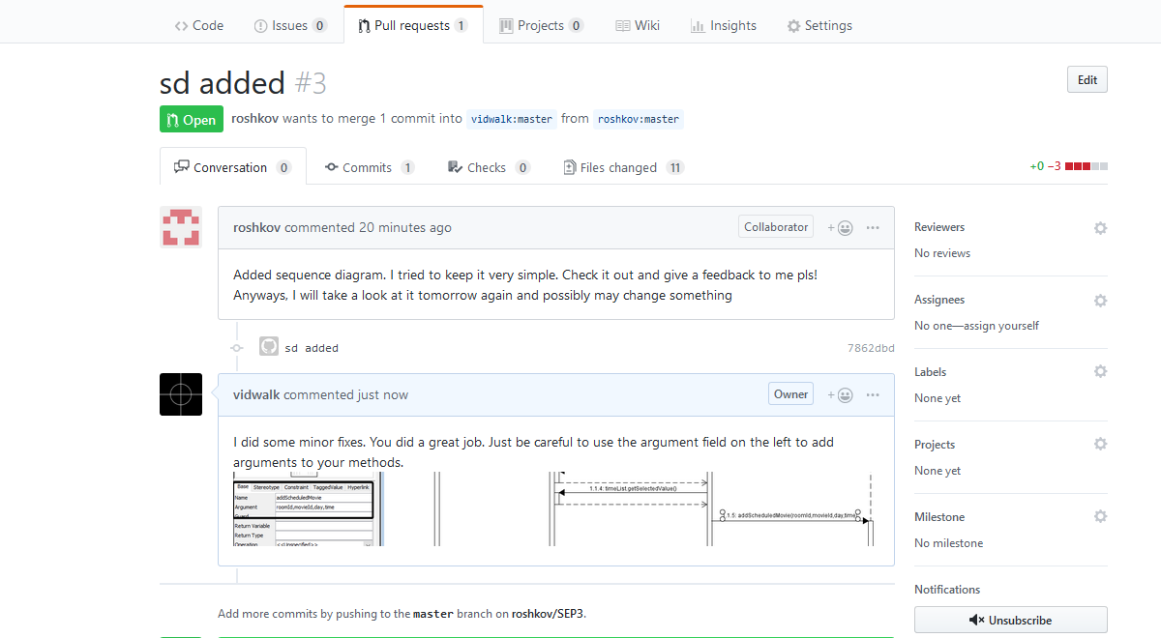This is some branches inside the project looked around the 13th-14th of December. They helped in the management of the source code and introduction of bug fixes.

GitHub was also used to provide each other with feedback and means of improving our work.

# 5.3.2 Swagger

Swagger is a tool that helps in designing, building, documenting, testing and standardizing an API. In the context of this project, it was used to document the API.

As soon as the API is started, the documentation can be checked through accessing a certain link(https://localhost:5003/swagger/index.html) 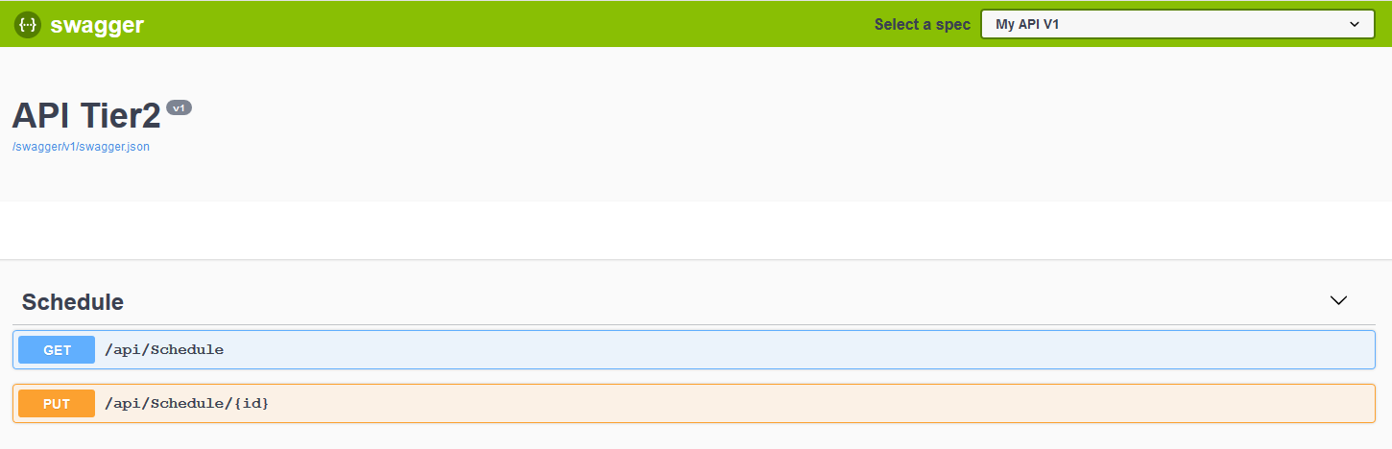

The actions that can be performed on the API are documented together with the Models.

### Treelo

Trello is project management tool based on the web. It was used to organize the tasks in the team and as a reminder that the tasks need to be done in tine.

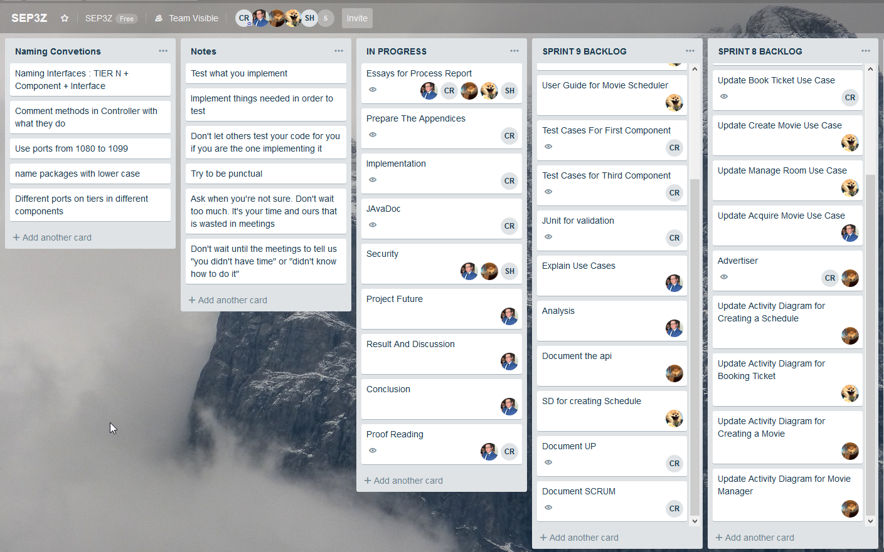

This is an example of how Trello was used during this project. Different notes and conventions were created to supply the users with the needed information without requesting it from another.

# Personal Reflections

**Claudiu Rediu**

This semester project has been a fulfilling experience in most aspects. As with every project, I got to learn something about myself, working in teams and programming. I’m happy to say that I got the chance to improve myself.

My goal is to work on myself, so I can bring my best. Usually, I take the role of the leader if there isn’t anyone more willing and able than me. Through my leadership, I try to make things as efficient as possible, so people can concentrate more on the important stuff and do their work faster and better.

Some of my issue this semester had been mostly with myself. One of my main issues was that I got angry easily and waste time on petty arguments instead of listening to everyone. Trying to push my agenda on others didn’t help. I’ve identified this problem early on and fixed it and soon as I could. My goal isn’t to become an obstacle for others.

The second issue with myself is that sometimes I take too much of the workload. The reasons are usually from a lack of patience, trust in others and the pleasure of working. I’ve tried being more patient and trusting of others, especially towards the end. It has worked with me, but I don’t consider that it will always be this easy.

In conclusion, I’ve enjoyed working with my teammates. Everyone agreed on what needs to be done, so there wasn’t any stress during the project period, as everything went smoothly, and we finished before the deadline.

**Nikita Roskovs**

My overall experience of the semester project group work has been satisfying. There was friendly atmosphere in the team and all my group mates have been ready to help and open to discuss any ideas or issues cropped up.

Team used planning tools and had regular meetings, so everyone always stayed updated and aware of the overall process of the project. Everybody was free to choose tasks dependent on what they want to implement or know the most about. All the parts always been discussed during the meetings, so everyone was clear with the tasks they had to fulfill. In the beginning we tried to split tasks equally, however it did not work out perfectly, because as soon as we moved to coding part, it was quite hard to split the code of the components between multiple group members by reason of longer implementing and testing process.

Planning was done well. We managed to stick to schedule we set and almost always achieved all we planned to achieve during the particular sprint without being too overwhelmed.

Comparing to the last semester, this time I’ve been trying to delve into the coding parts made by other group mates in order to understand the mechanism of created system more detailed.

All in all, I enjoyed working with my group and want to thank all of them for that experience

**Dominika Kubicz**

I really liked that my group mates were very helpful. Whenever I needed help with a problem they were keen to help. I also enjoyed that the group work was well organized. Every week we agreed on tasks that have to be done by the next meeting. All members had responsibilities which they scrupulously fulfilled. I really appreciated the fact that whenever I missed a part of the meeting, the group shared with me what was done and what decisions were made. Other pros were the numerous discussions during the meeting. The team had a lot of ideas and they were always discussed so we could pick the best one.

On the other hand, I found some of the discussions pointless. We, sometimes, during the discussion changed the topic and weren’t talking about the important details anymore. Also, whenever a meeting was scheduled, very often other members didn’t say if the date fit their schedule and if they will attend the meeting.

In conclusion, previous months with my group was enjoyable. The team mates were friendly and helpful. Thanks to them I gained team work skills and learned more about Java and c#.

**Stefan Harabagiu**

Working on the project for this semester has been an overall satisfactory experience for me.

Trying to design a distributed system that operates on a three tier architecture has been an interesting and engaging assignment that also came with its fair share of challenges. Working in both Java and C# was for me the most interesting bit, as we were just introduced to the latter of the two languages. I also appreciated the fact that we got to experiment some more with SCRUM as the last semester it was quite weird because it was the first time we worked in this manner. The addition of the requirement for all members to use Git was also a good idea.

This semester I also had the opportunity to practise my ability to work in a group some more, as I actively tried to better communicate my ideas and be more flexible with the way I wanted certain tasks to be done.

Working with this semester’s group has certainly been an improvement to the last semester. The rules to what a group should contain were less strict this semester and I think this was for the better, as I was able to properly choose my team mates, basing my decision on competence and not nationality.

As a conclusion, this semester project has been an interesting and well thought opportunity to learn more and develop myself.

**Andrei Cioanca**

Compared to the last semester, this project has been considerably more interesting and less confusing.

The relative freedom we got from the professors meant that we could focus on coming up with interesting ideas for our project instead of getting bogged down into details or artificially created requirements that wouldn’t benefit anyone in a real-life scenario.

That said, we did have a few contrived objectives, but in the end, they had good reason to be there as the focus this semester was on communication between different coding languages and those requirements taught us a few valuable concepts when it comes to such communication.

The working period was a lot smoother. This can be attributed to the experience that all of us have accumulated over the semesters as well as the way our professors structured the programming lectures, especially in DNP.

I am absolutely content with the result of our semester project and I’m looking forward to the next one!

# Supervision

During the implementation of the system we had numerous meetings with the supervisors. Our first meeting was about the project proposal. Our idea for the system was accepted. Next, we handed-in architecture part for the application. In the feedback the teacher told us that in the implementation we must include communication between c# and Java. That is why we had to convert the database adapter to c# language.

We had one more important meeting with Jakob Knop Rasmussenon the 10th of December. During the talk all team members asked questions about what they were struggling with. Some of our problems concerned the communication between different components. We asked about the preferred document type for connection data and we had some problems with running the web API and tier 1 component at the same time. One question was related to the web API. One of the members asked if there is a more elegant way for reading data from the user than taking one value from the query and one from the body. We also were not sure about testing our system. The supervisor reassured us that testing the use cases is enough. We had our doubts about the deployment, but it turned out that we don’t have to deploy our product. Another question concerned the JavaDoc. The teacher told us that we should do it. When we asked if there is something similar to JavaDoc for c# part of the system, he told us that we are not obligated to do anything regarding c# part. We were also worried that we have some hard coded values in the system. Jakob told us that hard coding values is not a negative thing and can be accepted. During the meeting we also asked about documentation. We weren’t quite sure how to document the web API part of the system. The teacher told us about some available tools we might use.

In conclusion we mostly struggled with implementing the connection between components. Thanks to the supervisor meetings we managed to find solutions to the challenges we encountered and continue with the project.

# Conclusions

To sum up, we formed a group of five students from three different nationalities. Despite our work culture, we managed to work together as a team. Each member had an important role to play for this project to be a success. Everyone stood up to the challenge and invested their best efforts into the cause.

During the project we had some problems we had to overcome. Whenever we had a dilemma we first discussed on a group meeting. If someone had a small issue we just asked other members for help. In case that we haven’t found a solution after a solid discussion we asked the supervisors for help. The walked us through and help us find the best possible solution.

To organize our work in a most efficient way we used the UP and SCRUM framework. That made our meetings more productive. Even though the amount of time we had for the project wasn’t enough to make a full 2 week sprint, we had a shorter ones just to follow the SCRUM. Each sprint consisted of a sprint planning, retrospective, review and a daily meeting. All this effort we put in following the framework led us to completing the project successfully.

We worked a total of 1350 hours on our system. During that time, we improved our c# and Java skills along with writing important documentation and team work. The project helped us develop ourselves and gain some new knowledge.

1. 1. <https://www.mindtools.com/pages/article/newLDR_86.htm>
   2. https://trello.com/?truid=tr1a198c-8292-7afe-4d0a-9de8ba56c48a

  
2. <http://www.belbin.com/media/1336/belbin-for-students.pdf>
3. https://www.mindtools.com/pages/article/newLDR_86.htm