*Go out to the W3Schools links above, and select at least three functions to experiment with. For each:*

* *Provide an explanation of when it might be used.*
* *Provide an appropriate alias for the column header in the results.*
* *Provide the SQL statement, run the statement, then take a screenshot of the results.*

Function #1: AVG

AVG returns the average value of an expression. The expressions can be a field or a formula. I’ve downloaded a sample database from <https://www.mysqltutorial.org/mysql-sample-database.aspx>. It represents a business selling scale models of classic cars. AVGmight be useful to find what the average order sum is to represent the success of the business.  
  
I’ll be using the alias Average Order for the result here.  
  
SELECT AVG(amount) as 'Average Order' from payments;

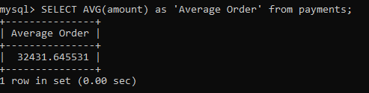

Function #2: MAX

MAX returns the greatest value in a column from a table. Going to look for the last time an order was made using the alias ‘Date of Last Order’

SELECT MAX(orderDate) AS 'Date of Last Order' FROM orders;

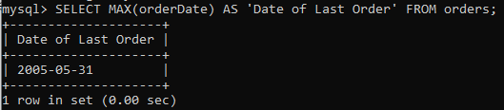

Function #3: WHERE

WHERE is used to put conditions on a select statement.  
  
Going to see when the last time someone made a payment over 50,000 dollars. Using ‘Date of Payment’ and ‘Amount of Payment’

SELECT paymentDate AS 'Date of Payment', amount AS 'Amount of Payment' FROM payments WHERE amount > 50000;

