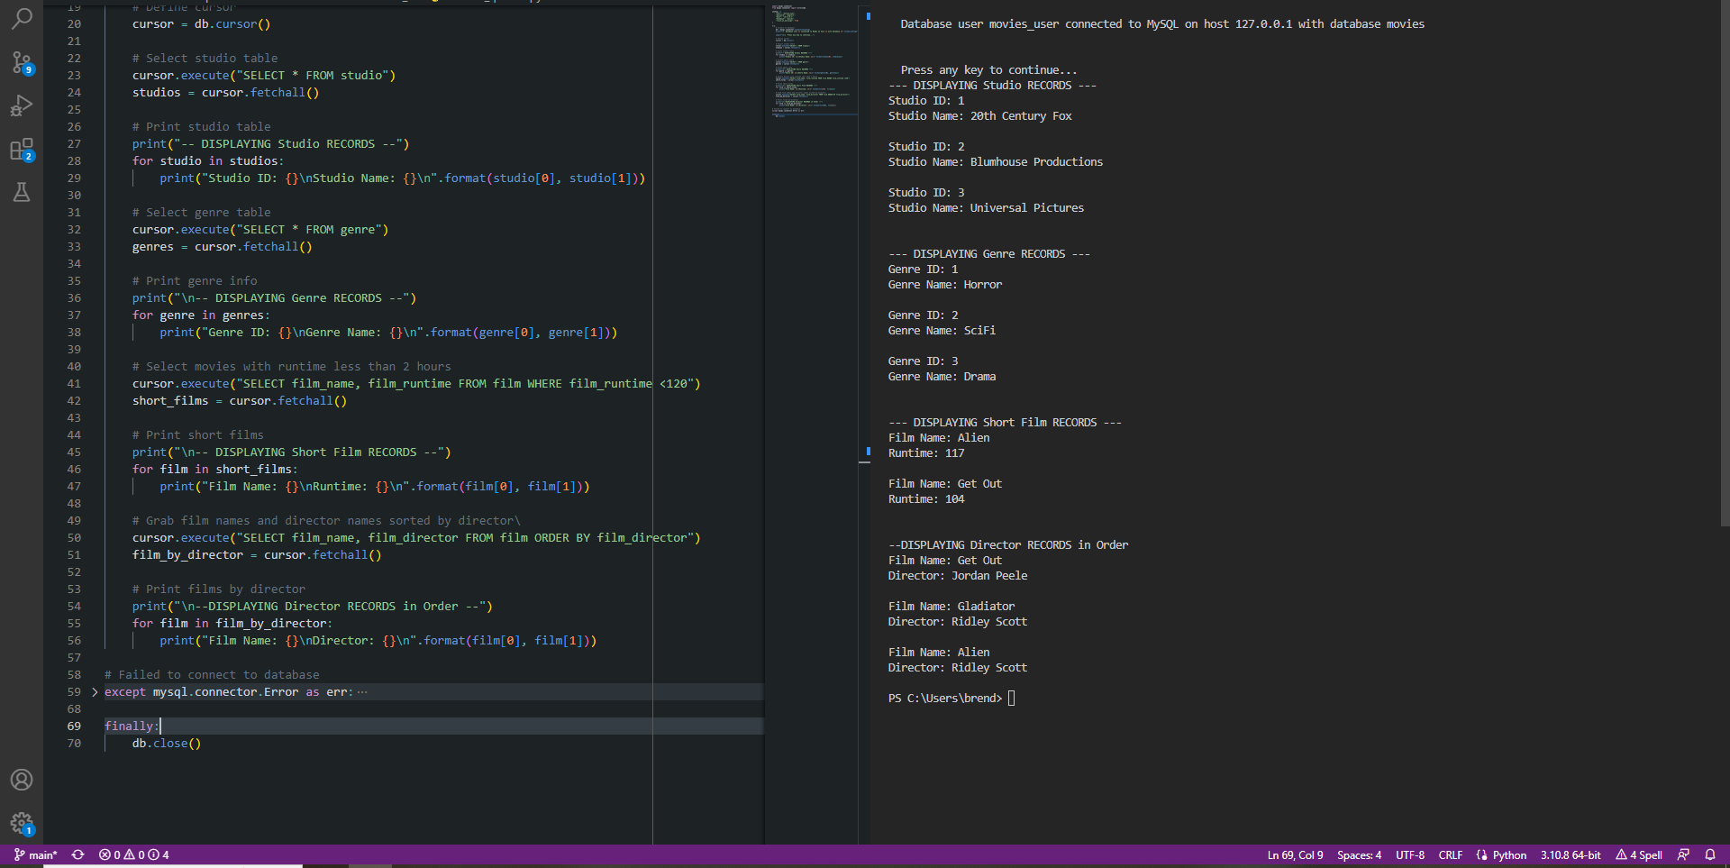<https://github.com/Drabynoops/csd-310>