# **Game Design Document – Defend & Capture**

## Genre & Goals

Defend & Capture will be an entry level, small scale RTS game targeted at an audience that is younger, more casual, or new to the RTS genre. The game attempts achieve this by using a low poly art style that is friendly for younger players and isn’t gritty or matured to the eye making it more applicable for these audiences. Although currently in early stages of development, character designs and the art style are established to be for these audiences with the first map being a toy soldiers aesthetic design.

The game represents a game of rock paper scissors between units, the player controls an army they’ve made to push and destroy an enemy base. An enemy AI pushes to do the same to the player. It attempts to set up a simulation style combat with AI aspects on the player side that helps guide fights, as well as enemy controlled AI that presents a challenging task to overcome for these newer/casual players. There are several main mechanics that are key to understanding:

* Base construction,
* Resource management,
* Troop controls and manoeuvres,
* Combat centric mechanics.

### Base construction

The empty template base is given to the player at the start, it contains seven ‘pads’, these pads, indicated as grey platforms around the central part of the base, provide spaces for the player to spend resources to build one building on these spaces. The buildings allow for resource production, the unlocking of other buildings or the production of troops. All of which are important to utilise and link to the other main mechanics, but with a limited number of pads the player has to manage these buildings and discover which is the most prevalent at the time to overcome the AI.

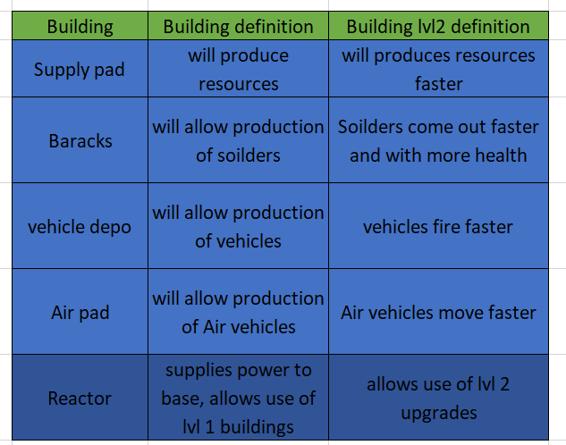

*Figure [1]*

### Resource management

Resources are split into 3 types and relate back to building that increase their counts (from left to right in figure [2]):

* Supplies
  + These are received when the player has supply pads. The more supply pads a player has the quicker they’ll get supplies. If a supply pad is upgraded, they’ll receive more supplies per pad.
  + Payer can spend these supplies on other buildings and upgrades, but primarily will use them to produce troops using other buildings.
  + Players receive these in the hundreds making it the most abundant resource.
* Power
  + Power dictates what buildings can be built at a specific time. A reactor existing on the base will provide 1 power, an upgraded reactor proves another power for a total of 2. Specificities are located in figure [3]
* Population
  + A player can create up to 50 troops as of early development, this may fluctuate depending on tests.
  + This reduces strain and keeps the game light. The more troops the more hectic it’ll be and the more power it’ll require on the PC to perform the AI protocols.
  + Barracks, vehicle, and air depots will create one unit per unit bought, this will increase the population by 1 until the player cannot make more.

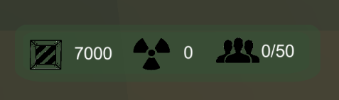

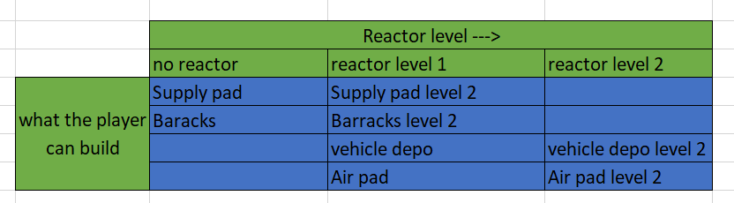*Figure [2]*

*Figure [3]*

### Troop controls and manoeuvres

The player troops will be able to be controlled using the mouse and keyboard and will primarily use ray casts and unity navmesh system and custom arrays systems to navigate the map. The 3 ways of the player interacting controlling the troops will be:

* Single click
  + Single clicking a unit will highlight them in a gold circle to let the player know they are selected and ready to move, clicking the again reverts this and ‘unselects’ that unit
  + Clicking on another unit while another is selected selects this as well and they can be moved together.
* Group selects
  + Pressing shift will bring up a circle on the floor pressing shift will deselect all currently selected troops, this button can be tapped to unselect all troops
  + All troops that aren’t selected that enter the circle, become selected.
* Map clicks
  + Right clicking on the map while units are selected cause the units to move to that space.

During tight battles the player is expected to micromanage the position of units so they can get a better angle and can shoot past their friends at the enemy, the goal of this is to make battles more engaging, although, if the majority of your troops don’t get involved because they’re waiting on placement in battles, battles would become frustrating. To solve this player-controlled units AI will analyse if they’re in combat and attempt to move and get in range/ get an angle on enemy troops to shoot at without player input. Units will still prioritise commands over their own AI.

### Combat centric mechanics.

Combat is a rock paper scissors style fight between each unit, using the system in figure [4]. In this stage of development combat is semi simulated with units attacking the closest units in range and shooting their own projectiles towards this enemy. The projectiles they shoot are what determines the damage and weaknesses thus creating the rock paper scissors system.

* Soldiers shoot bullets
* Tanks shoot missiles
* Aircraft shoot rockets

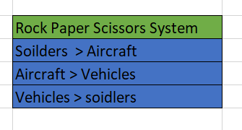

*Figure [4]*

The Enemy will attempt to utilise this rock paper scissors mechanic just like the player should, the AI can see what the players making by fighting them in combat, it will then send the relevant troops over to the battle to counter the players troops, the player will have to keep on top of this to win.

## Minimum viable product

* Player can build buildings and each of them effect the game in their specific way.
* Players can control troops using the single click system
* Player units and enemy units fight and can hurt each other
* Player can destroy the enemy base and win, and Players can have their base destroyed and lose (Conquest)
* Enemy Ai moves around the map randomly

## Minimum awesome product

* Player can build buildings and each of them effect the game in their specific way.
* Players can control the troops using single click, group select, select all of one type of units and select all units
* Player can upgrade existing units using the building upgrades system
* Units fight each other and rock paper scissors system is completely integrated
  + Flanking troops (if a troop is shot in the back) they take extra damage
* Players can decide which units fight which unit by clicking on the unit then the enemy unit
* Enemy AI uses tactics to fight for example, flanking and counter flanking, distractions, counter units, rushes/ turtling, scouting, directly fighting troops weak to the unit, or holding strategic areas of the map.
* More than one map
* More than one game type, conquest and dominion (hold areas to gain points, first to x points wins)

## Assets

### Custom built Blender Assets

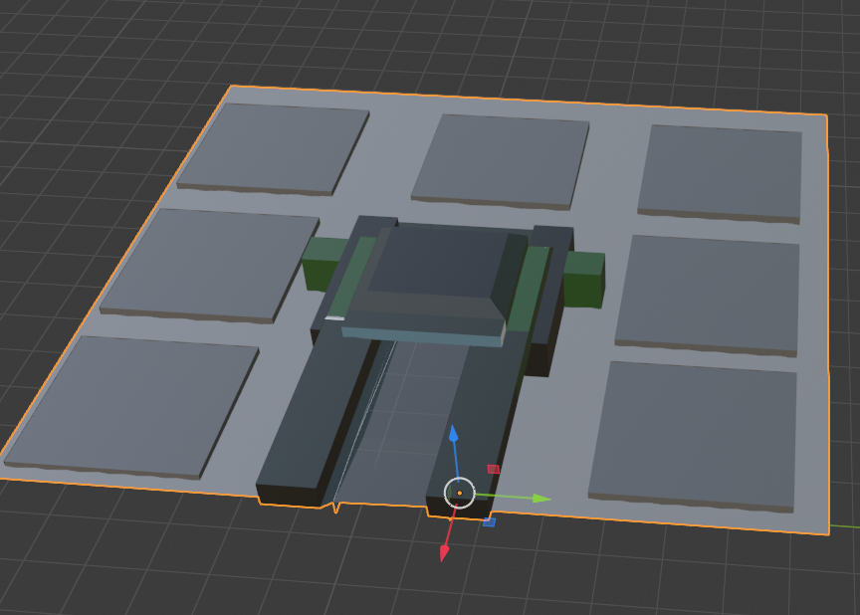

Home base

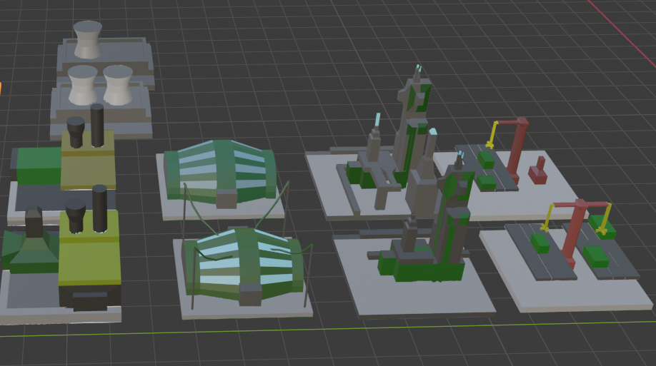

🡨reactor level 1 and 2

🡨level one buildings

🡨level 2 buildings

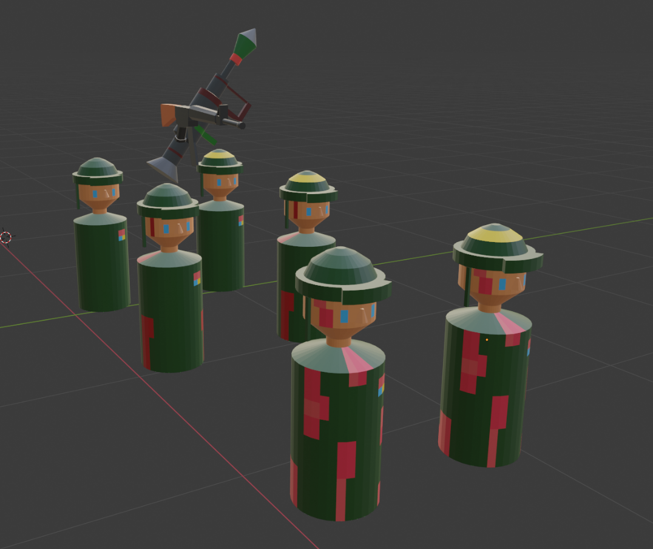solider models with decreasing health represented with bloodier models

gun and rocket launcher.

## Unity Store Assets

Unity Store assets were selected to save time in modelling. High quality low poly assets that were free to use and credit in projects were used to.

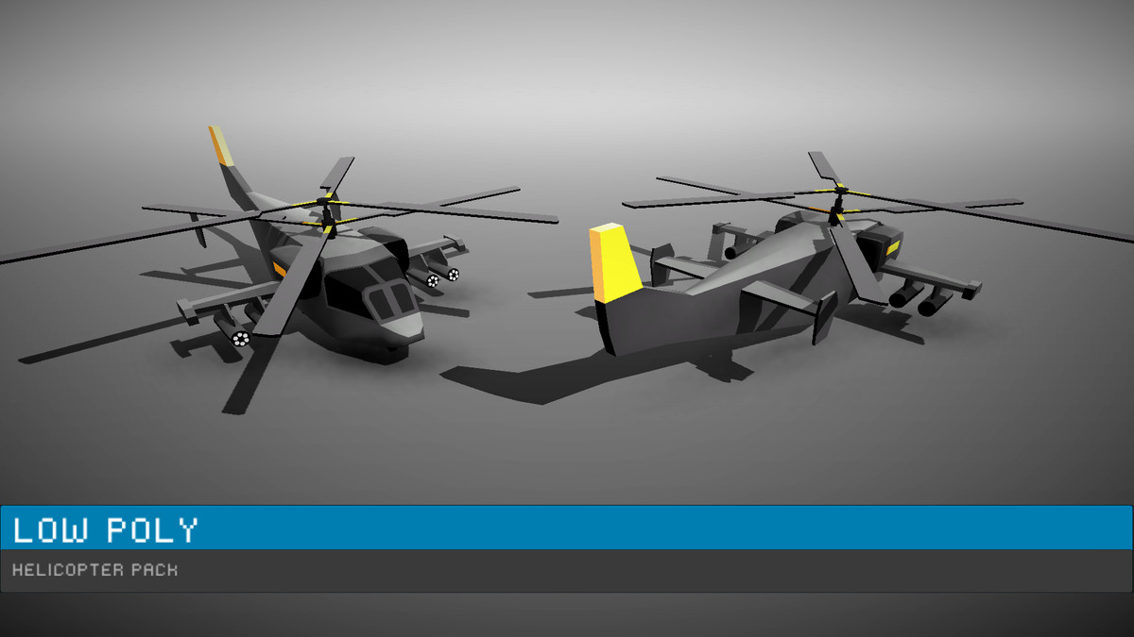

<https://assetstore.unity.com/packages/3d/vehicles/air/low-poly-helicopters-pack-free-121151>

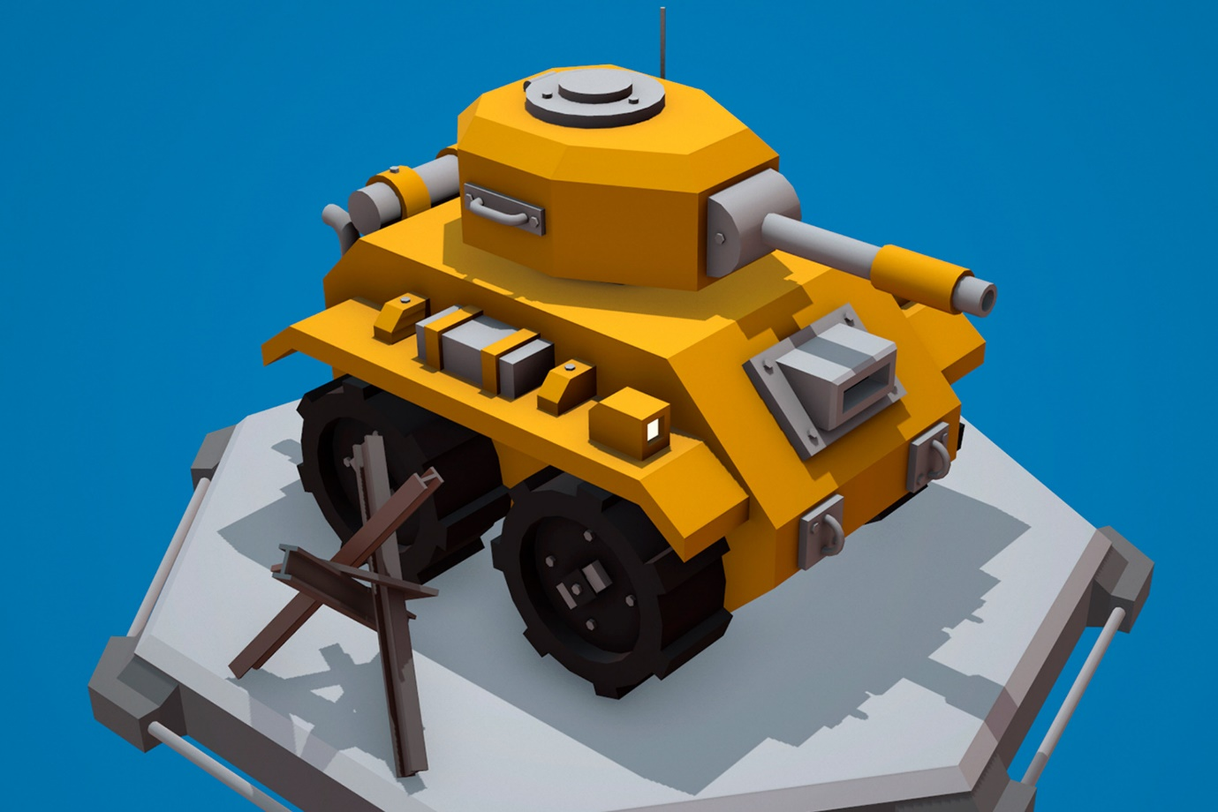

<https://assetstore.unity.com/packages/3d/vehicles/land/cartoon-tank-free-165189>

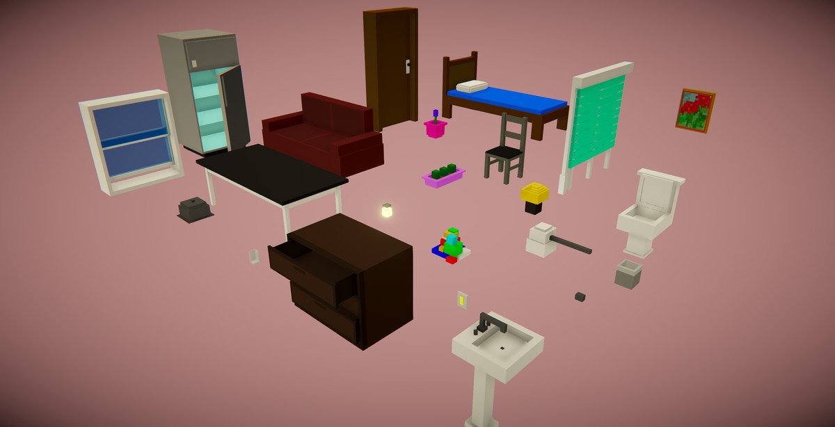

<https://assetstore.unity.com/packages/3d/props/furniture/voxel-furniture-free-170365>

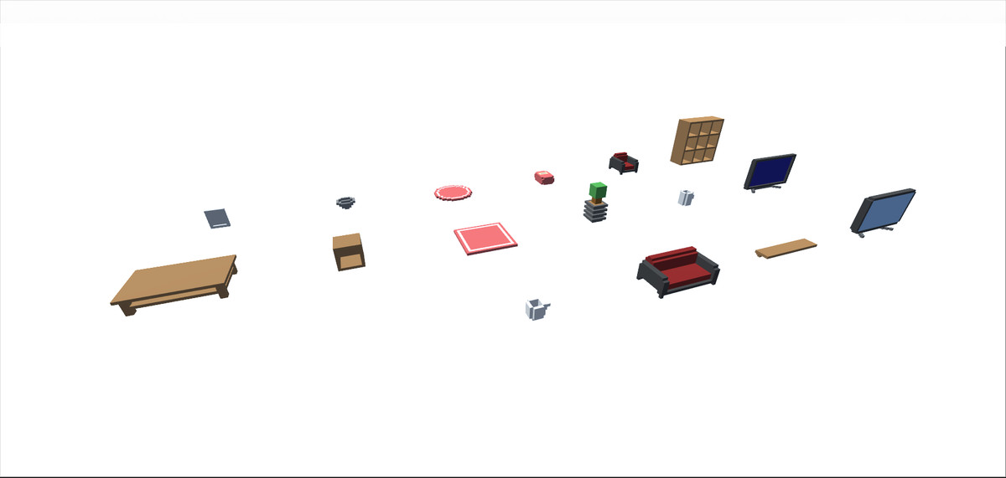

<https://assetstore.unity.com/packages/3d/props/furniture/too-many-items-living-room-props-129097>

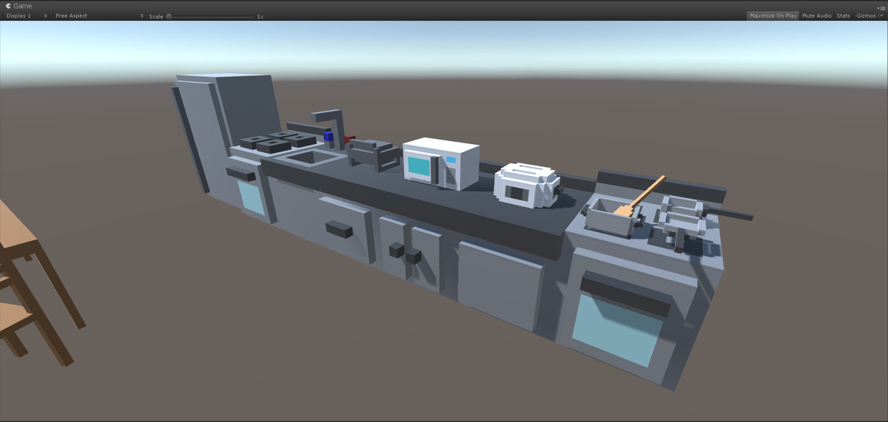

<https://assetstore.unity.com/packages/3d/props/too-many-items-kitchen-props-127635>

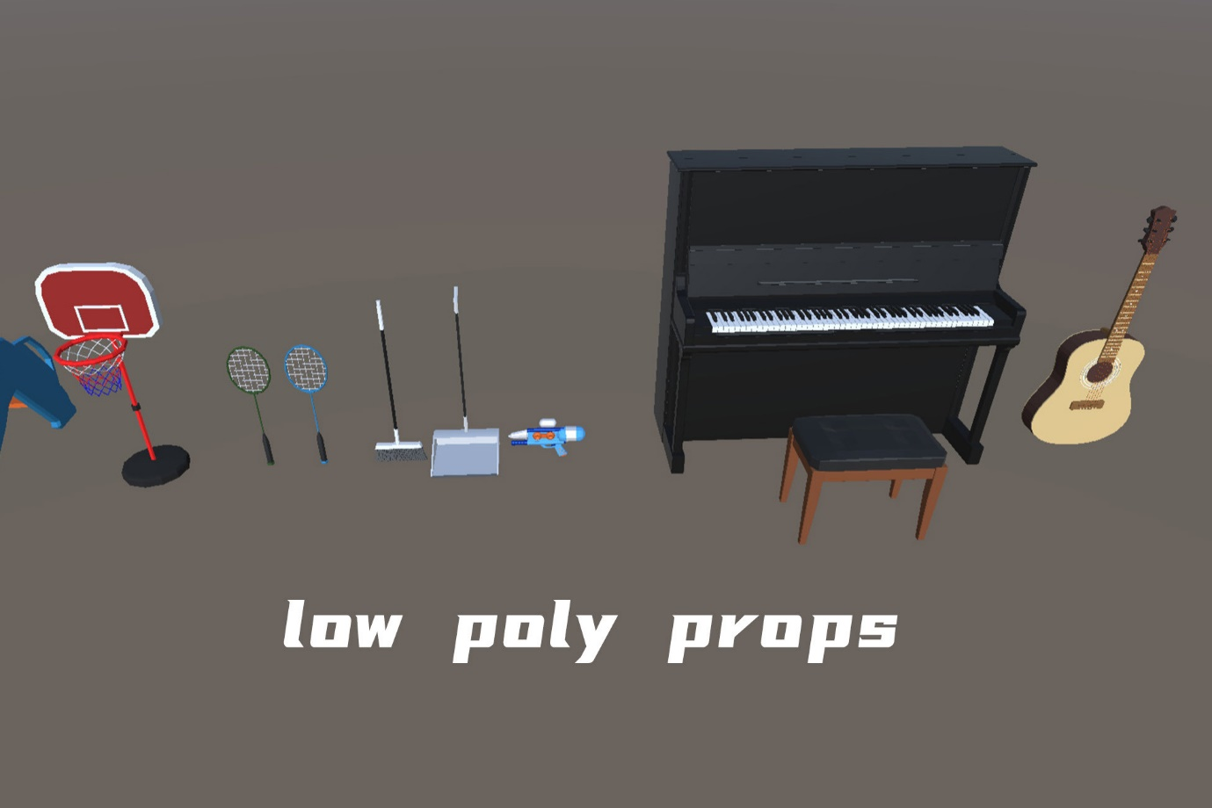

<https://assetstore.unity.com/packages/3d/props/15-low-poly-models-202061>