**HCI usability examples**

In the first example, the paper tells us about how the authors want to implement HCI methods to Educational Games, to facilitate learning through focus, ease of use and understanding. Specifically, it uses a video-diary method.The second example that we found useful was a paper that talks about the implementation of HCI methods to wearable electronic solutions. It uses mock-ups and prototypes to help understand the merge between HCI and Ergonomics in Clothing and Wearable Solutions.

This example points out that, most systems, in particular, wearable electronics, fail because there’s not a clear understanding of the human factor i.e. it’s needs, requests or problems.

**Proposal of steps to achieve a good development**

We propose a model based on the spiral model, with focusing on HCD (Human Centered Design) and functionality as it’s most important aspect. HCD will be implemented in every process of the paradigm.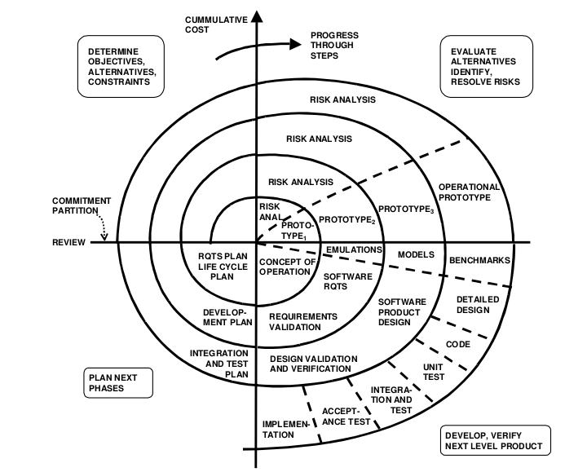

This implementation starts with a comprehensive requirement analysis process followed by an iterative evaluation cycle that was longer than a hard programming iteration and it focused more on requirement gathering and low-fidelity prototyping early in the development process. This design process results in improvement usability and low-risk scenarios.

This model makes us able to provide constant feedback in the form of prototypes and mock-ups. Taking special care in the needs of the users in every iteration and updating them when needed.

Every iteration of the process has a risk analysis so we can assess the ups and downs of a project, and to test if the project complies with the requirements.

We also expect that every prototype gets closer to a user friendly experience. It will use a repository for version control, as well as schedules for every group meeting and logs after every update or change in the project. These logs would serve as evidence of contributing to the project, as it can measure the grade of involvement of each team member, taking into consideration the difficulty of the task at hand, as well as having a time-frame estimate with each log uploaded. Each of these measurements will be reviewed with all team members, to have an impartial view of everyone's involvement, as well as allowing the pertinent member to advocate about his/her involvement.

Possible disadvantages that this model would have are similar to the standard spiral model, like losing scope of the projects as it becomes broader, being cost inefficient, or not having a time estimate for completion of the project.

**Sources:**

Looi, Q., & See, S. (2021). Effectively Engaging Students in Educational Games by Deploying HCI Evaluation Methods. Retrieved 23 April 2021, from<http://citeseerx.ist.psu.edu/viewdoc/download?doi=10.1.1.449.7554&rep=rep1&type=pdf>

Rügge, I., Ruthenbeck, C., & Scholz-Reiter, B. (2021). Changes of HCI Methods towards the Development Process of Wearable Computing Solutions. Retrieved 23 April 2021, from<https://link.springer.com/content/pdf/10.1007%2F978-3-642-02806-9_35.pdf>

Hoppenbrouwers, S., van Bommel, P., & J ̈arvinen, A. (2021). Method Engineering as Game Design: anEmerging HCI Perspective on Methods andCASE Tools. Retrieved 23 April 2021, from<http://citeseerx.ist.psu.edu/viewdoc/download?doi=10.1.1.142.9160&rep=rep1&type=pdf>

<https://humanresearchroadmap.nasa.gov/Evidence/other/HCI.pdf>