# **Persona: Full-time Student/ Part-Time Employee**

## **Personal information**

**Age:** 18 - 30

**Occupancy:** Student/Employee

**Location:** Mérida, Yucatán

**Description:** University student studying by remote mode during the pandemic and also working a part-time job.

## **Backstory**

Tell us a bit about them and their life

Full-time student and part-time employee, working to survive focusing on studies in his/her free time. Usually in a 6-8 hour shift that makes it difficult to connect to the online courses.

Has good motivation but a lack of options to continue studying at a regular pace.

## **Goals**

He/She needs to reduce the impact of academic dynamics on his/her education. Semesters being taken remotely won’t come back unless he/she retakes which implies losing time and finishing college almost a year later than expected.

**Existing practices**

He/She has learned through the semesters how to use many technologies such as Moodle, Webwork, MS Teams, etc; where the teachers upload every material and homework or activity related to the assignment.

**Average Student’s Device and Internet Usage**

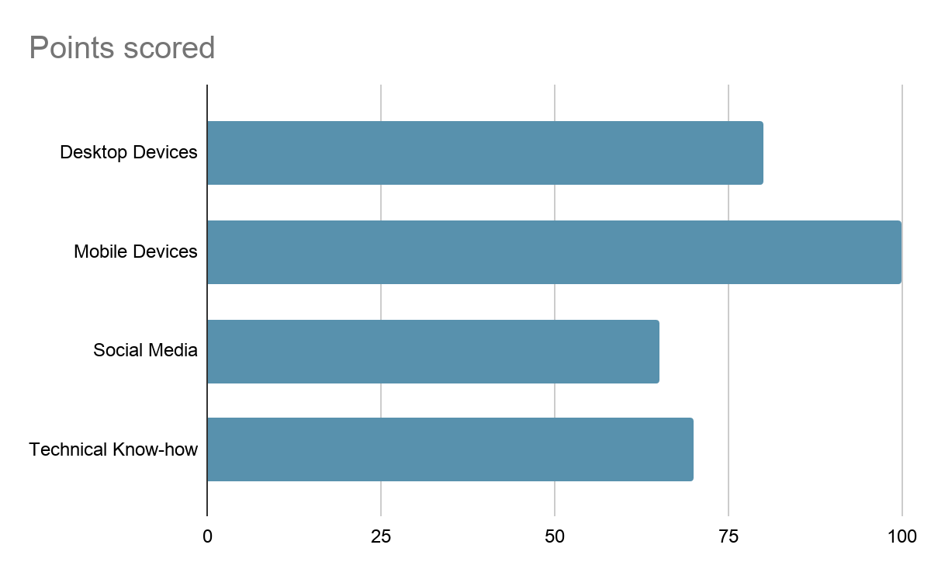

## **Motivations and frustrations**

His/Her main issue on taking remote class sessions is the poor time the student has to attend because there is the need to work in class hours, also the many tools that need to be used to be aware of how to achieve her homeworks and activities.

**Why we chose this persona**

The reason why we chose this persona is because we are trying to focus on students like us that are currently having trouble with remote modality and have trouble checking every platform that the teacher knows how to use.

Persona: Full time Student

Personal Information

**Age:** 18 - 30

**Occupancy:** Student

**Location:** Mérida, Yucatán

**Description:** University Student taking his/her courses through online platforms

## **Backstory**

Tell us a bit about them and their life

Full-time student focusing on studies in his/her free time. Usually has the time to schedule the courses.

Has good motivation, flexible schedules and disponibility to be in a computer on a regular basis

## **Goals**

He/She needs to reduce the impact of academic dynamics on his/her education. Semesters being taken remotely won’t come back unless he/she retakes which implies losing time and finishing college almost a year later than expected.

**Existing practices**

He/She has learned through the semesters how to use many technologies such as Moodle, Webwork, MS Teams, etc; where the teachers upload every material and homework or activity related to the assignment.

**Average Student’s Device and Internet Usage**

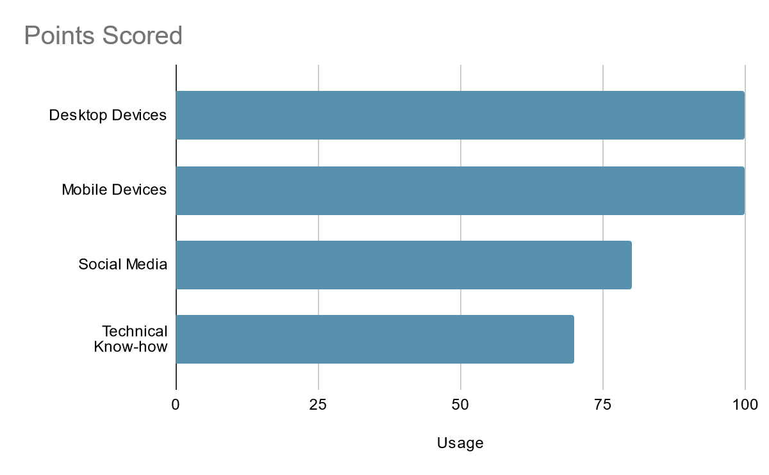

## **Motivations and frustrations**

His/Her main issue in taking remote class sessions is the many tools that need to be used to be aware of how to achieve her homeworks and activities.

His/Her Motivations are to pass the current semester courses, to learn the most from those courses and improve his/her abilities with the technologies used

**Why we chose this persona**

The reason why we chose this persona is because we are trying to focus on students like us that are currently on the semester that can organize better the platforms being used but still would be benefited by our solution

Persona: Tech-Savvy University Professor

Personal Information

**Age:** 25 - 75

**Occupancy:** Professor

**Location:** Mérida, Yucatán

**Description:** University Professor teaching courses through online platforms

## **Backstory**

Tell us a bit about them and their life

Open to change, medium skilled at tech professor. Motivated about helping their students grow at a professional level.

## **Goals**

Recent generations seem to have a lack of motivation and trouble dealing with established systems, it’s become more usual not to make deliveries on time. Wishes to have students dedicated to their education.

**Existing practices**

He/She has been troubleless using existing tech tools in order to assign, grade and receive homework.

## **Motivations and frustrations**

His/Her main issue on teaching remote class sessions is the interest students seem to be taking on this, there’s no real way to realize if students care about their education since basic interactions are missing.

**Why we chose this persona**

We have to consider the fact that not all professors are skilled at tech and many of them would have trouble using a badly designed interface, but also consider professors that could take real advantage of this.

Persona: Non Tech-Savvy University Professor

Personal Information

**Age:** 25 - 75

**Occupancy:** Professor

**Location:** Mérida, Yucatán

**Description:** University Professor teaching courses through online platforms

## **Backstory**

Tell us a bit about them and their life

Open to change, poor skilled at tech professor. Motivated about helping their students grow at a professional level.

## **Goals**

Recent generations seem to have a lack of motivation and trouble dealing with established systems, it’s become more usual not to make deliveries on time. Wishes to have students dedicated to their education.

**Existing practices**

Assigning, grading and receiving homework from online tools has been challenging, with no proper preparation it’s hard to come up with the right usage for these tools.

## **Motivations and frustrations**

His/Her main issue on teaching remote class sessions is the interest students seem to be taking on this, there’s no real way to realize if students care about their education since basic interactions are missing.

**Why we chose this persona**

We have to consider the fact that not all professors are skilled at tech and many of them would have trouble using a badly designed interface, but also consider professors that could take real advantage of this.

Persona: Refused to change University Professor

Personal Information

**Age:** 35 - 75

**Occupancy:** Professor

**Location:** Mérida, Yucatán

**Description:** University Professor teaching courses through online platforms

## **Backstory**

Tell us a bit about them and their life

This persona has been teaching their class in a certain way for many years and doesn’t see the point of making a change now, a true believer that the old fashion way is the right thing to do.

## **Goals**

Recent generations seem to have a lack of motivation and trouble dealing with established systems, it’s become more usual not to make deliveries on time. Wishes to have students dedicated to their education.

**Existing practices**

The same old fashion way to do stuff.

## **Motivations and frustrations**

It’s all about tradition and customs, there’s no good reason for changing something that works for this persona, at this point of life they just want to keep doing the same way forever.

**Why we chose this persona**

It’s natural for people to get used to a system or a custom, and especially taking on those older classical teachers we can’t assure that they will take a change as something good, we have even seen professors that don’t use Moodle because they want the job to be printed and delivered on a manila folder.