**HCI Project**

# Usability Test Plan

**[1.0]**

**[Euan Briceño Rodrigo - Rodriguez Díaz Fernando - Medina Gamboa Guillermo - Kú Martínez Ricardo]**

**[01/07/2021]**

## Table of Contents

**Usability Test Plan** **1**

Table of Contents 2

Document Overview 3

Executive Summary 5

Methodology 5

Length of Sessions 6

Roles 6

Facilitator 6

Data Logger 6

Test Observers 6

Ethics 6

Test Artifacts 6

Procedure 7

Roles and Responsibilities 7

Usability Tasks 8

**Tasks** **8**

Metrics 8

Process 11

Usability Metrics 13

Scenario Completion 13

Critical Errors 13

Non-critical Errors 13

Subjective Evaluations 14

Scenario Completion Time (time on task) 14

Usability Goals 14

Completion Rate 14

Error-free rate 14

Time on Task (TOT) 14

Subjective Measures 14

Problem Severity 14

Impact 15

Frequency 15

Problem Severity Classification 15

Reporting Results 15

Appendix A - Persona 16

**Persona: Full-time Student/ Part-Time Employee** **16**

Personal information 16

Backstory 16

Goals 16

Motivations and frustrations 17

Backstory 18

Goals 18

Motivations and frustrations 19

Appendix B - Moderator script 19

Appendix C - Video release 21

Appendix D - Post-Task questionnaire 21

Appendix F - Post-Test questionnaire 22

Resultado 23

Jose Baeza - Post Tasks 23

## Document Overview

This document describes a test plan for conducting a usability test during the development of “the HCI Project” The goals of usability testing include establishing a baseline of user performance, establishing and validating user performance measures, and identifying potential design concerns to be addressed in order to improve the efficiency, productivity, and end-user satisfaction. The specific goals include:

* Determine if every element of the plug-in is understandable for the user.
* Determine if it is easy to use.
* Determine if the user can finish the tasks without any help.

The usability test objectives are:

* To determine design inconsistencies and usability problem areas within the user interface and content areas. Potential sources of error may include:
  + Navigation errors – failure to locate functions, excessive keystrokes to complete a function, failure to follow recommended screen flow.
  + Presentation errors – failure to locate and properly act upon desired information in screens, selection errors due to labeling ambiguities.
  + Control usage problems – improper toolbar or entry field usage.
* Exercise the application or web site under controlled test conditions with representative users. Data will be used to access whether usability goals regarding an effective, efficient, and well-received user interface have been achieved.
* Establish baseline user performance and user-satisfaction levels of the user interface for future usability evaluations.

The team used the persona of the analysis from the surveys to develop the test plan and the user profile. The persona is described as:

* 20 years old
* Full time college student
* Part time Target employee
* An engineer career (probably)
* Have classes online
* Middle-class - Paying his tuition and expenses with help from parents and loans

Based on the persona of Alex, we will be recruiting participants with the following characteristics:

* Age – 18-29 years old (typical college student age)
* Education – Undergraduate college student
* Gender – Even mix of male and female
* Use computer daily for activities (shopping, research...) in addition to email and social media
* Have knowledge of how to use MS Teams for classes
* Have a smartphone or laptop

## 

## Executive Summary

The purpose of this test is to evaluate a plugin for Microsoft Teams from the perspective of college students from the Software Engineer degree in the Mathematics Faculty of the Autonomous University of Yucatán.

This plugin will connect and link the notifications of supported platforms, which at this time consists of the EnLinea2(Moodle) webpage of FMAT and the Slack app from Slack Technologies.

The specific goals of this test include, but are not limited to:

* Login to the supported platforms through Microsoft Teams
* Successfully install the plugin in the machine being used
* View the notifications of the supported platforms through Microsoft Teams
* Navigate to supported platform’s app/webpage through notifications sent by the plugin.

Upon review of this usability test plan, including the draft task scenarios and usability goals for the Microsoft Teams plugin, documented acceptance of the plan is expected.

## Methodology

Given the current pandemic situation, we wouldn’t be able to have a number of participants as big as we’d like. We will still try to have a significant sample of students from different careers, being software engineering our focus.

When it comes to the number of participants, 10 would be ideal but because of the pandemic, this might not happen and we would reduce it to eight, from which at least four are expected to be studying software engineering and the rest would be from different exact science / engineering careers. We don’t require participants to have any other background than at least two semesters taken of these careers.

Recluting in an ideal scenario would be picking random people at the university, but then, again, we are limited due to the pandemic and recluting will happen from people we know from different semesters and can talk to.

The participants' responsibilities will be to attempt to complete a set of representative task scenarios presented to them in as efficient and timely a manner as possible, and to provide feedback regarding the usability and acceptability of the user interface. The participants will be directed to provide honest opinions regarding the usability of the application, and to participate in post-session subjective questionnaires and debriefing.

A member of our team will be present for the duration of the test to ensure the well execution of the activities and answer any questions participants may have. We can only answer questions about execution but never about how the system works.

### Length of Sessions

Each session will be 55 minutes to an hour. The test will include:

* Welcome and pre-test questionnaire. (10 min)
* Task Scenarios. (25 min)
* Post-task questions after each scenario. (10 min)
* Post-test questionnaire. (10 min)

## Roles

The roles involved in a usability test are as follows. An individual may play multiple roles and tests may not require all roles.

### Facilitator

* Provides overview of study to participants
* Defines usability and purpose of usability testing to participants
* Assists in conduct of participant and observer debriefing sessions
* Responds to participant's requests for assistance

### Data Logger

* Records participant’s actions and comments

### Test Observers

* Silent observer
* Assists the data logger in identifying problems, concerns, coding bugs, and procedural errors
* Serve as note takers.

**Test Participants**

* Provides overview of study to participants
* Defines usability and purpose of usability testing to participants
* Assists in conduct of participant and observer debriefing sessions
* Responds to participant's requests for assistance

### Ethics

All persons involved with the usability test are required to adhere to the following ethical guidelines:

* The performance of any test participant must not be individually attributable. Individual participant's name should not be used in reference outside the testing session.
* A description of the participant's performance should not be reported to his or her manager.

### 

### 

### Test Artifacts

* Moderator Script
* Pre-test questionnaire
* Post-test questionnaire
* Task scenarios order list

### Procedure

Participants will take part in the usability test via remote screen-sharing technology. The participant will be seated at their workstation in their work environment. Verbal communication will be supported via MS Teams.

The facilitator will brief the participant and instruct that he or she is evaluating the plugin application from MS Teams, rather than the facilitator evaluating the participant. Participants will complete a pretest demographic and background information questionnaire. Sessions will begin when all participant questions are answered by the facilitator. The facilitator will inform the participant that time-on-task will be measured and that exploratory behavior outside the task flow should not occur until after task completion.

The facilitator will instruct the participant to read aloud the task description from the printed copy and begin the task. Time-on-task measure will begin. The facilitator will encourage the participants to ‘think aloud’ and that a verbal record will exist of the task-system interaction. The facilitator will observe and enter user behavior and comments, and system interaction in a data logging application.

After each task, the participant will complete the post-task questionnaire and elaborate on the task session. After all tasks have been attempted, the participant will complete a post-test satisfaction questionnaire.

### Roles and Responsibilities

|  |  |  |
| --- | --- | --- |
| Role | Team Member | Responsibilities |
| Facilitator | Ricardo Kú | Greets User, Follows Moderator Script, escort User out. |
| Logger | Rodrigo Euán | Uses artifact, timer and notepad to write down behaviour and observable results. |
| Logger/Technician | Fernando Rodríguez | Operates equipment, hands pre and post- task questionnaires. |
| Observer | Guillermo Medina | Observe User, identify possible problems during test. |

## 

## Usability Tasks

|  |  |  |
| --- | --- | --- |
| **Preferred Scenario** | **Tasks** | **Estimated Time (Min)** |
| The HCI professor asks you to use Moodle for assignments. | Login to supported platforms via MS Teams plugin | 1 |
| You want to go from MS Teams to Moodle as quickly as possible. | Navigate to supported platform’s app/webpage through the MS Teams Hub | 1 |
| You are required to view every activity from the logged platforms | The system will have a notification feed | 1m 20s |
| You are required to configure the autosave video session from MS Teams and store it local. | Configure autosave each video session recorded from MS Teams. | 1 |

# 

# 

# Tasks Metrics

|  |  |  |  |
| --- | --- | --- | --- |
| **Requirements** | **Attribute** | **Metrics** | **Scenario** |
| Navigate to supported platform’s app/webpage through the MS Teams Hub | Effectiveness  Efficiency  Satisfaction | Completion rate | You want to go from MS Teams to Moodle as quickly as possible. |
| Error Free rate |
| Time on Task (TOT) |
| Redirect user to selected assignment from the notification feed | Effectiveness  Efficiency  Satisfaction | Completion rate | Log-in to Moodle from the system and access to a Moodle assignment from a plug-in notification. |
| Error Free rate |
| Time on Task (TOT) |
| You are required to view every activity from the logged platforms | Effectiveness  Efficiency  Satisfaction | Completion rate | Access the plugin notification feed from the main page of Microsoft Teams and filter notifications to “all notifications”. |
| Error Free rate |
| Time on Task (TOT) |
| Students can configure the plugin to automatically start downloading all video sessions available for download to a cloud storage | Effectiveness  Efficiency  Satisfaction | Completion rate | You are required to configure the autosave video session from MS Teams and store it local. |
| Error Free rate |
| Time on Task (TOT) |

## Process

|  |  |  |
| --- | --- | --- |
| Scenario | Screen | Minimum Interactions |
| Redirect user to selected platform authentication page | | |
| Log-in to Moodle from the system and access to Moodle as quickly as possible. | Principal | 1. Click sign in with enLinea2 |
| Moodle tool | 1. Type credentials and log-in on the pop-up window. |
| Home page | 1. Click on the moodle button |
| Redirect user to selected assignment | | |
| Log-in to Moodle from the system and access to Moodle as quickly as possible. | Principal | 1. Click sign in with enLinea2 |
| Access Plugin | 1. Click on the notifications feed tab on the plugin main page |
| Notification feed | 1. Click on the “Entrega final HCI” |
| You are required to view every activity from the logged platforms | | |
| Access the plugin notification feed from the main page of Microsoft Teams and filter notifications to “all notifications” | Principal | 1. Click plugin icon from Microsoft Teams hub |
| Access Plugin | 1. click on the notifications feed tab on the plugin main page |
| Filter the notification feed | 1. Use filter option in the notification feed tab  2. enable “all notifications” option from the filter |
| Auto store video sessions by downloading to cloud storage | | |
| Configure the plugin to automatically start downloading all video sessions available for cloud storage and local | Principal | 1. Click to access the teams improvement tool |
| Improving teams | 1. Click to select autosave video configuration |
| Autosave video configuration | 1. Click save for the default configuration. |

The task descriptions below are required to be reviewed by the application owner, business-process owner, development owner, and/or deployment manager to ensure that the content, format, and presentation are representative of real use and substantially evaluate the total application. Their **acceptance is to be documented** prior to the usability test.

## Usability Metrics

Usability metrics refers to user performance measured against specific performance goals necessary to satisfy usability requirements. Scenario completion success rates, adherence to dialog scripts, error rates, and subjective evaluations will be used. Time-to-completion of scenarios will also be collected.

### Scenario Completion

Each scenario will require, or request, that the participant obtains or inputs specific data that would be used in the course of a typical task. The scenario is completed when the participant indicates the scenario's goal has been obtained (whether successfully or unsuccessfully) or the participant requests and receives sufficient guidance as to warrant scoring the scenario as a critical error.

### Critical Errors

Critical errors are deviations at completion from the targets of the scenario. Obtaining or otherwise reporting of the wrong data value due to participant workflow is a critical error. Participants may or may not be aware that the task goal is incorrect or incomplete.

Independent completion of the scenario is a universal goal; help obtained from the other usability test roles is cause to score the scenario a critical error. Critical errors can also be assigned when the participant initiates (or attempts to initiate) and action that will result in the goal state becoming unobtainable. In general, critical errors are unresolved errors during the process of completing the task or errors that produce an incorrect outcome.

### Non-critical Errors

Non-critical errors are errors that are recovered from by the participant or, if not detected, do not result in processing problems or unexpected results. Although non-critical errors can be undetected by the participant, when they are detected they are generally frustrating to the participant.

These errors may be procedural, in which the participant does not complete a scenario in the most optimal means (e.g., excessive steps and keystrokes). These errors may also be errors of confusion (ex., initially selecting the wrong function, using a user-interface control incorrectly such as attempting to edit an uneditable field).

Noncritical errors can always be recovered from during the process of completing the scenario. Exploratory behavior, such as opening the wrong menu while searching for a function, will be coded as a non-critical error.

### Subjective Evaluations

Subjective evaluations regarding ease of use and satisfaction will be collected via questionnaires, and during debriefing at the conclusion of the session. The questionnaires will utilize free-form responses and rating scales.

### Scenario Completion Time (time on task)

The time to complete each scenario, not including subjective evaluation durations, will be recorded.

## Usability Goals

The next section describes the usability goals for the HCI Project

### Completion Rate

Completion rate is the percentage of test participants who successfully complete the task without critical errors. A critical error is defined as an error that results in an incorrect or incomplete outcome. In other words, the completion rate represents the percentage of participants who, when they are finished with the specified task, have an "output" that is correct. Note: If a participant requires assistance in order to achieve a correct output then the task will be scored as a critical error and the overall completion rate for the task will be affected.

**A completion rate of 100% is the goal for each task in this usability test.**

### Error-free rate

Error-free rate is the percentage of test participants who complete the task without any errors (critical **or** non-critical errors). A non-critical error is an error that would not have an impact on the final output of the task but would result in the task being completed less efficiently.

**An error-free rate of 80% is the goal for each task in this usability test.**

### Time on Task (TOT)

The time to complete a scenario is referred to as "time on task". It is measured from the time the person begins the scenario to the time he/she signals completion.

### Subjective Measures

Subjective opinions about specific tasks, time to perform each task, features, and functionality will be surveyed. At the end of the test, participants will rate their satisfaction with the overall system. Combined with the interview/debriefing session, these data are used to assess attitudes of the participants.

## Problem Severity

To prioritize recommendations, a method of problem severity classification will be used in the analysis of the data collected during evaluation activities. The approach treats problem severity as a combination of two factors - the impact of the problem and the frequency of users experiencing the problem during the evaluation.

### Impact

Impact is the ranking of the consequences of the problem by defining the level of impact that the problem has on successful task completion. There are three levels of impact:

* **High - prevents the user from completing the task (critical error)**
* **Moderate - causes user difficulty but the task can be completed (non-critical error)**
* **Low - minor problems that do not significantly affect the task completion (non-critical error)**

### Frequency

Frequency is the percentage of participants who experience the problem when working on a task.

* **High: 37.5% or more of the participants experience the problem**
* **Moderate: 12.5% - 25% of participants experience the problem**
* **Low: 12.5% or fewer of the participants experience the problem**

### Problem Severity Classification

The identified severity for each problem implies a general reward for resolving it, and a general risk for not addressing it, in the current release.

**Severity 1** - High impact problems that often prevent a user from correctly completing a task. They occur in varying frequency and are characteristic of calls to the Help Desk. Reward for resolution is typically exhibited in fewer Help Desk calls and reduced redevelopment costs.

**Severity 2** - Moderate to high frequency problems with moderate to low impact are typical of erroneous actions that the participant recognizes needs to be undone. Reward for resolution is typically exhibited in reduced time on task and decreased training costs.

**Severity 3** - Either moderate problems with low frequency or low problems with moderate frequency; these are minor annoyance problems faced by a number of participants. Reward for resolution is typically exhibited in reduced time on task and increased data integrity.

**Severity 4** - Low impact problems faced by few participants; there is low risk to not resolving these problems. Reward for resolution is typically exhibited in increased user satisfaction.

## Reporting Results

The Usability Test Report will be provided at the conclusion of the usability test. It will consist of a report and/or a presentation of the results; evaluate the usability metrics against the pre-approved goals, subjective evaluations, and specific usability problems and recommendations for resolution. The recommendations will be categorically sized by development to aid in implementation strategy.

## Appendix A - Persona

# Persona: Full-time Student/ Part-Time Employee

## Personal information

**Age:** 18 - 30

**Occupancy:** Student/Employee

**Location:** Mérida, Yucatán

**Description:** University student studying by remote mode during the pandemic and also working a part-time job.

## Backstory

Tell us a bit about them and their life

Full-time student and part-time employee, working to survive focusing on studies in his/her free time. Usually in a 6-8 hour shift that makes it difficult to connect to the online courses.

Has good motivation but a lack of options to continue studying at a regular pace.

## Goals

He/She needs to reduce the impact of academic dynamics on his/her education. Semesters being taken remotely won’t come back unless he/she retakes which implies losing time and finishing college almost a year later than expected.

**Existing practices**

He/She has learned through the semesters how to use many technologies such as Moodle, Webwork, MS Teams, etc; where the teachers upload every material and homework or activity related to the assignment.

**Average Student’s Device and Internet Usage**

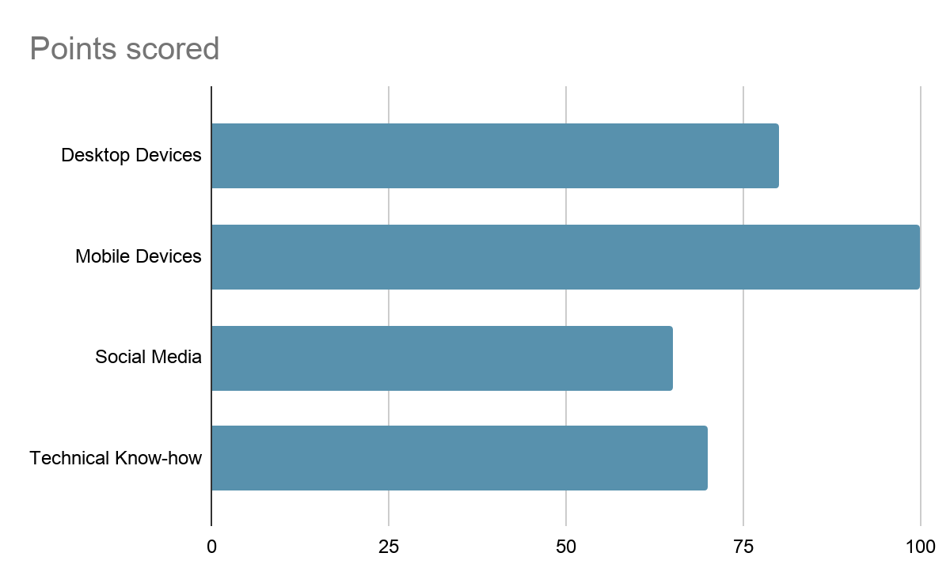

## Motivations and frustrations

His/Her main issue on taking remote class sessions is the poor time the student has to attend because there is the need to work in class hours, also the many tools that need to be used to be aware of how to achieve her homeworks and activities.

**Why we chose this persona**

The reason why we chose this persona is because we are trying to focus on students like us that are currently having trouble with remote modality and have trouble checking every platform that the teacher knows how to use.

Persona: Full time Student

Personal Information

**Age:** 18 - 30

**Occupancy:** Student

**Location:** Mérida, Yucatán

**Description:** University Student taking his/her courses through online platforms

## Backstory

Tell us a bit about them and their life

Full-time student focusing on studies in his/her free time. Usually has the time to schedule the courses.

Has good motivation, flexible schedules and disponibility to be in a computer on a regular basis

## Goals

He/She needs to reduce the impact of academic dynamics on his/her education. Semesters being taken remotely won’t come back unless he/she retakes which implies losing time and finishing college almost a year later than expected.

**Existing practices**

He/She has learned through the semesters how to use many technologies such as Moodle, Webwork, MS Teams, etc; where the teachers upload every material and homework or activity related to the assignment.

**Average Student’s Device and Internet Usage**

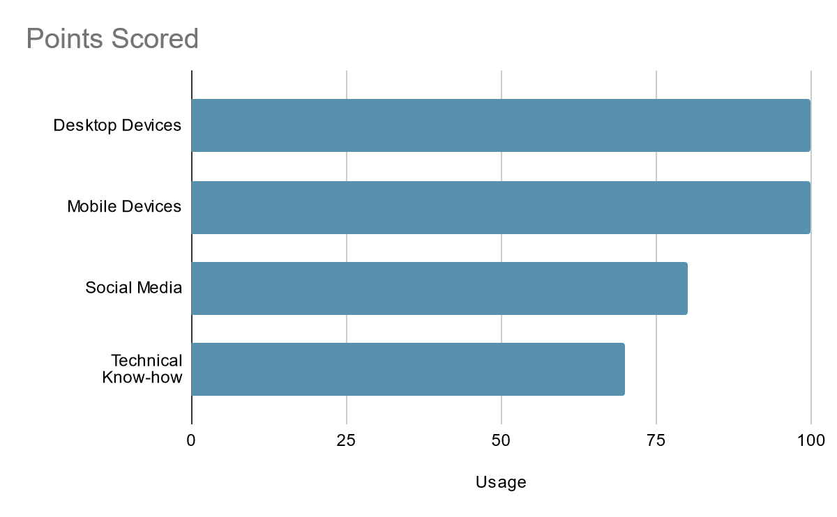

## Motivations and frustrations

His/Her main issue in taking remote class sessions is the many tools that need to be used to be aware of how to achieve her homeworks and activities.

His/Her Motivations are to pass the current semester courses, to learn the most from those courses and improve his/her abilities with the technologies used

## Appendix B - Moderator script

**TEST DAY MODERATOR SCRIPT**

**Welcome the participant.**

Hello/Hey/Hi _________. My name is Rodrigo, and I am a part of the HCI Team.

How is your day going?(work on making the user feel comfortable... give the user a moment to talk)

**State the purpose of the study.**

First of all, I want to thank you for participating in this study. I understand your time is valuable, but hopefully you find this experience enjoyable. We are performing usability testing on a plugin for MS Team for tracking your activities in each platform. For the next 40 minutes we are going to spend time together to get your impressions of this plugin. We are going to ask you to complete a series of tasks that match goals typical uses like yourself might have when using this plugin.

We are interested in knowing how you do things, where you look, things like that. More than what you’re doing, though, we’re interested in knowing what you’re thinking, how you react to things on the plugin.

**Describe thinking out loud.**

One important thing we need you to keep in mind while you are testing is that we need you to “think out loud.” You know when you are using something, and you may get frustrated or confused, and you think in your head, “Why is this so hard?” “What am I looking for?” “I think this is what I need to do.” We want you to do the same thing, but instead of just thinking it, we want you to say it out loud.

I know that sounds a little bizarre, but you’ll get used to it quickly. This really helps us understand what is going through your mind while you are using the website. If you like it, we want to know that. If you get frustrated or are confused, we want to know that too. We don’t know anything you are not willing to tell us, so please speak up and say what’s on your mind. We want to know what you think of your experience with it, whether positive or negative. I want to let you know that there are no wrong answers in this study. We’re looking for your genuine impressions.

We’re going to watch you complete these tasks, take notes, and with these notes we will report our findings to our sponsors. They will use our findings to improve their website in the future.

**Provide the forms required for participation.**

Before we proceed with any testing, we do have a few forms we need you to complete. The first one is a video release form. As we said when we recruited you for this study, we are going to be videotaping this session. Here’s the release form; go ahead and read it, and sign at the bottom if you agree. (send the form to the user)

**Explain the testing process.**

The way this testing is going to work is that we are going to give you a number of tasks to complete. Each task will have a specific goal, and we want you to explore the prototype and complete each task. We will tell you if you need to use certain login credentials and such, but most of the time you will be accomplishing each goal as you feel is the most effective way to do it.

While you’re using the plugin, we need you to stream your screen and I will be watching your screen. I will be with you for the rest of the test. After each one, we will talk about your experience with it, how you felt during the task, and so on.

Go through all of the tasks and complete each the best way you can. I’ll explain more about that in a moment.

**Ask the participant to share any questions or concerns.**

So before we get started, do you have any questions or concerns?

**Start the study.**

OK, then we can begin. Here is task #1. As I said earlier, I am going to stay here in the room with you during the first couple of tasks. I won’t be saying anything, I’m just going to be observing. Do not hesitate to ask if you have any questions.

## Appendix C - Video release

**USABILITY VIDEO PERMISSION FORM**

I hereby grant permission to be videotaped as part of my participation in the HCI Project usability test conducted on_____________ [date] at my own house via MS Teams. Only my first name may be reported in association with the session results. I understand and consent to the use and release of the video recording in the HCI Project. I understand the video recording and any highlights extracted from it may be used for any of the following purposes:

* conference presentations
* educational presentations or courses
* informational presentations
* on-line educational courses
* as part of research

I give up any rights to the video recording and to understand that the recording may be used for the purposes described in this release form without further permission. I understand that if for any reason I do not want to continue, I can leave at any time during this recording session. I can also deny

consent at any time. By signing this form I acknowledge that I have completely read and fully understand the above release and agree to be bound

thereby. I hereby release any and all claims against any person or organization utilizing this material for educational purposes. Full Printed

Name___________________________________________________

Street Address/P.O. Box________________________________________

City ________________________________________________________

Prov/Postal Code/Zip Code______________________________________

Phone ___________________________

Signature____________________________ Date____________________________

## Appendix D - Post-Task questionnaire

**Post-Task Questionnaire**

* I thought this task was...

1. – Very difficult
2. – Somewhat difficult
3. – Neither difficult nor easy
4. – Somewhat easy
5. – Very easy

* The task could be made easier by...

5

5

5

4 - Poder entrar a configuracion antes

## Appendix F - Post-Test questionnaire

## 

## 

## 

## Resultado

## Jose Baeza - Post Tasks

5

5

3 - Puedas poner todas las notificaciones confunde ver un filtro predeterminado

4 - No se entendió bien donde se encontraba el botón de Teams

Post Test

5

2

5

2

4

1

5

2

4

2

Feedback lo de notification

Gerardo Dueñas Escalante Post Task

5

4 - Las notificaciones deben estar en MS Teams

5

5

Post Test

5

1

5

1

5

1

5

1

5

1

Rosales Post test

5

1

5

5

5

1

4

1

5

1

Heriberto Estrada - Post Task

5

5

5

4 - Dejar entrar a esta configuración sin tener que loggearte

Post Test

4

1

5

2

4

1

4

1

4

2