HL7 Context Management “CCOW” Standard:
Technology- and Subject-Independent Component Architecture,
DRAFT Version 1.5,
April 30, 2003

Editors: Robert Seliger
Sentillion

Copyright© 2003 by Health Level Seven, ® Inc. ALL RIGHTS RESERVED. The reproduction of this material in any form is strictly forbidden without the written permission of the publisher.
Health Level Seven and HL7 are trademarks of Health Level Seven, Inc.
Table of Contents
1 Introduction 19
1.1 Clinical Context 19
1.2 Links and Subjects 19
1.3 Annotations and actions 20
1.4 Architecture Summary 20
1.4.1 Component Architecture 21
1.4.2 Context Organization and Representation 23
1.4.3 Application Authentication 23
1.4.4 Context Transactions 23
1.4.5 Context Actions 24
1.4.6 Context Agents 24
1.4.6.1 Mapping Agents 25
1.4.6.2 Annotation Agents 25
1.4.6.3 Action Agents 25
1.5 Reading This Document 25
2 Scope and Objectives 27
2.1 Specification Organization 27
2.2 Assumptions/Assertions 28
2.3 CMA Design Center 29
3 Technology Neutrality 31
4 Requirements and Capabilities 33
5 System Architecture 35
5.1 Use-Model 35
5.2 Context Management Responsibility 43
5.3 Context Change Detection 43
5.4 Context Data Representation 44
5.5 Context Data Access 44
5.6 Context Data Interpretation 45
5.6.1 Context Subject Data Definition Constraints 46
5.6.2 Establishing the Meaning of Context Data Item Names 46
5.6.3 Establishing the Meaning of Context Data Item Values 46
5.6.4 Representing Context Subjects That Cannot Be Uniquely Identified 47
5.6.5 Context Subjects and Item Name Format 47
5.6.6 Standard Context Subjects and Data Items 47
5.6.7 Non-Standard Context Subjects and Data Items 47
5.6.8 Representing “Null” Item Values 48
5.6.9 Representing an Empty Context Subject 48
5.6.10 Case Sensitivity with Regard to Item Names and Item Values 48
6 Component Model 51
6.1 Component and Interface Concepts 51
6.1.1 Interfaces and References 51
6.1.2 Interface Interrogation 52
6.1.3 Principal Interface 52
6.1.4 Context Management Registry 52
6.1.5 Interface Reference Management 53
7 Context Session Management 55
7.1 Context Session Defined 55
7.2 Context Session Use Models 56
7.2.1 Shared Clinical Workstation 56
7.2.2 Interrupt-Driven User 56
7.3 Theory of Operation 56
7.4 Context Session Management Policies 57
7.4.1 Creating a Context Session 57
7.4.2 Cloning Context Data 57
7.4.3 Deactivated Sessions 58
7.4.4 Session Participation 58
7.4.5 Activating a Deactivated Session 58
7.4.6 Session Termination 58
7.4.7 No Active Session 59
8 General Theory of Operation for Clinical Links 61
8.1 Multiple Subjects and the Meaning of “Link” 61
8.1.1 Context Manager Support for Multiple Context Subjects 61
8.1.2 Effect of Multiple Subjects on Context Change Transaction 62
8.1.3 Context Manager Treatment of Multi-Subject Context Data 62
8.1.4 Effect of Multiple Subjects on Mapping Agents 63
8.1.5 Effect of Multiple Subjects on Annotation Agents 63
8.1.6 Application Treatment of Multiple Subjects 63
8.2 Context Subjects Dependencies 63
8.3 Empty Contexts Subjects 65
9 Theory of Operation for Common Links 67
9.1 Component Architecture for Common Links 67
9.2 Mapping Agents 68
9.3 Annotation Agents 69
9.4 Context Change Transactions 69
9.5 Joining a Common Context Session 70
9.6 Context Change Transactions 70
9.7 Transactional Consistency 71
9.8 Context Change Notification Process 71
9.9 Application Synchronization Relative To The Context 73
9.10 Leaving a Common Context Session 73
9.11 Behavioral Details 74
9.11.1 Notification Policy When Context Data is Not Changed During A Transaction 74
9.11.2 Application Behavior When it Cannot Cancel Context Changes 74
9.11.3 Application Behavior When it Does Not Understand Context Identifiers 74
9.11.4 Application Behavior with Regard to an Empty Context 74
9.11.5 Surveying Details 75
9.12 Common Clinical Context Use Model 76
9.12.1 Lifecycle of Common Context 77
9.12.2 Context Selection Change Use Case 80
9.12.3 Abnormal Termination of Common Context Use Case 89
9.13 Optimizations 91
9.14 The Simplest Application 91
10 Mapping Agents 95
10.1 Assumptions and Assertions 95
10.2 Interfaces 96
10.3 Theory of Operation 96
10.3.1 Mapping Agents and Secure Context Subjects 97
10.3.2 Initializing a Context Session When a Mapping Agent is Present 97
10.3.3 Calling Sequence When Multiple Mapping Agents are Present 98
10.3.4 Terminating a Context Session When a Mapping Agent is Present 98
10.3.5 Distinguishing Between Mapping Agents and Context Participants 99
10.3.6 Mapping Agent Updates to Context Data 99
10.3.7 Conditions for Mapping Agent Invalidation of Context Changes 100
10.3.8 Treatment of Mapping Agent Invalidation of Context Changes 101
10.3.9 Mapping Null-Valued Identifiers 102
10.3.10 Initializing Mapping Agents 103
10.3.11 Handling Mapping Agent Failures 104
10.4 Mapping Agent Effect on Application Security Policies 104
10.5 Identifying Mapping Agent Implementations 104
10.6 Performance Costs and Optimizations 105
11 Annotation Agents 107
11.1 Assumptions and Assertions 107
11.2 Interfaces 107
11.3 Theory of Operation 108
12 Theory of Operation for Secure Links 109
12.1 Secure Link Terms 109
12.2 Point-of-Use Device Assumptions 109
12.3 Secure Link Common Context System Description 110
12.3.1 Authenticating Secure Subject Access 110
12.3.2 Secure Mapping Agent 110
12.3.3 Secure Annotation Agent 110
12.3.4 Context Management Interfaces 111
12.3.5 Overall Secure Link Component Architecture 111
12.4 Process for Setting a Secure Context Subject 112
12.5 Designating Applications for Setting/Getting Secure Subjects 113
12.6 Busy Applications 113
13 Patient Link Theory of Operation 115
13.1 Patient Link Component Architecture 115
13.2 Patient Subject 115
13.3 Patient Mapping Agent 115
13.4 Patient Link Context Change Process 116
13.5 Stat Admissions 116
14 User Link Theory of Operation 117
14.1 User Link Terms 117
14.2 Point-of-Use Device Assumptions 117
14.3 User Link Component Architecture 117
14.4 User Subject 118
14.5 User Authentication Data Is Not Part of the User Context 118
14.6 User Link Common Context System Description 118
14.6.1 User Mapping Agent 118
14.6.2 Authentication Repository 119
14.6.3 Overall User Link Component Architecture 119
14.7 User Link Context Change Process 120
14.8 Designating Applications for User Authentication 121
14.9 Signing on to Applications Not Designated for Authenticating Users 122
14.10 Application Behavior When Launched 122
14.11 Access Control Lists 122
14.12 Changing Users 122
14.13 Logging-Off and Application Termination 123
14.14 Automatic Log-Off 125
14.15 Re-authentication Time-out 126
14.16 Co-Existence with Applications Not User Link-Enabled 126
14.17 Populating the User Mapping Agent 127
14.18 Authentication Repository 127
14.18.1 Repository Implementation Considerations 128
14.18.2 Populating the Repository 128
15 Chain of Trust 131
15.1 User Context Change Transactions and the Chain of Trust 131
15.2 Creating the Chain of Trust 131
15.2.1 Object Infrastructures 131
15.2.2 Secure Communications Protocols 132
15.2.3 Security Building Blocks 132
15.2.4 Security Attacks On the Chain Of Trust 134
15.2.5 Chain of Trust Implementation Limitations 135
15.3 Digital Signatures and CMA Components 135
15.3.1 Public Key / Private Key Encryption as a Means for Generating Signatures 136
15.3.2 Incorporation of Signatures into the Context Management Architecture 137
15.3.3 Computing a Digital Signature 138
15.3.4 Public Key Distribution 139
15.3.4.1 Passcode-Based Public Key Distribution 139
15.3.4.1.1 Passcode Generation Requirements 140
15.3.4.1.2 Protecting Passcodes 141
15.3.4.2 PKI-Based Public Key Distribution 142
15.3.4.2.1 Certificate Generation Requirements 143
15.3.4.2.2 Protecting Certificates 144
15.3.4.2.3 Protecting Certificate Authority Public Keys 144
15.3.4.3 Protecting Private Keys 144
15.3.5 System Configuration Requirements 145
15.3.6 Defending Against Replay Attacks 146
15.4 Trust Relationships 146
15.4.1 Trust Between Applications and Context Manager 147
15.4.2 Trust Between Context Manager and a Context Agent 147
15.4.3 Trust Between Applications and Authentication Repository 148
15.5 Chain of Trust Interactions 148
16 Theory of Operation for Context Actions 151
16.1 Context Action Component Architecture 151
16.1.1 Context Action Subject Data Definitions 151
16.1.2 Secure Context Actions 152
16.1.3 Action Timeouts 152
16.1.4 Action Subject Lifecycle 152
16.1.5 Context Action Subject Mapping Agents 152
16.1.6 Context Action Continuations 153
16.1.7 Context Action Interfaces 153
16.1.8 Overall Context Action Component Architecture 154
16.2 Component Roles and Responsibilities 154
16.2.1 Context Action Clients 154
16.2.2 Action Agents 155
16.2.3 Context Manager 155
16.3 Context Action Interactions 155
17 Interface Definitions 157
17.1 Interface Definition Language 157
17.1.1 Interface Definition Body 157
17.1.2 Simple Data Types 158
17.1.3 Exception Declaration 159
17.1.4 Sequences 159
17.1.5 Interface References 159
17.1.6 Principal Interface 160
17.1.7 Qualifying Names 160
17.2 Interface Implementation Issues 160
17.2.1 NotImplemented Exception 160
17.2.2 GeneralFailure Exception 160
17.2.3 Coupon Representation 160
17.2.4 Format for Application Names 161
17.2.5 Extraneous Context Items 161
17.2.6 Forcing the Termination of a Context Change Transaction 161
17.2.7 Character-Encoded Binary Data 162
17.2.8 Representing Message Authentication Codes, Signatures and Public Keys 163
17.2.9 Representing Basic Data Types as Strings 163
17.2.10 Pre-Defined Context Agent Coupons 164
17.3 Interfaces 165
17.3.1 AuthenticationRepository (AR) 166
17.3.2 Synopsis 166
17.3.2.1 Connect 166
17.3.2.2 Disconnect 167
17.3.2.3 SetAuthenticationData 167
17.3.2.4 DeleteAuthenticationData 167
17.3.2.5 GetAuthenticationData 168
17.3.3 ContextAgent (CA) 170
17.3.3.1 Synopsis 170
17.3.3.2 ContextChangesPending 170
17.3.3.2.1 Inputs 170
17.3.3.2.2 Outputs 171
17.3.3.2.3 Outputs for Mapping Agents 171
17.3.3.2.4 Exceptions 172
17.3.3.3 Ping 172
17.3.4 ContextData (CD) 174
17.3.4.1 Synopsis 174
17.3.4.2 GetItemNames 174
17.3.4.3 DeleteItems 175
17.3.4.4 SetItemValues 175
17.3.4.5 GetItemValues 175
17.3.5 ContextFilter (CF) 178
17.3.5.1 Synopsis 178
17.3.5.2 SetSubjectsOfInterest 178
17.3.5.3 GetSubjectsOfInterest 179
17.3.5.4 ClearFilter 179
17.3.6 ContextManager (CM) 180
17.3.6.1 Synopsis 180
17.3.6.2 MostRecentContextCoupon 181
17.3.6.3 JoinCommonContext 181
17.3.6.4 LeaveCommonContext 181
17.3.6.5 StartContextChanges 182
17.3.6.6 EndContextChanges 182
17.3.6.7 UndoContextChanges 183
17.3.6.8 PublishChangesDecision 183
17.3.6.9 SuspendParticipation 184
17.3.6.10 ResumeParticipation 185
17.3.7 ContextParticipant (CP) 186
17.3.7.1 Synopsis 186
17.3.7.2 ContextChangesPending 186
17.3.7.3 ContextChangesAccepted 187
17.3.7.4 ContextChangesCanceled 187
17.3.7.5 CommonContextTerminated 187
17.3.7.6 Ping 187
17.3.8 ContextSession (CS) 188
17.3.8.1 Synopsis 188
17.3.8.2 Create 188
17.3.8.3 Activate 188
17.3.9 ContextAction (CX) 189
17.3.9.1 Synopsis 189
17.3.9.2 Perform 189
17.3.9.2.1 Inputs 189
17.3.9.2.2 Outputs 190
17.3.9.2.3 Exceptions 190
17.3.10 ImplementationInformation (II) 193
17.3.10.1 Synopsis 193
17.3.10.2 ComponentName 193
17.3.10.3 RevMajorNum 193
17.3.10.4 RevMinorNum 193
17.3.10.5 PartNumber 193
17.3.10.6 Manufacturer 193
17.3.10.7 TargetOS 193
17.3.10.8 TargetOsRev 193
17.3.10.9 WhenInstalled 193
17.3.11 MappingAgent (MA) 195
17.3.11.1 Synopsis 195
17.3.11.2 ContextChangesPending 195
17.3.11.3 Ping 195
17.3.12 SecureBinding (SB) 196
17.3.12.1 Synopsis 196
17.3.12.2 InitializeBinding 196
17.3.12.2.1 Passcode-Based Secure Binding 197
17.3.12.2.2 PKI-Based Secure Binding 197
17.3.12.2.3 Exceptions 197
17.3.12.3 FinalizeBinding 198
17.3.12.3.1 Passcode-Based Secure Binding 198
17.3.12.3.2 PKI-Based Secure Binding 198
17.3.12.3.3 Additional Outputs 199
17.3.12.3.4 Exceptions 200
17.3.13 SecureContextData (SD) 201
17.3.13.1 Synopsis 201
17.3.13.2 GetItemNames 201
17.3.13.3 SetItemValues 202
17.3.13.4 GetItemValues 202
18 Conformance 205
18.1 General Approach and Goals 205
18.1.1 Context Management Standard Declaration of Conformance 206
18.1.2 Conformance and Component Implementation Interdependencies 206
18.1.3 Future Conformance Requirements 206
18.2 Application 207
18.3 Session Management Application 208
18.4 Context Manager 209
18.5 Mapping Agent 210
18.6 Annotation Agent 211
18.7 Action Agent 212
18.8 Authentication Repository 213
19 Backwards Compatibility 215
20 Appendix: Diagramming Conventions 217
20.1 Use Case Diagram 217
20.2 Use Case Interaction Diagrams 218
20.3 Component Architecture Diagrams 219
20.4 Component Interaction Diagrams 220
21 Glossary 221

FIGURES
Figure 1. Patient Linked Applications 20
Figure 2. CMA Components and Interfaces 22
Figure 3. Organization of HL7 Context Management Specification Documents 27
Figure 4. Overall Role of the CMA Specification 29
Figure 5. CMA and Technology Neutrality 31
Figure 6. Patient Selection Change Use Case 37
Figure 7. Patient Context Automatically Changes within all Context Participant Applications 38
Figure 8. User Informed of Potential Data Loss and Cancels Context Change 39
Figure 9. User forces Application AAA to Become Out of Synchrony with other Context Participants 40
Figure 10. Context Participant Not Responding to Selection Change Request 41
Figure 11. User Accepts Consequences of going ahead with Patient Selection Change with all Applications 42
Figure 12. Component Architecture for Common Links 68
Figure 13. Context Change Process for Common Links 70
Figure 14. Common Clinical Context Use Model 76
Figure 15. Common Context Lifecycle Use Case 77
Figure 16. Context Selection Change Use Case 80
Figure 17. Abnormal Termination of Common Context Use Case 89
Figure 18. Component Architecture for Secure Links 112
Figure 19. User Link Sign-On Process 113
Figure 20. User Link Component Architecture 120
Figure 21. User Link Context Change Process 121
Figure 22. User Subject Context Data Mapped for Different Applications 127
Figure 23. Signing A Message 137
Figure 24. Forming Signature Using Method Parameters 138
Figure 25. Component Architecture for Context Actions 154
Interaction Diagrams
Interaction Diagram 1. Common Context Lifecycle 78
Interaction Diagram 2. Suspending/Resuming Context Participation 79
Interaction Diagram 3. All applications accept the changes 81
Interaction Diagram 4. An application conditionally accepts the changes; user decides to cancel changes 82
Interaction Diagram 5. An application does not respond to survey 83
Interaction Diagram 6. An application does not respond to change notification 84
Interaction Diagram 7. An application responds after context change transaction has completed 85
Interaction Diagram 8. A non-surveyed application participates in context change 86
Interaction Diagram 9. An application conditionally accepts the changes; user decides to accept consequences of change 87
Interaction Diagram 10. An application conditionally accepts the changes; user breaks link with common context 88
Interaction Diagram 11: Abnormal Termination of Common Context 90
Interaction Diagram 12. Simplest Application 93
Interaction Diagram 13. Context Change Transaction with Mapping Agent 99
Interaction Diagram 14: Mapping Agent Invalidates Context Change Transaction 103
Interaction Diagram 15. User Logs Off From One Application 125
Interaction Diagram 16. User Logs-Off From Context Session 125
Interaction Diagram 17. Populating Authentication Repository with User Authentication Data 149
Interaction Diagram 18. User Link Context Change Transaction 150
Interaction Diagram 19. User Initiated Context Action 156
Tables
Table 1. User Link-Enabled Application Behavior for Termination and Log-Off 123
Table 2. Chain of Trust Attacks and Defenses 134
Table 3. Handling Transaction Instigator Failure 162
Table 4. Character Representations for Basic Data Types 164

Changes from Version 1.4:
- Clarified in Section 17.2.4, Format for Application Names, that the dash (-) character is part of the BNF for an application name.
- Introduced the concept of subjects that may be used for resynchronization. Once applications have resynchronized their internal states to such a subject subsequent to a context change in which the subject is set, applications are not required to remained synchronized with the subject.
- Specified the use of PKI as an optional alternative in addition to passcodes for distributing public keys.
- The interface MappingAgent, deprecated in CMA 1.4, has been removed altogether.

Introduction
This document specifies the Health Level Seven Context Management Architecture (CMA). This architecture enables multiple applications to be automatically coordinated and synchronized in clinically meaningful ways at the point-of-use. The architecture specified in this document establishes the basis for bringing interoperability among healthcare applications to point-of-use devices, such as a personal computer that serves as a clinical desktop.

Clinical Context
Clinical context is state information that a user establishes and modifies while interacting with healthcare applications at the point-of-use (e.g., a clinical desktop). The context is common because it establishes parameters that should uniformly affect the behavior or operation of multiple healthcare applications. The context needs to be managed so that the user has a way of controlling it, and so that applications have a way of robustly coordinating their behavior as the context changes.
Examples of clinical context include but are not limited to:
- The identity of a patient whose data the user wants to view or update via the applications.
- The identity of the user who wants to access the applications.
- A moment in time around which temporal data displays should be centered by the applications.
- A particular patient encounter that the user wants to review via the applications.
Healthcare application developers often implement a common clinical context capability for their own applications. However, there are currently no standards that enable independently-developed applications to share a common clinical context. Further, with the diversity of application programming technologies currently available, a common context solution should strive to be applicable to at least several of the dominant and emerging technologies.

Links and Subjects
The approach taken for the CMA is to define the architecture that enables applications to establish a single link based upon a set of clinical subjects of common interest. The applications automatically and cooperatively change their state whenever the user sets a new value for one or more of these subjects.
Certain links enable applications to remain in constant synchrony with each other according to the values of one or more common clinical subjects. Other links enable applications to be resynchronized so that they return to synchrony with each other but are not required to remain synchronized.
While the complete set of subject data definitions are specified in the document Health Level-Seven Standard Context Management Specification, Subject Data Definitions, Version CM-1.5, there are two standard link subjects that are core to the CMA, and are therefore introduced in this document:
- Patient, which enables the user to select the patient of interest once from any application as the means to automatically synchronize all of the applications to the selected patient. Patient.
- User, which enables the user to securely logon once to any application as the means to automatically synchronize all of the applications to the user.
In addition, healthcare vendor and/or provider organizations can define custom subjects and thereby implement custom links between applications that understand these subjects. The basis for custom subjects is also established in this document.
Applications that share the same common context are said to be participants in a common context session. These applications have established and maintain a common context link. There is only one link, while there can be multiple subjects. However, in the vernacular that arose as the CMA was being developed, it became useful to refer specific link subjects. This has given rise to the terms such as Patient Link and User Link. An example of a set of Patient Linked applications is shown in Figure 1.
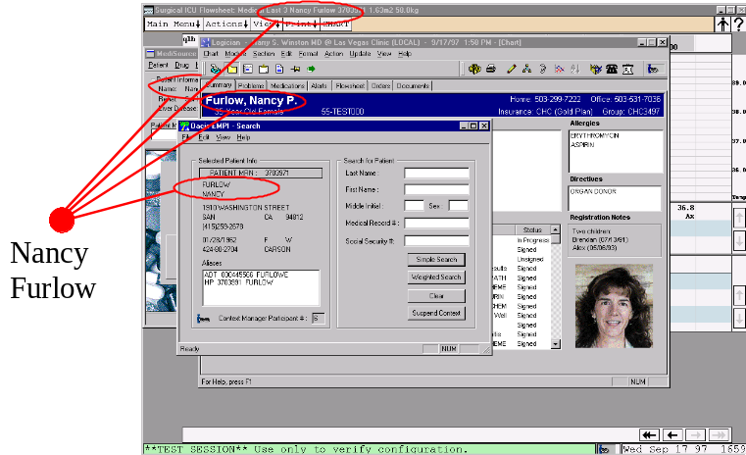
Figure 1. Patient Linked Applications

Annotations and actions
Context subjects enable applications to remain synchronized in terms of the identity of real world objects. These objects may be physical entities, such as a specific patient, or a conceptual entity, such as particular clinical encounter. The CMA complements the capability to synchronize applications by its additional support for context annotations and context actions.
Context annotations provide a means for representing attributes of an identified context subject. For each set of annotations, the source of these attributes is generally a system designated by a healthcare enterprise as being the authentic source for these attributes for the enterprise. Context actions provide a means for the end-user to perform a context-sensitive interactive task that involves multiple applications. For each context action, the application that services the action is generally one that has been designated by the healthcare enterprise as being the authoritative service for the action.
Taken together, the capability to identify entities, to associate attributes with these entities, and to perform related actions upon these entities provide a complete object-oriented computing system. However, by keeping these mechanisms architecturally distinct, applications can elect to use only one, several, or all of the CMA’s context-centered capabilities to meet their specific needs, as described in the remainder of this document.

Architecture Summary
The CMA defines the interfaces, and the policies that govern the use of these interfaces, between applications known as context participants, and a coordinating component known as the context manager. An assemblage of applications share a common context with each other by interacting with the context manager. Applications only need to directly interact with the context manager, as opposed to with each other, in order to share a common context. The context manager may in turn interact with additional context-aware components and services on behalf of the applications. The context manager, context participant applications, and underlying components and services are referred to as a context system.
The duration in time during which a set of applications comes together to share a common context is known as a context session. A context session begins when an application informs the context manager that it wants to “join” the context and it is the first application to do so. Additional applications may join the same session, each by informing that context manager that it wants to “join” the context. Each application that is a participant in the same session shares a common context with the other applications in the session. Applications eventually leave the context session, usually by terminating their execution. When the last application leaves, the context session ends.
It is possible for a single point-of-use device to host multiple context sessions, wherein only one session is active at a time. Applications are able to join the active context session, but are not allowed to join sessions that are not active. This enables a single user to have multiple sessions, and enables different users to each have their own session on the same device and therefore share the device.
New sessions must be explicitly created. This is generally performed on behalf of the user by an application or utility program that has been specifically designed to provide session management functions for users.

Component Architecture
A context management system is comprised of a several CMA-specified components and associated interfaces. The complete set of components and interfaces are illustrated in Figure 2. The primary purpose of the remainder of this document is to provide the detailed specification for each component and interface.
Note that the ContextManagementRegistry interface is the only CMA interface not specified in this document. This is because the implementation of this interface is technology-specific. The detailed specification for this interface is presented in each of the CMA technology mapping specification documents.
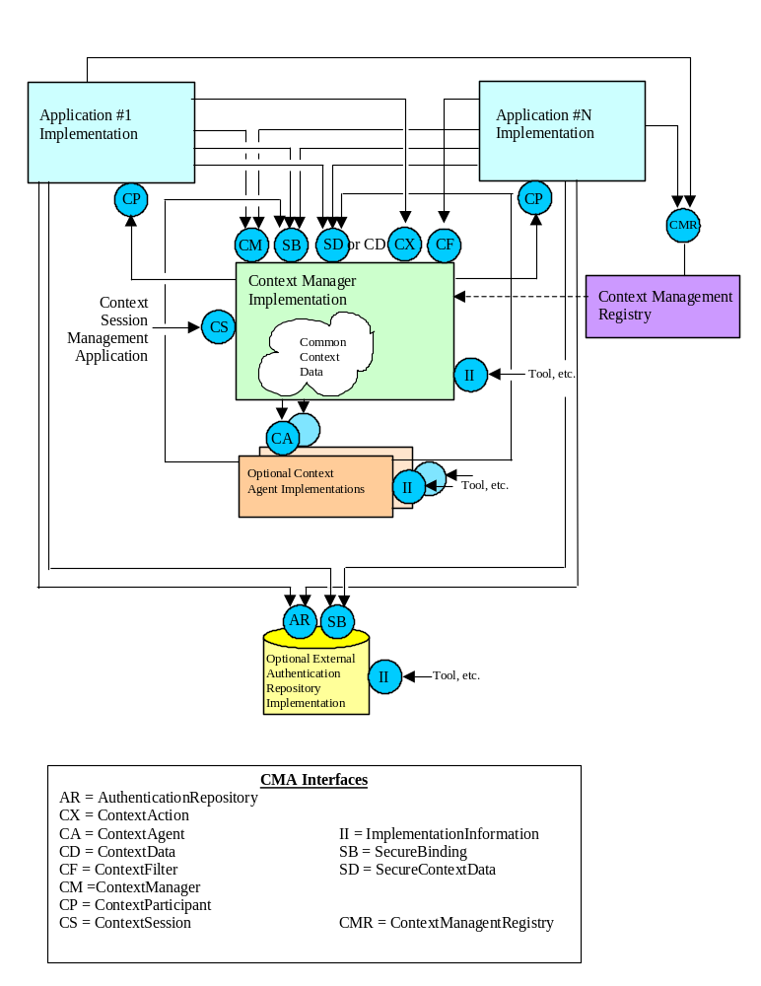
Figure 2. CMA Components and Interfaces

Context Organization and Representation
The data that represents the common clinical context for a context session resides in the context manager. Conceptually, there is one context manager per session per device. Context data is organized as a set of data items that are grouped by context subject. There are three classes of context subjects:
- An identity subject identifies a real-world entity (e.g., a specific patient) or concept (e.g., a specific encounter).
- An annotation subject contains data that describes or is otherwise pertinent to the entity or concept identified in an identity subject.
- An action subject represents a task that may be performed on behalf of the user, including the inputs needed to perform the task and the outputs that represent the result of performing the task.
The data that represents identity and annotation subjects persists in the context for the duration of the context session. The data that comprises these subjects can be updated over time, generally as the result of a user action. This serves as the basis for context sharing among the applications. The data that represents an action subject is transient and does not persist within the context; it exists in the context only from the time the action is requested until the action is performed.
A data item within a context subject is represented as a name/value pair. For an identity subject at least one of these items is the identifier for the real-world entity or concept represented by the subject. For an annotation subject, each item represents a data element within the overall annotation. For an action subject, each item represents an action input, which parameterizes an action request, or an action output, which conveys the result of performing the action.
In order for applications to have a common and unambiguous understanding of the semantic meaning for each data item that comprises a context subject, the data definitions for these items must be known when the applications are developed. CCOW has therefore defined a set of standard subjects such as patient, user, and encounter, and for each subject a corresponding set of standard data items. Additionally, individual organizations or groups of organizations may define custom subjects that follow data definitions defined by the organization(s).
In addition to defining the data definitions for each context subject's data items, the definition of a context subject also indicates whether or not the subject is a secure subject. When a subject is defined as secure, only applications with the appropriate access privileges are allowed by the context manager to set and/or get the context data for the subject. The necessary application privileges are configured on a site-specific basis. When a subject is not secure, application access privileges are not enforced.

Application Authentication
Applications must identify themselves using an application-specific digital signature when they interact with the context manager to access a secure subject. This provides the context manager with a reliable means for identifying applications in order to enforce their access privileges. A digital signature can be readily authenticated but not easily violated.
Similarly, the context manager identifies itself to applications using its own digital signature. This enables applications to be certain that they are interacting with the real context manager, as opposed to a rogue component. This overall scheme of bilateral authentication is referred to as the “chain of trust.”

Context Transactions
When the user performs an application gesture that instructs the application to set the value for one or more identity subjects within the common clinical context (e.g., the user has selected a different patient), the application starts a context change transaction within the user’s context session. Context items for identity and annotation subjects can be added or removed, or have their values set, during a context change transaction. Only one transaction can be in progress at a time.
When the application that instigated the transaction has completed its changes to the context data, the context manager conducts a two-phase process to coordinate the propagation of the context changes to the other applications.
In the first phase, the context manager surveys the other applications to determine which ones can apply the new context, and which ones either cannot, or prefer not to. An application cannot apply the changes if it is blocked, for example if it is waiting for the user to enter data. An application might prefer not to apply the new context if, for example, doing so might cause the user to lose work-in-progress.
The context manager informs the instigating application of the survey results. If all of the applications are willing to apply the new context, then they are all instructed to do so. If at least one of the surveyed applications is blocked (“busy”) or prefers to keep the previous context, then the user is asked by the instigating application to decide how to proceed:
- The user can cancel the context change.
- The user can break the link between the instigating application and the other applications. The new context is then applied only to the instigating application, while the other applications remain linked together and tuned to the previous context. This approach ensures that the link among applications is never broken unless the user has performed an explicit gesture instructing that the link be broken.
- The user can apply the changes anyway (as long as there are no busy applications).
The context manager broadcasts the decision to all of the context participants to complete the second phase of the transaction. If all of the applications were willing to apply the new context or if the user decided to apply the changes anyway, then the applications are synchronized with the current context. If the user has canceled the context change then the applications’ context is not altered. If the user broke the link then although all of the applications are no longer in synchrony, this happened only due to an explicit user gesture as opposed to an automatic application decision that could result in user confusion.

Context Actions
A context action enables an application to request, via the context manager, that another application or agent to perform a task on behalf of the requesting application. The request is generally issued in response to a user input or gesture. The application that services the request generally interacts with the user via a user-interface presented by the servicing application. This enables the application to obtain additional user inputs needed to perform its task and/or to convey information to the user about the status of the action.
The communication of a context action is context-based. The data that passes between the application requesting a context action and the application or agent that services the action can be mapped and/or annotated by context agents, just as any context data is. Further, communication between the requesting application, the context manager, and the servicing application are governed by CCOW security mechanisms and policies. Finally, the data that comprises the complete context is available to enhance and complement the action-specific data sourced by the application requesting a context action.
A context action may only be performed when there is no context change transaction in process for the user’s context session. This is because context actions may be context-sensitive (i.e., may rely on the values for various identity and annotation subjects), and require a stable context within which to perform. Similarly, a context change transaction may not be performed when a context action is being executed.

Context Agents
Context agents are a class of CMA components that provide services to context participant applications, as mediated by the context manager.
Mapping Agents and Annotation Agents are applications that provide an automatic means for adding data to the context during a context change transaction. This data is in addition to the data that is set by the application that instigated the context change transaction.
Action Agents are applications that provide services that context participant applications can request via the context manager, generally as the result of user input. These services, known as context actions, enables applications to delegate certain tasks to agents, wherein the task is executed within the context of the user’s context session. This enables, for example, the mapping via a mapping agent of the data that represents the inputs to a service request prior to the request being communicated to the action agent.

Mapping Agents
Mapping agents are a type of context agent that provides an automatic means for adding identifier items to an identity subject. For its subject, a mapping agent is responsible for computing a mapping between the identifier items set by the application that instigated a context change transaction and additional identifier items that also represent the subject. The additional identifier items enable all of the participant applications to “tune” to the same subject even when they do not necessarily have a common way to identify the subject.
A mapping agent only interacts with the context manager, so its existence is transparent to the applications. Prior to the second phase of a context change transaction, the context manager allows each mapping agent that is present to add data to the identity subject it is responsible for mapping.
There can be a mapping agent for each subject. For its subject, a mapping agent is responsible for obtaining the mapping data from an authentic source within the enterprise. For example, patient mapping agent might obtain its data from an enterprise’s master patient index system. The means by which a mapping agent obtains data from an authentic enterprise source is not specified by the CMA.

Annotation Agents
Annotation agents are a type of context agent that provides an automatic means for setting all of the data that comprises a particular annotation subject. Prior to the second phase of a context change transaction, but after the mappings performed by the mapping agents, the context manager allows each annotation agent that is present to set the data for an annotation subject.
For its subject, an annotation agent is responsible for obtaining this data from an authentic source within the enterprise. For example, a demographics annotation agent might obtain its data from an enterprise’s patient registration system. There is an annotation agent for each annotation subject.
Like a mapping agent, an annotation agent only interacts with the context manager, so its existence is transparent to the applications. The means by which an annotation agent obtains data from an authentic enterprise source is not specified by the CMA.

Action Agents
Action agents are a type of context agent that services a context action request, as represented by a context action subject. Each action agent services the request associated with a specific action subject. The actual request to perform the action is communicated to the agent by the context manager, on behalf of a context participant application that originated the request. The action result is communicated back to the context manager by the agent. The context manager then conveys the action result to the context participant that issued the context action request. There is an action agent for each action subject.
Like a mapping agent and annotation agent, an action agent only interacts with the context manager, so its existence is transparent to the applications. However, unlike a mapping agent or annotation agent, an action agent generally interacts with the user via a user-interface presented by the agent. The purpose of this user-interface is to enable an action agent to obtain additional user inputs needed to perform the action and/or to communicate information to the user about the status of the action.
The means by which an action agent performs its action is not specified by the CMA.

Reading This Document
This document presents a comprehensive specification of the HL7 Context Management Architecture. The precision of the specification becomes increasingly more detailed as the document progresses. Several of the early chapters present concepts that underlie the architecture and lead the reader through the rationale for various architectural choices, while all of the chapters in this document include information that the reader should find pertinent to the explanation of the CMA.
However, Chapters 4 through 17 all contain normative content and as such should be regarded as the core of the CMA specification. In particular, Chapter 17, Interface Definitions, concludes the core specification with the complete set of CMA interface definitions, including methods and their argument signatures. These interfaces are ultimately the basis for the implementation of applications and components that conform to the CMA specification.
A compliant CMA application or component shall implement the relevant set of CMA interfaces exactly as specified. A compliant application or component implementation shall adhere to these interface definitions and to the policies specified throughout this document that govern the use and behavior of these interfaces. See Chapter 18 for a complete description of what is required for applications and components to be able to claim conformance.

Scope and Objectives
The HL7 Context Management Architecture (CMA) enables independently developed applications to share data that describes a common clinical context. This document emphasizes the policies, protocols, software interfaces, and responsibilities applications must implement and adhere to as participants in a shared context session.
A common context session is comprised of applications launched directly or indirectly by a particular clinical end-user, wherein the applications share the same context data. Also included in this system is a context management facility that enables applications to share the context data.

Specification Organization
It is beyond the scope of this document to provide all of the details that are needed in order to fully implement a conformant CMA system. The necessary additional details are covered in a series of companion specification documents. As illustrated in Figure 3, these documents are organized to facilitate the process of defining additional link subjects and to accelerate the process of realizing the CMA using any one of a variety of technologies.
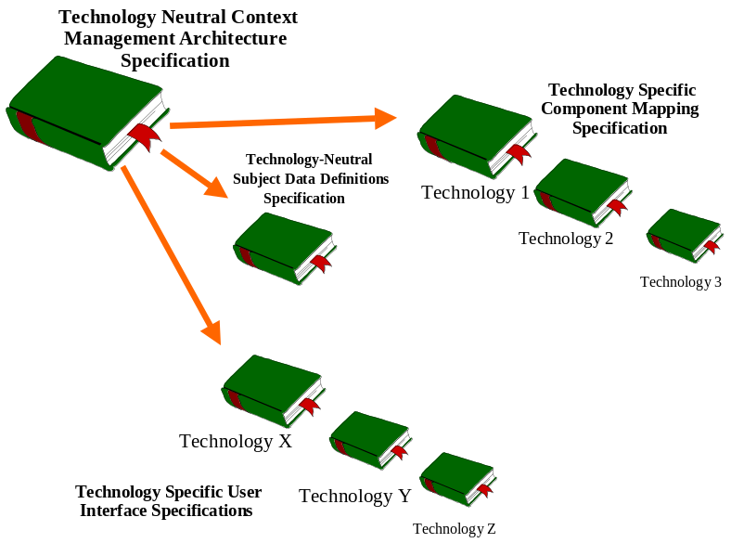
Figure 3. Organization of HL7 Context Management Specification Documents
The context management subjects and technologies that are of interest are determined by the HL7 constituency. There is a single HL7 context management data definition specification document for all of the standard link subjects. This document defines the data elements that comprise each link subject. Concurrent with the publication of this document, the following document has been developed:
Health Level-Seven Standard Context Management Specification,
Subject Data Definitions, Version CM-1.5
There is an HL7 context management user interface specification document for each of the user interface technologies with which CMA-enabled applications can be implemented. Each document reflects the user interface requirements established in this document in terms of a technology-specific look-and-feel. Concurrent with the publication of this document, the following document has been developed:
Health Level-Seven Standard Context Management Specification,
User Interface: Microsoft Windows and Web Browsers, Version CM-1.5
Finally, there is an HL7 context management component technology mapping specification document for each of the component technologies that can be used to implement the CMA. Each document provides the technology-specific details needed to implement CMA-compliant applications and the associated CMA components, as specified in this document. Concurrent with the publication of this document, the following documents have been developed:
Health Level-Seven Standard Context Management Specification,
Component Technology Mapping: ActiveX, Version CM-1.5
Health Level-Seven Standard Context Management Specification,
Component Technology Mapping: Web, Version CM-1.5

Assumptions/Assertions
Key assertions and assumptions that were made during the course of developing the CMA are indicated below:
- The architecture does not intend to solve nor is it a substitute for solving the patient identification problem. However, the architecture does attempt to accommodate established means for achieving consistent interpretations of patient identification information.
- Architectural support for context data other than that which is used to identify patients is a non-objective to the extent it complicates the architecture. However, the architecture is currently applicable to a wide range of context data elements.
- Architectural support for distributed applications is a non-objective to the extent it complicates the architecture. However, the architecture is currently applicable to distributed as well as co-located applications.
- Context management is not a form of data interchange nor is it a substitute for data interchange. However, the common context might contain data that can also be obtained by an application through data interchange mechanisms such as those based upon HL7 (e.g., a patient’s name or date of birth in addition to a patient identifier). When such data is provided, it is only as a means to simplify or optimize the sharing of common context.
- The context management facility is not visible to the clinical end-user. However, it might be visible to a systems integrator or systems administrator.
- The architecture is intended for use in clinical systems that are configured by an IT staff. Ad-hoc installation and configuration of a common context system by the clinical user is a non-objective to the extent it complicates the architecture.
- There is at most one context management facility per point-of-use device. However, applications shall work correctly with any facility implementation that conforms with the CMA specification. It is the decision of the IT staff as to which facility implementation is actually used by a clinical system.
- Implementation complexities will be shifted to the context management facility, as opposed to the applications, whenever this tactic is practical and reasonable. Minimizing the burden for the application developer is valued as an essential element for attracting the participation of the widest possible array of applications.
- It is assumed that the clinical data used by applications that share a common clinical context are appropriately synchronized (e.g., via back-end data interchange) to the degree necessary to ensure the consistent interpretation of the common context.
- It is assumed that any application that has been activated by the user can be used to set the user’s common clinical context as long as the application conforms to the CMA specification. This enables multiple applications to provide context setting capabilities, which is convenient for the user.
- It is assumed that any application that does not understand or is otherwise unable or unwilling (e.g., for security reasons) to respond to a change in the common clinical context will ignore the change. However, any application that chooses to ignore a context change must clearly indicate its decision, for example by blanking its data display and/or minimizing itself.

CMA Design Center
The CMA specification is primarily aimed at enabling interoperability in the form of application control by the end user. Applications that interoperate in this manner appear to the user as visually integrated. This is because the user can see ways in which the applications interoperate.
This is in contrast to traditional healthcare standards, which have been primarily aimed at enabling interoperability in the form of data interchange between applications. Further, the design focus for the CMA specification is applications that have a means for interchanging clinical data. The overall role of the CMA specification is illustrated in Figure 4.
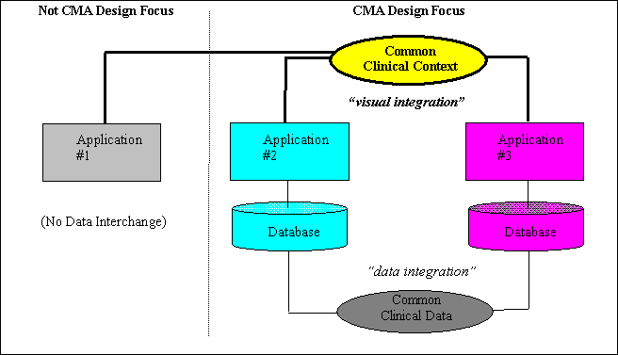
Figure 4. Overall Role of the CMA Specification

Technology Neutrality
The CMA is a technology-neutral specification. The term “technology neutral” does not mean that any technology is applicable. Rather, it means that the CMA is specified such that it can be implemented equally well with any one of a candidate set of relevant technologies. Specifically, the relevant technologies all have strong support for object-orientation, well-defined interfaces between communicating software entities (i.e., objects, components, etc.), and some form of request-reply messaging system for the necessary communication.
Further, in specifying the overarching set of interfaces and policies that govern an implementation of the CMA in any technology, the task of enabling context sharing between applications implemented in different technologies is greatly simplified. This is because the issues that need to be addressed pertain to the mechanics of the underlying technology, which generally can be bridged, rather than in resolving context management-related semantic and behavioral differences between the applications.
Given the synergistic state of the dominant contemporary computing technologies, the emphasis of this document is on the structure of the common context system, the roles and responsibilities of the applications and components that comprise the system, the precise definition of the interfaces they need to implement in order to be participants in the system, the interactions between the application and components (via their interfaces), and a host of architectural decisions that are intended to result in a robust, practical, and useful common context solution. The relationship between the CMA and specific technologies is illustrated in Figure 5.
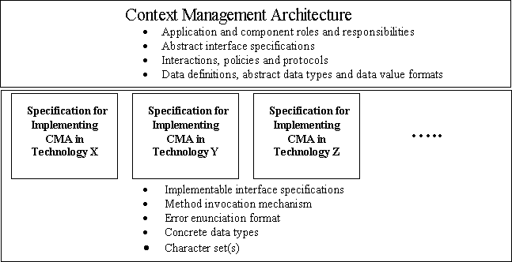
Figure 5. CMA and Technology Neutrality

Requirements and Capabilities
The architecture described in this document is intended to serve as an extensible basis for future, more advanced, common clinical context capabilities. However, for now, an attempt will be made to focus on the immediate issue of developing a robust solution for sharing a common patient selection context.
In a complete solution, at least the following issues need to be addressed:
- Extensibility - how can new context elements be easily added in the future?
- Coordination - how can applications be coordinated so that they respond to context setting changes in an orchestrated and manageable manner?
- Flexibility - how can applications and common context managers be structured so that they implement only the capabilities that they need?
- Performance - how can applications and common context managers be structured so that their temporal performance and utilization of computing resources is acceptable to the end-user?
- Localizability - how are internationalization issues addressed (e.g., local character sets, etc.)?
- Scalability - how is the performance of a common context system affected by the quantity of active applications?
- Applicability - how should context information be structured and managed so that application behaviors are useful to the end user?
- Usability - what are the policies that govern the use of a common context such that the resulting application behaviors are intuitive and reasonable?
- Verifiability - how will the correctness of independently developed common context implementations be verified?
Architectural approaches that address these issues are presented next.

System Architecture
At the most abstract level, the Context Management Architecture (CMA) provides a way for independent applications to share data that describe a common clinical context. However, the CMA must provide solutions for the following problems:
- What is the general use model for a common context, from the user’s perspective?
- Where does the responsibility for context management reside?
- How are changes to context data detected by applications?
- How is context data organized and represented so that it can be uniformly understood by applications?
- How is context data accessed by applications?
- How is the meaning of context data consistently interpreted by applications?
Before drilling into the details of the complete CMA, this chapter presents approaches and associated trade-offs for the problems listed above.

Use-Model
There are many possible use-models for a common clinical context.
The extremes of application support for making context changes are represented by:
- Context changes can be performed only via a single, distinguished, application.
- Context changes can be performed via any application.
In the model chosen for the CMA, context changes can be performed via any application. This is because it is not reasonable to assume the universal existence of a distinguished application, and it is beyond the interests and scope of HL7 to specify one.
The extremes of application behavior when context changes are made are represented by:
- When the user changes the context, the changes are automatically communicated to all of the applications that share the context. Applications that are able and willing to apply the context changes do so immediately. Applications that are unable or unwilling to apply the context changes maintain their current context. It is assumed that the user can easily determine which context an application is using.
- When the user changes the context, the changes are automatically communicated to all of the applications that share the context. However, the context changes are only allowed if all of the applications are able and willing to apply the context changes immediately.
The model developed for the CMA is a hybrid of these two extremes that attempts to enable a high degree of automatic context management while also emphasizing clinical safety:
- The likelihood that applications can become uncoordinated with regard to a common clinical context is minimized.
- The circumstances that can prevent context changes from being automatically applied are expected to be infrequent.
The CMA model also respects the challenges of retrofitting common context capabilities into existing healthcare applications. Only modest assumptions about the capabilities of these applications and technology used to develop them are presumed. The CMA model is as follows:
- All or part of the common context can be set by the user from any application for which providing this capability is functionally relevant.
- When the user changes the context, the change is automatically communicated to all of the applications that share the context. The applications are expected to apply the new context in a clinically meaningful manner. In general, applications are also expected to apply the context changes immediately. Exceptions are described below.
- An application may choose to defer applying a context change until some time in the future. For example, an application that retrieves large medical image files (that require substantial processing) might choose to not retrieve images each time a different patient is selected as part of the clinical context. Instead, the application might wait for an explicit directive or gesture from the user before actually retrieving the image. An application that behaves in this manner must be sure that it does not show data for an earlier context. Blanking-out its data displays or minimizing itself are possible ways that this can be accomplished.
- An application for which a change in the context might result in the loss of work performed by the user can request that the user explicitly decide whether to proceed with the context change anyway, or to cancel the change. The solicitation of user input is performed by the application that is being used to change the context. The solicitation includes an identification of the application for which work might be lost and a description of the work that might be lost. An application that behaves in this manner is expected to be able to discard its work in progress and apply the context changes if instructed to do so. For example, a medication ordering application might indicate that the inputs for a medication order that has not yet been completed by the user will be lost if the context is changed to a different patient.
- When an application is unable to respond to a context change, perhaps because the user left it waiting for user input, the user is asked to explicitly decide about how to proceed. The solicitation of user input is performed by the application that is being used to change the context. The solicitation includes the identification of the non-responsive application and indicates that the application cannot respond to a context change. For patient safety reasons, when there are applications that cannot respond to the changes, context changes will not be automatically applied to the applications that share a common context.
- When it is not desirable or possible for context changes to be automatically applied, either because there are applications for which work might be lost, or there are busy applications that cannot be notified about context changes, the user can explicitly interact with these applications to correct the situation, and then apply the context changes. For example, the user might complete or terminate a dialog that was left open in order to enable an application to apply the context changes.
- When it is not desirable or possible for context changes to be automatically applied, the user can also decide to apply the context change only to the application that is being used to change the context. The decision to do this is typically in response to an interruption during which the user needs to momentarily divert her attention to a different context for a specific application. The application is, in effect, disconnected from the common context, and must clearly indicate this fact to the user in a visual manner. The application can be subsequently instructed by the user to reconnect and apply the common context. The common context may have changed between the time the application was disconnected and the time it is reconnected to the common context.
A high-level summary of the interactions between applications when a clinical patient context is changed is illustrated below. Figure 6 illustrates the use case actors (i.e. external forces) involved in a context change such as a patient selection. (The actors are the user plus applications, all of which are represented in the Jacobson modeling technique as stick figures.) Figure 7 through Figure 11 illustrate some possible instances of the Patient Selection Change Use Case from the user’s perspective. Not all possible instances of this use case are provided.
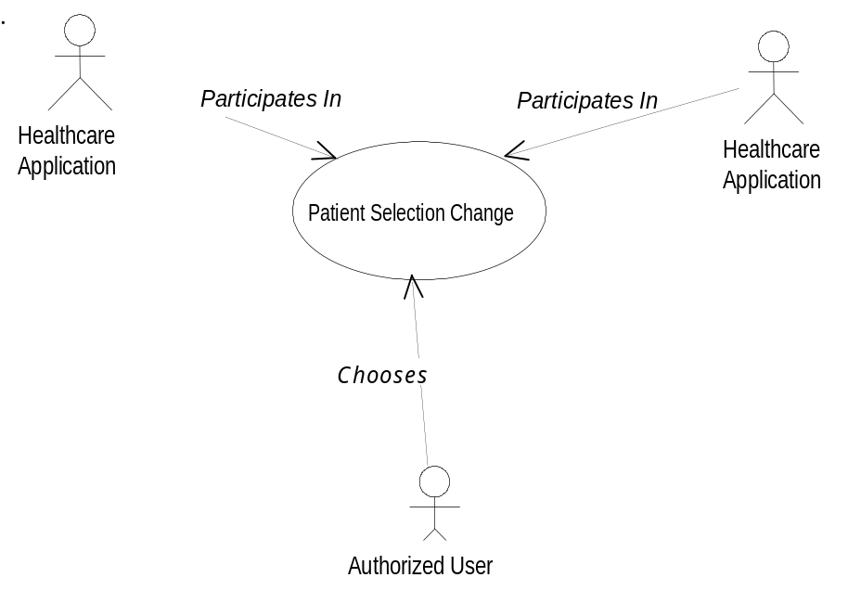
Figure 6. Patient Selection Change Use Case
The initial condition for each of the use case instances is that the currently selected patient is Jane Doe. In each instance, the user changes the common clinical context by selecting the patient Sam Smith. Some possible alternative outcomes follow:
- Figure 7 illustrates all applications reacting to the context change by changing their context to the patient “Sam Smith.”
- Figure 8 illustrates an application (Application DDD) conditionally accepting the context change and providing information describing work that could be lost if a context change occurs at this time. The user deciding to cancel the change is shown.
- Figure 9 illustrates a use case instance similar to Figure 8. However, the possible outcome of the user deciding to force a context change within Application AAA while the other applications remain with the original context is shown. This exemplifies Application AAA disconnecting from the common context system. Once disconnected, Application AAA’s context is no longer in synchrony with the other applications.
- Figure 10 illustrates healthcare application DDD not responding to a selection change request in a timely fashion. The user deciding to cancel the change is shown.
- Figure 11 illustrates the user being notified of potential data loss if selection change proceeds. The user accepting these consequences and proceeding with the change is shown.
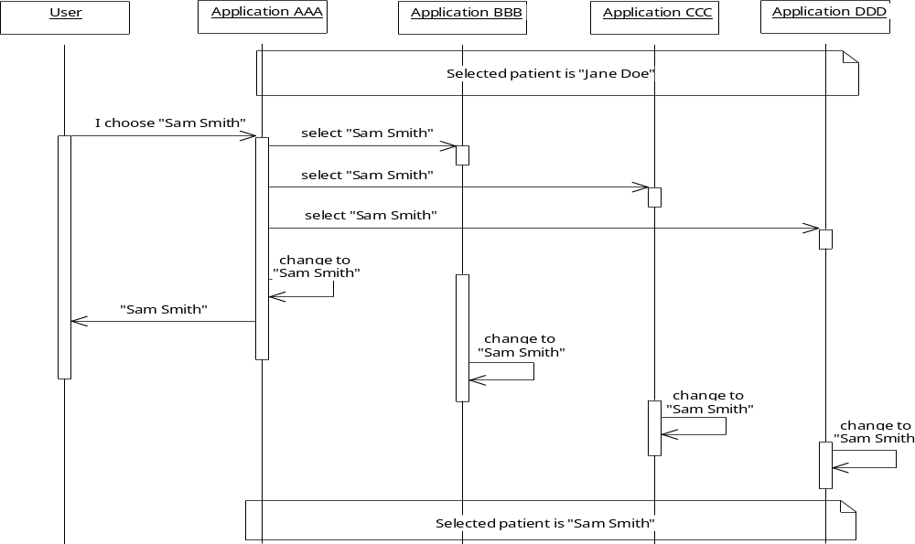
Figure 7. Patient Context Automatically Changes within all Context Participant Applications
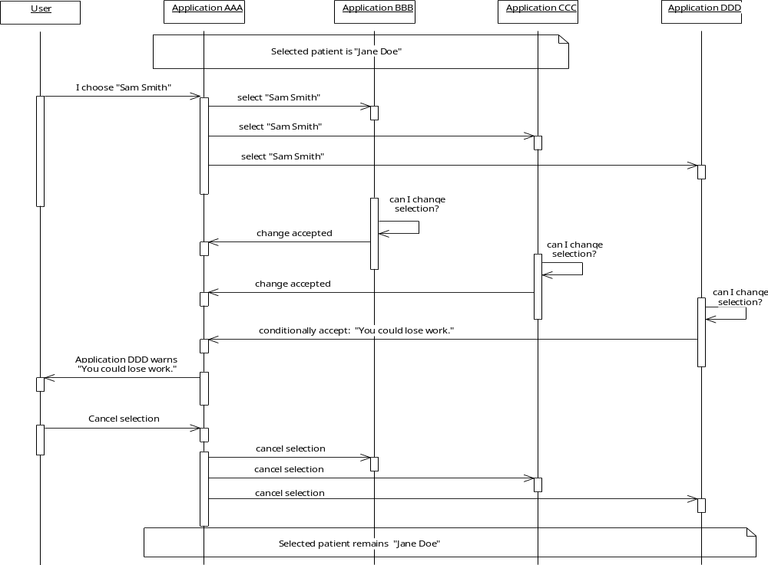
Figure 8. User Informed of Potential Data Loss and Cancels Context Change
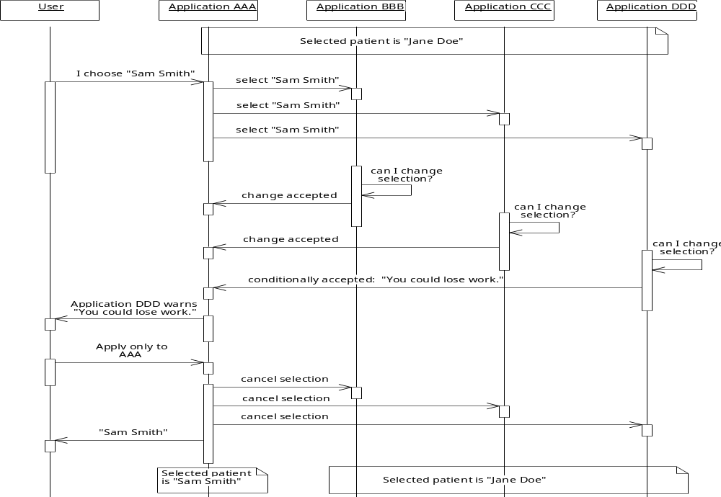
Figure 9. User forces Application AAA to Become Out of Synchrony with other Context Participants
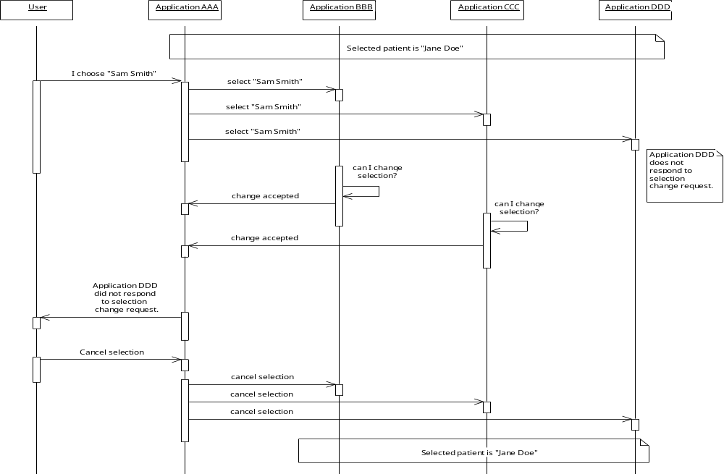
Figure 10. Context Participant Not Responding to Selection Change Request
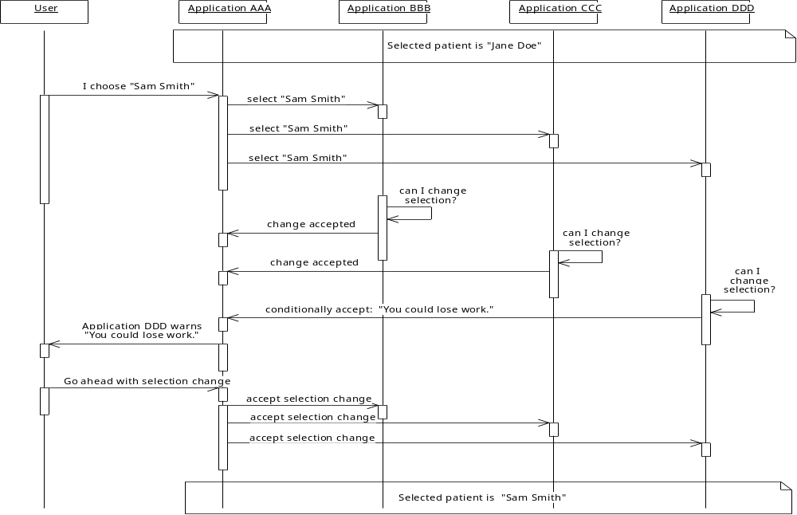
Figure 11. User Accepts Consequences of going ahead with Patient Selection Change with all Applications

Context Management Responsibility
There are two fundamental schemes for architecting the responsibility for context management:
- Distributed: The responsibility for managing the common context is uniformly distributed among the applications. There is no central point of common context management.
- Centralized: The responsibility for managing the common context is centralized in a common facility that is responsible for coordinating the sharing of the context among the applications.
In the distributed model, applications must either all know about each other, or at least form a completely connected graph within which each application knows at least one other application. This is necessary in order for the applications to communicate context and control data among themselves.
Further, each application has the responsibility to act as a server for the common context in addition to acting as a client of the context. This is to offset the fact that there is no central point of ownership for the context, so each application must be capable of being an owner. This may be elegant, but it does introduce implementation complexities and burdens on all applications.
In the centralized model, applications only need to know about a common service or resource. This service off-loads from the applications much of the burden of maintaining and managing the common context. While a centralized service represents a single point of failure and a potential performance bottleneck, it is nevertheless the approach that is pursued in this document. The primary reasons include:
- It is simpler from the perspective of the application developer.
- The consequence of the service being a single point of failure is offset by the fact that the service and the applications it serves are typically co-resident on the same personal computer. Failures, if any, will be localized to a single user.
- The consequence of the service being a performance bottleneck is offset by the fact that the applications are far more likely to become the performance bottlenecks.
Given this basic system structure, the approaches for the other major architectural issues are summarized next.

Context Change Detection
There are at least two distinct categories of architectural approaches for realizing a common clinical context system:
- Pull-model: A shared component is used to maintain the shared context data. Applications update this resource to change the data. Other applications periodically poll the component to determine if the data has changed.
- Push-model: A shared component is used to maintain the shared context data. This component notifies applications whenever the data is changed. In order to receive a notification, an application must have first explicitly indicated its interest in being notified.
Both models have advantages and disadvantages. For example, the pull model is simpler to implement (e.g., does not require applications to handle asynchronous notifications), but can lead to performance problems due to polling even when the context data has not changed. Conversely, the push model can be the basis for better performance, but introduces additional implementation complexity. Both models introduce the additional challenges of synchronizing concurrent access to the context data (e.g., to prevent two applications from attempting to change the data at the same time). In addition, both models must deal with failures modes that can occur when independent applications (i.e., applications that may be implemented as separate executables) are involved. For example, an application that crashes in the middle of changing the context data may leave the context data in an inconsistent state.
Given this analysis, the approach that is taken for the CMA is perhaps best described as a robust push-model. This is a push model that deals with synchronization and partial failure issues.

Context Data Representation
There are at least three distinct categories of architectural approaches for representing the common context data:
- Fully-populated objects: Objects are defined with properties and methods that model the real-world entities that they represent (e.g., a patient, a provider, etc.). These objects may be complex and involve a rich structure (e.g., are comprised of a logical network of objects).
- Fully-populated messages: Messages (as in “HL7 messages”) are used to convey detailed information about the context data.
- Name-value pairs: A set of name-value pairs represent only key summary information about the common context (e.g., just the patient’s name and medical record number). The symbolic name for an item describes its meaning. The data types for the items come from a set of simple primitive data types.
The fully-populated object approach is perhaps the purest approach, but is subject to performance concerns. Copies of the objects could be produced and then communicated to each application every time the state of the primary copy changes. However, this involves the performance cost of marshaling the objects. The problem is further compounded by the fact that marshaling capability would need to be explicitly implemented in either CORBA or COM. (Java RMI implicitly supports the capability to communicate objects by value.)
The fully-populated message approach is actually a stylized way of marshaling objects. While it is appealing to think of leveraging existing healthcare standards such as HL7, it is non-trivial to implement the parsers and translators to create and interpret these messages. Even if such an implementation was commercially available, it is not clear that it would be desirable to require that all of the applications in a shared context system be able to support HL7 messages.
The name-value pair approach represents the compromise that is pursued in this document. Using simple primitive data types enables the values of the items to be easily communicated between processes. Performance concerns are mitigated because an application will be able to examine the values of only those items of interest in a single out-of-process access. (The application simply indicates the names of the items whose values it is interested in.) The approach is also readily extensible, as new items (i.e., new name-value pairs) can easily be added to the set of items.
All of the context data representation approaches described above are subject to establishing semantic agreement about the meaning of the data. This is true whether the context data is represented as objects, messages, or name-value pairs. The process for establishing this agreement is beyond the scope of the CMA, and is instead specified in a series of HL7 context management subject-specific data definition documents. These data definitions are key to implementing a plug-and-play common clinical context system.

Context Data Access
Any common context architecture must provide a way for an application that has just started to obtain its initial view of the common context. The pull-model implicitly solves this problem. With the push-model, there are two basic approaches:
- When the application joins the common context system, the necessary data is pushed to it.
- The data can be accessed from a well-known location, such as a file, or from the component that is responsible for pushing changes to the context system participants. This is, in effect, a specialized use of the pull-scheme.
The approach to this problem is linked to the approach by which applications access the context data for updating it, and the approach by which applications obtain the values for the context data when it has changed.
The options are straightforward:
- Each application maintains a copy of the context data. As changes occur, each application updates its local copy accordingly.
- A central “authentic” copy of the context data is maintained. Context data updates are directed by applications to this copy. Applications access this copy in order to inspect changes.
The approach in which each application maintains its own copy of the context data has an elegance to it. However, in the absence of an authentic copy, an application that has gotten out of synchrony with its peers may have a difficult time restoring its notion of the common context. Further, the communication costs of keeping all applications in synchrony can become significant, particularly as the complexity and size of the common context increases over time as additional common context items are defined.
The approach that is taken for the CMA is to maintain a single authentic copy of the common context for each common context system. Applications can choose to cache context data or they can simply access the authentic copy whenever they need to. Applications can also selectively read or write specific context data name-value pairs. Further, when the context changes, an application is only informed about the change and is not provided with the data that has changed. The application can selectively access this data when it needs to.
This approach was chosen as a balance between performance and complexity. Performance issues are addressed by enabling applications to have selective access to context data. Complexity issues are addressed by not forcing applications to maintain their own copy of the common context data.

Context Data Interpretation
In order for applications to apply common context data in a clinically consistent manner, they must interpret the meaning of the data in a uniform manner. With context items represented as name-value pairs, applications must be able to uniformly interpret both the meaning of the name and the value of a context item, or determine that it cannot correctly interpret the item.
Context data items are grouped by subject, wherein each subject contains a semantically related set of data items. There are two classes of subjects:
- An identity subject identifies a real-world entity (e.g., a specific patient) or concept (e.g., a specific encounter).
- An annotation subject contains data that describes or is otherwise pertinent to the entity or concept identified in an identity subject.
The context data items from which a subject may be comprised may represent the following categories of information:
- data that identifies a real-world entity or concept (such as a specific patient or a specific encounter),
- data that can be used to corroborate the identity data,
- data that annotates the identity data with additional information from an authentic source that describes the identified entity or concept.
Identity information is required in order to establish a common context between applications that involves a real-world entity or concept. Corroborating data can be used by applications and/or users as a basis for checking further that the identified entity or concept is what was expected. Annotation data can be used by applications as a means for interchanging data pertaining to the identified entity or concept, wherein this information is provided by an authentic data source designated by a site.
For example, a patient’s name can rarely be used to uniquely identify a patient. Typically, a medical record number or similar identifier that is generally unique over some population of patients for one or more clinical systems is used. However, these identifiers are rarely meaningful to the user. Corroborating data might be comprised of the patient’s name, sex, and data of birth. This data provides applications and/or the user with an additional means to check that the identified patient is the intended patient. Annotating data might be comprised of the patient’s marital status, home telephone number, and nationality. This data provides applications with a means to share data that describes a patient in addition to identifying the patient.
The clinical context is considered to have changed in a meaningful manner when identifier data is set. Applications are notified of changes to the context when identifier data, and possibly corroboration and/or annotation data, are set. Changes to corroboration data and/or annotation data that are not accompanied by associated changes to identifier data are not meaningful and are rejected.

Context Subject Data Definition Constraints
The specification for an identity subject shall include the data definition for at least one identifier data item and may include the data definitions for zero or more corroborating data items. Data definitions for annotation data items are not allowed for an identity subject.
The specification for an annotation subject shall include the data definition for at least one annotation data item. Data definitions for identifier and corroborating data items are not allowed for an annotation subject.

Establishing the Meaning of Context Data Item Names
Given this approach of organizing context data items into identifier, corroborating, and annotating data, there are two basic techniques for establishing the meaning of context item names:
- Apply a Context Management-specific information modeling process to identify and define candidate clinical context item names and meanings.
- Leverage names and their meaning as established by existing healthcare standards, such as the HL7 messaging standard.
The approach that is taken for the CMA is that existing HL7 messaging terms and their meaning are used as the default source for clinical context item names. New item names and associated meanings will be created only when the HL7 messaging standard is not applicable. The standard set of clinical context data context item names are specified in the document Health Level-Seven Standard Context Management Specification, Subject Data Definitions. Only the specified set of context data items shall be implemented by conformant systems.
The reason for this approach is that the value-added for HL7 context management is not in defining clinical content, but rather in enabling new forms of clinically-rooted point-of-use-based interoperability between independently-developed healthcare applications. There is little incentive to create new information models and develop new clinical concepts when there are existing concepts, such as those already specified for HL7 messaging, which can be leveraged.

Establishing the Meaning of Context Data Item Values
The abstract data types used to represent context data item values are also leveraged from the HL7 messaging standard. These types may be represented as strings encoded using a simple subset of the HL7 character encoding rules. These types may also be mapped into convenient technology-specific data types. The actual clinical context data context item data types are specified in the document Health Level-Seven Standard Context Management Specification, Subject Data Definitions.
There are two basic approaches for establishing the meaning of context item values:
- Assume that each item has a value that can be globally interpreted by all of the applications that share a common clinical context.
- Provide multiple values for each item name such that each value represents that same real-world entity or concept. Each application can apply the value it understands.
In some cases, it is safe to assume that a context item’s value can be globally interpreted by all applications. For example, if a patient’s date of birth is defined to be a corroborating context data item, the value of this item has a single global interpretation.

Representing Context Subjects That Cannot Be Uniquely Identified
Unfortunately, it is not possible to assume that all context subjects, such as patients, can be identified using globally unique identifier values. For example, a patient cannot necessarily be globally identified using a single identifier, such as a medical record number.
However, in these cases, there may be multiple synonymous identifier values, each of which is pertinent to a subset of the applications that share a common context. For example, a hospital and its affiliated clinics may assign their own medical record numbers to the same patient population. Applications, such as master patient index systems, enable tracking and mapping between these values. The result is multiple distinct values that identify the same patient.
It is not the purview of the CMA to resolve global identification issues. It is within the scope of the CMA to at least recognize that multiple identifier values may be necessary. Therefore, the approach taken in this document is to support multiple identifier values for context items when necessary.
An item that can have multiple values is actually represented as multiple items that have a common name prefix but use a distinct name suffix. The prefix for an item, and the constraints on values for the suffix, is defined in the document Health Level-Seven Standard Context Management Specification, Subject Data Definitions. The suffixes are configured into an application using an application-specific process when the application is installed at a site.
The values for such items are provided either by an application when it changes the clinical context, or by an external mapping agent. (See Chapter 10, Mapping Agents.)

Context Subjects and Item Name Format
All context items are organized by subject. Each subject represents a real-world entity or concept that is identified as part of the overall common clinical context. The name of a context item includes the subject to which it belongs. The name of a context item also indicates its role and meaning.
The scheme for assigning subject labels and item names must ensure that the complete name for each item is unique across all item names for all subjects. To this end, standard subject labels, an approach for assigning custom subject labels, and the format of the names of each item that comprise the data for a subject, are defined in the document Health Level-Seven Standard Context Management Specification, Subject Data Definitions.

Standard Context Subjects and Data Items
Each of the standard HL7 CMA subjects and associated context data items are defined in the document Health Level-Seven Standard Context Management Specification, Subject Data Definitions. This includes the core subjects of patient, encounter, observation, user, and certificate, and their respective context data items.

Non-Standard Context Subjects and Data Items
Organizations, such as healthcare provider institutions and vendors, may define their own context subjects and data items. These items are in addition to the standard subjects and the standard items defined for the standard subjects. The scheme for defining custom subjects and custom items for standard subjects is specified in the document Health Level-Seven Standard Context Management Specification, Subject Data Definitions.

Representing “Null” Item Values
The value of a context data item can be set to the distinguished value of null to indicate that the item does not have a valid value. This capability provides a means for an application to explicitly indicate it has not set a valid value for a particular context item. For example, setting the value of the identifier whose name is:
“Patient.Id.MRN.St_Elsewhere_Hospital”
to null indicates that the application has not set a valid value for this identifier.
The actual representation of null is technology-dependent and is specified in each of the HL7 context management technology mapping specification documents.

Representing an Empty Context Subject
A context identity subject is empty when a real-world entity or concept is not currently identified. For example, for the patient subject, this means that a patient is not currently identified.
An empty context subject is represented in either of two ways:
- There are no context identifier items.
- There are context identifier items, but the values for all of these items are null.
The initial state for all subjects in the context is that they do not contain any items. See Section 9.6, Context Change Transactions. An application can explicitly establish an empty context. See Section 9.11.4, Application Behavior with Regard to an Empty Context.

Case Sensitivity with Regard to Item Names and Item Values
Context item names are case insensitive. This means that case is not to be used for the purposes of comparing names. Further, the case used to represent the same item name can be different for different applications, and the case used to represent a particular item’s name at one time need not necessarily be the same at a later time. For example, the item names:
“Patient.Id.MRN.St_Elsewhere_Hospital”
“patient.id.mrn.st_elsewhere_hospital”
“PATIENT.ID.MRN.ST_ELSEWHERE_HOSPITAL”
are all equivalent.
A context item whose value is represented as a character string is also case insensitive, unless otherwise noted in the HL7 context management subject-specific data definition specification document that defines the item.
However, for consistency with the situations in which item values are case sensitive, the case used to represent the value for a particular item is preserved once the value has been set. The case for the item’s value is maintained until a different value is subsequently established for the item.
For example, the following flow of events is allowed:
- An application sets the value of “Patient.Id.MRN.St_Elsewhere_Hospital” to “RS779238XZW”.
- An application gets the value of “Patient.Id.MRN.St_Elsewhere_Hospital” as “RS779238XZW”.
- An application sets the value of “Patient.Id.MRN.St_Elsewhere_Hospital” to “AS119292RUH”.
- An application gets the value of “Patient.Id.MRN.St_Elsewhere_Hospital” as “AS119292RUH”.
- An application sets the value of “Patient.Id.MRN.St_Elsewhere_Hospital” to “rs779238xzw”.
- An application gets the value of “Patient.Id.MRN.St_Elsewhere_Hospital” as “rs779238xzw”.
The following flow of events is not allowed:
- An application sets the value of “Patient.Id.MRN.St_Elsewhere_Hospital” to “RS779238XZW”.
- An application gets the value of “Patient.Id.MRN.St_Elsewhere_Hospital” as “rs779238xzw”.

Component Model
The architecture for a common clinical context system is described in terms of components and the interfaces they must implement in order to be participants in the system. Only the components and interfaces that are germane to the establishment and maintenance of a common clinical context for a point-of-use device are described.
A role is described for each component, and the policies that govern the intended use of the interfaces are detailed. These policies can be thought of as the patterns of allowed interactions between components. Both normal and exceptional interactions are described.
The key components in a common clinical context system are a clinical context manager, one or more context participant applications, and an optional mapping agent for each context subject.
The context manager coordinates the applications each time there is a context change. It is also the “owner” of the authentic context for the system. The context participant applications set and/or get the context from the context manager. They must follow the policies established later in this document in order to behave as proper context management “citizens.”
A context agent is a service component that, from the perspective of an application, is a transparent participant in a context change. A context agent’s primary role is to add additional subject-specific context data to the context or to perform actions on behalf of the user at the request of an application. For example, a mapping agent, which is a type of context agent, is useful when a subject is known to the various context participant applications via multiple distinct identifiers, but only one or a few of these identifiers are known to the application that sets the context. An action agent, which is also a type of context agent, is useful when an application needs to delegate the performance of a user-level task.
Additional context management components are also defined, but serve in supporting roles. All of the necessary components are detailed later in this document.
The context manager does not need to know about the functionality or specific features implemented by any of the applications. Conversely, all applications perceive the context manager through a uniform set of interfaces and capabilities. Further, the applications do not need to know about each other in order to participate in the same context system. Finally, context agents are transparent to applications, as they directly interact only with the context manager.
Applications and the context management components can all be independently implemented and still interoperate as long as they comply with the CMA specification. The CMA specification is in turn predicated upon an underlying component model, described next.

Component and Interface Concepts
The clinical context manager and the applications that participate in a common context system are modeled in the architecture as components. The component model that is used is a high-level hybrid of the component models defined by Microsoft for its Component Object Model (COM) and by the Object Management Group for its Object Management Architecture (OMA).

Interfaces and References
Components have one or more formally-defined object-oriented interfaces. Each interface defines a semantically related set of operations (methods) that the component is capable of performing. The interfaces implemented by a component represent the only way that other components can interact with it. Each interface is denoted by a reference that can be resolved at run-time to access the component instance that implements the interface.
Each method has a name and a set of inputs, outputs, and exceptions. The inputs enable a component’s clients to parameterize the behavior of the method each time they request that it be performed. The outputs enable the component to convey to a client the results that pertain to having properly performed the method. The exceptions enable the component to convey to a client the fact that something unexpected was encountered during the course of performing the method (such as an error condition). A method completes by returning outputs or by raising exceptions. Methods need not have inputs, outputs, or exceptions.
Components can interact with each other in a location independent manner. A component only needs a reference to another component’s interface to perform calls against the component. Knowledge of the physical location of a component that services a call is not needed.

Interface Interrogation
The interfaces that a component implements can be determined by other components at run-time through direct interrogation. The interrogator uses the symbolic name of the interface, or an identifier that denotes the interface, to indicate the desired interface. If the interface exists, the component being interrogated returns a reference to the interface. Otherwise an error indication is returned.
It is assumed that all of the components defined in this document include a common method that enables interface interrogation. The name and signature for this method is the same for all components implemented using a particular technology. The details of this method vary for different implementation technologies and are not specified in this architecture document.

Principal Interface
Every component implements at least one well-known interface, referred to as the component’s principal interface. The principal interface includes the same interface interrogation method as a component’s other interfaces. The name of the principal interface is the same for all components implemented using a particular technology. The principal interface enables components to perform initial interface interrogations because the name of the principal interface is known a priori, and because all components implement it.
The details of the principal interface and the methods that it supports vary for different implementation technologies and are not specified in this architecture document.

Context Management Registry
The context management registry (formerly known as the interface reference registry) is a service that contains references to the principal interfaces for instances of context management components. The registry implements methods that enable applications to query the registry to locate references to context management component instances. Components also use the registry to obtain interface references to each other. A reference obtained from the registry can be used by an application or component to access a specific instance of a component via the component’s referenced interface.
For the situations in which there is a distinct instance of a particular type of component for each context session, the registry will by default only return references to the component instances that are participants in the active context session for the point-of-use device. (For a definition of “active session” see Chapter 7, Context Session Management.)
Conceptually, there is a single instance of the registry for each point-of-use device. For each technology-specific implementation, the registry shall be implemented as a well-known service associated with the device. This enables applications and components resident upon or accessed from a particular device to have an a priori means for knowing how to communicate with the registry.
Each reference that is stored in the registry is denoted in the registry by a symbolic name and/or description. This enables components to query the registry for references of interest based upon a symbolic and/or logical description of the reference of interest. The means by which interface references are denoted and placed into the registry, and the means by which components access the registry to retrieve the references, are technology-dependent. The interfaces defined for the registry are also technology-dependent.

Interface Reference Management
To ensure orderly system behavior, components must have a means of knowing whether or not other components possess references to any of its interfaces. This enables a component to determine when it needs to be in a running state (because there is at least one other component that possess a reference), and when it can terminate (because no components possess a reference). The means by which this is accomplished is technology-specific.
It is assumed that each component that holds an interface reference performs an implicit or explicit action, which is technology specific, that indicates it wants to use a particular interface reference that it has obtained (e.g., from the context management registry). It is also assumed that a component performs an implicit or explicit action, which is technology-specific, when it no longer intends to use a particular reference. The latter action is referred to as disposing an interface reference.

Context Session Management
This chapter describes Context Management Architecture (CMA) support for context session management. Each session is comprised of a set of applications and agents, all of which are associated with a particular point-of-use device, and all of which share context with each other. One or more context sessions may be hosted on the same point-of-use device. This enables different users that share a point-of-use device, such as a personal computer, to each have their own context sessions. It also enables a single user to have multiple context sessions on a single device.
Only one context session may be active at a time on a point-of-use device, but users may switch between context sessions or create new context sessions. Existing sessions may also be terminated.
It is envisioned that applications that enable users to manage their context sessions will be developed. These “session management” applications will enable users to create new sessions and to access existing sessions. Session management applications may also manage the visibility and accessibility of the applications within the session. For example, a session management application might enforce the policy that even though multiple users might each have their own sessions on the same point-of-use device, each user is only able to see and access the applications in their own session.
It is beyond the scope of the CMA to define the capabilities or visual appearance of session management applications. Instead, a set of session management policies and interfaces are defined that enable a wide range of session management applications to be created. In particular, these policies and interfaces enable the necessary security capabilities to be applied as it pertains to session management.

Context Session Defined
The duration in time during which a set of applications comes together to share a common context is known as a context session. A context session is created when a user launches an application and the application informs the context manager that it wants to “join” the context and it is the first application to do so. Additional applications may join the same session, each by informing that context manager that it wants to “join” the context. Each application that is a participant in the same session shares a common context with the other applications in the session. Applications eventually leave the context session, usually when the user terminates their execution. When the last application leaves, the context session terminates.
It is possible for a single point-of-use device to host multiple context sessions. Multiple sessions may be created, but only one session is active at a time. Applications are able to join the active context session, but are not allowed to join sessions that are not active. This policy enables a single user to have multiple sessions, and enables different users to each have their own session on the same device and therefore share the device. Further, this policy provides the basis for enforcing session management security, wherein the current and presumably authorized user is only able to launch applications that join the current user’s session(s), as opposed to sessions belonging to other users.
New sessions must be explicitly created. This is generally performed on behalf of the user by a session management application that has been specifically designed to provide session management functions for users, including mechanisms that ensure that the user is first authenticated before being allowed to create a new session or access an existing one.
The data that represents the common clinical context for a context session resides in the context manager. Conceptually, there is one context manager per session per device. Context data is organized as a set of data items that are grouped by context subject.

Context Session Use Models
There following use models illustrate context sessions.

Shared Clinical Workstation
In this use model a clinical workstation is shared by multiple clinical users, for example, an ICU clinical workstation that is located at a patient’s bedside. The user’s use of the workstation overlaps in time, such that the primary care nurse for the patient has a context session created at the start of his shift, the attending physician creates and then ends a session for the duration of an examination, and a respiratory therapist creates then ends a session for the duration of the therapy. These sessions overlap in time, as exemplified below. However, only one session is active at a time on the workstation:
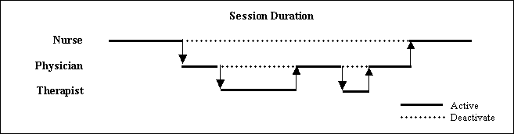

Interrupt-Driven User
In this use model a clinical workstation is used by a single user, for example, a physician in her office. During the course of using the workstation to review the data for a patient, the physician is interrupted by a phone call and asked to participate in a consultation pertaining to another patient. The physician creates a new session in order to perform the consultation. These sessions overlap in time, as exemplified below. However, only one session is active at a time on the workstation:
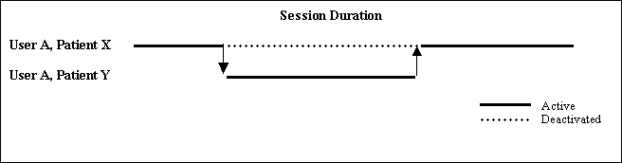

Theory of Operation
Context sessions are created, must be activated to enable applications to join the session, may be deactivated so that application cannot join the session, and may be terminated (generally when there are no applications that are participants in the session).
The first context session for a point-of-use device is created when there is no existing context session associated with the device and an application that is launched from the device is the first to use the device’s context management registry to locate the context manager. (See Section 6.1.4, Context Management Registry.) This first session is automatically activated. Once it locates the context manager, the application joins the active context session. Until another session is created on the device the first session is active, and is the only session. Until another session is created on the device, all applications will join the first and only context session.
Additionally, new context sessions can be explicitly created by the current user or another user. The means by which the user creates a new session is implementation-dependent and may be mediated by a session management application whose role is to provide controls that enable users to manage context sessions.
Whenever a session becomes the active session for the device, the previously active session for the device is automatically deactivated. This requires cooperation between the context managers that represent the various sessions on a point-of-use device. How this cooperation is achieved is context manager implementation-dependent.
When a new context session is created it does not have any context participants. Participants must explicitly join the session. The context management registry will always return a reference to the context manager for a device’s active session. Therefore, whenever an application locates the interface reference for a device’s context manager, it will always obtain the reference to the context manager for the device’s active session. When the application subsequently joins the context session, it will be a participant in the active session.
In order to enable sessions to be secured, such that a user cannot access anyone else’s sessions, an application is not allowed to join a deactivated session. Therefore, it is not possible for an application launched by one user to join a session that is owned by another user. An application that previously joined another context session remains a participant in the (deactivated) session that it joined.
The architecture also only allows applications that are designated to do so to activate a deactivated context session. This enables the session management application to verify that the user who wants to activate an existing session is the user who owns the session. It also enables a context manager to verify that only designated applications are allowed to activate it.
For example, the session management architecture enables a session management application to first authenticate the user before allowing the user to create or activate an existing session. The session management application can do this either by serving as the application designated to authenticate users (See Section 14.8, Designating Applications for User Authentication) or by using a context action to request that another application authenticate the user (See Chapter 16, Theory of Operation for Context Actions).
Finally, the session management architecture does not define the semantics for how and when multiple sessions owned by the same user may be accessed. Instead, the session management application is responsible for imparting a particular discipline on how sessions may be accessed. For example, it is possible for session management application to implement a stack oriented access discipline or a random access discipline.

Context Session Management Policies

Creating a Context Session
A context session can be created in two ways. First, if an application launched from a device is the first to query the device’s context management registry for a reference to a context manager, then the registry shall automatically create a new context manager instance to service the session. If the context manager is the only context manager for the device, then the session that it represents shall be automatically activated when the context manager is created.
Second, any context manager can be used to create a new session. This results in a new context manager being created to represent the new session. This new session is not active nor is it automatically activated. It must be explicitly activated in order to become active. See Section 7.4.5, Activating a Deactivated Session. The context management registry will continue to return the interface reference to the presently active context manager. It will not return a reference to the newly created context manager until the newly created context manager is activated.

Cloning Context Data
Context data can be explicitly copied from the context manager for one session to the context manager for another session. This would typically be done by the application that created a new session, such as a session management application. However, the application must have the appropriate context subject access privileges in order to get and set the context data. See Chapter 12, Theory of Operation for Secure Links.

Deactivated Sessions
The currently active context session shall be automatically deactivated when another session on the same device is activated.
Once a session is deactivated it shall not be possible for applications to join the session. This prevents an application associated with one user’s session from becoming a participant in another user’s session. If an application attempts to join a deactivated context session, then the context manager shall raise an exception.
However, all other context management functions shall still be allowed. For example, applications may leave the session, and it is still possible for context change transactions to be performed upon the session. This enables an application such as a session management application to perform session management tasks, even with sessions that are not active, for example, copying data from a session that is not active to a newly created session.

Session Participation
An application may be a participant in more than one session. This is necessary, for example, in order to create a session management application that controls user access to the various sessions on a device.

Activating a Deactivated Session
The context manager for a deactivated session can be explicitly instructed to become active. In so doing, the context manager for the presently active context session on the device shall be automatically deactivated. (This requires cooperation between the context managers that represent the various sessions on a point-of-use device. How this cooperation is achieved is context manager implementation-dependent.)
For security reasons, only an application that has been designated for activating context sessions may activate a context manager. The designation of the application or applications that are allowed to activate sessions is configured on a site-specific basis. The means by which this is accomplished is context manager implementation-dependent. Typically, only the session management application used by a site would be designated as the application that is allowed to activate sessions, but other use models may allow multiple applications to be designated as well.

Session Termination
A context manager terminates (and its session is, by definition, deactivated) when the last participant leaves the session represented by the context manager. A context manager also terminates if, after it is created, at least one application does not join the session represented by the context manager in a timely manner. (The context manager decides how long “timely” is. How this value is determined is an implementation decision.)
If an application attempts to join the context session via a context manager that has already terminated, then the application shall receive an exception notification. Depending upon the timing of when the application attempted to communicate with the context manager, this notification may be issued by the context manager or it may be issued by the underlying technology-specific communications substrate.
When a session terminates, the values for all of the context data items in the session shall be set to empty by the context manager and then the context manager shall terminate. In so doing, the possibility of an application accessing the context data in the interval of time between termination of the session and termination of the context manager is eliminated.

No Active Session
It is possible that there is no active context session for a particular point-of-use device. This is clearly the case prior to the creation of the first session. It can also be the case if the currently active session terminates. The termination of the active session does not automatically cause a presently deactivated session to become active. A session may only become active per the specifications detailed in Section 7.4.5, Activating a Deactivated Session.
When there is no active session for a device, but there are deactivated sessions, then when asked to locate a context manager the context management registry shall not return a reference to any context manager. In this situation either an existing context manager needs to be activated, a new context manager needs to be created, or all of the deactivated context managers must terminate (thereby allowing a new context manager to be automatically created and activated) before the registry will return a valid context manager reference.

General Theory of Operation for Clinical Links
Clinical links and the subjects that they represent are broadly classified as common or secure. The treatment of common links is described in Chapter 9. Patient Link, which is a common link for the patient subject, is detailed in Chapter 13. With a common link, any application can get or set the context data for the subject represented by the link.
The treatment of secure links is described in Chapter 12. User Link, which is a secure link for the user subject, is detailed in Chapter 14. With secure links, only applications with the appropriate access privileges are allowed by the context manager to set and/or get the context data for the subject represented by the link. Whether or not the subject represented by a link is secure is defined as part of the subject's data definition and is invariant across sites. However, for each subject that is defined as secure, the necessary application access privileges are configured on a site-specific basis.
There are, however, a number of concepts, rules, and policies that pertain to both common and secure clinical links in general, as described in this chapter.

Multiple Subjects and the Meaning of “Link”
Even though there are multiple subjects in a common context system (e.g., patient and user), there is only one link that coordinates the CMA-compliant applications that participate in a context session. This means that when an application is linked, it shall “tune” to all of the subjects it is capable of dealing with. For example:
- An application that is only Patient Link-enabled tunes to just the patient context.
- An application that is only User Link-enabled tunes to just the user context.
- An application that is both Patient Link-enabled and User Link-enabled tunes to both the patient context and the user context.
Conversely, when the user breaks an application’s link, then the application shall no longer be tuned to any context subject.
Independent of the number of context subjects it supports, a single visual cue shall be provided by an application to indicate whether or not it is linked. The appearance of this cue is defined in the each of the HL7 context management technology-specific user interface specification documents.

Context Manager Support for Multiple Context Subjects
The potential relationships between context subjects require that a context manager implementation have an understanding of multiple subjects and of the inter-relationships between subjects. Further, applications will, in general, need to deal with multiple context subjects. There are two basic ways to address these issues:
- Maintain a context manager per subject, and enable context managers to interact with each other to maintain the overall context.
- Support multiple context subjects within a single context manager.
The first approach has the advantage that context manager implementations can be specialized to support a single subject. For example, this would enable a Patient Link context manager from one vendor to be used with a User Link context manager from another vendor. The disadvantages are that applications would need to deal with multiple context managers.
Further, the context managers would need some way to cooperate in order to coordinate transactions that affect multiple subjects. This coordination would require the definition of additional context manager interfaces. This coordination would also increase the complexity of the failure scenarios because of the increased opportunity for partial failures (e.g., one context manager fails while the other context manager continues to function).
The second approach has the advantage that it enables the complexities of dealing with multiple subjects to be hidden within the implementation of a single context manager. Additional context manager interfaces are not required, and partial failure scenarios are avoided. This approach also has the advantage that applications only need to deal with a single context manager.
The second approach has the disadvantage that context manager developers will need to support all subjects within their context managers. However, it is the CMA philosophy to push complexity into the context manager whenever it simplifies the creation of new applications and the reengineering of existing applications. The second approach is the one that is pursued because, from the perspective of an application, it is simpler than the first approach.

Effect of Multiple Subjects on Context Change Transaction
For application flexibility and backwards compatibility, it is highly desirable that:
- An application does not have to know about all possible subjects in order to set the context pertaining to just one subject.
- Either one, some, or all subjects can be set within a single context change transaction.
However, these desires raise the question of how to treat context data for a subject that is not “touched” during a transaction by the instigating application? There are two approaches:
- At the completion of the transaction, an untouched subject is empty, meaning that it does not contain any context items.
- At the completion of the transaction, the untouched subject is unaffected, meaning that it contains the same items and item values as it did before the transaction.
In the first approach, the context manager would ensure that each context change transaction begins with an empty context (i.e., all subjects are empty). With multiple subjects, only the subject that is touched during a transaction will contain items at the completion of the transaction.
However, a problem arises with this approach, as illustrated by the following example. An application that is only Patient Link-enabled might be co-resident with applications that are Patient Link and User Link-enabled. If the application that is only Patient Link-enabled changes the patient context, the user context shared by the other applications will be lost (i.e., it will be empty).
Applications could be required to know about all subjects and to explicitly copy the subjects that are not to be set from the current context to the new context. However, this creates a burden on the application developers. It is also a substantial impediment to backwards compatibility.
The second approach avoids this problem, as described in Section 8.1.3, Context Manager Treatment of Multi-Subject Context Data.

Context Manager Treatment of Multi-Subject Context Data
When a context change transaction is started, the context manager shall create a transaction-specific version of the proposed context data. This version of the context data is initially empty and shall not contain any context items for any subject.
The application that instigated the transaction then establishes the content of the new proposed context by setting context data item values for one or more subjects. The application then informs the context manager that it has completed its context changes. The context manager shall then “post-fill” the proposed context before the context manager surveys the context participants.
Specifically, for each subject in the current context that was “untouched” by the application (meaning that no existing item values were set and no new items were added to the subject), the items for the subject are automatically copied by the context manager into the proposed context.
With these rules, the instigating application only needs to set the values for the context items that it wants to change. For example, an application can just set subjects based upon the user’s explicit gestures, such as selecting a patient, signing on, or both. Further, an application only needs to set the subject context items that it is capable of setting. For example, an application may not be able to set all of the corroborating data for a subject. Similarly, a participant application does not have to deal with all subjects, or be able to interpret all of the context data items defined for a subject. An application is able to only get the items it knows about and is able to interpret.

Effect of Multiple Subjects on Mapping Agents
Each identity subject (e.g., patient) shall have at most one corresponding mapping agent. When a context change transaction reaches the phase during which the context manager instructs mapping agents to map the context data (i.e., context changes are pending), the context manager shall interact with each mapping agent in the order described in Chapter 10, Mapping Agents. Each mapping agent shall be informed only once per transaction that context changes are pending.

Effect of Multiple Subjects on Annotation Agents
Each annotation subject (e.g., certificate) shall have at most one corresponding annotation agent. When a context change transaction reaches the phase during which the context manager instructs annotation agents to set the context data (i.e., context changes are pending), the context manager shall interact with each annotation agent in the order described in Chapter 11, Annotation Agents. Each annotation agent shall be informed only once per transaction that context changes are pending.

Application Treatment of Multiple Subjects
An instigating application can set one, some, or all subjects in a single context change transaction. However, unless the user expects multiple subjects to change as a result of a gesture, it is recommended that an application generally set only one subject at a time. This enables the user to relate changes in the common context to gestures that they have explicitly performed. Cause-and-effect between a user’s gesture and a change in application state is an important element in creating systems that are easy for people to use.
An instigating application may also need to get the context data for various subjects at the conclusion of the transaction that it instigated. Specifically, if the application is interested in one or more annotation subjects, then the application will need to explicitly get the context items for these subjects. This is because the context item values for each annotation subject are set by a corresponding annotation agent during the course of the transaction but subsequent to when the instigating application completed its setting of subjects.

Context Subjects Dependencies
For simplicity, it is generally desirable that there not be any semantic dependencies between context subjects. This enables an application to set a context subject without concern for the other available subjects.
With this assumption, it is possible for an application to independently set the context data items for just one subject, some, or all subjects during the course of a single context change transaction. A context subject whose items have not been set by the application shall remain as it was prior to the transaction. (See Section 8.1.3, Context Manager Treatment of Multi-Subject Context Data.)
However, in certain cases there are real-world semantic dependencies between context subjects, wherein the context data item values for one subject must be consistent with the context data item values for one or more other subjects. An application that sets the context during a context change transaction needs to be cognizant of subject dependencies, however the context manager also plays a role in enforcing dependency rules.
The context manager cannot necessarily guarantee that dependent subjects have consistent context item data values. However, the context manager shall enforce rules that indicate application cognizance of the dependencies between the subjects whose context item data it sets.
These rules ensure that whenever a parent subject is set during a transaction, then each child subject that depends upon the parent subject is also set. Specifically, a child subject that is not set under these conditions shall be forced by the context manager to be empty at the conclusion of the transaction (i.e., the child subject’s pre-transaction value is not post-filled by the context manager, but rather the child subject is set to empty).
A child subject may always be set if its parent subject has not been set and if the parent’s pre-transaction value is not empty. If under these conditions a child subject is not set, then the child subject’s pre-transaction value shall be post-filled by the context manager.
If a parent subject is set to empty, or it is not set and its current value is empty, then each child subject may only be set to empty. This is the same thing that the context manager will automatically do under these conditions.
To illustrate the subject dependency rules enforced by the context manager, consider the example of the child subject Encounter, which is specified as being dependent upon the parent subject Patient.
If prior to a context change transaction both the Encounter and Patient subjects are already set and not empty, and during the transaction the application sets the Patient subject but not the Encounter subject, then at the end of the transaction the context manager shall ensure that Encounter subject is empty. This is in contrast to the context manager post-filling the context data items for the Encounter subject, as would be if the Encounter subject was not dependent upon the Patient subject. (See Section 8.1.3, Context Manager Treatment of Multi-Subject Context Data, for an explanation of post-filling context data items.)
Alternatively, if the context data items for the Encounter subject are set so that this subject is not empty, but the Patient context is empty, then this shall result in the context manager raising an exception to the application that instigated the transaction, and the context manager shall cancel the transaction.
In contrast, it is acceptable for an application to set the context data items for the Encounter subject even if the context items for the Patient subject are not set by the application during the transaction, as long as the Patient subject is not currently empty.
It shall be explicitly defined in each subject’s data definition as to whether or not the subject is dependent upon one or more other subjects. A directed acyclic graph of dependent subjects is allowed.
Whether or not a standard subject is dependent upon another subject is specified in the document Health Level-Seven Standard Context Management Specification, Subject Data Definitions.
An identity subject may be dependent upon another identity subject. An identity subject shall never be dependent upon an annotation subject. An annotation subject shall always be dependent upon an identity subject. An annotation subject shall never be dependent upon another annotation subject.
Beholden to the rules above, subject dependencies for custom subjects, if any, may be defined by the organization that specifies the custom subject. However, while a custom subject may be dependent upon any other subject, a custom subject shall not require that a standard subject, or a custom subject defined by another organization, be dependent upon it. For example, it cannot be asserted that standard subject S is dependent upon custom subject C.

Empty Contexts Subjects
As described in Section 5.6.9, Representing an Empty Context Subject, applications can indicate that a subject is empty. When a subject is explicitly set to empty, its context data is not post-filled by the context manager.

Theory of Operation for Common Links
Common links involve context subjects for which application access privileges are not enforced by the context manager. Any application can get or set the context data for the subject represented by a common link. Common links form the foundation for CMA-based context management.

Component Architecture for Common Links
The following context management interfaces for common links are modeled and illustrated in Figure 12. Component Architecture:
- ContextManager (CM) - implemented by the context manager; used by applications to join/leave a common context session and to indicate the start/end of a set of changes to the common context data.
- ContextSession (CS) - implemented by the context manager; used by applications to manage context sessions.
- ContextData (CD) - implemented by the context manager; used by applications to set/get the data items that comprise the common context.
- ContextFilter (CF) – implemented by the context manager, used by applications to set/get the names of the specific subjects that must be set during the course of a context change transaction in order for the application to be included as a participant in the transaction.
- ContextParticipant (CP) - implemented by an application that wants to participate in a common context session; used by the context manager to inform an application that the context has been set.
- ContextAgent (CA) - used by the context manager to inform a mapping agent or an annotation agent that the clinical context has changes pending and that the mapping agent or annotation should perform its context data mapping responsibilities. Also used by the context manager to inform a context agent to perform a context action.
- ImplementationInformation (II) – implemented by the context manager and mapping agents; used by applications, context management components, and tools, to obtain details about a component’s implementation, including its revision, when it was installed, etc.
Formal definitions of these interfaces, as well as example interactions between the components via these interfaces, are presented later in this document.
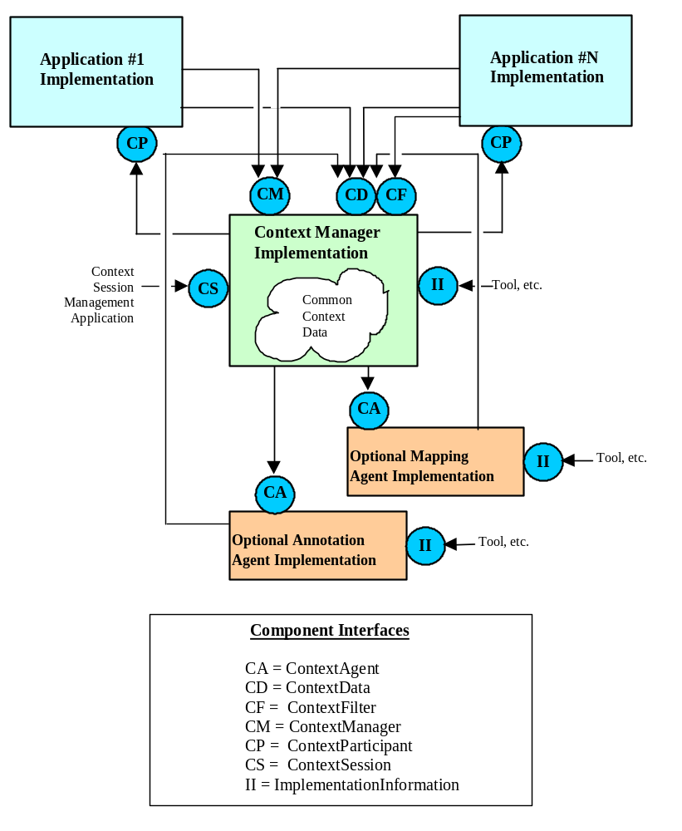
Figure 12. Component Architecture for Common Links

Mapping Agents
An optional mapping agent may also be part of the common context system. There may be at most one common mapping agent for each common subject. The context manager does not enforce access privileges for mapping agents that map common subjects (as opposed to secure subjects, for which access privileges are enforced).
For example, a patient mapping agent maps the identifiers for patients. Whenever an application sets the patient context, the context manager instructs the patient mapping agent (if present) to provide any additional identifiers it knows for the patient. The site-suffix for each of the mapped identifier items denotes the site for which the patient identifier is valid, for example:

Example Item Names | Example Item Values
Patient.Id.MRN.St_Elsewhere_Hospital  Patient.Id.MRN.General_Hospital | 123-456-789Q36  6668-3923-987122
Mapping agents are described in more detail in Chapter 10.

Annotation Agents
An optional annotation agent may also be part of the common context system. There may be at most one annotation agent for each annotation subject. The context manager does not enforce access privileges for annotation agents that annotate common subjects (as opposed to secure annotation subjects, for which access privileges are enforced).
For example, a hypothetical demographics annotation agent would set an annotation subject that contains the demographic data for the current patient. Whenever an application sets the patient context, the context manager would instruct the demographics annotation agent (if present) to provide the data for the demographics subject, for example:
Example Item Name | Example Item Value
Demographics.An.MothersMaidenName | Smith^^^^^
Annotation agents are described in more detail in Chapter 11.

Context Change Transactions
All changes to the common context are governed by a context change transaction that is initiated by an application but is coordinated by the context manager:
- An instigating application initiates a context change transaction and sets the context data within the context manager. This context contains the identity of the real-world entity or concept represented by each context subject.
- The context manager consults the mapping agents (if present) and they add data to the context manager’s context. This data includes additional identifiers by which each real world entity or concept is known.
- The context manager consults the annotation agents (if present) and they add data to the context manager’s context. This data includes additional information that describes or is otherwise pertinent to each context subject.
- The context manager surveys the other applications, and if the transaction completes, they obtain the context data from the context manager.
As an example, the high-level events that transpire when a user selects a patient are summarized in Figure 13. This description assumes that a patient mapping agent and a hypothetical demographics annotation agent are present. The patient mapping agent is presumed to know the identifiers for all patients for all applications within the common context system. The demographics annotation agent is presumed to know the demographics for all patients within the common context system.
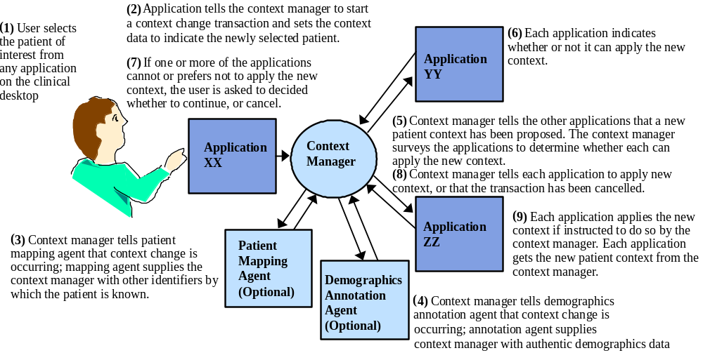
Figure 13. Context Change Process for Common Links
The details for how this process works and the responsibilities of the applications and CMA components are described next.

Joining a Common Context Session
Applications join a common context session via the context manager for the session. The context manager’s ContextManager interface is used for this purpose. The application obtains a reference to this interface by interrogating the context manager’s principal interface. A reference to the context manager’s principal interface is obtained from the point-of-use device’s context management registry. (See Section 6.1.4, Context Management Registry.)
An application typically retrieves the current common context data from the context manager’s ContextData interface in order to establish its initial context. A reference to the context manager’s ContextData interface is obtained by interrogating the context manager’s principal interface or by interrogating the context manager’s ContextManager interface. The context data is represented as a set of name-value pair items.

Context Change Transactions
Once an application is a participant within a common context session, the context manager will inform the application of context data changes through the application’s ContextParticipant interface. This data can be set by any of the participants in the common context session. A participant executes a context change transaction to effect a context change. The transaction is coordinated by the context manager and involves the instigator of the transaction as well as the other participants.
The ContextManager interface is for beginning and ending a context change transaction. The ContextData interface is used for setting the new context data.
When a context change transaction is started, the context manager creates a transaction-specific version of the new proposed context data. This version of the context data is initially empty and does not contain any name-value pair items. This is to prevent data from the current context from becoming mixed with the data for the new context. Items are added to the proposed context data during the course of the transaction.
This proposed context data is updated during the course of the transaction and is intended to be visible only to the application that instigated the transaction. All other applications continue to view the previous, most-recently published context data. The published context data is replaced with the proposed context data if the transaction completes successfully.
Prior to the first context change transaction, the published set of context data items is empty. Items are added during the course of subsequent transactions.
While the context manager serves as a holder for the current context data, its semantic understanding of the meaning of this data is intended to be minimal. Further, the specific items that constitute the context data are not assumed to be hardwired into the context manager implementation. This enables new context items to be defined over time without requiring changes to context manager implementations. This includes context items that represent identifier data as well as corroboration data.
Only one context change transaction is allowed at a time. Once it has started a change transaction, the instigator of the transaction is free to update the context data via the context manager’s ContextData and/or SecureContextData interfaces.

Transactional Consistency
In order to ensure that changes to this set of items are self-consistent, a participant must explicitly begin and end a context data change transaction. All of the context change operations that are performed within the scope of the transaction are treated as a single logical unit of work. When the transaction completes, either all of the changes are published, or none of them are. Other participants that access the ContextData and/or SecureContextData interfaces to read the context data values will see the values as they were prior to the transaction. Only the instigator of the transaction will see the values as they are during the course of the transaction. This prevents other participants from accidentally seeing inconsistent values.
This capability relies upon the proper use of context coupons, which are monotonically increasing identifiers that are assigned each time a change transaction begins. The context manager provides the instigator of a transaction with the context coupon when it is started. All other participants can only obtain from the context manager the coupon for the most recently committed transaction. A coupon is also provided as a parameter to most of the methods defined for the ContextData and SecureContextData interfaces, thereby enabling the manager to determine whether it should respond in terms of the transaction-in-progress or the most recently committed transaction.
When the instigator of the context changes is done, it informs the context manager that the changes have been completed. A context manager may unilaterally decide to terminate a transaction and undo the changes if an application fails to indicate that it is done with its changes in a timely manner. (The context manager decides how long “timely” is. How this value is determined is an implementation decision.)

Context Change Notification Process
When the instigator completes the context changes, the context manager initiates a two-step change notification process wherein it determines whether to publish the shared context data changes. This process is inspired by the two-phase commit protocol used in many database systems to ensure transaction consistency. For the purposes of managing a common clinical context, the protocol has been simplified.
In the first step of the process, the context manager notifies all relevant context agents that a new context has been proposed. The agents may then add data to the context. Once the agents have been notified, the context manager post-fills the proposed context with data items from the current context (see Section 8.1.3, Context Manager Treatment of Multi-Subject Context Data for a description of post-fill). The context manager then surveys the applications.
Specifically, each application is informed that there is a proposed set of context data changes and is asked to indicate whether it can accept these changes. At this point, applications are provided with the context coupon value for this transaction. This enables the applications to access the proposed context data in order to consider specific data values as part of their decision about whether to accept the changes. This is accomplished via the context manager’s ContextData and/or SecureContextData interfaces. It is possible for a participant to obtain just the values for the data items for the subjects that have been set, as opposed to the data item values for subjects that have been post-filled.
In the second step of the process, the context manager gathers the results of the survey and provides them to the application that instigated the context change. Depending upon the survey responses the application may be free to go ahead and publish the changes, or it may need to solicit guidance from the user about how to proceed. This guidance is required when there is at least one surveyed application that:
- is unable to apply the context change because it is blocked (e.g., it is a single threaded application that has a modal dialog open); these applications are referred to as “busy”
- might lose work performed by the user if it applies the context changes (e.g., the user was in the process of entering data that would not be applicable in the new context); these applications are referred to as having “conditionally accepted” the context changes.
For each application in one of these states, the user is provided with a description that identifies the application and explains its situation.
When user guidance is required, the following choices are offered:
- Cancel - the context change is canceled; the context changes are not published.
- Break Link - the context changes are applied just to the application with which the user initiated the context changes. This application essentially breaks away from the common context session until the user explicitly instructs the application to rejoin the session. The application that has broken away displays a distinct visual cue indicating that its context may be different from the other applications (e.g., it might display a warning message in a prominent location).
- Apply - the context data changes are applied to all of the applications, including those that indicated that they might lose work performed by the user; this choice is allowed only when there are no busy applications.
It is the responsibility of any application that enables the user to instigate a context change to present, when necessary, a dialog that obtains the user’s guidance as described above. The appearance of the dialog and the commands that the user can choose from are specified in each of the HL7 context management technology-specific user interface specification documents. This will ensure a consistent and familiar set of interactions for users across CMA-conformant applications.
The ability for any one application to require the user’s direct involvement in mediating context changes provides an important efficiency and safety feature.
The efficiency feature addresses the fact that changing the context may cause an application to loose work performed by the user. This work may be in the form of data entered but not yet saved by the user, or may be in the form of an expensive computation (such as a lengthy database retrieval) that would need to be re-performed in light of a context change. Allowing the user to decide how to proceed in these circumstances minimizes the likelihood that the user will unintentionally loose work.
The safety feature addresses the fact that it may not always be possible to force an application to accept changes to the context data. Specifically, this is the case for blocked, or busy, applications.
If context changes were automatically applied piecemeal to just the applications that could respond, applications could become out of synchrony with regard to their clinical context, without the user being aware of the situation. For example, the user might assume that after a context change, all of the applications are displaying data for the same patient when in fact they are displaying data for different patients. The approach described above avoids this problem. This is because the only time that an application ceases to follow can become out of synchrony with regard to the clinical context used by the other applications is when the user has explicitly instructed it to break its link with away from the common context.
In the second step of the two-step change notification process, the applications in the common context session are informed about whether or not the context changes are to be applied. If all of the surveyed applications indicate that they accept the changes, then the changes are applied and are reflected as the new context state. If the user indicates that the changes should be canceled, then the changes are discarded.
Once a participant has been informed that the context data has been set, it is free to inspect the data to obtain the new values if it has not already done so (again, using the context manager’s ContextData and/or SecureContextData interfaces). The participants can also assume that all of the other participants are applying the same context data.
Subsequent to the completion of the context change transaction, the application that instigated the context change transaction may also want to inspect the context data. This is necessary if the application is interested in annotation data that might have been set by one or more annotation agent during the transaction.
In either case, the context change transaction completes when all of the applications have been informed of the outcome of the survey. If the context manager is unable to inform an application of the survey outcome, it will keep trying periodically, unless the manager determines that the application has terminated. The periodic attempt to notify a non-responsive application does not prevent the transaction from completing, nor will it prevent a new transaction from being started.

Application Synchronization Relative To The Context
There are two policies that govern the behavior of applications as it pertains to remaining current with the context data:
- Constant Synchronization: An application that is constantly synchronized maintains lock-step synchrony with the context data. If the context data changes then the application changes its internal state accordingly. The only way that an application’s internal state may differ from the context is if the user has explicitly broken the application’s link with the context. (See Section 9.8, Context Change Notification Process.) The policy of constant synchronization with the context data enables the creation of context sharing capabilities that support the safe use of applications wherein users are likely to expect constant synchronization, such as for Patient Link. This policy all enables the creation of secure context wherein it is necessary to enforce sustained synchronization of applications to prevent unintended access to applications and/or underlying data, such as for User Link.
- Temporary Synchronization: An application that temporarily synchronizes its internal state with the context data each time the context data is set may subsequently be directed by the user to do things that cause the application to no longer be synchronized with the context. The policy of temporary synchronization enables the creation of context sharing capabilities wherein users may intentionally synchronize applications without being locked into the synchronized state among all of the applications on an ongoing basis. This policy is best used when the absence of constant synchronization does introduce safety or security hazard for users.
It shall be specified in the data definitions for the context subject as to which of the above synchronization behaviors are required for applications.

Leaving a Common Context Session
When an application terminates, it explicitly leaves the common context session by informing the context manager via its ContextManager interface. At this time, the context manager shall dispose of any application interface references that it possesses, and the application shall dispose of any context manager interface references that it possesses.
A diagram of the overall common context system model is presented in Figure 14, followed by component interaction diagrams that represent typical common context data update transactions.

Behavioral Details

Notification Policy When Context Data is Not Changed During A Transaction
If an application performs a context change transaction, and if the only context item values set by the application are for context subjects that require application synchronization, as opposed to application resynchronization (i.e., none of the items are for a resynchronization subject), and the values set for these items are the same as the present values for these items, and if context agents do not subsequently add data to the proposed context, then applications are not surveyed nor are they notified about the context change transaction. Instead the context manager shall behave as if all of the applications had been surveyed and each responded with accept, as detailed in Section 9.11.5, Surveying Details.
This policy eliminates spurious context change surveys and subsequent notifications when in fact the context has not effectively been changed.

Application Behavior When it Cannot Cancel Context Changes
It is possible that an application that instigated a context change transaction cannot easily implement the capability to cancel the transaction. In this case, it is acceptable for the application to not offer canceling the transaction as an option to the user. The details of how this appears to the user are specified in each of the HL7 context management technology-specific user interface specification documents.

Application Behavior When it Does Not Understand Context Identifiers
It is possible that an application is unable to interpret any of the context identifier items that were set when the current context was established by another application. For example, the selected patient might not be a patient known to the application.
An application that is unable to interpret any of the identifiers shall still participate in the context change transaction. This situation is not a basis for the application to prevent the transaction from proceeding. Specifically, the application shall not use the surveying process to reject the context change.
However, at the completion of the transaction, the application shall clearly indicate to the user that it is unable to apply the current context. The application shall not show any patient data. The details of how this indication appears to the user are specified in each of the HL7 context management technology-specific user interface specification documents.

Application Behavior with Regard to an Empty Context
The context is empty when a context session is first initialized. (See Section 5.6.9, Representing an Empty Context Subject). When this is the case, all of the applications in the context session shall clearly indicate to the user that there is no current context. The details of how this indication appears to the user are specified in each of the HL7 context management technology-specific user interface specification documents.

Surveying Details
During the context change survey, the context manager informs each of the applications in the common context session (except for the application that instigated the changes) that there are pending context data changes. When an application is surveyed, it shall create a visual cue that indicates it is about to change its clinical context before responding to the survey. It shall not change its context yet. The context-changes-pending indication shall only be removed once the context manager has informed the surveyed application about how to proceed.
Under normal circumstances, the application will eventually be notified by the context manager about whether or not the context changes should be applied. However, if the context manager is unable to inform the application about how to proceed (e.g., because the application blocked after responding to the survey but before being notified that the context changes have been accepted), the user will at least be able to determine that the application may not be in synchrony with the other applications. This is because the application is presumably still displaying a visual cue that indicates it might change its clinical context. The fact that this cue is still being displayed after the context has been set clues the user that there is a problem with the application.
An application can explicitly respond to a context change notification survey by indicating one of the following:
- Accept: It is willing to accept the context data changes and to change its internal state accordingly if the changes are published.
- Accept-Conditional: It is in the midst of a task that might cause work to be lost if the user does not complete the task; if the changes are published it is willing to terminate the task, accept the context data changes and change its internal state accordingly.
If the changes are subsequently published, an application can defer changing its internal state until some time in the future (for example, when it regains the focus for user-inputs). However, it must offer a visual cue that indicates it not in synchrony with the new context. For example, it might blank out its data display or minimize itself.
An application that cannot interpret the context data (e.g., does not know who the patient is) shall accept the changes. However, the application shall clearly indicate to the user (e.g., by displaying a message) that it cannot apply the current context data.
The context manager infers an implicit response from an application under the following conditions:
- Terminated: the context manager has determined that the application has terminated without first informing the context manager
- Busy: the context manager has determined that the application is still running but is unable to answer the survey (e.g., the application is single-threaded and has a modal dialog open)
It is not possible for a surveyed application to explicitly reject, and therefore prevent, a context change.
The context manager gathers the survey responses and returns them to the application that was used to instigate the context change transaction. Applications that have responded with accept-conditional are expected to also provide a succinct but informative description of the consequences to the user of applying the context changes. The context manager then prepends the name of the application (provided by the application when it joined the common context session) to the description. This description is shown to the user by the instigating application.
The context manager also provides the instigating application with a succinct but informative description about any applications that are busy. This description includes the name of the application. This information is provided by the context manager on behalf of these applications, as they are unable to do so for themselves. This description is also shown to the user by the instigating application.
Applications that have terminated do not affect the survey process. The context manager considers such applications to no longer be part of the common context session. Any information that the manager is maintaining about terminated applications is discarded.
Applications that have suspended their participation in the context are not involved in the survey process.
Applications that have joined the session but indicated that they do not want to participate in surveys are not involved in the survey. However, they are informed along with the other participants whenever the decision to accept the changes is published. (They are not informed about decisions to cancel changes, as this information would be irrelevant.)
Applications that have joined the session but indicated that they only want to be notified of changes to specific subjects shall only be surveyed when the item values for one of these subjects have been set during the course of the transaction. The application will then be subsequently informed about whether the decision was to accept or cancel the transaction. (If the application also indicated that it does not want to participate in surveys at all, as described above, then it will not be surveyed even for the subjects that it is interested in, and it will only be informed whenever the decision is to accept the changes and at least one of the item values for at least one of the subjects of interest to the application has been set.)

Common Clinical Context Use Model
The Common Clinical Context Use Model (Figure 14) illustrates a session with four actors (Authorized User, Healthcare Application, Context Manager, and a System’s Administrator) applying forces on three use cases. The use cases are Lifecycle of Common Context, Context Selection Change, and Abnormal Termination of Common Context.
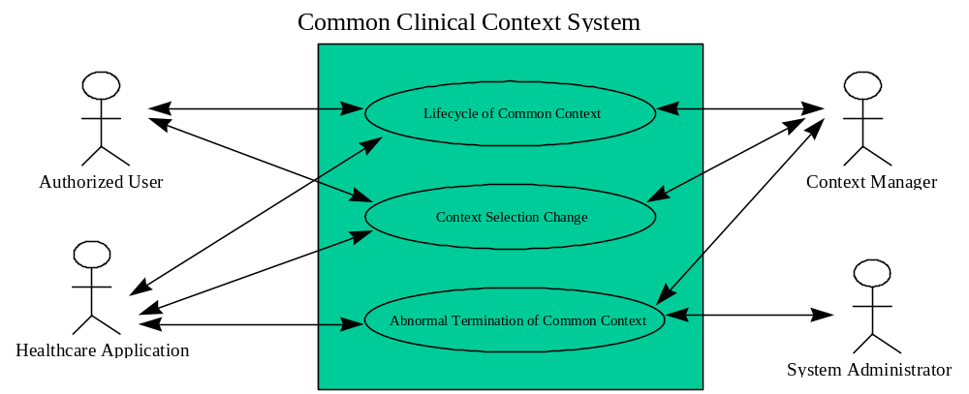
Figure 14. Common Clinical Context Use Model
The common clinical context system is presented by providing a diagram of each use case followed by interaction diagrams illustrating different behavioral flows of the associated use case. Each use case has an associated description, which is provided below. Further, for brevity the specific interface names (ContextManager, ContextParticipant, and ContextData) are not used; their abbreviations are used instead (CM, CP, and CD). Also, the word “interface” is abbreviated to “iface”. The diagram notes (illustrated as a sheet of paper with corner folded over) are from a software developer’s perspective, not the user of the application.

Lifecycle of Common Context
A common context does not initially exist. An application must establish the common context. The common context ceases to exist when there are no longer any applications participating in the common context. Figure 15, Interaction Diagram 1, and Interaction Diagram 2 illustrate this use case.
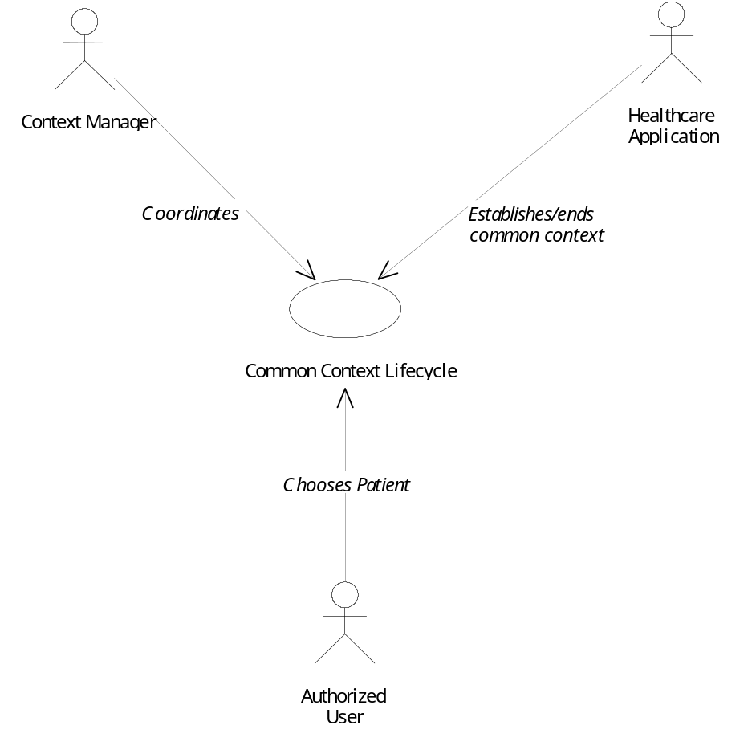
Figure 15. Common Context Lifecycle Use Case
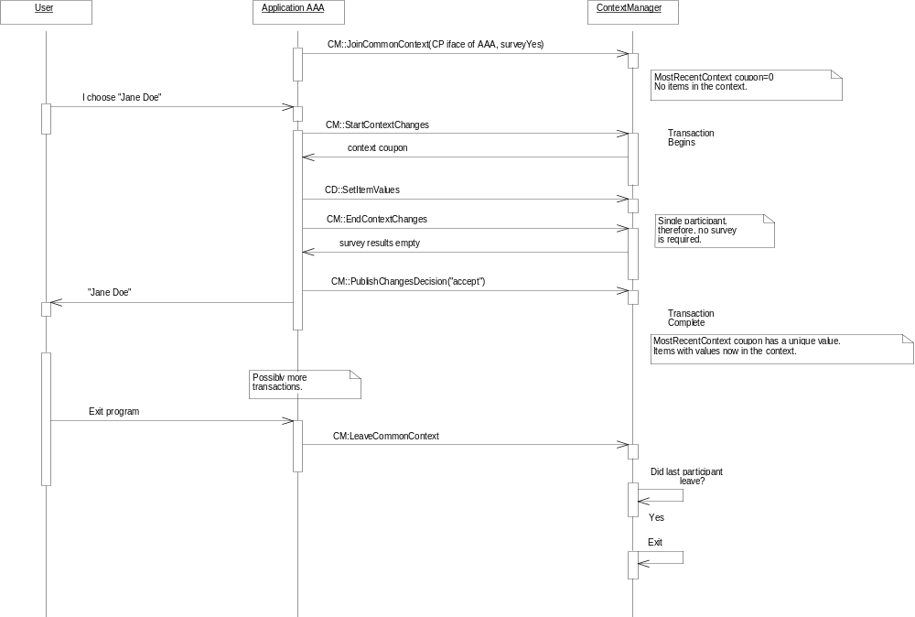
Interaction Diagram 1. Common Context Lifecycle
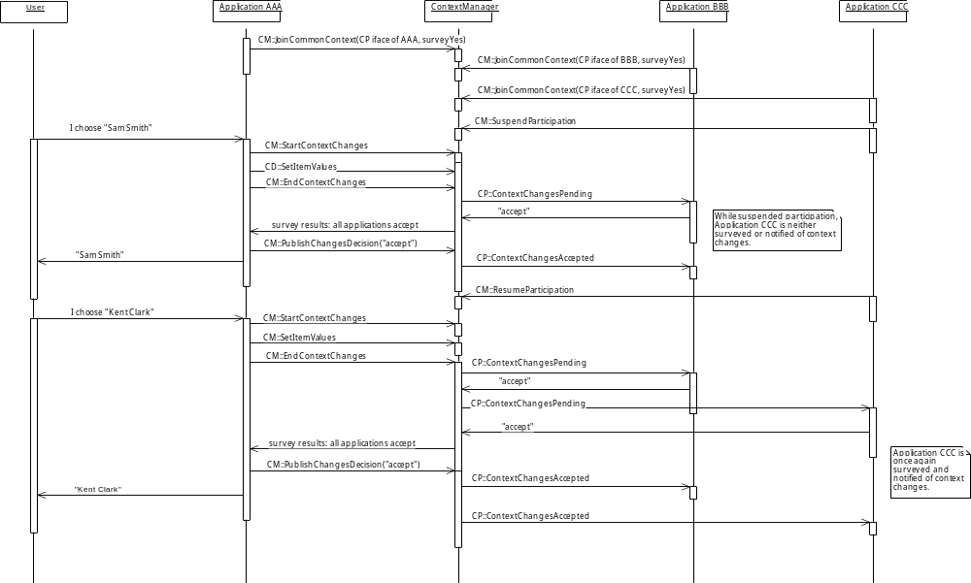
Interaction Diagram 2. Suspending/Resuming Context Participation

Context Selection Change Use Case
The Context Selection Change use case assumes a patient context has been established. The user is currently focused on one application, while several other healthcare applications may be executing on the same host machine. The user chooses to change the selected patient from “Jane Doe” to “Sam Smith”.
Figure 16 illustrates this use case. There are several possible instances of this use case which are provided in Interaction Diagram 3 through Interaction Diagram 10.
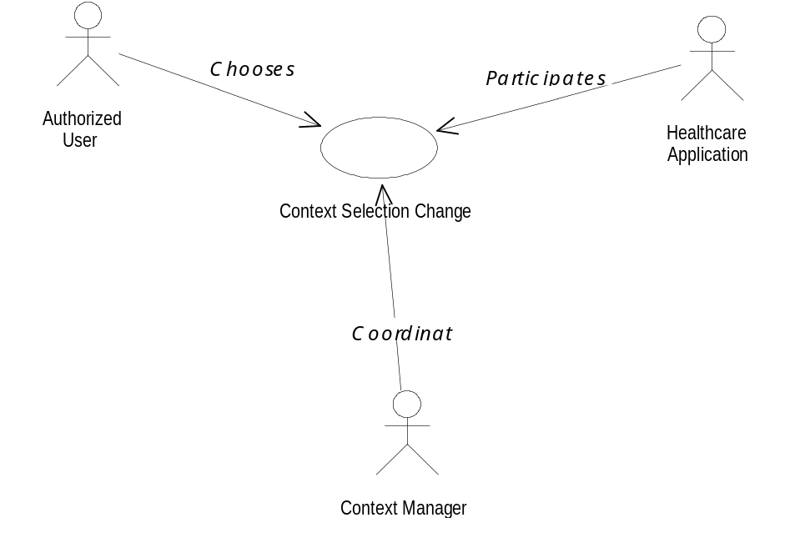
Figure 16. Context Selection Change Use Case
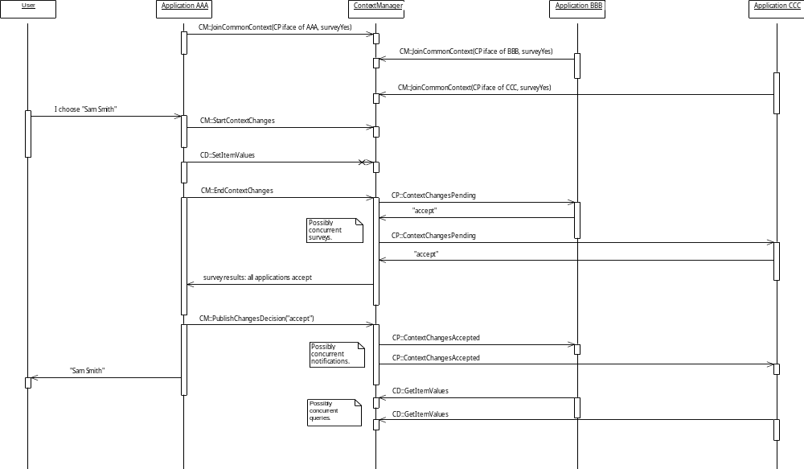
Interaction Diagram 3. All applications accept the changes
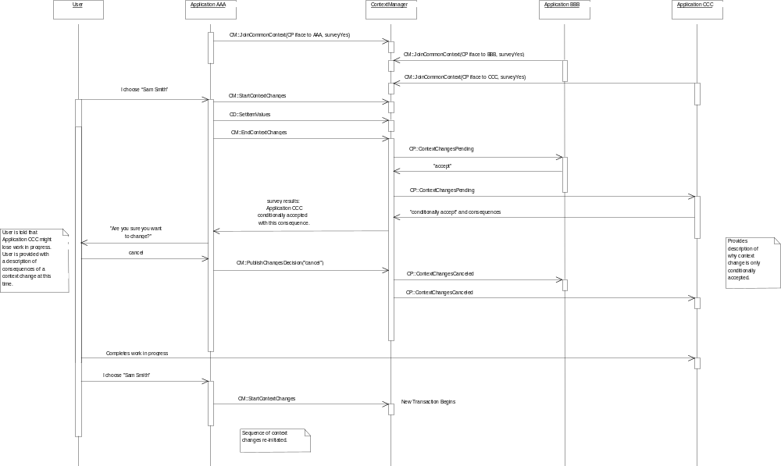
Interaction Diagram 4. An application conditionally accepts the changes; user decides to cancel changes
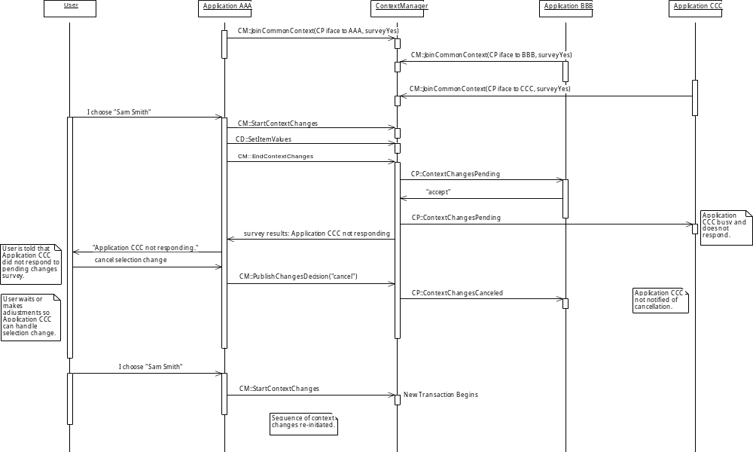
Interaction Diagram 5. An application does not respond to survey
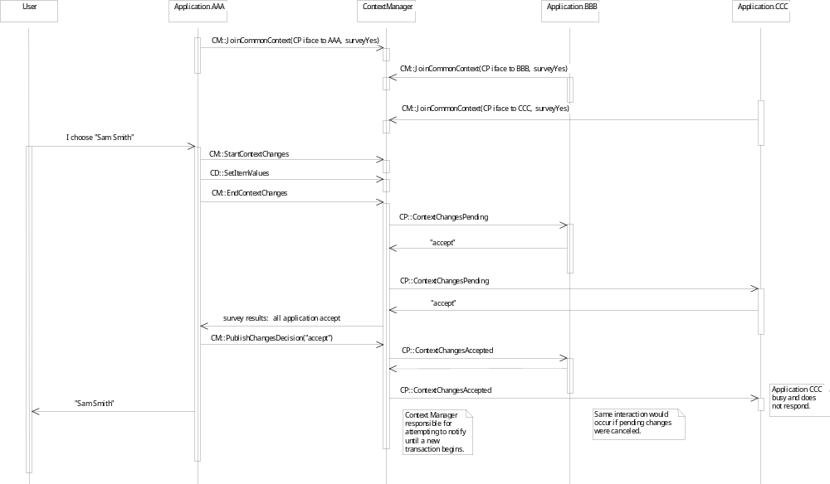
Interaction Diagram 6. An application does not respond to change notification
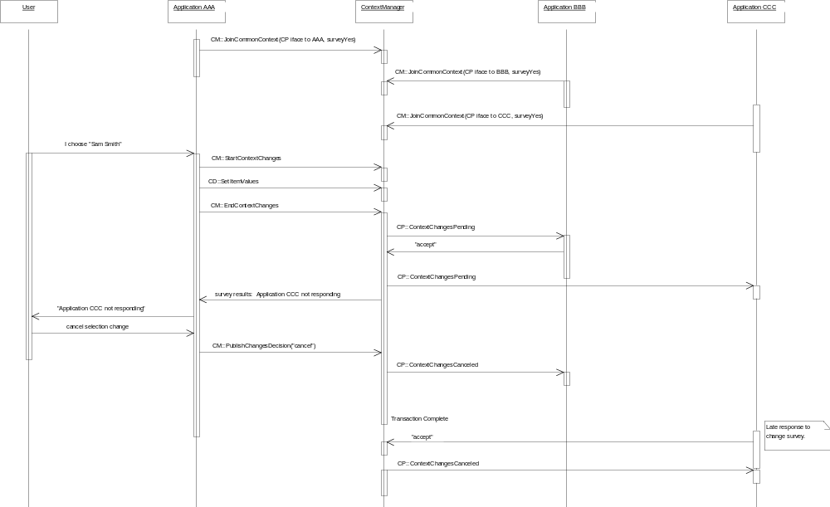
Interaction Diagram 7. An application responds after context change transaction has completed
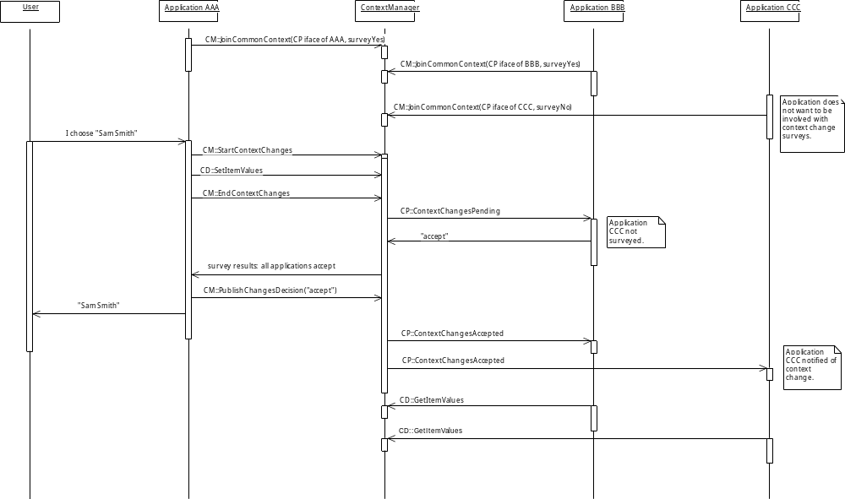
Interaction Diagram 8. A non-surveyed application participates in context change
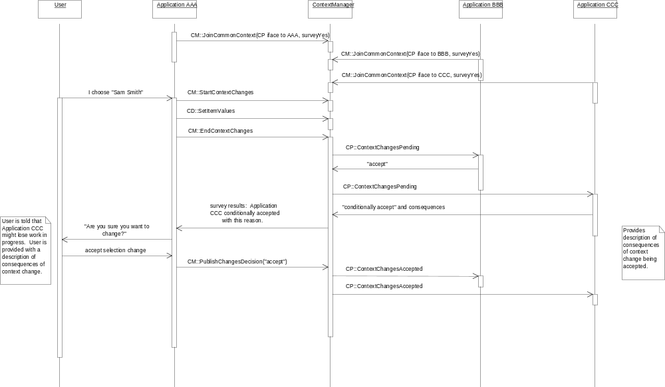
Interaction Diagram 9. An application conditionally accepts the changes; user decides to accept consequences of change
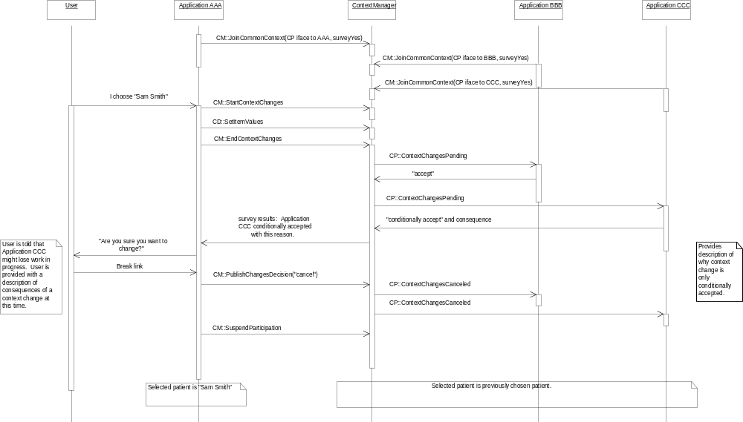
Interaction Diagram 10. An application conditionally accepts the changes; user breaks link with common context

Abnormal Termination of Common Context Use Case
The Abnormal Termination of Common Context Use Case involves a system administrator forcing the termination of the context manager through some action. The common context participants are notified of the termination of the common context.
Figure 17 illustrates the abnormal termination use case while Interaction Diagram 11 captures an instance of this case.
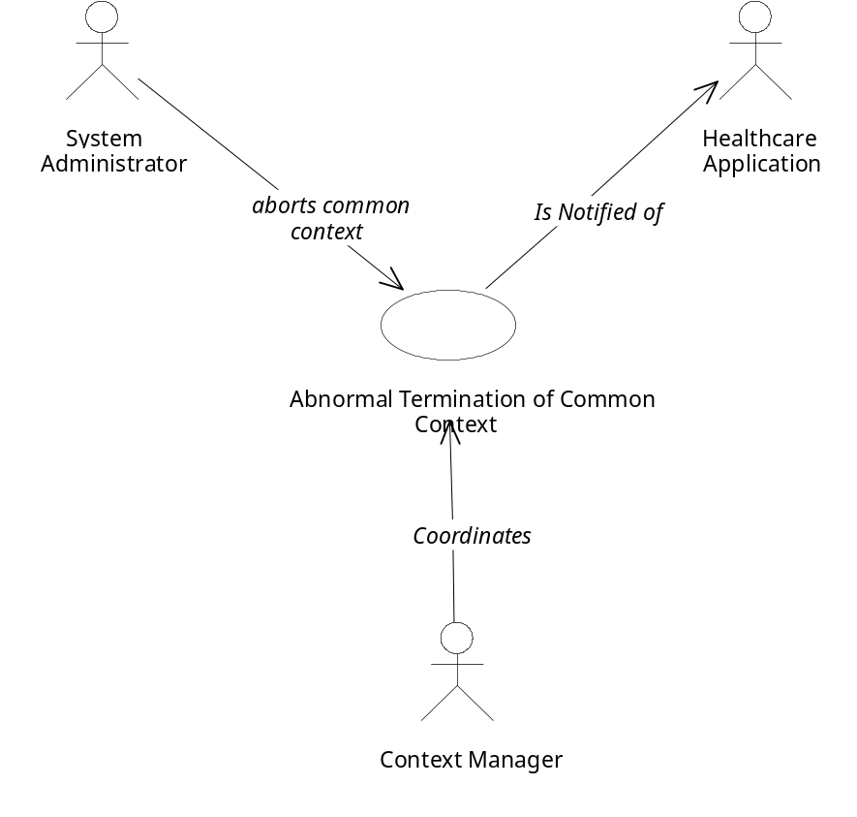
Figure 17. Abnormal Termination of Common Context Use Case
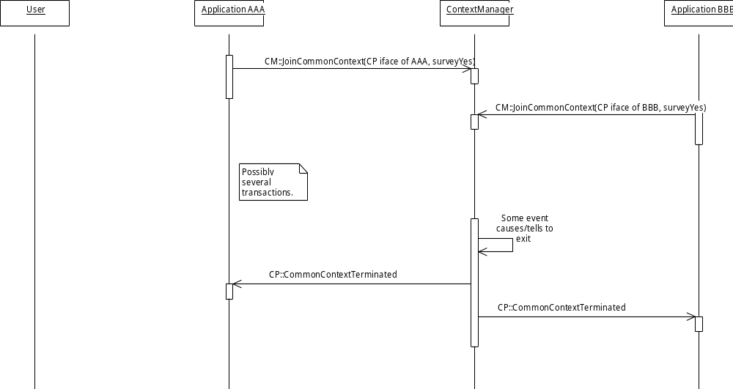
Interaction Diagram 11: Abnormal Termination of Common Context

Optimizations
There are several optimizations that have been designed into the specification. These optimizations are reflected in the interface specifications described in Chapter 17:
- An application can indicate that it never wants to participate in the survey conducted by the context manager when the context data changes. The context manager will assume that such applications always accept the changes. Read-only data displays represent a class of applications for which this capability is useful.
- An application can selectively suspend its participation in the surveying process without actually leaving the common context. This enables an application to perform computational tasks without being interrupted by context changes. This also enables an application to minimize its use of computational resources if it is in a state (e.g., minimized) in which responding to context changes provides no benefit to the user. The application can subsequently resume its participation in the common context. The capability to suspend and resume is an optimized alternative to joining and leaving the common context.
- An application can be a participant in only those transactions during which context subjects that are of interest to the application are set.
- An application can obtain just the context items from the subjects that were altered by the most recent change transaction. This capability will become increasingly useful as additional common context data items are defined.
- Multiple common context items can be accessed by an application in a single invocation of a context manager method. This optimizes performance by reducing the number of calls an application needs to make to access context items.
- When an application is notified about a context change, it is also provided with the context coupon value that it needs in order to access the context data. This simplifies the design of applications because they do not necessarily need to keep track of context coupon values.
- Context managers can be implemented to conduct the change survey and the subsequent change notifications in a concurrent manner, thereby decreasing the amount of time it takes to complete these computations.
Additional optimizations, such as enabling applications to indicate their interest in only being notified when specific context data items change are candidates for future enhancements.

The Simplest Application
The responsibilities that an application must implement in order to behave properly as a participant in a common context session depends upon the application’s functionality. Applications that need to participate in the context change survey must implement straightforward but non-trivial behaviors. However, for many applications it will suffice to implement a very small set of behaviors. Specifically, the simplest participants are those that do not participate in the survey, do not set the context data, and only want to be informed when context changes have been accepted. These applications only need to do the following:
- Join the common context session via the context manager’s ContextManager interface.
- Implement the ContextParticipant method that enables the application to be informed about accepted context changes.
- Use the context manager’s ContextFilter interface to instruct the context manager to survey and notify the application only when specific subjects that are of interest to the application are set.
- Access the context data via the context manager’s ContextData interface.
- Leave the common context session upon termination, via the context manager’s ContextManager interface.
As the interaction diagram below illustrates, this amounts to implementing one method for ContextParticipant. (The others can be stubbed with trivial default behaviors.) It also requires using two ContextManager methods: one to join and one to leave a common context session. Finally, it requires using one ContextData method to access the context data. The application does not necessarily need to keep track of the value of the context change coupon, as the context manager each time a change occurs provides the correct coupon value to the notified application. The result is that simple applications are not penalized for being co-participants with applications that have more sophisticated needs.
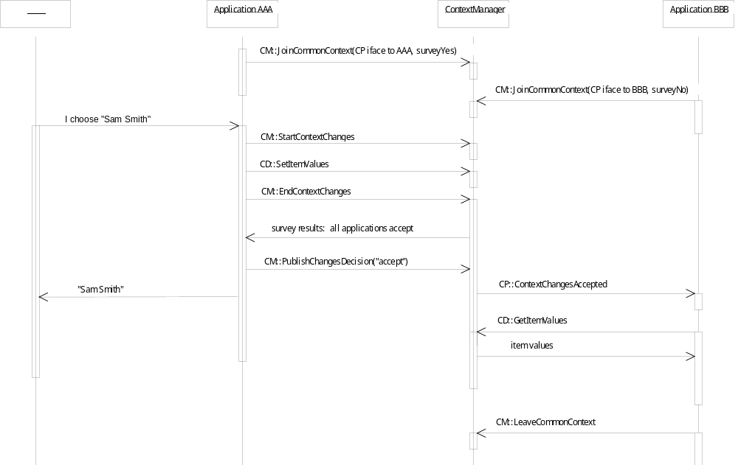
Interaction Diagram 12. Simplest Application

Mapping Agents
A mapping agent is a context agent that provides a common context system with a means to automatically supply multiple synonymous identifiers for the same real-world entity or concept, even when only one identifier is known to the application used to instigate a context change. This mapping is performed in a manner that is transparent to the user and to the applications in the context system.
For example, multiple medical record numbers within a healthcare enterprise might identify a patient. However, each application might only be able to denote a particular patient via just one of these identifiers. When the user selects a patient using such an application, the application sets the new patient context using the patient identifier it knows. The context manager automatically delegates the task of mapping the provided identifier to additional identifiers to a mapping agent. A master patient index system might serve as the basis for implementing a mapping agent capable of mapping patient identifiers.
Mapping agents are not necessarily needed in order to realize a useful and correctly functioning common context system. Specifically, mapping agents are not needed when each real-world entity or concept has a single identifier that is already known to all of the applications in the common context system. For example, there are healthcare enterprises that have a uniform way to identify their patients. A patient mapping agent for a context system in such an enterprise is not necessary.

Assumptions and Assertions
It is not an objective of the CMA to define how mapping agents should be implemented or to prescribe or assume a particular mapping agent implementation. Instead, a mapping agent is treated as an abstraction. Interfaces are defined that enable mapping agents to be connected to context managers for the purpose of aiding in the mapping of context identifiers between multiple identifier spaces.
Additional assumptions and assertions include:
- When present, the mapping agent is the authority within a common context system on the mapping between context identifiers for a specific identity subject.
- There may be at most one mapping agent per subject, and the agent for a subject may only map the data for that subject.
- A mapping agent does not allow an identifier to map to more than one real-world entity or concept (e.g., a patient mapping agent does not allow a patient identifier to map to more than one patient).
- There is at most one mapping agent per context subject per context system. (Behind the “scenes” mapping agents may work together, or may be implemented using a single common service. However, this is not visible to the context manager or the context participants.)
- A context manager does not know about the mapping agent implementation; a context manager only “sees” a mapping agent through its CMA-defined interface.
- Context participant applications do not “know” about the mapping agent (or even if there is one); the mapping agent does not “know” about context participant applications.
- The mapping agent may reside on a computer that is remote from the computer(s) upon which the context manager(s) they serve reside; however, these computers must be connected by a LAN or WAN whose performance is LAN-equivalent.
- Mapping agents are an optional component of a CMA context management system.

Interfaces
The following interfaces are defined for and implemented by mapping agents:
- ContextAgent (CA) – used by the context manager to inform a mapping agent that the clinical context has changes pending and that the mapping agent should perform its context data mapping responsibilities.
- ImplementationInformation (II) - used by a context manager to obtain details about who implemented the mapping agent, when it was installed, etc., for the purpose of creating detailed error reports.
In addition, mapping agents set/get context data items using the context manager’s ContextData and/or SecureContextData interfaces.
The mapping agent interfaces are modeled and illustrated in Figure 12. Component Architecture.

Theory of Operation
Assume, first, that one or more context participants have already joined the same common context and that they are connected to the context manager. Further, assume that the context manager already has an interface reference to each mapping agent’s ContextAgent interface. How these references are obtained is described in Section 10.3.2, Initializing a Context Session When a Mapping Agent is Present.
Given these conditions, a context participant instigates a context change transaction via the context manager’s ContextManager interface, sets the new context data via context manager’s ContextData or SecureContextData interface, and then indicates it is done setting the data via the context manager’s ContextManager interface.
At this point, before the other context participants are surveyed, the manager informs each mapping agent that the context data has changes pending, via each mapping agent’s ContextAgent interface. The proposed context data items that are available to the mapping agent are exactly as the instigating participant set them.
Applications (including the instigating application) are not allowed to set context item values after the instigating application has completed its changes. However, the context manager does allow mapping agents to add data to the context (i.e., the mapped context item values).
In order to enable a mapping agent to map the necessary data, the context manager presents the proposed context to the mapping agent via the agent’s ContextAgent interface. Specifically, the data just for the context subject that the mapping agent is supposed to map is presented to the agent. The mapping agent returns the data it has mapped to the context manager also via the agent’s ContextAgent interface.
The context manager shall only allow a mapping agent to map data for the context subject that the agent is the mapping agent for (i.e., the patient mapping agent may only map the context data for the patient subject). Further, the context manager shall only allow a mapping agent to add data to a subject. A mapping agent is not allowed to change the data value for any context item for which a value has already been set.
Once the mapping agent has completed its mapping tasks, the context manager surveys the context participants and processing of the context change transaction is performed as usual. With this approach, all of the synonymous values for an identifier will be set before the other applications are informed via a context manager-initiated survey that the context has been set.
However, if the instigating application has set multiple values for a context identifier, and the mapping agent detects an inconsistency among these values, then it informs the context manager that the context change transaction has been invalidated. This is because the mapping agent is the authority in a context system when it comes to mappings between identifiers. Allowing the transaction to proceed could create confusion about the context among the other context participants.
The details about the conditions under which a mapping agent can invalidate a context change transaction are described in 10.3.7 Conditions for Mapping Agent Invalidation of Context Changes.
When the mapping agent invalidates a context change transaction, the context manager does not survey the participating applications. Instead, the context manager informs the instigating application that the transaction has been invalidated. The instigating application then asks the user to intervene to decide how to proceed.
The user can decide (via a dialog presented by the application that was used to instigate the context change) whether to cancel the context change or to break the instigating application away from the common context session. In either case, the context change transaction is terminated and the context changes are discarded. Additional identifiers are not mapped and the other applications are not surveyed.
This approach gives the user the option of applying the context changes to just the application used to instigate the context change while also preventing the other applications from becoming confused about the context.
The details of this situation are described in 10.3.8 Treatment of Mapping Agent Invalidation of Context Changes.

Mapping Agents and Secure Context Subjects
Only the mapping agent designated for setting the context for a specific secure context subject shall be allowed by a context manager to set the data for the subject. A mapping agent for a secure context subject must implement all or the policies and behaviors specified for See Chapter 12, Theory of Operation for Secure Links.

Initializing a Context Session When a Mapping Agent is Present
A mapping agent and the context manager it serves must be connected to each other. There are two ways in which this can be accomplished. Either the context manager connects to the mapping agent, or the mapping agent connects to the context manager. The order in which this connection occurs has significant impact on complexity and computing resource utilization.
The mapping agent could conceivably locate and connect to a context manager the same way a context participant does. This requires that the connection be made before the first time a context participant application sets the context. This is so that the mapping agent can be instructed by the context manager to perform its mapping tasks.
A consequence of this approach is that a context manager will execute even if it is not actively servicing any context participants. Further, the requirement that the connection be made before the first time a context participant application sets the context introduces initialization-sequencing complexities.
In general there is no way to know when the first context participant will connect to a context manager, so the only prudent recourse would be to launch the context manager and the mapping agent as part of the boot-up process for the point-of-use device they serve. This would complicate the installation process for context managers and mapping agents.
The alternative is for the context manager to connect to the mapping agent. This approach enables the connection to be deferred until the mapping agent is needed to service a context participant. However, a means by which context managers can locate the necessary mapping agent must be established.
Fortunately, the fact that there is only one mapping agent per context subject enables the location process to be easily implemented using the technology-specific context management registry. Specifically, a reference to a mapping agent’s principal interface is entered into the context management registry. The symbolic name and/or description of the interface within the registry indicates the context subject that the mapping agent maps. The context manager obtains this reference and uses it to interrogate the mapping agent to obtain references to its other interfaces, such as ContextAgent.
An additional benefit of the manager-connects-with-agent approach is that it is not even necessary for distinct connect/disconnect methods to be defined. Instead, the context manager simply informs the mapping agent whenever the context manager has changes pending. The context manager explicitly provides a reference to its principal interface to the mapping agent. If necessary, the mapping agent then interrogates the context manager via its principal interface to obtain a reference to other context manager agent interfaces, such as SecureBinding (which is used by mapping agents for secure subjects).
The sequence of events is shown in Interaction Diagram 13. Context Change Transaction with Mapping Agent.

Calling Sequence When Multiple Mapping Agents are Present
The order in which mapping agents for unrelated context subjects are informed by the context manager about a pending context change is not specified. The context manager may inform unrelated mapping agents about a context change in a serial or concurrent manner.
However, a mapping agent for a dependent subject is informed about a pending context change only after the mapping agent for the subject it depends on has been informed. The order in which mapping agents for context subjects that depend upon the same subject are informed is not specified.

Terminating a Context Session When a Mapping Agent is Present
To enable the orderly termination of the context session, the context manager shall implicitly or explicitly dispose of any mapping agent interface references that it possesses prior to terminating. The mapping agent shall dispose of any context manager interface references that it possesses when it has completed its mapping actions for a context change transaction. The means by which these disposals are effected is technology-specific.
The consequence of these disposals is that at the end of a context change transaction, only context participant applications will possess context manager interface references. If there are no participants, then the context manager can properly terminate. (Participants dispose of any context manager interface references that they possess prior to terminating. See Section 6.1.5, Interface Reference Management.) This also means that once the context manager terminates, the mapping agent can also properly terminate.
Interaction Diagram 13. Context Change Transaction with Mapping Agent

Context manager
Context participant
Mapping Agent
ContextManager::JoinCommonContext()
ContextManager::JoinCommonContext()
ContextManager::StartContextChanges()
ContextData::SetItemValues()
ContextManager::EndContextChanges()
ContextAgent::ContextChangesPending(), inputs contain data to map
Return from ContextChangesPending, outputs contain mapped data
Return from EndContextChanges()
Surveying the other context participants occurs here

Distinguishing Between Mapping Agents and Context Participants
When a mapping agent is informed that a context change is pending, the context manager provides it with two coupons. One coupon denotes the context change transaction; the other denotes the mapping agent. The mapping agent coupon is not the same as any of the coupons assigned by the context manager to the context participants. Each type of mapping agent shall have a unique coupon value, as described in Section 17.2.10, Pre-Defined Context Agent Coupons.
The mapping agent shall use the coupon that denotes it whenever it needs to denote itself to the context manager, for example for creating a secure binding (See Section 17.3.12, SecureBinding (SB)). The context manager uses this coupon to distinguish between mapping agents and context participants, as well as to determine the specific type of agent (e.g., patient mapping agent, user mapping agent. etc).

Mapping Agent Updates to Context Data
A mapping agent shall only add additional context identifier and corroborating data items to the context as part of its mapping activities. Additions to the context for these types of context data items are primarily for the benefit of the context participants other than the application that instigated the context change. This is because it cannot be assumed that the instigating application will re-read these context data items once it has completed its context changes. In contrast, the other applications do not read the new context until they are surveyed, which occurs after the mapping agent has added data to the context.
If a mapping agent was allowed to change the values for identifier or corroborating context data items that have been set by the instigating application, it could be confusing to the user. This is because the user might see differences between the context data as displayed by the instigating application and as displayed by the other context participant applications.
Given this concern, a mapping agent shall not alter the values of any of the identifier or corroborating context data items that have already been set by the instigating participant as part of the proposed context. Any attempt to alter existing context data items by the mapping agent shall result in the context manager raising an exception.
A mapping agent shall not delete identifier or corroborating context data items. Any attempt to delete context data items by the mapping agent shall result in the context manager raising an exception.

Conditions for Mapping Agent Invalidation of Context Changes
A context subject is comprised of a set of context data items, each of which is represented as name/value pairs (see Section 5.4, Context Data Representation, and Section 5.6, Context Data Interpretation). It is the responsibility of every application that sets these items to ensure that they are self-consistent. However, there are a variety of potential item name and/or item value inconsistencies that a mapping agent must be able to detect.
Specifically, if an application has set multiple values for a context identifier item, and the mapping agent determines that these values do not all identify the same real-world entity or concept (e.g., patient), the mapping agent shall invalidate the context change transaction.
Specifically, a mapping agent shall invalidate a context change transaction when:
- The instigating application sets more than one value for the same context identifier item, but the mapping agent determines that at least two of these values identify different entities or concepts.
- The instigating application sets more than one value for the same context identifier item, but the mapping agent knows that at least one of these values is inconsistent with the other values.
There are situations in which the mapping agent must not invalidate a context change transaction even though there are apparent context item inconsistencies. A mapping agent must not flag what it believes to be inconsistencies when in fact the suspect items might represent reasonable application behaviors.
The following scenarios illustrate the desired mapping agent behaviors, in this case for a patient mapping agent. Assume that there are two patients, each with identifiers for two sites, and the mapping agent is able to map the patient identifiers for both sites:
 |  | Patients and Their Site-Specific Identifiers
Institution | John Doe | Jim Smith
St. Elsewhere Hospital | 123-456-789Q36 | 155-213-424Y82
St. Elsewhere Clinic | 2888-91922-W928 | 18291-81293-D812
The first two scenarios represent inconsistencies that the mapping agent must respond by invalidating the context change transaction. The last three scenarios represent inconsistencies that the mapping agent must ignore:
 | What the instigating application does… | Example… | What the mapping agent does…
1 | Sets two identifier values, both with the intent of denoting John Doe, but the values erroneously denote John Doe and Jim Smith. | Item identifies John Doe:  [Patient.Id.MRN.St_Elsewhere_Hospital,  123-456-789Q36]  Item erroneously identifies Jim Smith:  [Patient.Id.MRN.St_Elsewhere_Clinic,  18291-81293-D812] | Invalidates the context change transaction because the first identifier value denotes John Doe, while the second denotes Jim Smith.  Mapping is not performed.
2 | Sets more than one identifier pair, both with the intent of denoting John Doe. The first value is John Doe’s hospital identifier, but the second value is not John Doe’s clinic identifier. | Item identifies John Doe:  [Patient.Id.MRN.St_Elsewhere_Hospital,  123-456-789Q36]  Item does not identify John Doe:  [Patient.Id.MRN.St_Elsewhere_Clinic,  0000-00000-0000] | Invalidates the context change transaction because while the first identifier value is John Doe’s hospital identifier, the second value is known not to be John Doe’s clinic identifier.  Mapping is not performed.
3 | Sets only one context identifier item and the name of the item is not known to the mapping agent. | Item name not known to mapping agent:  [Patient.Id.MRN.General_Hospital,  6668-3923-987122] | Ignores this situation and does not inform the context manager about inconsistencies.  Mapping is not performed.
4 | Sets more than one value for a context identifier item, and one or more of the item names are not known to the mapping agent. | Item name known to mapping agent:  [Patient.Id.MRN.St_Elsewhere_Hospital,  123-456-789Q36]  Item name not known to mapping agent:  [Patient.Id.MRN.General_Hospital,  6668-3923-987122] | Ignores this situation and does not inform the context manager about inconsistencies.  Mapping is performed.
5 | Sets the corroborating or annotating data to values that are different (or incomplete) as compared to the corroborating or annotating data known to the mapping agent | Application sets corroborating data containing the identified patient’s name to “Jack Doe” but mapping agent knows the identified patient as “John Doe”. | Ignores this situation and does not inform the context manager about inconsistencies.  Mapping is performed.
In summary, detectable inconsistencies between identifier values are the only reason that a mapping agent shall invalidate a transaction. Transactions shall not be invalidated when unknown identifier names are used by an application or because of corroborating or annotating data inconsistencies.

Treatment of Mapping Agent Invalidation of Context Changes
Applications that instigate context change transactions and then explicitly set more than one identifier during a context change transaction shall explicitly handle the situation in which a mapping agent invalidates a context change transaction. (Applications that set only one identifier do not need to handle this situation.)
An instigating application is not provided with a means to distinguish between the invalidation of a context change transaction and the presence of a busy application. These are clearly different situations, but are to be handled by an instigating application in the same way. The application shall present a dialog that clearly indicates that a problem has been encountered while attempting to change the common context.
The dialog shall include a description of the problem that was encountered. The dialog shall also enable the user to cancel the context change or to break the link between the instigating applications and the other applications.
When the mapping agent has invalidated a transaction it shall not be possible for the user to force a common context change. If the user decides to break the link between the instigating application and the other applications, instigating application shall only apply the context change to itself. This application shall break away from the common context and shall clearly indicate to the user that it is not participating in the common context.
If the user cancels the context change, then the instigating application shall indicate this fact to the context manager. Both the instigating application and the context manager shall discard the current transaction. The context manager shall not survey the other applications.
Independent of the reason for which the mapping agent invalidated the transaction, the context manager shall always provide to the instigating application the same user-friendly description of the problem that was encountered. This is in order to keep things simple for the user, who is unlikely to be concerned about the details of what went wrong. This description shall be included in the dialog by the instigating application.
The appearance of the dialog and the commands that the user can choose from are specified in each of the HL7 context management technology-specific user interface specification documents. The wording for the user-friendly description that is included in the dialog is also specified in these documents. This will ensure a consistent and familiar set of interactions for users across CMA-conformant applications.
The sequence of events that occur when a mapping agent invalidates a context change transaction is shown in Interaction Diagram 14: Mapping Agent Invalidates Context Change Transaction.

Mapping Null-Valued Identifiers
A mapping agent shall not perform any mapping when the context subject is empty (See Section 5.6.9, Representing an Empty Context). The net effect is that the context subject remains empty, and all of the applications see the context as such.
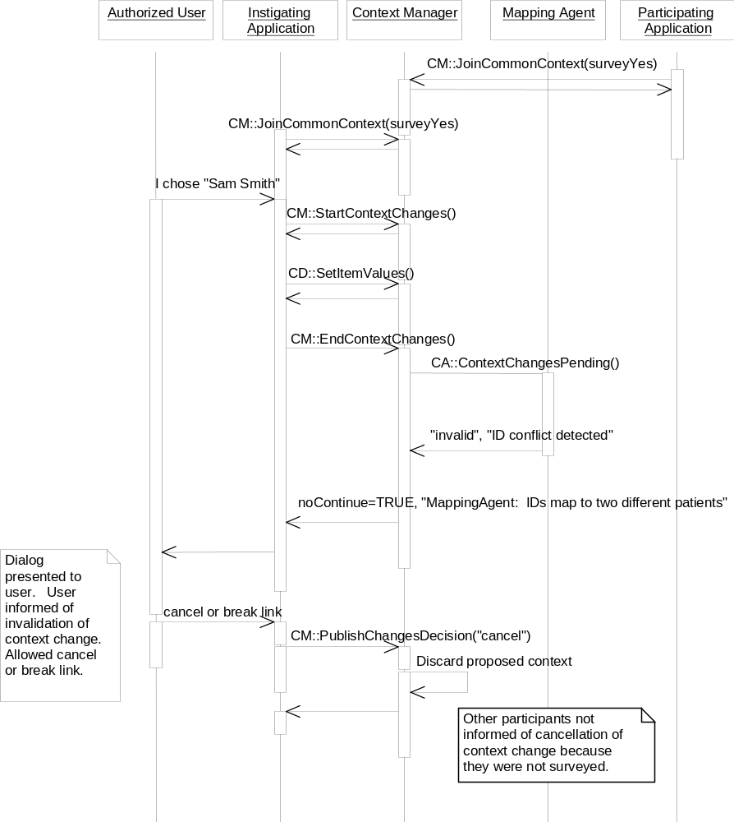
Interaction Diagram 14: Mapping Agent Invalidates Context Change Transaction

Initializing Mapping Agents
Different mapping agent implementations may require different initialization methods. For example, a mapping agent might need to authenticate the current user in order to enforce security policies. Other than being automatically launched by a context manager, the additional steps needed to initialize a mapping agent are implementation issues and are not addressed by this specification. (Future versions of the CMA specification may provide standardized ways of initializing mapping agents.)
It can be the case that different mapping agent implementations will require different explicit or implicit actions on the part of the user to complete their initialization tasks. An example of an explicit user action is signing on to the mapping agent via a mapping agent-supplied dialog. An example of an implicit user action is signing on to a context participant application that relays its authentication of the user to the mapping agent; this obviously implies a relationship with the mapping agent that goes beyond this specification.

Handling Mapping Agent Failures
A context manager must be able to detect and handle the failure of a mapping agent. Specifically, a context manager shall behave in a robust manner even if its calls to a mapping agent’s ContextAgent interface do not return in a timely manner.
The recourse, after a timeout has occurred, is for the context manager to continue with the normal processing of the context change transaction. If the mapping agent has indeed failed, then some of the context participants may not be able to interpret the next context. However, this fail-soft approach still enables the user to perform useful work until the mapping agent failure is corrected.
Finally, even if a mapping agent has failed, a context manager shall continue to try to access the mapping agent during subsequent transactions on the prospect that the failure has been corrected. In doing so, the context manager may need to obtain a new interface reference for the mapping agent (because the old reference may no longer be valid).
Note that this policy of continually attempting to access a failed mapping agent also applies even when a context manager is first launched. It may be the case that a mapping agent becomes available after the context manager has begun executing. (See Section 10.3.10, Initializing Mapping Agents, for one explanation of why this might happen.) A context manager that does not locate and initiate a mapping agent when it is launched shall nevertheless keep trying between and/or during context change transactions. It is an implementation decision as to how the performance impact of this policy is minimized.

Mapping Agent Effect on Application Security Policies
Mapping agents may implement their own security policies in terms of what context data it will map for a particular user. Mapping agent security policies can differ from the policies of the participating applications. For example, a mapping agent’s policies might effect what patients a user can, or cannot, access.
When the mapping agent’s policy is more restrictive than one or more of the participating application’s, a mapping agent might elect to not map an identifier because doing so would violate the security rules known to the mapping agent. When the mapping agent’s policy is less restrictive than one or more of the participating applications, each application’s own security policy will be the predominating policy for the current change transaction.
A mapping agent that elects to not map an identifier because of security concerns shall not indicate this fact to the user. The user will simply observe that access to the selected subject is not possible through one or more of the participating applications. These applications do not know that the identifier for the selected patient has not been mapped because of the mapping agent’s security policy. Instead, it looks to the applications as though a subject has been selected but the identifier(s) by which the subject is known to the applications has not been provided. These applications behave as specified for in Section 9.11.3, Application Behavior When it Does Not Understand Context Identifiers.

Identifying Mapping Agent Implementations
Context managers use a mapping agent’s ImplementationInformation interface to provide system administrators with a description of the mapping agent implementation it is using. This information can help system administrators diagnose run-time problems that involve mapping agents.
The ImplementationInformation interface shall be supported by all mapping agent implementations. A context manager shall not interact with a mapping agent that does not support this interface.

Performance Costs and Optimizations
When present, a mapping agent will be involved in every context change transaction. This adds an overhead to the context change transaction in the form of the added communication between the context manager and the mapping agent, and for the time it takes for the mapping agent to validate the identifiers and provide any additional mappings for the identifiers. However, these costs are viewed as being worth the benefits of the semantic integrity that a mapping agent brings to a context system.
In some cases, a mapping agent will be implemented using an underlying application that provides its own user interface, for example, for patient selection. This type of mapping agent is, in effect, both a mapping agent and a context participant application. In the case in which this underlying application is used to instigate a context change, performing identifier validations and mappings is superfluous. It is possible to optimize the mapping agent implementation so that it does not perform identifier validations and mappings when it knows that it was essentially itself that instigated a context change.
However, the only information that is readily available to the mapping agent that could help it determine this fact is the context change coupon. This coupon is provided by the context manager to an application when the application starts a context change transaction. This coupon is also provided by the context manager to the mapping agent via its ContextAgent interface during each context change transaction.
It is an implementation decision as to how the portion of an application that implements a mapping agent obtains the value of the context coupon from the portion of the application that instigates a context change transaction.

Annotation Agents
An annotation agent is a context agent that provides a common context system with a means to automatically supply additional data that describes a particular context subject.
This data is provided in a manner that is transparent to the user and to the applications in the context system.
For example, a user certificate annotation agent might provide the data that represents a users digital certificate. This certificate would be the certificate for the user currently identified in the user subject.
In some cases an annotation agent for a specific annotation subject may be an optional enhancement to a context system. In other cases, in order to achieve the desired context sharing capabilities, an annotation agent for a specific annotation subject may be a required component.

Assumptions and Assertions
It is not an objective of the CMA to define how annotation agents should be implemented or to prescribe or assume a particular annotation agent implementation. Instead, an annotation agent is treated as an abstraction. Interfaces are defined that enable annotation agents to be connected to context managers for the purpose of setting annotation data during the course of a context change transaction.
Additional assumptions and assertions include:
- When present, the annotation agent is the authority within a common context system on the content for its annotation subject.
- There is at most one annotation agent per annotation subject per context system. (Behind the “scenes” annotation agents may work together, or may be implemented using a single common service. However, this is not visible to the context manager or the context participants.)
- A context manager does not know about the annotation agent implementation; a context manager only “sees” an annotation agent through its CMA-defined interface.
- Context participant applications do not “know” about the annotation agent (or even if there is one); the annotation agent does not “know” about context participant applications.
- The annotation agent may reside on a computer that is remote from the computer (s) upon which the context manager(s) they serve reside; however, these computers must be connected by a LAN or WAN whose performance is LAN-equivalent.
- Annotation agents are an optional component of a CMA context management system.

Interfaces
The following interfaces are defined for and implemented by mapping agents:
- ContextAgent (CA) - used by a context manager to inform an annotation agent that the clinical context has changes pending and that the annotation agent should set the necessary annotation data.
- ImplementationInformation (II) - used by a context manager to obtain details about who implemented the annotation agent, when it was installed, etc., for the purpose of creating detailed error reports.
In addition, annotation agents set/get context data items using the context manager’s ContextData and/or SecureContextData interfaces.
The annotation agent interfaces are modeled and illustrated in Figure 12. Component Architecture.

Theory of Operation
The theory of operation for an annotation agent is essentially the same as for a mapping agent. (See Chapter 10, Mapping Agents.) However:
- Annotation agents are not informed about the pending context change until all of the mapping agents have been informed and have completed their mapping process.
- An annotation agent may not set data for a context subject other than the annotation subject that it corresponds to. An annotation agent that attempts to do so will be presented with an exception by the context manager.
- Only the annotation agent may set the context data for the context subject that it is the agent for. Other agents, and context participants, may not set the data for the agent’s subject.
- An annotation agent may not invalidate a context change transaction.
Further, annotation subjects can be a secure. Only the annotation agent designated for setting the context for a specific secure annotation subject shall be allowed by a context manager to set the data for the subject. See Chapter 12, Theory of Operation for Secure Links.

Theory of Operation for Secure Links
This chapter describes Context Management Architecture (CMA) support for secure links. With secure links, only applications with the appropriate access privileges are allowed by the context manager to set and/or get the context data for the subject represented by the link. Whether or not the context subject represented by a link is secure is defined in the subject's data definition and is invariant across sites. However, the necessary application access privileges are configured on a site-specific basis.
Secure links are an extension of CMA support for common links. Specifically, support for secure links add security capabilities that not only enable the creation of the User Link capability, but which also serve as a foundation for future subjects that require security.
In order to accomplish this, the architecture for common links is extended. The interfaces defined for common links are used unchanged: ContextManager, ContextParticipant, and ImplementationInformation. Two additional security-related interfaces are defined: SecureContextData, which is modeled upon the common link interface ContextData, and SecureBinding, which enables a trusted relationship to be established between applications and components. Further, the interface ContextAgent, which replaces the deprecated interface MappingAgent, enables a trusted relationship to be established between the context manager and context agents.
Additional capabilities for secure links include:
- The provider institution decides which applications are to be trusted.
- In keeping with the CMA philosophy, the approach is conceived for low re-engineering costs.
The architecture that supports these capabilities is described next.

Secure Link Terms
The following terms are used to describe the theory of operation for secure links:
- Secure Link-enabled application - an application that implements the CMA secure link capability.
- Empty context – a context is not defined for a particular identity subject, either because no context identifier items are present in the subject’s context data (as is the case when a context manager is first initialized) or because the values of all of the identifier items for the subject that are present in the context data are null (as is the case when an application explicitly indicates that the context is empty).

Point-of-Use Device Assumptions
The following assumptions are made about the point-of-use device upon which Secure Link-enabled applications are deployed:
- The point-of-use devices upon which Secure Link-enabled applications are deployed may reside in physically unsecured locations.
- While recommended, it may not be the case that appropriate security precautions have been taken to restrict the types of operating system-level actions, such as installing new programs, that users can perform on point-of-use devices that reside in physically unsecured locations.
In summary, the CMA is intended to be no less secure than the Secure Link-enabled applications would be were they not Secure Link-enabled. In general, Secure Link-enabled applications will be substantially more secure.

Secure Link Common Context System Description
Consistent with the CMA support for common links, accessible from each point-of-use device are applications that are context participants, a context management registry, and a context manager. The applications perform context change transactions.
However, the secure context is communicated throughout the common context system in a secure manner. This is to prevent people from accidentally or maliciously controlling applications that are Secure Link-enabled.
The necessary security is achieved by adding capabilities to the CMA that enable the realization of a “chain of trust” among the Secure Link-enabled applications and associated CMA components. With the chain of trust, Secure Link-enabled applications and CMA components work together to mutually authenticate their mutual interactions, thereby providing the basis for ensuring that only authorized users are allowed access to a common context system.
The chain of trust not only simplifies the overall solution, but results in a system that is more secure than would be the case if authentication data were part of the common context, and were therefore vulnerable to security attacks directed against the context manager or context agent.
The chain of trust is specified in Chapter 15.

Authenticating Secure Subject Access
The data definition for each context subject shall stipulate whether or not the subject is secure. A secure subject is one for which attempts by an application or agent to set and/or get the subject’s data must first be authenticated by the context manager. In so doing, the context manager must ensure that the application or agent is among those listed as being allowed to set and/or get the subject’s data. The list of applications and agent access privileges is configured into the context manager on a site-specific basis. The means for doing this are not specified by the CMA.
There are two types of security available for secure subjects. Subjects for which applications and agents must have appropriate privileges to set and/or get the subject’s data shall be specified in their data definitions as “Secure subject, authenticated sets and gets.” Subjects for which applications and agents must have appropriate privileges to set the subject’s data, but for which any application or agent may get the subject’s data, shall be specified in their data definitions as “Secure subject, authenticated sets only.”

Secure Mapping Agent
A secure mapping agent may be part of the common context system. A secure mapping agent implements the CMA security policies and secure interfaces defined for implementing secure links. There may be at most one secure mapping agent for each secure subject. The context manager enforces access privileges for mapping agents that map secure subjects.

Secure Annotation Agent
A secure annotation agent may be part of the common context system. A secure annotation agent implements the CMA security policies and secure interfaces defined for implementing secure links. There may be at most one secure annotation agent for each secure annotation subject. The context manager enforces access privileges for annotation agents that set secure subjects.

Context Management Interfaces
The context management interfaces defined for secure links are similar to the ones defined for common links. A context participant still implements ContextParticipant (CP). The context manager still implements ContextManager (CM), but it also implements the following interfaces:
- SecureContextData (SD) - Similar to the ContextData interface defined for common links, this interface is used by applications to securely set/get the values for the items (logically represented as name-value pairs) that comprise the clinical context.
- SecureBinding (SB) - Used by applications to establish a secure communications binding with the context manager before using the SecureContextData interface.
The interfaces implemented by a secure mapping agent are ContextAgent (CA) and ImplementationInformation (II). These are the same interfaces as defined for a common mapping agent.

Overall Secure Link Component Architecture
The overall Secure Link architecture (including the Common Link Architecture) is illustrated in Figure 18. Component Architecture for Secure Links. (A description for how to interpret the notation used in this diagram appears in the appendix Diagramming Conventions.)
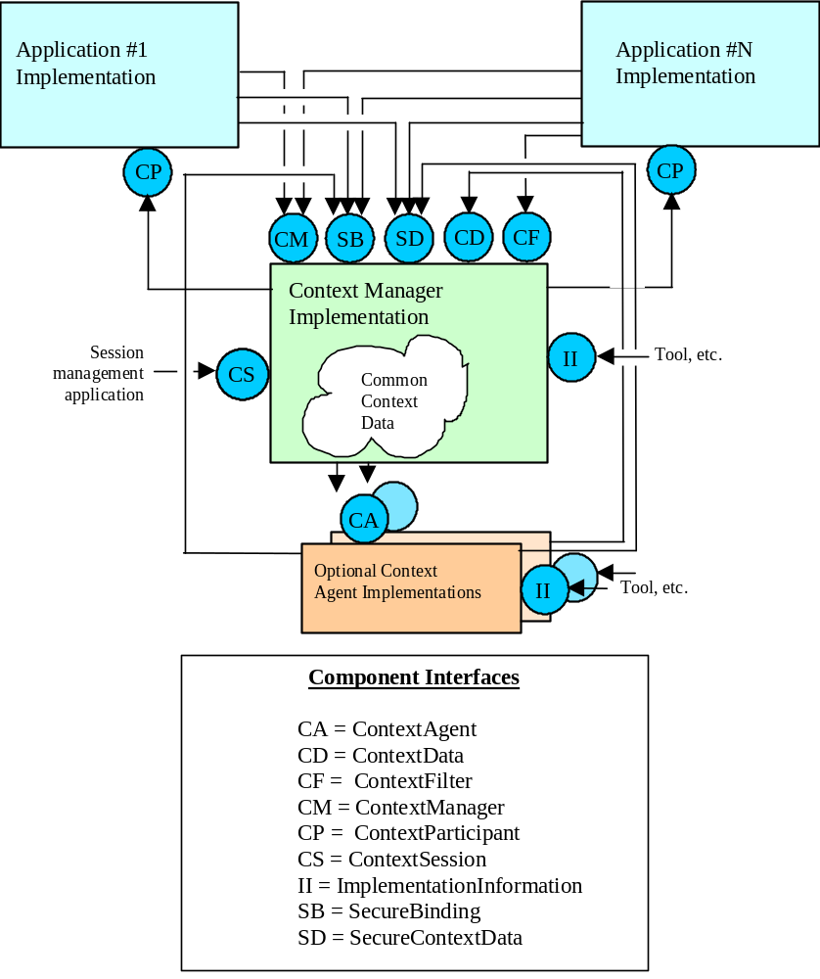
Figure 18. Component Architecture for Secure Links

Process for Setting a Secure Context Subject
The process for performing a context change transaction to set a secure context is essentially the same as defined for common subjects:
- An instigating application initiates a context change transaction and sets the secure context within the context manager. This context contains the appropriate data for the secure subject.
- The context manager consults the secure mapping agent (if present) and it adds data to the context manager’s secure context
- The context manager surveys the other applications, and if the transaction completes, they obtain pertinent secure context data from the context manager.
As an example using “User Link”, the high-level events that transpire when an application sets secure context data are summarized in Figure 21. User Link Context Change Process. This description assumes that a user mapping agent is present. The user mapping agent is presumed to know the logon names for all users for all applications. (See Section 14.6.1, User Mapping Agent.) The description omits most of the details pertaining to the surveying of the participant applications by the context manager. This process is identical to the process defined for Patient Link. (See Chapter 13.)
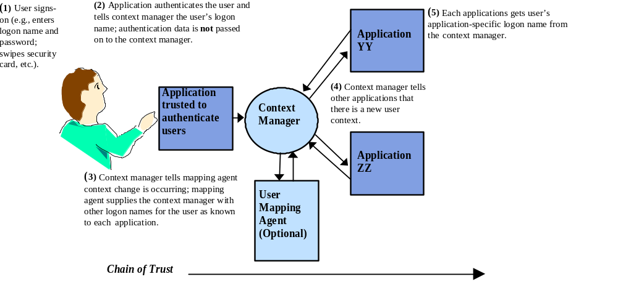
Figure 19. User Link Sign-On Process

Designating Applications for Setting/Getting Secure Subjects
Any Secure Link-enabled application has the potential to set secure context data for use by all other Secure Link-enabled applications accessible from a point-of-use device. Similarly, any Secure Link-enabled application has the potential to get secure context data that has been set by another Secure Link-enabled application accessible from a point-of-use device.
However, depending upon the type of security defined for a particular context subject, each site may designate on a per-application basis whether or not the Secure Link-enabled application is allowed to get and/or set the context data items for the subject. Only the applications designated as allowed to set the data items for the subject shall be allowed by a context manager to do so. Only the applications designated as allowed to get the data items for the subject shall be allowed by a context manager to do so.
The one exception to this rule is that any application shall be allowed to set any secure subject to empty.
A context manager implementation-specific configuration process is used to designate, for each secure subject, which applications are allowed to set and/or get the items for the subject. One, several, or all of the Secure Link-enabled applications accessible from a point-of-use device can be designated as being allowed to set and/or get the data items for a secure subject. It is recommend that a healthcare institution analyze the use cases for their clinical applications to determine how to best deploy Secure Link-enabled applications.
The decision criteria for a provider institution’s choice of whether to designate an application for setting and/or getting secure subject data is based upon whether they trust the application’s security capabilities as it pertains to that secure subject data. For example, for applications that set the user context (i.e. User Link), it might not be a good choice to designate an application that maintains user passwords in plain text (which can easily be read by unauthorized users).

Busy Applications
When a context change transaction is conducted, it is possible that an application is unable to participate because it is busy. For example, a single-threaded application that has a modal dialog open will not be able to respond until the dialog is closed.
This situation is dealt with for secure links in the same way as for common links. Specifically, a busy application effectively prevents a context change transaction from occurring. The only option for the application that instigated the transaction is to ask the user if they want to break the link.
However, breaking the link has the potential to compromise security. As an example using User Link, with a broken link, multiple users could effectively be logged on to different applications that are nevertheless participants in the same context session.
This situation is not substantially different from breaking the link for a common subject, which results in different applications that are accessed from the same point-of-use device being tuned to different common subjects.

Patient Link Theory of Operation
Patient Link enables the user to select a patient once, from any Patient Link-enabled application, as the means for automatically “tuning” all of the Patient Link-enabled applications in the common context system to the same patient. Patient Link is an exemplar of a common link.

Patient Link Component Architecture
Patient Link is a common link. The optional additional component of a patient mapping agent is defined, as described below.

Patient Subject
The context identity subject of Patient is defined for Patient Link. The context data identifier item for this subject is an alphanumeric patient identifier, such as a medical record number. The patient’s name is not used as an identifier.
The Patient subject is not dependent upon any other subject.
This identifier is unlikely to be universally unique. However, it is assumed that a population of patients across which the identifier is unique can be established. Each such population is referred to as a site, as it is typical that each population of patients corresponds to a physical site within an overall healthcare institution.
Consequently, a single patient may be identified using multiple patient subject identifier items. Each item is differentiated by a different site-specific suffix. An application shall be configurable such that it can be instructed on-site as to which suffix (of suffices) it is to use when it interacts with the context manager to set or get patient context data.
The format of a patient subject identifier item name includes a site-specific suffix. Use of this suffix, and the values that may be assigned to this suffix, is at the discretion of each healthcare institution at which a context management system is deployed.
In addition to identifier items, the patient subject also supports corroborating and annotating data items. The actual names, meaning, and data types used to represent the values for these context data items are defined in the document Health Level-Seven Standard Subject Data Definitions.
An example of a patient subject identifier item appears below:
Example Item Name | Example Item Value
Patient.Id.MRN.St_Elsewhere_Hospital | RAS1958-12939213-122

Patient Mapping Agent
An optional patient mapping agent is also part of the common context system. The patient mapping agent maps the identifiers for patients. Whenever an application sets the patient context, the context manager instructs the patient mapping agent (if present) to provide any additional identifiers it knows for the patient. The site-suffix for each of the mapped identifier items denotes the site for which the patient identifier is valid, for example:
Example Item Names | Example Item Values
Patient.Id.MRN.St_Elsewhere_Hospital  Patient.Id.MRN.General_Hospital | 123-456-789Q36  6668-3923-987122
Mapping agents are described in detail in Chapter 10.

Patient Link Context Change Process
The process for performing a context change transaction is as defined for common links in general. (See Section 9.4, Context Change Transactions.)

Stat Admissions
A stat admission occurs when an application needs to enable the user to record information about a patient even if an identifier for the patient is not known. In this case, the application should indicate to the user that it is breaking its participation in the patient context, and then break its participation upon user confirmation. This is because it is not possible for the application to identify the patient, which is needed in order to change the common context. The only reasonable recourse is for the application to break its participation in the common context.

User Link Theory of Operation
This chapter describes CMA support for User Link. With User Link, a user can securely sign on to any User Link-enabled application accessible from a point-of-use device using just one logon name and one means of authentication (such as a password) .
User Link is an exemplar of a secure link. It also adds the following additional capabilities:
- The provider institution decides which applications are to be trusted to authenticate users.
- There can be multiple ways to authenticate users, including passwords, biometrics, etc.
- In keeping with the CMA philosophy, the User Link approach is conceived for low re-engineering costs.
The architecture that supports these capabilities is described next.

User Link Terms
The following terms are used to describe the User Link theory of operation:
- User Link-enabled application - an application that implements the CMA User Link capability.
- Sign on – the act of identifying oneself to an application, prior to initiating a user session, in a manner that can be authenticated by the application, typically involving a secret password or a biometric reading (such as a thumb-print scan).
- Log-off – the termination of a user’s session with an application.

Point-of-Use Device Assumptions
The following assumptions are made about the point-of-use device from which User Link-enabled applications are accessible:
- Logging-off from an application does not require user authentication.
- The devices upon from User Link-enabled applications are accessible may reside in physically unsecured locations.
- While recommended, it may not be the case that appropriate security precautions have been taken to restrict the types of operating system-level actions, such as installing new programs, that users can perform on devices that reside in physically unsecured locations.
In summary, the CMA is intended to be no less secure than the User Linked applications would be were they not User Linked. In general, User Linked applications will be substantially more secure.

User Link Component Architecture
User Link is a secure link. The architecture for User Link also defines a user mapping agent and an authentication repository as optional additional components, as described below.

User Subject
The context identity subject of User is defined for User Link. This is a secure subject, with authenticated sets only. The context data identifier item for this subject is the user’s logon name. A logon name denotes a user to an application. A user’s logon name is generally different from their given name.
The User subject is not dependent upon any other subject.
This identifier is unlikely to be universally unique. However, it is assumed that a population of users across which each logon name is unique can be established. Each such population is referred to as an application, as it is typical that within an overall healthcare institution each population of users corresponds to a particular application.
Consequently, a single user may be identified using multiple user subject identifier items. Each item is differentiated by a different application-specific suffix. An application shall be configurable such that it can be instructed on-site as to which suffix (or suffices) it is to use when it interacts with the context manager to set or get user context data.
The format of a user subject identifier item name includes an application-specific suffix. Use of this suffix, and the values that may be assigned to this suffix, is at the discretion of each healthcare institution at which a context management system is deployed.
In addition to identifier items, the user subject also supports corroborating data items. The actual names, meaning, and data types used to represent these context data items are defined in the document Health Level-Seven Standard Context Management Specification, Data Definition: User Subject.
An example of a user subject identifier item appears below:
Example Item Name | Example Item Value
User.Id.Logon.3M_Clinical_Workstation | robs

User Authentication Data Is Not Part of the User Context
The data used to authenticate a user is not included as part of the user context data. This data is typically a password, but it can be any data that is used to authenticate a user, such as a biometric sample. Instead, each application is expected to be able to sign on a user given just the application-specific logon name for the user.
This approach substantially reduces security risks because the data used by an application to authenticate the user remains private to the application. If this data were part of the user context, it would be vulnerable to undesired access. However, in order for applications to tune to the user context, they must trust that the context data is authentic. The means by which this is accomplished is referred to as the “chain of trust” and is described below.

User Link Common Context System Description
A common context system that supports User Link includes context participant applications, a context manager, and two optional components: a user mapping agent, and an authentication repository. These optional components are described next.

User Mapping Agent
An optional user mapping agent may be part of the common context system that supports User Link. The user mapping agent maps the logon names for users. The user mapping agent is similar to, but distinct from, the patient mapping agent (although a single mapping agent implementation could fulfill both roles).
Whenever an application sets the user context, the context manager instructs the user mapping agent (if present) to provide any additional logon names it knows for the user. The application suffix for each of the mapped identifier items denotes the application for which the mapped logon name is valid, for example:
Example Item Names | Example Item Values
User.Id.Logon.3M_Clinical_Workstation  User.Id.Logon.Medicalogic_Logician  User.Id.Logon.HP_CareVue | robs  rob_seliger  r_seliger

Authentication Repository
In order to make it practical to re-engineer existing applications to support the chain of trust, the CMA authentication repository component is defined. This repository enables applications to securely store and retrieve application-specific user authentication data. The repository is used by applications that do not have a built-in means to easily sign on a user given only a logon name.
- AuthenticationRepository (AR) - Used by applications to securely interact with the repository to store and retrieve user authentication data.
- SecureBinding (SB) – Used by applications to establish a secure communications binding with the repository before using the AuthenticationRepository interface. This is the same interface that the context manager implements.
- ImplementationInformation (II ) – Originally defined for the patient mapping agent, this interface is added to the authentication repository so that applications, other components, and tools, can obtain details about the authentication repository, including its revision, when it was installed, etc.

Overall User Link Component Architecture
The overall User Link architecture (including support for common links such as Patient Link) is illustrated in Figure 20. User Link Component Architecture. (A description for how to interpret the notation used in this diagram appears in the appendix Diagramming Conventions.)
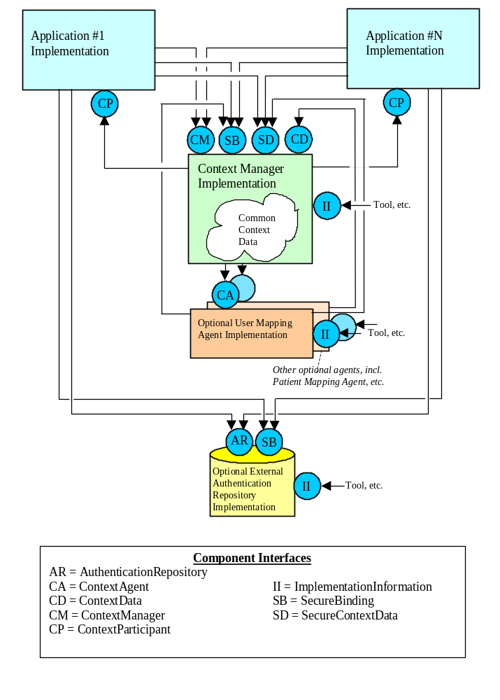
Figure 20. User Link Component Architecture

User Link Context Change Process
The process for performing a context change transaction to set the user context is the same as defined for secure links in general. However, the process may optionally include the use of an authentication repository.
The high-level events that transpire when a user signs-on are summarized in Figure 21. User Link Context Change Process. This description assumes that a user mapping agent is present and that a user digital certificate annotation agent is present. The user mapping agent is presumed to know the logon names for all users for all applications. (See Section 14.17, Populating the User Mapping Agent.) The user certification annotation agent is presumed to know the digital certificates for all users. The description omits most of the details pertaining to the surveying of the participant applications by the context manager. This process is identical to the process defined for Patient Link. (See Chapter 13.)
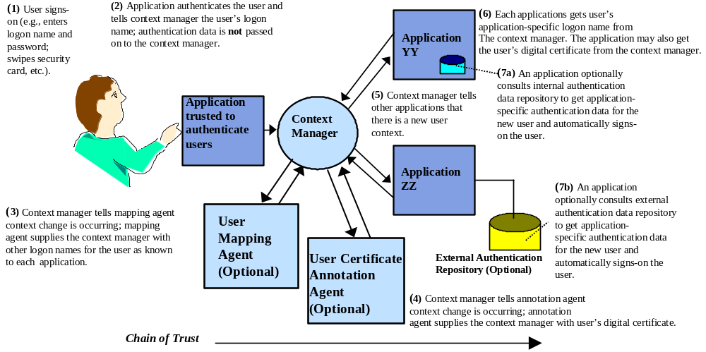
Figure 21. User Link Context Change Process

Designating Applications for User Authentication
Any User Link-enabled application can serve as the means by which a user signs-on to all of the User Link-enabled applications accessible from a point-of-use device. To serve in this capacity, the User Link-enabled application shall provide a mechanism for establishing and authenticating the user’s identity.
The CMA does not specify an application’s user authentication mechanism, visual appearance, or implementation. The authentication mechanisms can vary among applications. Applications can be created whose sole purpose is to enable user authentication for devices that provide access to User Linked applications.
However, even though any User Link-enabled application has the potential to be used for signing on to a device that provides access to User Linked applications, the provider institution designates the specific application or applications it trusts for this task. Only the designated applications shall be allowed by a context manager to complete a context change transaction that involves a change to the user subject.
The one exception to this rule is that any application shall be allowed to set the user subject to empty. This is so that any application can be used to log-off from all User Linked applications that are participants in a context session. (See Section 14.13, Logging-Off and Application Termination.)
A context manager implementation-specific configuration process is used for indicating the designated applications. One, several, or all of the User Link-enabled applications can be designated for this purpose. The designated applications for a device can differ among devices. It is recommend that a healthcare institution analyze the use cases for their clinical applications to determine how to best deploy User Link.
The decision criteria for a provider institution’s choice of whether to designate an application for authenticating users is based upon whether they trust the application’s security capabilities as it pertains to user authentication. For example, it might not be a good choice to designate an application that maintains user passwords in plain text (which can easily be read by unauthorized users).

Signing on to Applications Not Designated for Authenticating Users
A User Link-enabled application that has not been designated for authenticating users on a particular device shall not allow the user to sign on to the application or set the user subject. The user must sign on to a designated application in order to sign on to a linked but non-designated application. The user must break a non-designated application’s link with the common context in order to sign on to just the application.
If the application has not been designated for authenticating users and it is the first to be launched on from a device, the user must either launch an application that has been designated for authenticating users, or the user must break the link of the non-designated application. The user can then sign on to just the non-designated application.
The CMA does specify a means by which an application can determine whether it has been designated for authenticating users. See Section 17.3.12, SecureBinding (SB). This enables an application to determine whether it has been designated before a user attempts to sign on to the application. An application can use this information to present or hide its user interface user sign on controls accordingly.

Application Behavior When Launched
When a User Link-enabled application is launched, it shall join the active common context session for the device being used to access the application. The application shall set its user context to match the current user context. If the application is Patient Link-enabled, it shall also set its patient context to match the current patient context. The application may decide as to whether or not it will also set its internal state to match other context subjects that are set for the context session.

Access Control Lists
Access control lists (ACL), which determine the privileges and capabilities a particular user has, are presumed to be maintained by each application. While it is desirable that there be only one centrally administered ACL, achieving this is beyond the scope of the CMA. However, before central or distributed ACL’s can be properly used it is essential that the user be authenticated. This is precisely the capability that User Link supports.

Changing Users
With User Link, it is advantageous for applications to support a change-user capability. This capability enables a new user to sign on to the active context session without explicitly requiring that the current user first log off. There are two ways in which this can be implemented by an application:
- The application performs a single user context change transaction to establish the new user as the current user.
- The application performs a two-step process. In the first step, the current user is logged off and the user context is set to empty (to indicate that there is no user). In the second step, the new user is signed on, and the user context is set to indicate who the new user is.
The first approach is recommended because it is the simplest and the most efficient from the perspective of the context system (e.g., only one context change transaction per user change). The second approach is acceptable, however the two-step process should be invisible to users.
The gestures needed to change the user, and the appearance of an application as it pertains to this capability, are not specified by the CMA.

Logging-Off and Application Termination
User Link provides applications with an easy way to enable users to:
- Terminate a specific User Linked application.
- Log off from a specific User Linked application.
- Log off from all of the User Linked applications that are participants in the same context session.
There are many possible ways in which these capabilities can be realized in a common context system. The approach described in Table 1. User Link-Enabled Application Behavior for Termination and Log-Off is defined because it is simple for users to understand, yet enables design flexibility for application developers.
Table 1. User Link-Enabled Application Behavior for Termination and Log-Off
User Action | Effect on Application That User’s Action Is Directed At | Effect on the Common Context | Effect on Other User Linked Applications in the Context Session
Terminate a specific User Linked application. | Application leaves the common context, ceases execution, and exits | None. | None.
Log-off from a specific User Linked application.  See Interaction Diagram 15. User Logs Off From One Application. | Application:  - continues to run,  - logs the user off,  - visually indicates that it has no user,  - leaves common context (i.e., breaks link) | None. | None.
Log-off from all of the User Linked applications that are participants in the same context session.  See Interaction Diagram 16. User Logs-Off From . | Application:  - continues to run,  - instigates a context change transaction to set the user context to empty,  - visually indicates that it has no user,  - continues to be a context participant. | User subject set to empty. | When the context change is completed, each application:  - continues to run,  - logs the user off,  - visually indicates that it has no user,  - continues to be a context participant.
The basic idea is that each User Link-enabled application optionally supports gestures that enable the user to terminate the application, log off from just the application, or log off from all of the User Linked applications that are participants in the same context session.
All User Link-enabled applications must behave properly as participants in a context change transaction, as described in Table 1. All User Link-enabled applications must be able to properly deal with the context when the user context is empty.
However, the CMA does not specify the user gestures that are needed to initiate the actions described in Table 1. The gestures may be different among applications. Further, an application may chose which action gestures, if any, it will support. For example, a particular application might not enable the user to terminate it, log off from it, or log off from all User Linked applications in a session.
An application that enables the user to log off shall clearly indicate that in doing so, the user will cause the application to break its link with the common context session.
There are several subtleties involved with the behaviors described in Table 1:
- Any application can set the user context to empty, including applications that have not been designated for authenticating users. This enables any application to be used for logging off from all of the User Linked applications in a session.
- A user might terminate the application(s) designated for authenticating users. The next user will need to re-launch one of the designated applications before being able to sign on to the User Linked applications.
- It is conceivable that the collective capabilities of a particular set of User Link-enabled applications results in a system that does not provide any way for the user to log off from a context session. A site must be mindful in its choice of applications in order to prevent this from happening.
One issue with context session log off is the treatment of “busy” applications. Busy applications affect session sign on as well as session log-off, and is dealt with in Section 12.6, Busy Applications.
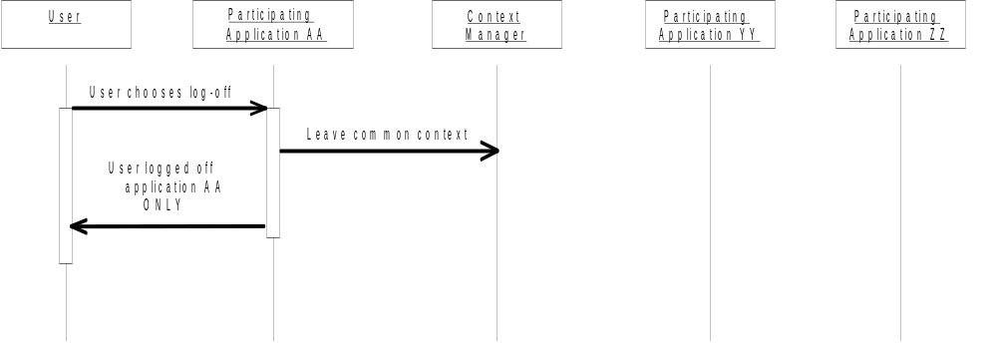
Interaction Diagram 15. User Logs Off From One Application
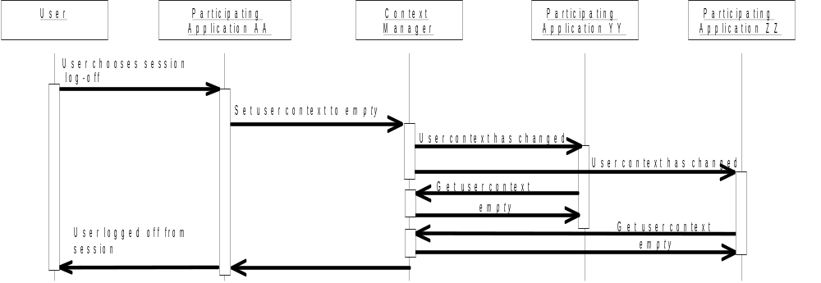
Interaction Diagram 16. User Logs-Off From Context Session

Automatic Log-Off
An automatic log-off logs the current user off of the User Linked applications that are participants in a context session when the user has not interacted with the applications for an appreciable period of time.
Any application can initiate an automatic log-off by performing a context change transaction that sets the user context to empty. This will have the effect of causing all of the other User Linked applications in the same context session to also log the user off. Once an automatic log-off has completed, the next user signs-on via one of the designated applications.
In contrast to a user-initiated log-off, an automatic log-off is initiated automatically by an application. The CMA does not specify an automatic log-off policy or implementation. It is an application decision as to how and when to initiate an automatic log-off.
For example, an application might monitor user interactions with the mouse and keyboard to determine whether or not the user is actually engaged in using any of the applications in the context session. The capability to do this depends upon the application’s implementation and the underlying point-of-use device technology.
An application that initiates a context change transaction to affect an automatic log-off must be prepared to handle the condition in which surveyed applications are busy, or have responded with a conditional accept of the transaction. In this case the instigating application shall cancel the context change transaction. It shall not present a dialog to the user, as this could be disruptive or confusing to the user. The application may elect to initiate an automatic log-off again in the future.
It is necessary that the administrator is able to configure the behavior of automatic log-off as it pertains to a session. Otherwise, the administrator has no control over an application whose policy for initiating an automatic log-off interferes with the users’ work.
Therefore, any application that initiates an automatic log-off shall provide a means for controlling this capability. Specifically, it shall be possible to configure that application in terms of whether the log-off it initiates is session-wide (and therefore affects all of the context participants in the session), or is limited to just the application. If the automatic log-off is limited to just the application, then the application shall not perform a context change transaction when the automatic log-off interval transpires. Instead, it shall just log the user off from itself.

Re-authentication Time-out
A re-authentication time-out requires the currently signed-on user to re-authenticate herself before being allowed to continue using the applications that are participants in the same context session. The time-out occurs when the user has not interacted with the applications for an appreciable period of time. Applications maintain their internal state as the user left it prior to the time-out, but interaction with the applications cannot resume until the user has been reauthenticated.
The time-out often manifests as a screen that overlays the entire display and that provides a mechanism with which the user can re-authenticate herself. However, the CMA does not specify a re-authentication time-out policy, visual appearance, or implementation.
Any application can initiate a re-authentication time-out. However, a User Link-enabled application that does so shall be:
- responsible for enabling the user to re-authenticate herself
- configurable such that a systems administrator can enable or disable the time-out capability.
These requirements enable sites to practice the following CMA recommendation: only a User Link-enabled application that has been designated for authenticating users should be allowed to initiate a re-authentication time-out. This enables the user to re-authenticate herself using an application that is also normally used for signing on to a context session.
This recommendation avoids the problem of forcing the user to be re-authenticated by an application not normally used for signing on, and therefore having to remember their logon name and password for the application.
Once the current user is re-authenticated, then the User Link-enabled applications resume as they were. If a different user signs on, then the User Link-enabled applications handle this as they do whenever there is a change of user.

Co-Existence with Applications Not User Link-Enabled
User Link-enabled applications will co-exist with applications that are not User Link-enabled. Users will still need to manually sign on to and log-off from each of the applications that are not User Link-enabled.
Co-existence can create confusion among users, as they might assume that all of the applications accessed form a point-of-use device are User Link-enabled. Training, plus visual cues documented in the HL7 context management technology-specific user interface specification documents are partial solutions. Ultimately, users will come to learn which applications are User Link-enabled, and which are not, and will adjust their use of these applications accordingly.

Populating the User Mapping Agent
The user mapping agent is conceptually similar to the patient mapping agent defined for a Patient Link common context system. For example, both types of mapping agents implement the same interface specification, ContextAgent. However, the behavior and management of the user mapping agent is substantially influenced by security considerations. Several of these considerations are described in this section. The role of the user mapping agent is illustrated in Figure 22. User Subject Context Data Mapped for Different Applications.
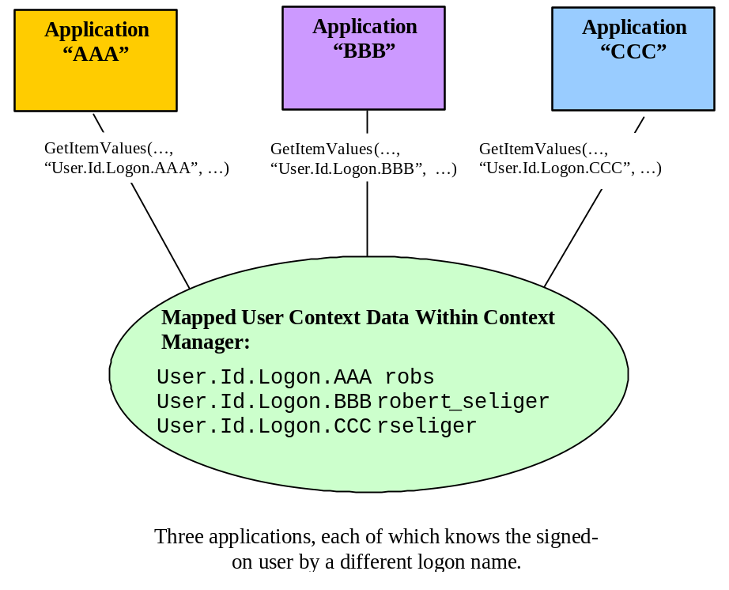
Figure 22. User Subject Context Data Mapped for Different Applications
In order for the user mapping agent to be able to provide additional logon names for users, it must be populated with the necessary logon names. However, unlike the patient mapping agent, for which there exists healthcare standards that can be used to obtain the necessary patient data (e.g., HL7’s Admission/Discharge/Transfer messages), an equivalent means does not exist for user data. In the absence of applicable standards, the means by which a user mapping agent is populated depends upon the user mapping agent implementation.

Authentication Repository
The chain of trust has the potential to maximize the overall security of a common context system because the data used to authenticate a user is never passed between applications and therefore cannot be easily intercepted or spoofed. However, not passing around this data creates a problem when there are applications that require user authentication data to perform a user sign on. For example, many existing healthcare applications require the user’s password to establish sessions with their underlying databases.
The common context system therefore includes a user authentication data repository as an additional context management component. This repository enables applications to securely maintain application-specific user authentication data. The repository is used by applications that do not have a built-in means to easily sign on a user given only a logon name. The repository may be implemented as a distributed or centralized service.
For example, some applications obtain the user’s password from the user and then hand it off to an underlying database. The database does the actual authentication. The security capabilities of the database prevent these applications from retrieving user passwords. Therefore, it is not possible for these applications to sign on a user knowing only the user’s logon name. For these applications, an external means of maintaining user logon names and associated authentication data is required.
The authentication repository provides a way of doing this that is minimally invasive to the application. The repository is not used for authenticating users. Rather, it enables existing applications that need user authentication data to sign on the user to have a means for obtaining this data when participating in a User Link common context system.
The User Link user authentication data repository provides the capability to securely store the data that an application uses to authenticate its users. The application can use a user’s logon name to retrieve the user’s authentication data from the repository. The application can then use the authentication data to establish a user session with a database or other underlying application services.
In keeping with the spirit of the CMA, the interfaces to the authentication repository, but not its implementation, are defined. These interfaces enable an application to securely retrieve a user’s authentication data and to update this data when necessary (for example, if the application periodically requires that users change their passwords).

Repository Implementation Considerations
The repository can be implemented as a central or distributed service that services multiple applications. However, the repository shall always appear as a private service to each application. This means that an application should never be aware that there are other applications using the repository.
The user authentication data stored in the repository on behalf of an application shall be encrypted by the application prior to being communicated to the repository. The encryption technique that is used is determined by the application. The authentication data shall remain encrypted within the repository, as the repository never has the need to interpret or use this data.
The interface AuthenticationRepository enables an application to put tuples comprised of a logon name and a corresponding bit stream (representing the user’s authentication data) into the repository. This interface also enables an application to retrieve a user’s authentication data using the user’s logon name.
The means by which the repository maintains its data must be secure and shall guard against security attacks. However, the security mechanisms that are employed to achieve these objectives are an authentication repository implementation decision.

Populating the Repository
The authentication repository needs to be populated with the authentication data for each user for each application that it services. One way to do this is to create a batch process that loads the necessary data. However, in many cases the necessary data is inaccessible. For example, most database management systems do not provide a means for accessing the user passwords that they store.
A simpler alternative is to incrementally populate the repository. This can be accomplished by involving each of the applications that use the repository in the process of populating the repository, as follows:
- When the context manager informs the application that the user context has been set, the application obtains the logon name for the new user from the context manager.
- The application then accesses the repository to securely retrieve the user’s authentication data. The user’s logon name is supplied as the search parameter.
- If the repository cannot find the user logon name, which will be the case if the repository has not yet been populated with data for the user, then it informs the application that the logon is not known.
- The application then prompts the user to enter his/her authentication data by whatever means the application normally uses (e.g., a password dialog box).
- The application attempts to sign-on the user using whatever underlying mechanism (e.g., database) it normally uses to do this.
- If the user is successfully signed on, then the application updates the authentication repository with the user’s authentication data, using the user’s logon as the update key. The application shall encrypt the user’s authentication data prior to putting the data in the repository.
This scheme is relatively easy to implement for almost any application. It is essential, though, that the repository and its interfaces are secure, as detailed in Chapter 15.

Chain of Trust
This chapter defines the behaviors, algorithms, policies, and protocols that User Link-enabled applications and components must adhere to in order to properly realize the chain of trust.

User Context Change Transactions and the Chain of Trust
The major difference between a context change transaction that involves secure subjects and a transaction that involves only common subjects is support in the former for the chain of trust. Additional application and component behaviors are defined to prevent the chain of trust from being violated.
Two types of defenses are required:
- The applications and components that participate in the chain of trust must be able to authenticate each other’s identity. The objective is to prevent rogue applications or components from impersonating a real application or component as a means to manipulate the user context. Such manipulations could result in an unauthorized user gaining access to the Secure Link-enabled applications.
- The applications and components that participate in the chain of trust must be able to validate the integrity of user context data that they communicate to each other. The objective is to prevent a rogue program from modifying the data as it is passed between applications and components as a means to manipulate the user context. Such manipulation could result in an unauthorized user gaining access to the User Link-enabled applications.
Techniques for creating the chain of trust using passcodes, public key infrastructure (PKI), message authentication codes, and digital signatures are described next.

Creating the Chain of Trust
There are three general sources of mechanisms for creating the chain of trust:
- Mechanisms incorporated into existing commercially available object infrastructures, such as those based upon CORBA or COM.
- Mechanisms based upon existing commercially available secure communications infrastructures, such as the Secure Socket Layer service (SSL) or the Secure Hyper-Text Transfer Protocol (S-HTTP).
- Mechanisms based upon existing widely available security building blocks, such as public key / private key encryption.
These alternatives are discussed next.

Object Infrastructures
It is conceivable that the chain of trust could be realized using the security mechanisms built into commercially available object infrastructures such as those based upon CORBA or COM. Unfortunately, these infrastructures currently employ security models that are fundamentally different from what is needed for User Link:
- Security for these infrastructures is based upon keeping track of who the user is and their respective access privileges.
- To do this requires that the user has signed on to the underlying operating system.
- However, signing on at the operating system level takes too much time. This is the very problem that User Link is trying to solve.
For example, security in Microsoft’s COM-based infrastructure is based upon tracking who the user is and what their permissions are. This means that when security is enabled for a COM interface, a COM server accepts or rejects a COM client’s access attempts based upon the privileges of the user on whose behalf the COM client is working. This does not work for User Link because a COM server (specifically, the context manager) needs to accept or reject accesses based upon which application is the COM client. The user is not relevant in this case.
It may be possible to establish a stylized approach for adapting object infrastructure security mechanisms to realize the chain of trust. However, this could make it particularly difficult to define a technology-neutral specification for the chain of trust. This could result in different User Link architectures for different technologies. This is counter to the overall CMA objective of technology-neutrality.

Secure Communications Protocols
User Link-enabled applications and the various CMA components could communicate using a secure communications protocol, such as the Secure Sockets Layer (SSL) service. SSL enables secure (i.e., encrypted) transmission of data between a client and a server. It also enables a client to authenticate a server (and a server to authenticate a client).
SSL uses the RSA public key encryption system for authentication and for data integrity and confidentiality. Of interest for the chain of trust is the SSL capability for clients and servers to authenticate each other. An SSL server uses its private key to create a digital signature. Public keys are issued to prospective clients. The public key is used by the client to authenticate the server by decoding the server’s signature. Only a signature that has been encoded using the server’s private key can be (easily) decoded via the server’s public key.
For example, in the chain of trust, an SSL connection would be established between an application that has been designated for authenticating users and the context manager. In this scenario, the application is an SSL server, while the context manager is an SSL client.
SSL and its secure communications counterparts, such as S-HTTP, provide off-the-shelf mechanisms for implementing the chain of trust. However, this technology has not been integrated with popular object infrastructures, such as those based upon COM or CORBA.
While secure communication services could provide a means for implementing the chain of trust, the practical implications of using multiple communications technologies within the User Link architecture are a cause for concern. For example, it could become overly complicated to have some communications be via COM or CORBA interfaces, while other communications use SSL or S-HTTP.
Further, the chain of trust generally does not require confidentiality. For example, the User Link architecture does not require that sensitive data, such as a user’s password, be communicated between applications. Secure communication channels are overkill and are not a good fit for User Link.

Security Building Blocks
The security building blocks that are available on most popular operating systems can form the basis for realizing the chain of trust. The two building blocks of particular interest are:
- Digital signatures.
- Secure (or one-way) hashing.
Digital signatures, which cannot be easily forged, are typically used by people as a means to authenticate each other’s identity whenever they communicate electronically. However, a digital signature also enables an application or component to identify itself in a way that can be authenticated whenever it communicates with another application or component.
Digital signatures are formed using public key / private key encryption techniques. While these techniques enable encryption, they also enable the formulation of digital signatures. An application or component formulates its digital signature using its private key and sends the signature along with the data that it wants to share. The recipient of a signed message applies the sender’s public key to the signature to authenticate the sender and to verify the integrity of the data that was sent.
There are several public key / private key algorithms and related standards. Commercial implementations of many of these algorithms are available in a variety of technologies. RSA is an example of an algorithm that has been widely implemented.
A secure hash function is used for producing a unique numeric surrogate from an arbitrary data stream. It is improbable that two different data streams will yield the same hash value. A secure hash function is an essential part of the infrastructure needed to support the use of digital signatures.
Specifically, a secure hash function enables the efficient computation of a digital signature. A secure hash function also plays a role in enabling public keys to be reliably distributed. It is essential that the holder of a public key is able to determine who (or what) the key belongs to. Otherwise an impostor could present its own public key while claiming to be someone or something that it is not. The holder of the public key would mistake subsequent communications as coming from a valid source when in fact it came from an impostor.
There are several secure hashing algorithms and related standards. Commercial implementations of many of these algorithms are available in a variety of technologies. MD5 is an example of an algorithm that has been widely implemented.
Taken together, digital signatures and secure hashing could be used in the chain of trust as the means for User Link-enabled applications and User Link components to authenticate each others’ identity each time they communicate. This capability is fundamental to the establishment and maintenance of the chain of trust.
To accomplish this, a digital signature would be explicitly included as a method parameter for each CMA-specified interface that requires this level of security. The use of digital signatures enables the specification of a system that has the desired User Link semantics and that can be readily implemented using existing security standards and technology.
Creating a system that employs digital signatures for applications and components is simpler than creating a signature-based system for users. This is because the population of applications and User Link components that requires signatures is small compared to the number of users of the system. Further, the population of applications and User Link components does not change nearly as often as the user population. The result is that the work required to create and maintain the chain of trust is substantially less than would be the case if user signatures were required.
Another advantage of digital signatures is that they can be used to ensure the integrity of any data communicated during interactions among and between User Link components and User Link-enabled applications. The recipient of the data can use the signature to determine if the data has been tampered with between the time it was sent and the time it was received.
Method-based digital signatures fit well with the component-based Context Management Architecture. For example, realizing the chain of trust in this manner enables a technology-neutral specification for the chain of trust. This is because the approach can exploit capabilities common to public key / private key implementations that are commercially available in multiple technologies. Further, the ways in which digital signatures are used can be arranged to achieve the desired security behaviors needed for User Link.
The trade-off is that more effort is required to architect the chain of trust than would be the case if a standard “off-the-shelf” component-based solution was available. This trade-off is viewed as acceptable. Therefore the approach pursued in the CMA is to use method-based digital signatures as the basis for the chain of trust.

Security Attacks On the Chain Of Trust
The primary challenge for realizing the chain of trust is minimizing the likelihood that an intruder is able to violate the chain of trust to obtain access to a User Link-enabled application. This violation could occur if a rogue program was able to set the user context to represent a user who either has not been authenticated, or who is different from the user who has been authenticated.
The chain of trust based upon the security building blocks described in Section 15.2.3, Security Building Blocks, defends against the security attacks described in the table below, all of which are directed at manipulating the user context. Refer to Figure 21. User Link Context Change Process for the specific trust relationships:
Table 2. Chain of Trust Attacks and Defenses
Attack | Defense
Attempt to impersonate an application in order to set the user context (Step #2). | An application presents its signature to the context manager in order to set the user context. The context manager uses the signature to authenticate the application to ensure that has been designated for authenticating users.
Attempt to impersonate the context manager so that the user context that the user mapping agents sees, and therefore maps, is bogus (Step #3). | The context manager presents its signature to the mapping agent when the mapping agent gets the user context data from the context manager. The mapping agent uses the signature to authenticate the context manager.
Attempt to impersonate the user mapping agent as a means to set bogus user logon names within the user context (Step #3). | The mapping agent presents its signature to the context manager when it sets user context data. The context manager uses the signature to authenticate the mapping agent.
Attempt to impersonate the context manager so that the user context that a participant application sees is bogus (Step #5). | The context manager presents its signature to the participant application when the application gets the user context data from the context manager. The application uses the signature to authenticate the context manager.
Attempts to impersonate the authentication repository as a means to obtain user authentication data from an application (Step #6b). | The application encrypts the user authentication data using the authentication repository’s public key before providing the data to the repository. Only the real authentication repository can decrypt this data. Further, the application pre-encrypts the data using an application-specific encryption scheme. The data remains encrypted even when stored inside the repository.
Attempt to impersonate an application as a means to obtain user authentication data from the authentication repository (Step #6b). | An application must present its signature to the authentication repository when it gets user authentication data from the repository. The repository uses the signature to authenticate the application. Further, the application encrypts the authentication data before storing it in the repository. Only the application that encrypted the data can subsequently decrypt it.
The chain of trust does not necessarily need to defend against every type of attack, including attacks to gain access to the user’s logon name (i.e., Step #4). A user’s logon name is easy to guess or obtain, and in the absence of user authentication data (e.g., a password) a logon name does not provide a means for gaining access to a system.
The chain of trust also does not defend against applications that do a poor job of authenticating users (i.e., Step #1). Provider institutions must ensure that the applications they designate for authenticating users meet their security needs.
Other types of attacks that are not defended by the chain of trust can result in a denial of service, which may cause a common context system to function improperly. For example, a rogue program might continually invoke context manager methods, causing the context manager’s performance to degrade while it services these invocations.
These programs do not breach security in terms of enabling unauthorized access to User Link-enabled applications, but they do result in inconveniences for users of the system. In general it is extremely hard, and can be quite costly, to defend against denial of service attacks.
The most effective preventatives for denial of service attacks begin with physical security, in which a malicious user is denied access to any of the computers within a system. Without access to the system, a malicious user will have a much harder time installing rogue programs. Physical security is strongly encouraged, but it is beyond the scope of the CMA to specify the necessary measures.
Additional potential limitations of the chain of trust are described in Section 15.2.5, Chain of Trust Implementation Limitations.

Chain of Trust Implementation Limitations
A secure implementation of the chain of trust requires that the User Link components (i.e., context manager, applications, mapping agent, authentication repository) all have a robust way of authenticating each other’s identity. Providing this capability requires the use of underlying operating systems primitives, including file access privileges and memory protection mechanisms.
Not all operating systems implement these security primitives to the same degree of robustness. The approach for implementing the chain of trust described below is therefore fundamentally limited by the capabilities (or lack thereof) of the underlying operating system upon which a User Link system is deployed.
In particular, Windows NT and most Unix-based operating systems provide the necessary primitives. User Link systems deployed on these operating systems will offer robust security capabilities. In contrast, Windows 95 and Windows 98 lacks many of the necessary primitives. User Link systems deployed on this operating system will offer useful capabilities, but the systems will not be any more secure than native Windows 95/98.

Digital Signatures and CMA Components
Digital signatures created using a public key / private key encryption system are incorporated into the component interfaces defined for User Link-enabled applications and components. In the chain of trust these signatures (and corresponding keys) are not associated with a user, but rather with an application or component. The signatures and keys for a particular application are the same independent of who the user is.
Several of the methods defined for the existing context manager interfaces already require that applications identify themselves (e.g., ContextData::SetItemValues ). The participant coupon, which is an integer, is assigned by the context manager to an application when it joins a common context session (via ContextManager::JoinCommonContext). This coupon is subsequently used by the application to identify itself when it calls a context manager method that requires application identification.
The methods requiring applications to identify themselves do so to enforce the correct behavior of a common context system. For example, only the application that instigated a context change transaction or a mapping agent can set context data. Similarly, only the instigating application can end the transaction in progress.
However, the use of a participant coupon is not intended to be a security mechanism. For example, a rogues application can impersonate a valid application by obtaining (or even guessing) the value of the valid application’s coupon. Coupons are simply to enable the context manager to identify the applications it is dealing with.
An elaboration of the coupon approach is to use digital signatures as a means for applications to identify themselves in a manner that can be authenticated. It is relatively straightforward to use digital signatures in addition to coupons whenever it is necessary to authenticate an application or component.
Based on this approach, CMA interfaces are defined that enable the establishment of the necessary signature-based security relationships among and between applications and context management components. Additional CMA-defined interfaces subsequently enforce these security relationships as applications and components interact during the course of a context change transaction.

Public Key / Private Key Encryption as a Means for Generating Signatures
Providing applications with digital signatures requires that each application or component that is to be trusted is assigned a public key and private key based upon an algorithm such as RSA. The private key is used to create a digital signature. The corresponding public key is used to verify the signature.
For example, an application supplies its participant coupon and its signature to the context manager whenever it performs a context manager method that requires the context manager to authenticate the identity of the application and validate the integrity of the data sent by the application.
A digital signature is formed by applying a secure hash function (alternatively known as a one-way hash function) to the data that is to be transmitted. The resulting hash value is referred to as the message digest, as it is a numeric surrogate for the plain-text message. It is computationally improbable that two messages will produce the same hash value.
The message digest is then encrypted by the sender using its private key. The digest can only be decrypted using the sender’s public key. In other words, any party holding the sender’s public key can authenticate that the message came from the sender and that the data sent was received in tact.
The encrypted hash value enables the sender of the data to ensure that the receiver of the data can authenticate the sender’s identity. The receiver uses the same secure hash function as the sender to perform its own computation of a hash value using the data it received. Note that the data was not encrypted. Just the hash value computed from the data was encrypted.
The receiver compares the hash value it computed with the value it decrypted. The encrypted hash value can only be successfully decrypted using the public key that matches the sender’s private key. If the hash values match, then the data sender’s identity has been confirmed, and the integrity of the data has been validated.
If the hash values do not match, then either the data was tampered with between the time it was sent and was received, or the sender is not who it claims to be.
The algorithm for creating the hash value must be compatible with the public key / private key scheme that is employed. For example, if RSA is the public key / private key scheme that is used, then an RSA-supported hashing algorithm (e.g., MD5, SHA-1) must be employed to create the hash value. When the signature is computed in this manner, authenticity and data integrity can be verified.
The specific secure hash algorithm and the public key / private key scheme that is employed is technology-specific. Each of the HL7 context management technology mapping specifications indicates the secure hash algorithm public key / private key scheme that is needed for a particular technology-specific implementation.
The overall process for signing a message is illustrated Figure 23. Signing A Message.
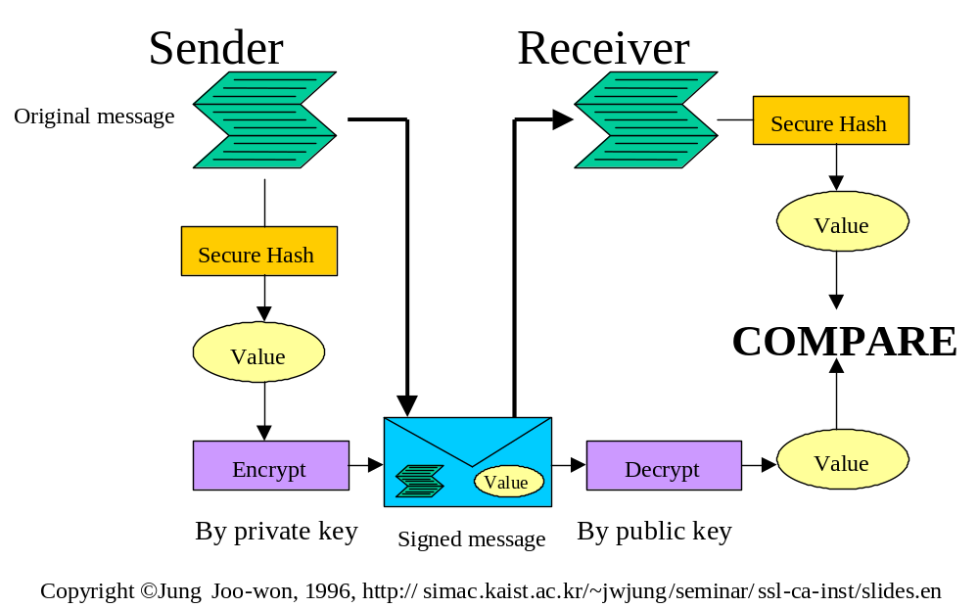
Figure 23. Signing A Message

Incorporation of Signatures into the Context Management Architecture
Digital signatures are incorporated in the Context Management Architecture to enable authentication between User Link-enabled applications and User Link components. For example, digital signatures enable the context manager to authenticate the identity of any application that performs a context manager method. The context manager can also ensure the integrity of the parameter values that it received from the application.
The context manager accomplishes this by computing a hash value from the input parameters it receives from the application. To obtain the application-computed hash value from the signature the context manager must use the same public key / private key scheme as the application. The context manager must also use the same hash algorithm as the application.
The context manager compares the hash value it computes to the hash value it has obtained by decrypting the application’s digital signature. If the two hash values match, then the method invocation is authentic and data integrity is ensured.
Otherwise, there has been a breach of security: either the method was invoked by an impostor of the application, and/or the parameter values provided by the application were tampered with after they were sent but before they were received by the context manager. The context manager rejects the method invocation.
To be more specific, for the context manager method SecureContextData::SetItemValues, the hash value would be computed using the value of the participant application’s coupon (i.e., input parameter participantCoupon), current context change transaction coupon (i.e., input parameter contextCoupon), the names of the items whose values are to be set (i.e., input parameter itemNames), and the values for these items (i.e., input parameter itemValues).
The use of a hash in forming a signature is illustrated Figure 24. Forming Signature Using Method Parameters.
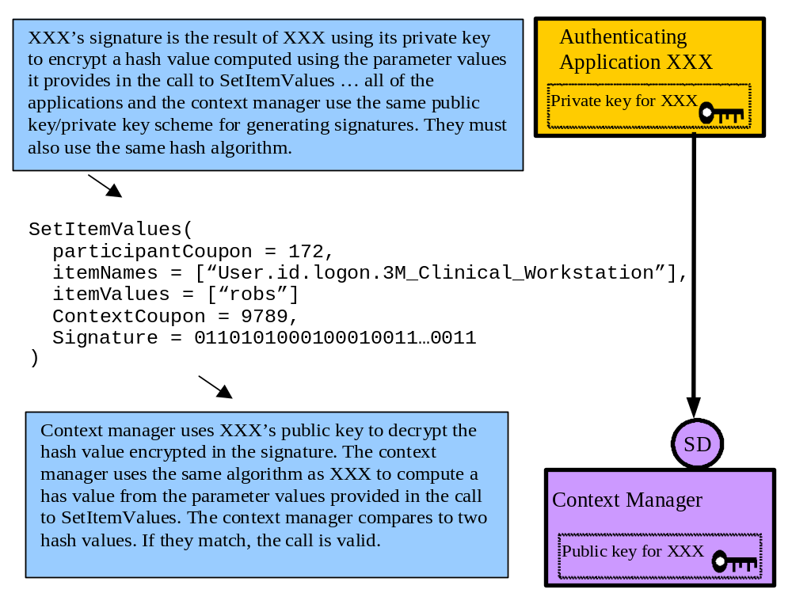
Figure 24. Forming Signature Using Method Parameters

Computing a Digital Signature
Secure hash algorithms use a character string as the representation of the data value upon which a hash value is to be computed. Therefore, parameter values that are to be protected from tampering during a method invocation must be converted to character strings. These strings must then be concatenated to form a single string. It is the concatenated string that is used to compute the hash value.
The rules for concatenation are as follows. These rules take into account the fact that the mapping of CMA interfaces to specific technologies may alter the order in which method parameters are declared and/or may require additional technology-specific parameters. The rules ensure that the process for creating signatures is invariant across technologies:
- The architectural specification for each method that is to be signed will define which method parameters must be protected from tampering, and are therefore to be used in formulating the signature.
- The architectural specification for each method that is to be signed will define the order in which the string representations of the parameters are to be concatenated.
- The string representation of an array parameter starts with the first element in the array and ends with the last element in the array.
- A parameter or array element whose value is null or empty is omitted from the string.
- An array that does not contain any elements (i.e., the array length is zero) is omitted from the string.
- Delimiters are not required because there is no need to parse the string.
For example, the concatenated string that might be produced based upon the example in Figure 24. Forming Signature Using Method Parameters would look like:
172User.id.logon.3M_Clinical_Workstationrobs9789
In another example, where the value of the context item “logon” is null, the concatenated string would look like:
172User.id.logon.3M_Clinical_Workstation9789
In a final example, where the context items are:
- User.id.logon.3M_Clinical_Workstation = “robs”
- User.co.GivenName = “Robert Seliger”
The concatenated string would look like:
172User.id.logon.3M_Clinical_WorkstationUser.co.GivenNamerobsRobert Seliger9789
The rules for representing various data types as character strings are specified in Section 17.2.9, Representing Basic Data Types as Strings.
Finally, once the hash value has been computed, encrypting the hash value with the sender’s private key generates the digital signature.

Public Key Distribution
Public key distribution is the process by which an entity, such as the context manager, makes its public key available to the other entities, such as an application, that need to use the key. This process must ensure that a receiving entity can reliably establish the identity of the entity that created the key. If this is not accomplished then it is possible for a rogue entity to impersonate a valid entity by presenting its own (rogue) key as the key belonging to the valid entity representing the valid entity’s public key as its own.
In contrast, private keys are not distributed, but remain the secret of the owner of the corresponding public key. A discussion about protecting private keys appears in Section 15.3.4.3, Protecting Private Keys.
There are a variety of ways that keys can be distributed, including via a certificate authority. However, the default approach chosen for the CMA minimizes the amount of infrastructure that is required to create a Secure Link solution, yet is upwards compatible with more elaborate approaches.
Specifically, public keys are exchanged as part of a dynamic process that occurs each time a Secure Link-enabled application or Secure Link-enabled component is launched. This approach enables a high-degree of security while minimizing the effort and cost to develop and deploy Secure Link solutions.
A two-step secure binding process is used to dynamically distribute an application’s or component’s public key. The default process depends upon the use of passcodes (described below), which all Secure Link-enabled applications and Secure Link components shall support. Additionally, and optionally, PKI-based digital certificates may also be used as the means to dynamically distribute an application’s or component’s public key.

Passcode-Based Public Key Distribution
A passcode is a shared secret in the form of a complex, arbitrary alphanumeric string that is assigned to Secure Link-enabled applications (specifically, applications that are capable of being designated for authenticating users) and Secure Link-enabled components. An application or component uses its passcode to prove its identity when it presents its public key.
A passcode is not actually transmitted when a secure binding is established. Instead, a secure hash function is used to produce a message authentication code. A message authentication code is a secure hash value produced from a data stream that consists of data that is openly communicated between two parties, and “secret” data that they both know but do not openly communicate. In the CMA, a passcode serves as the shared secret.
The passcode-based binding process involves a “bindee” and a “binder.” An application is always a bindee, while a component may be a bindee or binder. In order to bind, a bindee must be assigned a passcode. Both the bindee and the binder must have knowledge of the passcode. The means for providing the bindee and binder with a passcode are not specified in the CMA. However, requirements and guidelines are described in Section 15.3.4.1.1, Passcode Generation Requirements.
The following table describes the relationships between Secure Link-enabled applications and Secure Link components in terms of the secure binding process:
Bindee | Binder
Context Participant Application | Context Manager
Context Participant Application | Authentication Repository
Context Agent | Context Manager
The bindee initiates the binding process with the binder. The bindee assumes it knows the identity of the binder, but will prove the binder’s identity as part of the binding process. Similarly, the binder will establish the identity of the bindee as part of the binding process.
The following interactions then occur:
- The bindee symbolically identifies itself to the binder. The binder uses this information to locate the binder’s copy of the bindee’s passcode. The passcode is not transmitted by the bindee.
- The binder sends back a public key that the bindee shall use for verifying subsequent digitally signed communications from the binder. This key shall remain valid until the next time that the bindee and binder establish a secure binding. The binder also sends back a message authentication code. This code is a secure hash value computed from a data stream formulated from the binder’s public key and the binder’s copy of the bindee’s passcode.
- The bindee uses the public key it has received and its copy of its passcode to formulate a data stream from which it also computes a secure hash value. (The hash algorithm it uses must be the same as the one that the binder used.) The bindee shall compare the resulting hash value to the message authentication code. If the two match, then the binder is who it claims to be and the public key received by the bindee indeed belongs to the binder.
- The bindee again identifies itself to the binder but this time sends a public key that the binder shall use for verifying subsequent digitally signed communications from the bindee. The key shall remain valid until the next time that the bindee and binder establish a secure binding. The bindee also sends a message authentication code. This code is a secure hash value computed from a data stream formulated from the bindee’s public key and the bindee’s copy of its passcode.
- The binder uses the public key it has received and its copy of the bindee’s passcode to formulate a data stream from which it also computes a secure hash value. (The hash algorithm it uses must be the same as the one that the bindee used.) The binder shall compare the resulting hash value to the message authentication code. If the two match, then the bindee is who it claims to be and the public key received by the binder indeed belongs to the bindee.

Passcode Generation Requirements
An application requires a passcode for binding with the context manager. This passcode is a secret known only to the application and the context manager.
An application also requires a passcode for binding with the authentication repository. This passcode is a secret known only to the application and the authentication repository. An application that binds to both the context manager and the authentication repository shall use different passcodes for each binding.
A context agent requires a passcode for binding with the context manager. This passcode is a secret known only to the agent and the context manager.
Passcodes are similar to passwords used by people. However, because passcodes are only used by computer programs, they can be much longer and complex than passwords typically are. This makes passcodes extremely hard to guess, even when brute force techniques are employed.
An application passcode shall be a randomly generated character string comprised of no less than one hundred twenty eight (128) characters and no greater than two-hundred fifty-six (256) characters. A passcode shall only be comprised of alphanumeric characters, as well as the underscore (_) and dash (-) characters. A passcode shall not contain white space (e.g., tabs, spaces). A passcode shall be arbitrary but shall not contain any words or phrases.
The BNF for a passcode appears below:
SPACE = “ “
UNDERSCORE = “_”
PERIOD = ”.”
DASH = “-“
ALPHA = “a-zA-Z”
NUMERIC = “0-9”
POUND = “#”
passcode = [ ALPHA | NUMERIC | UNDERSCORE | DASH ] *
An application’s passcode may be generated such that the same passcode is used for every instance of the application everywhere. This is the least secure means of generating passcodes because a security breach affects every instance of the application at every site. A preferable approach is to generate a site-specific version of an application’s passcode. A security breach is then limited to the particular site.

Protecting Passcodes
Passcodes must remain secret. There are numerous ways in which this can be achieved. The specific approach is left as an implementation decision for applications and the various context management components.
However, the following approach is recommended for applications. The assumption is that any application that is used to authenticate users probably uses a server to maintain user account and authorization information. The application might be organized using a client/server architecture, or a web server architecture.
The principle challenge is how to create an application such that the portion of the application that serves as a context participant has a secure means to store and retrieve its passcode. In the case of client/server systems, an approach could be to store the passcode on each device upon which the client has been loaded. In web systems, an approach could be to transmit the passcode from the web server to the point-of-use device. Both of these approaches introduce substantial security risks that would require great effort to defend against.
An alternative is for an application to store its passcode in a server, where it can be more readily protected (including literally placed under lock and key). This could be the application’s database server, or it could be a separate server whose specific role is to securely maintain passcodes.
The server would never actually transmit the passcode. Rather, it would be responsible for verifying message authentication codes received by the application. It would also be responsible for computing the application’s message authentication code.
In this approach, the server must be able to authenticate the identity of the application. The server must also be sure that the data it sends and receives from the application is not tampered with while it is in transit. This implies that the application must have the means for establishing a trusted relationship with the server in a manner somewhat akin to the relationship the application establishes with the context manager or authentication repository.
There are many ways in which the necessary relationship can be implemented. However, because this relationship does not involve interoperation between applications, and because the optimal approach depends heavily upon the architecture and design of the application, a single approach is not specified. Instead, the approach for the server-based maintenance of an application’s passcode is left as an application design exercise.

PKI-Based Public Key Distribution
If PKI exists in the healthcare enterprise than digital certificates may be used instead of passcodes as the basis for the distribution of public keys between Secure Link-enabled applications and Secure Link components. An application or component that supports PKI for distributing its public key shall have an X.509 v3 compliant digital certificate created for it and signed by the certificate authority that the enterprise trusts. Certificates shall be represented as a DER encoded string per the ISO/IEC X.509 v3 standard. This string contains binary data that has been character-encoded per the convention defined in the CMA specification (see Section 17.2.7Character-Encoded Binary Data).
Within this certificate is the name of the application or component and a statically assigned public key that the application or component uses for signing a dynamically created public key (i.e., a different public key) that is used for authenticating all subsequent communications.
The certificate for an application or component shall be distributed to all of the applications or components that require it for key exchange prior to establishing a secure binding. Otherwise key exchange shall use the passcode scheme described above.
The means by which certificates are created and distributed is not specified. The means for providing the bindee and binder with the necessary certificates are not specified in the CMA. For example, application and component implementations may provide tools for manually entering the necessary certificates and/or they may automate the process via the use of network directory services. However, requirements and guidelines are described in Section 15.3.4.2.1, Certificate Generation Requirements.
The PKI-based binding process involves a “bindee” and a “binder.” An application is always a bindee, while a component may be a bindee or binder. In order to bind, digital certificates must be issued by a certificate authority for both the binder and the bindee. Additionally, both the bindee and the binder must possess the public key of the certificate authority that issued the certificate. The certificate authority’s public key is itself contained in a certificate that was self-signed by the authority.
There are two ways in which the bindee and the binder can decide to perform a PKI-based binding instead of a passcode-based binding. First, the decision can be made statically via implementation-specific configuration settings in the bindee and the binder if both support PKI and if both support the capability for an authorized systems administrator to establish the necessary configuration settings.
Alternatively this decision can be made dynamically each time that a binding is initiated. Specifically, the bindee can present to the binder one or more technology-specific binding parameters that indicate that the bindee wants to use PKI. If the binder is PKI-capable, then the secure binding can proceed. Otherwise the binder indicates that it does not support PKI via an appropriate exception that is communicated to the bindee, and the PKI-based binding process is aborted and a passcode-based binding process is performed instead.
The following table describes the relationships between Secure Link-enabled applications and Secure Link components in terms of the secure binding process:
Bindee | Binder
Context Participant Application | Context Manager
Context Participant Application | Authentication Repository
Context Agent | Context Manager
The bindee initiates the binding process with the binder. The bindee assumes it knows the identity of the binder, but will prove the binder’s identity as part of the binding process. Similarly, the binder will establish the identity of the bindee as part of the binding process.
The following interactions then occur:
- The bindee locates a copy of the binder’s certificate. The bindee validates the authenticity of this certificate using the public key of the issuing certificate authority, which the bindee possesses.
- The bindee symbolically identifies itself to the binder. The binder uses this information to locate a copy of the bindee’s certificate. The certificate is not transmitted by the bindee. The binder validates the authenticity of this certificate using the public key of the issuing certificate authority, which the binder possesses.
- The binder sends back a public key that the bindee shall use for verifying subsequent digitally signed communications from the bindee. This key shall remain valid until the next time that the bindee and binder establish a secure binding. The binder also sends back a digital signature where the data that is signed is the public key.
- The bindee shall verify the signature using the public key that it can obtain from the binder’s certificate. If the signature can be verified, then the binder is who it claims to be and the public key received by the bindee indeed belongs to the binder. (Note that the public key from the binder’s certificate is not the same public as the binder returned. The former key is used to verify the authenticity of the latter key, wherein the latter key is used for all subsequent communications from the binder that requires a digital signature.)
- The bindee again identifies itself to the binder but this time sends a public key that the binder shall use for verifying subsequent digitally signed communications from the bindee. The key shall remain valid until the next time that the bindee and binder establish a secure binding. The bindee also sends a digital signature where the data that is signed is the public key.
- The binder uses the public key it has received and its copy of the bindee’s certificate to verify the signature. The binder shall compare the resulting hash value to the message authentication code. If the signature can be verified, then the bindee is who it claims to be and the public key received by the binder indeed belongs to the binder. (Note that the public key from the bindee’s certificate is not the same public key as the bindee sent. The former key is used to verify the authenticity of the latter key, wherein the latter key is used for all subsequent communications from the bindee that includes a digital signature.)

Certificate Generation Requirements
For PKI-based secure binding, the context manager requires a certificate. Each application that wants to use PKI instead of passcodes also requires a certificate for binding with the context manager.
Additionally, for PKI-based secure binding, an application also requires a certificate for binding with the authentication repository if the application uses an authentication repository, and the authentication repository requires a certificate.
Finally, for PKI-based secure binding, each context agent that wants to use PKI instead of passcodes requires a certificate for binding with the context manager.
Applications and components shall use the names shown in Table 3 as one of the organizational unit (ou) fields within the certificate subject name.
Table 3. Certificate Target Names
Certificate Target | Field
Application | ou=CCOW.ApplicationName  where ApplicationName is the symbolic name of the application (See Section 17.2.4, Format for Application Names, for the specification of an application’s symbolic name)
Authentication Repository | ou=CCOW.AuthenticationRepository
Context Manager | ou=CCOW.ContextManager
Mapping Agent | ou=CCOW.MappingAgent_Subject  where Subject is the name of the standard or custom mapped subject
Annotation Agent | ou=CCOW.AnnotationAgent_Subject  where Subject is the name of the standard or custom annotated subject
Action Agent | ou=CCOW.ActionAgent_Subject  where Subject is the name of the standard or custom action subject

Protecting Certificates
As long as certificates are properly used then special precautions to protect them are not required. Specifically, certificates are not secret and as they are digitally signed by the issuing certificate authority they cannot be tampered with. An application or component that is presented with a certificate shall validate the authenticity of the certificate by verifying the digital signature of the certificate authority that produced the certificate. Only certificates that can be validated shall be used by applications or components.
In order to validate a certificate via a digital signature of course requires that the application or component possess the issuing certificate authority’s public key. The means by which a certificate authority’s public key is distributed is not specified. For example, applications and component implementations may provide tools for manually entering the necessary key and/or they may be pre-loaded by the developer of the application or component with the public keys for relevant certificate authorities.

Protecting Certificate Authority Public Keys
As long as certificate authority public keys are properly used then special precautions to protect them are not required. Specifically, a public key is not a secret, and if it is tampered with or altered then it will only result in the inability of an application or component to verify the authenticity of certificates issued by the certificate authority. While this may be viewed as a denial of service, it is beyond the scope of the CMA to defend against denial of service attacks (see Section 15.2.4, Security Attacks On the Chain Of Trust.)
However, the means by which an application or component is instructed as to which certificate authority(s) to trust must be protected, otherwise an application or component could be instructed to trust a rogue certificate authority. An application or component must take precautions to ensure that only authorized system administrators are allowed to control which certificate authority(s) the application or component is supposed to trust.

Protecting Private Keys
The key distribution process described in Section 15.3.4, Public Key Distribution, does not prescribe when keys are created. However, once created, a private key must remain the secret of its owner for as long as it is in use.
It is possible to statically create a public key / private key pair for an application or component. However, this approach requires the use of a persistent store within which the public key / private key pair are housed when the application or component is not executing. If such a store were used, it would need to be defended against security attacks. This can be accomplished, but at the cost of adding complexity to applications or components.
The recommended alternative approach is for an application or component to dynamically create its key pair when launched. This enables the keys to be kept in memory, and avoids the complexity of using a persistent store. While it is conceivable that an in-memory private key could be accessed by an intruder, most contemporary operating systems enable a process to prevent other processes from reading its memory.
Every private key must remain the secret of its owner for as long as the key is in use. This is true both for the private key used to digitally sign the messages used in PKI-based secure binding, and for the private key used for post-binding digitally signed communications.
By definition, the key pair used to establish a secure binding when PKI-based secure binding is used is statically generated and the associated private key must be maintained by the owing application or component in a persistent store. Specifically, the key pair is generated prior to the application or component becoming operational, such as when the application or component is installed. The reason that this key pair is statically generated is to enable the one-time creation of a certificate that contains the corresponding public key. This certificate is subsequently disseminated.
In so doing, however, it is imperative that the application or component appropriately protect its corresponding private key. The value of this key must not be accessible outside of the application or component, or a person could create a rogue program that impersonated a valid application or component. Typical safeguards include keeping the key on a secured server if the application or component architecture allows this, or obfuscating the key within the application code.
In contrast, the recommended approach for the private key used to digitally sign post-securing binding communications is for applications or components to dynamically create the key pair when launched. This enables the keys to be kept in memory, and avoids the complexity of using a persistent store. The applicability of these keys is transient, and matches the lifetime of the context session initiated by the secure binding in which the keys were exchanged. While it is conceivable that an in-memory private key could be accessed by an intruder, most contemporary operating systems enable a process to prevent other processes from reading its memory.

System Configuration Requirements
The minimum set of system configuration capabilities necessary in order to deploy a Secure Link system are summarized as follows:
- The context manager shall provide a means for manually the symbolic names of the applications that have been designated for authenticating users. The names of designated applications may be established on a site-wide basis. It shall not be possible for anyone but an authorized system administrator to modify the names known to a context manager.
- The context manager shall provide a means for manually entering or automatically obtaining the symbolic name and corresponding passcode for each Secure Link-enabled application that has been designated for authenticating users to be used at a particular site. This process shall be performed such that the passcode remains a secret known only to the application, the context manager, and perhaps an authorized system administrator who conveys the information from the application to the context manager.
- The context manager shall provide a means for manually entering or automatically obtaining the symbolic name and corresponding passcode for the user each secure context agent used at a particular site. This process shall be performed such that the passcode remains a secret known only to the user context mapping agent, the context manager, and perhaps an authorized system administrator who conveys the information from the application to the context manager.
- The authentication repository shall provide a manually means for entering or automatically obtaining the symbolic name and corresponding passcode for each application that uses the authentication repository at a particular site. This process shall be performed such that the passcode remains a secret known only to the application, the authentication repository, and perhaps an authorized system administrator who conveys the information from the application to the authentication repository.
- Secure Link-enabled applications capable of being designated for authenticating users, and the user mapping all secure context agents, shall provide a means for manually entering or automatically obtaining of either obtaining a passcode or for entering a passcode for the context manager, and for the authentication repository if the application uses one. This process shall be performed such that the secret passcode remains a secret known only to the application or user mapping agent, the context manager, and perhaps an authorized system administrator who conveys the information from the application or user mapping context agent to the context manager.
Additional minimal system configuration requirements must be supported by those applications and context management components that also support the PKI-based secure binding process:
- Each application and component shall provide a means for manually entering or automatically obtaining the digital certificate for a site’s certificate authority. This process shall be performed such that once this certificate has been entered or obtained it can only be replaced by an authorized system administrator.
- Each application, each context agent, and the authentication repository, shall provide a means for manually entering or automatically obtaining the digital certificate for the context manager to be used at a particular site. This process shall be performed such that only an authorized system administrator can replace these certificates.
- Each application that uses the authentication repository shall provide a means for manually entering or automatically obtaining the digital certificate for the authentication repository to be used at a particular site. This process shall be performed such that only an authorized system administrator can replace this certificate.
- The context manager shall provide a means for manually entering or automatically obtaining the symbolic name and digital certificate for each Secure Link-enabled application to be used at a particular site. This process shall be performed such that only an authorized system administrator can replace these certificates.
- The context manager shall provide a means for manually entering or automatically obtaining the symbolic name and digital certificate for each Secure Link-enabled context agent to be used at a particular site, as well as the certificate for the site’s certificate authority. This process shall be performed such that only an authorized system administrator can replace these certificates.
There are numerous ways in which these capabilities can be implemented. It is beyond the scope of the CMA to specify these capabilities. The specific approaches are left as an implementation decision for applications and the various context management components.

Defending Against Replay Attacks
In a replay attack, an intruder captures valid messages that have been previously communicated and retransmits them at a later time in the hope of violating a system.
For example, an intruder might capture a message that enables a user to log on. Even though the intruder might not be able to read the message (it might be encrypted), the intruder might be able to “replay” the message at later time in order to gain access to the system. In this case, the intruder would be able to log on as the user whose actions resulted in the transmission of the original message.
The general approach for defending against replay attacks is to include a “nonce” in each message. The nonce is simply a number that is different each time a message is sent, and is used in computing the hash value for a message. The recipient of a message can keep track of nonces it has seen, and simply reject messages that contain previously seen nonces.
In the CMA, context change coupons in conjunction with the recommend approach of dynamically-generated public key/private key pairs (see Section 15.3.4.3, Protecting Private Keys) defend against replay attacks.
A context change coupon serves as a nonce whose uniqueness is ensured while a context management system is active (i.e., from the time the first participant joins to the time the last participant leaves). Dynamically-generated keys ensure that signed messages can only be authenticated while a context management system is active. Signed messages from earlier activations of the system are meaningless. Together, the use of context change coupons as nonces and dynamically generated keys provide a strong defense against replay attacks.

Trust Relationships
This section specifies application and component behaviors for realizing the chain of trust.

Trust Between Applications and Context Manager
A Secure Link-enabled application shall obtain a reference to the context manager’s principal interface from the context management registry. The application shall interrogate this interface to obtain a reference to the context manager’s SecureBinding interface.
A Secure Link-enabled application shall establish a secure binding with the context manager, per Section 15.3.4, Public Key Distribution, after it has joined the common context session but before it instigates any user context change transactions. This ensures that the application:
- is communicating with the real context manager,
- has obtained the real context manager’s public key,
- has provided the context manager with its public key.
A Secure Link-enabled application shall always create a digital signature to sign the context manager methods it invokes in order to set context data that includes secure subject context items. This enables the context manager to authenticate the application to ensure that the application is allowed to set the data, and to ensure the integrity of the communicated context data items.
A Secure Link-enabled application may also need to create a digital signature to sign the context manager methods it invokes in order to get context data that includes secure subject context items. This enables the context manager to authenticate the application to ensure that the application is allowed to get the data.
The context manager shall create a digital signature to sign return values it communicates to an application whenever these values include secure subject context items. This enables the application to authenticate the context manager, and to ensure the integrity of the communicated context data items.
All other interactions between applications and the context manger do not need to follow these rules.

Trust Between Context Manager and a Context Agent
A context agent shall obtain a reference to the context manager’s principal interface from the context management registry. The context agent shall interrogate this interface to obtain a reference to the context manager’s SecureBinding interface.
The context agent shall establish a secure binding with the context manager, per Section 15.3.4, Public Key Distribution, before it accesses any user context data. This ensures that the context agent:
- is communicating with the real context manager,
- has obtained the real context manager’s public key,
- has provided the context manager with its public key.
The context agent shall create a digital signature to sign the context manager methods it invokes in order to set context data that includes user subject context items. This enables the context manager to authenticate the context agent, and to ensure the integrity of the communicated context data items.
The context agent may also need to create a digital signature to sign the context manager methods it invokes in order to get context data that includes secure subject context items. This enables the context manager to authenticate the context agent to ensure that the agent is allowed to get the data.
The context manager shall create a digital signature to sign return values it communicates to the context agent whenever these values include secure subject context items. This enables the context agent to authenticate the context manager, and to ensure the integrity of the communicated context data items.
All other interactions between the context manager and the context agent do not need to follow these rules.

Trust Between Applications and Authentication Repository
A Secure Link-enabled application shall obtain a reference to the authentication repository’s principal interface from the secure registry. The application shall interrogate this interface to obtain a reference to the authentication repository’s SecureBinding interface.
A Secure Link-enabled application shall establish a secure binding, with the authentication repository, per Section 15.3.4, Public Key Distribution, after it has joined the common context session but before it instigates any user context change transactions. This ensures that the application:
- is communicating with the real authentication repository,
- has obtained the real authentication repository’s public key,
- has provided the authentication repository with its public key.
A Secure Link-enabled application shall create a digital signature to sign the authentication repository methods it invokes in order to set user authentication data. This data shall also be encrypted by a means chosen by the application, and then encrypted again upon communication using the authentication repository’s public key. The repository shall decrypt the data using its private key only when it needs to service a valid application request to retrieve the data. The repository shall never decrypt the data from its application-specific encrypted form.
This enables the authentication repository to authenticate the application, to ensure the integrity of the communicated authentication data, to keep the authentication data confidential when it is communicated, and to defend against intrusions into the repository to obtain user authentication data.
The authentication repository shall create a digital signature to sign user authentication data it communicates to an application. User authentication data that is communicated back to an application shall remain encrypted as it was when provided by the application. This data shall be encrypted again upon communication using the application’s public key.
This enables the application to authenticate the authentication repository, to keep the authentication data confidential when it is communicated, and to ensure the integrity of the communicated user authentication data.
All other interactions between applications and the authentication repository do not need to follow these rules.

Chain of Trust Interactions
The detailed interactions for several User Link use cases involving the chain of trust are illustrated below. A description for how to interpret the notation used in these diagrams appears in Appendix I. The following additional notation is used:
- The character “|” indicates the concatenation of two strings, for example, “qrs|xyz” to form “qrsxyz”.
- XXSignature(a|b|c) indicates the digital signature for XX. The signature is formed by applying a one-way hash function to the parameter values a, b, and c, and then encrypting the resulting hash value using XX’s private key.
- XXPublicKey(abcd) indicates that the data “abcd” is encrypted using the public key for XX.
- XXEncrypt(abcd) indicates that the data “abcd” is encrypted using an encryption scheme chosen by XX.
- Hash(abcd) indicates a value produced by applying a one-way hash function to the data “abcd” .
- The abbreviation ZZ represents application ZZ, CM represents the context manager, AR represents the authentication repository, and MA represents the user mapping agent.
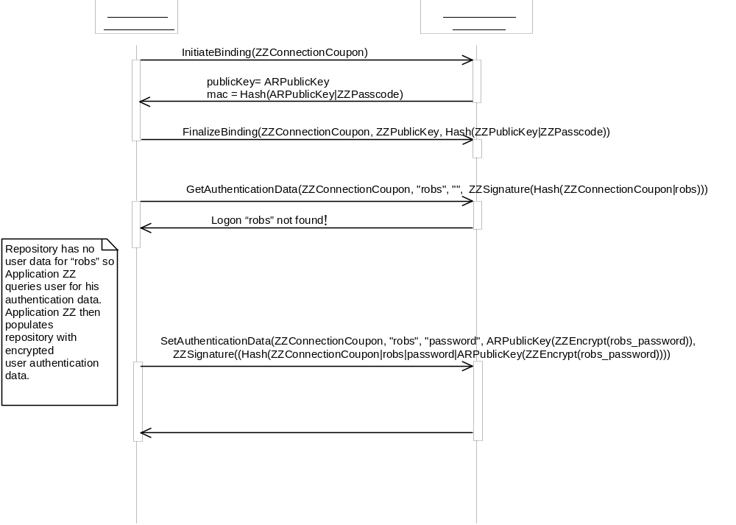
Interaction Diagram 17. Populating Authentication Repository with User Authentication Data
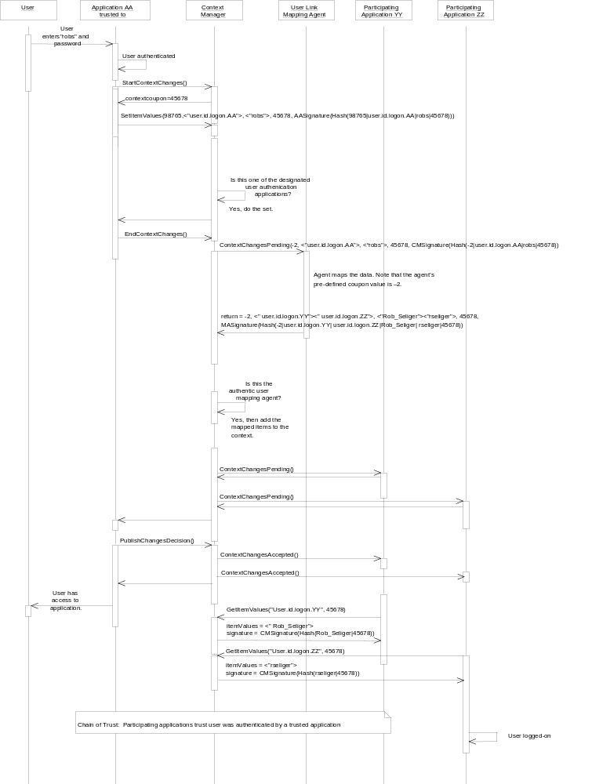
Interaction Diagram 18. User Link Context Change Transaction

Theory of Operation for Context Actions
A context action enables an application to request, via the context manager, that an action be performed by an action agent on behalf of the requesting application. The request is generally issued in response to a user input or gesture, and the action agent generally presents the user with a user-interface for the purpose of obtaining additional information from the user needed to perform the action and/or for conveying information to the user about the result of performing the action. The action is always performed upon a real-world or conceptual object that can be identified in the context, such as the patient, user, etc.
For example, certain clinical applications require that the user be re-authenticated in order to enter data, even though the user is already signed-on. With an authenticate-user action, a clinical application can request that the authentication agent authenticate the current user. In so doing, the agent presents the user with a user-interface for obtaining the user’s credentials (e.g., a password) and may display an error message to the user if the user cannot be properly authenticated (e.g., indicating that the user has entered the wrong password).
The context manager mediates the communication that governs the execution of a context action. This means that applications and action agents do not need to know about each other. They only need to know about the context manager. Further, because this communication is context-based, the data that passes between the application requesting a context action and the agent that services the action can be mapped and/or annotated by context agents, just as any context data is. In addition, the data that comprises the complete context is available to enhance and complement the action-specific data sourced by the application requesting a context action. Finally, the communication can employ the CMA “chain of trust” (See Chapter 15), ensuring security for those context actions that require it. These features enable the interactions between the application requesting a context action and agent that services the request to be kept very simple.

Context Action Component Architecture
Context actions follow request/reply semantics, wherein an application requests that another application or agent perform a context action. The context manager mediates the communication of the request and corresponding reply, such that the requester and the replier never communicate directly, but only with the context manager via CMA-specified interfaces.

Context Action Subject Data Definitions
The semantics, inputs, and outputs for a context action is represented by a corresponding action subject data definition. Action subjects are defined and treated similar to context subjects. An action subject specifies the names, meaning, constraints, and data types for the action input data items that parameterize an action request. An action subject also specifies the names, meaning, constraints, and data types for the action output data items that represent an action reply.
Action subject inputs are set by the application when it requests that the context manager perform an action. The action agent sets the action subject outputs when it provides the action result to the context manager.
Action subjects shall never be dependent upon another subject, nor shall any subject be dependent upon an action subject. However, an action subject shall always pertain to real-world or conceptual object that can be identified within the context. This is because actions are, in effect, operations on such objects. Specifically, for a standard action subject, at least one input or output for the action subject must represent the identity of a standard identity subject. For a custom action subject, at least one input or output for the action subject must represent the identity of a standard identity subject or a custom identity subject.
Action subjects for standard context actions are defined in the document Health Level-Seven Standard Context Management Specification, Subject Data Definitions. Custom action subjects, which represent custom context actions, can be specified similarly to standard action subjects, but use the same naming conventions as is employed for custom identity and annotation subjects, as specified in the document Health Level-Seven Standard Context Management Specification, Subject Data Definitions.

Secure Context Actions
Context actions may be secure, or common. With secure context actions, only those applications designated by a site may request that the action be performed and/or only those agents designated by a site may service the action request.
Whether or not a context action is secure is specified in the data definition for the action subject that specifies the context action. The necessary security is achieved via the CMA’s “chain of trust,” exactly the same as for secure links in general. (See Chapter 12, Theory of Operation for Secure Links.)

Action Timeouts
Certain actions may allow the requester to specify a timeout such that the requester will be presented with an exception if the action does not complete in the specified amount of time. Actions that support timeouts will include one or more action input data items in their action subject data definitions that enable the action requester to specify a timeout value. The actual names, semantics, units, and constraints for these data items shall be specified as part of the action subject data definition.

Action Subject Lifecycle
Action subjects differ from context subjects in that action subject data items do not persist in the context. Instead, the action subject inputs, which are set by an application when it requests that the context manager perform an action, are set within the context and remain in tact until the action result is received by the context manager from the action agent. Once the action result, which comprised of a set of action output items, is received the action input items are discarded from the context and the action output items are set within the context. When the action result is subsequently returned to the application by the context manager, these items are also discarded from the context. At the conclusion of the action, there are no data items pertaining to the action in the context.

Context Action Subject Mapping Agents
Mapping agents for standard and custom identity subjects can be used to map action subject inputs and outputs. Inputs are mapped after the context manager receives them from the application that requested the action but before the action agent receives them from the context manager. Outputs are mapped after the context manager receives them from the context agent but before they are passed on by the context manager to the application that requested the action.
Specifically, when a particular set of inputs or outputs for an action subject are a proper subset of the context items defined for a standard identity subject, then the mapping agent, if present, for this identity subject shall be instructed by the context manager to map the set of inputs or outputs. When a particular set of inputs or outputs for an action subject are a proper subset of the context items defined for a custom identity subject, then the mapping agent, if present, for this identity subject shall be instructed by the context manager to map the set of inputs or outputs.
A particular mapping may be called twice during the course of performing a particular context action. This occurs if there is both an input and an output that requires mapping by the mapping agent.
When an identity subject mapping agent is presented with a set of action subject inputs or outputs to map, the context manager shall first convert the context item name for each item so that it conforms to the context items names defined in the identity subject data definition. To enable this to be possible, for each action subject input or output, the data definition for the action subject shall also specify the name of the corresponding identity subject context item name. The context manager must be made aware of the name correspondences. How this is achieved is not specified and depends upon the context manager implementation.
Further, an optional action subject-specific mapping agent that is responsible for mapping context subject inputs and outputs that do not correspond to identity subjects may also be employed. This mapping agent behaves like a normal mapping agent, and may be secure as necessary. It is provided by the context manager with all of the action subject inputs or outputs for a particular action that have been identified in the action subject data definition as being (a) particular to the action subject and (b) capable of being mapped. This type of agent may be called twice during the course of performing a particular context action. This occurs if there are both inputs and outputs that require mapping by the mapping agent. It may be the case that the set of inputs that require mapping are different from the set of outputs that require mapping, so that the mapping agent will see different values to map depending upon when it is called.

Context Action Continuations
When an agent that services a context action request requires additional input from the user, the agent needs to transfer the user’s focus to its user interface so that it may obtain the necessary inputs and/or so that it may display information to the user that is pertinent to the result of performing the action. This transfer of focus from the action-requesting application to the action-servicing agent is referred to as a continuation.
A continuation is the coordinated transfer of the user’s focus from the context participant application (with which the user’s interaction resulted in a request to perform a context action) to the agent that services the context action request. The context manager facilitates this transfer of focus in order to ensure that there are no implementation dependencies between context participants and context action agents.
In order to present the user with an integrated series of user interface interactions, technology-specific policies for continuations may be specified in each of the HL7 context management technology mapping specification documents. These policies affect the implementations of action-requesting applications, action-servicing agents, and the context manager.
The specific things that action-requesting applications, action-servicing agents, and the context manager must do to facilitate continuations are technology-specific and depend upon the technology with which these components are implemented. The set of technology-specific policies for continuations are specified in each of the HL7 context management technology mapping specification documents.
Agents are allowed to not implement a continuation if (a) it does not make functional sense for the agent to do so or (b) the specific circumstances in which the action is being performed do not require a continuation.

Context Action Interfaces
All of the interfaces defined for context management are also used for context actions. For example, an application continues to use the context manager’s ContextManager (CM) interface in order to join the common context, which the application must do prior to requesting via the context manager that a context action be performed. The context manager’s SecureBinding (SB) interface is used by applications and action agents in order to establish a secure communications binding with the context manager prior to requesting or servicing a secure context action. The context manager’s interfaces ContextData (CD) and/or SecureContextData (SD) are used by agents that service context actions to obtain additional context data.
In addition to these interfaces, the following interface, implemented by the context manager, is defined:
- ContextAction (CX) – Enables an application to request, via the context manager, that an action agent perform a context action.
Further, an action agent, which is a type of context agent, shall also implement the Context Agent (CA) and ImplementationInformation (II) interfaces.

Overall Context Action Component Architecture
The overall Context Action architecture is illustrated in Figure 25. Component Architecture for Context Actions. (A description for how to interpret the notation used in this diagram appears in the appendix Diagramming Conventions.)
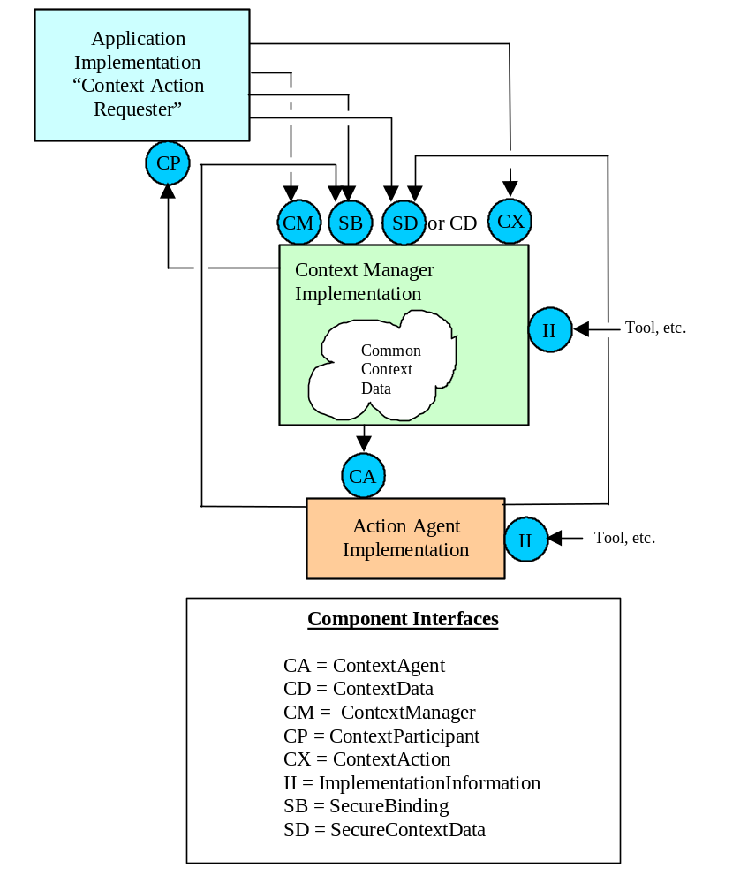
Figure 25. Component Architecture for Context Actions

Component Roles and Responsibilities

Context Action Clients
An application must be a context participant (i.e., must have joined a context session) in order to request, via the context manager’s ContextAction (CX) interface, that a context action be performed. The action is performed with the context of the participant’s context session.
The context manager will forward the request to an action agent, which actually performs the action. In formulating the request, the context participant sets the values for the action subject data items that represent the inputs to the request.
A request by a context participant to perform a context action returns when the action has been performed. The action result is set by the action agent and is represented by the action subject data items that represent the request outputs.
A context participant that is a context action client must always be prepared to process context action continuations. (See Section 16.1.6, Context Action Continuations.) This is because it cannot be determined ahead of time as to whether or not the agent that services the action will require additional user input.

Action Agents
An action agent is a type of context agent that is capable of servicing context action requests. A context action agent implements the the ContextAgent (CA) interface (See Section 9.1, Component Architecture for Common Links). Each action agent services the requests represented by a specific action subject.
The actual request to perform the action is communicated to the agent by the context manager, on behalf of a context participant application that originated the request, via the agent’s ContextAgent (CA) interface. The action result is communicated back to the context manager by the agent. The context manager then conveys the action result to the context participant that issued the context action request.

Context Manager
The context manager serves as the intermediary between an action-requesting application and the action agent that is capable of servicing the request. The context manager ensures that the action subject inputs are mapped by the mapping agent, if any, for the action subject. The context manager also authenticates the signature of the application and checks the integrity of the action inputs if the action subject’s data definition indicates that action requesters must be authenticated. The context manager then forwards the request to the appropriate action agent, and, if necessary, includes its signature as part of this communication.
The context manager obtains the action result outputs from the action agent. The context manager ensures that the action subject outputs are mapped by the mapping agent, if any, for the action subject. The context manager also authenticates the signature of the action agent and checks the integrity of the action outputs if the action subject’s data definition indicates that action agents must be authenticated. The context manager then returns the outputs to the action-requesting application, and, if necessary, includes its signature as part of this communication.
During the course of performing a context action, the context manager shall only allow the application that is requesting the action to set the action subject inputs, the mapping agent for the action subject to map the action subject inputs and outputs, and the action agent that services the action to set the action outputs. Only the action subject that represents the action to be performed may be set. The context manager shall not allow any other context subject or action subject to be set. Depending upon an application’s or components access privileges, the context manager shall allow the data that comprises existing context subjects to be accessed.
Action subject data is not maintained in the context across actions. Therefore, at the completion of an action, the context manager shall set the action subject that represents the action to empty.
The context manager shall only allow one action to be performed at a time. The context manager shall not allow a context change transaction to be performed while an action is being performed. The context manager shall not allow an action to be performed while a context change transaction is being performed.

Context Action Interactions
The following interaction diagram illustrates a generic context action use case. The use case involves the user, who initiates the action via a context participant application, an action subject mapping agent, which maps the action inputs and outputs, the context manager, which mediates the execution of the action, and an action agent, which actually services the action. The use case also depicts the points at which the action agent performs a continuation to obtain additional user inputs.
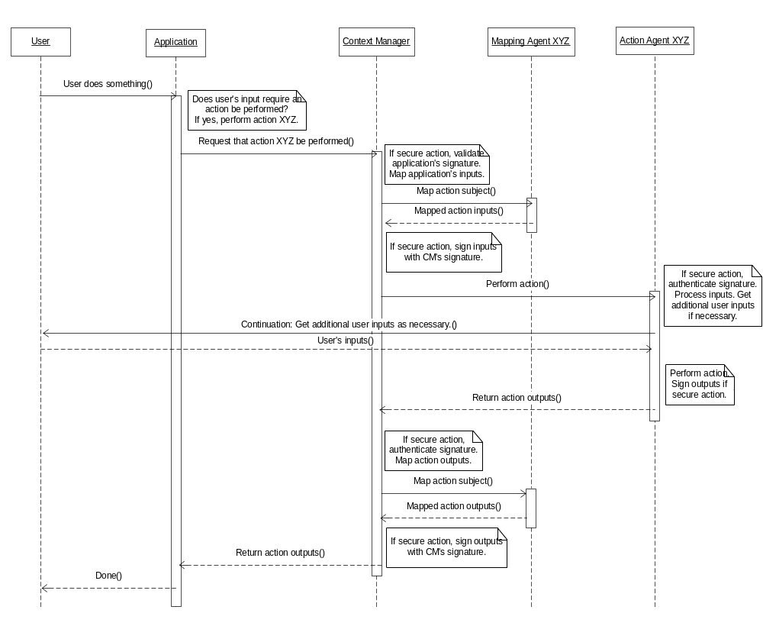
Interaction Diagram 19. User Initiated Context Action

Interface Definitions
It is assumed that an underlying technology infrastructure that supports distributed objects is used to implement a common context system, although a specific technology is not assumed. However, the capabilities of Microsoft’s COM-based Automation technology are considered as a baseline. This implies that the architecture must work well within the constraints of Microsoft Automation, including issues that pertain to performance and supported data types.
An abstract set of CMA component interface definitions is described below. These interfaces are defined using a precise and concise interface definition language (IDL) created for specifying the CMA. This IDL is not meant to be a comprehensive interface specification language. Only the capabilities that are required for specifying CMA component interfaces are included in the IDL.
A CMA-specific IDL is used because existing interface specification languages have direct or indirect ties to specific technologies. For example, OMG’s IDL implies that the interfaces are implemented using CORBA-based technology. Microsoft’s MIDL requires that the interfaces are implemented using COM/DCOM technology. The use of these specification languages confuses and possibly compromises the technology-neutrality of the CMA specification.
Experience has shown that the interface constructs represented in IDL defined below can be easily mapped to interfaces that can be implemented using a specific technology such as ActiveX, CORBA, Java, or HTTP. The mapping for each specific technology appears in a separate Context Management specification document.

Interface Definition Language
The interface definition language (IDL) used in this document enables specifying the following facts about a component interface:
- The interface’s symbolic name.
- The set of component properties and methods that can be accessed via the interface.
- The name and data type of each property, and optional restrictions (e.g., read-only).
- The names and data types for each method’s input and outputs.
- The names and data content for each method’s exceptions.
The IDL also defines a set of simple data types and the capability to represent sequences of these types.
In the following sections, IDL reserved words are shown in bold font. Identifiers are shown in italics. An identifier is an alphanumeric string that starts with an alphabetic character.

Interface Definition Body
The body of an interface definition creates a lexical scope distinct from all other interface definitions. The body of an interface is specified as:
interface interfacename { ... }
Interfacename is the symbolic name of the interface. The curly brackets delimit the scope of the interface’s body.
The body of an interface begins with the declaration of any exceptions that can be raised by methods defined for the interface. The details of declaring exceptions are discussed later.
The properties that can be accessed through the interface are listed next. A property is a data value that can be read or set via the interface:
datatype propertyname
Datatype is the data type for the property. The type is one of the simple types defined below, as denoted by the appropriate IDL reserved word.
Propertyname is the symbolic name of the property. A property’s name must be distinct as compared to the names of other properties, methods, and exceptions defined within the same lexical scope.
Properties can also be sequences. Sequences are described below.
Properties can be restricted to read-only:
readonly datatype propertyname
The value of a read-only property can be read, but not set, via the interface.
Finally, the methods are listed:
methodname inputs ( ... ) outputs ( .... ) exceptions ( ... )
Methodname is the symbolic name of the method. A method’s name must be distinct as compared to the names of other properties, methods, and exceptions defined within the same lexical scope.
The method’s inputs, outputs, and exceptions follow the method’s name. If a method does not have any inputs, outputs, or exceptions, then only white space shall appear between the appropriate set of parentheses.
Each input and output is defined as:
datatype name
Datatype is the data type for the input or output. The type is one of the simple types defined below, as denoted by the appropriate IDL reserved word. In an actual interface definition, the appropriate IDL reserved word is used to indicate the type. Inputs and outputs can also be sequences. Sequences are described below.
Name is the symbolic name of the input or output. The name of inputs for a method must be distinct for the method. The name of each output for a method must be distinct for the method.
Multiple inputs and outputs are separated by a comma.
Exceptions are listed only by their name. Multiple exceptions are separated by a comma.

Simple Data Types
The following simple data types are supported. The reserved words used to indicate each type are shown:
Type | Description
byte | Eight uninterpreted bits
short | 16-bit signed integer
long | 32-bit signed integer
float | 32-bit floating point number
double | 64-bit floating point number
boolean | Indicates true, or false
string | A string of characters
date | A specific year/month/day/time, with a precision of one second, and including the time zone
type | An enumeration that denotes each of these data types (except type) as well as the special types null (valid value not known) and empty (data type not known)
variant | A tagged union of all of these data types (including type and variant)
The concrete representations of these data types are not defined. They depend upon the interface implementation technology.

Exception Declaration
An exception declaration introduces an exception that can be raised by one or more of the methods defined for the interface within whose lexical scope the exception declaration appears. Each exception declaration indicates the exception name and an optional set of data values. The name denotes the exception and the data values provide additional run-time information about the reason for the exception.
An exception declaration is specified as:
exception name { ... }
Name is the symbolic name of the exception. An exception’s name must be distinct as compared to the names of other properties, methods, and exceptions defined within the same lexical scope.
Exception data values are specified as:
datatype name ;
Datatype is the data type for the exception value. The type is one of the simple types defined above, as denoted by the appropriate IDL reserved word. In an actual interface definition, the appropriate IDL reserved word is used to indicate the type. Exception values can also be sequences. Sequences are described below.
Name is the symbolic name of the exception value. The name of each value for an exception must be distinct for the exception.

Sequences
A sequence is a single-dimensional vector of sequential data values. Each data value is denoted by an index whose type is long. The values for these indices are sequential. The value of the first index is not specified; this value depends upon the interface implementation technology.
A sequence with no restrictions on the quantity of values it can contain is specified as:
datatype[]name
Datatype is the data type of the values in the sequence. The type is one of the simple types defined above, as denoted by the appropriate IDL reserved word. Name is the name of the property, input or output, or exception data value.
A sequence with restrictions on the quantity of values it can contain is specified as:
datatype[quantity] name
Quantity is a numeric value that indicates the maximum quantity of values that the sequence can contain. A sequence may contain less than this quantity. The means by which the quantity of values in a sequence is determined depends upon the interface implementation technology.

Interface References
An interface reference enables access to a specific interface to a specific instance of a component that implements the interface. The interface reference data type represents an interface reference. The type of a property, method input, method output, and exception data value can be an interface reference:
interfacename name
Interfacename is the name of the interface that the reference represents. Name is the name of the property, input or output, or exception data value.

Principal Interface
The reserved word Principal is the interface name for a component’s principal interface. The role of a component’s principal interface is discussed in Section 6.1, Component and Interface Concepts. The type of a property, method input, method output, and exception data value can be an interface reference to a principal interface:
Principal name
Name is the name of the property, input or output, or exception data value.

Qualifying Names
In the IDL there is never a case in which the names of properties, methods, and exceptions defined in one lexical scope are referenced in another lexical scope. However, when documenting the interfaces it can be useful to indicate the scope within which a particular property, method, or exception name has been defined.
The convention for doing so is to formulate a qualified name comprised of the name of the interface within whose scope the property, method, or exception of interest was defined, followed by a pair of colons (::) followed by the name of the property, method, or exception, for example:
ContextManager::JoinCommonContext
denotes the method JoinCommonContext as defined for the interface ContextManager.

Interface Implementation Issues
This section describes requirements that all CMA interface implementations must respect.

NotImplemented Exception
In the event that a method is not implemented, the exception NotImplemented shall be raised. This exception can be raised, for example, when a method has been deprecated and is no longer implemented by a CMA component. This exception can implicitly be raised by any method defined using CMA IDL and need not be explicitly declared.

GeneralFailure Exception
In the event that a method cannot be properly performed due to an error or failure condition, and an explicitly defined exception does not appropriate represent the situation, then the exception GeneralFailure shall be raised. This exception might be raised, for example, when a CMA component is unable complete a computation due to an internal error. This exception can implicitly be raised by any method defined using CMA IDL and need not be explicitly declared.

Coupon Representation
A participant coupon is a 32-bit integer, represented as the CMA IDL data type long, that is assigned by a common context manager to denote each application that joins a common context session. An application is assigned a participant coupon when it joins a common context session. It subsequently uses the coupon to identify itself when performing methods on the context manager.
A context coupon is a 32-bit integer that is assigned by a common context manager to denote each context change transaction. Each time a new transaction is started a new coupon is assigned by the context manager to denote the transaction. Applications use a context coupon to denote the transaction of interest.
Participant coupons shall have unique values for the duration of a common context session (i.e., from the time the first application joins to the time the last application leaves). Context coupons shall also have unique values for the duration of a common context session.
The distinguished value of 0 shall never be assigned as a participant coupon value or as a context coupon value.

Format for Application Names
Several interfaces require that an application provide a CMA IDL string that contains a symbolic name for the application. This string is generally used to distinguish one application from another.
This string shall only be comprised of alphanumeric characters, blank spaces (no tabs), the underscore (_) and period (.) characters. The string shall neither begin nor end with a blank space.
Additionally, an application that is capable of allowing multiple instances of itself to join the same context session shall append to the end of its symbolic name the number-score character (#) followed by a string that distinguishes one instance of the application from another.
The composition of the appended string is not specified, as long as no two instances of the application join the same context session and use the same appended string at the same time. The appended string shall only be comprised of alphanumeric characters, blank spaces (no tabs), as well as the underscore (_) and period (.) characters. The appended string shall neither begin nor end with a blank space.
Character case is not considered when comparing application names.
The BNF for an application name appears below:
SPACE = “ “
UNDERSCORE = “_”
PERIOD = ”.”
DASH = “-“
ALPHA = “a-zA-Z”
NUMERIC = “0-9”
POUND = “#”

initialAppChar = ALPHA | NUMERIC | UNDERSCORE | PERIOD | DASH
endAppChar = initialAppChar
appChar = initialAppChar | SPACE
appNameBody = appChar* endAppChar
appQualifier = POUND initialAppChar [appNameBody]
appName = initialAppChar [appNameBody] [appQualifier]
An example of an application name is:
“3M Clinical Workstation#0”
“3M Clinical Workstation#1”
“3M Clinical Workstation#2”
Application names formed as such shall be interpreted as representing the same logical application (e.g., “3M Clinical Workstation”) while also representing distinct running instances of the application (i.e., three instances of “3M Clinical Workstation”).

Extraneous Context Items
Context participants shall robustly deal with the situation in which context data items that they do not recognize are nevertheless part of the common context. This might occur, for example, in a system comprised of context participants that have been implemented using different versions of the CMA data definition specifications. A participant implemented using an earlier version of these specifications might not recognize context items defined in subsequent versions of the specifications. Context participants shall simply ignore context data items whose names they do not recognize.
Similarly, context managers shall allow any context data item for any CMA-defined subject to be part of the context, as long as the name for the item is properly formatted.

Forcing the Termination of a Context Change Transaction
The context manager may need to force the termination of a context change transaction when it appears that the instigator of the transaction has failed before completing the transaction. Specifically, it is recommended that any context manager method that can result in the ContextManager::TransactionInProgress exception being thrown should first explicitly confirm that the transaction instigator is still alive.
Most context manager implementations will employ a timer to monitor the activity of a transaction instigator. If the instigator does not perform the necessary operations on the context manager’s interfaces in a timely manner, it can be inferred that the instigator has failed. The method ContextParticipant::Ping is defined to enable the context manager to probe a context participant to determine its liveliness. The context manager may additionally confirm the liveliness of a context participant using technology-specific mechanisms.
The duration of these timers, and the use of confirmation techniques, are implementation-dependent.
The context manager shall clean up after the failure of the instigator by performing the following actions:
- The coupon assigned by the manager for the transaction is invalidated.
- The transaction-specific version of the context data is discarded.
- The coupon and context data associated with the most recently committed transaction are unaffected.
- The context manager’s internal state is set to indicate that there is no longer a transaction in progress.
Additional actions depend upon when the context manager determines that the instigator has failed, as described in Table 4. Handling Transaction Instigator Failure.
Table 4. Handling Transaction Instigator Failure
Instigator fails… | Leaving sessions in the following state… | Context manager cleans-up by…
before ending the transaction (see ContextManager::EndContext  Changes) | a context change transaction is in progress, although surveying has not yet been performed | performing the actions described above
after ending the transaction but before publishing its decision to accept or cancel the changes (see ContextManager::Publish  ChangesDecision) | a context change is in progress and the surveyed participants are waiting for the survey decision | publishing the fact that the context changes have been canceled and then performing the actions described above

Character-Encoded Binary Data
Several of the CMA component interfaces use CMA IDL string parameters that contain character-encoded binary data. The following representation of character-encoded binary data shall be applied for all such parameters.
Each byte of data shall be represented by two printable characters. The four high bits of the byte (i.e., the high octet) shall be represented by the left character. The four low bits of the byte (i.e., the low octet) shall be represented by the right character.
An array of bytes shall be represented by character-encodings such that the left most character-encoded byte in the string represents the data byte at lowest array index. The encoding follows sequentially, such that the right most character-encoded byte in the string represents the data byte at the highest array index.
Each four bits of data (i.e., an octet) is represented by an alphanumeric character as follows:
Data (Octet) | Character
0000 | 0
0001 | 1
0010 | 2
0011 | 3
0100 | 4
0101 | 5
0110 | 6
0111 | 7
1000 | 8
1001 | 9
1010 | A or a
1011 | B or b
1100 | C or c
1101 | D or d
1110 | E or e
1111 | F or f
The actual character set that is employed is technology-specific. Each of the HL7 context management technology mapping specification documents indicates the character set that is used for a particular technology-specific implementation.
Binary data that is character-encoded as a string shall not include white space or any other characters other than the ones shown in the table above. The character-encoded string is not case sensitive. An example of binary data character-encoded per these conventions is:
Binary Data: | 00000001 11101001 11000111 1000010
Character-Encoded String: | 01E9C782

Representing Message Authentication Codes, Signatures and Public Keys
Message authentication codes, digital signatures, public keys are used as input or output parameters for several of the methods defined for CMA component interfaces. The CMA IDL data type for each of these parameters is string. Each string contains character-encoded binary data, encoded per Section 17.2.7, Character-Encoded Binary Data.
The binary data that is encoded is technology-specific. Each of the HL7 context management technology mapping specification documents indicates the binary data types needed for a particular technology-specific implementation. It is necessary that both the sender and receiver of a message authentication code, digital signature, or public key agree upon the format of the underlying binary data type, and the algorithms used to create the data. The method SecureBinding::InitializeBinding, defined in Section 17.3.12.2, InitializeBinding, enables this agreement to be established.

Representing Basic Data Types as Strings
Several of the CMA component interfaces use input or output parameters whose values are computed from the string representations of data values of various types. For example, digital signatures are computed from a one-way hash value, which is, in turn, computed from a string formed by concatenating a list of data values, each of which is represented as a string.
The following data types shall be represented as character strings using the formats described in Table 5. Character Representations for Basic Data Types.
Table 5. Character Representations for Basic Data Types
Type | String Representation | Comments
boolean | 0, if false  1, if true
short | dddd, where d is a numeric character representing a decimal digit and the number of characters depends upon the value of the number. | Leading minus sign (-dddd) if number is negative. No plus sign if positive.
long | Same as for short.
date | yyyy/mm/dd hh:mm:ss
string | As is. | Case is preserved.
float | dddd.dddd, where d is a numeric character representing a decimal digit. The number of digits before the decimal point depends on the magnitude of the number. The number of digits after the decimal point shall not exceed four, and other than the first digit after the decimal trailing zero’s shall not be used. | Leading minus sign  (-dddd.dddd) if number is negative. No plus sign if positive.
double | Same as float, except that the number of digits after the decimal shall not exceed eight.
byte | bb, where b is a hexadecimal digit. The byte is represented as unsigned. | Lower case for alphabetic characters that represent hex digits (i.e., a, b, c, d, e, f).
The actual character set that is employed is technology-specific. Each of the HL7 context management technology mapping specification documents indicates the character set that is used for a particular technology-specific implementation.

Pre-Defined Context Agent Coupons
Pre-defined participant coupon values are used for context agents because they do not explicitly join the context session, and therefore do not have a means similar to a context participant application for dynamically obtaining a coupon. Instead, a context agent is implicitly “pulled” into the context session each time a context change transaction occurs, when the context manager performs the method ContextAgent::ContextChangesPending on a context agent.
However, secure context agents such as the user mapping agent need to know their participant coupon values prior to the first context change transaction. For example, the user mapping agent needs to establish a secure binding with the context manager before it can set user context items. In order to establish this binding, the user mapping agent must present the context manager with its coupon. By having a priori knowledge of its coupon value, the user mapping agent can establish its secure binding whenever it decides to, up until the time it actually attempts to set the context.
Therefore, a unique participant coupon value is pre-defined for each type of context agent for the context identity, annotation, or action subject that it represents. The implementation of a context agent for a standard subject shall use the coupon value assigned for such a context agent for the subject that it represents. The implementation of a context manager shall use the pre-defined coupon value defined for an agent when it communicates with the agent.
The specific pre-defined coupons for each type of context agent for each of the standard subjects shall be defined in the document Health Level-Seven Standard Context Management Specification, Subject Data Definitions.
Conversely, a context agent for a custom subject shall use a coupon value that is assigned on site at the time at which the context agent is deployed. Each site shall ensure that the coupon value that it assigns to a custom context agent deployed at the site is unique for the site. Both a custom context agent and the context manager shall provide a means for being configured on site as to which coupon value has been assigned to each custom agent used at the site.
The coupon value assigned to a standard or custom agent shall always be negative, whereas positive coupon values denote context participant applications. The coupon values used for agents shall be within the range of values indicated in the table below, where on range of values is reserved for agents for standard subjects and another range is reserved for agents for custom subjects.
Context Agent | Coupon Value
Reserved for Context Agents for Standard Subjects | -1 through –9,999
Reserved for Context Agents for Custom Subjects | -10,000 through –20,000

Interfaces
This section specifies the methods for each of the CMA interfaces, starting on the next page.

AuthenticationRepository (AR)
interface AuthenticationRepository {
exception AuthenticationFailed { string reason; }
exception UnknownApplication {}
exception UnknownConnection {}
exception LogonNotFound { string logonName; }
exception UnknownDataFormat { string dataFormat; }

Connect
inputs(string applicationName)
outputs(long connectionCoupon)
raises(UnknownApplication)

Disconnect
inputs(long connectionCoupon)
outputs()
raises(UnknownConnection)

SetAuthenticationData
inputs(long connectionCoupon, string logonName, string dataFormat,
string userData, string appSignature)
outputs()
raises(UnknownConnection, AuthenticationFailed)

DeleteAuthenticationData
inputs(long connectionCoupon, string logonName, string dataFormat,
string appSignature)
outputs()
raises(UnknownConnection, AuthenticationFailed, LogonNotFound,
UnknownDataFormat)

GetAuthenticationData
inputs(long connectionCoupon, string logonName, string dataFormat,
string appSignature)
outputs(string userData, string repositorySignature)
raises(UnknownConnection, AuthenticationFailed, LogonNotFound,
UnknownDataFormat)
}

Synopsis
This interface enables a context participant to securely maintain the data it uses to authenticate its users in an external repository.

Connect
This method enables an application to establish a connection with the authentication repository. An application must have a connection before it can set or get user authentication data.
The value of the input applicationName is a succinct string that contains the application’s symbolic name. The output connectionCoupon is the value of a connection coupon that the application can subsequently use to denote itself when performing other authentication repository methods.
The value of input applicationName is used by the authentication repository to determine the passcode or certificate for an application. The passcode or certificate is needed when an application establishes a secure binding with the authentication repository (see Section 17.3.12 SecureBinding (SB)). Multiple instances of an application can connect to the authentication repository using the same name. Each instance of the application will be assigned a unique connection coupon. Each instance of the application will need to establish a secure binding with the repository.
The value of the input applicationName is also used by the authentication repository to store/retrieve the user authentication data within the repository.
The exception UnknownApplication is raised if the input applicationName does not represent an application currently known to the authentication repository.

Disconnect
This method enables an application to disconnect from the authentication repository. An application shall disconnect before it terminates. The value of the input connectionCoupon denotes the application.
The exception UnknownConnection is raised if the input connectionCoupon does not denote an application currently connected to the authentication repository.

SetAuthenticationData
This method enables an application to store authentication data for a particular user’s logon name within the authentication repository. This method also enables an application to update authentication data for a particular user’s logon name that it has already stored in the repository.
The value of the input connectionCoupon denotes the application, the value of the input logonName is a user’s logon name, the value of the input userData is the application-specific data used to authenticate the user, and the value of the input appSignature is the application’s digital signature. This signature enables the authentication repository to authenticate that the request to set the authentication data came from the application denoted by the value of connectionCoupon, and that the values of connectionCoupon, logonName, dataFormat, and userData, were not tampered with between the time they were sent and were received.
Concatenating the string representations of the following inputs in the order listed shall form the data from which a message digest is computed by the application:
- connectionCoupon
- logonName
- dataFormat
- userData
An application shall compute its digital signature by encrypting the message digest with its private key.
The value of the input dataFormat is an application-defined string that is used when an application needs to maintain multiple forms of authentication data for a user (e.g., password, thumbprint image, etc.). If only one form of authentication data is needed, this string can be empty (“”). Multiple calls of SetAuthenticationData are required to set different forms of authentication data for a particular user. The value of dataFormat for each call shall indicate the form of authentication data to be stored.
The value of the input userData contains user authentication data that has been encrypted by the application using an encryption technique chosen by the application. This data is character-encoded per Section 17.2.7, Character-Encoded Binary Data. The structure of the encoded binary data is application-dependent and is not specified.
The exception UnknownConnection is raised if the input connectionCoupon does not denote an application that is currently connected to the repository.
The exception AuthenticationFailed is raised if the process of authentication determines that the signature is not the signature for the application denoted by the input connectionCoupon or that the input parameter’s values have been tampered with.

DeleteAuthenticationData
This method enables an application to delete from the authentication repository some or all of the authentication data that it previously stored for a particular logon name. Both the logon name and the associated authentication data are deleted.
The value of the input connectionCoupon denotes the application and the value of the input logonName is the logon name to be deleted.
The value of the input dataFormat is an application-defined string that is used when an application maintains multiple forms of authentication data for a user (e.g., password, thumbprint image, etc.) within the repository. If this string is empty, then all of the forms of authentication data stored for the user are deleted. If this string is not empty, then just the denoted form of authentication data is deleted.
The value of the input appSignature is the application’s digital signature.
Concatenating the string representations of the following inputs in the order listed shall form the data from which a message digest is computed by the application:
connectionCoupon
logonName
dataFormat
An application shall compute its digital signature by encrypting the message digest with its private key.
This signature enables the authentication repository to authenticate that the request to delete the authentication data came from the application denoted by the value of connectionCoupon, and that the values of coupon, logonName, and dataFormat were not tampered with between the time they were sent and were received.
The exception UnknownConnection is raised if the input connectionCoupon does not denote an application that is currently connected to the repository.
The exception AuthenticationFailed is raised if the process of authentication determines that the signature is not the signature for the application denoted by the input connectionCoupon or that the input parameter values have been tampered with.
The exception LogonNotFound is raised if user authentication data corresponding to the logon name denoted by the input logonName does not reside in the repository.
The exception UnknownDataFormat is raised if the form of authentication data denoted by the input dataFormat is not found in the repository.

GetAuthenticationData
This method enables an application to retrieve from the authentication repository the authentication data previously stored for a particular user’s logon name. The value of the input connectionCoupondenotes the application, the value of the input logonName is a user’s logon name, and the value of the input appSignature is the application’s digital signature.
This signature enables the authentication repository to authenticate that the request to get the authentication data came from the application denoted by the value of connectionCoupon, and that the values of coupon, logonName, and dataFormat were not tampered with between the time they were sent and were received.
Concatenating the string representations of the following inputs in the order listed shall form the data from which a message digest is computed by the application:
connectionCoupon
logonName
dataFormat
An application shall compute its digital signature by encrypting the message digest with its private key.
The value of the input dataFormat is an application-defined string that is used when an application needs to maintain multiple forms of authentication data for a user (e.g., password, thumb-print image, etc.). If only one form of data is used, this string can be empty. Multiple calls of GetAuthenticationData are required to get different forms of authentication data for a particular user. The value of dataFormat for each call shall indicate the form of authentication data to be retrieved.
The value of the output userData is the application-specific data used to authenticate the user. The output userData remains encrypted, as it was when it was stored by the application using SetAuthenticationData.
The output userData shall be used as the data from which a message digest is computed by the application. The authentication repository shall compute its digital signature by encrypting the message digest with its private key.
This signature enables the application to authenticate that the authentication data returned by this method came from the authentication repository and that the value of userData was not tampered with between the time it was sent and was received.
The exception UnknownConnection is raised if the input connectionCoupon does not denote an application that is currently connected to the repository.
The exception AuthenticationFailed is raised if the process of authentication determines that the signature is not the signature for the application denoted by the input connectionCoupon or that the input parameter values have been tampered with.
The exception LogonNotFound is raised if user authentication data corresponding to the logon name denoted by the input logonName does not reside in the repository.
The exception UnknownDataFormat is raised if the form of authentication data denoted by the input dataFormat is not found in the repository.

ContextAgent (CA)
interface ContextAgent {

ContextChangesPending
inputs(long agentCoupon, Principal contextMgr,
string[] itemNames, string[] itemValues, long contextCoupon,
string managerSignature)
outputs(long agentCoupon, string[] itemNames, string[] itemValues,
long contextCoupon, string agentSignature,
string decision, string reason)
raises()

Ping
inputs()
outputs()
raises()
}

Synopsis
This interface enables a context agent to be notified about context changes.

ContextChangesPending
This method informs a context agent (e.g., mapping agent, annotation agent, context agent) in a common context session that a change to the common context data is pending. The method also enables an action agent to be instructed to perform a specific context action.

Inputs
The value of the input contextCoupon denotes the context change transaction or context action. The value of the input agentCoupon is a predefined coupon that denotes the specific type of context agent. (See Section 17.2.10, Pre-Defined Context Agent Coupons). The value of the input contextMgr is an interface reference to the context manager’s principal interface. This is so that the context agent can easily obtain the context manager interface(s) it needs.
As an optimization, the context manager provides the context agent with a relevant set of context data items. In most cases, it should be unnecessary for an agent to obtain additional data from the context manager. However, the context manager methods ContextData::GetItemValues and/or SecureContextData::GetItemValues may be used by a context agent, although extreme care should be exercised when these interfaces are used by an agent, as the data presented via these interfaces may not necessarily be the same as the data that the agent is presented with via the ContextChangesPending method. The data presented via ContextChangesPending is always the correct data as far as an agent is concerned.
When the agent is a mapping agent, the context data shall include all of the items for the context subject whose identifier items the agent is supposed to map. For example, for a patient mapping agent, these items will contain all of the items currently set for the patient subject.
When the agent is an annotation agent, the context data shall include all of the items for the subject upon which the annotation subject depends.
When the agent is an action agent, the context data shall include all of the items that represent the action subject inputs for the action that the agent is supposed to perform.
The names of the context items are contained in the input sequence itemNames. The values for each of these items are contained in the input sequence itemValues. The i^{th} element in itemValues is the value for the item named by the i^{th} element in itemNames. Note that the representation of an item value is always a string, character-encoded as necessary per the conventions defined in Section 17.2, Interface Implementation Issues.
If the context items contained in the inputs itemNames and itemValues are for a secure subject, then the context manager’s digital signature shall be provided as the value of the input managerSignature. This signature enables the agent to authenticate that the context items came from the real context manager, and that the values were not tampered with between the time they were sent and were received.
Concatenating the string representations of the following inputs in the order listed shall form the data from which a message digest is computed by the context manager:
- agentCoupon
- itemNames (i.e., All the elements in the order that they appear in the array.)
- itemValues (i.e., All the elements in the order that they appear in the array.)
- contextCoupon
The context manager shall compute its digital signature by encrypting the message digest with its private key.
If the context items contained in the inputs itemNames and itemValues are not for a secure subject, then the value of the input managerSignature shall be an empty string (“”).

Outputs
As an optimization, an agent may provide as outputs the set of context data items that should be added to the context. (Note that agents may only add data to the context.) In most cases this eliminates the need for an agent to set additional data via the context manager’s ContextData or SecureContextData interfaces. However, the context manager methods ContextData::SetItemValues and/or SecureContextData::SetItemValues may still be used by context agents.
If a context agent has explicitly added data to the context via the context manager’s interfaces, then the values of the output sequences itemNames and itemValues should be empty (i.e. zero elements).
Otherwise, the outputs itemNames and itemValues contain the names and values for the context items whose values are to be set by the context manager. The names of the context items are contained in the output sequence itemNames. The values for each of these items are contained in the output sequence itemValues. The i^{th} element in itemValues is the value for the item named by the i^{th} element in itemNames. Note that the representation of an item value is always a string, character-encoded as necessary per the conventions defined in Section 17.2, Interface Implementation Issues.
When the context items to be set belong to a secure subject, then the agent shall also provide its digital signature as the value of the output agentSignature. This signature enables the context manager to authenticate that they came from a valid secure subject context agent, and that the values were not tampered with between the time they were sent and were received.
Concatenating the string representations of the following outputs in the order listed shall form the data from which a message digest is computed by the context agent:
- agentCoupon
- itemNames (i.e., All the elements in the order that they appear in the array.)
- itemValues (i.e., All the elements in the order that they appear in the array.)
- contextCoupon
An agent shall compute its digital signature by encrypting the message digest with its private key.
If the context items contained in the outputs itemNames and itemValues are not for a secure subject, then the value of the output agentSignature shall be an empty string (“”).

Outputs for Mapping Agents
If the agent is not a mapping agent, then the outputs decision and reason are not used. The value of the output decision and the value of the output reason shall be an empty string (“”).
Otherwise, if the agent is a mapping agent, then these outputs are used. A mapping agent shall respond with an indication of how it wants to deal with the context change:
- The changes are valid
- The changes are invalid
If the changes are valid, then the value of the output decision shall be “valid”. If the changes are invalid, then the value of the output decision shall be “invalid”. The changes shall only be declared invalid if the set of identifiers in the proposed context data do not all represent the same real-world entity or concept. If the changes are invalid, then the value of the output reason shall contain a succinct but detailed string describing why the changes were invalid. Otherwise the value of reason shall be an empty string (“”).
The context manager shall treat the value of the output decision in a case-insensitive manner. The context manager shall preserve the case used in the value of the output reason.

Exceptions
No exceptions have been defined for this method. However, there are a number of incorrect behaviors that are possible concerning the values of the outputs. When a context manager detects any of the following incorrect behaviors, it shall not update the context data with the context items provided by the agent as the values of the outputs itemNames and itemValues:
- The value of agentSignature is not a digital signature and a signature is required in order to perform this method.
- A value for agentSignature is required and provided, but the process of authentication determines that: the agent did not previously provide its public key via the context manager’s interface SecureBinding; that the input agentSignature has been forged; that the input parameter values have been tampered with; that the agent has not been designated for setting secure context data.
- The output agentCoupon does not denote a context agent that is currently a participant in the common context session.
- The ouput contextCoupon does not denote the transaction currently in progress.
- The number of items in the output nitemNames does not match the number of items in the output itemValues.
- The format of an item named in the output itemNames for deletion does not conform to the specification for the item in the relevant HL7 Context Management Data Definition Specification.
- The data type for one or more of the items whose value is contained in the output itemValues is not the same as the expected data type.
- The data value for one or more of the items whose value is contained in the output itemValues is determined to be unacceptable. This exception is used by context manager implementations that enforce semantic constraints on the common context. Not all context manager implementations will do this.
- The value for one or more of the items named in the output itemNames has already been set by the application that instigated the context change transaction.
- The value for one or more of the items named in the output itemNames is for a context subject other than the subject that the agent is for (e.g.., the user certificate annotation agent returns context item values for the patient identity subject).
The context manager implementation may opt to log or otherwise record these errors. However, the means for doing so is beyond the scope of this specification. Other than through the explicit intervention of a systems administrator, a context agent implementation may not necessarily be aware that any of these errors have transpired.

Ping
This method provides a means for a context manager to determine whether or not a context agent in a common context session is still running. This method shall be implemented by all agents to return immediately. The context manager can then perform this method to probe a context agent when the agent’s existence is in doubt.
In performing this method, the context manager will be able to indirectly exercise the underlying communications infrastructure. The infrastructure will either indicate that the method was successfully performed, that the method failed because the agent no longer exists, or that the method failed but it cannot be determined whether or not the agent exists. In this last case, the manager shall assume that the agent still exists.

ContextData (CD)
interface ContextData {
exception UnknownParticipant { long participantCoupon; }
exception UnknownItemName { string itemName; }
exception BadItemNameFormat { string itemName; string reason }
exception BadItemType { string itemName; type actual;
type expected; }
exception BadItemValue { string itemName; variant itemValue;
string reason; }
exception NameValueCountMismatch {long numNames; long numValues }
exception ChangesNotPossible {}
exception ChangesNotAllowed {}
exception InvalidContextCoupon {}

GetItemNames
inputs(long contextCoupon)
outputs(string[] names)
raises(InvalidContextCoupon)

DeleteItems
inputs(long participantCoupon, string[] itemNames,
long contextCoupon)
outputs()
raises(NotInTransaction, UnknownParticipant, InvalidContextCoupon,
BadItemNameFormat, UnknownItemName, ChangesNotPossible,
ChangesNotAllowed)

SetItemValues
inputs(long participantCoupon, string[] itemNames,
variant[] itemValues, long contextCoupon)
outputs()
raises(NotInTransaction, UnknownParticipant, InvalidContextCoupon,
NameValueCountMismatch, BadItemNameFormat, BadItemType,
BadItemValue, ChangesNotPossible, ChangesNotAllowed)

GetItemValues
inputs(string[] itemNames, boolean onlyChanges, long contextCoupon)
outputs(variant[] itemValues)
raises(InvalidContextCoupon, BadItemNameFormat, UnknownItemName)
}

Synopsis
This interface enables a context participant to get and set context data for common subjects, which are subjects for which secure access is not required. The data is represented as a set of items, each of which is structured as a name/value pair.

GetItemNames
This method enables a participant in a common context session to obtain the names of common subject context items in the context.
This method can be performed outside the scope of a context change transaction. In this case, the value of the input contextCoupon must denote the most recently committed transaction. The output itemNames is a sequence containing the common subject context item names that represent the state of the common context as it was when the most recently committed transaction was completed.
This method can also be performed within the scope of a context change transaction that is currently in progress. In this case, the input contextCoupon must denote the current transaction. The output itemNames contains the common subject context item names that represent the state of the common context as it has been established so far by the transaction. The output itemNames is empty (i.e. zero elements) until a participant explicitly sets item values via the ContextData::SetItemValues method within the scope of the transaction.
The exception InvalidContextCoupon is raised if the input contextCoupon does not denote the most recently committed transaction or the transaction currently in progress.

DeleteItems
This method is no longer supported, as a method to delete items from the context is extraneous. Specifically, per Section 9.6, Context Change Transactions, when a context change transaction is started, the context manager creates a transaction-specific version of the context data. This version of the context data is initially empty. Items are then added to the transaction-specific context data during the course of the transaction. Therefore, there is not need to be able to delete items.
It is acceptable for a technology-specific implementation of this interface to indicate in a technology-specific manner that this method is not implemented.

SetItemValues
This method enables an application or mapping agent in a common context session to set the value of one or more common subject context items. The application or mapping agent denotes itself with its participant coupon as the value of the input participantCoupon. The names of the context items to be set are contained in the input sequence itemNames. The values for each of these items are contained in the input sequence itemValues. The i^{th} element in itemValues is the value for the item named by the i^{th} element in itemNames.
If an item named in itemNames is not currently an common subject context item in the context, it will be added. The data type for a newly added item is the same as the data type of the element in itemValues that contains the item’s value.
This method can only be performed within the scope of a context change transaction. The value of the input contextCoupon must denote the current transaction.
The exception NotInTransaction is raised if there is no change transaction currently in progress.
The exception UnknownParticipant is raised if the input participantCoupon does not denote an application or mapping agent that is currently a participant in the common context session.
The exception InvalidContextCoupon is raised if the input contextCoupon does not denote the transaction currently in progress.
The exception NameValueCountMismatch is raised if the number of items in the input nitemNames does not match the number of items in the input itemValues.
The exception BadItemNameFormat is raised if the format of an item named for addition does not conform to the specification for the item in the relevant HL7 Context Management Data Definition Specification.
The exception BadItemType is raised if the data type for one or more of the items whose value is to be set is not the same as the expected data type.
The exception BadItemValue is raised if the data value for one or more of the items whose value is to be set is determined to be unacceptable or if the item does not belong to a common subject (i.e., it belongs to a secure subject). This exception may also be used by context manager implementations that enforce semantic constraints on the common context, but not all context manager implementations will do this.
The exception ChangesNotPossible is raised if the ContextData::SetItemValues method is invoked by an application after the ContextManager::EndContextChanges method has already been invoked for the transaction currently in progress. (This exception is not raised if a mapping agent invokes ContextData::SetItemValues after ContextManager.)
The exception ChangesNotAllowed is raised if the caller is a context agent that has attempted to set a value for a context subject other than the subject that it is the agent for. This exception is also raised if the caller is a context agent that has attempted to set a value for a context item for which a value has already been set by the application that instigated the context change transaction. Finally, this exception is raised if the caller has attempted to set a value for an annotation subject and the caller is not an annotation agent.

GetItemValues
This method enables a participant in a common context session to obtain the value of one or more common subject context items.
When the value of the input contextCoupon denotes the most recently committed transaction, the item values that are returned represent the state of the common context as it existed when the transaction was completed. This is true even if there is currently a new transaction in progress.
When the value of the input contextCoupon denotes the transaction currently in progress, the item values that are returned represent the state of the common context as it has been established so far by the transaction. The capability to access the items for the transaction in progress enables applications to use this information to determine how they want to respond to the context change survey conducted by the context manager (see Sections 9.8, Context Change Notification Process and 17.3.7, ContextParticipant (CP)). For example, an imaging application that caches data may respond to the survey differently depending upon whether the proposed context change involves a patient currently in the application’s cache.
The items of interest are indicated in the input sequence itemNames. These names can be fully-qualified item names, which means that the all of the fields for an item’s name are explicitly specified (e.g., "Patient.Id.MRN.St_Elsewhere_Hospital").
Alternatively, a wild card represented by an asterisk (*) can be used in place of a specific string for any of the item name fields except for the subject field (which is lexically the first field on the left). The wild card enables a participant to obtain one or more items without having to specify complete item names.
If a wild card is used, it must appear in only the last field specified in the item name string (which is lexically the last field on the right). Additional field names and/or wild cards must not appear after a wild card (i.e., lexically to the right of the wild card). Examples of properly formatted items names include:
“Patient.*” matches all of the context items for the patient subject
“Patient.Id.*” matches all of the patient identifier items
“Patient.Id.MRN.*” matches all of the patient identifiers that are site-specific medical record numbers
Conversely, “Patient.Id.*.*” and “Patient.Id.*.St_Elsewhere_Hospital” are examples of improperly formatted item names.
The sequence output itemValues contains the values of all of the items whose names match the set of names specified in the input itemNames. A specific item’s value will be included at most once in itemValues, even if its name matches more than one of the names specified in itemNames. For example, even if itemNames includes the names:
“Patient.Id.MRN.St_Elsewhere_Hospital”
and:
“Patient.Id.*”
the value for the item named “Patient.Id.MRN.St_Elsewhere_Hospital” will be included only once in itemValues.
The elements in the sequence itemValues alternate between the complete name of an item (represented as a string) and the corresponding item value (represented by the appropriate data type). For example, if several context data items are returned, then the first element in the list is the name of the first item, the second element in the list is the value of the first item, the third element in the list is the name of the second item, the fourth element in the list is the value of the second item, and so on.
The input onlyChanges enables a participant to instruct the context manager to filter which items it returns no matter what names were specified. When the value of onlyChanges is true, then the items that are returned are limited to only the context subjects whose items were set by the most recently committed context change transaction, or by the transaction in progress, as indicated by the value of contextCoupon.
For example, if onlyChanges is true, contextCoupon denotes the most recently committed context change transaction, and itemNames includes the name:
“Patient.Id.*”
but items in the patient subject were not set during the transaction, then the output itemValues will not contain any items pertaining to the patient subject.
The exception InvalidContextCoupon is raised if the input contextCoupon does not denote the most recently committed transaction or the transaction currently in progress.
The exception BadItemNameFormat is raised if the format of the name of one or more of the items whose value is to be set does not conform to the specification for the item in the relevant HL7 context management data definition specification.
The exception UnknownItemName is raised if one or more of the items named, wild cards not withstanding, is not the name of a common subject item in the context as it stands under the current transaction.

ContextFilter (CF)
interface ContextFilter {
exception UnknownParticipant { long participantCoupon; }
exception UnknownItemName { string itemName; }
exception BadItemNameFormat { string itemName; string reason }
exception FilterNotSet {}

SetSubjectsOfInterest
inputs(long participantCoupon, string[] subjectNames)
outputs()
raises(UnknownParticipant, BadItemNameFormat, UnknownItemName)

GetSubjectsOfInterest
inputs(long participantCoupon)
outputs(string[] subjectNames)
raises(UnknownParticipant FilterNotSet)

ClearFilter
inputs(long participantCoupon)
outputs()
raises(UnknownParticipant)
}

Synopsis
This interface enables a context participant to get and set a filter containing the names of the specific context subjects whose item values must be set during the course of a transaction in order for the participant to be included in the processing of the transaction. The intent of this interface is to enable applications to ignore notifications for changes to subjects that they do not implement. An application should not use this interface to filter notifications about subjects that it implements.

SetSubjectsOfInterest
This method enables an application in a common context session to set names of those subjects for which it will be surveyed and notified whenever the item values for these subjects are set during the course of a context change transaction.
The application denotes itself with its participant coupon as the value of the input participantCoupon.
The names of the context subjects for which the application will be surveyed and notified are contained in the input sequence subjectNames. Specifically, per Section 1.5, Context Data Item Format, in the document Health Level-Seven Standard Context Management Specification, Subject Data Definitions, these names are the subject_label portion of a context item name.
If a subject included in the list is a standard HL7 subject, then the descriptor of the defining organization for the subject, specifically [hl7.org], may be optionally included in the subject’s name. Otherwise the subject is, by definition a custom subject, and the descriptor shall be included as part of the subject’s name.
(In the event that the input subjectNames is empty (i.e., has zero elements), then the application shall not be surveyed or notified during the course of any context change transaction).
If, when an application joined the context session, it indicated that it did not want to be surveyed, then independent of the value of subjectNames, the application will not be surveyed for any transaction. The application will, however, still be notified whenever a transaction is accepted and at least one of the subjects names in subjectNames has been set.
Subsequent to joining the context session and prior to returning from a successful call of this method, an application shall be surveyed and notified about all context change transactions, no matter what subjects have been set during the course of the transaction. (If, when an application joined the context session, it indicated that it did not want to be surveyed, the application shall not be surveyed for any transaction.) An application should be prepared to receive surveys and notifications for subjects that are not necessarily of interest until it has successfully called this method.
An application may call this method any number of times during the course of a context session. Each time that this method is successfully performed, the list of subjects contained in the input subjectNames shall become the list of subjects filtered by the context manager on behalf of the application. A new list of subject names shall take affect upon the start of the next context change transaction subsequent to the successful return of this method. An application should be prepared to receive surveys and notifications for subjects that are not necessarily of interest until this time.
The exception UnknownParticipant is raised if the input participantCoupon does not denote an application that is currently a participant in the common context session.
The exception BadItemNameFormat is raised if the format of the name of one or more of the subjects in the input subjectNames does not conform to the specification for subject labels as defined in the HL7 context management data definition specification.
The exception UnknownItemName is raised if one or more of the subjects named in the input subjectNames is not the name of a subject known to the context manager.

GetSubjectsOfInterest
This method enables an application in a common context session to get names of those subjects for which it will be surveyed and notified whenever the item values for these subjects are set during the course of a context change transaction. The list of subjects are those that have been set by the application during its most recent call to ContextFilter::SetSubjectsOfInterest.
The application denotes itself with its participant coupon as the value of the input participantCoupon.
The names of the context subjects for which the application will be surveyed and notified are contained in the output sequence subjectNames. Specifically, per Section 1.5, Context Data Item Format, in the document Health Level-Seven Standard Context Management Specification, Subject Data Definitions, these names are the subject_label portion of a context item name.
If a subject included in the list is a standard HL7 subject, then the descriptor of the defining organization for the subject, specifically [hl7.org], is omitted from the subject’s name. Otherwise the subject is, by definition a custom subject, and the descriptor is included as part of the subject’s name.
If the application has not requested that all subjects be filtered, meaning that it will not be surveyed or notified during the course of any context change transaction, then the output subjectNames is empty (i.e. zero elements).
The exception UnknownParticipant is raised if the input participantCoupon does not denote an application that is currently a participant in the common context session.
The exception FilterNotSet is raised if this method is called but there is not at least one subject that is being filtered for the application. This can occur if the application has never successfully called ContextFilter::SetSubjectsOfInterest or if the application called ContextFilter::ClearFilter and has not subsequently called ContextFilter::SetSubjectsOfInterest.

ClearFilter
This method enables an application in a common context session to clear a filter that it has previously set via the method ContextFilter::SetSubjectsOfInterest. After a filter is cleared, the application will be surveyed and notified whenever the item values for any subject are set during the course of a context change transaction.
The application denotes itself with its participant coupon as the value of the input participantCoupon.
If, when an application joined the context session, it indicated that it did not want to be surveyed, then independent of any calls to this method, the application will not be surveyed for any transaction. The application will, however, still be notified whenever a transaction is accepted.
The exception UnknownParticipant is raised if the input participantCoupon does not denote an application that is currently a participant in the common context session.

ContextManager (CM)
interface ContextManager {
exception AlreadyJoined {}
exception UnknownParticipant { long participantCoupon; }
exception TransactionInProgress { string instigatorName; }
exception NotInTransaction {}
exception InvalidTransaction { string reason; }
exception TooManyParticipants { long howMany; }
exception ChangesNotEnded {}
exception AcceptNotPossible {}
exception UndoNotPossible {}
exception InvalidContextCoupon {}
exception ContextNotActive {}

readonly long MostRecentContextCoupon

JoinCommonContext
inputs(ContextParticipant contextParticipant,
string applicationName, boolean survey, boolean wait)
outputs(long participantCoupon)
raises(AlreadyJoined, TooManyParticipants, TransactionInProgress,
ContextNotActive)

LeaveCommonContext
inputs(long participantCoupon)
outputs()
raises(UnknownParticipant)

StartContextChanges
inputs(long participantCoupon)
outputs(long contextCoupon)
aises(UnknownParticipant, TransactionInProgress,
InvalidTransaction)

EndContextChanges
inputs(long contextCoupon)
outputs(boolean noContinue, string[] responses)
aises(InvalidContextCoupon, NotInTransaction,
InvalidTransaction)

UndoContextChanges
inputs(long contextCoupon)
outputs()
raises(InvalidContextCoupon, NotInTransaction, UndoNotPossible)

PublishChangesDecision
inputs(long contextCoupon, string decision)
outputs()
raises(NotInTransaction, InvalidContextCoupon, ChangesNotEnded,
AcceptNotPossible)

SuspendParticipation
inputs(long participantCoupon)
outputs()
raises(UnknownParticipant)

ResumeParticipation
inputs(long participantCoupon, boolean wait)
outputs()
raises(UnknownParticipant, TransactionInProgress)
}

Synopsis
This interface enables a context participant to join and leave a common context session, and to perform context change transactions.

MostRecentContextCoupon
This read-only property contains the value of the context coupon that represents the most recently committed changes to the common context data. Even if there is a change transaction in progress, this property’s value represents the previously committed transaction. If no transactions have been committed, the value of this property is 0.

JoinCommonContext
This method enables an application to join a common context session. The application must provide a reference to its ContextParticipant interface as the value of the input contextParticipant.
The value of the input applicationName is a succinct string that can be used to easily and clearly identify the application to the user (see Section 17.2.4, Format for Application Names). This string must be unique relative to the other applications that have already joined the common context session.
If an application subsequently attempts to establish a secure binding with the context manager (see Section 17.3.12, SecureBinding (SB)), then this string is used by the context manager to determine the passcode or certificate for the application.
The application can also indicate whether it wants to participate in context change surveys (the value of the input survey indicates true), or that it just wants to be informed when a context change has been accepted (the value of the input survey indicates false).
An application can only join a common context session between context change transactions. If no transaction is in progress, the application is able to immediately join the context change session.
If a transaction is in progress and the value of the input wait indicates true, this method will block until the transaction completes. It is recommended that an application that is willing to wait also display a message to the user indicating that it is attempting to join a common context session. If a transaction is in progress and the value of the input wait indicates false, this method immediately raises the exception TransactionInProgress.
The output participantCoupon is the value of the participant coupon that the application can subsequently use to denote itself when performing other ContextManager methods.
The exception AlreadyJoined is raised if an application with the same name as the value of applicationName has already joined the context.
The exception TooManyParticipants is raised if the context manager is unable to accommodate an additional common context participant.
The exception ContextNotActive is raised if the context manager does not represent an active context session.

LeaveCommonContext
This method enables an application that is a participant in a common context session to leave the session. The application denotes itself using its participant coupon as the value of the input participantCoupon. Once this method returns, the application shall dispose of any context manager interface references it possesses and the application is free to terminate.
In order to avoid a deadlock condition, this method does not block. If this method was allowed to block, it would be possible for an application to block while the context manager was attempting to perform a method on the application’s ContextParticipant interface. For single-threaded applications, this could cause a deadlock.
Consequently, if a context change transaction is in progress when this method is called, the application may still be notified about the context change even though it has left the common context. The application is free to ignore this notification or may not even be capable of responding. The context manager will robustly handle the failure of an application to respond.
The exception UnknownParticipant is raised if the input participantCoupon does not denote an application that is currently a participant in the common context session.

StartContextChanges
This method enables an application to indicate that it wants to start changing the common context. The application denotes itself with its participant coupon as the value of the input participantCoupon. A context change transaction is initiated. Actual changes to the context data are conducted via the ContextData interface. The output contextCoupon is the value of the context coupon that has been assigned by the context manager to denote the change transaction.
The context manager will automatically terminate context change transaction if it does not detect activity on its ContextData interface or if the ContextManager::EndContextChanges method is not performed in a timely manner. The amount of time that the manager will wait before terminating the transaction depends upon the manager’s implementation.
The exception UnknownParticipant is raised if the input participantCoupon does not denote an application that is currently a participant in the common context session.
The exception TransactionInProgress is raised if a context change transaction is already in progress.
The exception InvalidTransaction is raised if a suspended application calls this method.

EndContextChanges
This method enables the application that instigated a context change transaction to indicate that it has completed its changes to the common context. The value of the input contextCoupon denotes the transaction currently in progress. This method initiates the two-step change notification process and returns after the first phase of the notification process is conducted by the context manager. During the first phase, the applications in the common context session are surveyed to determine their ability or willingness to apply the context changes. The ContextParticipant::ContextChangesPending method is performed on each application in the survey.
The output responses is a sequence of strings that is used to convey the results of the survey to the application that instigated a context change transaction.
If all of the applications surveyed indicate that they are willing to accept the context changes, then the output sequence responses is empty (i.e. zero elements) and the output noContinue is false. The sequence is empty because there is no useful information to be conveyed about the applications that have accepted, other than the fact that they all accepted. The method ContextManager::PublishChangesDecision with the decision accept shall be subsequently performed by the instigating application to communicate to the other applications the decision to accept the context changes and to complete the transaction.
If there are surveyed applications that either are unable to provide a response to the survey (e.g., because they are “busy”), or that want to inform the user that work-in-progress might be lost if the context is changed, then the return value contains a string for each such application. The application that invoked this method is expected to display the strings to the user and to obtain guidance about how to proceed.
The output noContinue indicates true if the mapping agent invalidated the transaction, or at least one of the surveyed applications is “busy”. It is not possible for the user to continue to apply the context change transaction if the value of noContinue is true. The only option the user has is to cancel the change or to disconnect the instigating application from the common context session. For either user decision, the method ContextManager::PublishChangesDecision with the decision cancel shall be performed by the instigating application.
If the mapping agent has not invalidated the transaction and there are no busy applications (i.e., noContinue is false), but there are applications that have conditionally accepted the context changes, the user can instruct the instigating application to apply the context changes anyway, cancel the changes, or to disconnect from the common context session.
The method ContextManager::PublishChangesDecision with the decision accept shall be subsequently performed by the instigating application to complete the transaction if the user decides to apply the context changes.
The method ContextManager::PublishChangesDecision with the decision cancel shall be subsequently performed by the instigating application to complete the transaction if the user decides to cancel the context changes or to disconnect the instigating application from the common context session.
The exception InvalidContextCoupon is raised if the input contextCoupon does not denote the transaction currently in progress.
The exception NotInTransaction is raised if there is no change transaction currently in progress.
The exception InvalidTransaction is raised if, for each subject whose context data items have been set by the application during the transaction the context data that has been set does not include at least one identity subject. This exception is also raised if the items set for each identity subject set by the application do not include at least one item that is a subject identifier item (e.g., context data for an identity subject cannot be comprised of just corroborating data). This exception is also raised if context data items have been set for multiple context subjects and a semantic dependency that pertains to two or more of these subjects has not been satisfied.

UndoContextChanges
This method enables an application to discard any context data changes that it has already made. The context coupon parameter denotes the transaction currently in progress. The current transaction is brought to a close and the context coupon is no longer valid.
The exception InvalidContextCoupon is raised if the input contextCoupon does not denote the transaction currently in progress.
The exception NotInTransaction is raised if there is no change transaction currently in progress.
The exception UndoNotPossible is raised if the method ContextManager::UndoContext-Changes is attempted after the ContextManager::EndContextChanges method has been performed during the course of the current transaction.

PublishChangesDecision
This method enables the application that instigated a context change transaction to inform the other applications in a context session about whether the changes are to be applied or have been canceled. The value of the input contextCoupon denotes the transaction currently in progress.
The decision to accept the changes shall be published when the context changes are to be applied. The only times that context changes cannot be applied are when there were applications for which it was not possible to obtain a survey response (e.g., these applications were “busy”) or when a mapping agent invalidates the transaction.
The decision to cancel the changes shall be published when the context changes are to be discarded.
If the decision is to accept the changes, the value of the output decision parameter is “accept”. If the decision is to cancel the changes, the value of the output decision is “cancel”. The context manager is shall treat these values in a case-insensitive manner.
Once the decision has been published, the change transaction is complete.
The exception InvalidContextCoupon is raised if the input contextCoupon does not denote the transaction currently in progress.
The exception NotInTransaction is raised if there is no change transaction currently in progress.
The exception ChangesNotEnded is raised if the method EndContextChanges has not yet been performed during the course of the current transaction.
The exception AcceptNotPossible is raised if the decision to be published is accept but there were applications for which it was not possible to obtain a survey response (e.g., these applications were blocked). The decision accept in this case is erroneous. This exception defends against this case should it arise due to an application programming error.

SuspendParticipation
This method enables an application to indicate that it wants to suspend its active participation in a common context session while remaining registered as a participant. An application that is suspended will not be informed about context changes, and does not need to remain in synchrony with the context. The specific circumstances during which an application may suspend its participation are described below.
Use of this method also enables an application to ensure that the context manager does not give up the application’s slot in the common context to another application. Context managers can be implemented to support a maximum number of participants. If an application leaves a context session, it risks not being able to rejoin. In contrast, by suspending its participation, this possibility is avoided.
An application may suspend its participation as an alternative to leaving the common context (see Section 17.3.6.4, LeaveCommonContext). When an application suspends its participation for this reason this manner, as the direct result of an explicit user command, it shall behave exactly as though it has broken its link with the context session. For example, the application shall clearly indicate to the user that its link is broken. An application that is suspended shall still explicitly leave the context session when the application terminates.
In the absence of an explicit user command, an application may still suspend its participation. An application may elect to suspend its participation in order to minimize its use of computational resources. This might occur when the application is in a state such that responding to a context change does not provide any benefit to the user. For example, an application might suspend its participation when its display is minimized and therefore cannot be seen by the user.
An application that is decides to suspend itself (i.e., without an explicit command from the user) is still considered to be linked even though it is not tracking context changes. This is because the only way an application’s link can be broken is when the user explicitly indicates to the application that this be done. A self-suspended application shall continue to indicate that it is linked, but it shall not display data that is context-sensitive. For example, an application might ensure that its data display is not visible (i.e., the display is minimized) while it is suspended.
An application that wants to suspend itself denotes itself with its participant coupon as the value of the input participantCoupon.
A suspended application can subsequently resume its participation in the common context via the ContextManager::ResumeParticipation method. The application will not be surveyed, nor will it be informed of changes to the common context until the it invokes the ContextManager::ResumeParticipation method.
In order to avoid a deadlock condition, this method does not block. If this method was allowed to block, it would be possible for an application to block while the context manager was attempting to perform a method on the application’s ContextParticipant interface. For single-threaded applications, this could cause a deadlock.
Consequently, if a context change transaction is in progress when this method is called, the application may still be notified about the context change. The application is free to ignore this notification or may not even be capable of responding. The context manager will robustly handle the failure of an application to respond.
This method has no effect if the application has already suspended its participation.
A suspended application cannot instigate a context change transaction.
A suspended application will be informed about the termination of the common context session should this occur while the application is suspended (see Section 17.3.7, ContextParticipant (CP)).
Context manager implementations are encouraged to periodically confirm that suspended context participants are still running. This is to avoid the situation in which context manager continues to allocate internal resources to a suspended participant that subsequently fails without first informing the context manager that it is leaving the common context session.
The exception UnknownParticipant is raised if the input participantCoupon does not denote an application that is currently a participant in the common context session.

ResumeParticipation
This method enables a suspended application to indicate that it wants to resume active participation in a common context session. The application denotes itself with its participant coupon as the value of the input participantCoupon. Upon resuming, an application must automatically ensure that it has established synchrony with the current context. It can either set its internal state to match the current context, or it can set the current context to match its internal state. However, if there are secure context subjects for which the application does not have set privileges, then the application shall set its internal state to match the current context for these subjects.
The application denotes itself with its participant coupon. This method has no effect if the application did not previously invoke the method ContextManager::SuspendParticipation.
An application can only resume its participation in a common context session between context change transactions. If no transaction is in progress, the application is able to immediately resume participation in the context change session.
If a transaction is in progress and the value of the input wait indicates true, this method will block until the transaction completes. It is recommended that an application that is willing to wait also display a message to the user indicating that it is attempting to resume participation in a common context session. If a transaction is in progress and the value of the input wait indicates false, this method immediately raises the exception TransactionInProgress.
The exception UnknownParticipant is raised if the input participantCoupon does not denote an application that is currently a participant in the common context session.

ContextParticipant (CP)
interface ContextParticipant {
ContextChangesPending
inputs(long contextCoupon)
outputs(string decision, string reason)
raises()

ContextChangesAccepted
inputs(long contextCoupon)
outputs()
raises()

ContextChangesCanceled
inputs(long contextCoupon)
outputs()
raises()

CommonContextTerminated
inputs()
outputs()
raises()

Ping
inputs()
outputs()
raises()
}

Synopsis
This interface enables a context participant to be notified about context changes that it did not initiate.

ContextChangesPending
This method informs a participant in a common context session that a change to the common context data is pending. The value of the input contextCoupon denotes the transaction within which the context changes occurred. The participant shall respond with an indication of how it wants to deal with the change:
- Accept the change
- Conditionally accept the change (e.g., because it is in the middle of a task that would cause significant user work to be lost if a context change was allowed)
An application that accepts the changes is willing to apply the new context data if subsequently instructed to do so (by the ContextParticipant::ContextChangesAccepted or ContextParticipant::ContextChangesCanceled methods). For an application that accepts the changes, the value of the output decision shall be “accept” and the value of the output reason shall be an empty string (“”).
An application that conditionally accepts the changes is also willing to apply the changes, but only after informing the user that the application might loose work that the user is in the midst of performing. For an application that accepts the changes, the value of the output decision shall be “conditionally_accept”. The output reason shall contain a succinct but informative description of the work that might be lost. (The description shall not identify the application as this information is provided by the application when it joins the common context session.) The application through which the user instigated the context changes is responsible for informing the user of the situation and obtaining the user’s decision about how to proceed.
An application that cannot interpret the context data (e.g., does not know who the patient is) shall accept the changes. However, the application shall clearly indicate to the user (e.g., by displaying a message) that it cannot apply the current context data.
The context manager shall treat the value of the output decision in a case-insensitive manner. The context manager shall preserve the case used in the value of the output reason.
If a participant does not respond in a timely manner, it will be interpreted by the context manager as being busy. The amount of time that the manager will wait before determining that an application is busy depends upon the manager’s implementation. This method is not performed upon the application that instigated the context changes. Instead, the application is blocked by the manager when it performs ContextManager::EndContextChanges.

ContextChangesAccepted
This method informs a participant in a common context session that the result of the most recent context change survey was to accept the changes and that the common context data has indeed been set. The participant can access the context data via the context manager’s ContextData interface to obtain the changes. The value of the input contextCoupon denotes the transaction within which the context changes occurred. This coupon is needed in order to access the context data.
If it is not possible to perform this method on an application because it is busy, the context manager will periodically keep trying until it has successfully performed the method, or until a new context change transaction is initiated. The intervals at which the context manager tries to retry this method is implementation-dependant.

ContextChangesCanceled
This method informs a participant in a common context session that a context change transaction has been canceled. The value of the input contextCoupon denotes the transaction that has been canceled.
If it is not possible to perform this method on an application because it is busy, the context manager will periodically keep trying until it has successfully performed the method, or until a new context change transaction is initiated. The intervals at which the context manager tries to retry this method is implementation-dependant.

CommonContextTerminated
This method informs a participant in a common context session that the session is being terminated. The participant will not be subsequently informed about context changes, nor will it be able to perform common context changes. The participant shall dispose of any context manager interface references it holds. The participant shall not perform any other methods upon the context manager prior to performing the ContextManager::JoinCommonContext to establish its participation in a new instance of a common context session.

Ping
This method provides a means for a context manager to determine whether or not a participant in a common context session is still running. This method shall be implemented by all participants to return immediately. The context manager can then perform this method to probe a participant when its existence is in question.
In performing this method, the context manager will be able to indirectly exercise the underlying communications infrastructure. The infrastructure will either indicate that the method was successfully performed, that the method failed because the participant no longer exists, or that the method failed but it cannot be determined whether or not the participant exists. In this last case, the manager shall assume that the participant still exists.

ContextSession (CS)
interface ContextSession {

exception SignatureRequired {}
exception AuthenticationFailed { string reason; }

Create
inputs()
outputs(ContextManager newContextManager)
raises()

Activate
inputs(long participantCoupon, ContextManager cmToActivate, string nonce, string appSignature)
outputs()
raises(SignatureRequired, AuthenticationFailed)
}

Synopsis
This interface enables a context manager to be informed that it represents the active session for a point-of-use device.

Create
This method instructs the context manager to create a new context manager. The output newContextManager contains the interface reference to the new context manager’s principal interface. The newly created context manager is not active. It must be explicitly activated.

Activate
This method activates a context manager so that it represents the active session for a point-of-use device. The presently active context manager for the point-of-use device is automatically deactivated if this method is successfully performed. Any context manager, active or not, may be used to activate the desired context manager, which may in fact be itself.
This is a secure method that may only be called by an application that has been designated as being allowed to activate context sessions. The application denotes itself with its participant coupon as the value of the input participantCoupon. The value of the input cmToActive is the interface reference to the context manager to activate.
The application provides its digital signature as the value of the input appSignature. This signature enables the context manager to authenticate that call of this method came from a designated application. In order to prevent replay attacks, the application shall also provide a different string as the value of the input nonce each time it calls this method.
Concatenating the string representations of the following inputs in the order listed shall form the data from which a message digest is computed by the participant:
- participantCoupon
- cmToActivate
- nonce
An application shall compute its digital signature by encrypting the message digest with its private key.
The exception SignatureRequired is raised if the value of appSignature is not a digital signature.
The exception AuthenticationFailed is raised if the process of authentication determines that: the application that invoked this method did not previously provide its public key via the interface SecureBinding; that the input appSignature has been forged; that the input parameter values have been tampered with; that the participant has not been designated for activating context managers.

ContextAction (CX)
interface ContextAction {
exception UnknownParticipant { long participantCoupon }
exception UnknownItemName { string itemName; }
exception BadItemNameFormat { string itemName; string reason }
exception BadItemType { string itemName; type actual;
type expected; }
exception BadItemValue { string itemName; variant itemValue;
string reason; }
exception NameValueCountMismatch {long numNames; long numValues }
exception ActionNotPossible {}
exception ActionNotAllowed {}
exception SignatureRequired {}
exception AuthenticationFailed { string reason; }
exception TransactionInProgress { string instigatorName; }
exceotion ActionTimeout {}

Perform
inputs(long participantCoupon,
string[] inputNames, variant[] inputValues,
string appSignature)
outputs(long actionCoupon,
string[] outputNames, variant[] outputValues,
string managerSignature)
raises(UnknownParticipant,
NameValueCountMismatch, BadItemNameFormat, BadItemType,
BadItemValue, ActionNotPossible, ActionNotAllowed,
SignatureRequired, AuthenticationFailed,
TransactionInProgress, ActionTimeout)
}

Synopsis
This interface enables the context manager to receive requests from context participants to perform a context action. The context manager sequentially relays the request to perform the action to the appropriate action agent.

Perform
This method instructs the context manager to perform a context action. The context manager sequentially relays the request to perform the action to the appropriate action agent.

Inputs
The application denotes itself with its participant coupon as the value of the input participantCoupon.
The input data items for the context action are contained in the method inputs inputNames and inputValues, as defined by the action subject data definition for the action to be performed. The names of the data items are contained in the method input sequence inputNames. The subject name field for these items denotes the context action to be performed. The values for each of these items are contained in the input sequence inputValues. The i^{th} element in inputValues is the value for the item named by the i^{th} element in inputNames.
The application optionally provides its digital signature as the value of the input appSignature. A digital signature is required if the action is a secure action. This signature enables the context manager to authenticate that call of this method came from a trusted application, and that the values were not tampered with between the time they were sent and were received.
If the action to be performed is not a secure action, then value of the input appSignature input shall be an empty string (“”).
Concatenating the string representations of the following inputs in the order listed shall form the data from which a message digest is computed by the application:
- participantCoupon
- itemNames (i.e., All the elements in the order that they appear in the array.)
- itemValues (i.e., All the elements in the order that they appear in the array.)
An application shall compute its digital signature by encrypting the message digest with its private key.

Outputs
The value of the output actionCoupon denotes the context action most recently performed by the context manager. If multiple actions are requested in the call to this method, then actionCoupon denotes the last action in the set of actions that were performed.
The values of the output sequences outputNames and outputValues contain the output data items for the context action, as defined by the action subject data definition for the action that was performed. Specifically, the names of the data items are contained in the output sequence outputNames. OutputValues. The i^{th} element in outputValues is the value for the item named by the i^{th} element in outputNames.
Whenever the action being performed is a secure action, then the context manager shall provide its digital signature as the value of the output managerSignature, for all iterations of ContextAction::Perform. Otherwise, the value of the output managerSignature input shall be an empty string (“”).
Concatenating the string representations of the following output and input in the order listed shall form the data from which a message digest is computed by the context manager:
- actionCoupon
- outputNames (i.e., All the elements in the order that they appear in the array.)
- outputValues (i.e., All the elements in the order that they appear in the array.)
The context manager shall compute its digital signature by encrypting the message digest with its private key.

Exceptions
The exception UnknownParticipant is raised if the input participantCoupon does not denote an application that is currently a participant in the common context session.
The exception NameValueCountMismatch is raised if the number of items in the input itemNames does not match the number of items in the input itemValues.
The exception BadItemNameFormat is raised if the format of an item named does not conform to the specification for the item in the relevant HL7 Context Management Data Definition Specification.
The exception BadItemType is raised if the data type for one or more of the items whose value is to be set is not the same as the expected data type.
The exception BadItemValue is raised if the data value for one or more of the items whose value is to be set is determined to be unacceptable. This exception is used by context manager implementations that enforce semantic constraints on the common context. Not all context manager implementations will do this.
The exception ActionNotPossible is raised if another action is being presently being performed.
The exception ActionNotAllowed is raised if the any of the items named in input itemNames names context items that belong to a context subject other than the action subject that is to be performed.
The exception SignatureRequired is raised if the value of the input appSignature is not a digital signature and a signature is required in order to perform this method.
The exception AuthenticationFailed is raised if a digital signature is required and provided, but the process of authentication determines that: the application that invoked this method did not previously provide its public key via the interface SecureBinding; that the input appSignature has been forged; that the input parameter values have been tampered with; that the participant has not been designated for performing user context changes.
The exception TransactionInProgress is raised if a context change transaction is presently in progress.
The exception ActionTimeout is raised if a context action cannot be completed in the allotted time. This exception is only pertinent to context actions whose data definitions allow an application to specify a desired timeout interval.

ImplementationInformation (II)
interface ImplementationInformation {
readonly string ComponentName
readonly string RevMajorNum
readonly string RevMinorNum
readonly string PartNumber
readonly string Manufacturer
readonly string TargetOS
readonly string TargetOSRev
readonly string WhenInstalled
}

Synopsis
This interface enables a component to expose information pertaining to its implementation.

ComponentName
This read-only property is the name of the component, for example, “Patient Link Mapping Agent”.

RevMajorNum
This read-only property is the major number for the software revision for the component, as assigned by its manufacturer. For example, in the full revision number Z.32, ‘Z’ is the major number and might indicate a particular functional release of the software.

RevMinorNum
This read-only property is the minor number of the software revision for the component, as assigned by its manufacturer. For example, in the full revision number Z.32, ‘32’ is the minor number and might indicate a particular build of the software.

PartNumber
This read-only property is the part number that the component’s manufacturer assigned to the component.

Manufacturer
This read-only property is the name of the organization that developed the component.

TargetOS
This read-only property is the name of the operating system on which the component is able to execute.

TargetOsRev
This read-only property is the revision of the operating system named in target operating system on which the component is able to execute.

WhenInstalled
This read-only property is the date and time at which the component was installed on its host.

MappingAgent (MA)
interface MappingAgent {
ContextChangesPending
inputs(long mappingAgentCoupon, Principal contextMgr,
long contextCoupon)
outputs(string decision, string reason)
raises()

Ping
inputs()
outputs()
raises()
}

Synopsis
NOTE: This interface has been deprecated and will be removed from future versions on the CMA. Use of this interface is governed by Version 1.3 of the CMA.
This interface enables a mapping agent to be notified about context changes. A mapping agent may implement the interface ContextAgent (See Section 17.3.3) as an alternative to this interface.

ContextChangesPending
This method informs a mapping agent in a common context session that a change to the common context data is pending. The value of the input contextCoupon denotes the transaction within which the context changes occurred. The value of the input mappingAgentCoupon is a predefined coupon that denotes the specific type of mapping agent. (See Section 17.2.10, Pre-Defined Context Agent Coupons). The value of the input contextMgr is an interface reference to the context manager’s principal interface. This is so that the mapping agent can easily obtain the context manager interface(s) it needs.
The agent shall respond with an indication of how it wants to deal with the context change:
- The changes are valid
- The changes are invalid
If the changes are valid, then the value of the output decision shall be “valid”. If the changes are invalid, then the value of the output decision shall be “invalid”. The changes shall only be declared invalid if the set of identifiers in the proposed context data do not all represent the same real-world entity or concept. If the changes are invalid, then the value of the output reason shall contain a succinct but detailed string describing why the changes were invalid. Otherwise the value of reason shall be an empty string (“”).
The context manager shall treat the value of the output decision in a case-insensitive manner. The context manager shall preserve the case used in the value of the output reason.

Ping
This method provides a means for a context manager to determine whether or not a mapping agent in a common context session is still running. This method shall be implemented by all agents to return immediately. The context manager can then perform this method to probe a mapping agent when the agent’s existence is in doubt.
In performing this method, the context manager will be able to indirectly exercise the underlying communications infrastructure. The infrastructure will either indicate that the method was successfully performed, that the method failed because the agent no longer exists, or that the method failed but it cannot be determined whether or not the agent exists. In this last case, the manager shall assume that the agent still exists.

SecureBinding (SB)
interface SecureBinding {
exception UnknownBindee {}
exception UnknownPropertyName { string propertyName; }
exception BadPropertyType { string propertyName; type actual;
type expected; }
exception BadPropertyValue { string propertyName;
variant itemValue; string reason; }
exception NameValueCountMismatch {long numNames; long numValues }
exception ImproperKeyFormat { string reason; }
exception ImproperMACFormat { string reason; }
exception ImproperSignatureFormat { string reason; }
exception BindingRejected { string reason; }
exception AuthenticationFailed { string reason; }

InitializeBinding
inputs(long bindeeCoupon, string[] propertyNames,
variant[] propertyValues)
outputs(string binderPublicKey, string mac)
raises(UnknownBindee, NameValueCountMismatch,
UnknownPropertyName, BadPropertyType, BadPropertyValue,
BindingRejected)

FinalizeBinding
inputs(long bindeeCoupon, string bindeePublicKey,
string mac)
outputs(string[] privileges)
raises(UnknownBindee, ImproperKeyFormat, ImproperMACFormat, ImproperSignatureFormat,
AuthenticationFailed)
}

Synopsis
This interface enables a component to exchange security-related credentials with another component for subsequent use in interactions that need to be secure.

InitializeBinding
This method enables a context management component (“bindee”) to initiate the process of establishing a secure binding with another context management component (“binder”). The bindee shall complete the process of establishing a secure binding with the binder by performing the method SecureBinding::FinalizeBinding upon the binder.
A secure binding shall be established by the bindee before it attempts to interact with the binder via methods that entail the use of either the bindee’s or the binder’s digital signature. For example, an application or user mapping agent shall establish a secure binding with the context manager before it attempts to access the context manager in order to set or get context item values that require the bindee’s digital signature. An application shall establish a secure binding with the authentication repository before attempting to set or get user authentication data from the authentication repository.
This method shall be performed only after the bindee has been provided by the binder with a coupon to denote itself. The value of the input bindeeCoupon is this coupon. The value of bindeeCoupon depends upon the role bindee and binder, as described below:
Bindee | Binder | Value of bindeeCoupon
Context Participant Application | Context Manager | Participant coupon, obtained by the participant from the context manager via ContextManager::JoinCommonContext.
Context Participant Application | Authentication Repository | Connection coupon, obtained by the participant from the authentication repository via AuthenticationRepository::Connect.
Context Agent | Context Manager | Context agent coupon, based upon the type of mapping agent, as defined in Section 17.2.10, Pre-Defined Context Agent Coupons.
As part of the process of establishing a secure binding, it is necessary for the bindee and the binder to agree upon the properties of the underlying security algorithms that they will use in subsequent secure interactions. These properties may include the public key / private key scheme, the number of bits used to represent a key, and the type of one-way hash algorithm that is to be used to generate message digests and message authentication codes. The specific properties that must be agreed upon, and the allowed set of values for these properties, are defined in the each of the HL7 context management technology-specific component mapping specification documents.
The value of the input sequence propertyNames contains the names of the technology-specific secure binding-related properties for which the bindee wishes to establish agreement. The values for each of these properties are contained in the input sequence propertyValues. The i^{th} element in propertyValues is the value for the property named by the i^{th} element in propertyNames. The data type for a property is the same as the data type of the element in propertyValues that contains the property’s value.
The value of the output binderPublicKey is the binder’s public key, and shall be used by the bindee in all subsequent secure interactions that involve the binder. The value of binderPublicKey is character-encoded binary data formed by the binder when it computes its public key / private key pair.

Passcode-Based Secure Binding
The property names and values contained in input sequences propertyNames and propertyValues may indicate that passcode-based secure binding should be established. When a passcode-based secure binding is to be established, the value of the output mac is a message authentication code. This code shall be used by the bindee to prove the identity of the binder, and to ensure that the value of binderPublicKey has not been tampered with.
The value of mac is character-encoded binary data formed by the binder’s computation of a one-way hash value. This hash value is computed using an input string formed by concatenating the bindee’s passcode to the end of the character-encoded binary string containing the binder’s public key. This passcode is a secret known only to the bindee and the binder. Upon receipt of the output mac and binderPublicKey, the bindee independently creates the same string as the binder and performs the same hash computation. If the resulting hash value matches the value of mac, then the binder shall be considered authentic and the value of binderPublicKey shall be considered valid.
The algorithms used to compute mac and binderPublicKey are technology-specific. The format of these outputs are also technology specific.

PKI-Based Secure Binding
The property names and values contained in input sequences propertyNames and propertyValues may indicate that PKI-based secure binding should be established. When a PKI-based secure binding is to be established, the value of the output mac is a digital signature. (In this usage, mac stands for message authenticated using certificate.) This signature shall be used by the bindee to prove the identity of the binder, and to ensure that the value of binderPublicKey has not been tampered with.
The value of mac is character-encoded binary data representing the binder’s digital signature. This signature is computed using the character-encoded binary string representation of the binder’s public key. Upon receipt of the output mac and binderPublicKey, the bindee verifies the value of mac by using the binder’s public key, which the bindee has obtained from the binder’s digital certificate. (The means by which the bindee obtains the binder’s certificate is not defined. See Section 15.3.4, Public Key Distribution.) If the signature is verified, then the binder shall be considered authentic and the value of binderPublicKey shall be considered valid.
The algorithms used to compute mac and binderPublicKey are technology-specific. The format of these outputs are also technology specific.

Exceptions
The exception UnknownBindee is raised if the input bindeeCoupon does not denote a context management component currently known to the binder.
The exception NameValueCountMismatch is raised if the number of items in the input propertyNames does not match the number of items in the input propertyValues.
The exception UnknownPropertyName is raised if name for one or more of the properties whose value is to be set is not known to the binder. This exception is raised, for example, if the bindee seeks to use PKI to affect a secure binding, as indicated by properties that indicate this intent, but the binder does not support PKI.
The exception BadPropertyType is raised if the data type for one or more of the properties whose value is to be set is not the same as the expected data type.
The exception BadPropertyValue is raised if the data value for one or more of the properties whose value is to be set is determined to be unacceptable or incompatible.
The exception BindingRejected is raised if the binder is unable to establish a secure binding with the bindee. For example, the binder raises this exception if it does not know the bindee’s passcode.

FinalizeBinding
This method enables bindee to finalize the process of establishing a secure binding with a context management component, and enables the bindee to determine what access privileges it has. This method shall be performed by a bindee only after it has successfully performed the method InitializeBinding upon a binder. The bindee denotes itself using the same value for the input bindeeCoupon that it used when it performed the method InitializeBinding upon the binder.
The input bindeePublicKey is the bindee’s public key, and shall be used by the binder in all subsequent secure interactions that involve the bindee. The value of bindeePublicKey is character-encoded binary data formed by the bindee when it computes its public key / private key pair.

Passcode-Based Secure Binding
The property names and values contained in input sequences propertyNames and propertyValues may indicate that passcode-based secure binding should be established. When a passcode-based secure binding is to be established, the value of the input mac is a message authentication code. This code shall be used by the binder to prove the identity of the bindee, and to ensure that the value of bindeePublicKey has not been tampered with.
The value of mac is character-encoded binary data formed by the bindee’s computation of a one-way hash value. This hash value is computed using an input string formed by concatenating the bindee’s passcode to the end of the character-encoded binary string containing the bindee’s public key. This passcode is a secret known only to the bindee and the binder. Upon receipt of the inputs mac and bindeePublicKey, the binder independently creates the same string as the bindee and performs the same hash computation. If the resulting hash value matches the value of mac, then the bindee shall be considered authentic and the value of bindeePublicKey shall be considered valid.
The algorithms used to compute mac and bindeePublicKey are technology-specific. The format of these inputs are also technology specific.

PKI-Based Secure Binding
The property names and values contained in input sequences propertyNames and propertyValues may indicate that PKI-based secure binding should be established. When a passcode-based secure binding is to be established, the value of the input mac is a digital signature. This signature shall be used by the binder to prove the identity of the bindee, and to ensure that the value of bindeePublicKey has not been tampered with.
The value of mac is character-encoded binary data representing the bindee’s digital signature. This signature is computed using the character-encoded binary string representation of the bindee’s public key. Upon receipt of the output mac and binderPublicKey, the binder verifies the value of mac by using the bindee’s public key, which the binder has obtained from the bindee’s digital certificate. (The means by which the binder obtains the bindee’s certificate is not defined. See Section 15.3.4, Public Key Distribution.) If the signature is verified, then the binder shall be considered authentic and the value of binderPublicKey shall be considered valid.
The algorithms used to compute mac and bindeePublicKey are technology-specific. The format of these inputs are also technology specific

Additional Outputs
The sequence output privileges describes the bindee’s access privilege in a manner that depends upon the type of component with which the binding has been established.
When implemented by the context manager, this sequence indicates on a per-subject basis whether or not the bindee is allowed to get and/or set items within a subject, for example, via the context manager’s SecureContextData interface. For each subject for which the bindee has access privileges, the name of the subject appears as the i^{th} element in the sequence, and a string indicating the bindee’s access privilege for this subject appears as the i+1st element. The following types of access privileges are defined for the context manager:
- “Any” means that subject is a common subject, and access privileges are not enforced. The bindee may get or set the items in the subject, and the bindee’s digital signature is not required to do so.
- “None” means that the bindee can neither set nor get the items in the subject.
- “Get” means that the bindee can get, but not set, items in the subject. The bindee’s digital signature is not required to get the items in the subject.
- “Geta” means that the bindee can get, but not set, items in the subject. The bindee’s digital signature is required to get the items in the subject, so that the bindee may be authenticated by the context manager.
- “Set” means that the bindee can set as well as get items in the subject. The bindee’s digital signature is required to set the items in the subject, so that the bindee may be authenticated by the context manager. The bindee’s digital signature is not required to get the items in the subject.
- Seta” means that the bindee can set as well as get items in the subject. The bindee’s digital signature is required to get or set the items in the subject, so that the bindee may be authenticated by the context manager.
An example of the elements in the sequence privileges is:
“Patient”
“Any”
“User”
“Get”
The strings representing the subject name and access privileges are case insensitive.
When implemented by the authentication repository, the output sequence privileges indicates whether or not the bindee is allowed to get and/or set user authentication data for the application whose user data is maintained by the repository. A sequence with at most one element is returned. This element is a string that indicates whether or not the bindee is allowed to get and/or set user authentication data for the application. The following types of access privileges are defined for the authentication repository:
- “None” means that the bindee can neither set nor get the user authentication data.
- “Get” means that the bindee can get, but not set, the user authentication data. The bindee’s digital signature is required to get the user authentication data, so that the bindee may be authenticated by the authentication repository.
- “Set” means that the bindee can set as well as get the user authentication data. The bindee’s digital signature is required to get or set the user authentication data, so that the bindee may be authenticated by the authentication repository.
The strings representing access privileges are case insensitive.

Exceptions
The exception UnknownBinding is raised if the input bindingCoupon does not denote an bindee currently known to the binder.
The exception ImproperKeyFormat is raised if the input publicKey is not properly formatted.
The exception ImproperMACFormat is raised if the input mac is not a properly formatted message authentication code.
The exception ImproperSignatureFormat is raised if the input mac is not properly formatted digital signature.
The exception AuthenticationFailed is raised if the input mac does not establish the identity of the bindee and/or the integrity of the input bindeePublicKey.

SecureContextData (SD)
interface SecureContextData {
xception NotInTransaction { }
exception InvalidContextCoupon { }
exception UnknownParticipant { long participantCoupon }
exception UnknownItemName { string itemName; }
exception BadItemNameFormat { string itemName; string reason }
exception BadItemType { string itemName; type actual;
type expected; }
exception BadItemValue { string itemName; variant itemValue;
string reason; }
exception NameValueCountMismatch {long numNames; long numValues }
exception ChangesNotPossible {}
exception ChangesNotAllowed {}
exception SignatureRequired {}
exception AuthenticationFailed { string reason; }

GetItemNames
inputs(long contextCoupon)
outputs(string[] itemNames)
raises(InvalidContextCoupon)

SetItemValues
inputs(long participantCoupon, string[] itemNames,
variant[] itemValues, long contextCoupon, string appSignature)
outputs()
raises(NotInTransaction, InvalidContextCoupon, UnknownParticipant,
NameValueCountMismatch, BadItemNameFormat, BadItemType,
BadItemValue, ChangesNotPossible, ChangesNotAllowed,
SignatureRequired, AuthenticationFailed)

GetItemValues
inputs(long participantCoupon, string[] itemNames,
boolean onlyChanges, long contextCoupon, string appSignature)
outputs(variant[] itemValues, string managerSignature)
raises(InvalidContextCoupon, UnknownParticipant,
BadItemNameFormat, UnknownItemName, SignatureRequired,
AuthenticationFailed)
}

Synopsis
This interface enables a context participant to securely get and set context data. The data is represented as a set of items, each of which is structured as a name/value pair. The context data for all subjects – common as well as secure - can be accessed via this interface.

GetItemNames
This method enables a participant in a common context session to obtain the names of common and secure subject the items in the common context.
This method can be performed outside the scope of a context change transaction. In this case, the value of the input contextCoupon must denote the most recently committed transaction. The output itemNames is a sequence containing the common and secure subject item names that represent the state of the common context as it was when the most recently committed transaction was completed.
This method can also be performed within the scope of a context change transaction that is currently in progress. In this case, the input contextCoupon must denote the current transaction. The output itemNames contains the common and secure subject item names that represent the state of the common context as it has been established so far by the transaction. The output itemNames is empty (i.e. zero elements) until a participant explicitly sets item values via the ContextData::SetItemValues method within the scope of the transaction.
The exception InvalidContextCoupon is raised if the input contextCoupon does not denote the most recently committed transaction or the transaction currently in progress.

SetItemValues
This method is similar to ContextData::SetItemValues except that it can be used to set the values for context items belonging to common and/or secure context subjects. Another key difference is that the context participant’s digital signature shall be provided as the value of the input appSignature when secure subject item values are among the items to be set. This signature enables the context manager to authenticate that they came from a designated application or from a valid secure subject mapping agent, and that the values were not tampered with between the time they were sent and were received.
A signature is not required when the values for the user subject items are null. This enables any application to set the user context to empty. When a signature is not provided, the value of the input appSignature shall be an empty string (“”).
Concatenating the string representations of the following inputs in the order listed shall form the data from which a message digest is computed by the participant:
- participantCoupon
- itemNames (i.e., All the elements in the order that they appear in the array.)
- itemValues (i.e., All the elements in the order that they appear in the array.)
- contextCoupon
A participant shall compute its digital signature by encrypting the message digest with its private key.
The exception SignatureRequired is raised if the value of appSignature is not a digital signature and a signature is required in order to perform this method.
The exception AuthenticationFailed is raised if a digital signature is required and provided, but the process of authentication determines that: the application that invoked this method did not previously provide its public key via the interface SecureBinding; that the input appSignature has been forged; that the input parameter values have been tampered with; that the participant has not been designated for performing user context changes.

GetItemValues
This method is similar to ContextData::GetItemValues except that it can be used to get the values for context items belonging to common and/or secure context subjects. Another key difference is that context participant may need to provide its digital signature as an input in order to access the items named for retrieval, and the context manager may need to provide its digital signature as an output along with the items retrieved.
The inclusion of the context participant’s signature as an input enables the context manager to authenticate the context participant for secure subjects whose access privileges require doing so. (See Section 17.3.12.3, FinalizeBinding.) The inclusion of the context manager’s signature as an output enables the context participant to authenticate that the items retrieved did indeed come from the real context manager and that item values were not tampered with between the time they were sent and were received.
A context participant shall provide its digital signature as the value of the input appSignature whenever it lists for retrieval the name of at least one item belonging to a subject for which the context participant’s access privilege is either “Geta” or “Seta”. (See Section 17.3.12.3, FinalizeBinding.) Under these circumstances, the context participant shall also provide its participant coupon as the value of the input partcipantCoupon. Otherwise, value of the input appSignature input shall be an empty string (“”) and the value of the input participantCoupon shall be zero (0).
Concatenating the string representations of the following inputs in the order listed shall form the data from which a message digest is computed by the context participant:
- participantCoupon
- itemNames (i.e., All the elements in the order that they appear in the array.)
- onlyChanges
- contextCoupon
The context participant shall compute its digital signature by encrypting the message digest with its private key.
The context manager shall provide its digital signature as the value of the output managerSignature whenever at least one of the items named for retrieval belongs to a secure subject. Concatenating the string representations of the following output and input in the order listed shall form the data from which a message digest is computed by the context manager:
- itemValues (i.e., All the elements in the order that they appear in the array.)
- contextCoupon
The context manager shall compute its digital signature by encrypting the message digest with its private key.
The exception SignatureRequired is raised if the value of appSignature is not a digital signature and a signature is required to perform this method.
The exception AuthenticationFailed is raised if a digital signature is required and provided, but the process of authentication determines that: the application that invoked this method did not previously provide its public key via the interface SecureBinding; that the input appSignature has been forged; that the input parameter values have been tampered with; that the participant is not allowed to access the requested context items.

Conformance
The HL7 Context Management Standard, Version 1.5, (“the Standard”) is embodied in the following documents:
Health Level-Seven Standard Context Management Specification,
Technology and Subject-Independent Component Architecture, Version CM-1.5 (i.e., this document), called “the Architecture Specification” in this section.
Health Level-Seven Standard Context Management Specification,
Subject Data Definitions, Version CM-1.5, called “the Subject Specification” in this section.
Health Level-Seven Standard Context Management Specification,
User Interface: Microsoft Windows and Web Browsers, Version CM-1.5, called “the User Interface Specification” in this section.
Health Level-Seven Standard Context Management Specification,
Component Technology Mapping: ActiveX, Version CM-1.5, called the “ActiveX Technology Mapping” in this section.
Health Level-Seven Standard Context Management Specification,
Component Technology Mapping: Web, Version CM-1.5, called the “Web Technology Mapping” in this section.
The responsibilities for applications and CMA components relative to claims of conformance with the Standard are described below.

General Approach and Goals
Application standards, particularly those in healthcare, often represent a trade-off between “plug and play” interoperability and adaptability to a wide variety of user requirements. The Context Management Standard was conceived and is specified in order to be very nearly plug and play.
Specifically, the Standard contains very few options. Where there are options, vendors are generally expected to implement all the options, so that users are not surprised by compatibility issues after contracting for a product. In the few cases where there are optional features that need not be adopted by a vendor in order to claim compliance, a concise conformance form, defined later in this section, shall be used by vendors to unambiguously describe their conformance with the Standard so that purchasers may understand this a priori.
The following sections apply to the various kinds of programs that have categorically different requirements for conformance:
- Application
- Session Management Application
- Context Manager
- Mapping Agent
- Annotation Agent
- Action Agent
- Authentication Repository
The sections below describe the requirements for conformance for each of these types of programs.

Context Management Standard Declaration of Conformance
For each program category listed above a Context Management Standard Declaration of Conformance Form is defined. Vendors of products in one of the program categories should use to certify the conformance of those products. Purchasers should be able to receive a copy of the form, without modifications to the wording, signed by a representative of the vendor with the authority to enter into contracts, prior to contracting for the purchase of software for which conformance to the Standard is claimed.

Conformance and Component Implementation Interdependencies
It is the intention of the CCOW specification that implementations of CCOW-conformant applications, including session management applications, are able to interoperate on a plug-and-play basis with any implementation of any CCOW-conformant component from any vendor so long as the component and the application support a mutual CCOW-specified technology mapping. Further, it is the intention of the CCOW specification that any and all of the CCOW –specified components are able to interoperate on a similar basis with each other, as well as with applications including session management applications.
This does not mean that applications, including session management applications, and/or component implementations cannot be interdependent for the purposes of optimizing a vendor’s product packaging, pricing, performance, provision of proprietary functionality, and so on. It shall be the case, however, that these optimizations can be sacrificed for interoperability and replaceability when so doing achieves a desired solution for the system’s customer.

Future Conformance Requirements
It is not expected that products in all program categories will always be required to conform to all of the standard subjects or technology mappings defined in future versions of the Standard. As future versions of the Context Management Standard define new subject areas and technology mappings, the revised standards will include revised Declaration Forms, so that vendors can indicate the new subjects and/or technologies that they do support.
The table below indicates the expectations with respect to current and future conformance requirements.
Product Category | Technology Mappings | Standard Subject Areas
Application | declare those supported | declare those supported
Session Mgmt Application | declare those support | declare those supported
Context Manager | declare those supported | support all
Mapping Agent | declare those supported | declare those supported
Annotation Agent | declare those supported | declare those supported
Action Agent | declare those supported | declare those supported
Authentication Repository | declare those supported | n/a

Application
Any application claiming to conform to the Standard shall provide the following certificate and conform to the requirements that are checked.
Health Level Seven Context Management Standard
Declaration of Conformance
Version 1.5
Application
It is required that all the boxes below be checked.
Implements all of the policies, protocols, rules, and constraints defined for applications as specified in the Architecture Specification; Implements the ContextParticipant interface, and uses the ContextManager interface as well as the ContextData, ContextFilter, SecureContextData, SecureBinding, and ContextAction interfaces as necessary as defined in the Architecture Specification.
Implements the user interface policies, protocols, rules, and constraints defined for applications as specified in the User Interface Specification.
Can function as a fully CCOW compliant application without any dependencies on the implementation of any other CCOW applications, including session management applications, or CCOW components.
At least one of the boxes below must be checked.
Implements links for one or more standard identity subjects.
Names of links implemented: __________________________________________________
The following boxes below may be checked.
Implements links for one or more custom subjects.
Names of links implemented: __________________________________________________
Requests (i.e., is a client of) at least one of the following standard or custom action subjects.
Names of actions requested: ___________________________________________________
Uses an authentication repository, including the AuthenticationRepository interface.
At least one of the boxes below must be checked.
Employs the technology, subject to all of the policies, protocols, rules, and constraints, defined for applications as specified in the ActiveX Technology Mapping.
Employs the technology, subject to all of the policies, protocols, rules, and constraints, defined for applications as specified in the Web Technology Mapping.

Session Management Application
Any session management application claiming to conform to the Standard shall provide the following certificate and conform to the requirements that are checked.
Health Level Seven Context Management Standard
Declaration of Conformance
Version 1.5
Session Management Application
It is required that all the boxes below be checked.
Implements all of the policies, protocols, rules, and constraints defined for session management applications as specified in the Architecture Specification; Implements the ContextParticipant interface, and uses the ContextManager interface as well as the ContextData, ContextFilter, SecureContextData, SecureBinding, ContextAction, and ContextSession interfaces as necessary as defined in the Architecture Specification.
Implements the user interface policies, protocols, rules, and constraints defined for applications in general and session management application in particular as specified in the User Interface Specification.
Can function as a fully CCOW compliant session management application without any dependencies on the implementation of any other CCOW applications, including session management applications, or CCOW components.
At least one of the boxes below must be checked.
Implements links for one or more standard identity subjects.
Names of links implemented: __________________________________________________
The following boxes below may be checked.
Implements links for one or more custom subjects.
Names of links implemented: __________________________________________________
Requests (i.e., is a client of) at least one of the following standard or custom action subjects.
Names of actions requested: ___________________________________________________
Uses an authentication repository, including the AuthenticationRepository interface.
At least one of the boxes below must be checked.
Employs the technology, subject to all of the policies, protocols, rules, and constraints, defined for applications in general and session management application in particular as specified in the ActiveX Technology Mapping.
Employs the technology, subject to all of the policies, protocols, rules, and constraints, defined for applications in general and session management application in particular as specified in the Web Technology Mapping.

Context Manager
Any context manager claiming to conform to the Standard shall provide the following form, and conform to the statements that it contains.
Health Level Seven Context Management Standard
Declaration of Conformance
Version 1.5
Context Manager
It is required that all the boxes below be checked.
Implements all of the policies, protocols, rules, and constraints defined for context managers as specified in the Architecture Specification; Implements the ContextManager, ContextData, SecureContextData, SecureBinding, ContextFilter, ContextSession, ContextAction, and ImplementationInformation interfaces; uses the ContextParticipant, MappingAgent, ContextAgent and ContextAction interfaces, as defined in the Architecture Specification.
Implements general support for common and secure links and actions, as well as specific support for all standard links and all standard actions as well as support for custom links and actions, as specified in the Architecture Specification and Subject Specifications.
Can function as a fully CCOW compliant context manager without any dependencies on the implementation of any other CCOW applications, including session management applications, or CCOW components.
For each of the technologies supported (see below), implements full context sharing and interoperability amongst and between the applications and mapping agents that employ these technologies.
At least one of the boxes below must be checked.
Employs the technology, subject to all of the policies, protocols, rules, and constraints, defined for context managers as specified in the ActiveX Technology Mapping.
Employs the technology, subject to all of the policies, protocols, rules, and constraints, defined for context managers as specified in the Web Technology Mapping.

Mapping Agent
Any mapping agent claiming to conform to the Standard shall provide the following certificate and conform to the requirements that are checked.
Health Level Seven Context Management Standard
Declaration of Conformance
Version 1.5
Mapping Agent
It is required that all the boxes below be checked.
Implements all of the policies, protocols, rules, and constraints defined for a mapping agent as specified in the Architecture Specification.
Implements the ContextAgent interface, and the ImplementationInformation interface, and uses the SecureBinding, ContextData or SecureContextData interfaces as necessary as specified in the Architecture Specification.
Can function as a fully CCOW compliant mapping agent without any dependencies on the implementation of any other CCOW applications, including session management applications, or CCOW components.
At least one of the boxes below must be checked.
Implements mapping support for one or more standard identity or action subjects.
Names of subjects implemented: __________________________________________________
Implements mapping support for one or more custom identity or action subjects.
Names of subjects implemented: __________________________________________________
At least one of the boxes below must be checked.
Employs the technology, subject to all of the policies, protocols, rules, and constraints, defined for mapping agents as specified in the ActiveX Technology Mapping.
Employs the technology, subject to all of the policies, protocols, rules, and constraints, defined for mapping agents as specified in the Web Technology Mapping.

Annotation Agent
Any annotation agent claiming to conform to the Standard shall provide the following certificate and conform to the requirements that are checked.
Health Level Seven Context Management Standard
Declaration of Conformance
Version 1.5
Annotation Agent
It is required that all the boxes below be checked.
Implements all of the policies, protocols, rules, and constraints defined for an annotation agent as specified in the Architecture Specification.
Implements the ContextAgent and ImplementationInformation interfaces and uses the SecureBinding, ContextData or SecureContextData interfaces as necessary as specified in the Architecture Specification.
Can function as a fully CCOW compliant annotation agent without any dependencies on the implementation of any other CCOW applications, including session management applications, or CCOW components.
At least one of the boxes below must be checked.
Implements annotation support for one or more standard annotation subjects.
Names of subjects implemented: __________________________________________________
Implements annotation support for one or more custom annotation subjects.
Names of subjects implemented: __________________________________________________
At least one of the boxes below must be checked.
Employs the technology, subject to all of the policies, protocols, rules, and constraints, defined for annotation agents as specified in the ActiveX Technology Mapping.
Employs the technology, subject to all of the policies, protocols, rules, and constraints, defined for annotation agents as specified in the Web Technology Mapping.

Action Agent
Any action agent claiming to conform to the Standard shall provide the following certificate and conform to the requirements that are checked.
Health Level Seven Context Management Standard
Declaration of Conformance
Version 1.5
Action Agent
It is required that all the boxes below be checked.
Implements all of the policies, protocols, rules, and constraints defined for an action agent as specified in the Architecture Specification.
Implements the ContextAgent and ImplementationInformation interfaces and uses the SecureBinding, ContextData or SecureContextData interfaces as necessary as specified in the Architecture Specification.
Can function as a fully CCOW compliant action agent without any dependencies on the implementation of any other CCOW applications, including session management applications, or CCOW components.
At least one of the boxes below must be checked.
Implements action support for one or more standard action subjects.
Names of subjects implemented: __________________________________________________
Implements action support for one or more custom action subjects.
Names of subjects implemented: __________________________________________________
At least one of the boxes below must be checked.
Employs the technology, subject to all of the policies, protocols, rules, and constraints, defined for action agents as specified in the ActiveX Technology Mapping.
Employs the technology, subject to all of the policies, protocols, rules, and constraints, defined for action agents as specified in the Web Technology Mapping.

Authentication Repository
Any authentication repository claiming to conform to the Standard shall provide the following certificate and conform to the requirements that are checked.
Health Level Seven Context Management Standard
Declaration of Conformance
Version 1.5
Authentication Repository
It is required that all the boxes below be checked.
Implements all of the policies, protocols, rules, and constraints defined for an authentication repository as specified in the Architecture Specification; implements the AuthenticationRepository, SecureBinding, and ImplementationInformation interfaces as specified in the Architecture Specification.
Can function as a fully CCOW compliant authentication repository without any dependencies on the implementation of any other CCOW applications, including session management applications, or CCOW components.
At least one of the boxes below must be checked.
Employs the technology, subject to all of the policies, protocols, rules, and constraints, defined for authentication repositories as specified in the ActiveX Technology Mapping.
Employs the technology, subject to all of the policies, protocols, rules, and constraints, defined for authentication repositories as specified in the Web Technology Mapping.

Backwards Compatibility
The HL7 Context Management Architecture specified in this document, which is Version 1.5, is fully backwards compatible with Version 1.4 of the Architecture. However, the following points should be noted:
- The interface MappingAgent has been removed. This interface was deprecated in Version 1.4.

Appendix: Diagramming Conventions
There are four types of formal diagrams that are used throughout this document to describe the CMA architecture:
- A use case diagram depicts the actors (human and/or computer-based) and the roles that they play when participating in an interesting scenario.
- A use case interaction diagram illustrates the high-level interactions between the actors that participate in the use case.
- A component architecture diagram depicts components and their interfaces, and indicates the interfaces each component uses for communicating with other components.
- A component interaction diagram illustrates the series of method invocations that components perform on each other in order to implement a particular use case.
The conventions for each of these diagrams are explained below. The motivation for these types of diagrams may be found in Ivar Jacobson’s text Object-Oriented Software Engineering. The specific diagramming conventions are consistent with those defined for the Unified Modeling Language.

Use Case Diagram
The use case diagramming conventions are:
- A stick figure represents an actor, even if the actor is a computer-based entity, such as an application:

- An oval represents a use case. The name of the use case appears next to the oval:

- An arrow directed from an actor to the use case indicates that the actor participates in the use case. A label near the arrow succinctly describes the actor’s role in the use case:
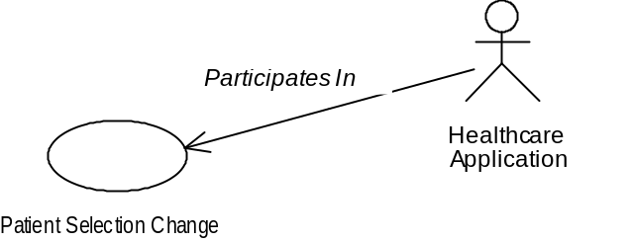

Use Case Interaction Diagrams
The use case interaction diagramming conventions are:
- The interacting actors are depicted by rectangles labeled with the actor’s name, arranged in a horizontal row. A vertical dashed bar descends from each of these rectangles:
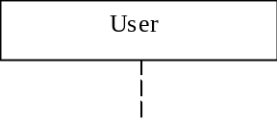
- An interaction that is initiated by an actor is represented as an arrow that emanates from the actor. The arrow terminates on the actor to which the interaction is directed. Each arrow is labeled with a short description of the interaction it represents:
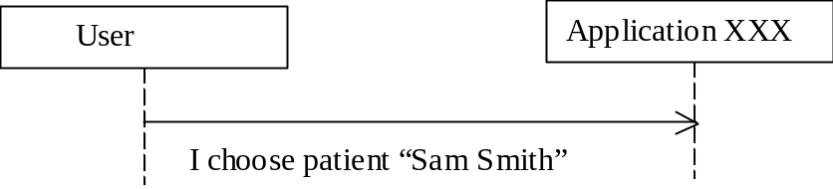
- A vertical bar indicates the start and end of the actions that an actor performs in response to an interaction. These actions may include additional interactions:
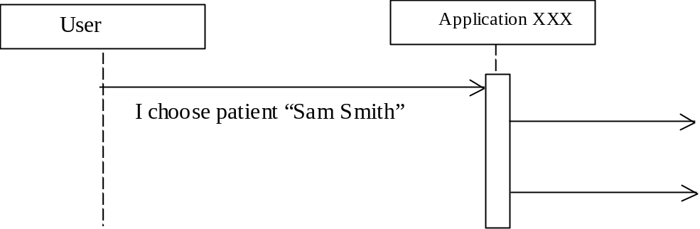
- An actor can respond to an interaction. A response is shown as an arrow labeled with an indication of the response:
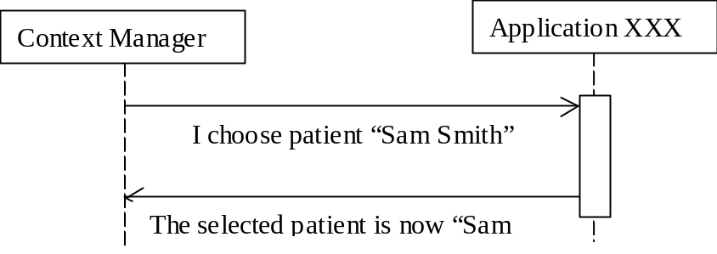
- The entire set of interaction arrows is temporally ordered, from left to right, top to bottom.

Component Architecture Diagrams
The component architecture diagramming conventions are:
- Each component is depicted as a rectangle. The name of the component appears within the rectangle:
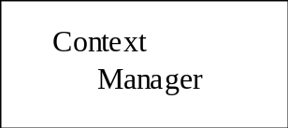
- Each of the interfaces implemented by a component is illustrated as a circle tangent to the rectangle that depicts the component. Each circle is labeled with the name of the interface it represents. Two or three letter abbreviations are typically used:
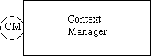
- A directed arrow connects components that communicate with each other. Arrows emanate from a client component and point to the server components that it uses. Each arrow terminates on the circle representing the specific server component interface that is used. A distinct arrow is used for each interface for each server component that a client component uses:
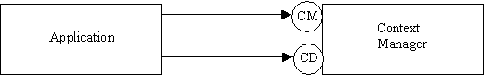

Component Interaction Diagrams
The component interaction diagramming conventions are:
- The interacting components are depicted by rectangles labeled with the component’s name, arranged in a horizontal row. A vertical dashed bar descends from each of these rectangles:
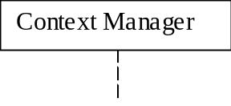
- A method that is invoked by a component is represented as an arrow that emanates from the bar and that terminates on the bar for the component that services the method. Each arrow is labeled with the name of the method it represents. Examples of actual parameter values may be included for clarity:
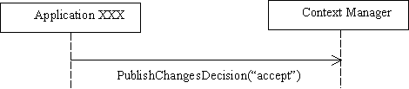
- A vertical bar indicates the start and end of the processing that a component performs in response to a method invocation. This processing may itself include method invocations:
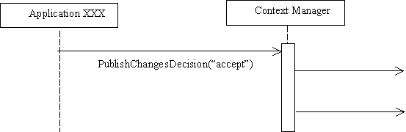
- Method return values are indicated when this aids in understanding the use case. A return value is shown as an arrow labeled with an indication of the return value:
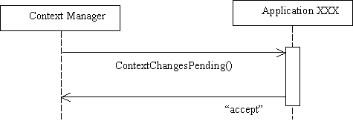
- The entire set of method invocation arrows is temporally ordered, from left to right, top to bottom.

Glossary
Term | Definition
Accept | An application’s response when it is willing to accept the context data changes and to change its internal state accordingly if the changes are published.
Accept-Conditional | An application’s response when it is in the midst of a task that might cause work to be lost if the user does not complete the task; if the changes are published it is willing to terminate the task, accept the context data changes and change its internal state accordingly.
ACL | Access control lists, which determine the privileges and capabilities a particular user has, are presumed to be maintained by each application.
Action agent | A context agent whose primary role is to perform a context action upon request.
Annotation agent | A context agent whose primary role is to set the data for an annotation data for an annotation subject.
Annotation data | Additional information from an authentic source that describes an entity or concept identified in a related context subject. Annotation data is represented as data items within an annotation subject.
Apply | A user choice; the context data changes are applied to all of the applications, including those that indicated that they might loose work performed by the user; this choice is allowed only when there are no busy applications.
Authentication repository | Enables applications to securely maintain application-specific user authentication data. The repository is used by applications that do not have a built-in means to easily sign-on a user given only a logon name.
AuthenticationRepository (AR) | Interface used by applications to securely interact with the repository to store and retrieve user authentication data.
Automatic Log-off | Logs the current user off of the User Linked applications that are participants in the same context session when the user has not interacted with the applications for an appreciable period of time.
Break Link | A user choice; the context changes are applied just to the application with which the user initiated the context changes.
Busy | When an application is unable to apply the context change because it is blocked (e.g., it is a single threaded application that has a modal dialog open); these applications are referred to as busy.
Cancel | A user choice; when the context change is canceled; the context changes are not published.
CCOW | Clinical Context Object Workgroup.
Centralized model | In the centralized model of context management, the responsibility for managing the common context is centralized in a common facility that is responsible for coordinating the sharing of the context among the applications.
Chain of trust | With the chain of trust, User Link-enabled applications and User Link components work together to ensure that only authorized users are allowed access to a common context session.
Clinical context | State information that users establish and modify as they interact with healthcare applications. The context is common because it establishes parameters that should uniformly affect the behavior or operation of multiple healthcare applications.
Common context session | Applications and components that have established and maintain a common context link, so that they share the same common context.
Common context system | Applications and components that comply with the CMA, such that they are able to establish and maintain one or more common context sessions.
Component architecture diagram | Depicts components and their interfaces, and indicates which interfaces each component use for communicating with other components.
Component interaction diagram | Illustrates the series of method invocations that components perform on each other in order to implement a particular use case.
Conditionally accept | When an application might lose work performed by the user if it applies the context changes (e.g., the user was in the process of entering data that would not be applicable in the new context); these applications are referred to as having conditionally accepted the context changes.
CMA | Context Management Architecture.
COM | Microsoft’s Component Object Model.
Component model | The architecture of a system as described in terms of components and the interfaces they must implement in order to be participants in the system.
Context action | An context-sensitive task that is performed by a context agent on behalf of an context participant application and as mediated by the context manager.
Context agent | A service component that from the perspective of an application is a transparent participant in a context change or context action.
Context change coupon | Unique identifier that is assigned by the context manager to denote each context change transaction.
Context changes pending | During the context change survey, the context manager informs each of the applications in the common context session (except for the application that instigated the changes) that there are pending context data changes. Each application decides whether or not it wants to accept the changes. All applications must accept in order for the context to change.
Context change survey | In the first step of completing a context change transaction the context manager surveys the applications. Each application is informed that there are a candidate set of context data changes and is asked to indicate whether it can accept these changes.
Context change transaction | A multi-step process in that coordinates changes to the common context data. First, an application begins a transaction. The application sets a transaction-specific version of the common context data. Second, the context manager conducts a context change survey. Third, the context manager reports the survey results to the application that began the transaction. Finally, the application indicates whether the changes are to be applied or cancelled. The decision as to how to proceed may involve the user. If changes are applied, then the transaction-specific version of the context data becomes the new context. Otherwise the transaction-specific context data is discarded.
Context manager | Coordinates applications each time there is a context change transaction. It is also the “owner” of the authentic context data for a common context system.
Context participants | Applications that set and/or get context data from the context manager. They must follow the policies established later in this document in order to behave as proper context management “citizens.”
Context subject | A subject represents a real-world entity or concept that is identified as part of the overall common clinical context.
ContextAction (CX) | Interface implemented by the context manager and used by an application to request that one or more context actions be performed. The context manager mediates the execution of each action, each of which is actually performed by a context agent.
ContextAgent (CA) | Interface implemented by a context agent and used by a context manager to inform the context agent that the clinical context has changes pending and that the agent should perform its context data mapping responsibilities.
ContextData (CD) | Interface implemented by the context manager; used by applications to set/get the data items that comprise the common context.
ContextFilter (CF) | Interface implemented by the context manager; used by applications to set/get the specific subjects whose item values must be set during the course of a context change transaction in order for the application to be included as a participant in the transaction.
ContextManager (CM) | Interface implemented by the context manager; used by applications to join/leave a common context session and to indicate the start/end of a set of changes to the common context data.
ContextParticipant (CP) | Interface implemented by an application that wants to participate in a common context session; used by the context manager to inform an application that the context has changed.
ContextSession (CS) | Interface implemented by the context manager; used by applications to create/active context sessions.
CORBA | Common Object Request Broker Architecture.
Corroborating data | Corroborating data can be used by applications and/or users as a basis for checking further that the identified context subject is what was expected.
DCOM | Distributed version of Microsoft’s Component Object Model.
Digital signature | Formed using public key / private key encryption techniques, a digital signatures enables
Dispose | A component performs an implicit or explicit action, which is technology-specific, when it no longer intends to use a particular reference. The latter action is referred to as disposing an interface reference.
Distributed model | In the distributed model of context management, the responsibility for managing the common context is uniformly distributed among the applications. There is no central point of common context management.
Empty context | A context is not defined for any subject, either because no context identifier items are present in the context data (as is the case when a context manager is first initialized) or because the values of all of the identifier items for the subject that are present in the context data are null (as is the case when an application explicitly indicates that the context is empty).
Empty context subject | A context subject is empty when a real-world entity or concept is not currently identified. For example, for the patient subject, this means that a patient is not currently identified.
Identifier data | Data that identifies a real-world entity or concept (such as a specific patient or a specific encounter). Identity information is required in order to establish a common context between applications that involves a real-world entity or concept. The string “id” indicates identifier data.
IDL | Interface Definition Language. IDL can specify: an interface’s symbolic name, the set of component properties and methods that can be accessed via the interface, the name and data type of each property, the names and data types for each method’s input and outputs, and the names and data content for each method’s exceptions.
Instigator | The application that began the current context change transaction.
ImplementationInformation (II) | Interface implemented by the context manager and mapping agent; used by applications, context management components, and tools, to obtain details about a component’s implementation, including its revision, when it was installed, etc.
Interface interrogation | The interfaces that a component implements can be determined by other components at run-time through direct interrogation.
Context management registry | A service that contains references to component interfaces. Components can use the registry to obtain interface references to each other.
Log-off | The termination of a user’s session with an application; it assumed that logging-off does not require user authentication.
Mapping agent | A context agent that whose primary role is to add additional subject-specific context identifier items to the context data.
MappingAgent (MA) | Deprecated interface implemented by a mapping agent and used by a context manager to inform the mapping agent that the clinical context has changes pending and that the mapping agent should perform its context data mapping responsibilities.
Message authentication code | A secure hash value produced from a data stream that consists of data that is openly communicated between two parties, and “secret” data that they both know but do not openly communicate.
Message digest | A digital signature is formed by applying a secure hash function (alternatively known as a one-way hash function) to the data that is to be transmitted. The resulting hash value is referred to as the message digest, as it is a numeric surrogate for the plain-text message.
Null item value | The value of a context data item can be set to the distinguished value of null to indicate that the item does not have a valid value.
OMA | Object Management Group’s Object Management Architecture.
Participant coupon | Unique identifier that is assigned by the context manager to denote each context participant within a session, including applications and mapping agents.
Passcode | Similar to passwords used by people. However, because passcodes are only used by computer programs, they can be much longer and complex than passwords typically are. This makes passcodes extremely hard to guess, even when brute force techniques are employed.
Patient Link | Enables the user to select the patient of interest once from any application as the means to automatically “tune” all of the applications to the selected patient.
Patient subject | The context subject of Patient is defined for Patient Link. The context data identifier item for this subject is the patient’s medical record number. The patient’s given name is not used as an identifier.
Principal interface | Every component implements at least one well-known interface, referred to as the component’s principal interface. The principal interface enables components to perform initial interface interrogations because the name of the principal interface is known a priori, and because all components implement it.
Private key / Public key | An approach for encrypting data, and for creating digital signatures, wherein a matched set of security keys is used. The private key remains the secret of its owner. The matching public key can be disseminated. X can send a message that only Y can read by encrypting the message using Y’s public key. Y decrypts the message using its private key. Alternatively, Y can digitally sign its messages using its private key. X can validate Y’s signature using Y’s public key.
Pull-model | A shared component is used to maintain the shared context data. Applications update this resource to change the data. Other applications periodically poll the component to determine if the data has changed.
Push-model | A shared component is used to maintain the shared context data. This component notifies applications whenever the data is changed. In order to receive a notification, an application must have first explicitly indicated its interest in being notified.
Re-authentication time-out | Requires the currently signed-on user to re-authenticate herself before being allowed to continue using the applications on a clinical desktop. The time-out occurs when the user has not interacted with the applications that are participants in the same context session for an appreciable period of time.
Repository | See authentication repository.
RMI | Java Remote Method Invocation mechanism.
RSA | A popular public key / private key algorithm.
Secure (or one-way) hash function | A function used for producing a unique numeric surrogate from an arbitrary data stream. It is improbable that two different data streams will yield the same hash value. A secure hash function is an essential part of the infrastructure needed to support the use of digital signatures.
SecureBinding (SB) | Interface used by applications to establish a secure communications binding with the context manager before using the SecureContextData interface. Also used by applications to establish a secure communications binding with the authentication repository before using the AuthenticationRepository interface.
SecureContextData (SD) | Interface similar to the ContextData interface defined for Patient Link; this interface is used by applications to securely set/get the values for the items (logically represented as name-value pairs) that comprise the clinical context.
S-HTTP | Secure Hyper-Text Transfer Protocol.
Sign on | The act of identifying oneself to an application, prior to initiating a user session, in a manner that can be authenticated by the application, typically involving a secret password or a biometric reading (such as a thumb-print scan).
SSL | Secure Socket Layer. SSL enables secure (i.e., encrypted) transmission of data between a client and a server. It also enables a client to authenticate a server (and a server to authenticate a client).
Stat admission | Occurs when an application needs to enable the user to record information about a patient even if an identifier for the patient is not known.
Technology neutral | Means that the common clinical context approach should work equally well with any one of a candidate set of relevant technologies.
Use case diagram | Depicts the actors (human and/or computer-based) and the roles that the play when participating in an interesting scenario.
Use case interaction diagram | Illustrates the high-level interactions between the actors that participate in the use case.
User Link | Enables the user to securely logon once to any application as the means to automatically “tune” all of the applications to the user.
User subject | The context subject of User is defined for User Link. The context data identifier item for this subject is the user’s logon name. The user’s given name is not used as an identifier.
User Link-enabled application | An application that implements the CMA User Link capability.

In general, patients cannot be reliably identified using their given name because given names are not necessarily unique. Identifiers can be assigned, but often a single person accumulates multiple patient identifiers over time. This is because the assigned identifiers are not universally unique, and generally only refer to a population of patients known to a particular healthcare institution, or known to a site within an institution. Government assigned identifiers, such as a social security number, may not be unique, or may change over time. In general, there is currently no simple and reliable way to identify the same patient across all possible systems that might contain data pertinent to the patient.
A specific visual cue will be recommended within each of the HL7 context management technology-specific user interface specification documents.
Note that for a context data item whose value is case-sensitive per the data definitions for such an item, then a change in case for the item’s value shall be considered a change in the item’s value even if the value of the item when case is not considered has not changed.
A specific visual cue recommended within each of the HL7 context management technology-specific user interface specification documents.
A specific visual cue is recommended within each of the HL7 context management technology-specific user interface specification documents.
Terminating all of the applications accessed from a point-of-use device is not supported because there is no way to indicate this event via a change to the user context subject.
When a secure hash function is used, it is also computationally infeasible to invert the computed hash value. Specifically, given the secure hash function f and input value x, f(x) is relatively easy to compute. However, even knowing f it is infeasible to compute x given f(x).
The signing of a message digest rather than of the plain-text message is a performance expediency. A digest is typically several bytes in size, whereas the message represented by a digest can be of arbitrary size. It is generally faster to encrypt the digest rather than the entire message.
This is the inverse of the process used to send a secret message, in which the sender encrypts data with the intended recipient’s public key. Only the holder of the private key can decrypt the data.
This coupon denotes the current context change transaction, not the application. Each context change coupon is unique over the execution lifetime of a particular context manager.
Not all applications need a public key. Applications that need public keys are those that are designated for authenticating users, and those that use the authentication repository.
Base64 encoding was not selected as a character-encoding scheme for binary data, as the added compression offered by the scheme is of minimal advantage for the CMA, wherein only relatively small quantities of binary data are transmitted.
In CMA Version 1.2, only two privileges were defined for the context manager: “Get” and “Set”. However, with the introduction of authenticated gets (See 17.3.13.4, GetItemValues), it is necessary to introduce the “Geta” and “Seta” privileges. This allows the privileges “Get” and “Set” to maintain the meaning that was specified in V1.2. Further, if a bindee did not have any access privileges for a subject, then, in V1.2, that subject did not appear in the list of subjects included in the output privileges. Now, that subject will appear in the list but with an access privilege of “None”. In V1.2, in the absence of authenticated gets, it was not possible to actually define a subject for which a bindee did not have any access privileges, so the change in how this is represented will not affect existing applications. Finally, in V1.2, it was not possible for an application to determine if a subject was a secure subject or a common subject. Now a common subject will appear in the list of subjects with an access privilege of “Any”. By definition, a subject with any other type of access privilege is a secure subject.
These privileges are the same as specified in the CMA Version 1.2. The descriptions for these privileges have been elaborated but the meaning is also unchanged. It is understood that the privilege “Get” for the authentication repository has the same meaning as “Geta” for the context manager, and that “Set” for the authentication repository has the same meaning as “Seta” for the context manager. The names for the authentication repository’s access privileges are unchanged relative to the new privileges introduced for the context manager in order to preserve backward compatibility.
 Object-Oriented Software Engineering, Ivar Jacobson, Addison-Wesley, 1994.
 OMG Unified Modeling Language Specification - Version 1.3, Object Management Group, June 1999.

