Specification and Implementation Guide for the Continuity of Care Record (CCR)
Version 1.0
October 6, 2004

NOTE: This document is not an ASTM standard. It is under consideration within an ASTM technical committee but has not received all approvals required to become an ASTM standard. It shall not be reproduced or circulated or quoted in whole or in part, outside of ASTM committee activities except with the approval of the chair of the committee having jurisdiction and the president of the society. Copyright ASTM, 100 Barr Harbor Drive, West Conshohocken, PA 19428-2959. All rights reserved.

Table Of Contents (to be inserted)

This Implementation Guide contains instructions for using the Continuity of Care Record (CCR) XML schema for generation of a standards-compliant CCR. This Implementation Guide is intended to be extremely strict regarding requirements on the use and formatting of the CCR XML and extremely strict regarding the content allowed within each field/XML tag. This is an interoperability standard for data expression and exchange, on paper as well as between healthcare information systems. Strict adherence to this Implementation Guide and the .xsd will be critical to support interoperability. Unlike many other standards in use in healthcare, there are no end-user or vendor configurable fields in the CCR. Optionality, cardinality, enumeration, and specificity of mapping are intended to be tightly controlled.

This Implementation Guide is to be used with the CCR XML .xsd. Note that only the .xsd that accompanies this Implementation Guide will be valid for generation of a CCR under this version of the CCR standard. ASTM E31 Committee on Healthcare or others may provide sample .xsl files as well as sample patients for use in testing CCR implementations, but it is the responsibility of the entity doing the implementation to assure compliance with the CCR standard, with this Implementation Guide, and with the CCR XML .xsd.

Implementation

The CCR is defined as a data object that represents a snapshot of a patient’s relevant administrative, demographic, and clinical information at a specific moment in time. The format of the CCR is XML. It must be well-formed XML, and it most conform to the CCR .xsd. The CCR is an XML document, but the use of the word ‘document’ refers to the XML as a document, not to the CCR as a clinical document – such as a Clinical Note, Encounter Note, History & Physical, or Discharge Summary. To reiterate, the CCR represents a summary of the patient’s data at a specific point in time. In the EHR world, the CCR represents the Patient Summary, which for most EHRs is represented as the ‘Overview’ of the patient or the ‘Patient Summary.’

This Implementation Guide will walk through the CCR in explicit detail. All implementations must strictly conform to this Implementation Guide and the accompanying CCR .xsd. There are no end-user or vendor configurable fields in the CCR. All fields and their appropriate use and formatting are specifically spelled out.

Overall CCR Structure

The CCR XML is defined using a set of core principles:

- The CCR structure and architecture is object-oriented. The CCR is an XML document that is defined within this Implementation Guide as a Document Object. The CCR Document Object is built from a set of discrete XML building blocks, which are defined as Data Objects. The Data Objects are contained within Sections in the CCR Document Object.

All data must be contained within elements. No data in the CCR are allowed to be contained within tag attributes. Tag attributes are reserved for system processing instructions and data security coding.
- Concepts used more than once are defined as a Complex Data Types. Complex Data Types are defined by adding the post-fix ‘Type’. Examples: ProblemType; CodeType.
- Element and attribute names use the Pascal Notation where the first letter of each word is capitalized.
- Normalization is provided through the use of internal links for all discrete data objects that can potentially be referred to more than once within the document.

The CCR core structure is represented in Figure 1. Note that within this version of the CCR Implementation Guide all diagrams are derived from the proprietary commercial XML tool TurboXML – this is for the sole purpose of illustrating the concepts, hierarchy, and object inheritance within the CCR. This is not an endorsement of TurboXML.

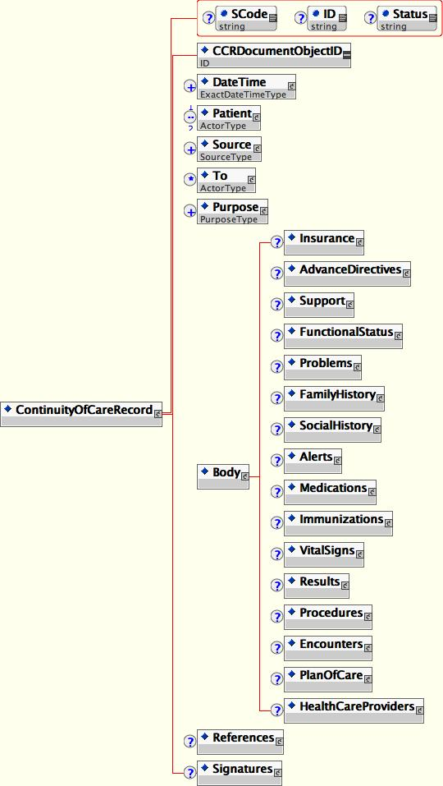123

iop\\
Figure 1 – General Structure of CCR

CCR XML Header

The CCR XML Document Header exists under the tag <ContinuityOfCareRecord>. Its expression is as follows:

XML Example | Description
<ContinuityOfCareRecord xmlns="urn:astm-org:CCR" xmlns:xsi="http://www.w3.org/2001/XMLSchema-instance" xsi:schemaLocation="urn:astm-org:CCR CCR1.0.xsd" ID="20000302105811" SCode="AAA000XXX000"> | This is the root of the CCR document. Note the use of the "urn:astm-org:CCR" namespace to identify the type and version of the schema used, the ID assigned to the document to uniquely identify it, and the SCode to define the document’s security parameters.

The Header Tag Attributes are:

xmlns – This defines the XML namespace and must state “urn:astm-org:CCR”.

xmlns:xsi – This defines the xsi and must state “http://www.w3.org/2001/XMLSchema-instance”.

xsi:schemaLocation – This defines the schema location and must state “urn:astm-org:CCR CCR1.0.xsd”.

ID – This is a ObjectID space reserved for maintenance of data integrity. It is not used in this version (Version 1.0) of the CCR.

SCode – This is a security parameter code for the overall CCR and applies to the entire CCR. This defines the security level of the CCR. The SCode is reserved for management of document and data object security levels. It is not used in this version (Version 1.0) of the CCR.

Status – This is a parameter that can selectively be used to track the status of a CCR within the generating entity/system to uniquely identify the status of any instance of a CCR. Status can be used between source and target systems to delineate a CCR instance status. It is not used in this version (Version 1.0) of the CCR.

Object IDs

The CCR and all Data Objects contained within the CCR must have ObjectIDs. The CCR has <CCRDocumentObjectID> and all Data Objects have a <CCRDataObjectID>. CCR Document and Data ObjectIDs are unique IDs used by the generating entity/system to uniquely identify each explicit instance of a CCR and each explicit Data Object. The uniqueness of these ObjectIDs is defined within the generating system, must be unique to and within each CCR, and is not considered unique across the universe of all CCRs. The CCR Document and Data Object IDs must be alphanumeric and must start with a letter as their first character. They can be of any character length.

Representation of Dates and Times in the CCR

Representation of dates and times in the CCR must accommodate the requirements for medical-legal precision as well as the occasional inexactitude of clinical dates and times relative to patient recollections of clinical events. The CCR uses two DateTime Complex Data Types to represent exact dates and times where required (ExactDateTimeType) and variable precision (DateTimeType).

Within each of these DateTime Complex Data Types, there is a <DateTimeType> tag that is used to define the specific date and time being referred to in each instance. The other tags in each Complex Data Type are then used to delineate the date, a date time, an age, or an approximate date or timeframe as used in the CCR.

<ExactDateTime>

The Complex Data Type ExactDateTimeType contains the datetime tag <ExactDateTime>. <ExactDateTime> must conform to the W3C DateTime as defined at http://www.w3.org/TR/xmlschema-2/#dateTime, and all times must be coordinated to a standard clock. A description of the parent standard, ISO 8601, can be found at http://www.iso.org/iso/en/prods-services/popstds/datesandtime.html#three. The clock at Greenwich, England, is used as the standard clock for international reference of time. This time was originally referred to as Greenwich Mean Time or GMT, but the official name is now Coordinated Universal Time or UTC. The letter designator for this clock is Z, and UTC is sometimes referred to as Zulu Time. Times in UTC are written in military time or 24-hour format such as 1830Z.

<ExactDateTime> is used to represent a specific time on a specified day. The required format for the CCR is the W3C standard calendar date and time representation is as follows, with the capital letter T used to separate the date and time components:

YYYY-MM-DDThh:mm:ss

This representation must be immediately followed by a "Z" to indicate that the time is Coordinated Universal Time (UTC) or by a sign, + or -, followed by the difference from UTC represented as hh:mm. If the time zone is included, both hours and minutes must be present. For example, to indicate 1:20 pm on September 1, 2004, for Eastern Standard Time, which is 5 hours behind Coordinated Universal Time (UTC), the CCR <ExactDateTime> would be:

2004-09-01T13:20:00-05:00.

See http://www.iso.org/iso/en/prods-services/popstds/datesandtime.html for more information on UTC formats and examples.

Each <ExactDateTime> must have a <DateTimeType>. There will be predefined allowed and/or required xs:string values to <DateTimeType> in each instance of use.

<ExactDateTime> is illustrated in Figure 2.

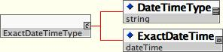

Figure 2 – Complex Data Type ExactDateTimeType

In all instances where an exact date and time are used in the CCR, the Complex Data Type ExactDateTimeType is specified and must follow the rules defined above.

DateTimeType

In all other instances where a date, a date time, an age, or an approximate date or timeframe is used in the CCR, the Complex Data Type DateTimeType is specified. The Complex Data Type DateTimeType is illustrated in Figure 3.

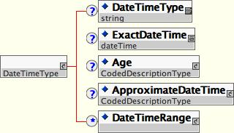

Figure 3 – Complex Data Type DateTimeType

The Definition Table for DateTimeType is as follows – note that this table format for defining Complex Data Types will be followed throughout this Implementation Guide:

DateTimeType | Accepted Values/Formatting | Optionality/0 - ∞ | Description
<DateTimeType> | Restricted – acceptable values are to be defined for each instance of use. | Required whenever DateTimeType is used. Bound (Single Element – Single Use Only) | <DateTimeType> defines the type of date/time and is required anytime a DateTimeType is used. Acceptable values are restricted. Specific Types may be required in a particular instance.
<ExactDateTime> | yyyy-mm-ddThh:mm:ss-hh(GMT):mm(GMT) | Optional  Bound (Single Element – Single Use Only) | A specific Date and Time is the preferred usage of DateTimeType. It can be Year Only; Year and Month; Year, Month, Day; Year, Month, Day, Hour; Year, Month, Day, Hour, Minutes; Year, Month, Day, Hour, Minutes, Seconds; It is required that time have its variation from GMT, when available, (stated as minus GMT). An example is 2004-01-12T13:30:00-05:00.
<Age> | Text string, or string with attributes and values. | Optional  Bound (Single Element – Single Use Only) | <Age> is allowed only when appropriate. Representations are age with Modifier – Age < 2 Weeks [__ Days]; Age 2 Weeks – 2 Months [__ Weeks]; Age 2 Months – 2 Years [__ Months]; Age > 2 Years [__ Years]. Age is a Complex Data Type CodedDescriptionType.
<ApproximateDateTime> | Text string, or string with attributes and values. | Optional  Bound (Single Element – Single Use Only) | <ApproximateDateTime> is allowed only when appropriate. Examples of Approximate Time are: One Week Ago; As A Child; When 30 Years Old; In 30s. ApproximateDateTime is a Complex Data Type CodedDescriptionType.
<DateTimeRange> | No content – must contain either one or both <BeginRange> and/or  <EndRange>, which in turn must contain a datetime representation, as defined above. | Optional  Bound (Single Element – Single Use Only) | Used to represent imprecise or precise datetime ranges.

DateTimeType Definition Table

CCR <DateTime>

CCR Document <DateTime> is a child of <ContinuityOfCareRecord>. CCR Document <DateTime> defines the dates and times relative to when the CCR was generated.

CCR Document <DateTime> must be <ExactDateTime> time.

CCR Document <DateTime> consists of one or more dates. Each CCR Document <DateTime> must have a <DateTimeType>. The only allowed xs:string values for <DateTimeType> under <DocumentDateTimes> are:

‘CCR Creation DateTime’
‘CCR Print DateTime’
‘CCR Save DateTime’
‘CCR Send DateTime’

Creation DateTime is the DateTime the CCR is created. Print DateTime is the DateTime the CCR is printed. Save DateTime is the DateTime the CCR is saved to any portable storage media. Send DateTime is the DateTime the CCR is transmitted to any other system by any means – fax, electronic message, email, HL7 CDA, or any other means of transmission.

CCR Creation DateTime is required. In addition, one or more CCR Print DateTime, CCR Save DateTime, or CCR Send DateTime is recommended.

CCR Document <DateTime> Example:

<DateTime>
<DateTimeType>CCR Creation DateTime</DateTimeType>
<ExactDateTime>2004-01-12T13:30:00-05:00</ExactDateTime>
</DateTime>
<DateTime>
<DateTimeType>CCR Print DateTime</DateTimeType>
<ExactDateTime>2004-01-12T13:50:00-05:00</ExactDateTime>
</DateTime>

<Patient>

The CCR can only be about one patient with the extreme exception of Siamese Twins, where it can contain data on two patients. Other than within that extreme exception, the CCR is a snapshot in time of the clinical and administrative data of a unique patient. That patient is defined in the CCR under <Patient> as the Complex Data Type ActorType .

<ActorType> Persons, Organizations, Locations, Systems

Individuals (Patients, Family, Support, Health Care Providers), organizations, locations, and systems (IT systems, EHRs, and the like) are expressed within the CCR by the Complex Data Type ActorType. Individuals, organizations, locations, and systems are normalized within the CCR, and each is represented and fully tagged only the first time they are encountered in the document. They are defined in their first instance in the CCR with a <CCRDataObjectID> of type xs:ID. Whenever they are referred to subsequently within the CCR they are referred to by a referral <CCRDataObjectID> of type xs:IDREF.

Each individual, organization, location, or system is defined by a subset of tagged data elements consistent with the representation of them as a <Person>, <Organization>
> (which includes locations), or <InformationSystem>.

All individuals, organizations, locations, or systems have a unique Data ObjectID defined in the CCR as <CCRDataObjectID>. This ObjectID is used in all internal links to the individual, organization, location, or system within the CCR using xs:ID and xs:IDREF. As mentioned previously, all data objects (and each ActorType is a data object) within the CCR have ObjectIDs. The ObjectIDs are unique within the CCR and do not have any uniqueness in the universe outside a specific instance of the CCR. Data ObjectIDs have a specific required format and must be sequential, consistent with their order in the XML document – this is required in order to provide standardization of implementation.

The format for ObjectIDs is as follows:

AA0000

They must be sequential and must start with AA0001, followed by AA0002. Once 9999 are used then the sequential numbering will be AB0000, then AB0001, and continuing.

Important Note – ObjectIDs are unique to each instance of the CCR. If a CCR is imported into one system, then exported again, the new instance of the CCR renumbers its ObjectIDs from AA0001 in sequence. ObjectIDs do not migrate from one instance of the CCR to another. The tag attribute ID, however, can be utilized in implementation to map ObjectIDs across CCRs and into and out of databases and information systems. The tag attribute ID is not be supported in this version (Version 1.0) of the CCR.

Example

<CCRDataObjectID>AA0001</CCRDataObjectID>

The overall XML structure of <Actor> is as illustrated in Figure 4. ActorType is defined (from the top down in Figure 4), in the following table:

ActorType | Accepted Values/Formatting | Optionality/0 - ∞ | Description
<CCRDataObjectID> | AA000-ZZ999 | Required  Bound | This is the ObjectID of the ActorType and is used for internal links within the CCR only. Its formatting is restricted to AA0000, and it must be unique and sequential within each new instance of the CCR.
<Person> | None – data can only be contained within child elements. | Optional  Bound (Single Element – Single Use Only) | Used when the Actor is a person.
<Organization> | None – data can only be contained with the child element <Name>. | Optional  Bound (Single Element – Single Use Only) | Used when the Actor is an organization.
<InformationSystem> | None – data can only be contained within child elements. | Optional  Bound (Single Element – Single Use Only) | Used when the Actor is an Information System – example: when the Source of the CCR is an Information System.
<ExternalIdentifiers> | None – data can only be contained within child elements. | Optional  Unbound (0 - ∞) | Contains real world IDs for the actor (SSN, MRN, Provider ID…). Represents the ID as a Complex Data Type IDType.
<Specialty> | None – data can only be contained within child elements. | Optional  Unbound (0 - ∞) | <Specialty> is a Complex Data Type – it is an instance of the Complex Data Type CodedDescription_Type. It defines the Medical Specialty of the Person or Organization.
<Address> | None – data can only be contained within child elements. | Optional  Unbound (0 - ∞) | Defines an address of a Person or Organization. Each address can specify a type (Home, Office…). a Priority for contacting (Primary – Preferred, Secondary), and a Status (Active, Temporary…).
<Telephone>  <Email>  <URL>  <Communication> | None – data can only be contained within child elements. | Optional  Unbound (0 - ∞) | These are each represented by the Complex Data Type – Communication_Type. They are used to define phone number, email, url, or other mode (<Communication>) of contacting Actor. Each can specify a <Type> (Home, Office…). a <Priority> for contacting (Primary – Preferred, Secondary), and a <Status> (Active, Temporary…).
<Roles> | None – data can only be contained within child elements. | Optional  Bound (0 - 1) | Can contain one or more instances of <Role>, which define the role of <Actor> in context to CCR.
<Relations> | None – data can only be contained within child elements. | Optional  Bound (0 - 1) | Can contain one or more instances of <Relation>, which define the relationship of the <Actor> to the patient in context to CCR.
<Status> | None – not support in this version of the CCR. | Optional  Bound (0 - 1) | Will be used to define current status of each <Actor> in future versions of the CCR.
<Comment> | None – data can only be contained within child elements. | Optional  Unbound (0 - ∞) | <Comment> is a Complex Data Type – Comment_Type. It is used for free text or structured text comments.
<Source> | None – data can only be contained within child elements. | Optional  Unbound (0 - ∞) | <Source> is a Complex Data Type – SourceType. It defines the source of the information contained in the DataType.
<Reference> | None – data can only be contained within child elements. | Optional  Unbound (0 - ∞) | <Reference> is a Complex Data Type – ReferenceType. It defines an internal, or external reference to a document, attachment, system, URL, data source…

ActorType Definition Table

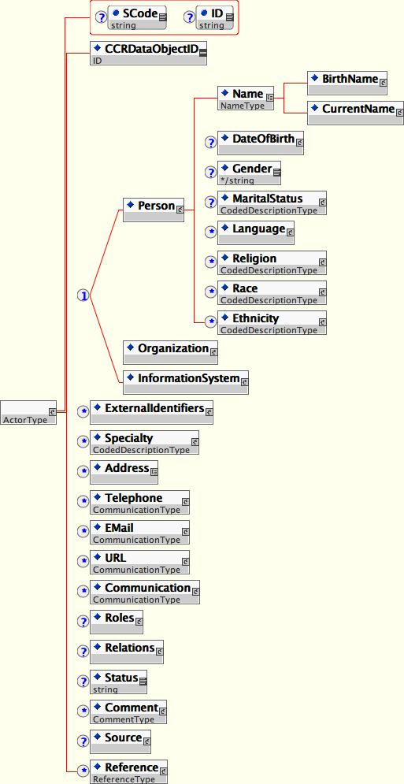

Figure 4 – Complex Data Type ActorType

Further definition of the XML within ActorType is as follows:

<Person>

<Person> defines the individual as an <Actor>. Its elements are defined in the following table.

<Person> | Accepted Values/Formatting | Optionality/0 - ∞ | Description
<Name> | None – data can only be contained within child elements. | Required when <Person> used.  Bound (Single Element – Single Use Only) | Each Element of Name is Optional and Unbounded (0 - ∞) allowing zero or more instances in each use. Two types of names are included and recommended: <BirthName> and <CurrentName>. In all instances where there is a known difference between <BirthName> and <CurrentName> both are required. This is to support MPI reconciliation.  Name elements are as follows:  <Given> - use zero or more times for First name.  <Middle>- use zero or more times for Middle name.  <Family>- use zero or more times for Last name.  <Suffix>- use zero or more times for Suffix (Jr., III…).  <Title> - use zero or more times for Degree or Title (MD, PhD., RN, Lord, JD, OD, DO, Esq., etc…).  <CurrentName> also provides the option for <NickName> which is the name the person prefers to be addressed by.
<DateOfBirth> | None – data can only be contained within child elements. | Optional  Bound (Single Element – Single Use Only) | This is an instance of DateType. <DateOfBirth> should be as accurate as possible, but if only an age is known or an approximate date, it is recommended that it be included.
<Gender> | None – data can only be contained within child elements. | Optional  Bound (Single Element – Single Use Only) | This is an instance of CodedDescriptionType.
<MaritalStatus> | None – data can only be contained within child elements. | Optional  Bound (Single Element – Single Use Only) | This is an instance of CodedDescriptionType.
<Language> | None – data can only be contained with the child elements. | Optional  Unbound (0 - ∞) | This is an instance of CodedDescriptionType with the added tag <Proficiency> to define the Actor’s level of proficiency.
<Religion> | None – data can only be contained within child elements. | Optional  Unbound (0 - ∞) | This is an instance of CodedDescriptionType.
<Race> | None – data can only be contained within child elements. | Optional  Unbound (0 - ∞) | This is an instance of CodedDescriptionType.
<Ethnicity> | None – data can only be contained within child elements. | Optional  Unbound (0 - ∞) | This is an instance of CodedDescriptionType.

<Person> Definition Table

<Organization>

<Organization> defines an Organization as an ActorType.

<Organization> | Accepted Values/Formatting | Optionality/0 - ∞ | Description
<Name> | String | Required when <Organization> used.  Bound (Single Element – Single Use Only) | This is the Name of the Organization.

<Organization> Definition Table

<InformationSystem>

<InformationSystem> defines an Information System as an ActorType.

<InformationSystem> | Accepted Values/Formatting | Optionality/0 - ∞ | Description
<Name> | String | Required when <InformationSystem> used.  Bound (Single Element – Single Use Only) | This is the Name of the Information System.
<Type> | String | Optional  Bound (Single Element – Single Use Only) | This defines the Type of Information System.
<Version> | String | Optional  Bound (Single Element – Single Use Only) | This defines the Version of the Information System.

<InformationSystem> Definition Table

Address

<Address> is used to define one or more addresses of an ActorType. <Address> is defined in the following table:

<Address> | Accepted Values/Formatting | Optionality/0 - ∞ | Description
<Type> | String | Optional  Bound (Single Element – Single Use Only) | This defines the Type of Address.
<Line1> | String | Optional  Bound (Single Element – Single Use Only) | This defines Line1 of Address.
<Line2> | String | Optional  Bound (Single Element – Single Use Only) | This defines Line2 of Address.
<City> | String | Optional  Bound (Single Element – Single Use Only) | This defines City of Address.
<State> | String | Optional  Bound (Single Element – Single Use Only) | This defines State or Province of Address.
<Country> | String | Optional  Bound (Single Element – Single Use Only) | This defines Country of Address.
<PostalCode> | String | Optional  Bound (Single Element – Single Use Only) | This defines PostalCode of Address.
<Priority> | String | Optional  Bound (Single Element – Single Use Only) | This defines the priority of the means of contact, such as Primary – Preferred; Secondary…
<Status> | String | Optional  Bound (Single Element – Single Use Only) | This defines the Status – Active, Inactive, Temporary. It can also be used to define days or times of year of availability.

<Address> Definition Table

Samples of ActorTypes are as follows for Referring Physician and Patient.

Sample 1 – Referring Physician

<Patient><CCRDataObjectID>AA0001 | This is the ID used to identify the ActorType Data Object within the document.
<ExternalID>  <ID>120001</ID>  <IDType>PHYSICIAN NUMBER</IDType>  </ExternalID> | This is a real-world ID used to identify the ActorType, such as a Provider ID Number.
<Person>  <Name>  <CurrentName>  <Given>John</Given>  <Middle>Q</Middle>  <Family>Doe</Family>  <Suffix>Jr.</Suffix>  <Title>MD</Title>  <Title>PhD.</Title>  </CurrentName>  </Name>  </Person> | The ActorType is a person.
<Specialty>  <Description>Emergency Medicine</Description>  </Specialty> | Specialty of the ActorType.
<Address>  <Type>Office</Type>  <Line1>94044 Link Road</Line1>  <City>San Francisco</City>  <State>CA</State>  <Country>USA</Country>  <PostalCode>94304</PostalCode>  </Address> | Address of the ActorType.
<Telephone>  <Value>555-555-5555</Value>  <Type>Office Phone</Type>  <Priority>Primary - Preferred</Priority>  <Status>Active</Status>  </Telephone>  <EMail>  <Value>jqdoe@pacifichealthclinic.org  </Value>  <Type>Practice EMail</Type>  </Email>  <URL>  <Value>www.pacifichealthclinic.org  </Value>  </URL> | Three ways to reach this ActorType:  - Email  - Telephone (office)  - Web
<InternalCCRLink>  <CCRDataObjectID>BB0004</CCRDataObjectID>  <LinkRelationship>Employer  </LinkRelationship>  </InternalCCRLink> | This ActorType is linked to another ActorType (an organization in this case), and the relation specifies what the role of the linked Actor is with respect to this ActorType.  In this case the linked ActorType is the Employer of the physician.
</ ActorType >

Sample 2 – The Patient
<CCRDataObjectID>AA0000 | The patient is an  ActorType.
<Person>  <BirthName>  <Given>Harriet</Given>  <Middle>Mary</Middle>  <Family>Kellogg</Family>  </BirthName><CurrentName>  <Given>Harriet</Given>  <Middle>Kellogg</Middle>  <Family>Parker</Family>  <Title>Esq.</Title>  </CurrentName> | The patient is a Person. She has changed her name so that her <CurrentName> differs from her <BirthName>.
<DateOfBirth>  <DateTime>1917-01-16</DateTime>  </DateOfBirth> | The Date of Birth is represented here as a fixed date.
<Gender>  <Description>Female</Description>  </Gender> | The Gender of the patient. Note this can and should be coded with a SNOMED code.
<MaritalStatus>  <Description>Married</Description>  </MaritalStatus> | The Marital Status of the patient. Note this can and should be coded with a SNOMED code.
<Language>  <Description>English</Description>  <Proficiency>  <Description>Fluent</Description>  </Proficiency>  </Language> | Languages and proficiency. Note this can and should be coded with a SNOMED code.
<Religion>  <Description>Catholic</Description>  </Religion> | Religion. Note this can and should be coded with a SNOMED code.
<Race>  <Description>Caucasian</Description>  </Race> | Race. Note this can and should be coded with a SNOMED code.
<Ethnicity>  <Description>Irish</Description>  </Ethnicity>  </Person> | Ethnicity. Note this can and should be coded with a SNOMED code.
<ExternalID>  <ID>938873P</ID>  <IDType>Medical Record Number</IDType>  <Source>  <ActorID>AA0012</ActorID>  </Source>  </ExternalID> | This is a reference to an external Medical Record Number – the <ActorID> points to the entity (perhaps a hospital) whose Medical Record Number this is.
<Address>  <Type>Home</Type>  <Line1>1010 Morris Road</Line1>  <City>San Francisco</City>  <State>CA</State>  <Country>USA</Country>  <PostalCode>94304</PostalCode>  </Address> | Home Address
<Telephone>  <Value>415-977-8765</Value>  <Type>Home Phone</Type>  <Priority>Preferred</Priority>  </Telephone>  <Telephone>  <Value>415-977-1000</Value>  <Type>Home Fax</Type>  <Priority>Secondary</Priority>  </Telephone>  <EMail>  <Value>hparker@hotmail.com</Value>  <Type>Personal Email</Type>  <Priority>Preferred</Priority>  </EMail> | Three ways of communicating with the patient; preferred are Home Phone and Personal Email
<Role>  <Description>Patient</Description>  </Role> | This tells us that this Actor is the patient.
<Comment>  <Source>  <ID>AA0001</ID>  </Source>  <Text>Any comment can be placed in this area.</Text>  </Comment>  </Patient> | Comment from the referring physician about the patient.

CCR <Source>, <To>, and <Purpose>

<Source> is required and can be unbounded to represent more than one source for the CCR. <Source> consists of explicit data or a link to an ActorType.

<To> is optional, is unbounded, and consists of explicit data or a link to an ActorType.

<Purpose> is optional and is unbounded. It is a Complex Data Type PurposeType and is illustrated in Figure 6.

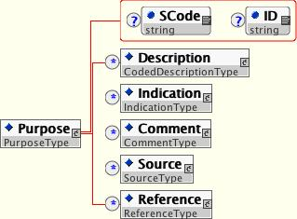

Figure 6 – Complex Data Type PurposeType

<Purpose> defines a specific reason that a CCR is generated. Note that the general use case of the CCR does not require a <Purpose>. <Purpose> should be utilized, however, when the CCR has a specific purpose such as patient admission, transfer, consult/referral, or inpatient discharge.

<Purpose> can be defined as a text string under <Description> or as an <Indication>. Under <Indication> purpose can be a text string under <Indication><Description> or a fully tagged <Problem> or an <InternalCCRLink> or external <Reference>.

<References>

<References> is a section that contains information about internal or external references. Internal references are to CCR Data Objects within the CCR, defined by <CCRDataObjectID> and xs:IDREF. External references are to data sources/locations that are outside the CCR. External reference data can be URLs, reference articles, clinical documents, paper or electronic patient records, diagnostic or document images, or any other data that would be of value to the providers using the CCR data for patient care.

Each <Reference> is a Complex Data Type ReferenceType as illustrated in Figure 7.
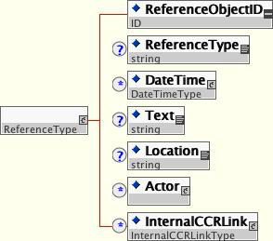

Figure 7 – Complex Data Type ReferenceType

The Definition Table for ReferenceType is as follows:

Reference_Type | Accepted Values/Formatting | Optionality/0 - ∞ | Description
<ReferenceObjectID> | xs:ID  AA0000-ZZ9999 | Required  Bound | This is the <Reference> ObjectID.
<ReferenceType> | String | Optional  Bound (Single Element – Single Use Only) | This refers to the Type of reference – Document, URL, Text, Article…
<DateTime> | None – data can only be contained within child elements. | Optional  Unbound (0 - ∞) | Records the reference document time (if applicable) and/or the time the reference was first referenced and last updated. This is an optional object attribute of <Reference>. <DateTimeType> can only contain the xs:string “First Referenced”, “Last Update”, “Reference Document Date” – which is used to record the document date for a clinical document, for example. Time must be an exact time.
<Text> | String | Optional  Bound (Single Element – Single Use Only) | This contains the Text description of the reference.
<Location> | String | Optional  Bound (Single Element – Single Use Only) | This defines the Location of the reference.
<Actor> | None – data can only be contained within child elements. | Optional  Bound (Single Element – Single Use Only) | Complex Data Type – ActorType. It defines an internal link to an ActorType in the CCR.
<InternalCCRLink> | None – data can only be contained within child elements. | Optional  Unbound (0 - ∞) | Contains <LinkID> as xs:IDREF and <LinkRelationshjp> which describes the relation between the referencing and referenced CCR Data Objects.

ReferenceType Definition Table

<References> is a section that contains details about references that refer to the overall CCR. Each CCR Section and each CCR Data Object have a <Reference> bucket that is optional and unbound for holding references specific to the Section or a Data Object. <ReferenceType> can only have the xs:string values: “CCR”, “CCR Section”, CCR Data Object”, “External Document”, “Electronic Medical Record”, “Paper Medical Record”, “Personal Health Record”, “Journal Article”, “Clinical Image”, “Scanned Document Image”, “Electrocardiogram”, and “Other”.

<Source>

<Source> in all instances of use is of the Complex Data Type SourceType. SourceType includes a link to <Actor> and a <SourceDateTime>, which is an <ExactDateTime>.

<InternalCCRLink>

Links are used to reference data contained within other parts of the document, such as a <Problem> under <Problems> being the <Indication> for a <Procedure> or <Medication>. Links are made using the Complex Data Type InternalCCRLinkType, which is illustrated in Figure 8.

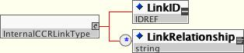

Figure 8 – Complex Data Type InternalCCRLinkType

There is no ‘bucket’ or section for InternalCCRLinks. They are referentially self-contained, since they are pointers from one data object to another data object. The Definition Table for InternalCCRLinkType is as follows:

InternalCCRLinkType | Accepted Values/Formatting | Optionality/0 - ∞ | Description
<LinkID> | Internal CCR ObjectIDs Only – xs:IDREF | Required  Bound (Single Element – Single Use Only) | This must be an internal CCR ObjectID.
<LinkRelationship> | Enumerated Values Only | Optional  Unbound (0 - ∞) | Links are internal references within the CCR that link a specific Data Object to another. Enumerated values are not yet defined for Links but will include:  “Indication”  “Etiology”  “Associated With”  “Must Occur Before”  “Must Occur After”

InternalCCRLinkType Definition Table

<Description> and CodedDescriptionType

The Complex Data Type CodedDescriptionType is used with the tag <Description> in the CCR to support the use of simple text strings by end-users, vendors, and systems which cannot fully tag data, while at the same time supporting the complete and detailed tagging and coding of discrete object-oriented data whenever possible.

A diagnosis can be used as an example where a diagnosis can be presented as a string:

<Problem><Description>Heart Attack</Description></Problem>

Or CodedDescriptionType can be used with embedding of tags to represent the diagnosis and its overall (ICD-9 CM) as well as component (SNOMED) codes as an object-oriented CCR data objects.

<Problem><Description>Myocardial Infarction><Code><Value>401.01</Value><CodeType>ICD-9 CM</CodeType><Version>2004</Version></Code><Attribute>Location<Code><Value>02345</Value><CodeType>SNOMED</CodeType><Version>4.1</Version></Code><Value>Anterior Septal<Code><Value>01165</Value><CodeType>SNOMED</CodeType><Version>4.1</Version></Code></Value></Attribute</Description></Problem>

Editor’s Comment – please note that these ICD and SNOMED codes are not correct, and the correct codes will be substituted in the published standard.

The ‘sig’ segment of prescriptions is another example that could be represented as either a text string or a fully mapped data object, but a far more complex one, and it is dealt with in more detail when discussing medications, immunizations, and products.

The Complex Data Type CodedDescriptionType is illustrated in Figure 9.

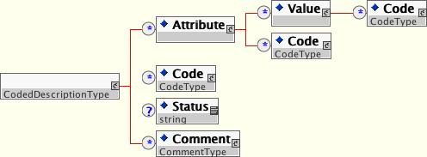

Figure 9 – Complex Data Type CodedDescriptionType

The Definition Table for CodedDescriptionType is as follows:

CodedDescription_Type | Accepted Values/Formatting | Optionality/0 - ∞ | Description
<Description> | String | Optional  Bound (Single Element – Single Use Only) | This is the text description as a string or the object (a diagnosis, for example) to which tagged attributes, values, and codes will apply. This can have a <Code>.
<Attribute> | String | Optional  Unbound (0 - ∞) | This is the container for the attribute descriptor – “Location”, “Severity”, “Laterality”, etc. These attributes can be individually coded.
<Value> | String | Optional  Unbound (0 - ∞) | This is a container for object attribute values – “Substernal”, “Left”, “Mild”, etc. These values can be individually coded.
<Code> | None – data can only be contained within child elements. | Optional  Unbound (0 - ∞) | <Code> is a Complex Data Type – CodeType. It is to be used whenever codes are defined for a given data domain.
<Status> | String | Optional  Bound | Not used in this version of the CCR. It will eventually have enumerated values for each data object type.
<Comment> | None – data can only be contained within child elements. | Optional  Unbound (0 - ∞) | This is a Complex Data Type CommentType.

CodedDescriptionType Definition Table

<Code> and CodeType

The Complex Data Type CodeType is used to express codes within the CCR. It is recommended that all data that can be, be discretely coded in implementations of the CCR. Recommended codes will be defined for each data object type.

CodeType is illustrated in Figure 10.

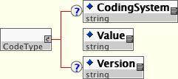

Figure 10 – Complex Data Type CodeType

In all instances where a Code is used in the CCR, the Complex Data Type Code_Type is specified. The Definition Table for Code_Type is as follows:

Code_Type | Accepted Values/Formatting | Optionality/0 - ∞ | Description
<CodingSystem> | String | Optional  Bound (Single Element – Single Use Only) | This defines the coding system – such as ICD-9CM, ICD-10, SNOMED, LOINC, NCPDP, X12, CPT.
<Value> | String | Required whenever Code_Type is used. Bound (Single Element – Single Use Only) | This is the Code – numeric or alphanumeric.
<Version> | String | Optional  Bound (Single Element – Single Use Only) | This defines the version – for example if <Type> is ICD-9CM, the <Version> might be 2004.

CodeType Definition Table

CommunicationType

The Complex Data Type CommunicationType is used to express telephone numbers, email addresses, URLs, as well as other forms of contacting a person or organization. Communication Type is used within <Actor>.

CommunicationType is illustrated in Figure 11.

d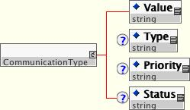

Figure 11 – Complex Data Type CommunicationType

The Definition Table for Communication_Type is as follows:

Communication_Type | Accepted Values/Formatting | Optionality/0 - ∞ | Description
<Value> | String | Required whenever Code_Type is used. Bound (Single Element – Single Use Only) | This is the telephone number, email address, url…
<Type> | String | Optional  Bound (Single Element – Single Use Only) | This defines the type – Home Telephone, Office Telephone, Pager, Mobile Telephone, FAX, Email, URL…
<Priority> | String | Optional  Bound (Single Element – Single Use Only) | This defines the priority of the means of contact, such as Primary – Preferred; Secondary…
<Status> | String | Optional  Bound (Single Element – Single Use Only) | This defines the Status – Active, Inactive, Temporary. It can also be used to define days and hours of availability – Active M, W, F 08:00-17:00…

ComunicationType Definition Table

<Comment> and CommentType

The Complex Data Type CommentType is illustrated in Figure 12.

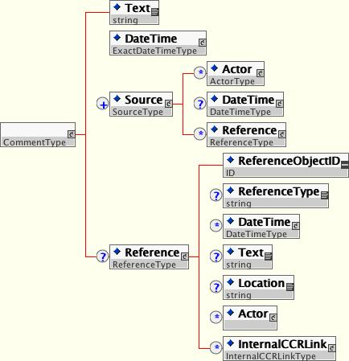

Figure 10 – Complex Data Type CommentType

The Definition Table for CommentType is as follows:

Comment_Type | Accepted Values/Formatting | Optionality/0 - ∞ | Description
<Text> | Text String | Required  Bound (Single Element – Single Use Only) | This is the text of the comment.
<DateTime> | None – data can only be contained within child elements. | Required  Bound (Single Element – Single Use Only) | Must be ExactDateTime. <DateTimeType> is required to state “Comment Date”.
<Source> | None – data can only be contained within child elements. | Required  Unbound | <Source> is a Complex Data Type SourceType. It defines the Actor who is the Source of the Comment. <DateTime> is not used for <Comment>.
<Reference> | None – data can only be contained within child elements. | Optional  Bound | Used as a pointer to an internal orm external reference.

CommentType Definition Table

Body and Data Objects

The core patient-specific data contained within the CCR is within the Body of the CCR Document Object.

The Body of the CCR Document Object is contained within the tag <Body>. <Body> contains sections, which contain the discrete data objects that make up the core of the CCR. The sections represent the core data sets defined under the CCR. All of the core data sets are defined under a constrained section tag.

The tags for the data objects (data items) within the body of the CCR are as follows:

Data Object Tag | Description
<Insurance> | Contains Insurance Information.
<AdvanceDirectives> | Contains Advanced Directives.
<Support> | Contains support persons and organizations relevant to patient.
<FunctionalStatus> | Contains Problems relating to the patient’s functional status.
<Problems> | Contains Problems.
<FamilyHistory> | Contains a pertinent Family Health History.
<SocialHistory> | Contains a pertinent Social History.
<Alerts> | Contains the patient’s Allergies, Adverse Reactions, and Alerts (for example, enzyme or metabolic pathway deficiencies).
<Medications> | Contains the patient’s Current Medications.
<Immunizations> | Contains the patient’s Immunization Status.
<VitalSigns> | Contains the patient’s pertinent Vital Signs.
<Results> | Contains the patient’s pertinent Results (lab, imaging, interventional).
<Procedures> | Contains a history of the patient’s pertinent clinical procedures.
<Encounters> | Contains a history of the patient’s pertinent healthcare encounters and pending appointments.
<PlanOfCare> | Contains all pending orders or other pertinent pending Plan Of Care items.
<HealthCareProviders> | Contains the patient’s relevant healthcare providers (Primary Provider(s), Specialist (s)).

Each of these Data Objects and the sections that contain them will be defined below.

Data Objects

Data Objects within Sections are Unbound (0 - ∞) allowing them to be repeated as necessary to express the patients pertinent history and current state of health.

Each CCR data object is defined as follows:

<Insurance>

<Insurance> is used to define each insurance plan that is pertinent to the patient. A patient may have one health plan or many. <Insurance> is Unbound (0 - ∞) and can be used for one or more health plans, worker’s compensation, auto insurance, pharmacy benefit manager (PBM), or other pertinent benefit plans.

Also contained within the <Insurance> data object is <Authorizations>, which can be used to define pertinent referral, procedure, therapy, intervention, device, or similar authorizations for the patient and/or provider. Authorizations are particularly pertinent to the referral, long-term care, inpatient, and procedure-based/surgical uses for the CCR.

<Insurance> is illustrated in Figure 14.
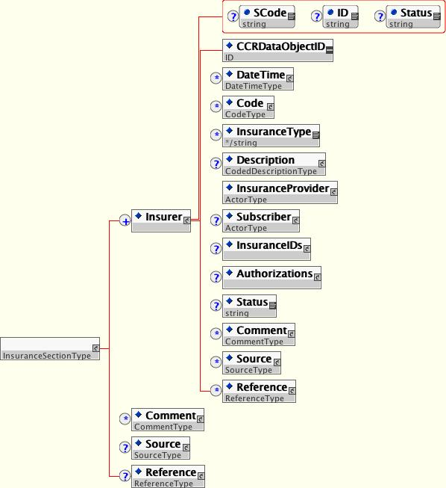

Figure 14 – <Insurance> Data Object

<Insurance> is defined as follows:

<Insurance> | Accepted Values/Formatting | Optionality/0 - ∞ | Description
<InsuranceType> | String | Optional  Unbound (0 - ∞) | This is the type of insurance – Health Care HMO, Health Care PPO, Health Care Indemnity, Auto, Worker’s Compensation…
<Description> | String | Optional  Bound (Single Element – Single Use Only) | This is name of the insurance company/payor/plan.
<InsuranceDateTime> | None – data can only be contained within child elements. | Optional  Unbound (0 - ∞) | Instance of Date_Type. Examples of <DateTimeType> would be Benefit Start Date and Benefit Stop Date, used to define the Effective Period or Effective Date, Termination Date, or Renewal Date.
<InsuranceProvider> | None – data can only be contained within child elements. | Required  Bound (Single Element – Single Use Only) | Link to <Actor>.
<Subscriber> | None – data can only be contained within child elements. | Optional  Bound (Single Element – Single Use Only) | Link to <Actor>.
<InsuranceIDs> | None – data can only be contained within child elements. | Optional  Bound (Single Element – Single Use Only) | Contains unbound element <IDNumber>, which is an instance of IDType. Examples are Subscriber Number, Member Number (if patient is not subscriber), Plan Number, Group Number, Plan Code…
<Authorizations> | None – data can only be contained within child elements. | Optional  Bound (Single Element – Single Use Only) | Contains unbound element <Authorization>. Can contain all of the specific data regarding an authorization as well as about what is authorized or a link to an internal CCR data object.

<Insurance> Object Type Definition Table

<AdvanceDirective>

<AdvanceDirective> is used to define the patient’s advanced directives at the time the CCR is generated.

< AdvanceDirective > is illustrated in Figure 15.

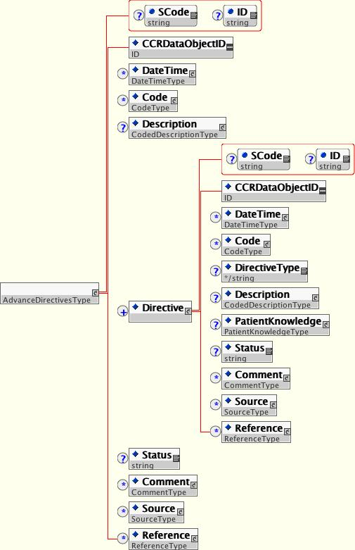

Figure 14 – <AdvanceDirective> Data Object

<AdvanceDirectives> is defined as follows:

<Insurance> | Accepted Values/Formatting | Optionality/0 - ∞ | Description
<AdvanceDirective> | None – data can only be contained within child elements. | Required  Unbound (0 - ∞) | <Description> defines a ‘group’ of directives, such as a Durable Power of Attorney, that may contain one or more specific <Directives>. <Description> is optional and bound.  <Description> contains descriptive text relative to the directive; <Value> contains Yes, No, or Unknown.
<Directive> | None – data can only be contained within child elements. | Required  Unbound (0 - ∞) | Used to represent discrete directives or one or more directives within a group.
<DirectiveType> | String | Optional  Bound (Single Element – Single Use Only) | Used to define the directive type – Resuscitation Status, CPR, Intubation, Antibiotics, Tube Feedings, IV…
<Description> | CodedDescriptionType | Optional  Bound (Single Element – Single Use Only) | Used to describe the directive as a text string or to map and code as a complex data object.
<PatientKnowledge> | None – data can only be contained within child elements. | Optional  Bound (Single Element – Single Use Only) | This defines whether or not the patient is aware of their Advance Directives. <Description> defines Patient Aware or Patient Not Aware; <Reason> defines why the patient is not aware. <Source> links to source.

<AdvanceDirective> Object Type Definition Table

<Support>

<Support> is used to list all of the patients support providers and contacts – family, legal guardian, durable power for healthcare, clergy, caregivers, support organizations, at the time the CCR is generated. The persons and organizations providing support are each itemized as an instance of the Complex Data Type ActorType or as a reference to a previously itemized ActorType in the CCR through xs:IDREF.

<Support> is illustrated in Figure 15.

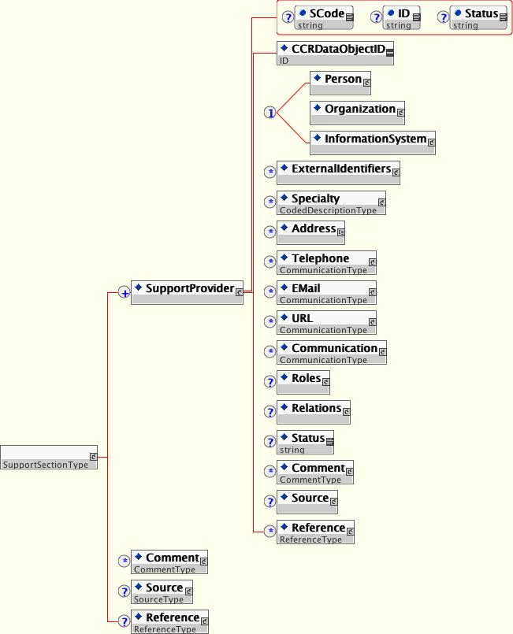

Figure 15 – <Support> Data Object

<FunctionalStatus>

<FunctionalStatus> is used to define the patient’s functional status – ambulatory status, ability to care for self, activities of daily living, at the time the CCR is generated. Functional Status is essentially a type of ProblemType (see <Problem> below), in that functional problems are essentially clinical problems for the patient. They are specifically defined within the CCR <FunctionalStatus> section, as separate from other clinical problems.

<FunctionalStatus> is illustrated in Figure 16.

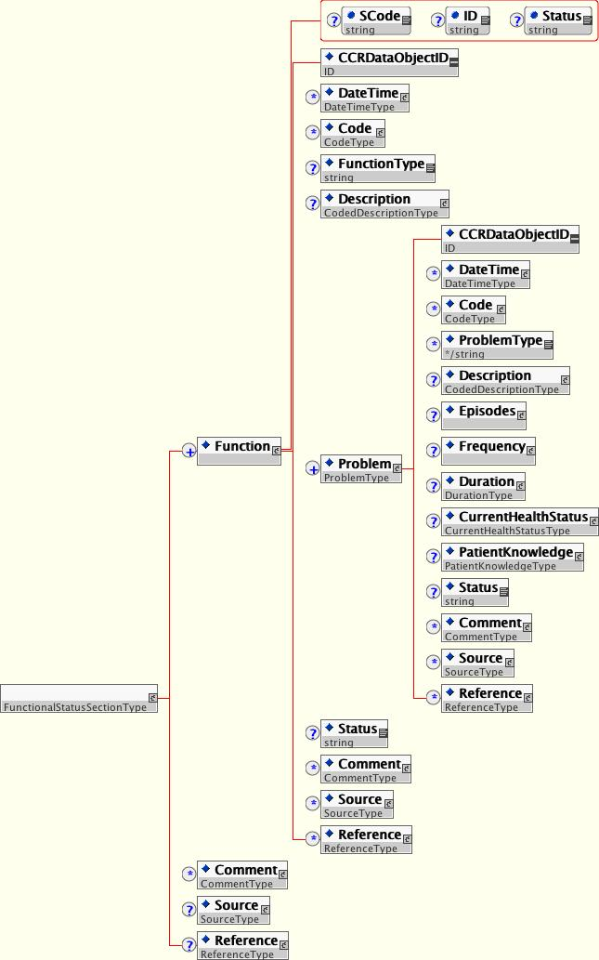

Figure 16 – <FunctionalStatus> Data Object

<Problem>

<Problem> is used to define the patient’s pertinent problems, conditions, and diagnoses at the time the CCR is generated. Problem is an instance of the Complex Data Type ProblemType.

< Problem> is illustrated in Figure 17.

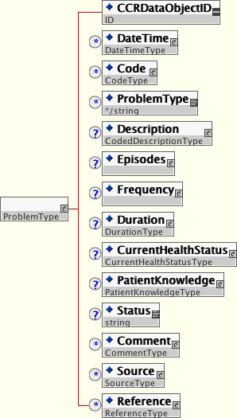

Figure 17 – <Problem> Data Object

<Problem> is defined as follows:

<Problem> | Accepted Values/Formatting | Optionality/0 - ∞ | Description
<ProblemType> | String (Enumerated) | Optional  Unbound (0 - ∞) | Defines problem type.
<Description> | CodedDescriptionType | Optional  Bound (Single Element – Single Use Only) | <Description> of the problem, diagnosis, condition – Myocardial Infarct, for example.
<Episodes> | None – data can only be contained within child elements. | Optional  Unbound (0 - ∞) | This is used to support documentation of discrete Episodes of a problem.
<Frequency> | None – data can only be contained within child elements. | Optional  Unbound (0 - ∞) | Used to define problem frequency if recurrent or episodic.
<Duration> | None – data can only be contained within child elements. | Optional  Unbound (0 - ∞) | Used to describe problem duration.
<CurrentHealthStatus> | None – data can only be contained within child elements. | Optional  Bound (Single Element – Single Use Only) | Used to define the health status of the Actor whom the problem applies to (used more commonly in Family History). <Status> defines Alive and Well, Ill, Seriously Ill, Terminal, Deceased. <Code> is an instance of Code_Type. <CauseOfDeath> defines if this condition was the cause of death of the Actor whom the problem applies to – values are Yes, No, Unknown. <TimeOfDeath> is an instance of Date_Type and could be an exact date or date/time, an age, or an approximate date.
<PatientKnowledge> | None – data can only be contained within child elements. | Optional  Bound (Single Element – Single Use Only) | This defines whether or not the patient is aware of their <Problem>. <Description> defines Patient Aware or Patient Not Aware. <Reason> defines why the patient is not aware. <Source> links to source.

<Problem> Object Type Definition Table

<FamilyHistory>

Family History is an instance of the Complex Data Type ProblemType, which is a variation of <Problem> with the addition of the element <FamilyMember>, which is used to define whom in the patient’s family the Family History data object refers to. Note that a single <Problem> can affect one or more <FamilyMember>s, and a single <FamilyMember> can have more than one <Problem>.

<FamilyHistory> is illustrated in Figure 18.

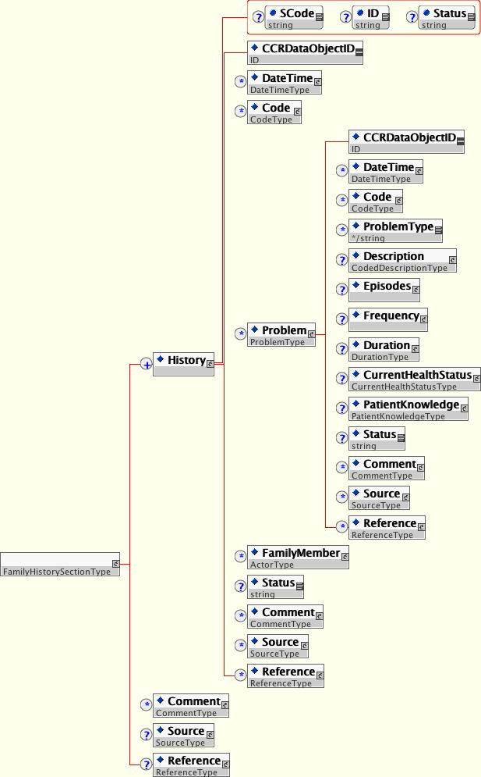

Figure 18 – <FamilyHistory> Data Object

<SocialHistory>

Social History defines <RiskFactor>s using the Complex Data Type CodedDescriptionType and the enumerated element <RickFactorType>.

Social History is illustrated in Figure 19.

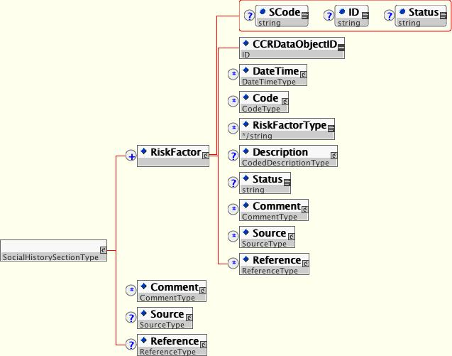

Figure 19 – <SocialHistory> Data Object

<Alert>

<Alert> is used to define a patient’s Allergies, Adverse Reactions, and Alerts (for example, enzyme or metabolic pathway deficiencies).

< Alert> is illustrated in Figure 20.
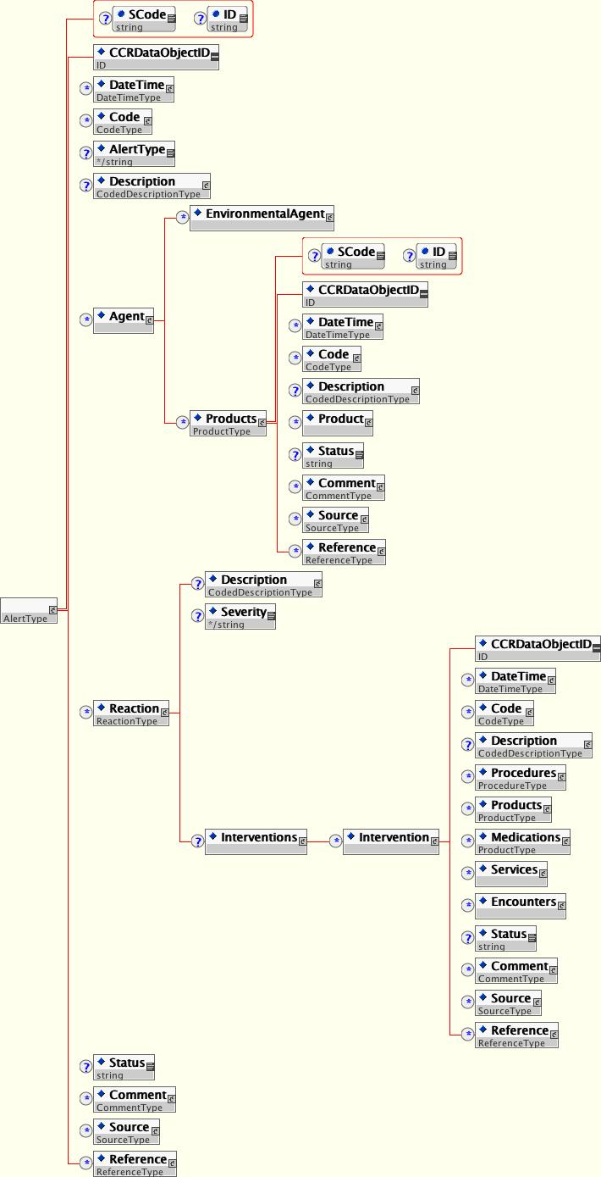

Figure 20 – <Alert> Data Object

<Alert> is defined as follows:

<Alert> | Accepted Values/Formatting | Optionality/0 - ∞ | Description
<AlertType> | String - Enumerated | Optional  Bound (Single Element – Single Use Only) | Classifies <Alert> type.
<Description> | CodedDescriptionType | Optional  Bound (Single Element – Single Use Only) | <Description> of the allergy, adverse reaction, or condition/alert.
<Reaction> | None – data can only be contained within child elements. | Optional  Unbound (0 - ∞) | Defines the reaction - Rash, Angioedema, Anaphylaxis, Nausea, etc. <Description> can be a string or can be used to encode the reaction; “Severity” is recommended as an <Attribute> to define the severity of the reaction.
<Agent> | None – data can only be contained within child elements. | Optional  Unbound (0 - ∞) | Defines the causative agent - <Description> is the name of the agent; <Code> is an instance of Code_Type to encode the agent.
<Interventions> | None – data can only be contained within child elements. | Optional  Unbound (0 - ∞) | Defines any intervention to counteract the reaction.
<DateTime> | None – data can only be contained within child elements. | Optional  Unbound (0 - ∞) | DateTime of reaction or alert should be included (contained under CCRRecurrentDataAttributesGroup).

<Alert> Object Type Definition Table

<Medication> and <Immunization>

<Medication> contains a list of the patient’s current medications at the time of generation of the CCR. <Immunization> is used to itemize a patient’s relevant immunization history.

< Medication> and <Immunization> are instances of the Complex Data Type ProductType as illustrated in Figure 21.

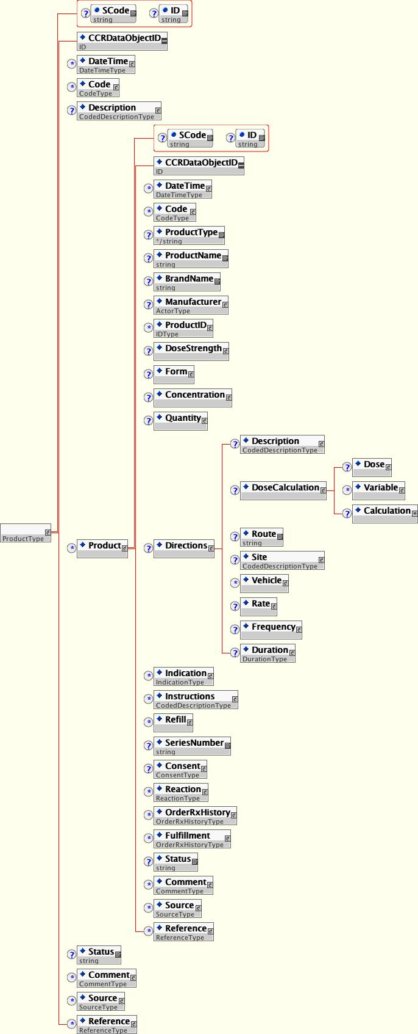

Figure 21 – Complex Data Type ProductType

The Complex Data Type ProductType and <Product> are defined as follows:

<Product> | Accepted Values/Formatting | Optionality/0 - ∞ | Description
<Description> | CodedDescriptionType | Optional  Bound (Single Element – Single Use Only) | Used to describe a product group, such as a GI Cocktail, an Insulin Sliding Scale, or the like.
<Product> | None – data can only be contained within child elements. | Optional  Unbound (0 - ∞) | Used to define a unique product.
<ProductType> | String - Enumerated | Optional  Bound (Single Element – Single Use Only) | Defines the product classification.
<ProductName> | String | Required  Bound (Single Element – Single Use Only) | The generic, non-proprietary, name of the product.
<BrandName> | String | Optional  Bound (Single Element – Single Use Only) | The Brand Name.
<Manufacturer> | None – data can only be contained within child elements. | Optional  Bound (Single Element – Single Use Only) | Links to an <Actor>.
<ProductID> | IDType | Optional  Bound (Single Element – Single Use Only | Can be used for Product Number, Lot Number, Serial Number, or the like.
<DoseStrength> | None – data can only be contained within child elements. | Optional  Bound (Single Element – Single Use Only) | The predefined strength that the medication comes in – 500mg tablets, for example.
<Form> | None – data can only be contained within child elements. | Optional  Bound (Single Element – Single Use Only) | The Form– Tablet, Capsule, Elixir, Suspension, Crème, Powder, Box, Syringe, etc.
<Concentration> | None – data can only be contained within child elements. | Optional  Bound (Single Element – Single Use Only) | Used to define product concentration, when applicable – 250 mg/ml, for example.
<Quantity> | None – data can only be contained within child elements. | Optional  Bound (Single Element – Single Use Only) | Defines the quantity - to be ordered, dispensed, or used, for example.
<Directions> | None – data can only be contained within child elements. | Optional  Bound (Single Element – Single Use Only) | Contains the directions for use. This is the ‘sig’ component of the Prescription, for example. <Description> can contain a text string or complex, coded data object.
<DoseCalculation> | None – data can only be contained within child elements. | Optional  Bound (Single Element – Single Use Only) | <Dose> defines the dose parameter 125, 250, 500; <Unit> defines the unit parameters mg/kg/hr, for example <Variables> defines dosing variables, which can be more than one. <Calculation> defines the calculation.
<Route> | String | Optional  Bound (Single Element – Single Use Only) | This defines the Route of administration – po, pr, sl, in either plain English or Latin abbreviation.
<Site> | CodedDescriptionType | Optional  Bound (Single Element – Single Use Only) | Site of use, implantation, or administration, when specified (commonly used in IM, IV, and immunizations, and implantable devices).
<Vehicle> | None – data can only be contained within child elements. | Optional  Unbound (0 - ∞) | Defines a product that is a vehicle for this product, such as an IV admixture, or vehicle/suspension.
<Rate> | None – data can only be contained within child elements. | Optional  Bound (Single Element – Single Use Only) | Defines a rate of administration.
<Frequency> | None – data can only be contained within child elements. | Optional  Bound (Single Element – Single Use Only) | Defines the frequency of administration – qd, bid, tid, qid, 5x/d…
<Duration> | None – data can only be contained within child elements. | Optional  Bound (Single Element – Single Use Only) | Defines the duration of use/administration.
<Indication> | None – data can only be contained within child elements. | Optional  Unbound (0 - ∞) | Indication for a product.
<Instructions> | CodedDescriptionType | Optional  Bound (Single Element – Single Use Only) | Description of instructions.
<Refill> | None – data can only be contained within child elements. | Optional  Bound (Single Element – Single Use Only) | Number of allowed refills per prescription.
<SeriesNumber> | String | Optional  Bound (Single Element – Single Use Only) | Defines number in series, such as a series of immunizations.
<Consent> | None – data can only be contained within child elements. | Optional  Bound (Single Element – Single Use Only) | Allows <Description> of consent as well as link to <Actor> or <ExternalReference>.
<Reaction> | None – data can only be contained within child elements. | Optional  Unbound (0 - ∞) | Defines the reaction - Rash, Angioedema, Anaphylaxis, Nausea, etc. <Description> can be a string or can be used to encode the reaction; “Severity” is recommended as an <Attribute> to define the severity of the reaction.
<OrderRxHistory> | None – data can only be contained within child elements. | Optional  Unbound (0 - ∞) | Product prescription and order history.
<Fulfillment> | None – data can only be contained within child elements. | Optional  Unbound (0 - ∞) | Product fulfillment history – tags as for <OrderRxHistory> above, but applied to fulfillment/dispensing.

<Product> Object Type Definition Table

<Result> for <Results> and <VitalSigns>

<VitalSigns> and <Results> utilize the ResultType to define relevant recent or historical Vital Signs and Results when the CCR is generated.

<Result> is illustrated in Figure 22.

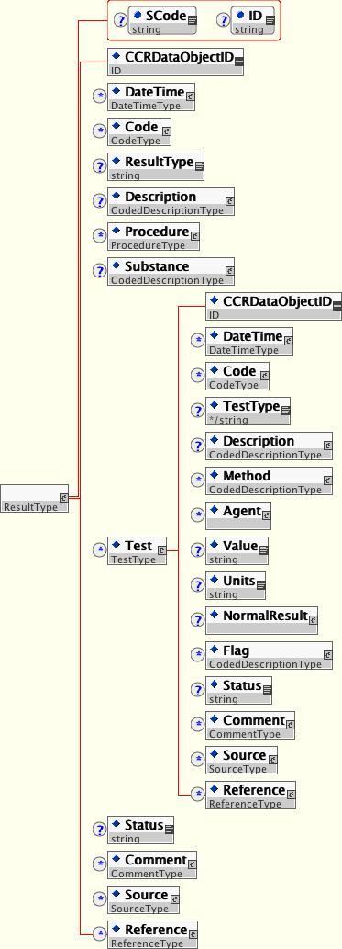

Figure 22 – <Result> Data Object

<Result> defines discrete values as <Test>. <Test> is a Complex Data Type TestType. The elements of <Result> are defined below and will be followed by the definition of Test-Type.

Result_Type | Accepted Values/Formatting | Optionality/0 - ∞ | Description
<Description> | CodedDescriptionType | Optional  Bound (Single Element – Single Use Only) | <Description> of the result – Blood Pressure, Heart Rate, Complete Blood Count (CBC), Urine Culture, Urinalysis…
<Procedure> | None – data can only be contained within child elements. | Optional  Unbound (0 - ∞) | This is an instance of a procedure or a link. This is the procedure for which there is the <Result>, and/or a procedure done to get the <Result>.
<Substance> | CodedDescriptionType | Optional  Bound (Single Element – Single Use Only) | Defines the substance for the test –
<Test> | None – data can only be contained within child elements. | Optional  Unbound (0 - ∞) | Test_Type – defined in the following Table.

<Result> Object Type Definition Table

Test_Type | Accepted Values/Formatting | Optionality/0 - ∞ | Description
<Description> | String | Optional  Bound (Single Element – Single Use Only) | <Description> of the test – Systolic Blood Pressure, Diastolic Blood Pressure, Hct, Hgb, Na, K, BUN, Cr, Urine Specific Gravity, etc…
<Method> | CodedDescriptionType | Optional  Unbound (0 - ∞) | Used when a <Description> modifier is needed – currently not used.
<Agent> | None – data can only be contained within child elements. | Optional  Unbound (0 - ∞) | Allows link to agent.
<Value> | String | Optional  Bound (Single Element – Single Use Only) | Contains the Test Result.
<Units> | String | Optional  Bound (Single Element – Single Use Only) | Defines the Unit(s) the Test Result is expressed in.
<NormalRange> | NormalType | Optional  Bound (Single Element – Single Use Only) | Defines the Normal Range for the Test Result.
<Flag> | CodedDescriptionType | Optional  Unbound (0 - ∞) | Defines an abnormal flag for the Test Result – Low, High, Panic Value.

Test_Type Definition Table

Procedure

<Procedure> defines all pertinent interventional, surgical, diagnostic, or therapeutic procedures or treatments pertinent to the patient at the time the CCR is generated.

<Procedure> is illustrated in Figure 23.

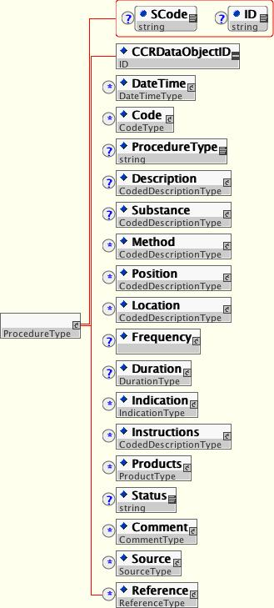

Figure 23 – <Procedure> Data Object

<Procedure> is defined as follows:

<Problem> | Accepted Values/Formatting | Optionality/0 - ∞ | Description
<Description> | CodedDescriptionType | Required  Bound (Single Element – Single Use Only) | <Description> of the Procedure – Echocardiogram, Exercise Stress Test, Appendectomy…
<Substance> | CodedDescriptionType | Optional  Bound (Single Element – Single Use Only) | Defines the substance collected.
<Method> | CodedDescriptionType | Optional  Unbound (0 - ∞) | Procedure method.
<Position> | CodedDescriptionType | Optional  Unbound (0 - ∞) | Patient position for/during the procedure.
<Frequency> | None – data can only be contained within child elements. | Optional  Bound (Single Element – Single Use Only) | Defines the frequency of the procedure.
<Duration> | None – data can only be contained within child elements. | Optional  Bound (Single Element – Single Use Only) | Defines the duration of the procedure.
<Location> | CodedDescriptionType | Optional  Unbound (0 - ∞) | Anatomical/physical location on the patient the procedure was/will be preformed.
<Indication> | None – data can only be contained within child elements. | Optional  Unbound (0 - ∞) | Indication for a procedure.
<Instructions> | CodedDescriptionType | Optional  Unbound (0 - ∞) | Description of instructions.
<Products> | None – data can only be contained within child elements. | Optional  Unbound (0 - ∞) | Describes or links to any products that are a key part of procedure (implanted devices, medications, reactive/provocative agents).

<Procedure> Object Type Definition Table

<Encounter>

<Encounter> defines all pertinent healthcare encounters as well as pending healthcare appointments of the patient at the time the CCR is generated. Encounters can be Hospitalization, Office Visit, Home Health Visit, Long-Term Care, or any other pertinent encounter.

<Encounter> is illustrated in Figure 24.

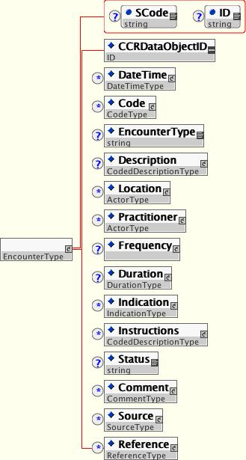

Figure 24 – <Encounter> Data Object

<Encounter> is defined as follows:

<Encounter> | Accepted Values/Formatting | Optionality/0 - ∞ | Description
<Description> | CodedDescriptionType | Optional  Bound (Single Element – Single Use Only) | Encounter type – Hospital Admission, Office Visit, Home Health Visit…
<Location> | None – data can only be contained within child elements. | Optional  Unbound (0 - ∞) | Link to <Actor>.
<Practitioner> | None – data can only be contained within child elements. | Optional  Unbound (0 - ∞) | Link to <Actor>.
<Frequency> | None – data can only be contained within child elements. | Optional  Bound (Single Element – Single Use Only) | Defines the frequency of the encounter.
<Duration> | None – data can only be contained within child elements. | Optional  Bound (Single Element – Single Use Only) | Defines the duration of the encounter.
<Indication> | None – data can only be contained within child elements. | Optional  Unbound (0 - ∞) | Indication for an encounter.
<Instructions> | CodedDescriptionType | Optional  Unbound (0 - ∞) | Description of instructions.

<Encounter> Object Type Definition Table

<PlanOfCare>

<PlanOfCare> defines all pending orders, interventions, encounters, services, and procedures for the patient. It defines what is pending in the care of the patient.

<PlanOfCare> is illustrated in Figure 25.

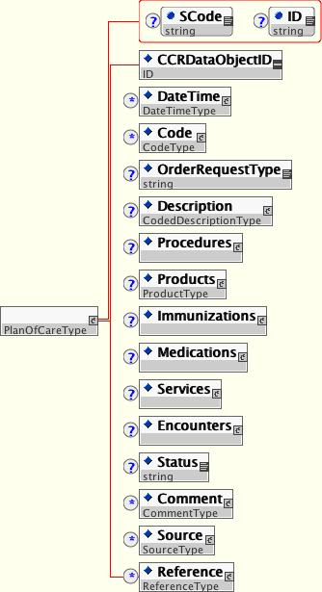

Figure 25 – <PlanOfCare> Data Object

<PlanOfCare> is defined as follows:

<PlanOfCare> | Accepted Values/Formatting | Optionality/0 - ∞ | Description
<Description> | CodedDescriptionType | Optional  Bound (Single Element – Single Use Only) | Used when needing to describe a Plan of Care group of items.
<Procedures> | None – data can only be contained within child elements. | Optional  Unbound (0 - ∞) | <Procedure>
<Products> | None – data can only be contained within child elements. | Optional  Unbound (0 - ∞) | <ProductType>
<Immunizations> | None – data can only be contained within child elements. | Optional  Unbound (0 - ∞) | <Immunization>
<Medications> | None – data can only be contained within child elements. | Optional  Unbound (0 - ∞) | <Medication>
<Services> | None – data can only be contained within child elements. | Optional  Unbound (0 - ∞) | <Service>
<Encounters> | None – data can only be contained within child elements. | Optional  Unbound (0 - ∞) | <Encounter>

<PlanOfCare> Object Type Definition Table

<HealthCareProvider>

<HealthCareProvider> defines all providers involved in the current or pertinent historical care of the patient. <HealthCareProvider> is an ActorType or is a link to a previously itemized ActorType within the CCR through xs:IDREF.

<HealthCareProvider> is illustrated in Figure 26.

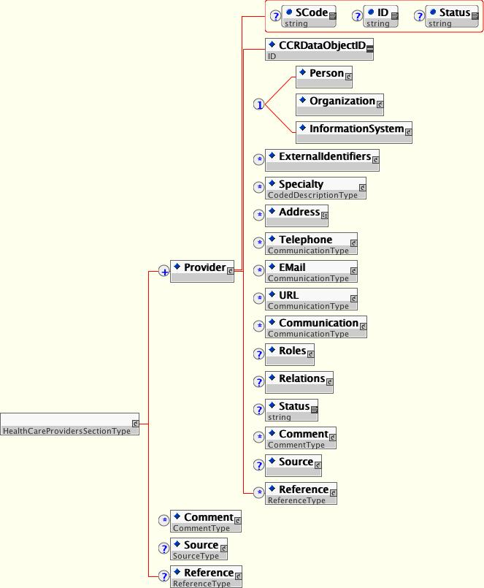

Figure 26 – <HealthCareProvider> Data Object

Coding

Detailed coded is recommended whenever practical within the CCR. The following are specific coding recommendations:

Problems

Problems should be coded at the highest level using the most recent ICD-9 CM codes at the time the CCR is generated. This is to accommodate the need for the various healthcare entities that will be interacting with the CCR data to have accurate coding for reimbursement purposes. In addition, it is recommended that problems be coded with SNOMED codes to as granular a level as possible.

Procedures

Procedures should be coded at the highest level using the most recent CPT codes at the time the CCR is generated. This is to accommodate the need for the various healthcare entities that will be interacting with the CCR data to have accurate coding for reimbursement purposes. In addition, it is recommended that procedures be coded with LOINC codes to as granular a level as possible.

Products and Agents

Products and agents should be coded with a known standard (NDC, for example) or proprietary (Multum, FDB, etc.) code with the type of code and the source and version clearly defined.

Results

Results should be coded with the most recent CPT codes at the time the CCR is generated for procedures and with LOINC for <Result> and <Test>.

Security and Privacy

The primary use case for the CCR is for the CCR document instance to provide a snapshot in time containing the pertinent clinical, demographic and administrative data for a specific patient. The data contained within the CCR are patient data and, if those data are identifiable, then end-to-end CCR document integrity and confidentiality must be provided while conforming to regulations or other security, confidentiality, or privacy protections as applicable within the scope of this standard.

Conditions of security and privacy for a CCR instance must be established in a way that allows only properly authenticated and authorized access to the CCR document instance or its elements. The CCR document instance must be self protecting when possible and carry sufficient data embedded in the document instance to permit access decisions to be made based upon confidentiality constraints or limitations specific to that instance.

Additional ASTM E31.20 guides, practices and specifications will be published in support of the security and privacy needs of specific use cases. When a specification is necessary to assure interoperability or other required functionality, the CCR core schema will be extended to meet the profile requirements of the underlying use case—building upon existing standards and specifications whenever possible. For profiles that require digital signatures, W3C’s XML Signature (http://www.w3.org/TR/xmldsig-core) or its components will be used with X.509 v3 digital certificates allowed or required. Encryption will be provided using W3C’s XML Encryption (http://www.w3.org/TR/xmlenc-core).

This specification is under the jurisdiction of ASTM Committee E31 on Healthcare Informatics and is the direct responsibility of Subcommittee E31.28 Continuity of Care Record Work Group.

