CCRSummary Tool

Rev | Status | Date | Author | CO# | Description
A | Draft |  |  |  | Initial version of document.

Overview
Top-level changes in the CCR can be monitored via the CCRSummary utility. This utility is available on every appliance via a URL of the following form:
https://<hostname>/router/CCRSummary.html
CCRSummary presents a summary of a CCR or CCRs that are uploaded to the utility. It is useful for comparing CCRs before and after a transaction at a high level. For example - it would not be useful for detecting that the dosage of a medication was changed but it would be very useful for checking to see that the number of medications stayed the same and that no other sections of the CCR were dropped or inappropriately changed.
CCRSummary upload screen:

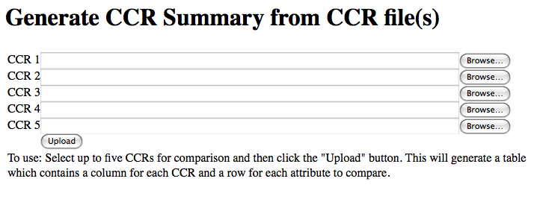

Example: Test of a simple CCR update
This test shows how to use the CCRSummary tool.
Test overview:
- Create a new account with a simple CCR
- Download the CCR
- Add a PDF file
- Download the new CCR
- Compare the two CCRs using the CCR summary tool.

1. Create a new account with a simple CCR

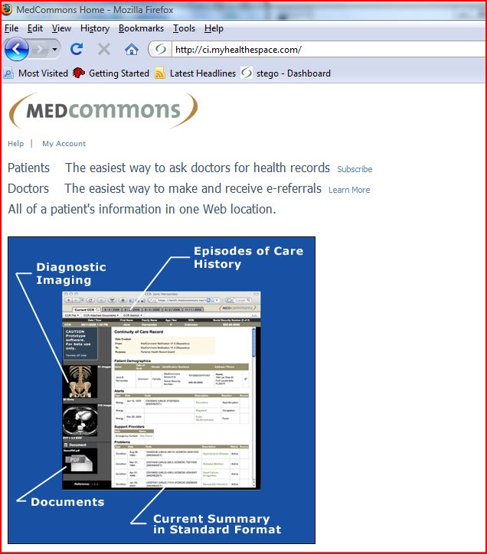

Click subscribe
[User is redirected thru Amazon - not shown here]
Now register the new account

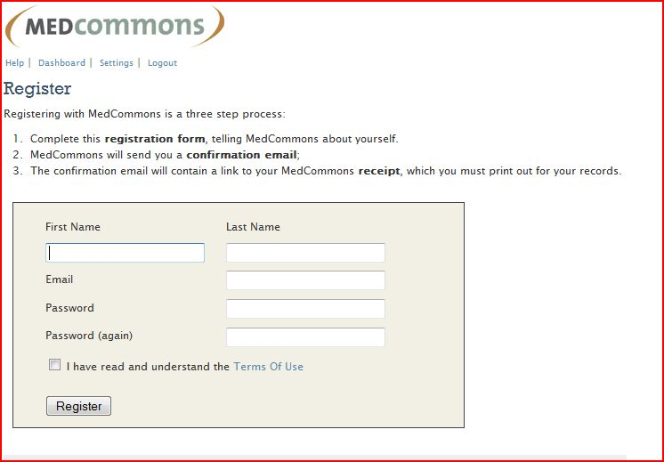

Fill out the form:

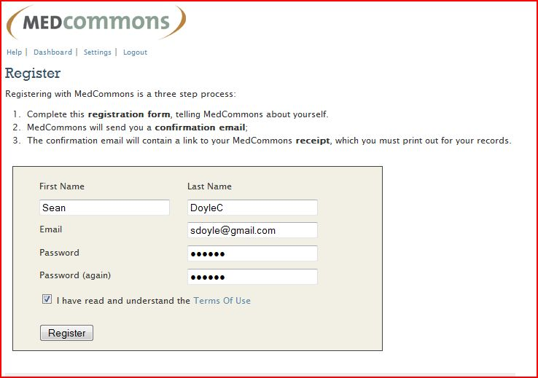

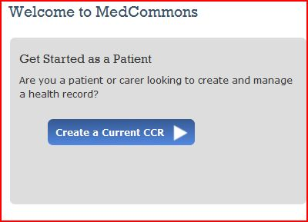
Click "Create a Current CCR".
Click "Save" button - then we have an account with a minimal CCR.

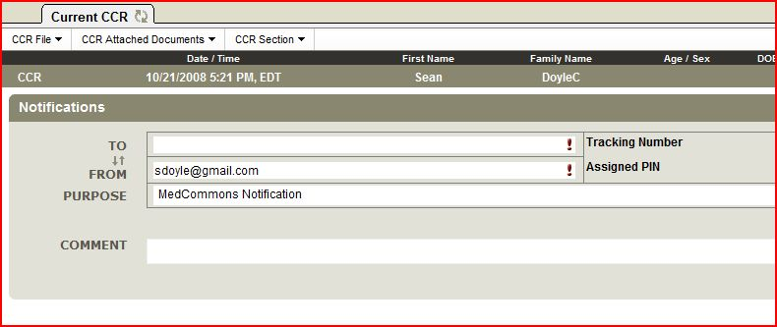

2. Download the CCR
Click on Current CCR tab; select "Download CCR" from menu

3. Add PDF file
Now add PDF. Confirm.

4. Download the new CCR
Select "Download CCR" again.

5. Compare the two CCRs using the CCR summary tool
Now we compare the two CCRs. Load the router/CCRSummary.html file; browse to the two CCRs which were downloaded in earlier steps.

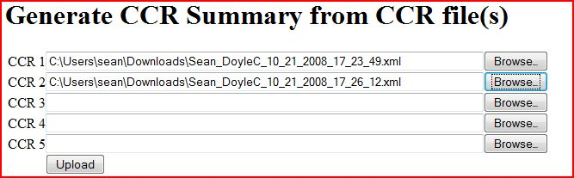
Click the upload button and view the results:
[Due to screen limitations - this has been broken into two images. Need to screenshots on a machine with bigger screen]

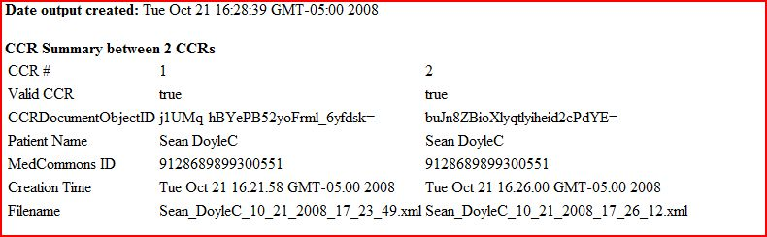

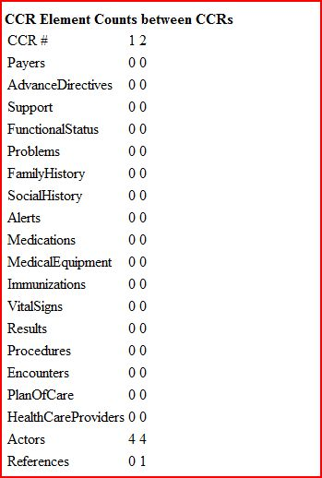

Note that the filename which was used for upload is displayed in the output; this makes it easier to keep track of changes.
Suppose we had a requirement of the following form:
MERGE-000X: If a single file is added as a CCR reference, the CCR will be unchanged except:
- The Reference element count shall be one greater than the original CCR
- The CCRDocumentObjectID shall contain with a new value in the new CCR
- The creation time of the CCR should make sense [Need better wording]
- No other fields shall be different.
The results above can be used as evidence that the test was passed. In the first CCR saved - there were zero references, in the second CCR there was one. The dates make sense - the new CCR was created 5 minutes after the original one.

