TP-0001 Data Import/Export Test Plan

(formerly known as the DDL Test Plan)
December 11, 2007 SWD

1. Installation

1.1 Installation of DDL web application on server
This is currently out of scope of the test plan. After the DDL.war file is built it is deployed to a web server on the network.

1.2 Installation of DDL client on user machine
The instructions below refer to a 'web browser'. This can be any of the following:
- IE6
- FireFox 2
- IE7
For each of these - DDL must be uninstalled if it already has been installed so that we're testing the user experience of downloading DDL for the first time.

Operating systems supported:
- Windows XP SP2
- Vista
- Fedora 7

(susan - also may want a statement, similar to browser above, that the following operating systems need to be tested. Those being...?)
(sean - shouldn't it be instead of F7 any Linux running JDK 5 or better?)

[TBD: we'll need to test upgrades of the DDL in place in the future]

1.2.1 Uninstall DDL
Before installing DDL - uninstall it first to so the user experience of installation can be tested.
There are two pieces of software which have to be uninstalled:
- Java
- DDL
both are removed (in Windows) via the "Add/Remove Programs" Control panel.

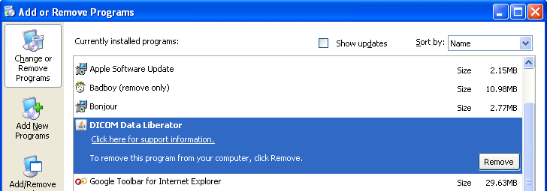

There is an additional manual step to completely uninstall the DDL - you must remove the folder "DDL" in your home directory. On a windows machine this is usually the C:\Documents and Settings\<username>\DDL - where <username> is the name of the windows account you are logged into.

1.2.2 New Installation
- Log into the the appliance (say - https://ci.myhealthespace.com/). This document currently assumes you're logging in as demodoctor.
- Click on the settings link

- Scroll down on the settings page until you see the plug-in components

- 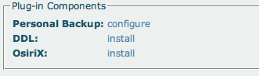

- Click on the link for DDL - this will launch the installer page

- 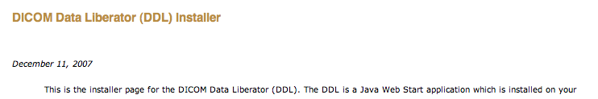

- Make sure that the date on the page is the version you want to install.
- For Windows - select the link "Install and Launch DDL"
- Java may need to be installed - if so you will be lead through the Java installation process. (susan - you just said above that you're supposed to un-install java first. Which makes the wording on this misleading. Assuming you just did uninstall Java, you now NEED to install it. For the actual user experience, you'd maybe have to install Java, maybe not. Say, is there any consideration given in the user world about what version of Java is installed on the machine? Perhaps that's outside the cope of this document and belongs in the fictitional user guide, but we oughtn't lose track of it.)
- Then the DDL itself will be downloaded:

- 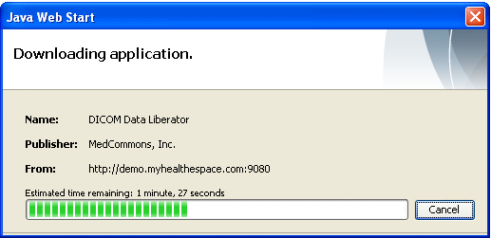
When the download is completed - the DDL will be launched.

1.2.3 Validating DDL Installation
The DDL icon

appears in the system tray. Select the 'About DDL' menu (in Windows - this is a right-mouse click, on MacOSX it is a simple click).
A web page should display which looks roughly like the following:

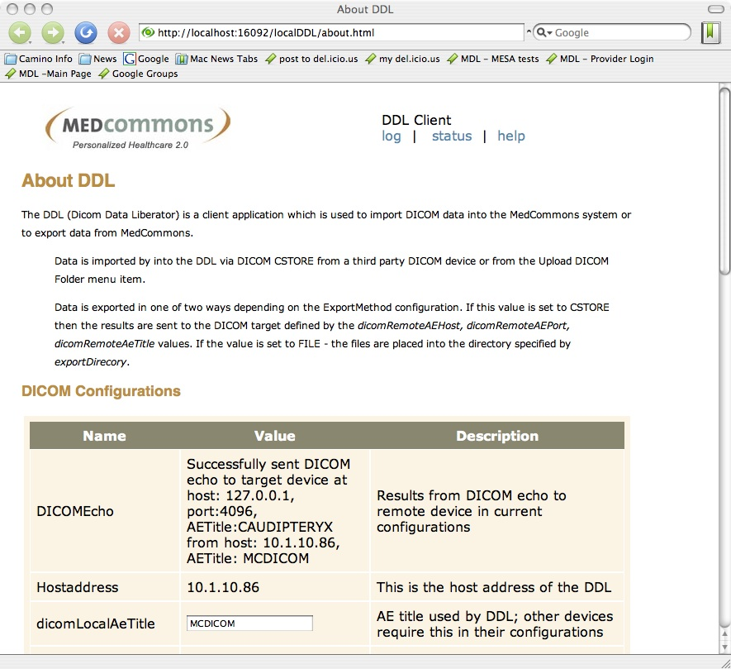

If this appears - record that the DDL installation was successful. If not, it fails.
Scroll down this page until you get to the "Other Configuration and Context values" table.

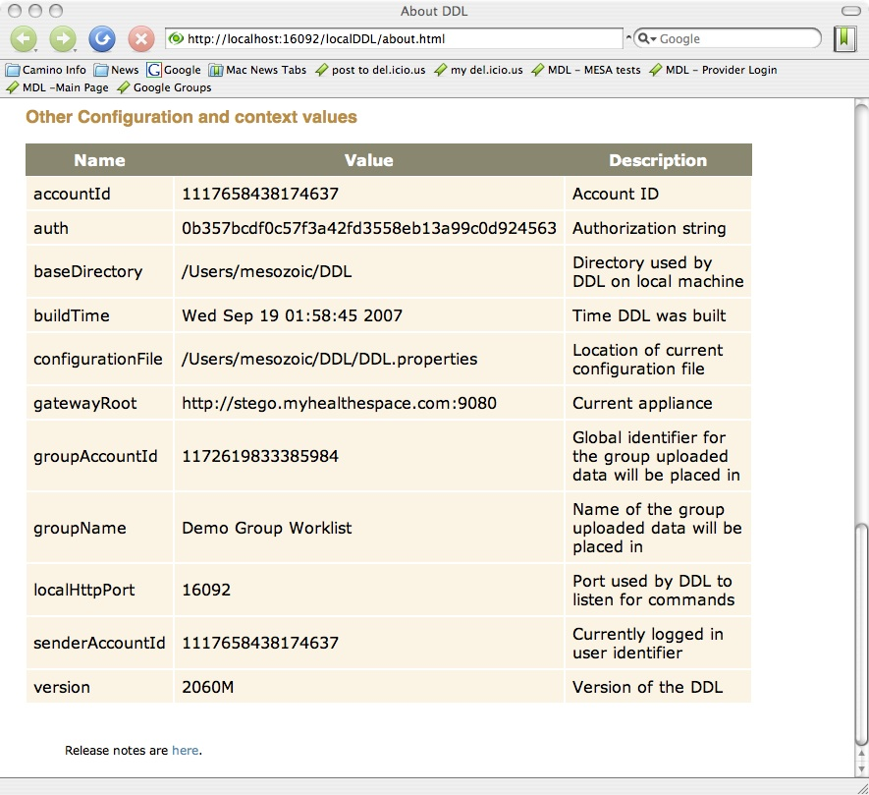

Find the 'version' and 'buildTime' values - record these in the test record.
Quit the DDL via the 'Shutdown' menu on the DDL system tray icon.

1.2.4 Validating DDL launch
- Make sure DDL is shut down (if it's running - the icon will be on the status bar). Select 'Shutdown' from the DDL menu.
- Select the shortcuts for the DICOM Data Liberator from either the windows Desktop or the Program menu.
- The DDL should launch in under XX seconds. First - the DDL warns you that you're not logged in. (susan - any idea yet what the XX seconds is yet?)

- 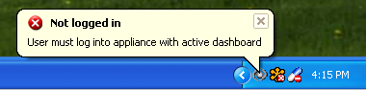
Then - a message appears that the DDL has started:

- 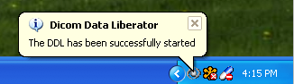

1.2.5: Configuring DDL DICOM
The DICOM protocol requires a bit of handshaking - you have to configure both sender and receiver applications.
As an example of a third party application we'll use Osirix here for configuration.
- Start up Osirix
- Open the Osirix->Preference menu; select first the Listener icon:

- 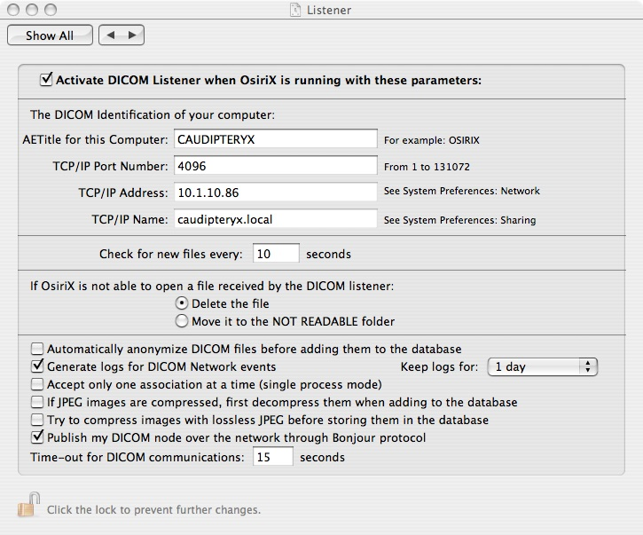

- Note the settings of AETitle, Port Number, and TCP/IP address. These three values are put into the DDL configurations for the dicomRemoteAeTitle, dicomRemotePort, and dicomRemoteHost:

- 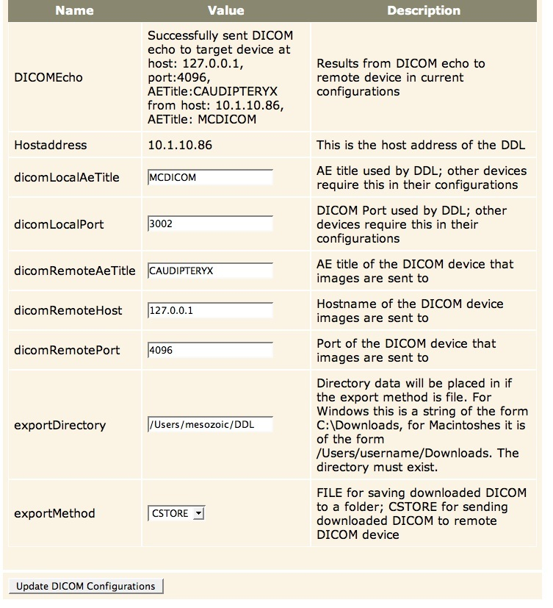

- To test that these values were correctly inserted - click 'Update DICOM Configurations'. If the value of the DICOM Echo field above shows success - then you have successfully configured DDL so that DDL can send to the Osirix Listener. (susan - what happens if it's not successful? I know, this never happens... :-) )
- To configure Osirix being able to send to DDL - return the Osirix-Preferences and select the "Locations" icon:

- 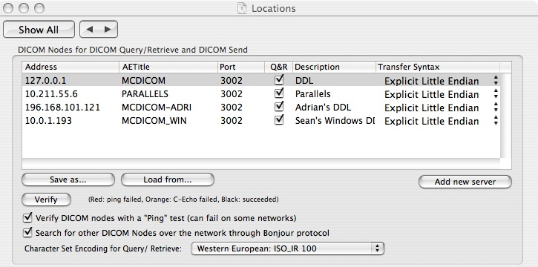
Set the Address/AETitle/Port in Osirix to match the fields HostAddress/dicomLocalAETitle/dicomLocalPort from the about page above.
[Documentation glitch - in the example above I've used the IP address 127.0.0.1 since it's on the same machine - but it should be '10.0.10.86' to fit the example better.

- Send a small DICOM study from Osirix to the DDL - it should accept the data.[need to include instructions on send]

Test 1: Setting the active worklist
Log into the appliance as any user (example "demodoctor@medcommons.net", password "tester"). When the worklist appears the following three three things should happen:
- Check: system tray app shows balloon with the name of the worklist.

- 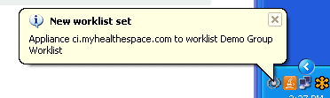

- Check: mouseover over the DDL icon displays worklist name

- 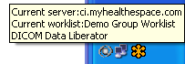

- Check: about page shows the correct name of the worklist in 'groupName'.

- 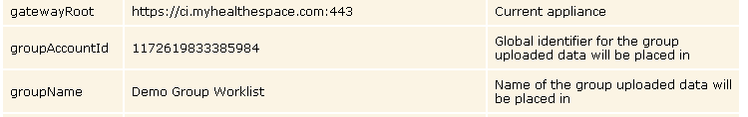

All three must have "Demo Group Worklist" for this test to pass.

Test 2: Uploading data to MedCommons Via DDL
Need to test with standard data sets (see appendix for download instructions)
Test 2A: Upload DICOM from file - new patient
- Select the "Upload DICOM Folder" from the DDL icon
- A small window will pop up. Select the folder QAImages/AdrianCR
- Select the 'Show Status" from the DDL icon - a status window will display
- Some data will appear on "Incoming DICOM" table - then this will disappear and a new entry will appear in the Upload table on the status page. If this is a clean install - the user is presented with three options on the status page: Create new patient; merge; delete. Choose 'Create new patient'.

- 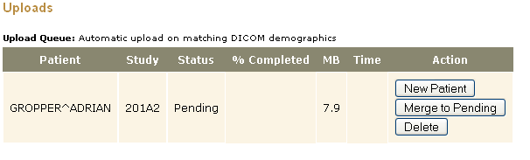

- The this entry on the status page should change to 'Queued' which will be changed to 'Active' while the upload is taking place. At the end of the transaction the status should appear to be complete:

- 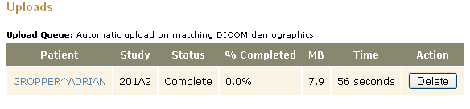

For this test to pass - when the status is Active the % Completed and MB fields must be updated as the transfer progresses. The final status must be "100%" complete and the total number of bytes should approximately match the size of the file:

- 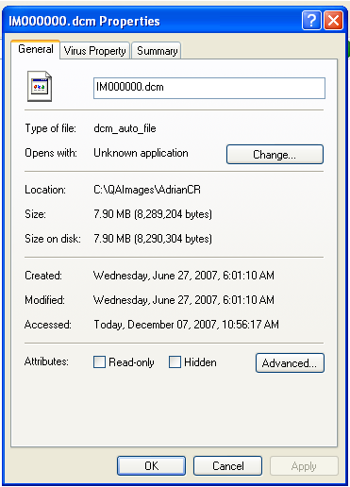

This upload was a single image - so we just look at the file size and see that it's 7.9MB. In general - there may be some small differences because the upload value includes the size of the CCR; if you look at the size of a folder only the DICOM images get uploaded. But for all uploads - the numbers should match within a percent or so of the size of the DICOM files because they are comparatively large.
- After the upload is complete a browser window will display containing the updated CCR with DICOM.
- A new entry should appear in the worklist for Gropper, Adrian.

- On the status page a link should appear that also launches the CCR. The CCR must be checked to make sure that the demographics match the ones that were in the original DICOM image.

- 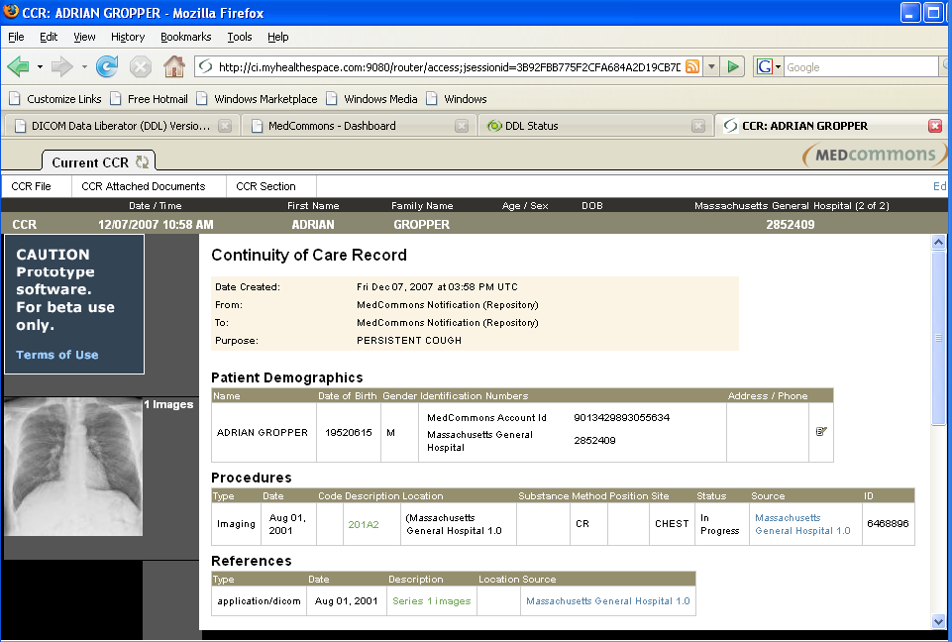
The following values must match for this test to pass:

  - The patient name must be ADRIAN GROPPER and it must be present in three places: the title bar of the browser window, the patient header and in the Patient Demographics field of the CCR.
  - The DICOM value for 'ReasonforStudy' must be present in two places - the CCR's purpose and the Dashboard's PURPOSE. For this study - the value must be 'PERSISTENT COUGH'
  - The date of birth must appear in the CCR in two places: in the patient header and in the Patient Demographics portion of the CCR.
  - The patient's sex must appear in two places: the brown/gray bar below the tab and in the Patient Demographics portion of the CCR. Must be Male.
  - The patient's ID must appear in the demographics block for Massachusetts General Hospital with value 2852409.
  - The Procedure must have the correct procedure date (8/1/2001), Description (201A2), Location (Massachusetts General Hospital), Site (Chest), Source (Massachusetts General hospital) and accession number ID 6468896.
  - The thumbnail image must appear as displayed above.
Test 2B: Upload of patient data - merge patient to existing account.
- Select the "Upload DICOM Folder" from the DDL icon
- A small window will pop up. Select the folder QAImages/PneumatixMR
- Select the 'Show Status" from the DDL icon - a status window will display
- Some data will appear on "Incoming DICOM" table - then this will disappear and a new entry will appear in the Upload table on the status page. If this is a clean install - the user is presented with three options on the status page: Create new patient; merge; delete.

- 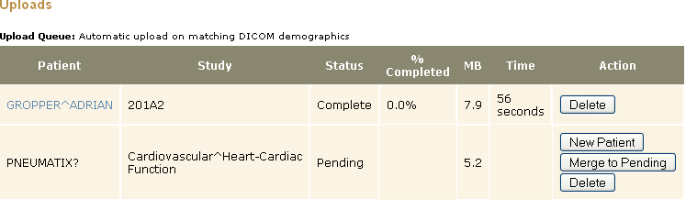

- In the viewer - select the Adrian Gropper CCR from Test 2A. Reopen the window from the dashboard or use an existing window if it's still open from the last test.
- Click on the Current CCR tab to switch to CCR edit mode

- 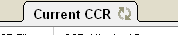

- Select Add DICOM from menu

- 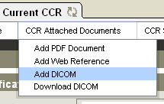
1) A balloon should appear near the DDL system tray application icon with the patient's name included:

- 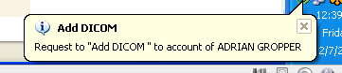

2) The status page should show the reference to the selected patient in the Pending area:

- 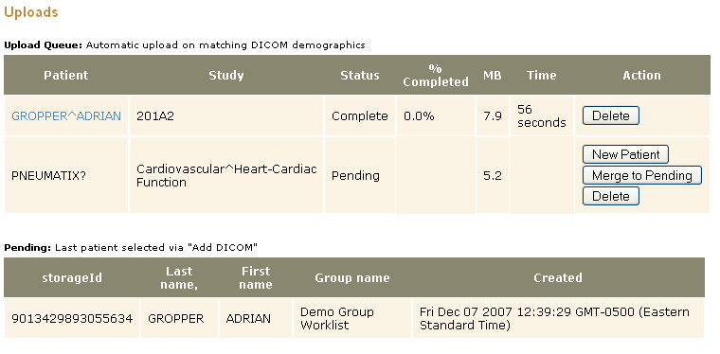

- Select the button "Merge to Pending" to put the data from Pneumatix into the account for Gropper, Adrian. A balloon should appear to confirm that the merge request was received

- 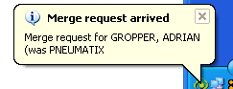 and the status row should update to show that the merge is in progress

- Note that both names are visible here - the new name is first and the second follows in parentheses. When the upload is finished - the status is complete

- Now go back to the worklist and select "Gropper, Adrian". The Current CCR should have three series: the original chest xray and the two new series from patient PNEUMATIX

- 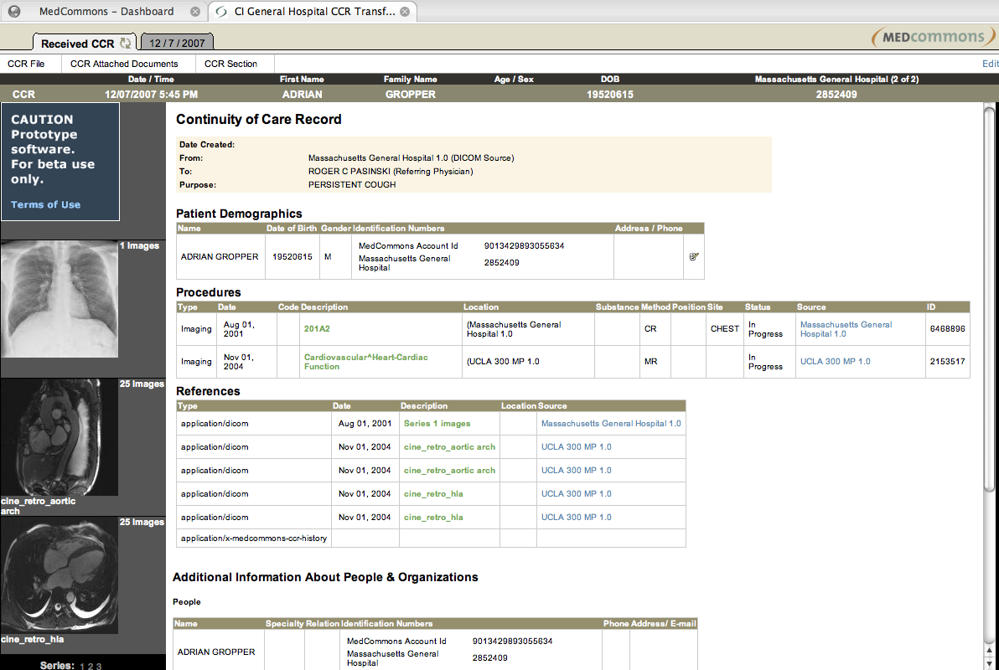

The following must be true:
  - There must now be two procedures - the original from 8/1/2001 and a new one from 11/01/2004.
  - The new procedure must be labeled as being from UCLA 300 MP with description "Cardiovascular^Heart-Cardiac Function", modality MR, and accession number 2153517
  - The demographics (patient name, date of birth, patient ids) must appear as they were in the original. They have not been changed by the "Add DICOM" action.
  - On the status page - the 'Pending' entry have disappeared when the CCR upload was completed.
Test 2C - Test of resetting Add DICOM
Only one patient can be in the "Add DICOM" pending match queue. Here we test to see that there is only one patient in the pending area at at time and that new "Add DICOM" actions by the user override old "Add DICOM" actions.
- Select "Jane Bewell" from the dashboard.
- Click on the current CCR tab to enter CCR edit mode.
- Click on Add DICOM.
- On the status page there must be an entry for Jane Bewell in the pending table

- 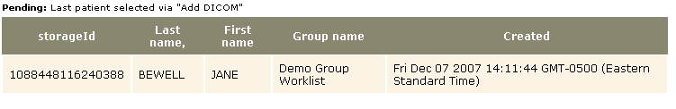

- Now select "Stella Patterson" from the dashboard and repeat the steps above to "Add DICOM" for this patient's account. A balloon should appear

- 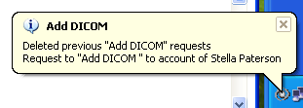 and the status page must now report the new value

- 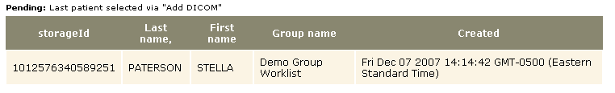

- If Stella Patterson does not appear in the Pending status - then the test fails.
Test 2D - Test of uploading known patient
a) A patient is known via 'New Patient'
- Select "Upload DICOM Folder"
- Select QAImages/Gropper_CT
- Images start arriving on the status page.

- 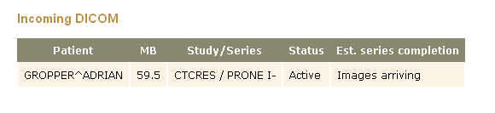

- Then - the upload job starts immediately:

- 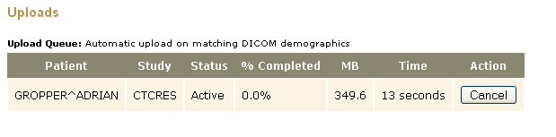

- If the status of the upload is 'Pending' or does not appear - this test failed.
b) A patient is known via "Add DICOM"
- Go to the dashboard - select "Create New Patient"
- Enter patient demographics:
- Patient name JOHN DOE
- For IDs - type is BORG IMAGING WHITE SPRUCE, ID is 473610

- 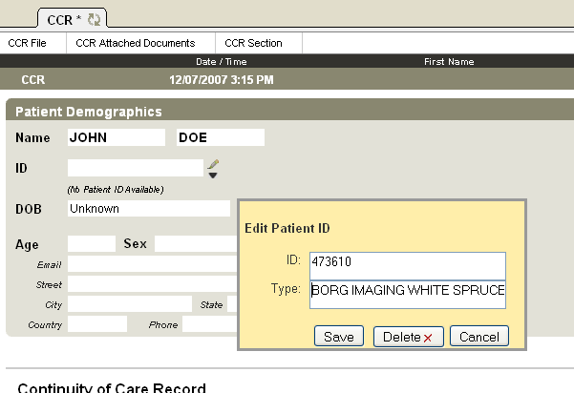

- Hit save; select "Yes" to "Create new Patient Account"
- In the viewer - select CCR Edit mode and then select the menu item "Add DICOM"
- From the DDL's system tray icon - selecd "Upload DICOM Folder".
- Select folder QAImages/DOE_JOHN
- The images should upload automatically.
- If the images do not upload automatically - the test fails.
c) Patient is known, but no matching DICOM identifer in CCR; therefore it stays in Pending. Important that match *doesn't* happen.
The reason that the match remains a pending match is that the CCR on the server for Jane Bewell does not have a patient id that matches what is in the DICOM header (and this DICOM study doesn't have any patient ids in it).
- From the DDL status page - select two buttons: Clear All Transactions and Clear Demographics (order doesn't matter)

- 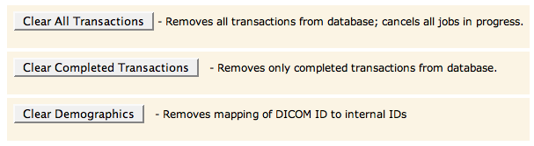

- The status page should now only contain empty status tables.
- From worklist - select Jane Bewell
- Select "Add DICOM" as above.
- Check the status page to see that Jane Bewell is pending

- 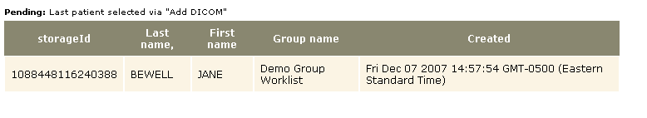

- Select "Upload DICOM Folder" from the DDL menu and select the folder QAImages/JaneBewellMR
- The status page should now contain the following

- 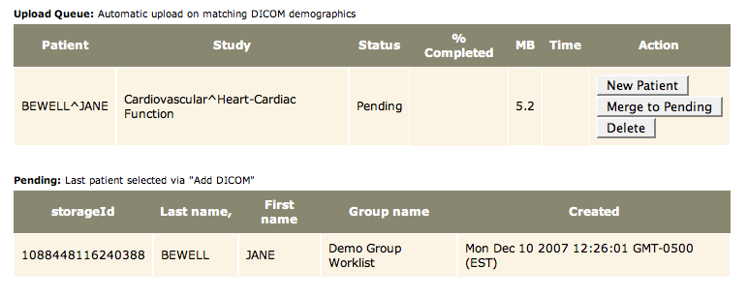

- If the upload proceeds automatically -the test fails.
- Now test deletion by clicking on the Delete button. The Upload Queue item should disappear. If it does not - the test fails. The Pending entry remains.
Test 2E - Test of canceling, restart patent upload
- Clear the status as above by clicking on Clear All Transactions and Clear Demographics.
- Select Upload DICOM Folder from DDL menu
- Select QAImages/Doe. The following should appear in the upload queue

- 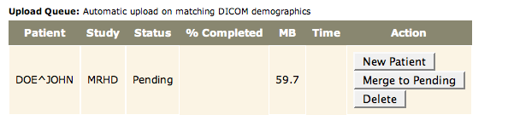

- Select New Patient, status should change to active

- 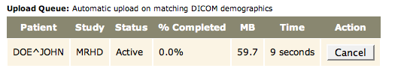

- Now select "Cancel". The status shoult now include the word 'Cancelled' page should change to have two other options

- 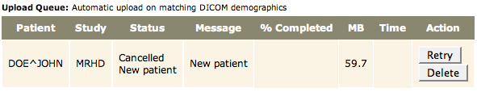

- Then select restart

- 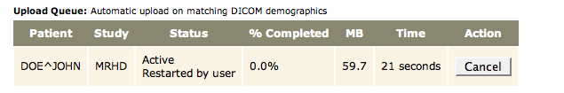
The job should now go to succesful completion

- 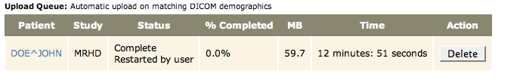

If the job does not successfully upload - the test fails.

Test 2F - Test of canceling, delete
- Repeat steps 1-5 of test 2E
- When the status is cancelled the following appears in the status page

- Now click the 'Delete' key. The status entry should disappear.
Test 2G - Test for recovery from network error
[TBD. Basic outline - start upload; then cause a network error (perhaps unplug ethernet cable); an error status should appear in the status page. Reconnect the ethernet, then hit retry. Job should go to completion]

Test 3: Downloading data from MedCommons via DDL
Open a CCR from the worklist.
- Select the Gropper, Adrian CCR
- Click on the tab

- 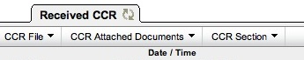

- Click on the CCR Attached Documents menu for Download DICOM:

- 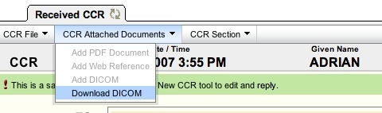

Launch the status page from the DDL icon. You should be able to see the download.
[More details:
Export DICOM data to DICOM device
Export DICOM data to local file system

Test 4: Testing Round Trip
Need to test all start of trips with all ends of trips.

Start of round trip
Get order without DICOM - presume that the user has gotten a fax/phone call to send DICOM to someone.
- Select worklist that you want to the patient to show up in
- Send DICOM to DDL or upload via Upload DICOM File menu item.
- Edit the CCR with order information (reason for procedure)
- Send to the person who requested the data.
Get order with DICOM
- Generate an order and send it.
- Log in as the recipient - View the order.
- "Add DICOM" to the existing order.
- Add PDF to the CCR
- Send it back to the originator

Test 5: Error recovery/restart
The DDL must be able to restart a job in three different transactions:
- Uploads from the DDL to an appliance
- Downloads from an appliance to DDL
- DICOM push of data from DDL to a DICOM device.
There is no corresponding restart for incoming DICOM - see requirements.
There are two separate cases for transfers needing to be restarted:
- The user has canceled the transaction
- There was an error in the transaction.
There are two actions on transactions which were cancelled or encountered an error:
- The transaction can be deleted
- The transaction can be restarted
All combinations of these need to be tested. Need tests which test that the deletions really clean up all data (files and database entries)

Test 6: DDL startup, updates
[Separate test plan]
DDL can be started up in four separate ways:
- Via the installer web page.
- Via the desktop links
- Via system menu
- Via system startup (manually installed)
[Need a procedure for testing updates. This means:
- DDL.war file for one version of DDL is installed on the server.
- The client installs DDL from this web server.
- A new version of DDL is installed on the server.
- The client should automatically update when relaunched from the menu item/desktop shortcut/or other link. The ddl.jnlp file is configured for automatic update; this is invoked when the DDL is started by JavaWebStart.
]
Procedure for automatically starting DDL in Windows:
- Make a copy of the shortcut "DICOM Data Liberator" that is on the windows desktop and put it into
c:\Documents and Settings\<username>\Start Menu\Programs\Startup
Note that the username may not be what you expect on a particular machine - not sure how to find it (sometimes the user is the admin). One way to find out is to look at where the DDL directory was created - that's the account you're logged into in windows. There's probably a better way.
- Reboot the machine.
- The DDL should start up normally and appear in the system tray. If it does not start up the test fails.
Note: that the DDL still needs to be logged in to do uploads and downloads (login typically happens passively when you refresh the dashboard page)

Test 7: Change DDL Local DICOM settings
A DICOM CSTORE SCP (Service Class Provider) listens on a specified network socket and identifies itself in DICOM transactions with the local AE (Application Entity) title. If a user changes the local DICOM port or the local AE title - the CSTORE SCP thread has to be terminated and restarted. The tests below make sure that this thread termination/restart is handled correctly.
It is critical for this test that between steps 2 and 7 the DDL is not restarted again because that means that the configurations will be retrieved from the local configuration file on startup rather than being changed dynamically in a given session. The last step of restarting ensures that the configuration changes are persistent.
- Shut down the DDL; delete the DDL/ directory. The test begins with a clean install (since this is the time that a user typically will edit the DICOM configurations. The default DICOM port (dicomLocalPort) is 3002; the AETitle (dicomLocalAeTitle) is "MCDICOM".
- Restart the DDL.
- Send DICOM to the DDL in two different ways:
  - Use a third party application (such as Osirix) to send the DICOM to port 3002 and AE title "MCDICOM"
  - Use the "Upload DICOM folder" menu (the DDL reads DICOM off of the disk and sends it to itself).
The DICOM should appear on the DDL status page as an upload job. Delete the uploaded jobs - if they made it to the Upload table the test has succeeded; otherwise it fails.
- Now open up the About page.
  - Edit dicomLocalPort and put in an invalid non-numeric value (such as ABDC). This should fail (an error will appear in balloon) and the value in the about page must remain at 3002. If the error message does not show up or the non-numeric value apparently is set by the user - the test fails.
  - Edit dicomLocalPort and set the value to 3004 and change the AE title to TEST. Click the "Update DICOM Configuration" button. A popup should say that the DICOM CSTORE SCP has been restarted due to configuration changes.
  - Now try to send DICOM to DDL from the third party application to the OLD configuration values (port 3002 and AETitle "MCDICOM"). This should fail. If the DICOM successfully gets to the status page - this test fails because it means that the old DICOM thread is still running on the old port. If the DICOM is not sent (Osirix will generate a failure message) then the test passes.
- Attempt to have DDL send DICOM to itself. The DICOM must appear on the status page and eventually the DICOM is put into the upload queue. The DDL automatically changes its internal configurations consistently when the user updates them; if there is a failure here the test does not pass.
- Now change the third party application to use port 3004 and the AE title of TEST. DICOM sent now from third party application must appear without error in on the status page.
- Now restart the DDL and look at the about page. The dicomLocalPort should be 3004 and the dicomLocalAeTitle should be TEST. This means that the configuration values were correctly stored in a preference file and then re-initialized propertly.

Random other tests (not categorized yet)
- Launch the DDL when there is another DDL running. You should get an error message saying that the DDL is already running.
- Closing the browser during an upload, download (desired behavior?)
- Closing the DDL during upload, download (desired behavior?)
- Simultaneous uploads? Simultaneous downloads?

Appendices

Appendix A: Standard Data Set
To download the standard data set:
- Click on QAImages
- Download to your machine
- Unzip the file QAImages.zip
- This currently has four Studies: AdrianCR, PneumatixMR, Jane BewellMR (same images as Pneumatix but different DICOM demographics), JaneBewellMRKnee.
- For DOE, JOHN images- put this into the unzipped QAImages directory.
- For Gropper_CT images - put this into the unzipped QAImages directory.
In the near future - this will contain the following sorts of images:
- DICOM study with one series, one image.
- DICOM study with n series and m images.
- Multiple DICOM studies for a single patient
- Multiple DICOM studies for multiple patients
- DICOM studies (may be a single image per study - we're testing data attributes here)
  - Unicode data sets (we have a French data set)
  - Compressed DICOM data
  - One each of CT, MR, PET, MG, CR, US to start. We'll add new vendors, pixel formats, modalities over time.
  - Data sets with missing elements (missing patient id, ... build a rogue's gallery of incomplete data [Note to Simon: yes- this happens in the real world]).
  - Multiframe data sets (the viewer may not display them - but we have to handle them as transport)

Appendix B: CCR Validation
For QA purposes - the only validation that really matters is the AAFP (American Association of Family Practitioners) tool available on the web. This services has two levels of testing:
- XML Schema valiation against the CCR XSD file.
- Internal semantic testing. For example - every Actor in the CCR must be referenced by at least one item; no ActorID references can exist that don't have a corresponding Actor.
Validation procedure:
- Get the CCR to be validated on disk. Download CCR from the viewer is one way to do this.
- Go to web site http://chit.dyndns.org/CCRValidation/
- Click on the Browse button to locate the CCR on disk.
- The resulting page shows success or failure (need to describe output - some warnings might be acceptable but failures are unacceptable).

AG Comments 12/9/07
1 - We probably want instructions on how to make DDL startup automatically.
2 - On the About Page, can we make the orange shade behind the three rows that pertain to DICOMRemote... slightly darker than the rest of the table?
3 - Need to test that DICOM REFERENCES also appear correctly and are clickable links in the Edit Mode of the CCR
4 - Re: Test 2D a) "A patient is known via New Patient" and 2D b) "via Add DICOM", please explain hat the scope of the match is. I assume it's ID and ID Type for all patients in the Group or is it all patients in the Appliance?
Configuration and exceptions aside, here's an overview table for accessing HealthURL DICOM via DDL. It has little to do with the testing but it summarizes the current configuration and will figure prominently in a Help or Tutorial version of this document.

 | Manual - Access to DDL Status page is required | Automatic - no interaction with DDL UI required
Create New Patient from DICOM | 2A - DDL Status > New Patient | N/A
Add DICOM to Existing Patient | Test 2B - DDL Status > Merge to Pending | Test 2D - Auto Match on DICOM Pt. ID
Download DICOM |  | Test 3 - Always Automatic

slb comments 12/14/07

Aside from the things I added in the body of the text (in an attractive blue), I have two comments...

1) Is there any way to link the screen shot files *while retaining the embedded image view* rather than inserting the images themselves? Word has this option, and not only does it allow for subsequent screen changes not requiring massive manual edits of documents, it speeds things up a lot. Not sure if googledocs allows this, but if it does, it's worth a look. This document is FAT and SLOW to load. However, I do like having the copious screen shots, because it's easy for people not familiar with the app to run the tests.

2) It's sometimes difficult to find the pass/fail criteria in each test. We ought to consider a way for making them *POP*. (Egad, did I just use that word?) So when I'm just scanning the document looking for how to determine whether something passes or fails, I don't have to read each and every line of text. I just look for a specific convention. it could be anything - just a specific way of using bold, italic bold, color, something...

3) OK, I lied - I have 3 comments, not two. The third one is that the document is very detailed and solid and useful. I enjoy not having ambiguity in test plans. Nice job!

