BookBuddy

INTRODUCTION:
Libraries remain an important part of academic institutions, but many physical library processes continue to depend on conventional record-management methods. Users may find it difficult to determine whether a book is available, identify suitable books for a particular subject, track previous borrowing activity, or discover what they should read next.
BookBuddy addresses these challenges by providing a centralized digital interface connected to the physical library. The system combines traditional library functions such as catalog management, borrowing, returns, reservations, overdue management, and analytics with social reading and AI-based personalization.
The platform is intended primarily for college students and faculty, while librarians and administrators receive dedicated management capabilities.

SCENARIO Based Case Study:
Consider Arun, a college student who regularly uses his institution’s physical library for academic learning and personal development. Although the library contains a large collection of books, Arun often faces difficulties in identifying suitable books, checking real-time availability, tracking borrowed books, and deciding what to read next.
To solve these challenges, the college introduces BookBuddy, a web-based digital library platform developed using the MERN technology stack – MongoDB, Express.js, React.js, and Node.js. BookBuddy connects the physical library with a centralized digital platform that supports library operations, social reading, and AI-powered personalized learning.
User Registration and Authentication
Arun begins by accessing the BookBuddy web application and selects the Student role. He creates an account using his student credentials and securely logs into the platform.
BookBuddy uses authentication mechanisms such as JWT-based authentication and bcrypt password hashing to protect user credentials. Role-based authorization ensures that students, faculty members, librarians, and administrators receive access only to the features permitted for their roles.
Book Discovery and Search
After logging in, Arun opens the Explore Books section. Instead of manually searching through physical shelves, he searches for books using the title, author, ISBN, keyword, or category.
He can further filter the results by:
- Category
- Author
- Availability
- Language
- Publication Year
- Rating
The platform also provides sorting options such as popular books, recently added books, highest-rated books, most-borrowed books, and alphabetical order.
Real-Time Book Availability
Arun selects a book titled Clean Code. The book details page displays the book’s metadata together with its physical library information.
For example:
Total Copies: 5
Available Copies: 2
Issued Copies: 3
Rack Number: 4
Section: Programming
Shelf Number: 2
BookBuddy clearly indicates whether a book is Available, Issued, Reserved, or Unavailable. Availability is updated after successful borrowing and return operations.
Borrowing a Book
Since the book is currently available, Arun proceeds to borrow it.
The borrowing process follows:
Search Book → Check Availability → Issue Book → Create Borrowing Record → Assign Due Date
Once the transaction is completed, BookBuddy updates the available-copy count, creates the borrowing record, updates Arun’s dashboard, and generates the appropriate notification.
Arun can now view the borrowed book under My Borrowings, together with its borrowing date, due date, and current status.
Reservation of Unavailable Books
A few days later, Arun searches for another book, but all copies are currently issued.
Instead of repeatedly checking the library manually, Arun selects the Reserve Book option. BookBuddy places him in the reservation queue and records the book, reader, reservation date, queue position, and reservation status.
When the book is returned, the system checks the reservation queue, identifies the next eligible reader, changes the reservation status, and sends a notification when the book becomes available.
Overdue Management
Arun forgets the due date of one of his borrowed books. BookBuddy automatically identifies the overdue status based on the current date and due date.
For example:
Due Date: 20 September
Current Date: 25 September
Overdue: 5 Days
The student receives an overdue notification, while the librarian can view the overdue record from the administrative dashboard.
This reduces the need for manual overdue tracking.
Reading History and Reading Diary
After returning books, Arun’s activities are maintained in his personal reading history.
BookBuddy records events such as:
- Borrowed
- Returned
- Read
- Rated
- Reviewed
Arun also maintains a Reading Diary, where completed books appear as a personal reading timeline.
For example:
September 2026
Clean Code
⭐⭐⭐⭐⭐
Finished: 25 September
Atomic Habits
⭐⭐⭐⭐
Finished: 28 September
The diary allows Arun to review his reading activity over monthly and yearly periods.
Ratings, Reviews and Social Reading
After completing a book, Arun gives it a rating from one to five stars and writes a short review.
He can also create custom lists such as:
- My Java Books
- DSA Books
- Semester Reading
- Books I Want to Read
BookBuddy provides social reading capabilities in which users can follow other readers, view reading activity, interact with reviews, and discover books through the community feed.
AI-Powered Book Recommendations
As Arun continues using BookBuddy, the system builds a better understanding of his reading preferences and learning interests.
Since Arun frequently reads books related to Java, programming, and backend development, the AI recommendation engine can suggest relevant books such as programming and software-development titles.
The recommendation system therefore moves beyond simple “popular books” and provides personalized discovery based on the reader’s activity and goals.
AI Library Assistant
Arun can also interact with the integrated AI Library Assistant.
He can ask questions such as:
“Suggest a beginner-friendly Java book.”
“Which books should I read to learn backend development?”
“Which DSA books are available?”
“I borrowed a Java book recently. What should I read next?”
The AI assistant can use the BookBuddy catalog and application data to provide relevant responses. Operational information such as availability, borrowing status, due dates, and physical location must be retrieved from the application’s actual data rather than generated as assumptions.
AI Smart Search
Arun does not always know the exact title of a book. Instead of entering a simple keyword such as “Java”, he can enter:
“I want an easy Java book for beginners.”
BookBuddy’s AI-powered semantic search interprets the intent behind the query and retrieves books that match the requested topic and difficulty.
This allows users to discover books based on meaning and learning requirements, rather than depending entirely on exact keyword matches.
Personalized Learning Path
Arun then tells BookBuddy:
“I want to become a Java Backend Developer.”
The AI learning module generates a structured learning path such as:
Java Basics → OOP → DSA → SQL → Spring Boot → REST APIs → System Design
Relevant books from the institution’s library can then be associated with each stage of the learning path.
This transforms BookBuddy from a conventional library management application into an AI-assisted learning platform.
Librarian and Administrator Operations
While Arun uses BookBuddy as a reader, the librarian manages the physical library through the administrative interface.
The librarian can:
- Add and update books
- Manage readers
- Issue books
- Record returns
- Manage reservations
- Monitor overdue books
- View transactions
The administrator can additionally manage users, librarians, categories, reports, analytics, and system settings.
Library Analytics
The administrator dashboard provides a consolidated view of library activity.
Important metrics include:
Total Books
Active Users
Books Issued
Overdue Books
Reservations
The system can also present borrowing trends, popular categories, active readers, overdue trends, and peak library usage.
AI-assisted analytics can summarize data-derived patterns to help administrators understand how the library is being used.
MERN-Based System Operation
The complete BookBuddy application operates through the MERN stack:
React.js + Vite
Handles the responsive user interface and reader/admin dashboards.
Node.js + Express.js
Handles backend services, REST APIs, business logic, authentication, borrowing, reservations, notifications, and other application operations.
MongoDB + Mongoose
Stores users, books, borrowing records, reservations, reviews, reading activity, notifications, and other application data.
AI Layer
Provides recommendations, semantic search, AI assistance, summaries, learning paths, and reading insights.
Cloudinary
Stores book-cover images, profile images, and other supported uploaded media.
Overall Scenario
Through BookBuddy, Arun no longer needs to depend entirely on manual library searches or separate records to manage his reading journey.
He can:
Discover → Check Availability → Borrow/Reserve → Read → Return → Rate/Review → Track Reading → Receive AI Recommendations → Follow a Learning Path
At the same time, the librarian can manage:
Books → Readers → Issue/Return → Reservations → Overdue → Transactions → Analytics
Therefore, BookBuddy provides a unified environment that connects physical library management, social reading, and AI-powered personalized learning in a single MERN-based platform.
SYSTEM REQUIREMENTS:

To ensure smooth development, deployment, and usage of the BookBuddy Web Application, certain system prerequisites must be met. These requirements include the software tools, development environment, database, testing utilities, and supporting technologies required to build and operate a reliable and scalable AI-powered digital library platform. BookBuddy uses the MERN technology stack, consisting of MongoDB, Express.js, React.js, and Node.js, along with supporting libraries and services.

1. Software Requirements

These are the essential tools and platforms required to develop, test, deploy, and run the BookBuddy application efficiently.

● Operating System: Windows 10/11, macOS, or Linux — Supports cross-platform development, testing, and deployment.

● Node.js (v16 or above): Provides the JavaScript runtime environment required for executing the backend services, managing application dependencies, and running server-side logic.

● npm (v8 or above): Node Package Manager used to install, manage, and update the libraries and dependencies required by the frontend and backend.

● React.js: A JavaScript library used to build the dynamic, responsive, and interactive user interface of the BookBuddy platform.

● Vite: A modern frontend build tool used to create, develop, bundle, and optimize the React-based BookBuddy application.

● Tailwind CSS: A utility-first CSS framework used to design a responsive and consistent user interface across desktop, tablet, and mobile devices.

● Redux Toolkit: Used for centralized state management and efficient handling of application data across different BookBuddy modules.

● React Router: Used to implement client-side routing and navigation between public, reader, AI, and administrator pages.

● Axios: Used for communication between the React frontend and the Express.js REST APIs.

● Express.js: A lightweight Node.js web framework used to create RESTful APIs, handle HTTP requests, implement middleware, and manage backend application routes.

● MongoDB: A NoSQL database used as the primary source of truth for storing books, users, borrowing records, reservations, reviews, reading history, notifications, and other application data.

● Mongoose: An ODM library used to define schemas, validate data, and interact efficiently with MongoDB from the Node.js backend.

● JWT (JSON Web Token): Used for secure authentication, session management, and authorization of users based on their assigned roles.

● bcrypt: Used for securely hashing user passwords before storing authentication credentials in the database.

● Cloudinary: Cloud-based media storage used for storing book cover images, profile images, and supported library documents.

● Multer: Middleware used for handling file uploads from the BookBuddy application.

● XLSX / CSV Parser: Used for importing and processing bulk book catalog data from Excel and CSV files.

● AI / LLM API: Used to provide intelligent features such as AI recommendations, natural-language book search, AI library assistance, book summaries, personalized learning paths, and reading insights.

● Postman: Used for developing, testing, and validating the REST APIs of the BookBuddy backend.

● MongoDB Compass: Used for inspecting, managing, and verifying MongoDB collections and stored application data.

● Visual Studio Code: Preferred integrated development environment for writing source code, managing project files, running terminals, and integrating Git-based development.

● Git and GitHub: Used for source-code version control, collaboration, project management, and maintaining development history.

● Web Browser: Google Chrome, Microsoft Edge, or Mozilla Firefox — Used for running, testing, and validating the BookBuddy web interface.

2. Hardware Requirements

The following specifications describe the minimum and recommended hardware requirements needed to develop, test, and use the BookBuddy application efficiently.

● Processor: Intel Core i5 (8th Generation or above) / AMD Ryzen 5 or better — Recommended for running the development environment, frontend server, backend server, database tools, and browser applications simultaneously.

● RAM: Minimum 8 GB; 16 GB recommended — Required for multitasking between Visual Studio Code, Node.js services, MongoDB tools, web browsers, and development utilities.

● Storage: At least 1 GB of free space for basic project dependencies and source files; additional storage may be required for development packages, cached files, uploaded assets, and local database data.

● Display: 1366 × 768 or higher — Recommended for proper development, testing, dashboard visualization, and responsive interface design.

● Internet Connection: A stable internet connection is recommended for installing dependencies, accessing MongoDB services, Cloudinary, AI APIs, GitHub, and deployment platforms.

● Input Devices: Standard keyboard and mouse or compatible touchpad — Required for application development, testing, and administration.

These hardware and software requirements provide the necessary environment for developing and operating BookBuddy as a responsive MERN-based digital library and AI-powered learning platform.

PROJECT ARCHITECTURE:

TECHNICAL ARCHITECTURE:

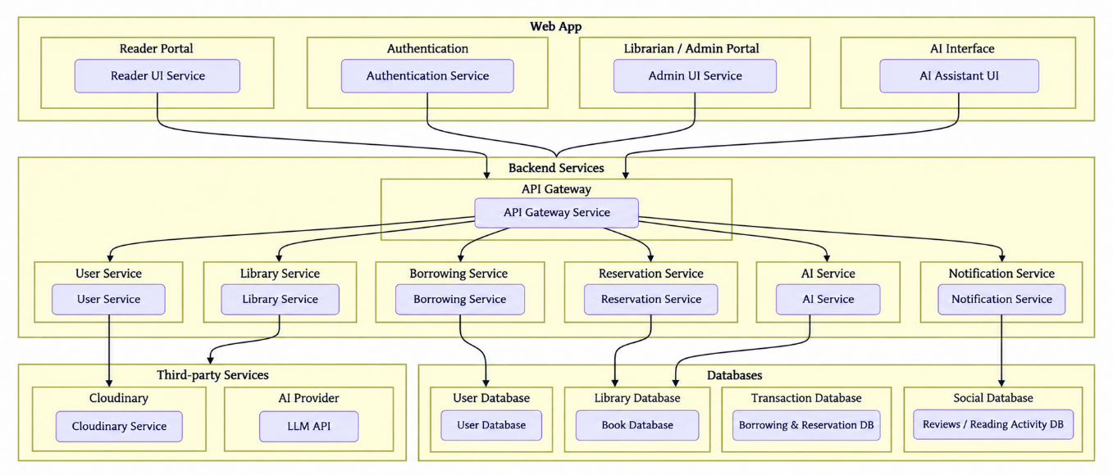

TECHNICAL ARCHITECTURE:
The BookBuddy application follows a full-stack MERN architecture integrated with an Artificial Intelligence layer. The architecture separates the presentation, application, data, and AI components so that each layer performs a specific responsibility. This approach supports maintainability, scalability, security, and easier integration of new features.
The overall architecture of BookBuddy consists of the following major components:
BOOKBUDDY
│
┌──────────────┴──────────────┐
│ │
FRONTEND BACKEND
│ │
React.js + Vite Node.js + Express.js
│ │
Tailwind CSS REST API Layer
│ │
Redux Toolkit │
│ ┌───────────┴────────────┐
└─────────────────┤ │
↓ ↓
MongoDB AI LAYER
+ Mongoose │
│ ┌──────────┼──────────┐
│ ↓ ↓ ↓
│ AI Assistant Recommendation
│ Smart Search Summary
│ Learning Path
│ Reading Insights
│
Cloudinary Storage
│
Book Covers / Profiles
1. Frontend Layer
The frontend is developed using React.js with Vite as the development and build tool. It provides the user interface through which students, teachers, librarians, and administrators interact with BookBuddy.
The frontend is responsible for:
- User registration and login interfaces
- Book discovery and search
- Book details and availability
- Borrowing and reservation screens
- Reading history and reading diary
- Ratings and reviews
- Social reading and activity feeds
- AI assistant interface
- Recommendation screens
- Learning path visualization
- Notifications
- Librarian and administrator dashboards
Tailwind CSS is used to create responsive layouts, while Redux Toolkit manages shared application state. React Router handles navigation between different application modules, and Axios communicates with backend REST APIs.
2. Backend Layer
The backend is implemented using Node.js and Express.js. It acts as the central application layer between the frontend, MongoDB database, file-storage services, and AI services.
The backend is responsible for:
- Authentication and authorization
- User and role management
- Book catalog management
- Borrowing and return operations
- Reservation management
- Overdue processing
- Reviews and ratings
- Reading history
- Notifications
- Analytics
- Excel/CSV import processing
- AI service integration
The Express.js server exposes REST APIs that receive requests from the React frontend, process the business logic, communicate with the required services, and return responses to the client.
3. REST API Layer
The communication between the frontend and backend takes place through REST APIs.
The general request flow is:
User
↓
React Interface
↓
Axios Request
↓
Express REST API
↓
Controller / Business Logic
↓
MongoDB / AI / Cloudinary
↓
API Response
↓
React Interface
This separation allows the frontend and backend to be developed and maintained independently.
4. Database Layer
MongoDB is used as the primary database and acts as the live source of truth for BookBuddy. Mongoose is used to define schemas and interact with MongoDB from the Node.js backend.
The database stores information related to:
- Users
- Books
- Authors
- Categories
- Borrowing records
- Reservations
- Transactions
- Reviews
- Ratings
- Reading history
- Reading diary
- Want-to-read lists
- Custom book lists
- Followers and activity
- Notifications
- AI-related user interactions
- Learning paths
The database layer ensures that operational information such as book availability, borrowing status, due dates, reservations, and user activity is persisted and retrieved from actual application data.
5. Authentication and Authorization Layer
BookBuddy implements secure authentication using JWT and bcrypt.
The authentication flow is:
User Login
↓
Credential Validation
↓
Password Verification
↓
JWT Generation
↓
Authenticated Request
↓
Role Verification
↓
Authorized Resource
The system supports role-based access for:
Student
Teacher
Librarian
Admin
Protected routes ensure that users cannot access operations outside their assigned permissions.
6. AI Layer
The AI layer is integrated with the backend and provides intelligent functionality on top of the BookBuddy library data.
The AI architecture can support:
- AI Library Assistant
- Personalized Book Recommendations
- AI Smart Search
- Semantic Search
- AI Book Summaries
- Personalized Learning Paths
- Reading Insights
The specified AI architecture can use an LLM API, embeddings, semantic search, optional RAG, and an optional vector database.
The conceptual AI flow is:
User Query / Reading Goal
↓
Backend API
↓
AI Processing Layer
↓
Library Data / Context
↓
Recommendation / Response
↓
React Frontend
For operational queries, the application database remains the authoritative source for information such as availability, reservation status, due dates, and physical book locations.
7. File Storage Layer
Cloudinary is used for cloud-based media storage.
It can store:
- Book cover images
- User profile images
- Library documents
The backend communicates with Cloudinary when users or administrators upload supported files.
8. Data Import Layer
BookBuddy supports bulk library catalog management using Excel and CSV files.
The import architecture follows:
Excel / CSV File
↓
File Upload
↓
Multer
↓
XLSX / CSV Parser
↓
Data Validation
↓
MongoDB
↓
Import Result
This allows existing library records maintained in spreadsheets to be migrated into the digital BookBuddy catalog.
Thus, the BookBuddy technical architecture integrates React.js, Node.js, Express.js, MongoDB, Mongoose, Cloudinary, and AI services into a unified system. The architecture supports both conventional library operations and advanced social reading and personalized learning features while maintaining a clear separation between the frontend, backend, database, storage, and AI components.

ER DIAGRAM:

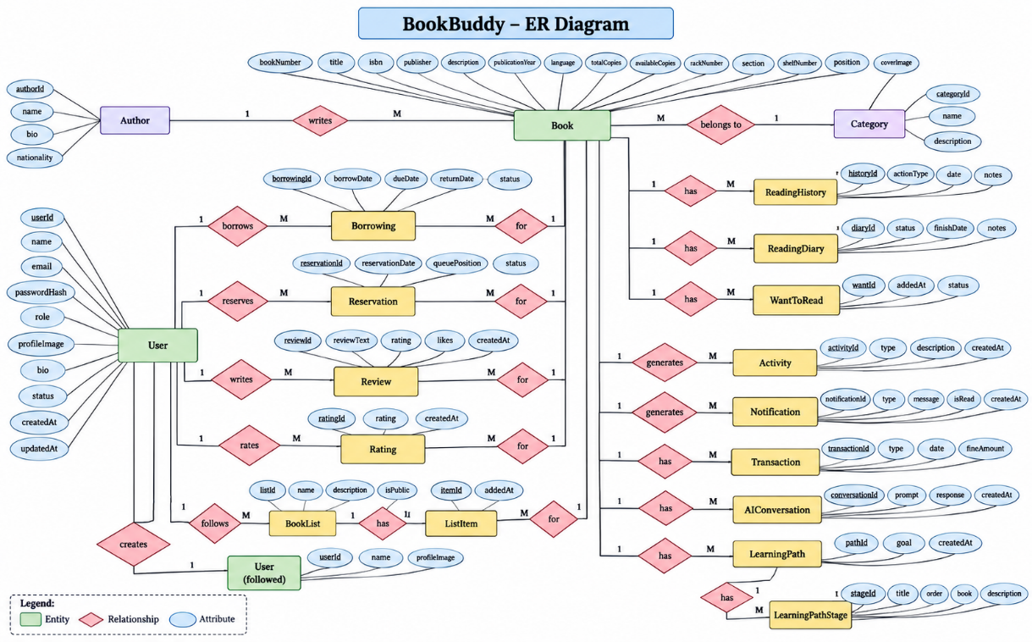

ER DIAGRAM:

The Entity-Relationship (ER) Diagram for BookBuddy represents the major entities of the AI-powered physical library and social reading platform and the relationships among them. The ER model provides a logical representation of how users, books, borrowing transactions, reservations, reviews, reading activities, and other system components are connected within the application.

1. Entities

The major entities used in the BookBuddy system are:

● User: Represents students, teachers, librarians, and administrators registered in the system. Important attributes include User ID, name, email, password hash, role, profile image, bio, status, and timestamps.

● Book: Represents the physical books maintained by the library. Its attributes include Book Number, title, author, publisher, ISBN, category, description, publication year, language, cover image, total copies, available copies, status, rack number, section, shelf number, and position.

● Author: Represents authors associated with books in the library catalog.

● Category: Represents the classification of books such as Programming, Science, History, Fiction, and other academic or general categories.

● Borrowing: Represents the borrowing lifecycle of a book by a reader. It contains the reader, book, borrow date, due date, return date, status, and information about the staff member who issued or returned the book.

● Reservation: Represents a request made by a reader for an unavailable book. It stores the reader, book, reservation date, queue position, status, available date, and completion date.

● Review: Represents textual feedback submitted by a reader for a book. It contains the reader, book, rating, review text, likes, and timestamps.

● Rating: Represents the rating provided by a reader for a book using the defined rating system.

● Reading History: Maintains the user's historical reading and library activity, including books borrowed, returned, read, rated, and reviewed.

● Reading Diary: Represents the personal reading timeline maintained by a reader, including completed books, finish dates, ratings, reviews, categories, and reading activity.

● Want to Read: Represents books saved by users for future reading.

● Book List / List Item: Represents custom collections created by users, such as Java Books, DSA Books, Semester Reading, or Books I Want to Read.

● Follow: Represents the social relationship between readers when one user follows another user.

● Activity: Represents social reading activities performed by users, such as completing a book, creating a list, or posting a review.

● Notification: Represents system-generated notifications related to borrowing, due dates, overdue books, reservations, social activity, new books, and AI recommendations.

● Transaction: Represents library-related operational events such as issue, return, reservation, cancellation, and overdue activity.

● AI Conversation: Represents the interaction history between a user and the BookBuddy AI assistant.

● Learning Path: Represents a personalized learning roadmap generated for a user based on a selected learning goal.

● Learning Path Stage: Represents individual stages within a personalized learning path and the books or topics associated with those stages.

The BookBuddy specification recommends these entities as clean Mongoose models with appropriate references while avoiding unnecessary duplication of mutable data.

2. Relationships

The important relationships between the entities are:

● User–Borrowing: A user can have multiple borrowing records, while each borrowing record belongs to a particular reader.

● Book–Borrowing: A book can appear in multiple borrowing records over time, while each borrowing record refers to a specific book.

● User–Reservation: A user can create multiple reservations, and each reservation belongs to one reader.

● Book–Reservation: A book can have multiple reservations and may therefore have an ordered reservation queue.

● User–Review: A user can write multiple reviews, while each review is associated with one reader.

● Book–Review: A book can receive multiple reviews from different readers.

● User–Rating: A user can provide ratings for books according to the application's rating rules.

● Book–Rating: A book can receive ratings from multiple users, which are used to calculate its aggregate rating information.

● User–ReadingHistory: A user maintains reading activity records through their reading history.

● Book–ReadingHistory: Each reading-history entry is associated with a particular book.

● User–ReadingDiary: A user maint

Key Features:

- Book Catalog Management – Add, update, search, filter, and manage books.
- Borrow & Return Management – Track book issues, returns, and due dates.
- Reservation System – Reserve unavailable books with queue tracking.
- Real-Time Availability – View available, issued, reserved, and unavailable books.
- Reading History & Diary – Maintain personal reading records and completed-book timelines.
- Ratings & Reviews – Rate books and share reviews with other readers.
- Social Reading – Follow readers, view activity, like/comment, and create book lists.
- AI Recommendations – Personalized book suggestions based on reading activity and interests.
- AI Smart Search & Assistant – Natural-language book discovery and library assistance.
- Personalized Learning Path – Generate structured reading paths based on learning goals.
- Notifications – Due-date, overdue, reservation, and activity notifications.
- Library Analytics – Borrowing trends, popular books, active readers, and overdue statistics.
- Excel/CSV Import – Bulk upload and update library book records.

ROLES AND RESPONSIBILITIES:

User:

BookBuddy provides a personalized user environment where students and faculty can manage their complete reading activities through a single platform. Users can create and manage their profiles, search for books, check availability, borrow or reserve books, and monitor due dates and borrowing history. The platform also allows users to maintain a personal Want to Read list and track completed books through a reading history and reading diary.

Users can actively contribute content to the BookBuddy community through ratings, reviews, custom book lists, and reading activities. They can rate books, write and manage reviews, create collections such as academic or personal reading lists, follow other readers, and interact with community activities. This user-generated content helps create a social reading environment where readers can discover books through the experiences and recommendations of other users.

BookBuddy also uses user-generated reading activity to support personalized experiences. Reading history, ratings, reviews, interests, and learning goals can contribute to AI-powered recommendations, smart book discovery, and personalized learning paths. As users continue to interact with the platform, their reading profile becomes a useful source for delivering more relevant book suggestions and learning guidance.

Admin :-
  - BookBuddy provides a dedicated administrative environment for librarians and administrators to manage the complete library system. Authorized staff can add, edit, delete, and view book records, manage authors and categories, maintain reader information, and monitor the overall library catalog. The system also supports role-based access so that administrative functions are available only to authorized users.
  - Administrators and librarians can manage the complete physical library workflow, including book issuing, returns, reservations, overdue records, and transaction history. They can check a reader and book before issuing a copy, update the book's availability after a return, monitor reservation queues, and review overdue books. BookBuddy also provides Excel/CSV bulk import functionality, allowing existing library catalog data to be validated and imported into MongoDB.
The administrative dashboard also provides library analytics and system controls. Administrators can monitor total books, active readers, issued books, available books, reservations, and overdue records, along with borrowing trends, popular books, category usage, and reader activity. Additional settings can be used to configure borrowing limits, borrowing duration, reservation rules, notification settings, and user roles, giving administrators centralized control over the BookBuddy platform.

through the app. They ensure the accuracy and quality of the service providers listed on the platform.

User Flow:
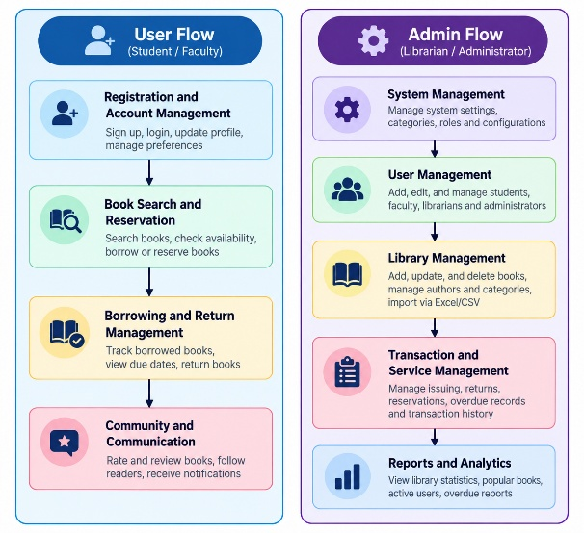

Customer Flow
  - Registration & Account – Create and manage account details securely.
  - Search & Booking – Find services by filters and complete bookings.
  - Payment – Pay securely using available methods.
  - Communication – Contact providers/support for queries or changes.
  - Feedback – Leave honest reviews to help improve services.

Admin Flow

  - System Management – Oversee app performance, settings, and security.
  - User Management – Verify, approve, suspend, or manage user accounts.
  - Service Provider Management – Verify and maintain quality of service providers.

MVC PATTERN:

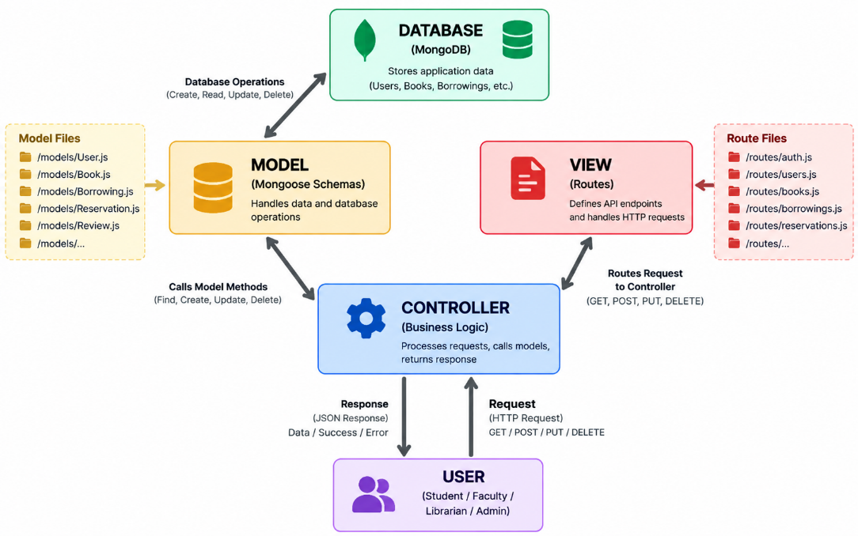

MVC PATTERN:
The BookBuddy application follows the Model-View-Controller (MVC) architectural pattern, which separates the application into three interconnected layers. This separation provides a structured approach for managing data, processing application logic, and handling client requests. It improves modularity, maintainability, scalability, and makes the MERN-based application easier to develop and test.
Model Layer (Data Layer)
The Model layer is responsible for managing the application's data and database operations. In BookBuddy, MongoDB is used as the primary database and Mongoose is used to define schemas and interact with the database.
The model layer manages entities such as:
- User
- Book
- Author
- Category
- Borrowing
- Reservation
- Review
- Rating
- Reading History
- Book List
- Notification
- Transaction
- AI Conversation
- Learning Path
It handles operations such as creating, retrieving, updating, and deleting records while maintaining references between related entities.
Controller Layer
The Controller layer acts as an intermediary between the routes and the models. It receives incoming requests from the frontend, validates and processes the input, invokes the appropriate business or database operations, and returns the required response.
For example, when a student requests to borrow a book, the controller can:
- Receive the borrowing request.
- Validate the user and book information.
- Check the book's availability.
- Create the borrowing record.
- Update the available-copy count.
- Generate the appropriate response.
Controllers are also used for operations such as authentication, book management, reservations, reviews, notifications, analytics, and AI-related requests.
View Layer (Frontend / Routing Layer)
In BookBuddy, the View layer is represented primarily by the React.js frontend, which provides the user interface for students, faculty, librarians, and administrators.
The React interface communicates with the backend through REST APIs using Axios. The Express.js routing layer defines API endpoints such as:
/api/auth
/api/users
/api/books
/api/borrowings
/api/reservations
/api/reviews
/api/ratings
/api/notifications
/api/analytics
/api/ai
These routes receive HTTP requests such as GET, POST, PUT, and DELETE and forward them to the appropriate controllers.
MVC Flow in BookBuddy
The overall request flow can be represented as:
User
↓
React.js View
↓
Axios Request
↓
Express.js Route
↓
Controller
↓
Mongoose Model
↓
MongoDB
↓
Controller Response
↓
React.js View
↓
User
For AI-based operations, the controller can additionally communicate with the AI service while retrieving required library information from MongoDB.
Advantages of Using MVC in BookBuddy
● Separation of Concerns: The frontend, request handling, and database operations are separated into clearly defined responsibilities.
● Maintainability: Changes to the database models, controllers, or frontend interface can be managed independently.
● Scalability: New modules such as reservations, social reading, analytics, and AI features can be added without restructuring the entire application.
● Reusability: Controllers, models, services, and frontend components can be reused across multiple application modules.
● Testing: Individual controllers, models, API routes, and frontend components can be tested independently.
● Security: Authentication, authorization, validation, and error-handling middleware can be applied to backend routes before requests reach protected controllers.
● Team Collaboration: Frontend, backend, and database development can be divided among team members, reducing conflicts and improving development efficiency.
Thus, the MVC architecture provides BookBuddy with a clean and organized structure for implementing its MERN-based physical library management, social reading, and AI-powered learning features.

PROJECT SETUP AND CONFIGURATION

Creating Project Folder
- Create a new project folder named BookBuddy.
- Open the BookBuddy project folder in Visual Studio Code.
- Initialize the frontend application using React.js with Vite.
- Create a separate server directory inside the project to contain the backend implementation.
- The project is organized into frontend and backend sections to maintain a clean full-stack architecture.
The basic project structure is organized as follows:
BookBuddy/
│
├── dist/
├── node_modules/
├── public/
│
├── server/
│ ├── data/
│ ├── src/
│ ├── uploads/
│ ├── .env.example
│ ├── postman_collection.json
│ └── README.md
│
├── src/
│ ├── components/
│ ├── config/
│ ├── data/
│ ├── hooks/
│ ├── layouts/
│ └── pages/
│ ├── admin/
│ ├── ai/
│ ├── auth/
│ ├── librarian/
│ └── public/
│
├── package.json
└── README.md
The application follows a modular structure so that frontend components, backend services, database operations, AI functionality, and administrative modules can be maintained independently.

FRONTEND SETUP

Installing and Configuring React Application
The frontend of BookBuddy is developed using React.js with Vite.
Open the project directory in the Visual Studio Code terminal and create the React application using:
npm create vite@latest
Select:
Framework: React
Variant: JavaScript
Navigate to the project directory and install the required dependencies:
npm install
The frontend development server can be started using:
npm run dev
The BookBuddy frontend uses React.js, Vite, Tailwind CSS, Redux Toolkit, React Router, and Axios as the primary frontend technologies.

SERVER SETUP
The backend is maintained separately inside the server directory.
Navigate to the server directory:
cd server
Initialize the Node.js project:
npm init -y
The backend is developed using Node.js and Express.js and exposes REST APIs for authentication, users, books, borrowing, returns, reservations, reviews, ratings, notifications, analytics, imports, and AI functionality.
The backend follows a modular structure similar to:
server/
│
├── src/
│ ├── controllers/
│ ├── middleware/
│ ├── models/
│ ├── routes/
│ ├── services/
│ ├── utils/
│ └── validators/
│
├── data/
├── uploads/
├── .env.example
├── postman_collection.json
└── README.md
The recommended backend request flow is:
Routes
↓
Controllers
↓
Services
↓
Models
↓
MongoDB
Authentication, authorization, validation, error handling, logging, and upload handling are implemented through middleware.

BACKEND DEVELOPMENT

Backend Architecture
The BookBuddy backend provides the application logic required to connect the React frontend with MongoDB, Cloudinary, and AI services.
The backend performs operations related to:
- User authentication
- Role-based access control
- User management
- Book catalog management
- Borrowing and returns
- Reservation management
- Reviews and ratings
- Social reading
- Notifications
- Analytics
- Excel/CSV import
- AI assistant
- AI recommendations
- Semantic search
- Learning paths
The backend API structure includes:
/api/auth
/api/users
/api/books
/api/authors
/api/categories
/api/borrowings
/api/returns
/api/reservations
/api/reviews
/api/ratings
/api/lists
/api/follows
/api/activities
/api/notifications
/api/analytics
/api/import
/api/ai
/api/settings
These APIs allow the frontend to communicate with the backend using standard HTTP methods such as GET, POST, PUT, and DELETE.

Controllers
Controllers are responsible for processing incoming API requests and executing the corresponding application logic.

authController.js
Handles authentication-related operations such as:
- Student login
- Teacher login
- Librarian login
- Administrator login
- Registration
- Password validation
- Token generation
- Logout
- Password recovery

userController.js
Handles user-related operations such as:
- View profile
- Update profile
- Manage user information
- Retrieve reader information
- Manage role-specific user operations

bookController.js
Handles:
- Add book
- View books
- Update book
- Delete book
- Search books
- Filter books
- Sort books
- View availability
- View physical location

borrowingController.js
Handles:
- Issue books
- Create borrowing records
- Check availability
- Assign due dates
- View current borrowings
- Process returns
- Update availability

reservationController.js
Handles:
- Create reservation
- View reservation queue
- Update reservation status
- Cancel reservation
- Process the next eligible reader

reviewController.js
Handles:
- Create review
- Edit review
- Delete review
- Retrieve reviews
- Manage review interactions

ratingController.js
Handles:
- Create ratings
- Update ratings
- Calculate rating information
- Retrieve user ratings

notificationController.js
Handles:
- Due-date notifications
- Overdue notifications
- Reservation notifications
- Social notifications
- New-book notifications
- AI recommendation notifications

analyticsController.js
Handles:
- Borrowing statistics
- Popular books
- Popular categories
- Active readers
- Overdue statistics
- Library usage trends

aiController.js
Handles AI-related operations such as:
- AI library assistant
- AI recommendations
- Semantic book search
- AI book summaries
- Personalized learning paths
- Reading insights

MIDDLEWARE
Middleware components execute before or during request processing.

authMiddleware.js
Used for:
- JWT validation
- Authentication
- Role verification
- Protected routes
The system supports the following roles:
STUDENT
TEACHER
LIBRARIAN
ADMIN
Users are restricted from accessing routes and actions that their assigned role does not permit.

upload.js
Handles supported file uploads such as:
- Book cover images
- Profile images
- Library documents
- Excel/CSV files
Uploaded images can be stored using Cloudinary, while the required Cloudinary URL and metadata are stored in MongoDB.

DATABASE DEVELOPMENT

1. Configuring MongoDB
BookBuddy uses MongoDB as the primary database and Mongoose as the Object Data Modeling library.
MongoDB acts as the live source of truth for the application.
Install Mongoose in the server directory:
npm install mongoose
The database connection is established when the backend server starts.
The database workflow is:
BookBuddy Backend
↓
Mongoose
↓
MongoDB
↓
Collections / Documents
The database stores operational information including users, books, current availability, borrowing records, reservations, reviews, ratings, reading history, and other application data.

2. CREATE DATABASE CONNECTION
A dedicated database configuration module is used to establish the MongoDB connection.
The connection configuration retrieves the MongoDB connection string from the environment configuration.
Example:
MONGODB_URI=your_mongodb_connection_string
The backend must establish a successful database connection before processing database-dependent operations.
The general flow is:
Server Start
↓
Load Environment Variables
↓
Connect to MongoDB
↓
Connection Successful
↓
Start Express Server
Environment variables are used so that database credentials and other sensitive configuration values are not hard-coded into the application.

3. CREATE SCHEMAS AND MODELS
The BookBuddy database is designed using Mongoose schemas based on the application's ER model.
The recommended models include:
User
Book
Author
Category
Borrowing
Reservation
Review
Rating
ReadingHistory
ReadingDiary
WantToRead
BookList
ListItem
Follow
Activity
Notification
Transaction
LibrarySetting
AIConversation
LearningPath
LearningPathStage
Appropriate references are used between related documents, while unnecessary duplication of mutable information is avoided.

1) User Model

User.js
The User model stores account and profile information.
Important fields include:
userId
name
email
passwordHash
role
profileImage
bio
status
createdAt
updatedAt
Supported roles are:
STUDENT
TEACHER
LIBRARIAN
ADMIN
The password is stored as a secure hash rather than as plain text.

2) Book Model

Book.js
The Book model represents the physical library catalog.
Important fields include:
bookNumber
title
author
publisher
isbn
category
description
publicationYear
language
coverImage
totalCopies
availableCopies
status
rackNumber
section
shelfNumber
position
createdAt
updatedAt
The model supports both catalog information and the physical location of the book within the library.

3) Borrowing Model

Borrowing.js
The Borrowing model records the complete borrowing lifecycle of a book.
Fields include:
reader
book
borrowDate
dueDate
returnDate
status
issuedBy
returnedBy
createdAt
updatedAt
Borrowing statuses include:
BORROWED
RETURNED
OVERDUE
When a book is issued, the available-copy count is reduced. When it is returned, the available-copy count is increased and the transaction is updated.

4) Reservation Model

Reservation.js
The Reservation model stores requests for unavailable books.
Fields include:
reader
book
reservationDate
queuePosition
status
availableDate
completedDate
createdAt
updatedAt
The reservation system maintains an ordered queue and notifies the next eligible reader when the book becomes available.

5) Review and Rating Models

Review.js
The Review model stores:
reader
book
rating
reviewText
likes
createdAt
updatedAt
Users can create, edit, and delete their own reviews, subject to authorization.

Rating.js
The Rating model stores book ratings submitted by readers and supports calculation of aggregate rating information.
Duplicate active ratings or reviews for the same reader-book combination can be prevented according to the application business rules.

6) Reading Models
BookBuddy maintains personal reading activity through:

ReadingHistory.js
Stores events such as:
Borrowed
Returned
Read
Rated
Reviewed

ReadingDiary.js
Stores completed reading activities, finish dates, ratings, reviews, categories, and reading timeline information.

WantToRead.js
Stores books saved by users for future reading.
These models allow BookBuddy to create a persistent personal reading record for each user.

7) Social Reading Models
The social layer contains:
BookList
ListItem
Follow
Activity
Users can create custom lists, add books to those lists, follow other readers, and generate reading-related activities.
Example custom lists include:
My Java Books
DSA Books
Semester Reading
Books I Want to Read

8) Notification Model

Notification.js
The Notification model stores system notifications.
Important fields include:
user
type
title
message
read
relatedEntity
createdAt
Notifications can be generated for:
Borrow
Due Soon
Overdue
Return
Reservation Available
New Follower
Review Like
Review Comment
New Book
AI Recommendation

9) Transaction Model

Transaction.js
The Transaction model maintains the history of important library operations.
It can record:
Issue
Return
Reservation
Cancellation
Overdue
This provides a traceable history of library activity for administrative and analytical purposes.

10) AI Models

AIConversation.js
Stores relevant user interactions with the BookBuddy AI assistant.

LearningPath.js
Stores personalized learning goals and learning paths generated for users.

LearningPathStage.js
Stores individual stages of the learning path, including sequence, title, description, and related books.
The AI architecture uses application data, semantic search, embeddings, and an LLM where applicable.

EXCEL / CSV DATABASE IMPORT
BookBuddy supports bulk catalog import through Excel and CSV files.
The import process is:
Excel / CSV
↓
Upload
↓
Read File
↓
Parse Data
↓
Validate Columns
↓
Validate Rows
↓
Preview Records
↓
Show Errors
↓
Confirm Import
↓
MongoDB
The import system validates:
Missing required columns
Missing required values
Duplicate Book Number
Duplicate ISBN
Invalid numeric values
Available Copies > Total Copies
Negative copies
Invalid status
Invalid publication year
Malformed records
Excel and CSV files are used for bulk import and update only. MongoDB remains the application's live source of truth.

IMAGE UPLOAD AND CLOUD STORAGE
BookBuddy uses Multer for receiving uploaded files and Cloudinary for storing supported images and documents.
The process is:
User / Admin
↓
Select Image
↓
Multer
↓
Backend Validation
↓
Cloudinary
↓
Cloudinary URL
↓
MongoDB
Book cover images and profile images can therefore be stored without placing large binary files directly inside MongoDB.

FRONT-END DEVELOPMENT

Frontend Structure
The BookBuddy frontend is organized inside the src directory.
src/
│
├── components/
├── config/
├── data/
├── hooks/
├── layouts/
│
└── pages/
├── admin/
├── ai/
├── auth/
├── librarian/
└── public/
The application can be extended with reader-specific screens, reusable components, services, and shared state modules as required by the implementation.

COMPONENTS
The components directory contains reusable interface elements used throughout the application.
Examples include:
Navigation components
Book cards
Search components
Forms
Dialogs
Status indicators
Tables
Charts
Notification components
AI interface components
Reusable components reduce code duplication and maintain consistency across different screens.

CONFIG
The config directory contains application-level configuration such as:
API configuration
Environment configuration
Application constants
Service configuration
Sensitive credentials are not stored directly in frontend source code.

DATA
The data directory contains structured application data used where appropriate for interface configuration, categories, static definitions, or development support.
Production operational data such as books, users, borrowing records, and reservations is retrieved from the backend and MongoDB.

HOOKS
The hooks directory contains reusable React hooks for tasks such as:
Authentication state
API interaction
Notifications
Application state
User preferences
Responsive behavior
Custom hooks help simplify component logic and improve code reusability.

LAYOUTS
The layouts directory contains common page structures for different roles and sections.
Examples include:
Public Layout
Reader Layout
Librarian Layout
Admin Layout
AI Layout
Layouts provide common navigation, headers, sidebars, and responsive page structures.

PAGES
The pages directory contains BookBuddy's major application modules.

Admin Pages
The admin directory contains interfaces for:
- Admin dashboard
- User management
- Book management
- Authors
- Categories
- Transactions
- Analytics
- Settings
- Bulk import

AI Pages
The ai directory contains:
- AI Assistant
- AI Recommendations
- Smart Search
- AI Book Summary
- Learning Path
- Reading Insights

Authentication Pages
The auth directory contains:
- Role selection
- Student login
- Teacher login
- Librarian/Admin login
- Registration
- Password recovery

Librarian Pages
The librarian directory contains screens for:
- Library dashboard
- Book management
- Issue books
- Return books
- Reservations
- Overdue management
- Transactions
- Library analytics

Public Pages
The public directory contains:
- Home
- About
- Explore Books
- Book Details
- Help / Contact
BookBuddy's complete navigation structure is based on public, authentication, reader, AI, and administrator/librarian modules.

STATE MANAGEMENT
BookBuddy uses Redux Toolkit where centralized application state is required.
Suggested state modules include:
authSlice
booksSlice
borrowingsSlice
reservationSlice
notificationSlice
socialSlice
aiSlice
analyticsSlice
uiSlice
Local component state is used for local interface behavior, while shared state is maintained centrally where appropriate.

FRONTEND AND BACKEND COMMUNICATION
The frontend communicates with the backend using Axios.
The overall communication process is:
User
↓
React Interface
↓
Axios
↓
Express REST API
↓
Controller
↓
Service
↓
Mongoose Model
↓
MongoDB
↓
JSON Response
↓
React Interface
For example, when a student borrows a book:
Student clicks Borrow
↓
React sends API request
↓
Borrowing API
↓
Availability checked
↓
MongoDB updated
↓
Borrowing record created
↓
Notification generated
↓
Updated response
↓
Dashboard updated

AI INTEGRATION
BookBuddy includes an AI layer connected through the backend.
The AI flow is:
User Query
↓
BookBuddy AI Router
↓
Query Classifier
↓
Retrieve Relevant Data
↓
MongoDB / Semantic Search / Embeddings / RAG
↓
LLM
↓
Validated Response
↓
User
The AI system supports:
AI Assistant
AI Recommendations
Smart Search
Semantic Search
Book Summaries
Learning Paths
Reading Insights
Operational information such as book availability, due dates, borrowing records, reservation status, rack location, user history, and library rules must be retrieved from the application's database instead of being invented by the AI.

API TESTING
BookBuddy REST APIs can be tested using Postman.
Important API areas include:
Authentication
Users
Books
Authors
Categories
Borrowings
Returns
Reservations
Reviews
Ratings
Lists
Follows
Activities
Notifications
Analytics
Import
AI
Settings
Testing ensures that requests, responses, validation, authentication, authorization, and database operations work correctly.

FINAL PROJECT STRUCTURE
The final BookBuddy project can be represented as:
BOOKBUDDY
│
├── FRONTEND
│ ├── React.js
│ ├── Vite
│ ├── Tailwind CSS
│ ├── Redux Toolkit
│ ├── React Router
│ └── Axios
│
├── BACKEND
│ ├── Node.js
│ ├── Express.js
│ ├── Controllers
│ ├── Middleware
│ ├── Routes
│ ├── Services
│ └── Validators
│
├── DATABASE
│ ├── MongoDB
│ └── Mongoose
│
├── STORAGE
│ └── Cloudinary
│
├── AI
│ ├── LLM API
│ ├── Semantic Search
│ ├── Embeddings
│ └── Optional RAG
│
└── TESTING
├── Postman
├── MongoDB Compass
├── Git
└── GitHub
Thus, the BookBuddy implementation follows a complete MERN + AI architecture, integrating the React frontend, Node.js/Express backend, MongoDB database, cloud image storage, REST APIs, social reading functionality, and intelligent AI services into a single digital library platform.

PROJECT SETUP AND CONFIGURATION

Creating Project Folder
- Create a new project folder named BookBuddy.
- Open the BookBuddy project folder in Visual Studio Code.
- Initialize the frontend application using React.js with Vite.
- Create a separate server directory inside the project to contain the backend implementation.
- The project is organized into frontend and backend sections to maintain a clean full-stack architecture.
The basic project structure is organized as follows:
BookBuddy/
│
├── dist/
├── node_modules/
├── public/
│
├── server/
│ ├── data/
│ ├── src/
│ ├── uploads/
│ ├── .env.example
│ ├── postman_collection.json
│ └── README.md
│
├── src/
│ ├── components/
│ ├── config/
│ ├── data/
│ ├── hooks/
│ ├── layouts/
│ └── pages/
│ ├── admin/
│ ├── ai/
│ ├── auth/
│ ├── librarian/
│ └── public/
│
├── package.json
└── README.md
The application follows a modular structure so that frontend components, backend services, database operations, AI functionality, and administrative modules can be maintained independently.

FRONTEND SETUP

Installing and Configuring React Application
The frontend of BookBuddy is developed using React.js with Vite.
Open the project directory in the Visual Studio Code terminal and create the React application using:
npm create vite@latest
Select:
Framework: React
Variant: JavaScript
Navigate to the project directory and install the required dependencies:
npm install
The frontend development server can be started using:
npm run dev
The BookBuddy frontend uses React.js, Vite, Tailwind CSS, Redux Toolkit, React Router, and Axios as the primary frontend technologies.

SERVER SETUP
The backend is maintained separately inside the server directory.
Navigate to the server directory:
cd server
Initialize the Node.js project:
npm init -y
The backend is developed using Node.js and Express.js and exposes REST APIs for authentication, users, books, borrowing, returns, reservations, reviews, ratings, notifications, analytics, imports, and AI functionality.
The backend follows a modular structure similar to:
server/
│
├── src/
│ ├── controllers/
│ ├── middleware/
│ ├── models/
│ ├── routes/
│ ├── services/
│ ├── utils/
│ └── validators/
│
├── data/
├── uploads/
├── .env.example
├── postman_collection.json
└── README.md
The recommended backend request flow is:
Routes
↓
Controllers
↓
Services
↓
Models
↓
MongoDB
Authentication, authorization, validation, error handling, logging, and upload handling are implemented through middleware.

BACKEND DEVELOPMENT

Backend Architecture
The BookBuddy backend provides the application logic required to connect the React frontend with MongoDB, Cloudinary, and AI services.
The backend performs operations related to:
- User authentication
- Role-based access control
- User management
- Book catalog management
- Borrowing and returns
- Reservation management
- Reviews and ratings
- Social reading
- Notifications
- Analytics
- Excel/CSV import
- AI assistant
- AI recommendations
- Semantic search
- Learning paths
The backend API structure includes:
/api/auth
/api/users
/api/books
/api/authors
/api/categories
/api/borrowings
/api/returns
/api/reservations
/api/reviews
/api/ratings
/api/lists
/api/follows
/api/activities
/api/notifications
/api/analytics
/api/import
/api/ai
/api/settings
These APIs allow the frontend to communicate with the backend using standard HTTP methods such as GET, POST, PUT, and DELETE.

Controllers
Controllers are responsible for processing incoming API requests and executing the corresponding application logic.

authController.js
Handles authentication-related operations such as:
- Student login
- Teacher login
- Librarian login
- Administrator login
- Registration
- Password validation
- Token generation
- Logout
- Password recovery

userController.js
Handles user-related operations such as:
- View profile
- Update profile
- Manage user information
- Retrieve reader information
- Manage role-specific user operations

bookController.js
Handles:
- Add book
- View books
- Update book
- Delete book
- Search books
- Filter books
- Sort books
- View availability
- View physical location

borrowingController.js
Handles:
- Issue books
- Create borrowing records
- Check availability
- Assign due dates
- View current borrowings
- Process returns
- Update availability

reservationController.js
Handles:
- Create reservation
- View reservation queue
- Update reservation status
- Cancel reservation
- Process the next eligible reader

reviewController.js
Handles:
- Create review
- Edit review
- Delete review
- Retrieve reviews
- Manage review interactions

ratingController.js
Handles:
- Create ratings
- Update ratings
- Calculate rating information
- Retrieve user ratings

notificationController.js
Handles:
- Due-date notifications
- Overdue notifications
- Reservation notifications
- Social notifications
- New-book notifications
- AI recommendation notifications

analyticsController.js
Handles:
- Borrowing statistics
- Popular books
- Popular categories
- Active readers
- Overdue statistics
- Library usage trends

aiController.js
Handles AI-related operations such as:
- AI library assistant
- AI recommendations
- Semantic book search
- AI book summaries
- Personalized learning paths
- Reading insights

MIDDLEWARE
Middleware components execute before or during request processing.

authMiddleware.js
Used for:
- JWT validation
- Authentication
- Role verification
- Protected routes
The system supports the following roles:
STUDENT
TEACHER
LIBRARIAN
ADMIN
Users are restricted from accessing routes and actions that their assigned role does not permit.

upload.js
Handles supported file uploads such as:
- Book cover images
- Profile images
- Library documents
- Excel/CSV files
Uploaded images can be stored using Cloudinary, while the required Cloudinary URL and metadata are stored in MongoDB.

DATABASE DEVELOPMENT

1. Configuring MongoDB
BookBuddy uses MongoDB as the primary database and Mongoose as the Object Data Modeling library.
MongoDB acts as the live source of truth for the application.
Install Mongoose in the server directory:
npm install mongoose
The database connection is established when the backend server starts.
The database workflow is:
BookBuddy Backend
↓
Mongoose
↓
MongoDB
↓
Collections / Documents
The database stores operational information including users, books, current availability, borrowing records, reservations, reviews, ratings, reading history, and other application data.

2. CREATE DATABASE CONNECTION
A dedicated database configuration module is used to establish the MongoDB connection.
The connection configuration retrieves the MongoDB connection string from the environment configuration.
Example:
MONGODB_URI=your_mongodb_connection_string
The backend must establish a successful database connection before processing database-dependent operations.
The general flow is:
Server Start
↓
Load Environment Variables
↓
Connect to MongoDB
↓
Connection Successful
↓
Start Express Server
Environment variables are used so that database credentials and other sensitive configuration values are not hard-coded into the application.

3. CREATE SCHEMAS AND MODELS
The BookBuddy database is designed using Mongoose schemas based on the application's ER model.
The recommended models include:
User
Book
Author
Category
Borrowing
Reservation
Review
Rating
ReadingHistory
ReadingDiary
WantToRead
BookList
ListItem
Follow
Activity
Notification
Transaction
LibrarySetting
AIConversation
LearningPath
LearningPathStage
Appropriate references are used between related documents, while unnecessary duplication of mutable information is avoided.

1) User Model

User.js
The User model stores account and profile information.
Important fields include:
userId
name
email
passwordHash
role
profileImage
bio
status
createdAt
updatedAt
Supported roles are:
STUDENT
TEACHER
LIBRARIAN
ADMIN
The password is stored as a secure hash rather than as plain text.

2) Book Model

Book.js
The Book model represents the physical library catalog.
Important fields include:
bookNumber
title
author
publisher
isbn
category
description
publicationYear
language
coverImage
totalCopies
availableCopies
status
rackNumber
section
shelfNumber
position
createdAt
updatedAt
The model supports both catalog information and the physical location of the book within the library.

3) Borrowing Model

Borrowing.js
The Borrowing model records the complete borrowing lifecycle of a book.
Fields include:
reader
book
borrowDate
dueDate
returnDate
status
issuedBy
returnedBy
createdAt
updatedAt
Borrowing statuses include:
BORROWED
RETURNED
OVERDUE
When a book is issued, the available-copy count is reduced. When it is returned, the available-copy count is increased and the transaction is updated.

4) Reservation Model

Reservation.js
The Reservation model stores requests for unavailable books.
Fields include:
reader
book
reservationDate
queuePosition
status
availableDate
completedDate
createdAt
updatedAt
The reservation system maintains an ordered queue and notifies the next eligible reader when the book becomes available.

5) Review and Rating Models

Review.js
The Review model stores:
reader
book
rating
reviewText
likes
createdAt
updatedAt
Users can create, edit, and delete their own reviews, subject to authorization.

Rating.js
The Rating model stores book ratings submitted by readers and supports calculation of aggregate rating information.
Duplicate active ratings or reviews for the same reader-book combination can be prevented according to the application business rules.

6) Reading Models
BookBuddy maintains personal reading activity through:

ReadingHistory.js
Stores events such as:
Borrowed
Returned
Read
Rated
Reviewed

ReadingDiary.js
Stores completed reading activities, finish dates, ratings, reviews, categories, and reading timeline information.

WantToRead.js
Stores books saved by users for future reading.
These models allow BookBuddy to create a persistent personal reading record for each user.

7) Social Reading Models
The social layer contains:
BookList
ListItem
Follow
Activity
Users can create custom lists, add books to those lists, follow other readers, and generate reading-related activities.
Example custom lists include:
My Java Books
DSA Books
Semester Reading
Books I Want to Read

8) Notification Model

Notification.js
The Notification model stores system notifications.
Important fields include:
user
type
title
message
read
relatedEntity
createdAt
Notifications can be generated for:
Borrow
Due Soon
Overdue
Return
Reservation Available
New Follower
Review Like
Review Comment
New Book
AI Recommendation

9) Transaction Model

Transaction.js
The Transaction model maintains the history of important library operations.
It can record:
Issue
Return
Reservation
Cancellation
Overdue
This provides a traceable history of library activity for administrative and analytical purposes.

10) AI Models

AIConversation.js
Stores relevant user interactions with the BookBuddy AI assistant.

LearningPath.js
Stores personalized learning goals and learning paths generated for users.

LearningPathStage.js
Stores individual stages of the learning path, including sequence, title, description, and related books.
The AI architecture uses application data, semantic search, embeddings, and an LLM where applicable.

EXCEL / CSV DATABASE IMPORT
BookBuddy supports bulk catalog import through Excel and CSV files.
The import process is:
Excel / CSV
↓
Upload
↓
Read File
↓
Parse Data
↓
Validate Columns
↓
Validate Rows
↓
Preview Records
↓
Show Errors
↓
Confirm Import
↓
MongoDB
The import system validates:
Missing required columns
Missing required values
Duplicate Book Number
Duplicate ISBN
Invalid numeric values
Available Copies > Total Copies
Negative copies
Invalid status
Invalid publication year
Malformed records
Excel and CSV files are used for bulk import and update only. MongoDB remains the application's live source of truth.

IMAGE UPLOAD AND CLOUD STORAGE
BookBuddy uses Multer for receiving uploaded files and Cloudinary for storing supported images and documents.
The process is:
User / Admin
↓
Select Image
↓
Multer
↓
Backend Validation
↓
Cloudinary
↓
Cloudinary URL
↓
MongoDB
Book cover images and profile images can therefore be stored without placing large binary files directly inside MongoDB.

FRONT-END DEVELOPMENT

Frontend Structure
The BookBuddy frontend is organized inside the src directory.
src/
│
├── components/
├── config/
├── data/
├── hooks/
├── layouts/
│
└── pages/
├── admin/
├── ai/
├── auth/
├── librarian/
└── public/
The application can be extended with reader-specific screens, reusable components, services, and shared state modules as required by the implementation.

COMPONENTS
The components directory contains reusable interface elements used throughout the application.
Examples include:
Navigation components
Book cards
Search components
Forms
Dialogs
Status indicators
Tables
Charts
Notification components
AI interface components
Reusable components reduce code duplication and maintain consistency across different screens.

CONFIG
The config directory contains application-level configuration such as:
API configuration
Environment configuration
Application constants
Service configuration
Sensitive credentials are not stored directly in frontend source code.

DATA
The data directory contains structured application data used where appropriate for interface configuration, categories, static definitions, or development support.
Production operational data such as books, users, borrowing records, and reservations is retrieved from the backend and MongoDB.

HOOKS
The hooks directory contains reusable React hooks for tasks such as:
Authentication state
API interaction
Notifications
Application state
User preferences
Responsive behavior
Custom hooks help simplify component logic and improve code reusability.

LAYOUTS
The layouts directory contains common page structures for different roles and sections.
Examples include:
Public Layout
Reader Layout
Librarian Layout
Admin Layout
AI Layout
Layouts provide common navigation, headers, sidebars, and responsive page structures.

PAGES
The pages directory contains BookBuddy's major application modules.

Admin Pages
The admin directory contains interfaces for:
- Admin dashboard
- User management
- Book management
- Authors
- Categories
- Transactions
- Analytics
- Settings
- Bulk import

AI Pages
The ai directory contains:
- AI Assistant
- AI Recommendations
- Smart Search
- AI Book Summary
- Learning Path
- Reading Insights

Authentication Pages
The auth directory contains:
- Role selection
- Student login
- Teacher login
- Librarian/Admin login
- Registration
- Password recovery

Librarian Pages
The librarian directory contains screens for:
- Library dashboard
- Book management
- Issue books
- Return books
- Reservations
- Overdue management
- Transactions
- Library analytics

Public Pages
The public directory contains:
- Home
- About
- Explore Books
- Book Details
- Help / Contact
BookBuddy's complete navigation structure is based on public, authentication, reader, AI, and administrator/librarian modules.

STATE MANAGEMENT
BookBuddy uses Redux Toolkit where centralized application state is required.
Suggested state modules include:
authSlice
booksSlice
borrowingsSlice
reservationSlice
notificationSlice
socialSlice
aiSlice
analyticsSlice
uiSlice
Local component state is used for local interface behavior, while shared state is maintained centrally where appropriate.

FRONTEND AND BACKEND COMMUNICATION
The frontend communicates with the backend using Axios.
The overall communication process is:
User
↓
React Interface
↓
Axios
↓
Express REST API
↓
Controller
↓
Service
↓
Mongoose Model
↓
MongoDB
↓
JSON Response
↓
React Interface
For example, when a student borrows a book:
Student clicks Borrow
↓
React sends API request
↓
Borrowing API
↓
Availability checked
↓
MongoDB updated
↓
Borrowing record created
↓
Notification generated
↓
Updated response
↓
Dashboard updated

AI INTEGRATION
BookBuddy includes an AI layer connected through the backend.
The AI flow is:
User Query
↓
BookBuddy AI Router
↓
Query Classifier
↓
Retrieve Relevant Data
↓
MongoDB / Semantic Search / Embeddings / RAG
↓
LLM
↓
Validated Response
↓
User
The AI system supports:
AI Assistant
AI Recommendations
Smart Search
Semantic Search
Book Summaries
Learning Paths
Reading Insights
Operational information such as book availability, due dates, borrowing records, reservation status, rack location, user history, and library rules must be retrieved from the application's database instead of being invented by the AI.

API TESTING
BookBuddy REST APIs can be tested using Postman.
Important API areas include:
Authentication
Users
Books
Authors
Categories
Borrowings
Returns
Reservations
Reviews
Ratings
Lists
Follows
Activities
Notifications
Analytics
Import
AI
Settings
Testing ensures that requests, responses, validation, authentication, authorization, and database operations work correctly.

FINAL PROJECT STRUCTURE
The final BookBuddy project can be represented as:
BOOKBUDDY
│
├── FRONTEND
│ ├── React.js
│ ├── Vite
│ ├── Tailwind CSS
│ ├── Redux Toolkit
│ ├── React Router
│ └── Axios
│
├── BACKEND
│ ├── Node.js
│ ├── Express.js
│ ├── Controllers
│ ├── Middleware
│ ├── Routes
│ ├── Services
│ └── Validators
│
├── DATABASE
│ ├── MongoDB
│ └── Mongoose
│
├── STORAGE
│ └── Cloudinary
│
├── AI
│ ├── LLM API
│ ├── Semantic Search
│ ├── Embeddings
│ └── Optional RAG
│
└── TESTING
├── Postman
├── MongoDB Compass
├── Git
└── GitHub
Thus, the BookBuddy implementation follows a complete MERN + AI architecture, integrating the React frontend, Node.js/Express backend, MongoDB database, cloud image storage, REST APIs, social reading functionality, and intelligent AI services into a single digital library platform.

Components (Reusable parts)
  - Footer.jsx → Footer component used across pages.

  - Home.jsx → Main home/landing page (probably entry page for app).

  - ui/ → Likely contains shared UI components (buttons, modals, etc.).

Output ScreenShots:

Landing Page:
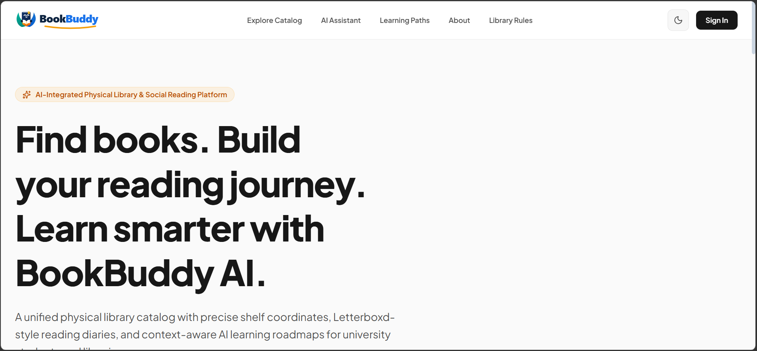

Register.jsx(Admin):
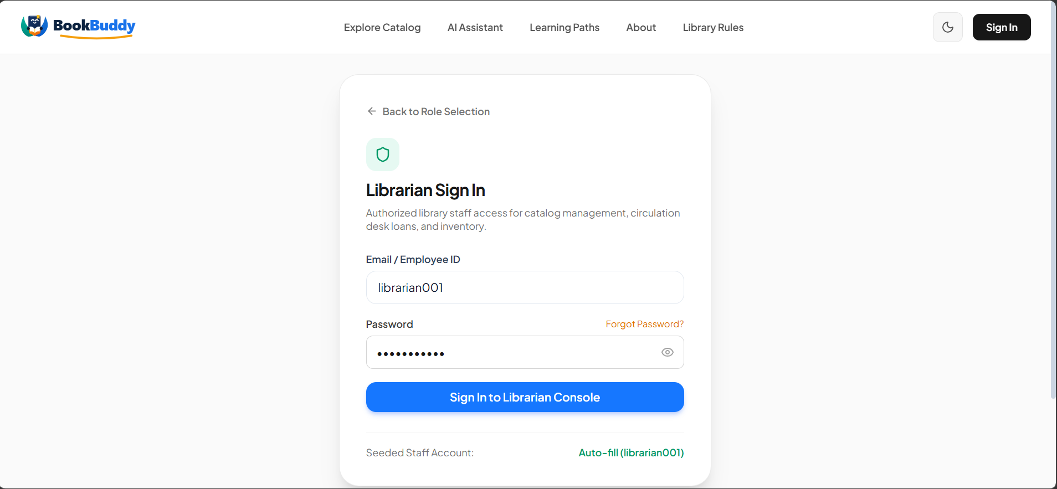

Login.jsx:

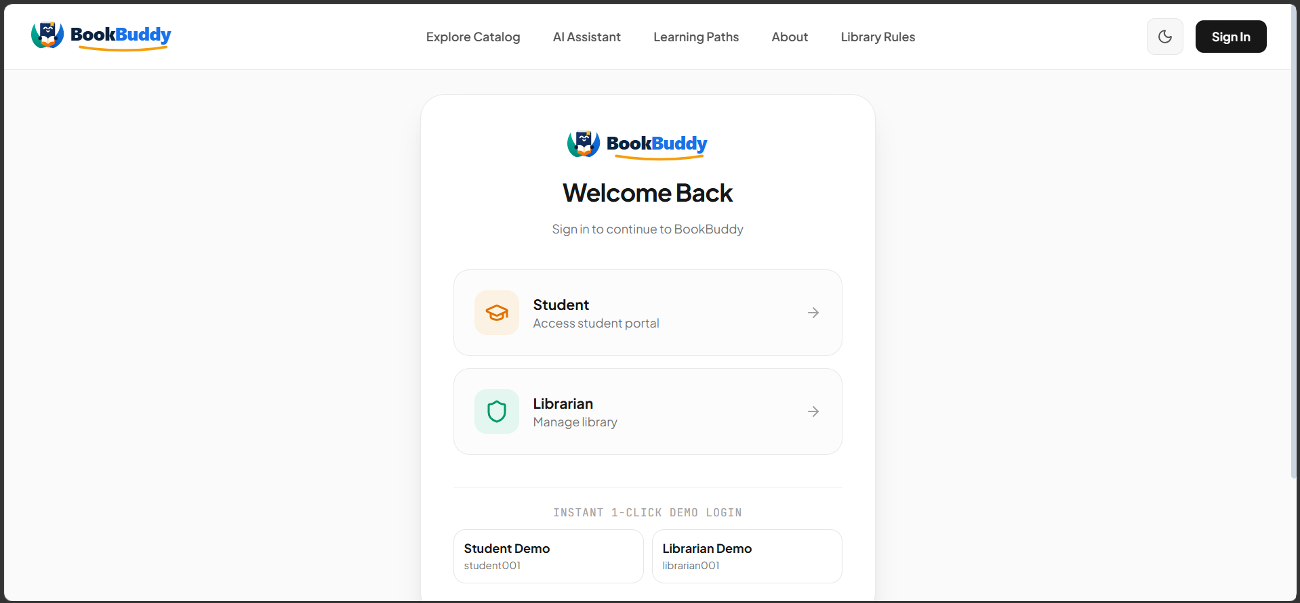

Admin HomePage:
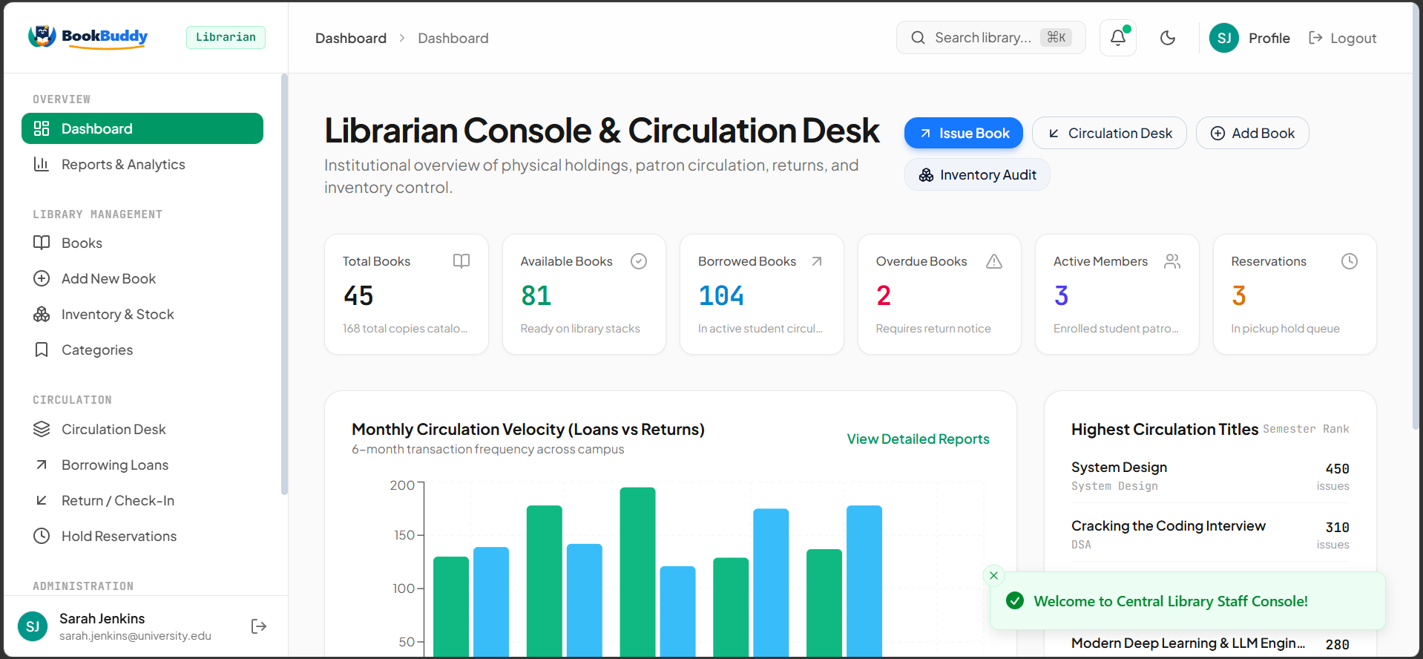

User’s Page:

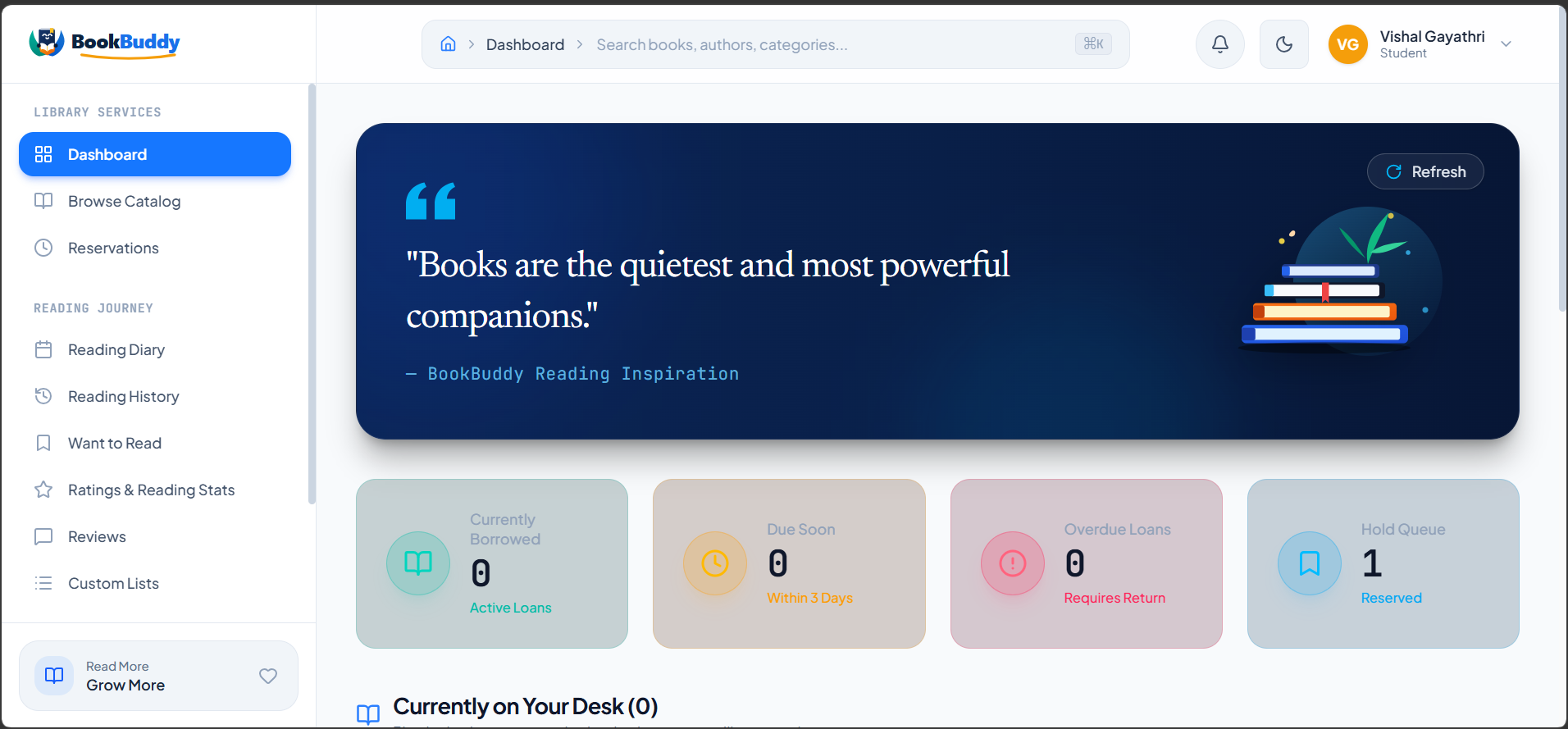

MyProductPage:
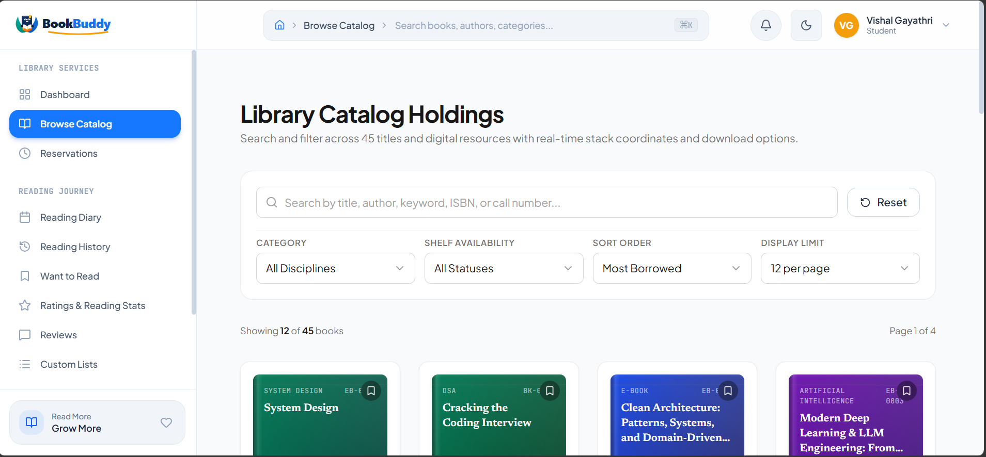

AddItemPage:

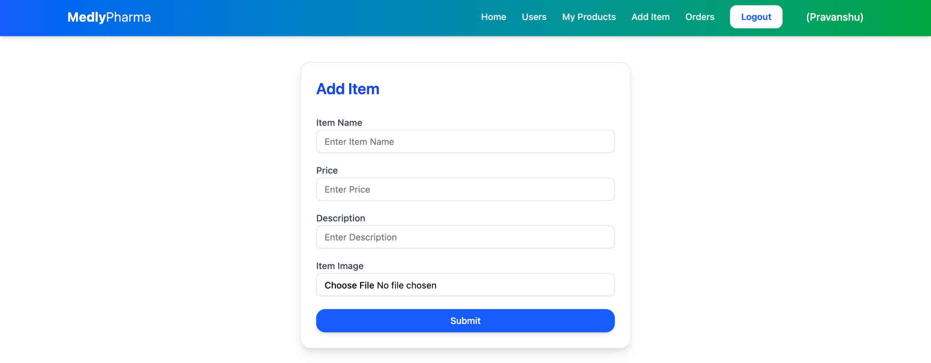

Order’s Page:
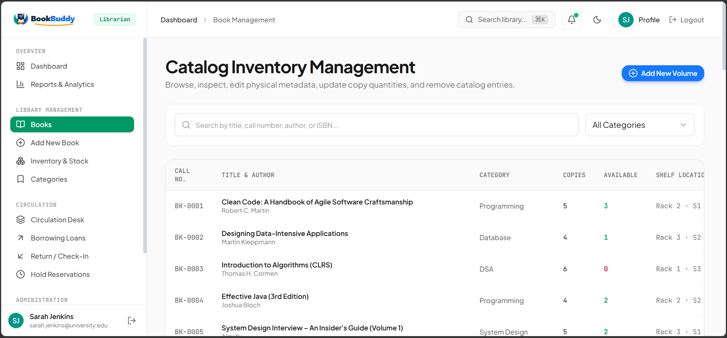

User’s Registration Page:
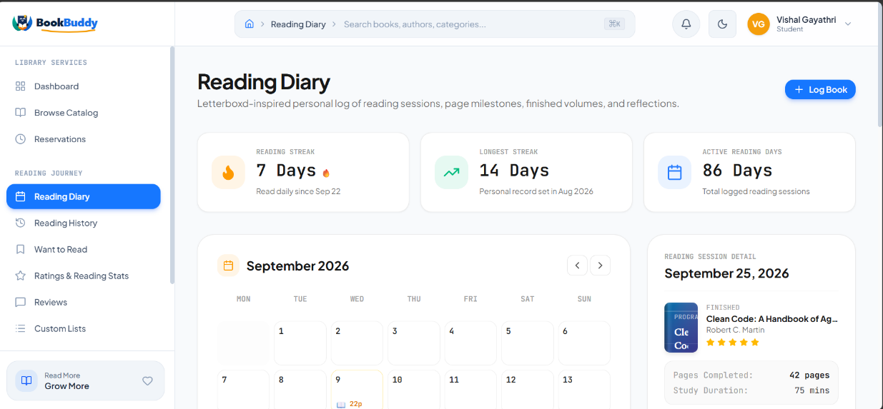

User’s Login Page:

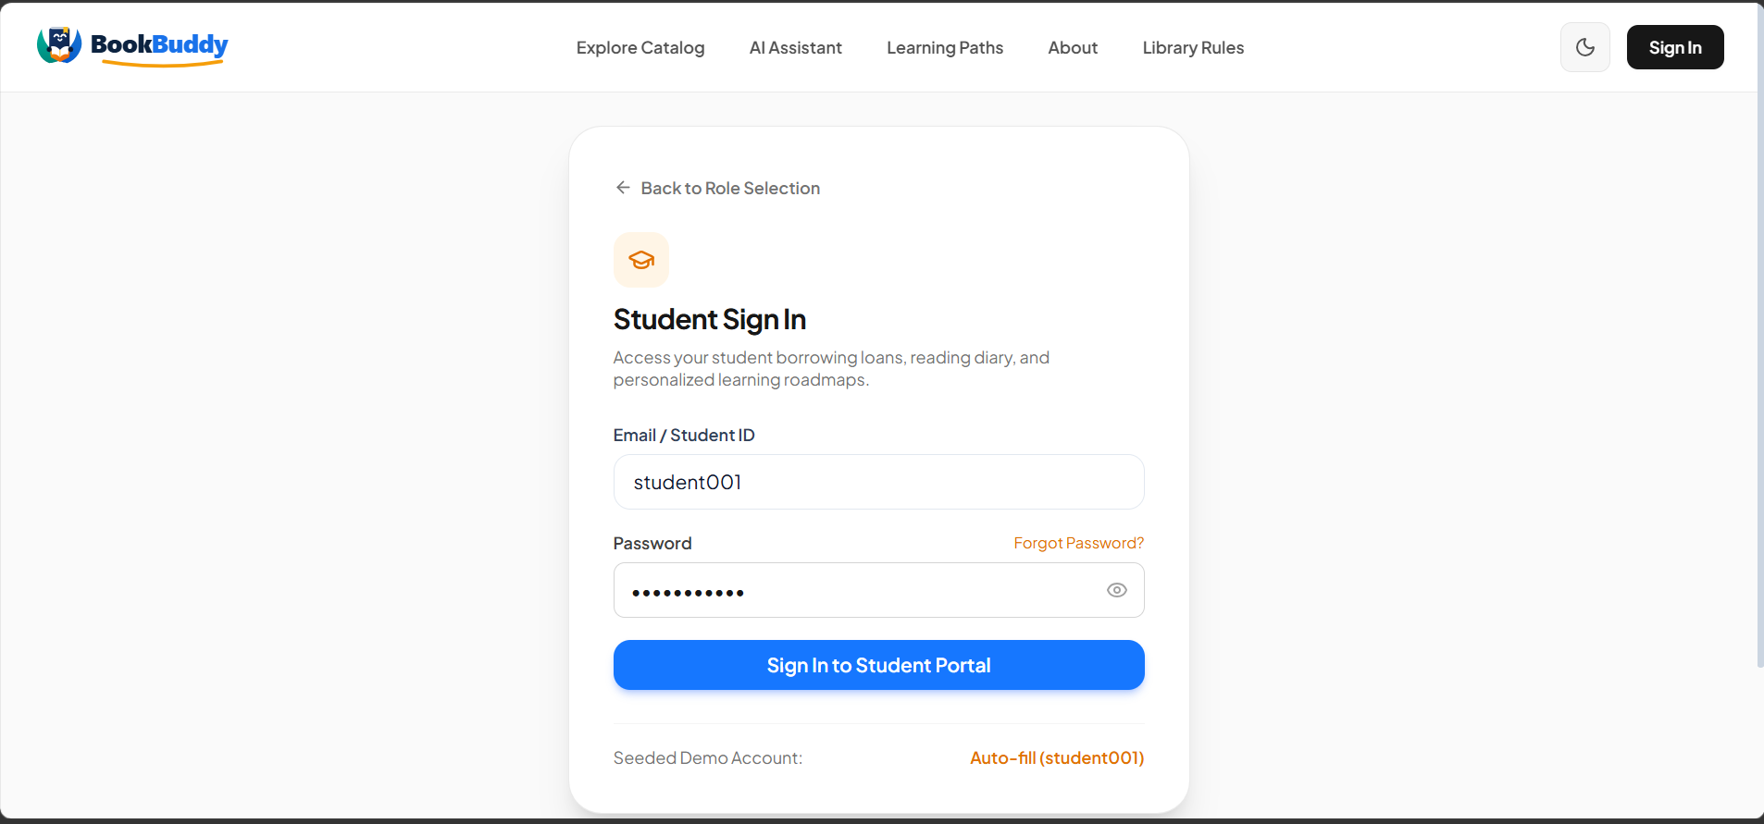

User’s HomePage:
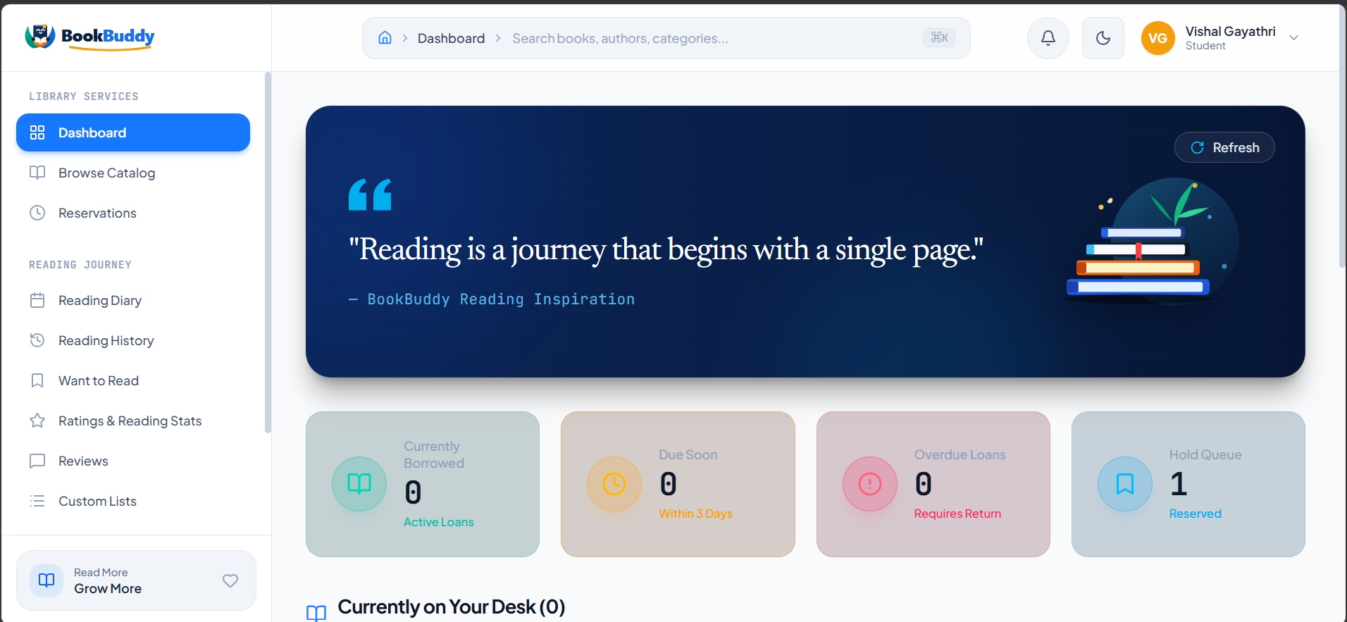

User’s Products Page:

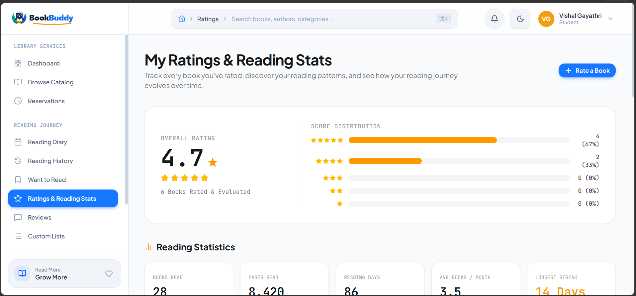

Report and Analytics Page:
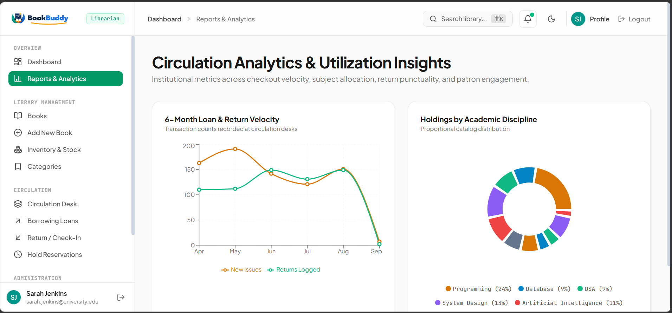

Circulation Desk:
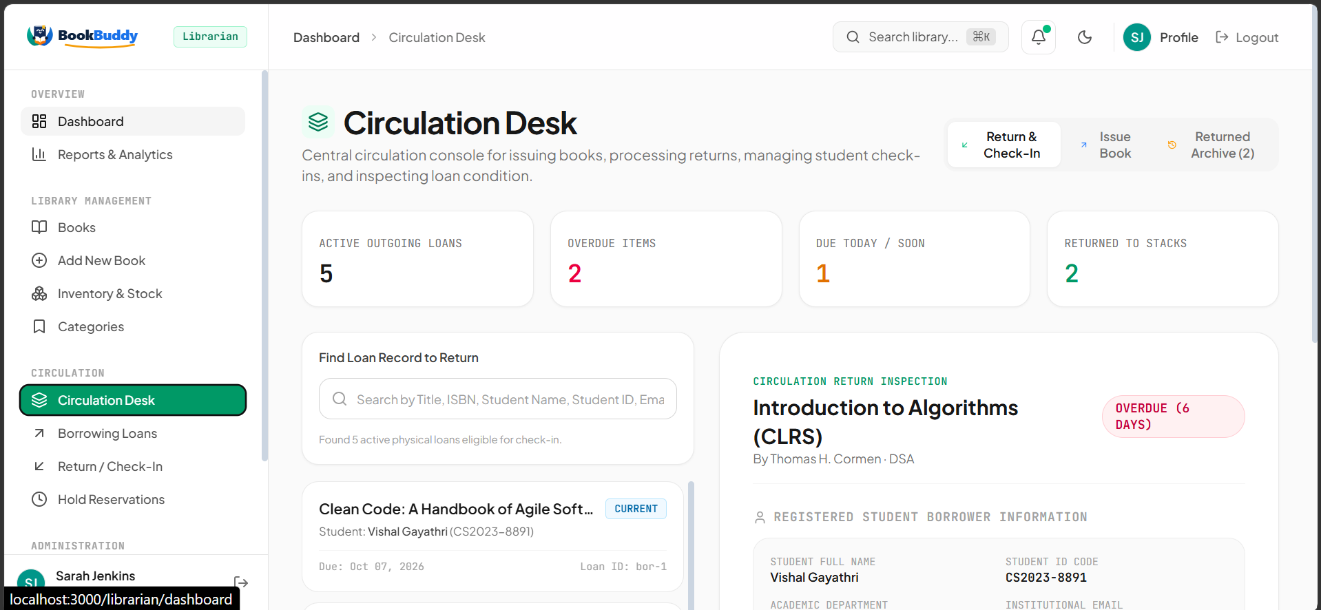

Library Physical Holiday ans Inventory Audit Page:
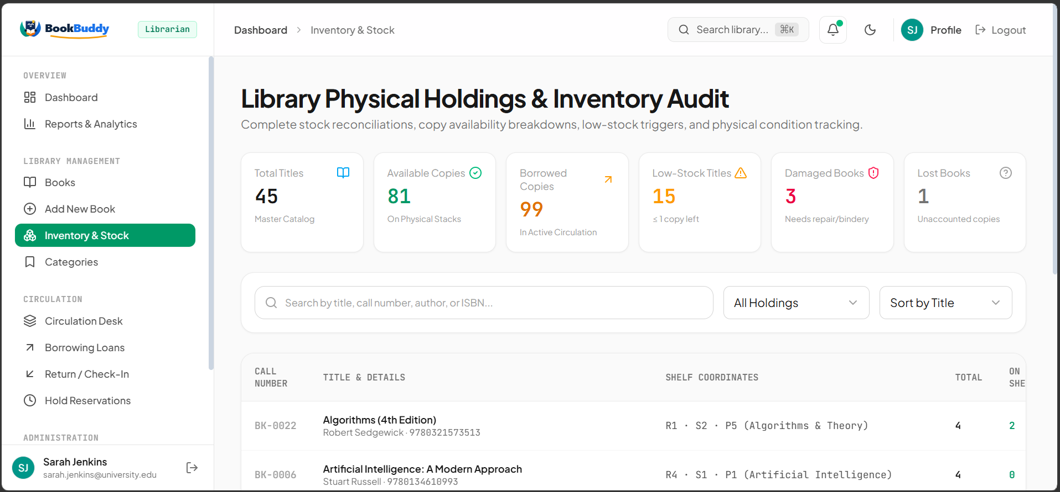

Demo Video Link:
https://drive.google.com/file/d/1XuTSN-HbfZ-Pp7mHl_zHRGNOb31sqPux/view?usp=drivesdk

Code Drive Link:
https://drive.google.com/file/d/1KBEQQwqaJjYbgBmOR23sPn7LvBUatCFZ/view?usp=sharing

