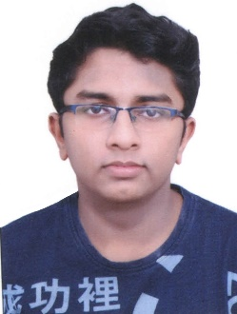Pratik Pujari

Mumbai, India [pratikpujari1000@gmail.com](mailto:pratikpujari1000@gmail.com) +91 9167421551 [LinkedIn Profile](https://www.linkedin.com/in/pratik-pujari-3472bb226/)

Passionate about learning new concepts in order to grasp a variety of knowledge which allowed me to develop ’Monster Chase’ game, 3D model of Tokyo SkyTree and Foodify app along with batchmates as a team which led to improvement of commumication and interpersonal skills.

|  |  |
| --- | --- |
| Education | Sardar Patel institute of technology JUN 2020 - May 2024(Projected)  **B. Tech in Computer Engineering**  C.G.P.A: 8.29  SHRI T.P BHATIA COLLEGE OF SCIENCE JUN 2018 – APRIL 2020  **12th HSC** 92%  ST. ANTHONY HIGH SCHOOL JUN 2012 - JUN 2018  **10th SSC** 93% |
| Projects | HEALTIFY WEBSITE – NOVEMEBER 2021  • Designed a website based on Health related issues and regarding common illness and  symptoms, solutions  • Using HTML/CSS, JavaScript  • Classification – 6.4/10  ARCADE LIBRARY – NOVEMEBER 2021  • Developed a program that contains upto 5 arcade games which reminds of old retro style  games with GUI interface  • Used Libraries: JAVA, MySQL, Java Util  • Classification – 9/10 |
| Skills | **MAIN DEVELOPMENT LANGUAGES**: Java, C/C++, Python, Dart,Flutter  **Web development:** HTML/CSS , Javascript  **DB DEVELOPMENT TOOLS:** SQL DBM, MySQL  **3D MODELING:** Blender, AutoCad  **GAME DEVELOPMENT:** UNITY 3D |
| Experience | Participated in Devheat GDSC Surat IIT 2021   * Constructed a website that advises on health-related issues and providing common solutions to the illness according to symptoms of the user   Participated in SPIT FACE-IT Hackathon   * Attempted in solving competitive level coding question on CodeChef Platform |
| Accomplishments | • Codewars Acc - Dracula_Codes (6 Kyu)  • Experience In Proteus, Sequel And Matlab  • Working With Masm/Tasm 8086 Assembly Language |