Test Cases run on the model
1. Simple Aggregation:
- Prompt: "Generate Python Pandas code to calculate the average value of 'Price' column from the CSV file."
- Expected Output: A Python Pandas code snippet that calculates the average of the 'Price' column.
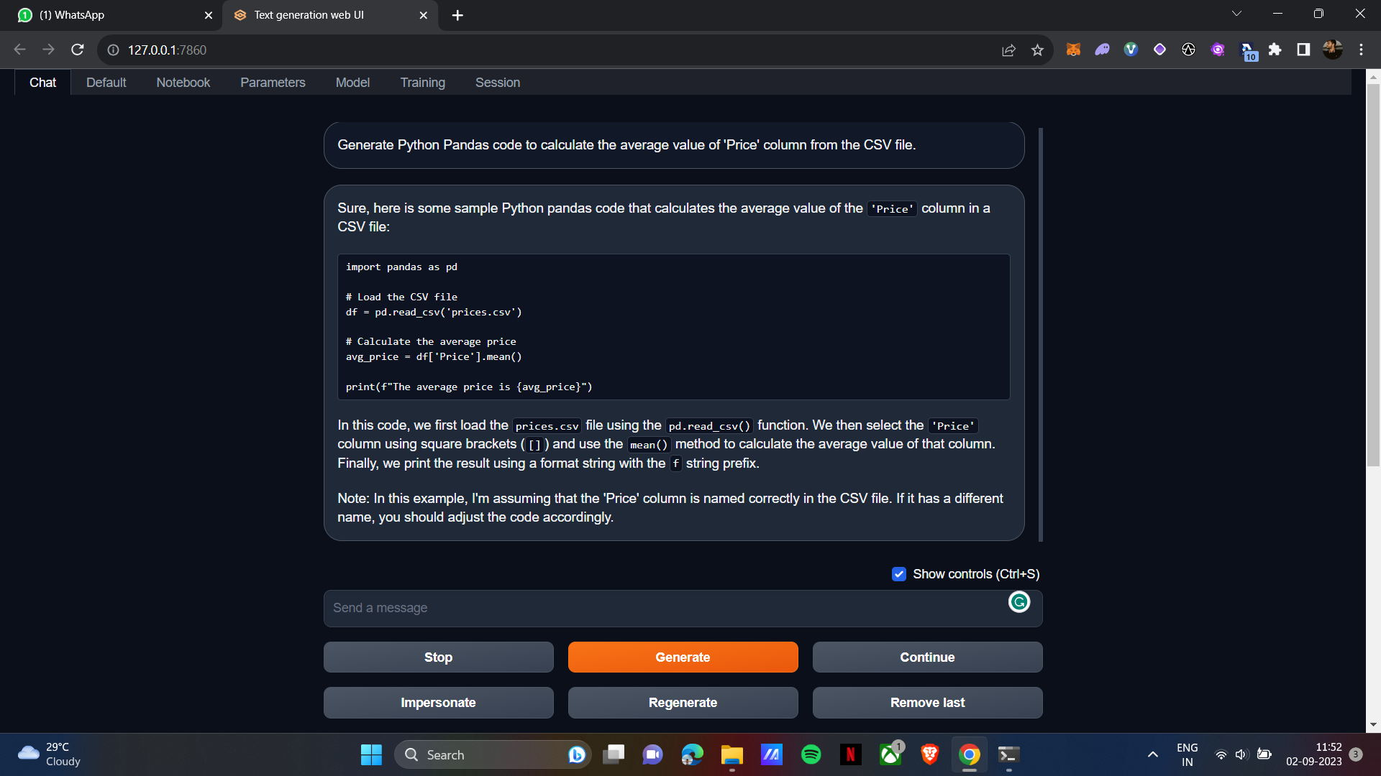

2. Filtering and Visualization:
- Prompt: "Generate Python Pandas code to filter rows where 'Category' is 'Electronics' and create a bar chart for the 'Quantity' column."
- Expected Output: Python Pandas code to filter rows with 'Electronics' in the 'Category' column and create a bar chart for 'Quantity'.
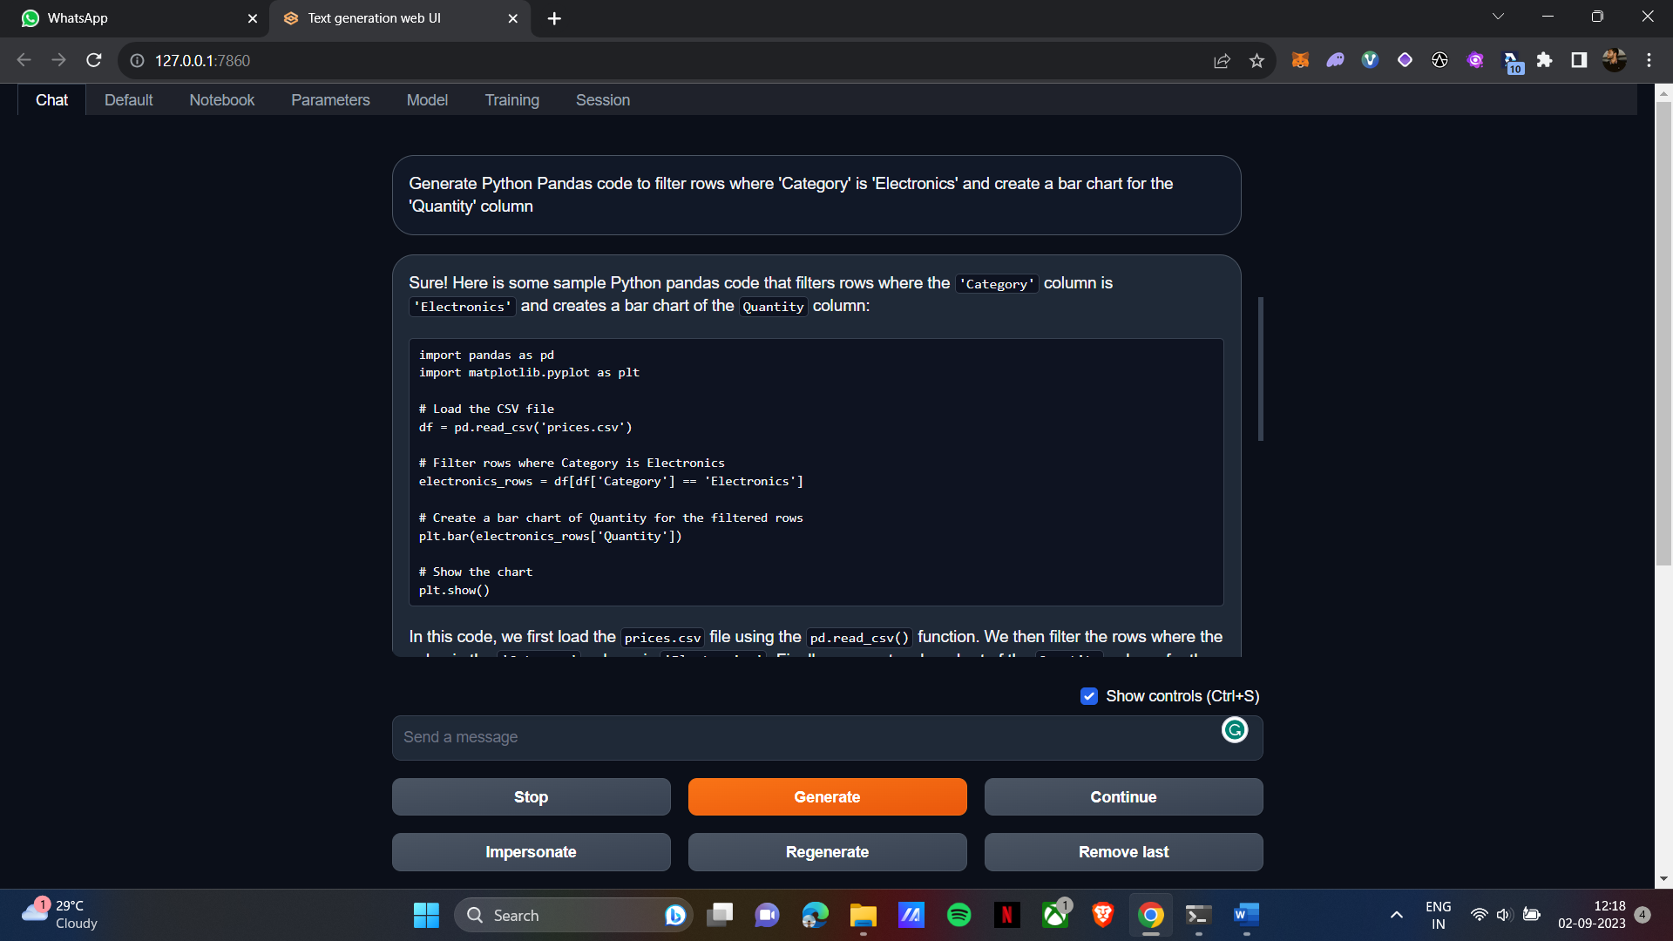

3. Testing Normal Prompts
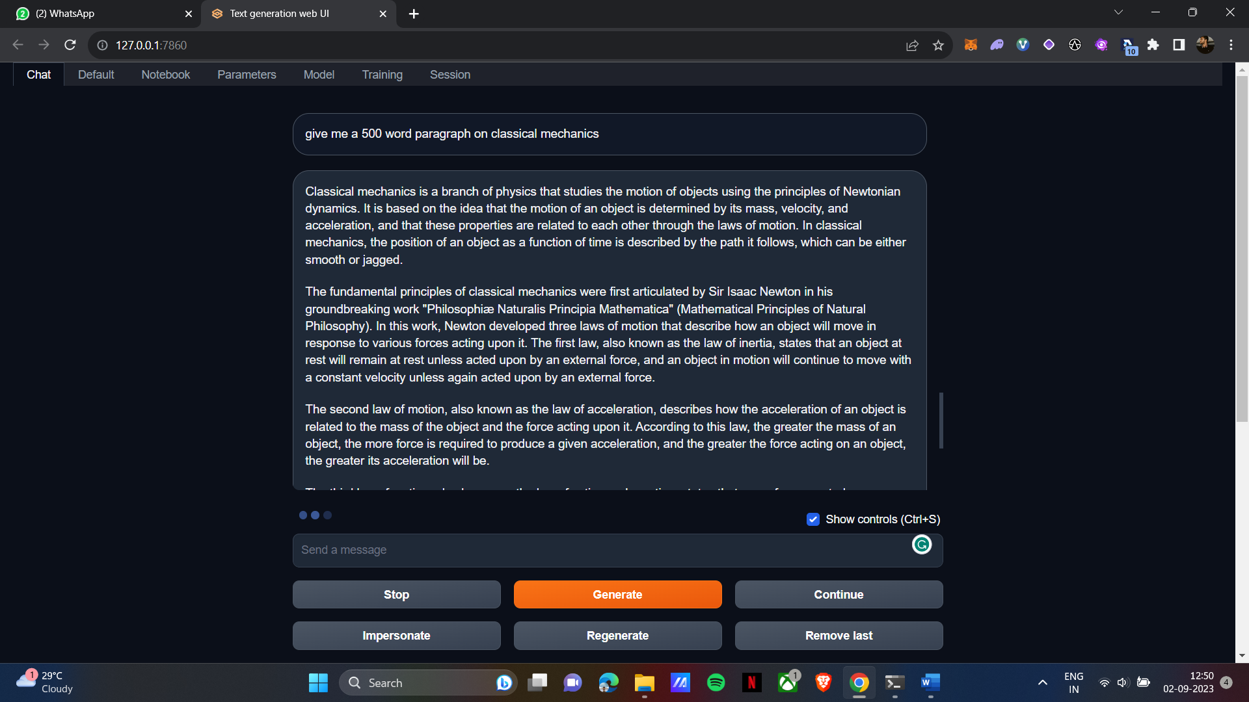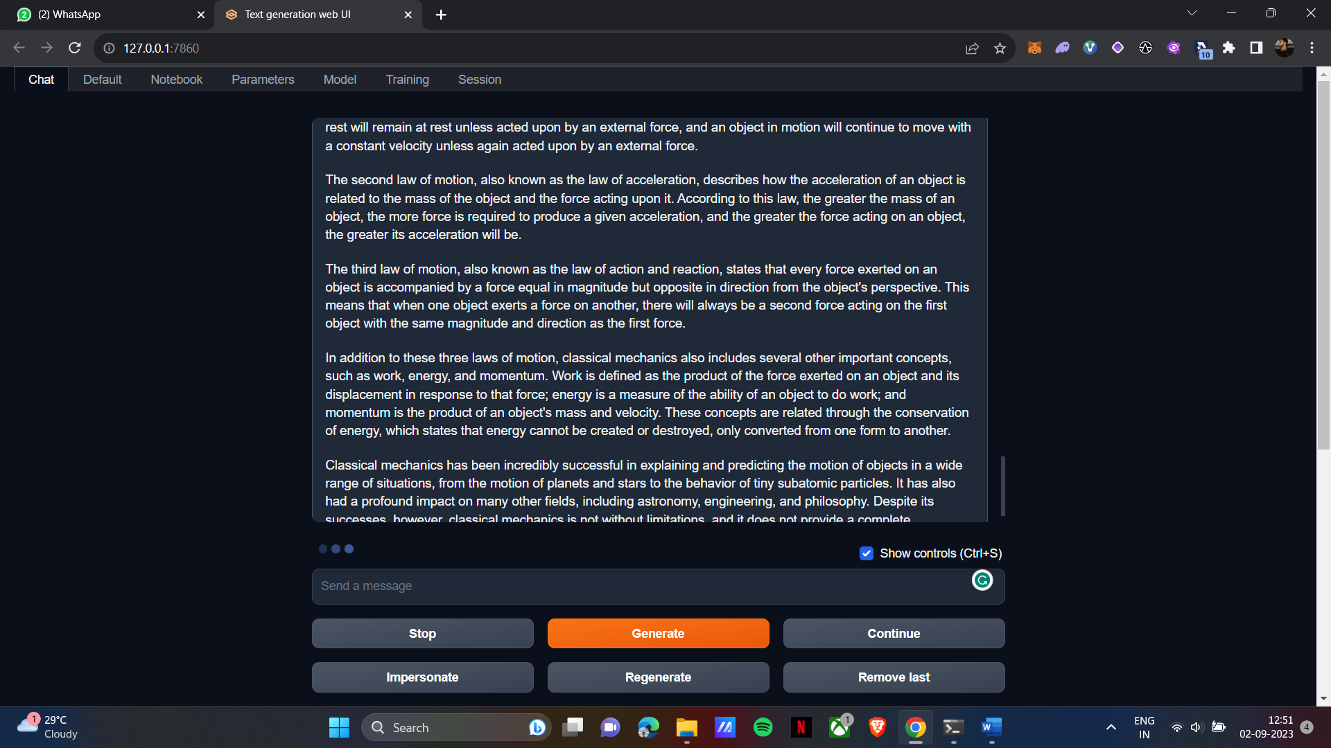
4. Data Transformation:
- Prompt: "Transform the 'Date' column to a datetime format and create a line chart to show the trend over time."
- Expected Output: Python Pandas code to convert 'Date' to a datetime format and generate a line chart to visualize the trend.
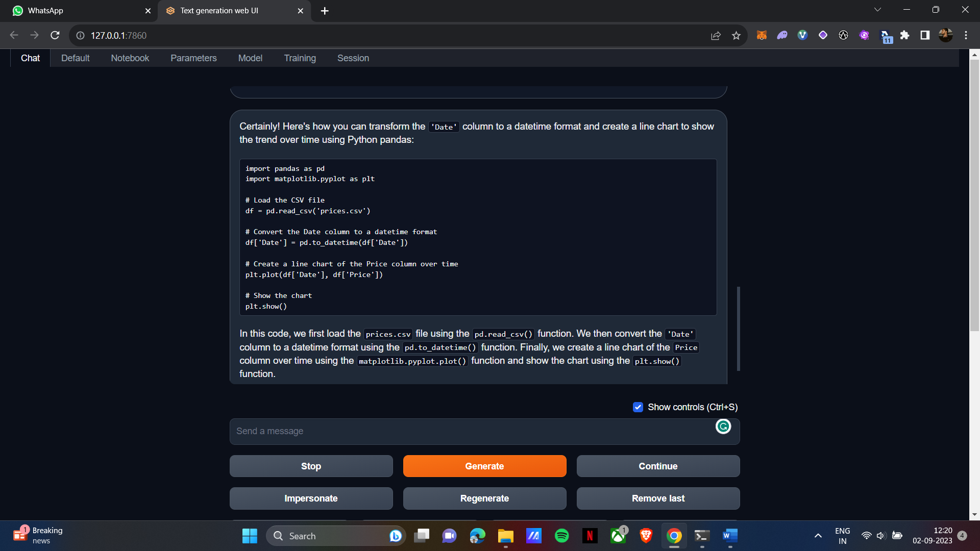
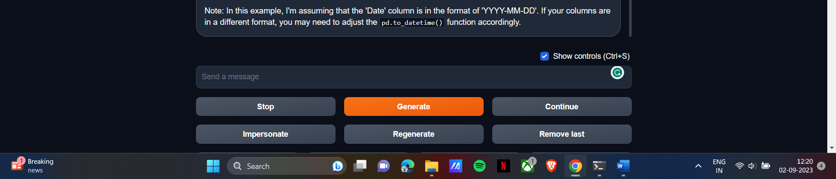

5. Multiple Data Manipulations:
- Prompt: "Generate Python Pandas code to calculate the sum of 'Revenue' for each 'Region,' filter rows where 'Year' is 2022, and create a stacked bar chart."
- Expected Output: Python Pandas code that performs the specified operations and creates a stacked bar chart.

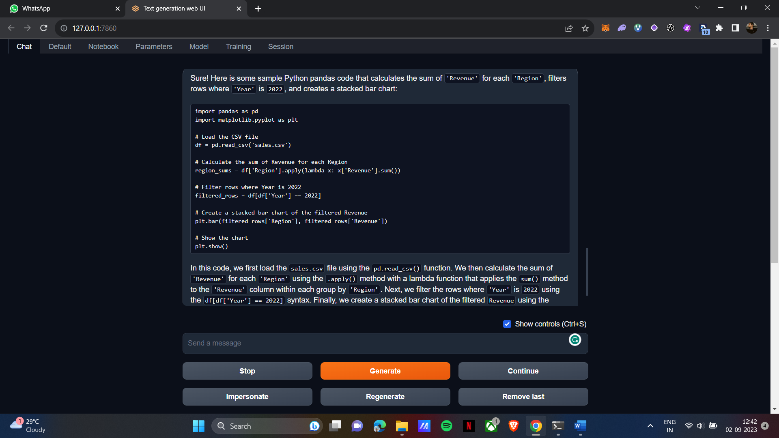

Fast API
import time
import copy
import asyncio
import requests
from fastapi import FastAPI, Request
from llama_cpp import Llama
from sse_starlette import EventSourceResponse
# Load the model
print("Loading model...")
llm = Llama(model_path="D:/Downloads/llama-2-7b-chat.Q2_K.gguf") # change based on the location of models
print("Model loaded!")
app = FastAPI()
@app.get("/llama")
async def llama(request: Request, question:str):
stream = llm(
f"""{question}""",
max_tokens=100,
stop=["\n", " Q:"],
stream=True,
)
async def async_generator():
for item in stream:
yield item
async def server_sent_events():
async for item in async_generator():
if await request.is_disconnected():
break
result = copy.deepcopy(item)
text = result["choices"][0]["text"]
yield {"data": text}
return EventSourceResponse(server_sent_events())

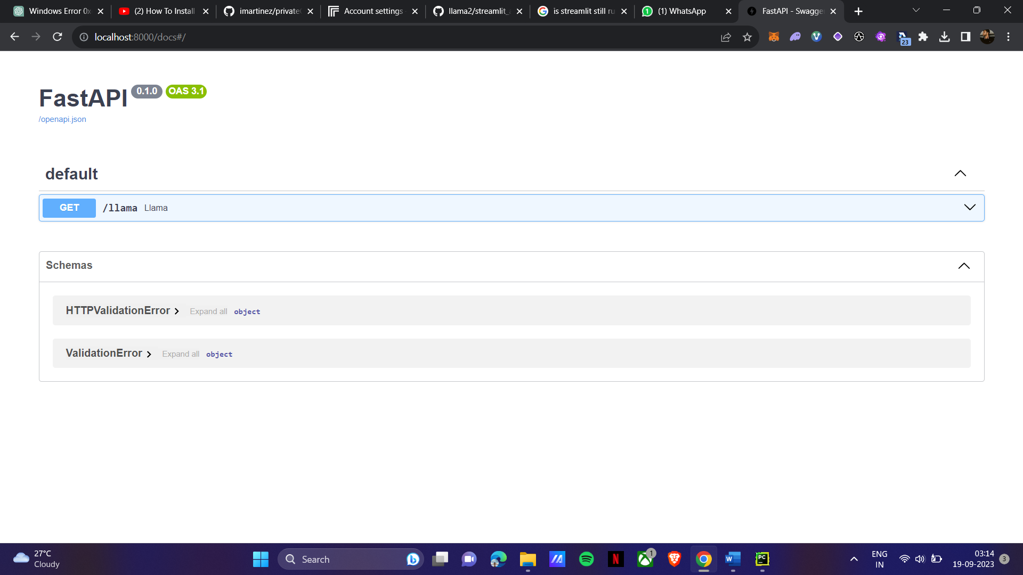

DocSense (Module-Chat with CSV)
Code:
import streamlit as st
from streamlit_chat import message
import tempfile
from langchain.document_loaders.csv_loader import CSVLoader
from langchain.embeddings import HuggingFaceEmbeddings
from langchain.vectorstores import FAISS
from langchain.llms import CTransformers
from langchain.chains import ConversationalRetrievalChain
DB_FAISS_PATH = 'vectorstore/db_faiss'
# Loading the model
def load_llm():
# Load the locally downloaded model here
llm = CTransformers(
model="D:/oobabooga_windows/oobabooga_windows/text-generation-webui/models/llama-2-7b-chat.ggmlv3.q4_1.bin",
model_type="llama",
max_new_tokens=512,
temperature=0.5
)
return llm
st.title("DocSense (Module- chat with csv)")
st.markdown(
"<h3 style='text-align: center; color: white;'>️ </a></h3>",
unsafe_allow_html=True)
uploaded_file = st.sidebar.file_uploader("Upload your Data", type="csv")
if uploaded_file:
# use tempfile because CSVLoader only accepts a file_path
with tempfile.NamedTemporaryFile(delete=False) as tmp_file:
tmp_file.write(uploaded_file.getvalue())
tmp_file_path = tmp_file.name
loader = CSVLoader(file_path=tmp_file_path, encoding="utf-8", csv_args={
'delimiter': ','})
data = loader.load()
# st.json(data)
embeddings = HuggingFaceEmbeddings(model_name='sentence-transformers/all-MiniLM-L6-v2',
model_kwargs={'device': 'cpu'})
db = FAISS.from_documents(data, embeddings)
db.save_local(DB_FAISS_PATH)
llm = load_llm()
chain = ConversationalRetrievalChain.from_llm(llm=llm, retriever=db.as_retriever())
def conversational_chat(query):
result = chain({"question": query, "chat_history": st.session_state['history']})
st.session_state['history'].append((query, result["answer"]))
return result["answer"]
if 'history' not in st.session_state:
st.session_state['history'] = []
if 'generated' not in st.session_state:
st.session_state['generated'] = ["Hello ! Ask me anything about " + uploaded_file.name ]
if 'past' not in st.session_state:
st.session_state['past'] = ["Hey ! 👋"]
# container for the chat history
response_container = st.container()
# container for the user's text input
container = st.container()
with container:
with st.form(key='my_form', clear_on_submit=True):
user_input = st.text_input("Query:", placeholder="Talk to your csv data here (:", key='input')
submit_button = st.form_submit_button(label='Send')
if submit_button and user_input:
output = conversational_chat(user_input)
st.session_state['past'].append(user_input)
st.session_state['generated'].append(output)
if st.session_state['generated']:
with response_container:
for i in range(len(st.session_state['generated'])):
message(st.session_state["past"][i], is_user=True, key=str(i) + '_user', avatar_style="big-smile")
message(st.session_state["generated"][i], key=str(i), avatar_style="thumbs")

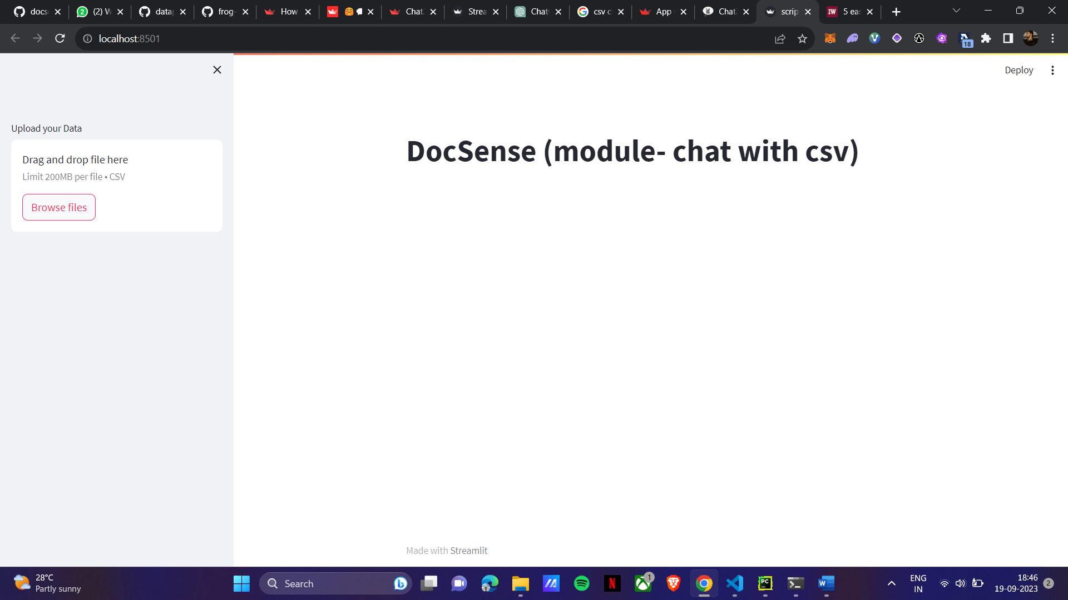
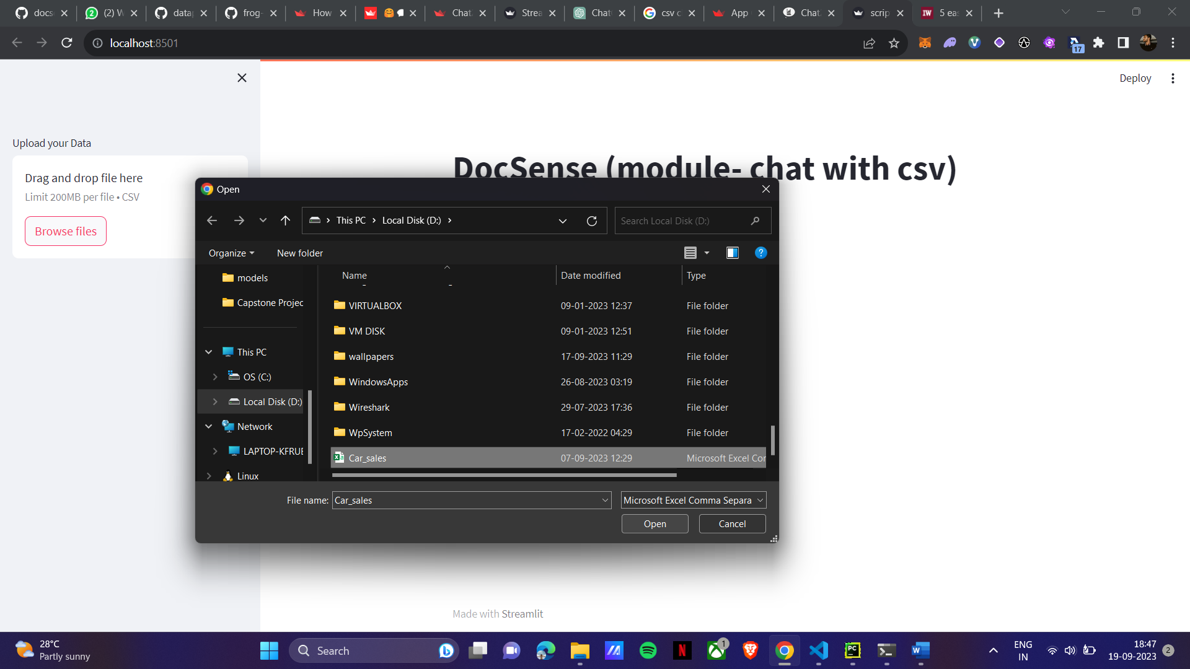
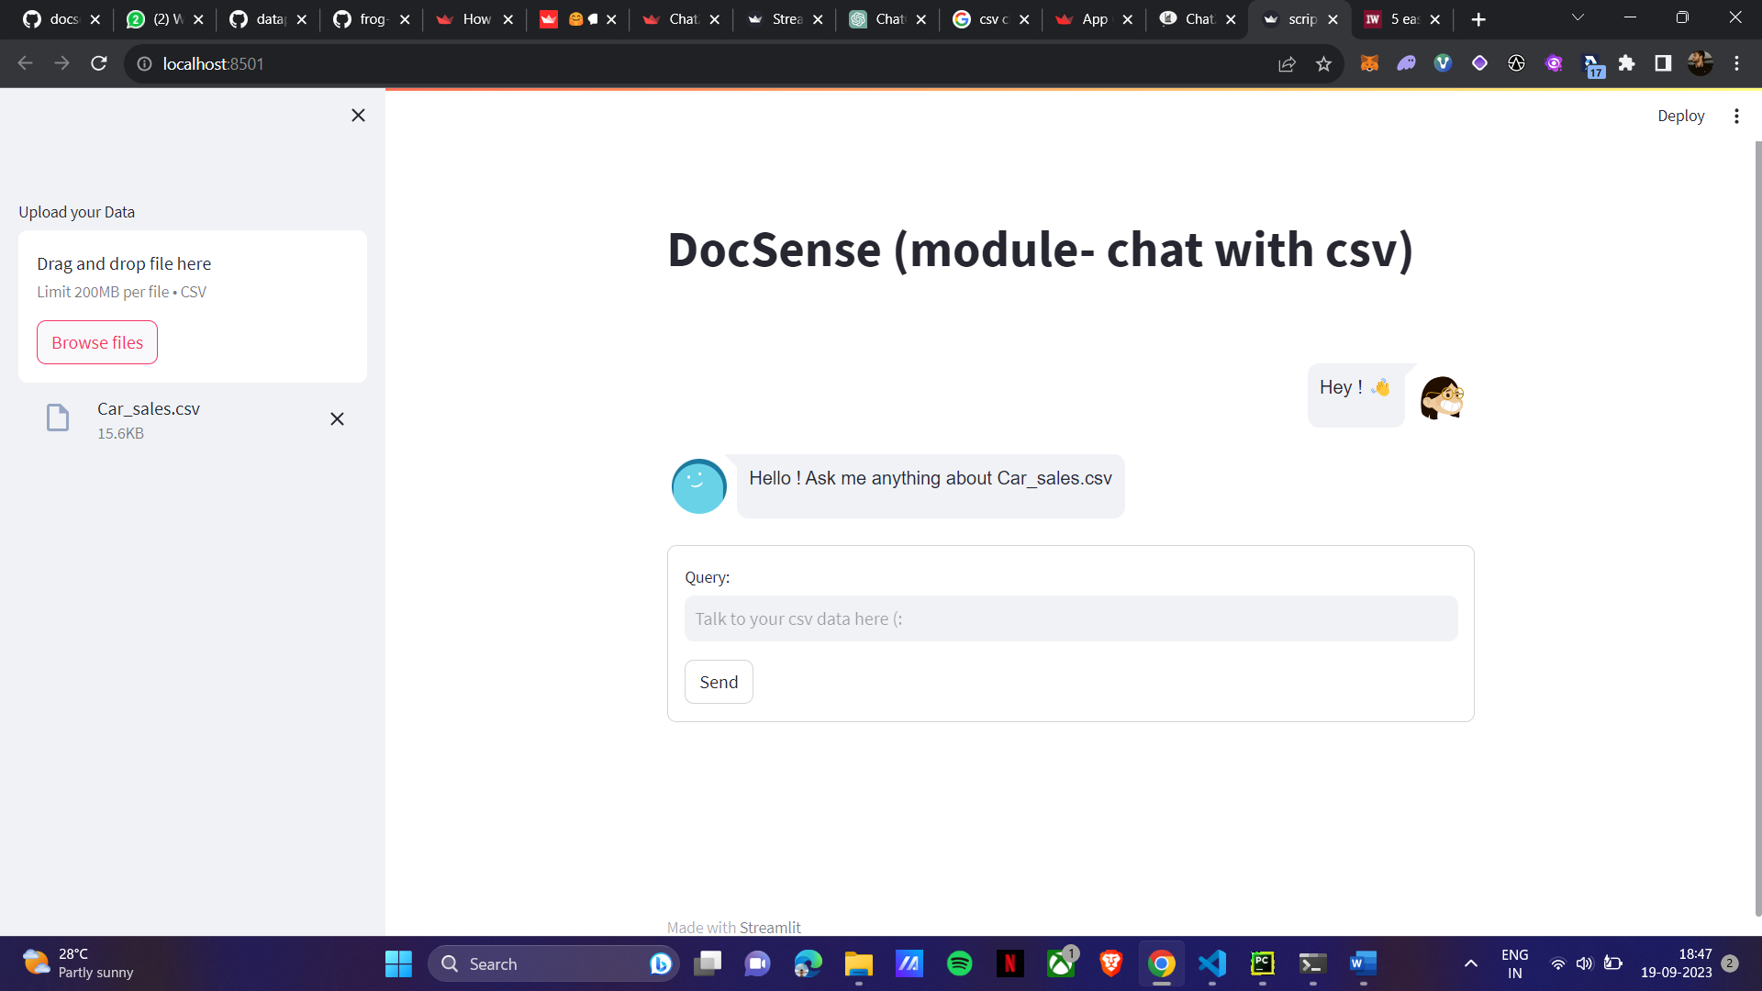

The model is not giving sensible answer because of the hardware limitations of the system and fine tuning of the model(remaining) due to that the number of tokens are getting exceeded from the maximum context length of the model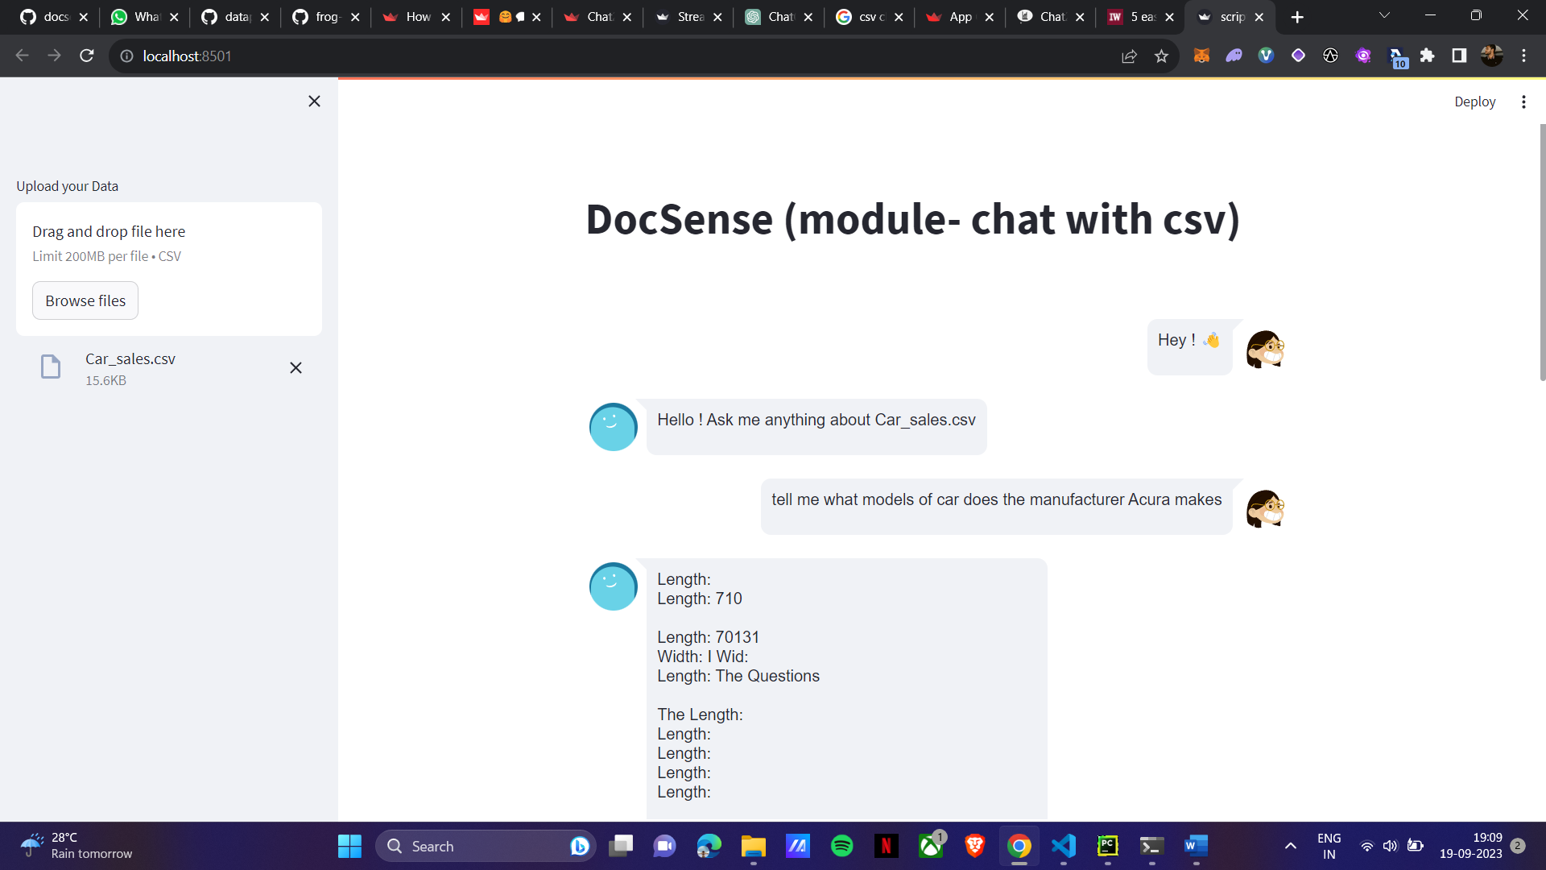

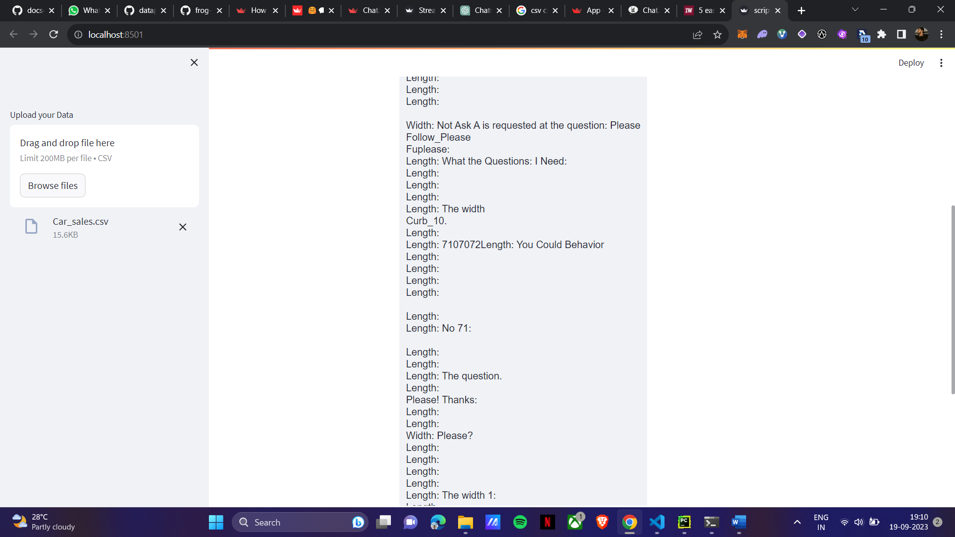
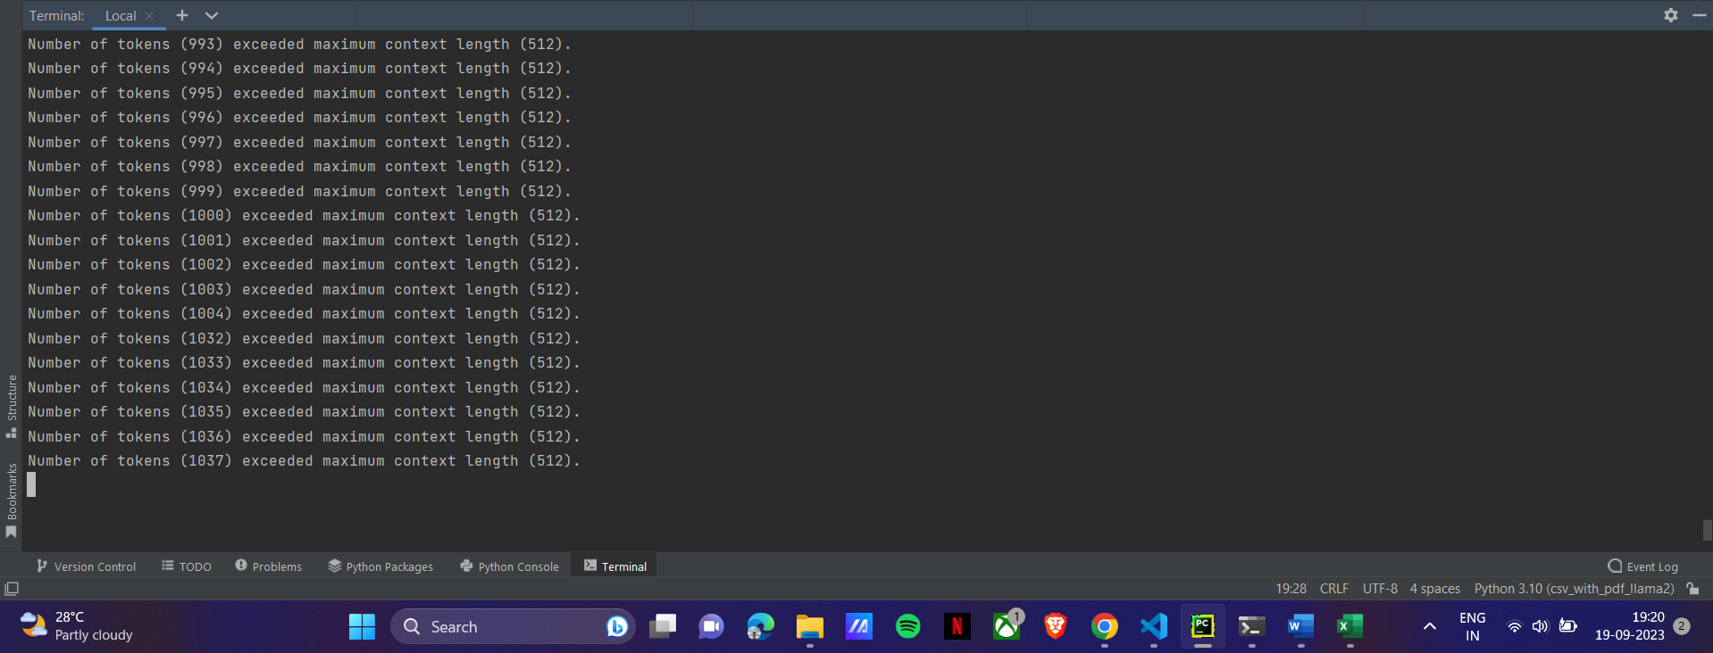

DocSense (Module- Youtube Summarizer)
Modeladd.py
from haystack.nodes import PromptModelInvocationLayer
from haystack.nodes.prompt.invocation_layer import DefaultTokenStreamingHandler
from llama_cpp import Llama
import os
from typing import Dict, List, Union, Type, Optional
import logging
logger = logging.getLogger(__name__)
class LlamaCPPInvocationLayer(PromptModelInvocationLayer):
def __init__(self, model_name_or_path: Union[str,os.PathLike],
max_length: Optional[int] = 128,
max_context: Optional[int] = 32000,
n_parts: Optional[int] = -1,
seed: Optional[int]= 1337,
f16_kv: Optional[bool] = True,
logits_all: Optional[bool] = False,
vocab_only: Optional[bool] = False,
use_mmap: Optional[bool] = True,
use_mlock: Optional[bool] = False,
embedding: Optional[bool] = False,
n_threads: Optional[int]= None,
n_batch: Optional[int] = 512,
last_n_tokens_size: Optional[int] = 64,
lora_base: Optional[str] = None,
lora_path: Optional[str] = None,
verbose: Optional[bool] = True,
**kwargs):
"""
Creates a new Llama CPP InvocationLayer instance.
:param model_name_or_path: The name or path of the underlying model.
:param kwargs: See `https://abetlen.github.io/llama-cpp-python/#llama_cpp.llama.Llama.__init__`. For max_length, we use the 128 'max_tokens' setting.
"""
if model_name_or_path is None or len(model_name_or_path) == 0:
raise ValueError("model_name_or_path cannot be None or empty string")
self.model_name_or_path = model_name_or_path
self.max_context = max_context
self.max_length = max_length
self.n_parts = n_parts
self.seed = seed
self.f16_kv = f16_kv
self.logits_all = logits_all
self.vocab_only = vocab_only
self.use_mmap = use_mmap
self.use_mlock = use_mlock
self.embedding = embedding
self.n_threads = n_threads
self.n_batch = n_batch
self.last_n_tokens_size = last_n_tokens_size
self.lora_base = lora_base
self.lora_path = lora_path
self.verbose = verbose
self.model = Llama(model_path = model_name_or_path,
n_ctx = max_context,
n_parts = n_parts,
seed = seed,
f16_kv = f16_kv,
logits_all = logits_all,
vocab_only = vocab_only,
use_mmap = use_mmap,
use_mlock = use_mlock,
embedding = embedding,
n_threads = n_threads,
n_batch = n_batch,
last_n_tokens_size = last_n_tokens_size,
lora_base = lora_base,
lora_path = lora_path,
verbose = verbose)
def _ensure_token_limit(self, prompt: Union[str, List[Dict[str, str]]]) -> Union[str, List[Dict[str, str]]]:
"""Ensure that length of the prompt and answer is within the maximum token length of the PromptModel.
:param prompt: Prompt text to be sent to the generative model.
"""
if not isinstance(prompt, str):
raise ValueError(f"Prompt must be of type str but got {type(prompt)}")
context_length = self.model.n_ctx()
tokenized_prompt = self.model.tokenize(bytes(prompt,'utf-8'))
if len(tokenized_prompt) + self.max_length > context_length:
logger.warning(
"The prompt has been truncated from %s tokens to %s tokens so that the prompt length and "
"answer length (%s tokens) fit within the max token limit (%s tokens). "
"Shorten the prompt to prevent it from being cut off",
len(tokenized_prompt),
max(0, context_length - self.max_length),
self.max_length,
context_length,
)
return bytes.decode(self.model.detokenize(tokenized_prompt[:max(0, context_length - self.max_length)]),'utf-8')
return prompt
def invoke(self, *args, **kwargs):
"""
It takes a prompt and returns a list of generated text using the underlying model.
:return: A list of generated text.
"""
output: List[Dict[str, str]] = []
stream = kwargs.pop("stream",False)
generated_texts = []
if kwargs and "prompt" in kwargs:
prompt = kwargs.pop("prompt")
# For more details refer to call documentation for Llama CPP https://abetlen.github.io/llama-cpp-python/#llama_cpp.llama.Llama.__call__
model_input_kwargs = {
key: kwargs[key]
for key in [
"suffix",
"max_tokens",
"temperature",
"top_p",
"logprobs",
"echo",
"repeat_penalty",
"top_k",
"stop"
]
if key in kwargs
}
if stream:
for token in self.model(prompt,stream=True,**model_input_kwargs):
generated_texts.append(token['choices'][0]['text'])
else:
output = self.model(prompt,**model_input_kwargs)
generated_texts = [o['text'] for o in output['choices']]
return generated_texts
def supports(cls, model_name_or_path: str, **kwargs) -> bool:
"""
Checks if the given model is supported by this invocation layer.
:param model_name_or_path: The name or path of the model.
:param kwargs: Additional keyword arguments passed to the underlying model which might be used to determine
if the model is supported.
:return: True if this invocation layer supports the model, False otherwise.
"""
#I guess there is not much to validate here ¯\_(ツ)_/¯
return model_name_or_path is not None and len(model_name_or_path) > 0

summary.py
from pytube import YouTube
from haystack.nodes import PromptNode, PromptModel
from haystack.nodes.audio import WhisperTranscriber
from haystack.pipelines import Pipeline
from model_add import LlamaCPPInvocationLayer
summary_prompt = "deepset/summarization"
def youtube2audio (url: str):
yt = YouTube(url)
video = yt.streams.filter(abr='160kbps').last()
return video.download()
whisper = WhisperTranscriber()
full_path = "llama-2-7b-32k-instruct.Q4_K_S.gguf"
model = PromptModel(model_name_or_path=full_path, invocation_layer_class=LlamaCPPInvocationLayer, use_gpu=False, max_length=512)
print(model)
prompt_node = PromptNode(model_name_or_path=model, default_prompt_template=summary_prompt, use_gpu=False)
print("###############################################")
print(prompt_node)
print("###############################################")
file_path = youtube2audio("https://www.youtube.com/watch?v=h5id4erwD4s")
pipeline = Pipeline()
pipeline.add_node(component=whisper, name="whisper", inputs=["File"])
pipeline.add_node(component=prompt_node, name="prompt", inputs=["whisper"])
output = pipeline.run(file_paths=[file_path])
print(output["results"])
print(output["results"][0].split("\n\n[INST]")[0])

yt_summary.py
import streamlit as st
from pytube import YouTube
from haystack.nodes import PromptNode, PromptModel
from haystack.nodes.audio import WhisperTranscriber
from haystack.pipelines import Pipeline
from model_add import LlamaCPPInvocationLayer
import time
st.set_page_config(
layout="wide"
)
def download_video(url):
yt = YouTube(url)
video = yt.streams.filter(abr='160kbps').last()
return video.download()
def initialize_model(full_path):
return PromptModel(
model_name_or_path=full_path,
invocation_layer_class=LlamaCPPInvocationLayer,
use_gpu=False,
max_length=512
)
def initialize_prompt_node(model):
summary_prompt = "deepset/summarization"
return PromptNode(model_name_or_path=model, default_prompt_template=summary_prompt, use_gpu=False)
def transcribe_audio(file_path, prompt_node):
whisper = WhisperTranscriber()
pipeline = Pipeline()
pipeline.add_node(component=whisper, name="whisper", inputs=["File"])
pipeline.add_node(component=prompt_node, name="prompt", inputs=["whisper"])
output = pipeline.run(file_paths=[file_path])
return output
def main():
# Set the title and background color
st.title("DocSense(Module- Youtube Video Summarizer)")
st.markdown('<style>h1{color: Black; text-align: center;}</style>', unsafe_allow_html=True)
# Input box for YouTube URL
youtube_url = st.text_input("Enter YouTube URL")
# Submit button
if st.button("Submit") and youtube_url:
start_time = time.time() # Start the timer
# Download video
file_path = download_video(youtube_url)
# Initialize model
full_path = "D:/Downloads/llama-2-7b-32k-instruct.Q4_K_S.gguf"
model = initialize_model(full_path)
prompt_node = prompt_node = initialize_prompt_node(model)
# Transcribe audio
output = transcribe_audio(file_path, prompt_node)
end_time = time.time() # End the timer
elapsed_time = end_time - start_time
# Display layout with 2 columns
col1, col2 = st.columns([1,1])
# Column 1: Video view
with col1:
st.video(youtube_url)
# Column 2: Summary View
with col2:
st.header("Summarization of YouTube Video")
st.write(output)
st.success(output["results"][0].split("\n\n[INST]")[0])
st.write(f"Time taken: {elapsed_time:.2f} seconds")
if __name__ == "__main__":
main()

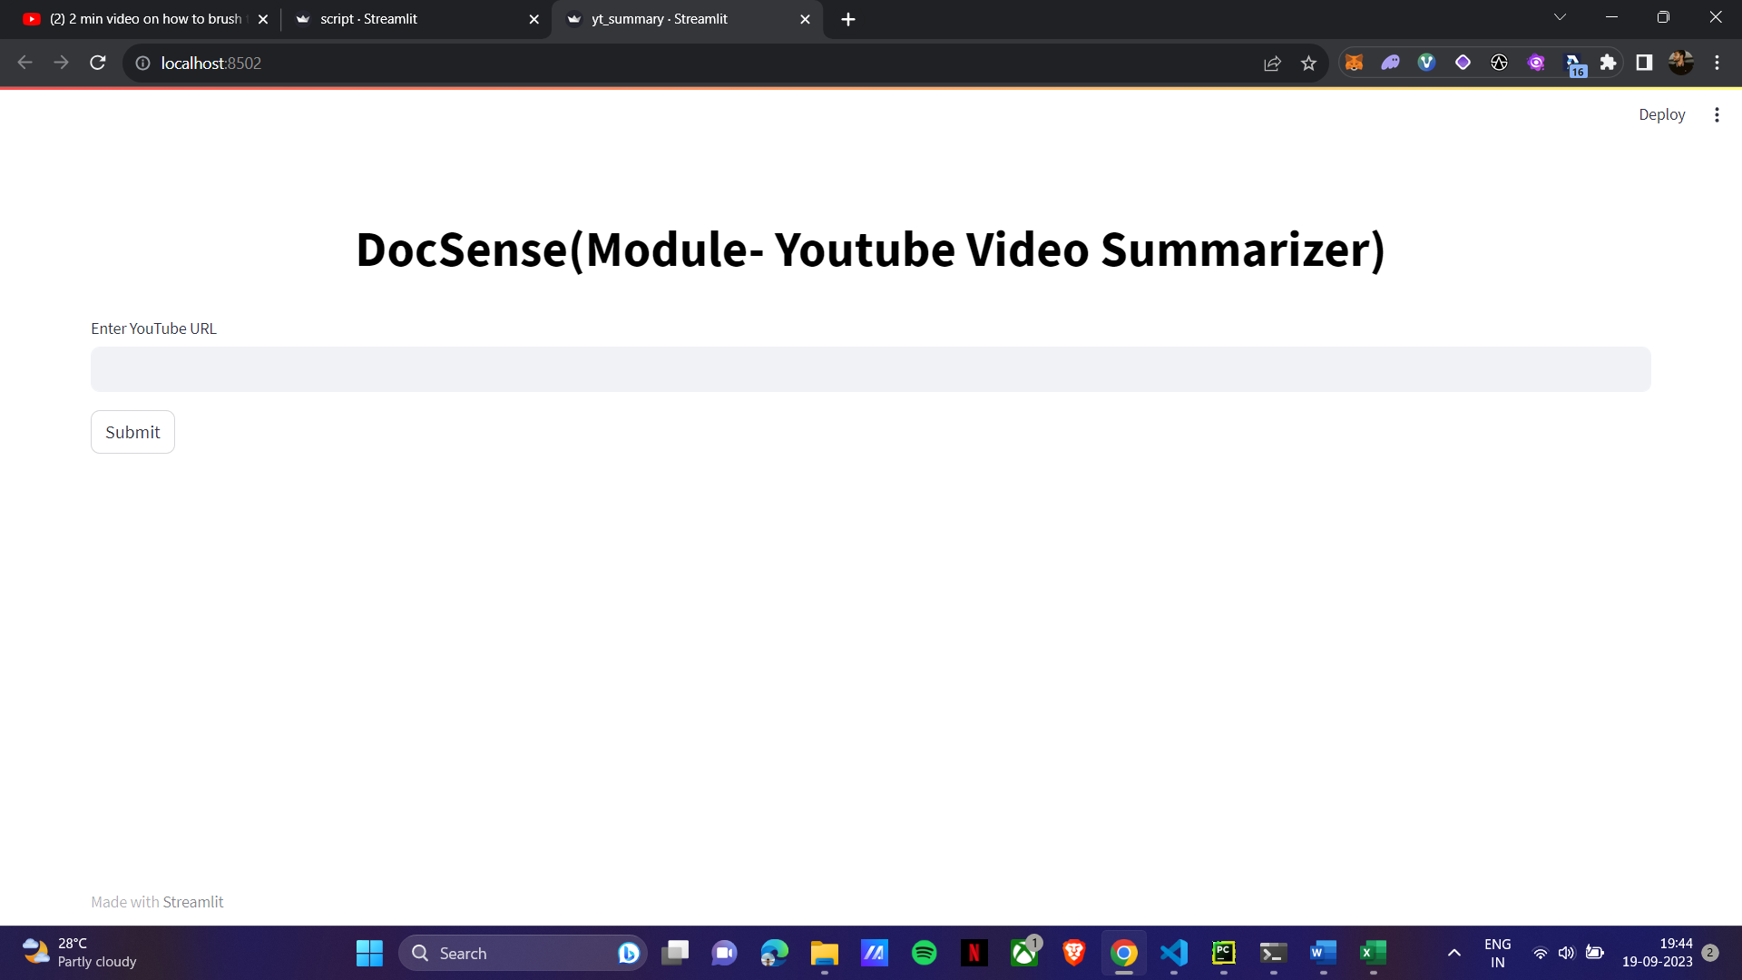
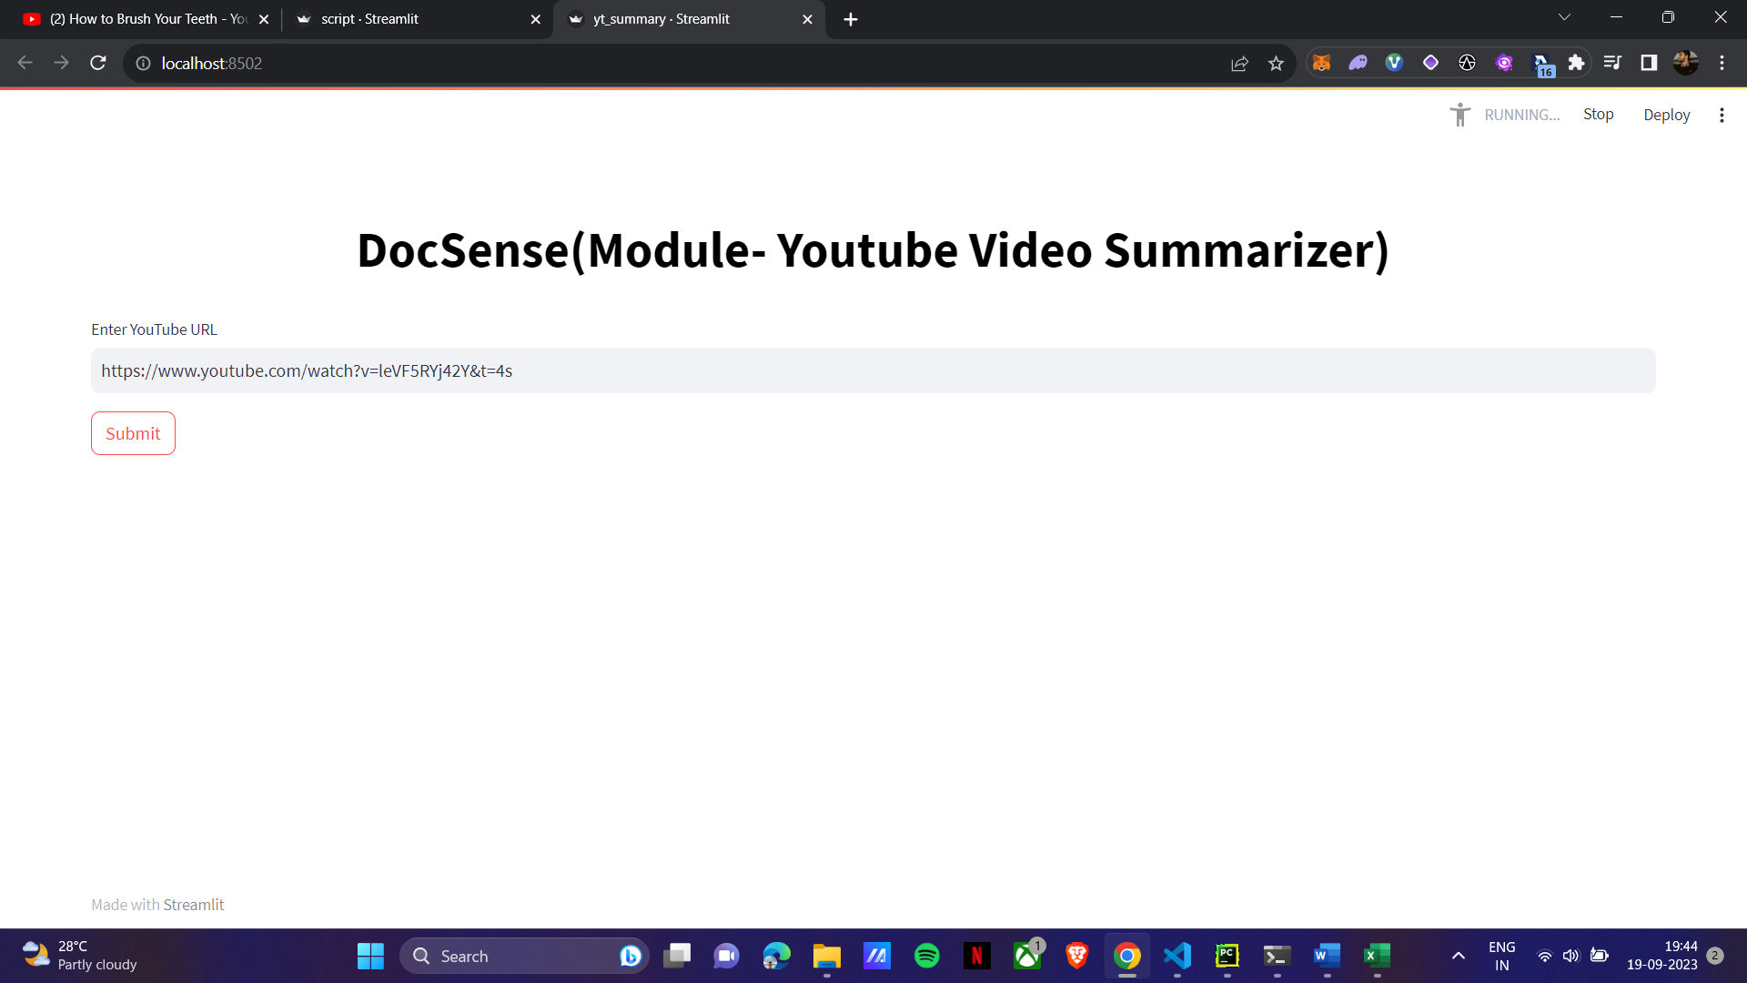

Same Problem follows of hardware capabilities here due to which streamlit is getting timed out in this case.
