Draftly
Grounded Legal Retrieval and Lawyer-Gated Drafting
for Sri Lankan Conveyancing
Final Project Report

In23-S5-CS3501 Data Science and Engineering Project
Group 06
230139N Dhanapala D.H.N.
230150N Dilshan A.D.L.
230123K De Silva B.K.P.

Supervisor: Dr. Nisansa de Silva
Teaching Assistant: Ovindu Atukorala

Department of Computer Science and Engineering
University of Moratuwa
October 2026

Abstract
A conveyancing answer in Sri Lanka is correct only when every provision on which it depends has been found, yet the governing law is spread across principal enactments, amending Acts, gazetted regulations and case law, and the client evidence arrives as scanned bundles in Sinhala, Tamil and English. General language models produce fluent answers with fabricated citations, a failure mode that is unacceptable in legal practice. This report presents Draftly, a platform that retrieves the statutory authority a conveyancing question requires, cites that authority or abstains, and converts lawyer-verified facts into prescribed Registration of Title Act instruments that only a lawyer may approve. The research component built a frozen corpus of 52 principal and 60 amending Acts with 4,557 sections and 6,346 typed relationships, and a benchmark of 50 scenario questions drawn from sixteen Sri Lanka Law College examination papers, each mapped to the sections indispensable to a complete answer. Seven retrieval systems, from BM25 to a hierarchical retriever that expands along typed statutory edges, were compared under complete-indispensable recall with matter-level bootstrap intervals. Hybrid fusion of BM25 and dense retrieval proved strongest (complete recall at 20 of 0.344 against 0.312 for the structure-aware retriever, a difference whose interval includes zero), no system completed a question requiring four or more sections, and a temporal filter removed every out-of-force section from the ranked results. This work was accepted at the NeurIPS 2026 GlobalSouthAI workshop. The findings set the design of the deployed retrieval engine, which fuses lexical and dense channels, passes every claim through a citation gate and returns an explicit abstention when authority is insufficient. The drafting platform implements the conveyancing workflow on a governed, versioned rule pack of 145 requirements and 25 deterministic checks, extracts candidate facts with Google Cloud Vision and a bounded language model, and enforces seven safety rules verified by 3,906 passing backend tests at 85.4 percent line coverage. All generated content remains unverified until a lawyer approves it, and the benchmark labels await a three-attorney validation whose protocol is specified in this report.

Table of Contents
Abstract 2
1 Introduction 5
1.1 Background of the Application Domain 5
1.2 Motivation 5
1.3 Importance and Purpose of the System 5
1.4 Overview of the System, Approach and Outcome 5
2 Literature Review 6
3 System Models 7
3.1 System Requirements 7
3.2 System Design 8
3.2.1 Architecture 8
3.2.2 Logical View 9
3.2.3 Process View 10
3.3 Database Design 11
3.4 Machine Learning and Data Science System Design 12
3.4.1 Corpus and Benchmark Construction 12
3.4.2 Retrieval Systems and the Chosen Engine 13
3.4.3 Grounded Answering and Abstention 14
3.4.4 Case-Law Rule Extraction 14
3.4.5 Document Reading and Field Extraction 14
4 System Implementation 15
4.1 Implementation Procedure 15
4.2 Materials 15
4.3 The Algorithm 16
4.4 Main Interfaces 17
5 System Testing and Analysis 18
5.1 Testing Approach 18
5.2 Unit Testing, Results and Analysis 19
5.3 Performance, Security and Failure Aspects 19
5.4 Evaluation of Machine Learning Models 19
6 Conclusion and Future Work 21
References 22
Appendix 23
Appendix A. Project Schedule 23
Appendix B. Confidence Intervals for Retrieval Results 23
Appendix C. Rule Pack Summary 23
Appendix D. Case-Law Pipeline Coverage 23
Appendix E. Demonstration Script 23
Appendix F. Grounded Research Sequence 24

1 Introduction
1.1 Background of the Application Domain
Conveyancing in Sri Lanka is the professional work of examining title to land, drafting the instruments that transfer or charge it, and executing, attesting and registering those instruments. Before a single line of a deed is drafted, a notary must establish that the seller owns the property, that the land is identified without ambiguity, that no undisclosed mortgage or charge affects it, which provisions and prescribed forms govern the transaction, whether any judgment alters how it must be handled, and that every execution and attestation requirement has been met. Four registration regimes coexist, and each differs in the legal effect of registration, the documents required and the forms used. This project addresses post-certificate transactions under the Registration of Title Act, No. 21 of 1998 [1], because that regime is statute-driven, uses gazetted prescribed forms and has a comparatively bounded scope.
1.2 Motivation
The law that governs one deed is fragmented and changes over time. The frozen corpus assembled for this project alone holds 112 enactments, and 21.5 percent of the links between reported judgments and statutory sections cite a section that was amended after the court decided the case, so the consolidated text available today is not always the law that applied. The client evidence is equally difficult: on a representative matter, 28.7 percent of the characters read by optical character recognition were Sinhala or Tamil, and sixteen of twenty-six pages required rotation before they could be read. Consultations with practising lawyers, notaries and a lecturer of Sri Lanka Law College [VERIFY: number of consultations] confirmed that junior practitioners assemble this information by hand, from several publishers and formats, with no assurance that the version in front of them is the one in force.
1.3 Importance and Purpose of the System
A missing provision, a misread parcel number or a superseded section can invalidate an instrument or expose a client to loss. General-purpose language models are unsuitable for this work because they generate plausible text and citations that no source supports. The purpose of Draftly is therefore not to replace the lawyer but to assemble the governing authority and the verified facts on which the lawyer decides: every answer must cite retrieved statutory text or abstain, every extracted fact remains a candidate until a lawyer verifies it, and no instrument can be exported until a lawyer approves it.
1.4 Overview of the System, Approach and Outcome
Draftly is one project with three connected parts. A research stage built a scenario benchmark from Law College examinations and measured whether structure-aware retrieval finds complete sets of indispensable provisions better than flat retrieval; the resulting paper was accepted at the NeurIPS 2026 GlobalSouthAI workshop [2]. That evidence set the design of the retrieval engine, which fuses lexical and dense retrieval, gates every claim on a retrieved citation and abstains when authority is insufficient. The drafting platform runs the Registration of Title Act workflow on a versioned rule pack, reads scanned documents, runs deterministic cross-document checks, drafts prescribed forms from verified facts and records every material action in a tamper-evident audit log. The principal outcomes are a published benchmark finding, a deployed engine, a tested platform and a documented plan for the lawyer validation that remains outstanding.
2 Literature Review
Legal information retrieval has been evaluated mostly by scoring cases or passages independently. IL-PCSR retrieves prior cases and statutes jointly from the text of Indian judgments [3], and LegalBench-RAG measures passage-level retrieval for legal question answering [4]. Such measures reward a system that finds one relevant provision, whereas a conveyancing answer is complete only when all of the provisions it depends on are found. More recent statute-oriented resources pose scenario questions whose facts share little vocabulary with the controlling text [5]. KoBLEX introduced provision-grounded multi-hop legal questions with a set-level exact-match measure [6], GreekBarRetrieval pairs bar-examination questions with the articles cited in official solutions [7], and further work has examined structure-aware [8] and temporally sensitive [9] statutory retrieval. None of these resources jointly separates indispensable from supporting provisions, scores with an all-or-nothing bundle measure and tests through matched ablations whether typed statutory relationships help.
Work on Sri Lankan law is limited. LawChain retrieves over Sri Lankan Acts with BM25, dense embeddings and a graph database, and reports a recall at five of 0.94 on questions generated from the legislative text, each of which needs one provision [10]. Its scope differs from the present work, which asks whether every indispensable section of a real examination scenario is retrieved, so the two results measure different tasks and are not directly comparable. Athulathmudali applies retrieval-augmented generation to scenario records for legal domain guidance [11], and SCaLe-QA trains embeddings on Sri Lankan judgments without a section-level benchmark [12]. No existing Sri Lankan system connects retrieval to a governed drafting workflow.
The methods adopted in this project rest on established retrieval theory. BM25 remains a strong lexical baseline for legal text because it rewards exact legal terms and section numbers [13]. Dense retrievers such as the BGE family map queries and passages into a shared embedding space and recover paraphrased content [14]. Reciprocal rank fusion combines ranked lists without score calibration and frequently outperforms each input list [15]. Cross-encoders based on compact transformers rerank candidate pairs with full attention [16], [17], and hierarchical retrieval first selects documents and then retrieves passages inside them [18].
Table 1 summarises how Draftly differs from the closest existing work. The system contributes a complete-answer benchmark and metric for Sri Lankan conveyancing, version-correct filtering of statutory sections, rule extraction that accepts a model output only when its supporting quotation appears verbatim in the judgment, a governed rule pack in which every requirement names its source class, and answering that cites retrieved authority or abstains.
Table 1. Comparison of Draftly with related work.
Aspect | Closest existing work | Draftly
Evaluation unit | One provision or passage per question [3], [4], [10] | Every indispensable section of an examination scenario
Legal version | Version-blind retrieval [3], [10] | Sections filtered by the law in force at the question date
Extraction trust | Model output accepted as produced | Output rejected unless its quotation is verbatim in the source
Workflow link | Retrieval or question answering only [10]–[12] | Retrieval feeds a lawyer-gated drafting workflow
Uncertainty | Answers regardless of evidence | Explicit abstention when authority is insufficient

3 System Models
3.1 System Requirements
The functional requirements were first specified in the Software Requirements Specification (SRS v1.0) and were refined during implementation. The system must allow a lawyer or clerk to create a Registration of Title Act matter and answer routing questions that classify the transaction; upload scanned documents and have them read, classified and split into logical documents; review each extracted candidate fact beside the evidence it came from and verify or correct it; compile a checklist of requirements from the governing rule pack and evaluate deterministic cross-document checks; resolve, escalate or waive each finding with a recorded reason; ask legal questions and receive answers that cite retrieved statutory sections or an explicit statement of insufficient authority; generate a prescribed-form draft populated only from verified facts; and approve and export the instrument, with every material action recorded in the audit history. A legal-content administrator must be able to govern the versioned rule pack and its sources.
The non-functional requirements follow from the legal and privacy obligations of the domain. Organisation and matter isolation must be enforced on the server so that no lawyer can read another organisation's data. Every material change must be written to an append-only, hash-chained audit log. Client identifiers must never be stored in plaintext, and original evidence must be immutable. Machine confidence must never convert a candidate value into a verified fact, and a correction must mark every dependent draft as stale. The retrieval service must fail closed, so that an unavailable engine produces an abstention rather than an error or an unsupported answer. The interface must support English and Sinhala, must never convey status by colour alone, and must remain usable at common laptop resolutions. Data builds and experiments must be reproducible from recorded inputs.
Fig. 1 presents the main use cases. Three human actors interact with the platform. The lawyer holds legal authority and is the only actor who may verify facts, resolve findings, approve a draft and export it; the legal clerk may prepare a matter by uploading documents, running checks and asking research questions; and the legal-content administrator maintains the rule pack. Three external services participate: the identity service authenticates users, while Google Cloud Vision and the Gemini language model support document reading and grounded answering. Exporting an instrument includes approval, and approval includes a generated draft, which reflects the two gates that separate machine preparation from legal authority.
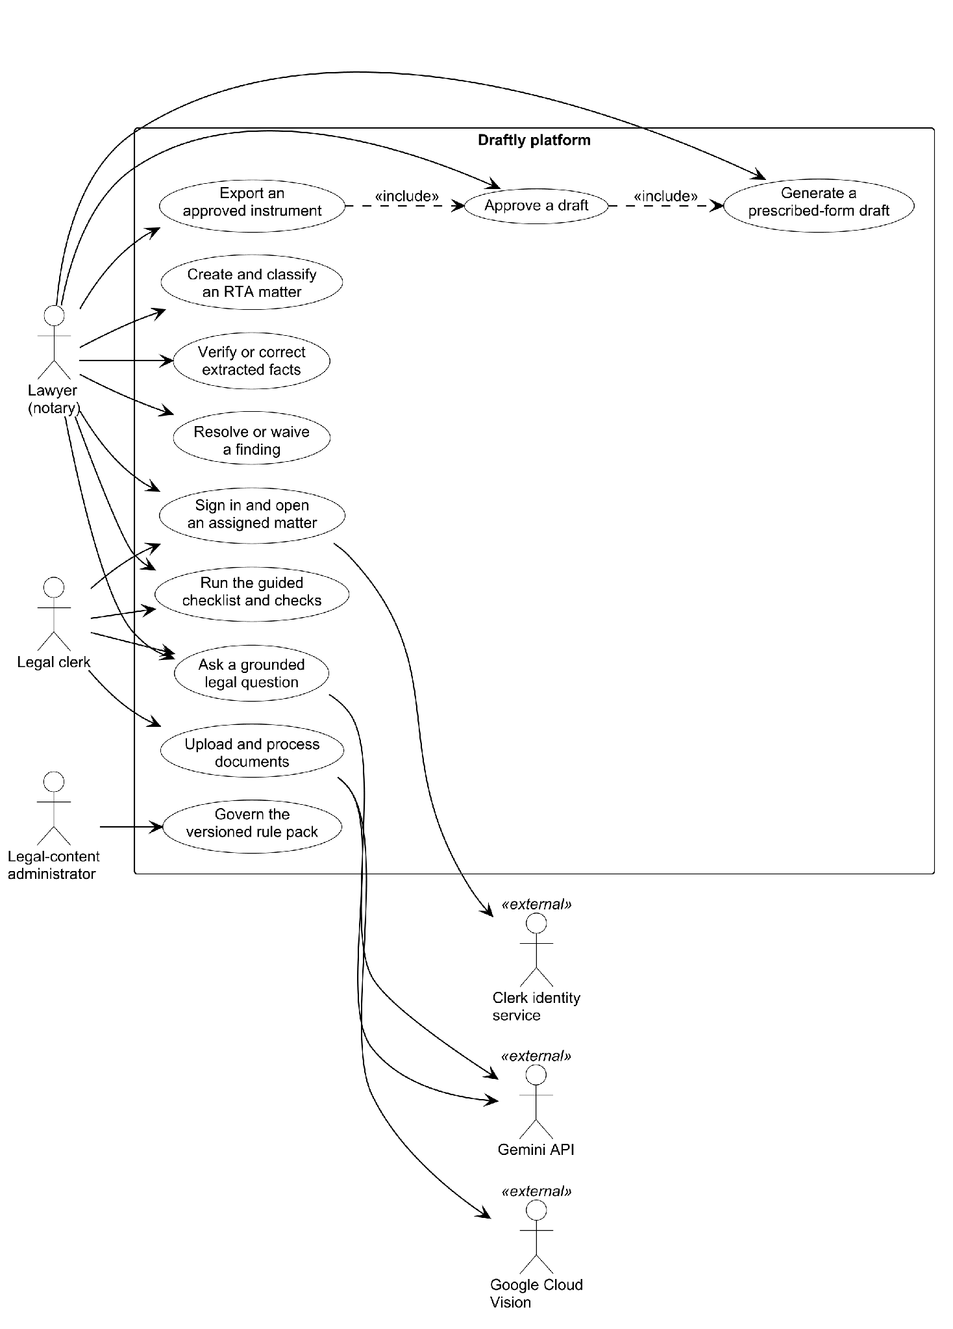
Fig. 1. Main use-case diagram of the Draftly platform.
3.2 System Design
3.2.1 Architecture
Draftly is deployed as a modular monolith behind a reverse proxy, with a separately built retrieval engine on the internal network. Fig. 2 shows the deployed architecture. The backend is a FastAPI application [19] organised into eighteen domain modules, each owning its data and exposing seventeen routers under a versioned API. Within every module the dependency direction is fixed: routers call application services, application services apply domain policies through ports, and infrastructure adapters implement those ports, so no domain rule depends on a web framework, a database driver or a vendor software development kit. The Next.js frontend [20] serves an English and Sinhala interface. PostgreSQL [21] stores all authoritative matter data, and an outbox worker processes background jobs with claim leases and retries so that document processing and assistant turns survive restarts. The retrieval engine is built from the research repository and is reachable only from the backend; any timeout or error from it is converted into an abstention. Google Cloud Vision [22] performs optical character recognition, and the Gemini API [23] performs page classification, field extraction and grounded answer composition.
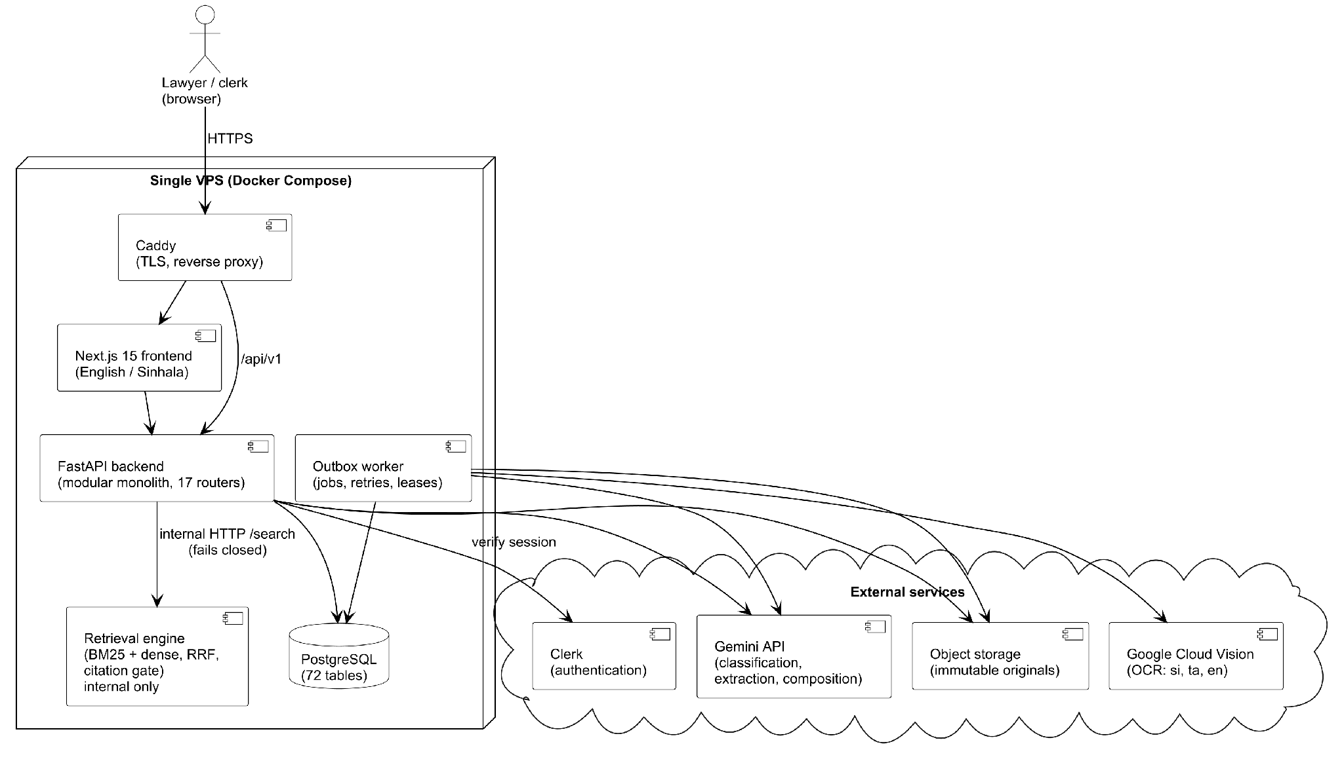
Fig. 2. Deployed architecture of the Draftly platform.
3.2.2 Logical View
Fig. 3 shows the principal domain classes and their associations. A Matter is the unit of work and scopes every other record. It involves Parties and holds SourceFiles, whose content hash makes the original evidence immutable. Candidate values extracted from a document are ExtractedFacts, each supported by one or more EvidenceReferences that point to a hash and text span in a SourceFile. A fact becomes verified only through a ReviewDecision made by a lawyer, and a correction creates a superseding fact rather than overwriting the old one. The RulePack is versioned content rather than per-tenant data: ChecklistItems, CrossDocumentChecks and GeneratedForm templates are instantiated from it, and every requirement cites a RequirementSource with a source class and a currency status. A GeneratedForm is filled only from verified facts, is gated by an Approval that pins the confirmed fact hash and the rule-pack version, and an Approval permits at most one FormExport. AuditEvents record every material action for the matter. On the research side, a ResearchConversation produces ResearchClaims, and each claim must carry at least one ResearchCitation.
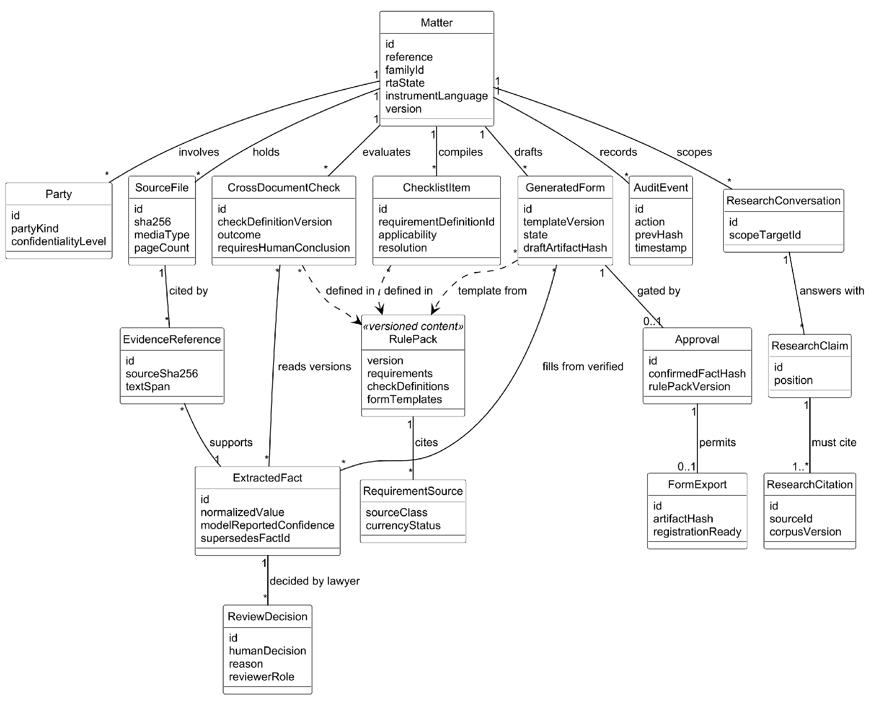
Fig. 3. Class diagram of the principal domain classes.
3.2.3 Process View
Fig. 4 presents the main activity, an end-to-end Registration of Title Act transfer, in three swimlanes. The lawyer or clerk creates the matter and uploads title documents, after which the system reads, rotates, classifies and splits the pages and extracts candidate facts marked unverified. The lawyer then verifies or corrects each candidate fact beside its evidence, and the loop repeats until no critical fact remains unverified. The system evaluates the deterministic checks; an open blocking finding must be resolved or waived with a reason before a draft can be generated. The draft is produced only from verified facts, and the lawyer either approves it, in which case the approval is pinned to the draft hash and the exported instrument is recorded in the audit log, or corrects facts, in which case every dependent draft becomes stale.
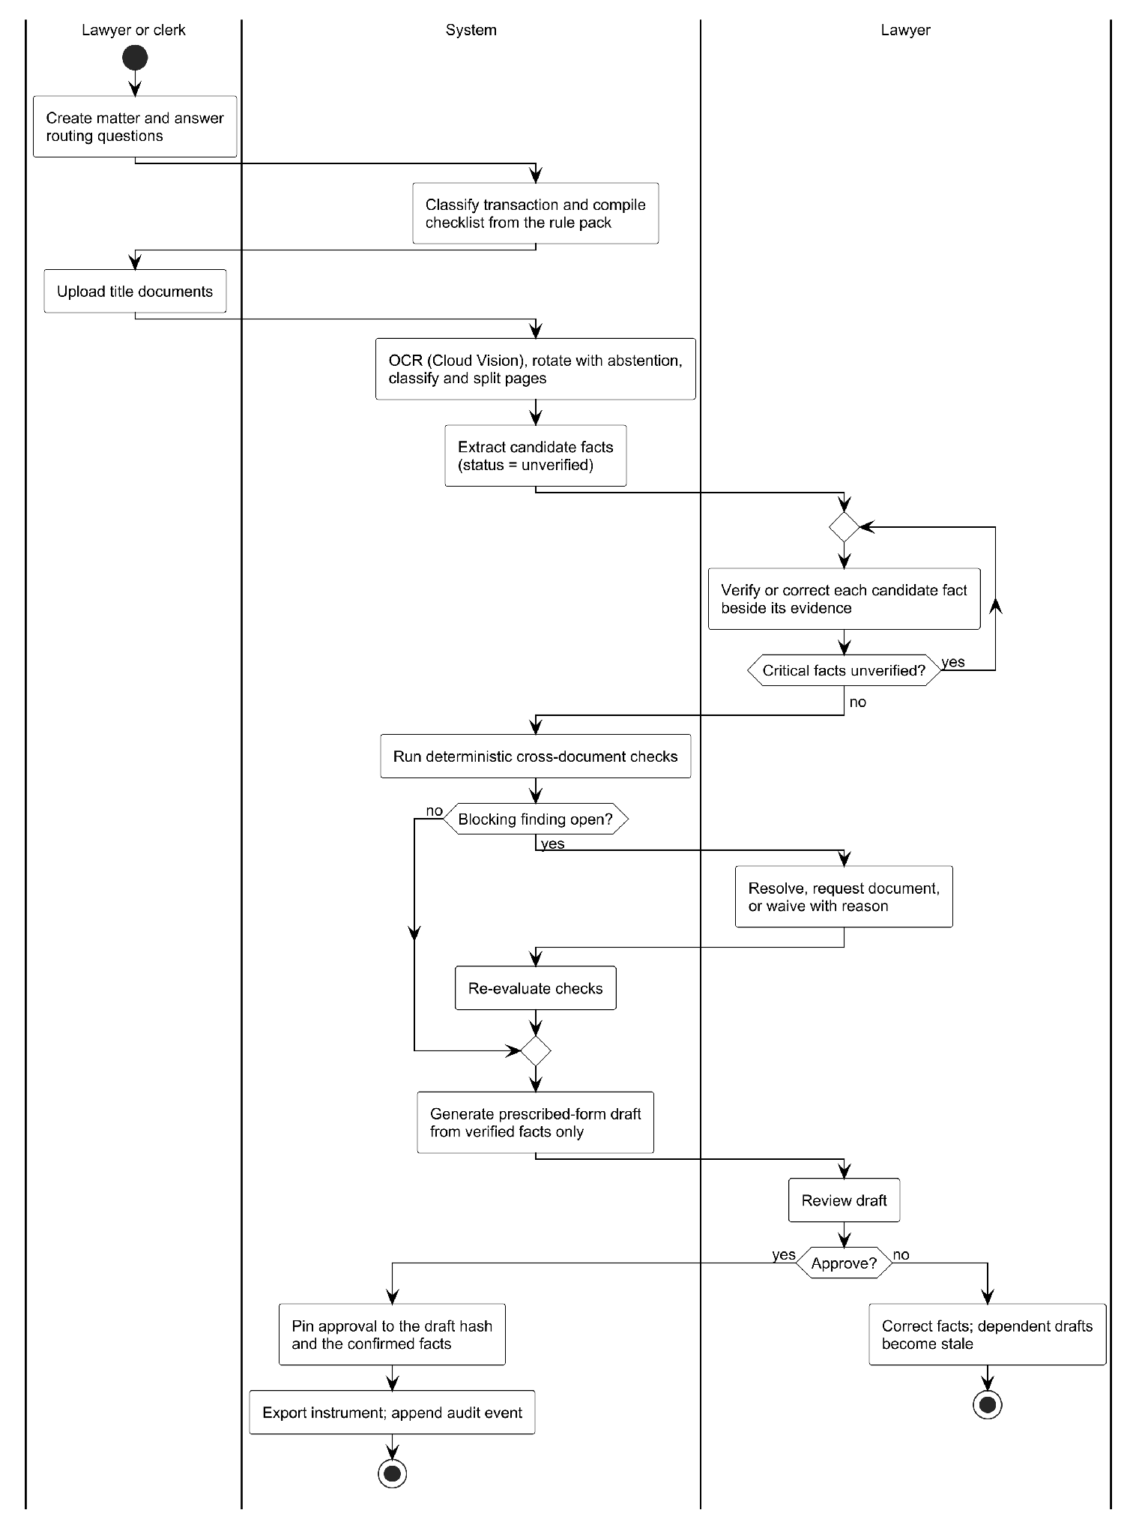
Fig. 4. Activity diagram of a Registration of Title Act transfer.
The sequence of messages behind a grounded research question, including the fail-closed path when the retrieval engine is unavailable, is given in Appendix F.
3.3 Database Design
The platform schema comprises 72 PostgreSQL tables defined through the object relational mapper and created by 21 Alembic migration revisions. Fig. 5 shows the core of that schema: the nineteen tables that carry a matter from evidence to an approved export and the tables that record grounded research. Solid lines denote foreign keys enforced by the database, and dashed lines denote logical references by identifier. Most matter-scoped tables carry a matter identifier and a user identifier with a composite index rather than a database-level foreign key to the matter, because organisation isolation is enforced by the service layer and verified by a tenancy test that sweeps every matter-scoped route.
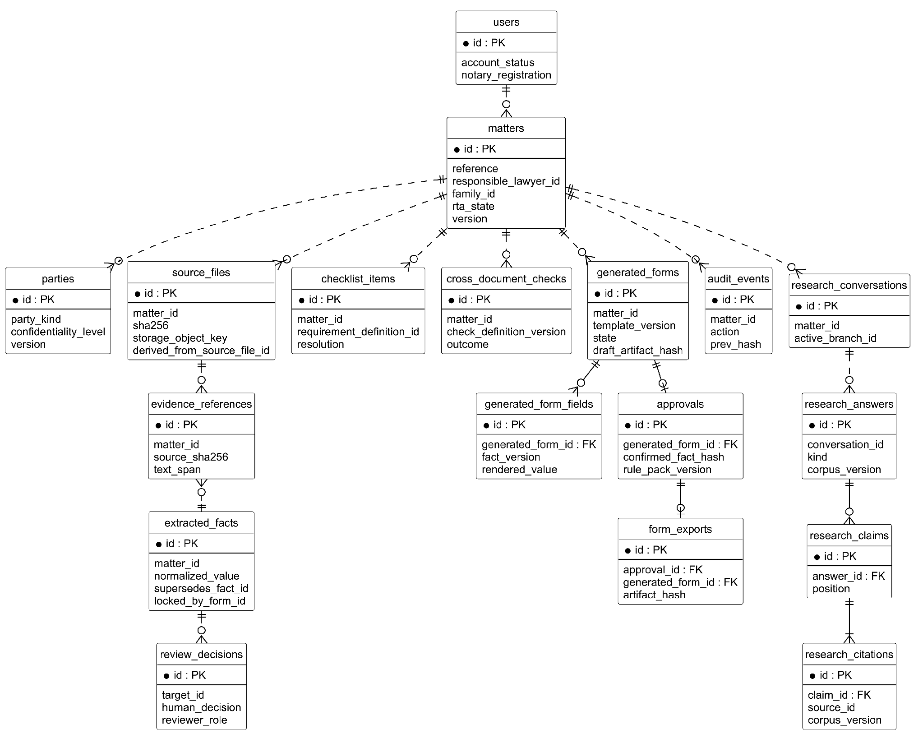
Fig. 5. Entity-relationship diagram of the core schema.
Several schema decisions follow directly from the legal requirements. Source files are identified by the SHA-256 hash of their content, and a derived file records the file from which it was produced, so the original evidence is never modified. Extracted facts are versioned: a correction inserts a new row that supersedes the earlier one, and a fact locked by a generated form cannot change beneath it. Review decisions record the reviewer role, the previous value and the reason for every human decision. A generated form stores the hash of its draft artifact, its fields record the fact version from which each value was rendered, and an approval stores the hash of the confirmed facts and the rule-pack version, so a later edit invalidates the approval instead of silently inheriting it. Form exports reference both the approval and the form. Audit events store the hash of the preceding event, which makes the log tamper-evident, and research claims and citations are linked by enforced foreign keys so that no stored claim can exist without its citation. Mutable records use a version column for optimistic concurrency, and a transactional outbox table decouples domain events from their delivery.
The research repository uses file-based stores instead of a relational database. The frozen benchmark corpus is held as JSON Lines files for Acts, sections, provisions and typed edges, with a manifest that records a corpus fingerprint and per-file hashes. The retrieval engine indexes its corpus in SQLite with the FTS5 extension, and the index file is named from a fingerprint of its inputs, so a changed corpus triggers a rebuild rather than serving stale results.
3.4 Machine Learning and Data Science System Design
The data science components serve one purpose: to place in front of the lawyer the complete statutory authority and the candidate facts on which a decision depends, while never presenting either as verified. Five components meet that purpose, and each was chosen on measured evidence.
3.4.1 Corpus and Benchmark Construction
The benchmark corpus was built deterministically from structured trees parsed from Government Printer and republisher texts. It contains 52 consolidated principal enactments named in the Sri Lanka Law College conveyancing curriculum, 60 amending Acts kept as separate documents so that amendment relationships have a source, 4,557 sections that serve as the retrieval unit and 17,854 sub-section provisions. Six types of typed edge, 6,346 in total, were derived from the trees: cross-references typed by their surrounding wording as definitions, exceptions, qualifications, procedural requirements or plain cross-references, together with amendment edges from amending to amended sections. Each section records the year in which it came into force.
The questions came from sixteen Law College conveyancing examinations set between 2018 and 2026, split into 667 atomic questions, of which 210 were suitable candidates and 144 were researched. Each fact pattern was researched by a language-model agent restricted to a search interface over the frozen corpus and checked by a second agent that had not seen the research. A deterministic validator confirmed that every cited section exists and that every excerpt is a verbatim substring of the section text. Only statute-only questions whose indispensable provisions were verified entered the benchmark, giving 50 questions in 40 matters that need 84 distinct indispensable sections; 31 of the 50 questions need three or more sections. The gold labels are therefore proposed rather than validated: agent agreement is not legal validation, and a three-attorney review with two-of-three agreement on every indispensable provision has been specified but not yet completed.
3.4.2 Retrieval Systems and the Chosen Engine
Seven retrieval systems were compared on identical queries. BM25 over title, heading and body [13] and a field-weighted variant served as lexical baselines. Dense retrieval used the bge-base-en-v1.5 embedding model [14], scoring long sections by the maximum over overlapping windows. A hybrid system fused the field-weighted lexical and dense rankings by reciprocal rank fusion [15], and a further variant reranked its top one hundred candidates with an MS MARCO cross-encoder [16], [17]. A hierarchical system followed the document-then-passage design of HiREC [18], routing each question to its three most likely Acts before retrieving sections inside them. The structure-aware system extended the hierarchical system by taking fifteen routed seed sections, adding every target of an enabled typed edge with support accumulated across seeds, removing sections not in force at the matter's reference date, and reranking.
Fig. 6 summarises the corpus and the retrieval method. The evaluation found that hybrid fusion was the strongest configuration and that structure did not improve complete recall, which is reported in Section 5.4. The deployed retrieval engine therefore fuses a lexical channel over SQLite FTS5 with a dense channel, and omits the cross-encoder, which halved the mean reciprocal rank of the first indispensable section. The engine retains a statute graph for explanation, but the benchmark evidence gives no basis to expect that graph expansion improves completeness.
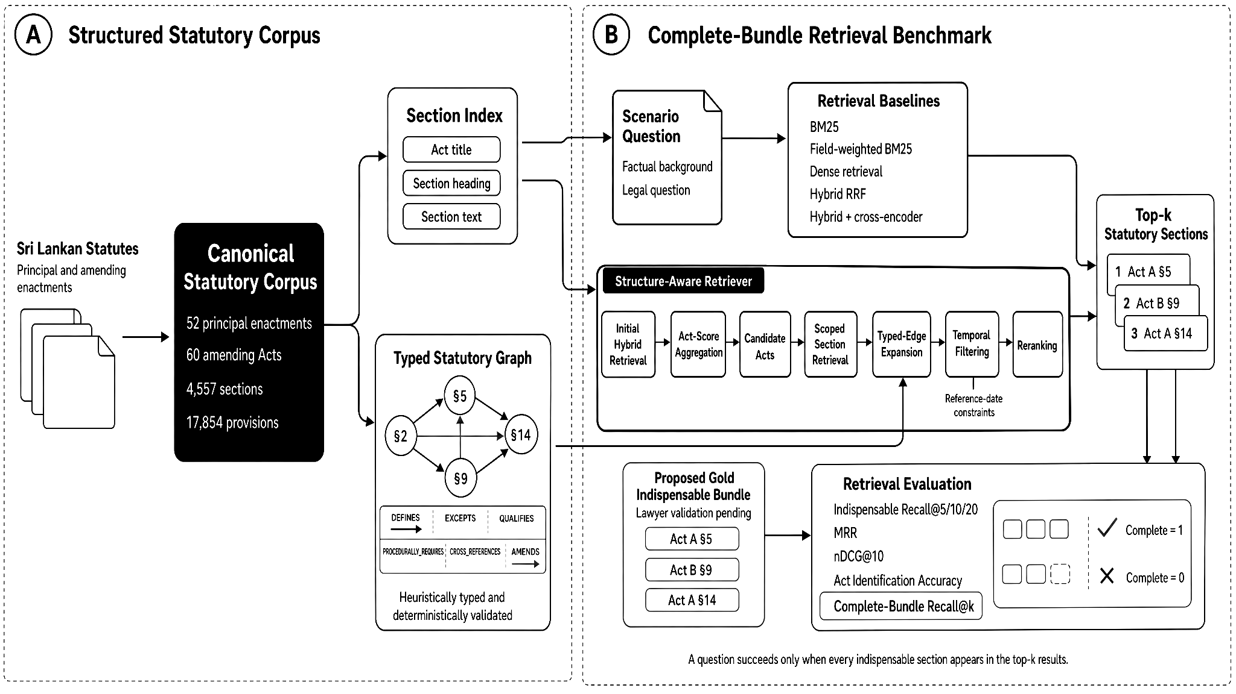
Fig. 6. Corpus construction and the retrieval systems compared.
3.4.3 Grounded Answering and Abstention
Retrieved passages are passed to a Gemini model [23] with an instruction to answer only from the supplied text and to cite an authority identifier for every claim. A citation gate then removes any claim that cites an identifier outside the retrieved set, a claim-level entailment check tests each remaining claim against its own citation, and one corrective retrieval is attempted for any part of the question left unsupported. The outcome is an answer, a partial answer that names the missing information, or an explicit abstention. The platform adds a further safeguard: if the engine is slow or unreachable, the question is answered with a statement of insufficient authority rather than an error.
3.4.4 Case-Law Rule Extraction
Legal rules were recovered from reported judgments in two tracks. The first reads the editor's headnote layout deterministically and yields a verbatim rule for 3,521 of 3,703 reported judgments, or 95.1 percent, at no model cost. The 182 judgments it cannot parse, and the unreported judgments, pass to a bounded language-model track in which Llama 3.1 8B [24], served through NVIDIA NIM [25], must return a supporting quotation that appears verbatim in the judgment; a validator rejects every rule whose quotation does not match and removes any statute section outside a closed catalogue. The validator, not the model, supplies the trust, which is why the smaller model was preferred.
3.4.5 Document Reading and Field Extraction
Scanned conveyancing bundles are read with Google Cloud Vision [22] using Sinhala, Tamil and English language hints. On the same twenty-six pages, Cloud Vision read 6,419 Sinhala and 2,083 Tamil characters, while docTR, RapidOCR and the Document AI OCR processor read none, which decided the engine. Page orientation is inferred from the vertex order of confident word polygons, and the system leaves a page unrotated and flags it for review when fewer than ten usable words are found or the dominant orientation holds less than seventy percent of the weighted vote. Pages are classified and split into logical documents in one batched Gemini call, and fields are extracted per logical document with every value kept as a string, because a parcel number such as 0021 read as an integer denotes a different parcel. Every extracted value is stored as an unverified candidate for lawyer review.
4 System Implementation
4.1 Implementation Procedure
The system was implemented in two repositories. The research repository holds the legal corpus, the extraction pipelines, the benchmark and the retrieval engine, and is written in Python 3.12 with dependencies managed by uv. Its retrieval engine uses SQLite with the FTS5 extension for lexical search, Gemini embeddings for the dense channel, a deterministic statute graph and a FastAPI service; the benchmark systems use the sentence-transformers library with the bge-base-en-v1.5 embedding model and an MS MARCO cross-encoder, and all benchmark runs were executed on a laptop processor without a graphics processor. The platform repository holds the FastAPI backend, which uses SQLAlchemy for persistence and Alembic for migrations, and the Next.js 15 and React 19 frontend, which uses next-intl for English and Sinhala and Clerk for authentication. Deployment uses Docker Compose on a single virtual private server behind Caddy, with a container for the frontend, the backend, the outbox worker, the database migrations and the retrieval engine.
Development followed a feature-branch workflow in which every change reached the main branch through a reviewed pull request, commit messages followed the Conventional Commits format, and continuous integration on GitHub Actions ran the backend and frontend test suites with coverage gates that may rise but not fall. Written agent conventions in each repository governed the use of AI-assisted coding tools: they forbid committing client data, forbid altering prescribed legal wording, require the design documents to be read before a service is changed, and require every generated output to remain unverified until a lawyer approves it. Data builds were made content-addressed and reproducible: re-running a corpus build produces byte-identical output, the benchmark records the hashes of its corpus manifest, public input and split file together with the code commit and software environment, and every number in the paper is generated from a single metrics file rather than typed by hand.
Three strategies guided the engineering choices. Deterministic methods were applied first and language models only to the residue that pattern matching cannot reach, which kept costs bounded and outputs reproducible. Every safety property was enforced at the layer that owns it and tested there, so tenancy is tested against a real database and approval gates are tested through the services that apply them. Negative and incomplete results were recorded rather than discarded, so that failed runs, abstentions and known gaps remain visible in the evaluation.
The work was divided by component. Dhanapala D.H.N. led the legal corpus, the statutory benchmark, the retrieval research and the paper, and the grounded research interface of the platform. Dilshan A.D.L. led document reading and field extraction, case-law extraction and linking, and the deployment stack. De Silva B.K.P. led the platform backend services and the drafting workflow, testing and quality assurance, and the retrieval baseline comparisons [VERIFY: confirm division of work]. The project schedule appears in Appendix A.
4.2 Materials
The system was built on existing legal and documentary materials, summarised in Table 2. Statutes and amending Acts were collected from Parliament of Sri Lanka and LawLanka publications and converted to Markdown for the retrieval engine and to structured JSON trees for the benchmark corpus. Reported judgments were taken from the CommonLII archive of the New Law Reports and Sri Lanka Law Reports, and unreported Supreme Court and Court of Appeal judgments from official court sources; 5,121 of the 9,177 judgments were identified as relevant to conveyancing. The benchmark questions were derived from sixteen Sri Lanka Law College conveyancing examination papers. The rule pack cites ten governed sources, among them the Registration of Title Act, No. 21 of 1998 [1] and the gazetted regulations and forms made under it. Scanned conveyancing documents used to evaluate document reading were supplied for the project; they contain personal data and are therefore described here only in aggregate, stored outside version control, and protected by assertions in code that stop any value from being written to a tracked file.
Table 2. Materials used by the system.
Material | Format | Size | Use
Statutes and amendments | Markdown; JSON trees | 57 statutes and 18 amendments (engine); 52 principal and 60 amending Acts (benchmark) | Retrieval corpus
Reported judgments (CommonLII) | HTML and text | 3,703 | Rule extraction, case linking
Unreported SC and CoA judgments | PDF and text | 5,474 | Rule extraction
Law College examination papers | Scanned PDF, transcribed | 16 papers; 667 atomic questions | Benchmark
Rule-pack sources | Act, gazettes, practice notes | 10 sources | Checklist, checks, forms
Scanned conveyancing documents | PDF and JPEG | 4 matters, 38 documents, 282 pages | OCR evaluation (aggregate only)

4.3 The Algorithm
Two algorithms carry the central guarantees of the system. The first, shown in Fig. 7, is the structure-aware retrieval procedure evaluated in the benchmark. It fuses the field-weighted lexical ranking with the dense ranking, routes the question to the Acts with the highest aggregate section scores, and takes the best sections inside those Acts as seeds. It then adds every section reachable from a seed along an enabled typed edge, counting how many seeds support each added section, removes every section that was not in force at the reference date of the matter, reranks the pool with the cross-encoder and combines the normalised reranker score, the normalised fused score and a logarithmic bonus for graph support. The temporal filter is the step that removed every out-of-force section from the results.
procedure BUNDLE_RETRIEVE(q, date, k)
L <- BM25F(q); D <- DENSE(q)
F <- RRF(L, D, k_rrf = 60)
A <- top 3 Acts by sum of top-5 fused section scores
S <- top 15 sections of F inside A // seeds
P <- S; support <- empty map
for s in S:
for (s, t, type) in EDGES where type in ENABLED:
P <- P + {t}; support[t] <- support[t] + 1
P <- {p in P : in_force(p, date)} // temporal filter
for p in P:
score[p] <- 0.5*norm(CE(q, p)) + 0.5*norm(F[p])
+ gamma*log(1 + support[p])
return top k of P by score
Fig. 7. Pseudocode of structure-aware retrieval with temporal filtering.
The second algorithm, shown in Fig. 8, is the answer gate used by the engine and the platform. It retrieves passages, asks the language model for claims that each cite an authority identifier, discards every claim whose citation lies outside the retrieved set or is not entailed by the cited text, and retries once for any unsupported part of the question. If no claim survives, or if retrieval fails, the procedure returns an abstention instead of an answer.
procedure ANSWER(q)
try P <- RETRIEVE(q) with timeout
catch error: return ABSTAIN("insufficient authority")
C <- COMPOSE(q, P) // claims with citations
C <- {c in C : cites(c) subset of ids(P) and ENTAILED(c, cites(c))}
for part in parts(q) with no claim in C:
P' <- RETRIEVE(REWRITE(part)); C <- C + GATE(COMPOSE(part, P'))
if C is empty: return ABSTAIN("insufficient authority")
outcome <- ANSWERED if every part supported else PARTIAL
return (outcome, C, status = UNVERIFIED)
Fig. 8. Pseudocode of the cite-or-abstain answer gate.
4.4 Main Interfaces
The interface follows the working order of a conveyancing matter. Fig. 9 shows the matters list and the matter workflow. The workflow page presents the checklist compiled from the rule pack for the classified transaction, grouped by module, and shows beside each requirement whether it is required by the Act, by a gazetted regulation, by registry practice or only by prudent professional practice.

Fig. 9. (a) Matters list. (b) Matter workflow compiled from the rule pack.
Fig. 10 shows the document review and checks pages. During document review each extracted value appears as an unverified candidate beside the page it came from, and the lawyer verifies or corrects it. The checks page groups deterministic findings by type, such as a parcel extent that differs between the deed schedule and the survey plan, and offers the lawyer the actions of resolving the finding, requesting a document or waiving it with a recorded reason.

Fig. 10. (a) Document review with candidate facts beside their evidence. (b) Cross-document checks.
Fig. 11 shows the draft editor and the approval gate. The prescribed form is populated only from verified facts, and an attempt to export before approval is refused. Approval records the confirmed fact hash, so a later correction makes the draft stale and requires a fresh approval.

Fig. 11. (a) Prescribed-form draft generated from verified facts. (b) Approval gate refusing export before approval.
Fig. 12 shows the grounded research interface. A question about a notary's territorial authority returns claims, each with the statutory section it cites, while a question whose answer depends on a stamp-duty rate set by a Gazette Order outside the corpus returns an explicit statement of insufficient authority rather than an estimate.

Fig. 12. (a) Cited answer. (b) Abstention for insufficient authority.
All screenshots show a synthetic matter created for demonstration; no client information appears in any figure.
5 System Testing and Analysis
5.1 Testing Approach
Testing followed one principle: each rule was tested at the layer that enforces it. A tenancy rule enforced in the database was tested against a real PostgreSQL instance, a refusal enforced in a service was tested through that service, and a behaviour enforced in the browser was tested in a browser. The backend suite combined unit tests of domain policies, integration tests of repositories and services against PostgreSQL, contract tests that compare the exported rule pack and API schemas with their published definitions, conformance tests shared by all services, and security sweeps that call every matter-scoped route with another organisation's credentials. The frontend suite tested the API client, the state store and the components with Vitest, and Playwright exercised the workflow refusal journeys in a browser. Tests that assert only that a mock was called were rejected, known gaps were recorded as tests that are expected to fail, so that an unresolved question remains visible in the build, and the whole backend suite was run in random order to expose hidden dependencies between tests.
5.2 Unit Testing, Results and Analysis
Table 3 summarises the final test execution. The backend suite collected 3,922 tests, of which 3,906 passed and none failed; ten are expected failures that document known gaps, one was skippeZd and five that call live external services were excluded from continuous integration. All 348 frontend tests and all three browser refusal journeys passed. The suite passed three consecutive runs with different random seeds, which indicates that no test depends on another test running first.
Table 3. Summary of platform test execution.
Suite | Tests run | Passed | Failed | Notes
Backend (pytest, real PostgreSQL) | 3,922 | 3,906 | 0 | 10 expected failures, 1 skipped, 5 live tests excluded
Frontend (Vitest) | 348 | 348 | 0 | Logic layer 93.3% line coverage
Browser refusal journeys (Playwright) | 3 | 3 | 0 | Not yet in CI (authentication keys)

During the final test cycle the number of backend tests run by continuous integration rose from 245 to 3,906 and the number of frontend tests from none to 348. Backend line coverage rose from 77.1 to 85.4 percent and branch coverage from 51.0 to 63.9 percent, which meets the planned line target of 80 percent but not the branch target of 70 percent. Frontend line coverage is 27.0 percent overall and 3.1 percent for components, because most screen behaviour is better tested in a browser and the browser suite awaits authentication test credentials. Fifteen defects were found and fixed, two of them critical: party creation failed because the event logger received a reserved keyword argument, and concurrent writes could fork a user's hash-chained audit log. Twelve of the fifteen defects appeared only against a real PostgreSQL database, because fakes and SQLite do not enforce foreign keys or run concurrent transactions in the same way. Each of the seven safety rules, from organisation isolation to quota metering, is traced to a named test file that passes.
5.3 Performance, Security and Failure Aspects
Security tests covered the failures a user could not see: a sweep confirms that every matter-scoped route hides another organisation's data, a database dump confirms that client identifiers are never stored in plaintext, forged pagination cursors are rejected, and malformed webhooks are refused rather than crashing the service. The outbox worker's leases and retries were tested for failure recovery, and the research service fails closed to an abstention. Per query, lexical retrieval took about 15 milliseconds, hybrid fusion 17 milliseconds, the structure-aware system 0.9 seconds and the cross-encoder variant 6.8 seconds on a laptop processor. Load and failover testing were planned but not executed, because the system runs on synthetic data only.
5.4 Evaluation of Machine Learning Models
Retrieval was evaluated on the test split of 40 questions in 32 matters, with questions averaged within each matter first and 95 percent intervals obtained from 2,000 matter-level bootstrap resamples. The principal metric, complete-indispensable recall at k, credits a question only when every indispensable section appears in the top k results. Table 4 reports the main results.
Table 4. Retrieval results on the test split (matter-macro means).
System | R@20 | C@10 | C@20 | MRR | Act@10
BM25 | 0.491 | 0.250 | 0.281 | 0.503 | 0.719
Field-weighted BM25 | 0.482 | 0.250 | 0.281 | 0.540 | 0.672
Dense (bge-base) | 0.379 | 0.125 | 0.188 | 0.316 | 0.562
Hybrid fusion (RRF) | 0.546 | 0.266 | 0.344 | 0.543 | 0.625
Hybrid + cross-encoder | 0.413 | 0.125 | 0.234 | 0.223 | 0.562
Hierarchical | 0.496 | 0.297 | 0.375 | 0.509 | 0.469
Hierarchical + bundle | 0.480 | 0.281 | 0.312 | 0.495 | 0.469

Hybrid fusion achieved the highest indispensable recall at 20 and the highest mean reciprocal rank, while the hierarchical systems matched it on complete recall without exceeding it: every pairwise difference among the hybrid, hierarchical and structure-aware systems has an interval that includes zero, and the structure-aware system trails hybrid fusion by 0.031 (95 percent interval from −0.156 to +0.078). The web-trained cross-encoder reduced mean reciprocal rank from 0.543 to 0.223, which is why it was excluded from the deployed engine. Removing any single component of the structure-aware system changed complete recall by at most one question in 32 matters. The one clear positive effect was temporal: every flat system placed sections not in force at the question date into its top ten results, between 2.3 and 8.4 percent of them, whereas the structure-aware system with its temporal filter placed none. The graph-support weight used in the reported run was 0.15, whereas the development sweep selected 0.3; the reported configuration is the one recorded in the run manifest.
The error analysis identifies coverage rather than ranking as the limitation. Fig. 13 shows that complete recall falls as the number of indispensable sections grows, and that no system completes any of the twenty test questions that need four or more sections. Of the 114 indispensable sections that the structure-aware system left outside its top twenty, only two were reachable by a single typed edge from a retrieved seed, because the provisions an answer needs are jointly required without any cross-reference connecting them. Scenarios enriched with facts that name the conditions the provisions test were much easier, with complete recall of 0.43 against 0.11 for the original wording.
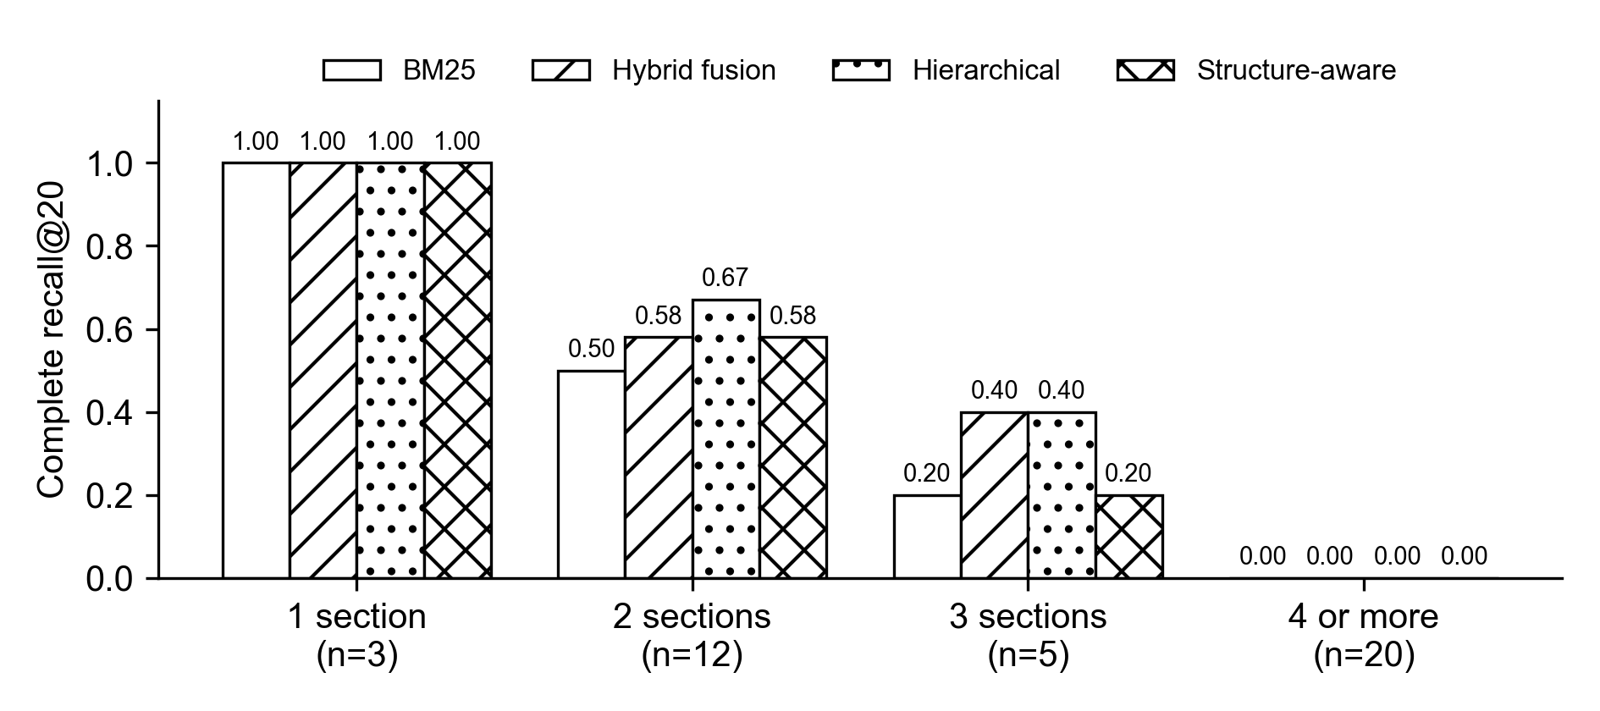
Fig. 13. Complete recall at 20 by the number of indispensable sections per question (test split).
The case-law extraction method was selected through a pre-registered ablation of thirty cases per arm. The 8-billion-parameter model with a head-and-tail window accepted 83.3 percent of cases, against 54.5 percent for the 70-billion-parameter model, while verbatim grounding was 1.00 in every arm. On a held-out set of 100 cases the chosen arm accepted 74 percent. A language-model judge, used only as a provisional proxy, rated 58.1 percent of the 74 accepted rules as fully usable, below the pre-registered threshold of 90 percent, so every extracted rule remains unverified pending lawyer review. For document reading, field-level accuracy could not yet be measured, because the paid extraction runs failed on a credential error and only 37 fields in one matter are labelled; the measured result is the engine comparison reported in Section 3.4.5.
All retrieval results are measured against proposed gold labels, and no lawyer has yet rated them. The three-attorney validation will record, for every indispensable provision, whether it is the correct authority and whether the question could be answered completely without it, and will report raw agreement and Fleiss' kappa. [If lawyer ratings arrive before 19 October 2026, replace this paragraph with the validated results and re-scored Table 4.]
6 Conclusion and Future Work
This project set out to support Sri Lankan conveyancing, in which an answer is correct only when every governing provision is found, the law changes over time, and the evidence arrives as bilingual scanned documents. The work shows that these problems can be addressed without allowing a machine to make a legal decision: every claim is grounded in retrieved statutory text or withheld, and no instrument leaves the system without a lawyer's approval.
The research finding answers the question posed in the introduction. On a benchmark drawn from real Law College examinations, hybrid fusion of lexical and dense retrieval was the strongest method, and statutory structure, as extracted here, did not improve the retrieval of complete sets of provisions. The bottleneck is coverage rather than ranking: provisions that a complete answer requires are rarely connected by cross-reference wording, and no system completed a question that needs four or more sections. The finding was accepted at the NeurIPS 2026 GlobalSouthAI workshop and determined the design of the deployed engine. Filtering sections by the law in force at the question date removed every anachronistic provision, and scenarios that state their legally relevant facts explicitly were far easier to answer, which suggests that query understanding, rather than more graph structure, is the most promising direction.
The platform shows that the lawyer-in-the-loop principle can be enforced in code and verified: each of its seven safety rules is traced to passing tests.
Several limitations remain. No lawyer has yet validated the benchmark labels, the extracted rules or the form templates; field-level extraction accuracy has not been measured; answer generation has not been scored for legal correctness; and the test split is small enough that most differences fall within their intervals. Future work begins with completing the three-attorney validation, after which every result will be re-measured against lawyer-approved labels. Retrieval will be adapted to Sri Lankan statutory text through fine-tuned embeddings and rerankers and through query rewriting for multi-section questions, and the dense channel will be enabled in production, where the deployed index is currently lexical only. Sinhala-valued fields will be labelled to measure extraction across scripts, and case-law questions will be added to support the planned court-hierarchy ranking.
References
[1] Registration of Title Act, No. 21 of 1998, Parliament of the Democratic Socialist Republic of Sri Lanka, 1998.
[2] [VERIFY: authors], "Does statutory structure help? Retrieving every indispensable provision for Sri Lankan conveyancing scenarios," presented at the GlobalSouthAI Workshop, 40th Conf. Neural Inf. Process. Syst. (NeurIPS), 2026.
[3] S. Paul, D. Ghumare, P. Goyal, S. Ghosh, and A. Modi, "IL-PCSR: Legal corpus for prior case and statute retrieval," in Proc. 2025 Conf. Empirical Methods Natural Lang. Process. (EMNLP), 2025, pp. 14588–14611.
[4] N. Pipitone and G. H. Alami, "LegalBench-RAG: A benchmark for retrieval-augmented generation in the legal domain," arXiv:2408.10343, 2024.
[5] L. Zheng, N. Guha, J. Arifov, S. Zhang, M. Skreta, C. D. Manning, P. Henderson, and D. E. Ho, "A reasoning-focused legal retrieval benchmark," in Proc. 2025 Symp. Comput. Sci. Law (CS&Law), 2025.
[6] J. Lee, D. Kim, S. Hwang, H. Kim, and G. Lee, "KoBLEX: Open legal question answering with multi-hop reasoning," in Proc. 2025 Conf. Empirical Methods Natural Lang. Process. (EMNLP), Suzhou, China, 2025, pp. 4019–4053.
[7] E. Beta, O. S. Chlapanis, D. Galanis, and I. Androutsopoulos, "GreekBarRetrieval: A benchmark for Greek statutory retrieval," arXiv:2608.18752, 2026.
[8] K. Chae et al., "Evaluating structure-aware retrieval and safety in statute-centric legal QA," in Proc. 64th Annu. Meeting Assoc. Comput. Linguistics (ACL), San Diego, CA, USA, 2026, pp. 45553–45573.
[9] M. Prior, A. Schultz, and M. Grabmair, "Asking for an old friend: Diagnosing and mitigating temporal failure modes in LLM-based statutory question answering," arXiv:2605.23497, 2026.
[10] O. Atukorala, R. Appuhami, and N. de Silva, "LawChain: A resource-efficient blueprint for legal information retrieval in low-resource jurisdictions," in GlobalSouthML Affinity Workshop, 43rd Int. Conf. Mach. Learn. (ICML), San Diego, CA, USA, 2026. [Online]. Available: https://icml.cc/virtual/2026/78334
[11] A. Athulathmudali, "AI for legal domain identification and guidance in Sri Lankan law," Int. J. Innov. Sci. Res. Technol., vol. 10, no. 12, pp. 609–621, 2025, doi: 10.38124/ijisrt/25dec441.
[12] L. Jayawardena, N. Wiratunga, R. Abeyratne, K. Martin, I. Nkisi-Orji, and R. Weerasinghe, "SCaLe-QA: Sri Lankan case law embeddings for legal QA," in Proc. SICSA Workshop Reasoning, Eval. Appl. Large Lang. Models (SICSA-REALLM), CEUR Workshop Proc., vol. 3822, Aberdeen, U.K., 2024, pp. 47–55.
[13] S. Robertson and H. Zaragoza, "The probabilistic relevance framework: BM25 and beyond," Found. Trends Inf. Retr., vol. 3, no. 4, pp. 333–389, 2009.
[14] S. Xiao, Z. Liu, P. Zhang, N. Muennighoff, D. Lian, and J.-Y. Nie, "C-Pack: Packed resources for general Chinese embeddings," in Proc. 47th Int. ACM SIGIR Conf. Res. Develop. Inf. Retr., 2024, pp. 641–649.
[15] G. V. Cormack, C. L. A. Clarke, and S. Buettcher, "Reciprocal rank fusion outperforms Condorcet and individual rank learning methods," in Proc. 32nd Int. ACM SIGIR Conf. Res. Develop. Inf. Retr., 2009, pp. 758–759.
[16] W. Wang, F. Wei, L. Dong, H. Bao, N. Yang, and M. Zhou, "MiniLM: Deep self-attention distillation for task-agnostic compression of pre-trained transformers," in Adv. Neural Inf. Process. Syst. (NeurIPS), vol. 33, 2020.
[17] N. Reimers and I. Gurevych, "Sentence-BERT: Sentence embeddings using Siamese BERT-networks," in Proc. 2019 Conf. Empirical Methods Natural Lang. Process. and 9th Int. Joint Conf. Natural Lang. Process. (EMNLP-IJCNLP), 2019, pp. 3982–3992.
[18] J. Choe, J. Kim, and W. Jung, "Hierarchical retrieval with evidence curation for open-domain financial question answering on standardized documents," in Findings Assoc. Comput. Linguistics: ACL 2025, Vienna, Austria, 2025, pp. 16663–16681.
[19] FastAPI. [Online]. Available: https://fastapi.tiangolo.com (Accessed on Sep. 28, 2026).
[20] Next.js. [Online]. Available: https://nextjs.org (Accessed on Sep. 28, 2026).
[21] PostgreSQL Global Development Group, PostgreSQL. [Online]. Available: https://www.postgresql.org (Accessed on Sep. 28, 2026).
[22] Google Cloud, "Cloud Vision API." [Online]. Available: https://cloud.google.com/vision (Accessed on Sep. 28, 2026).
[23] Google, "Gemini API." [Online]. Available: https://ai.google.dev (Accessed on Sep. 28, 2026).
[24] Meta, "Llama 3.1 8B Instruct model card." [Online]. Available: https://huggingface.co/meta-llama/Llama-3.1-8B-Instruct (Accessed on Sep. 28, 2026).
[25] NVIDIA, "NVIDIA NIM." [Online]. Available: https://build.nvidia.com (Accessed on Sep. 28, 2026).
Appendix
Appendix A. Project Schedule
[Insert the Gantt chart from draftly-research/proj-docs/gantt/draftly-gantt-v2.html, exported as an image.] The schedule ran from July to mid-October 2026. The corpus and engine were completed before the mid-evaluation in August; the benchmark was frozen on 4 September; the paper was completed on 7 September; the platform test report was issued on 20 September; the platform was deployed on 23 September; and the final evaluations took place between 28 September and 2 October 2026.
Appendix B. Confidence Intervals for Retrieval Results
Table B1. Test-split results with 95% matter-level bootstrap intervals.
System | R@20 | C@10 | C@20 | MRR
BM25 | 0.49 [0.35, 0.62] | 0.25 [0.09, 0.41] | 0.28 [0.12, 0.44] | 0.50 [0.36, 0.65]
Field-weighted BM25 | 0.48 [0.35, 0.61] | 0.25 [0.09, 0.41] | 0.28 [0.12, 0.44] | 0.54 [0.38, 0.70]
Dense | 0.38 [0.25, 0.50] | 0.12 [0.03, 0.25] | 0.19 [0.06, 0.34] | 0.32 [0.19, 0.45]
Hybrid fusion | 0.55 [0.41, 0.68] | 0.27 [0.12, 0.42] | 0.34 [0.19, 0.50] | 0.54 [0.40, 0.69]
Hybrid + cross-encoder | 0.41 [0.29, 0.54] | 0.12 [0.03, 0.23] | 0.23 [0.11, 0.39] | 0.22 [0.14, 0.32]
Hierarchical | 0.50 [0.34, 0.64] | 0.30 [0.16, 0.45] | 0.38 [0.22, 0.53] | 0.51 [0.35, 0.66]
Hierarchical + bundle | 0.48 [0.34, 0.63] | 0.28 [0.12, 0.44] | 0.31 [0.16, 0.47] | 0.50 [0.36, 0.64]

Appendix C. Rule Pack Summary
Version 1.0.0 of the Registration of Title Act rule pack contains 9 transaction families, 33 matter subtypes, 18 conditional modules, 23 checklist modules, 145 checklist requirements, 25 deterministic checks (22 of which block approval and 13 of which block draft generation), 52 document classes, 32 form templates and 25 routing questions. Its ten governed sources fall into seven source classes: law, regulation, registry operations, local-authority operations, professional practice, product rules and unverified sources. None of the form templates has yet been approved by a lawyer, and the compiler reports this as a requirement for source reverification.
Appendix D. Case-Law Pipeline Coverage
Of 9,177 judgments, 5,121 were identified as relevant to conveyancing, and 3,620 of those yielded at least one extracted rule, for 4,161 rules in total (1,065 from headnotes and 3,096 from the bounded language-model track). The deterministic case-to-statute linker produced 762 links, of which 462 were internally consistent, 61 were sent for review and 239 remained unresolved; 369 cases, or 7.2 percent of the conveyancing cases, have at least one consistent statute link. No link has been checked by a lawyer.
Appendix E. Demonstration Script
The demonstration uses a matter labelled SYNTHETIC. A research question about a notary's territorial authority returns cited statutory sections, and a question that depends on a stamp-duty rate set by Gazette Order returns an abstention. The transfer matter is then taken through document processing, fact verification, a blocking check, Form 8 draft generation, the refusal of export before approval, approval and export.
Appendix F. Grounded Research Sequence
Fig. 14 shows the sequence of messages behind a grounded research question. The research service sends the question to the retrieval engine, passes the returned passages to the composer and rejects every claim that cites an authority outside the retrieved set. If at least one supported claim remains, the answer, its claims and citations are stored with status unverified; otherwise, and whenever the engine is unreachable, the lawyer receives an explicit statement of insufficient authority.
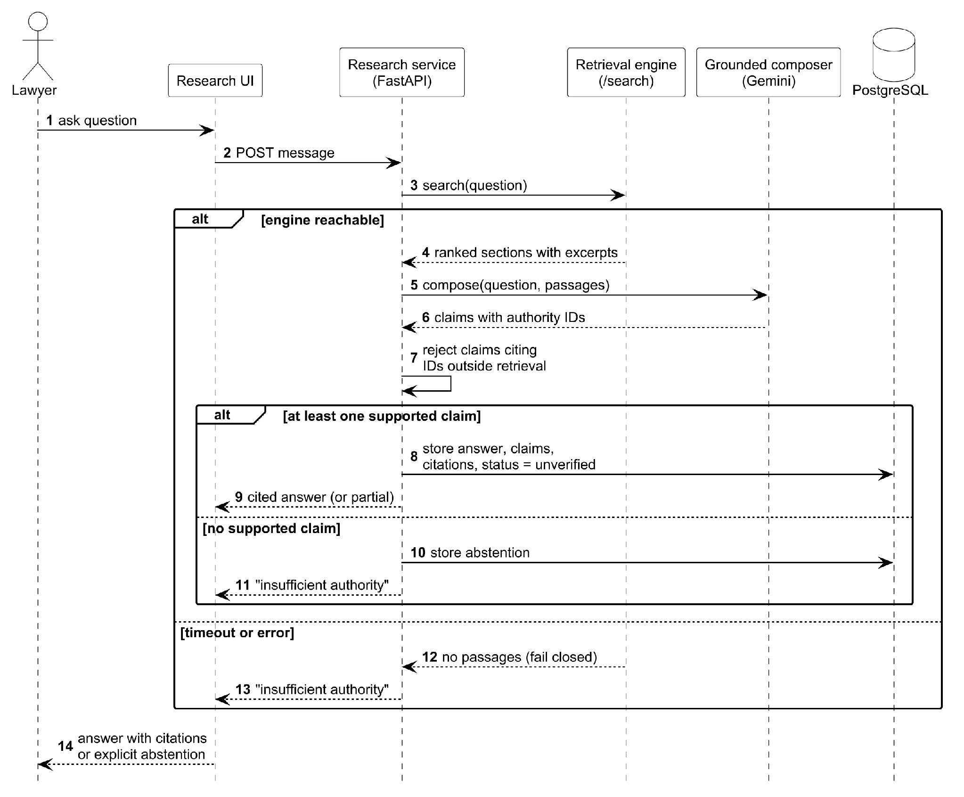
Fig. 14. Sequence diagram of grounded legal research.

