1. Introduction
   1. Abstract

The purpose of the project is to publish a 3D game with graphic shader functionality. The unreal engine is used for the development of the real-time game. The theme of the game is roguelike and the goal is to escape from a dungeon with a co-op combat system.

* 1. Executive Summary

There are over 73,000 games published on Steam and the number of games released on Steam is increasing every year. Team have to represent a model that is following public interest in general, but have to be unique in a way so that the game is attractive. Some contents in the game must be regulated before publishing such as hate-speech, copyright, and more.

1. Motivation
   1. Competitive Analysis

| Game | Feature | Image |
| --- | --- | --- |
| [Darkest Dungeon](https://store.steampowered.com/app/262060/Darkest_Dungeon/) | * Turn-Based Combat * Rougelike * Unique drawing * 2D Game |  |

The Darkest Dungeon is a challenging roguelike turn-based RPG with unique gothic 2D drawings. The successful feature of the game is the psychological stat system in the game such as horror, stress, and disease that increase and sometimes decrease the difficulty of the game. This feature helped the game to gain popularity as difficult game but also upset players because of too much unfair randomness that leads to mostly negative events. Thus, it is recommended to think a model that is more fair and not too random.

| Game | Feature | Image |
| --- | --- | --- |
| [Warriors: Rise to Glory!](https://store.steampowered.com/app/582330/Warriors_Rise_to_Glory/) | * Turn-Based Combat * Rougelike * Online Co-Op * Multi-player * Comedy |  |

The Warriors: Rise to Glory! is a rogue-like turn-based combat game. In the game, you create a gladiators with different styles and fight against enemy in the arena. The successful feature of the game is customizable character with various items and meme to entertain players, but some memes are outdated and arkward. It is encouraged to add adding more items to customize the character as free as possible, and put more recent parody to entertain players.

| Game | Feature | Image |
| --- | --- | --- |
| [Monster Hunter: World](https://store.steampowered.com/app/582010/Monster_Hunter_World/) | * Real-time Combat * Co-Op * Multi-player * Action * Open World |  |

Monster Hunter: World, is a real-time combat game. The game is open world using everything from disposal of the monsters to hunting down stronger monsters in the world by teaming up with other players. The successful feature of the game is great action with vivid combat effects and smooth movement. The downside of this game is too much repetition to gather items for upgrade. If possible, it is promised to reference the movement and effects in this game to improve combat effects in the team's game.

* 1. Journal Articles

1. [WHAT GAMES ARE SELLING ON STEAM: THE Q2 REPORT](https://howtomarketagame.com/2024/07/16/what-games-are-selling-q2-2024/)

* The author researched that there are about 8,362 games published in Steam as of July 2024. It is important to follow trends to attract players within a month because the game will be deleted from the list of steam algorithms which is based on earning 1000 reviews for recommendation. It is promising that co-op (and other multiplayer games) are very popular in the industry but action roguelike games are declining after too many copies of a game called, “Vampire Survivors”.

1. [MOST POPULAR VIDEO GAME GENRES IN 2024: REVENUE, STATICS](https://rocketbrush.com/blog/most-popular-video-game-genres-in-2024-revenue-statistics-genres-overview#:~:text=On%20the%20console%20front%2C%20the,shooter%2C%20and%20role%2Dplaying.)

* According to statistics, the game genres including RPG, strategy, and adventure games will still be a popular game genre in 2024. The game will be roguelike which is defined under the RPG genre with additional concepts of strategy and adventure. The revenue size of both PC games and mobile games are increasing but console games are showing decline.

1. [THE MOST POPULAR LANGUAGE IN STEAM IN 2024](https://games.logrusit.com/en/news/the-most-popular-languages-on-steam/)

* According to the statistics, surprisingly Chinese are mostly used in Steam. The top 5 most popular languages in Steam are Chinese, English, Russian, Spanish, and Portuguese. It would be idle to add one or more languages available in the game to localized. However, it does not guarantee to attract players in large numbers.

1. Requirements
   1. High-level Description:

* The product that we will develop will be a rogue-like action game created with Unreal Engine. It will include a custom shaders system created by our team that will create lighting and special particle effects.
  1. Functional requirements table

| **ID** | **Title** | **Requirement Description** | **Date** | **Done** |
| --- | --- | --- | --- | --- |
| F1 | User Interface | Users will interact with different interfaces in the game such as main menu screen, pause screen, options screen, etc. | 9/17/2024 |  |
| F2 | Character Stats | The user has stats about their player such as health bar and attack and defense levels | 9/17/2024 | X |
| F3 | Controllable Player | The user has an in-game character that they will be able to control by moving, attacking, and interacting with the in-game world | 9/17/2024 | X |
| F4 | Enemy Characters | The user will have adversary characters that will try to attack the player and that the player will have to fight off during gameplay | 9/17/2024 |  |
| F5 | Gameplay Tasks | During gameplay, the user will have to complete tasks to progress within the game | 9/17/2024 |  |
| F6 | Multiplayer Functionality | The user and another user will have the ability to play together co-op style | 9/22/2024 |  |

* 1. Functional requirements description
     1. **F1 User Interface**
        1. In our video game, the user will interact with different menus and interfaces to help them navigate through the game and explore possible options. These interfaces include menus such as the pause screen, main menu, and settings menu. These interfaces will be user-friendly and provide the user with options such as customization, beginning the game, and leaving the game.
     2. **F2 Character Stats**
        1. The playable character that the user will be controlling throughout gameplay will have real-time statistics available about their character such as health, attack level, and defense levels.
     3. **F3 Controllable Player** 
        1. The end user will have a character that they control throughout gameplay which they will use to physically navigate through different levels, interact with the environment they are in, and attack adversaries.
     4. **F4 Enemy Characters**
        1. The user’s playable character will have one or more adversary units that will try and harm the player and disrupt their progress through the game. Enemy units will be programmed to systematically try and break down the main character's health and try to end the player’s attempt at completing the level.
     5. **F5 Gameplay Tasks**
        1. Users will have tasks during gameplay that they will need to complete in order to unlock and complete certain levels. The users will have to strategically balance fighting off enemies whilst completing tasks at the same time.
     6. **F6 Multiplayer Functionality**
        1. The user will be able to play co-op with another player on the same screen to work together to complete the game. This is an optional functionality, users can play as a single player if they wish.
  2. Non-functional requirements table

| **ID** | **Title** | **Requirement Description** |
| --- | --- | --- |
| NF1 | Engine | The game will use Unreal engine as the backbone for the backend |
| NF2 | Programming Language | The C++ and Blueprints programming languages will be used for the application |

* 1. Non-functional requirements description
     1. **NF1 Engine**
        1. The engine that the video game will run on is Unreal engine. Our team will utilize plugins and extensions available on the Unreal engine to enhance gameplay.
     2. **NF2 Programming Language**
        1. Our scripts will be made using C++ as we have the most experience with it compared to other languages, we will also use Blueprints to make implementing those scripts easier

1. Design Document
   1. UML diagram

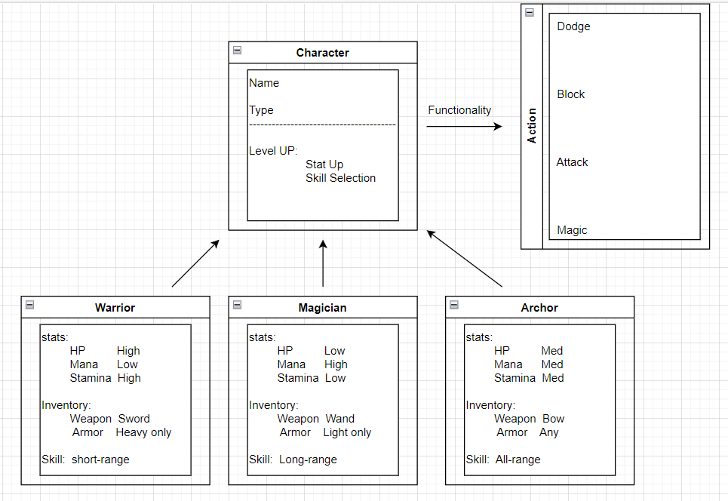

* 1. paragraph
* The base class will be the character which have attribute of name and Type. The Character class have ability to level up, and the player will have choices to increase stat with corresponding skill.

The sub classes of the Character class will be Warrior, Magician, and Archor. Each class will have different distribution of stats as well as some limitation over inventory and skill.

Finally, all classes will have functionality to battle including dodge, block, attack, and magic casting. However, there will be some probabaility added to the action so that some attempts can lead to failure.

1. Prototype 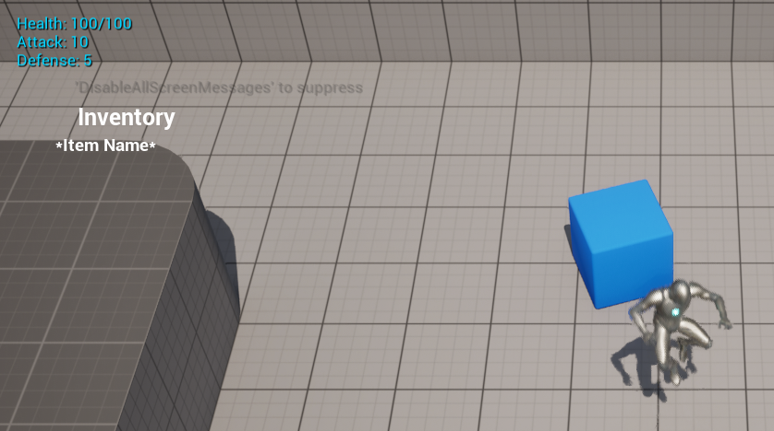

1. Team Reporting

| Week 1 | * Discussed and decided on the genre of game. |
| --- | --- |
| Week 2 | * Discussed getting the Github Repo up and running and whether we would use Git LFS or not, decided we wanted it to be a mix of Player Vs Player and Player Vs Environment. |
| Week 3 | * Setup Asana including setup tasks to start knocking out features. Added a theme of the players trying to escape an area. Examples would be a prison, hell, purgatory. Wanted some type of “Game Master” that Narrated the party going through the levels. Wanted top-down Camera for easy visibility. Procedural generation would add alot of replayability to the game but we want to focus on the core game first. |
| Week 4 | * Added Events and Code to Unreal including, Character Stats, Character Inventory, WASD movement, Test Item that can increase the damage and basic attacking motion. |

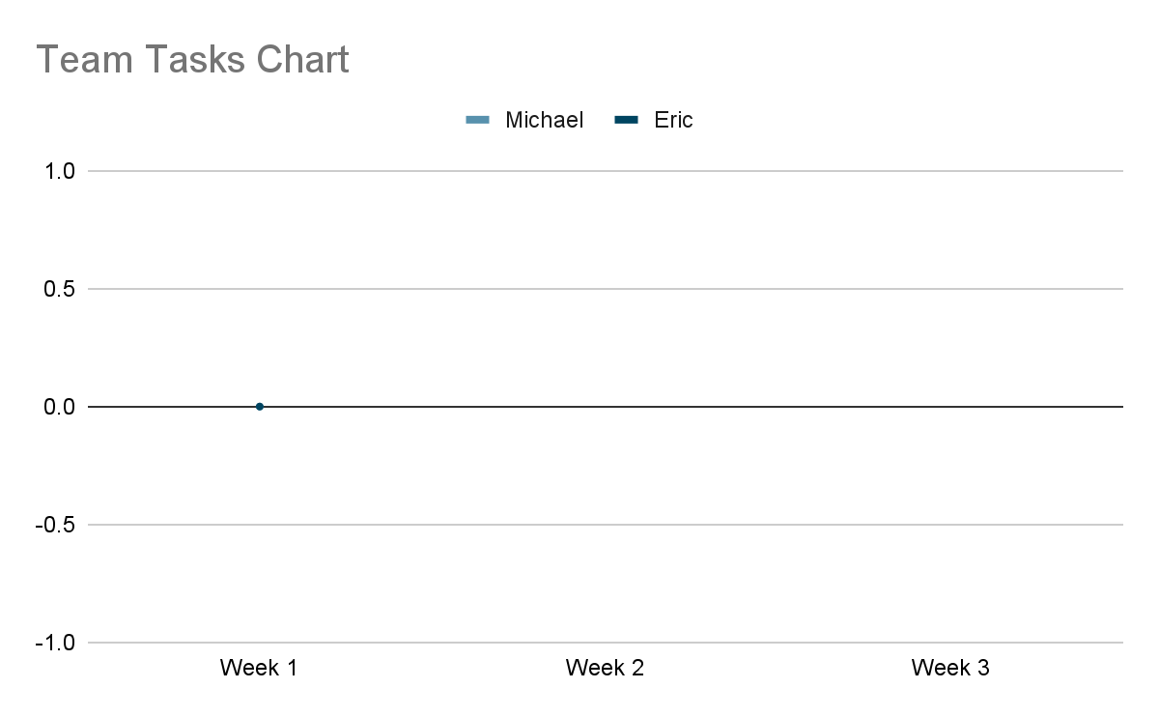

* 1. Individual Commit Requirements

Jae Min Whang:

Week2: [Commit I](https://github.com/Draftyjester/ProjectRogue/commit/3dd21cb339e1fe630bebff786d46492e228f986c)

* Github account setup<folk> (Complete)
* File upload in team repo (Complete)

Week 3: [Commit II](https://github.com/Draftyjester/ProjectRogue/commit/2c50f434000f89f4152cf442d32faaa4cccf7e0f)

* Design Document (Incomplete)
  + Introduction (Abstract/Exclusive summary)
  + Motivation (Competitive Analysis/Jounal Ariticle)

Week 4: [Commit III](https://github.com/Draftyjester/ProjectRogue/pull/7)

* Unreal Engine game
  + Added basic Attack motion (Complete)
* Design Document (Incomplete)
  + Individual Commit Requirements
  + Design Document (UML diagram)
  1. Team commit chart

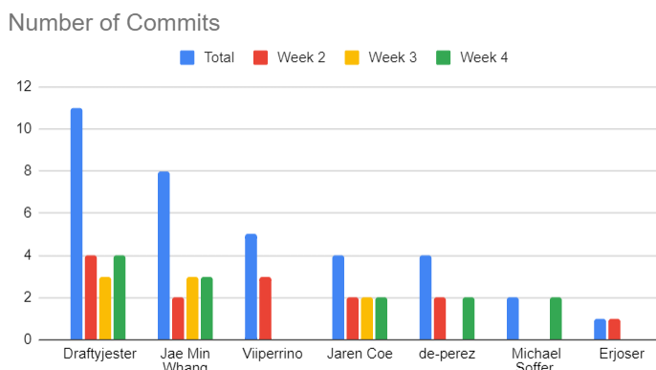

1. Conclusion