
North South University
Department of Electrical & Computer Engineering

Project Report
Title:
Quantifying Temperature-Driven Electricity Demand and Its Potential Climate Impact Using Machine Learning

Course title: Machine Learning
Name : | ID:
Atahar Hossain Piash | 2231877642
Rifat Imtiaze Ruddro | 2311474642
Course: CSE445 | Section: 1
Faculty: Dr. Sifat Momen [SFM1]

Date of Submission : | 31st August, 2026

1. Introduction

1.1 Problem Statement
The problem addressed here is narrow and can be stated precisely: given the observed relationship between weather and hourly national electricity demand in Spain, how would that demand change, by season and by hour of day, if every hour were uniformly warmer by 1 to 3 °C, and how much confidence can be placed in the answer?
This is one part of a larger question about how climate change affects energy systems. The larger question includes changes in renewable resource availability, in cooling water for thermal plants , in transmission ratings under high ambient temperatures, and in the economics of generation investment. None of those are addressed here. The domain of this work is the demand side only: the load that consumers draw, as a function of temperature and calendar, holding the physical and technological character of the Spanish system fixed at what it was between 2015 and 2018.
A second and less obvious part of the problem is methodological. A model that predicts hourly demand accurately is not necessarily a model that can answer a question about temperature. If a model is given the demand of the previous hour as an input, it will lean on that input almost exclusively, because consecutive hours are highly correlated. Such a model scores extremely well and is worthless for a counterfactual, because the demand history it depends on was itself recorded under the temperatures the counterfactual proposes to change. Distinguishing these two model classes, and showing quantitatively why the distinction matters, is part of the problem this work sets out to handle.

1.2 Importance of the Problem
Electricity infrastructure is sized against peak demand, not against annual consumption. Generation capacity, transmission and distribution equipment ratings, and operating reserve margins are all determined by the highest load the system must serve, which means a change in the timing of demand can require new investment even if the annual energy total does not move at all. Any analysis that reports only an annual figure is therefore reporting the quantity least relevant to planning.
Spain is a case where the seasonal question is particularly live . Cooling is almost entirely electric, whereas space heating is only partly electrified and relies substantially on gas and other fuels, so a warmer climate does not simply trade winter electricity for summer electricity on equal terms. Spain also has a generation mix in which hydro and gas provide much of the flexible response to demand changes, which means the carbon consequence of an extra megawatt-hour is not the same as the average carbon intensity of the system. Getting that distinction right changes the emissions answer materially.

1.3 Proposed Approach and how it differs
The approach has four elements. First, two model specifications are built and compared explicitly: one with demand history, which is the standard load-forecasting setup, and one without it, using only weather and calendar features expressed as heating and cooling degree-days. Feature importance from the first is used as the evidence that it must be discarded for scenario work, rather than the separation being asserted on principle.
Second, the functional form of the temperature response is not assumed. Four specifications are fitted on the same training and test split a random forest, a single-slope linear degree-day model, a piecewise model with separate coefficients for temperature bands, and a linear model interacting degree-days with time-of-day blocks and compared on test fit, interpretability and extrapolation behaviour before one is selected as primary.
Third, uncertainty is estimated by resampling whole training days and refitting the model 300 times, so that the reported intervals reflect uncertainty in the fitted coefficients. An earlier design in the same notebook resampled test hours instead, and is retained in the report as a comparison because the difference between the two is instructive: for a linear model the per-hour effect is a fixed function of the coefficients, so resampling hours produces intervals that look narrow and precise while measuring the wrong quantity.
Fourth, the emission factor is estimated from the same dataset rather than adopted from published national figures. Per-fuel factors are derived from IPCC inventory fuel carbon contents combined with plant thermal efficiencies, and a marginal factor is obtained by regressing hour-to-hour changes in fossil CO₂ on hour-to-hour changes in demand, cross-checked against a per-source decomposition of which generators actually follow load.
Much of the published work in this area either uses econometric specifications on aggregated data without a machine learning comparison, or uses machine learning for forecasting accuracy without addressing whether the resulting model supports counterfactual reasoning. The combination pursued here a deliberately weaker but interpretable response model, uncertainty targeted at coefficients, and an internally estimated marginal emission factor is the respect in which this work differs. Section 2 sets out the comparison in detail.

1.4 Goal and Research Hypothesis
The goal is to produce seasonal and hourly estimates of the demand response to uniform warming for Spain, each accompanied by an interval that supports a statement about whether the effect is distinguishable from zero, together with the implied change in CO₂ emissions.
The research hypothesis is that warming redistributes Spanish electricity demand across seasons rather than changing the annual total: that summer demand rises and winter demand falls by amounts that are individually detectable, and that the two largely offset, so that the annual mean change is not distinguishable from zero. A secondary hypothesis is that the temperature sensitivity of demand is not constant across the day, and that heating and cooling differ in this respect because electric heating follows building occupancy while cooling follows thermostats.

1.5 Key contributions
The contributions of this work are:
• A quantified demonstration that lag-based load forecasting models are unsuitable for temperature counterfactuals. The forecasting model reaches R² 0.984 while placing 90.7% of feature importance on the previous hour’s demand and 0.27% on temperature, and the report shows what is lost and gained by discarding it in favour of a model with R² 0.623.
• A four-way comparison of response-model functional forms on an identical chronological split, showing that test fit alone cannot discriminate between them (all four within 0.012 in R²) and that the selection must therefore rest on interpretability, extrapolation behaviour and mechanism.
• Evidence that temperature sensitivity is strongly time-of-day dependent, and asymmetrically so: heating sensitivity ranges from 3.2 to 326.0 MW/°C across four time blocks, a hundredfold variation, while cooling sensitivity varies only between 119 and 206 MW/°C.
• An uncertainty design that resamples training days and refits, targeting coefficient uncertainty, together with a direct comparison against the hour-resampling alternative showing why the latter is inadequate for a linear specification.
• A marginal emission factor of 0.207 kg CO₂/kWh estimated from the hourly generation record by two independent routes that agree exactly, and a decomposition attributing roughly 48% of the marginal response to reservoir hydro, which explains why the marginal factor sits 12% below the fleet average.
• A headline result reported as a redistribution with an explicit annual null: gross seasonal movement of 1,111 MW under +3 °C against a net annual change of +32 MW whose interval contains zero, with the same structure carried through to the emissions estimate.

1.6 Structure of the report
Every method and result below is referenced by the notebook project_final_last_v1.ipnyb cell that produced it, using the same cell numbering the notebook itself uses in its section headings: code cells numbered 1 to 68 in execution order. Markdown cells are not counted. This matches the labels in the notebook, so a reader can move between the two without translating.
One consequence of following cell order is worth stating in advance. The notebook was developed in stages, and the later stages revisit earlier decisions rather than simply extending them. Cell 51 computes a confidence interval that Cell 61 then replaces with a better one; Cell 45 trains a model whose accuracy is excellent and whose suitability for the actual research question is poor. The report keeps that structure instead of presenting a tidied-up pipeline, because in several places the reason for a choice is the failure of the thing that preceded it.
Section 2 covers data preparation, feature construction, model specification and the uncertainty methods. Section 3 presents results. Section 4 sets out the findings, what they imply for planning, and the limitations that qualify them.

2. Methodology

2.1 Overview
Figure 1 shows the full pipeline, from the two source datasets through to the three reported outputs. The one dead end in the diagram is deliberate: Model A is built, evaluated and then not carried forward, and the reason is recorded on the figure.
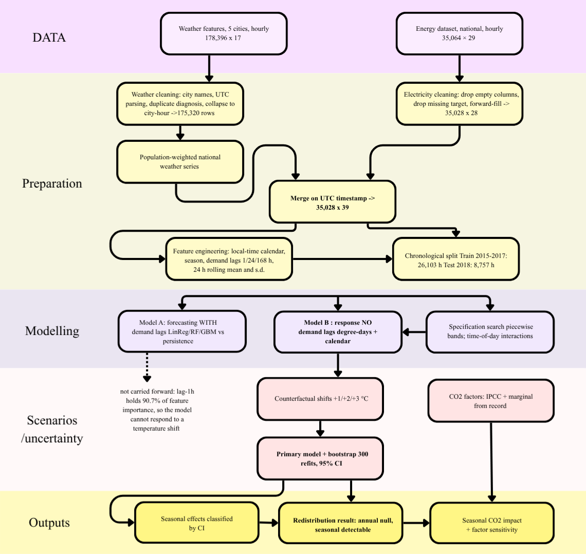
Figure 1. Methodology overview. Stages run top to bottom; cell references correspond to the notebook’s 68 code cells. Model A is trained and evaluated but excluded from scenario work on the evidence of its feature importance.
The remainder of this section describes each stage. Where a choice was made, the reasoning is given rather than only the operation.

2.2 Inspection of raw data(Cell 1-6)
Both files loaded without error. The weather file had 178,396 rows and no missing values in any column. The electricity file had 35,064 rows and 29 columns, with missing values scattered across the generation and forecast columns and two columns that were empty for every single hour.
The timestamp columns in both files were stored as text, in ISO format with a UTC offset that switches between +01:00 and +02:00 across the year. Parsing them without forcing a common timezone produced a mixed-offset object column and a pandas warning (Cell 5), which is the first sign that the daylight-saving transitions need explicit handling rather than being left to default behaviour.
Cell 5 found 21 fully duplicated rows in the weather file and none in the electricity file. Cell 6 showed why the weather file is not simply one row per hour: with five cities, a clean file would have exactly five rows per timestamp, but 2,114 timestamps had six rows, 366 had seven, 55 had eight, 10 had nine and 5 had ten. Only 32,514 of the timestamps had the expected five. The electricity file, by contrast, had a uniform one-hour gap between all 35,063 consecutive pairs, so it was already a regular hourly series.
Cell 6 also revealed that within a single city the parsed timestamps had 3,076 gaps of exactly zero hours, meaning the same city and hour appeared more than once. One city name was stored with a leading space (" Barcelona"), which would have been treated as a sixth city by any grouping operation

2.3 Cleaning the weather data(Cell 7-17)
Cell 7 stripped whitespace from city names. Cell 8 parsed both timestamp columns with utc=True, giving one unambiguous UTC index for both datasets; in UTC the series runs from 2014-12-31 23:00 to 2018-12-31 22:00.
Cells 9 to 14 identified the duplication before anything was removed. Cell 9 found 5,874 rows in duplicated city-and-timestamp groups 2,538 groups of two, 242 of three, 18 of four while Cell 10 found only 42 rows that were exact duplicates across all columns. Most duplicated hours therefore differed in at least one field, so dropping exact duplicates would not have repaired the structure. Cell 13 found that 2,777 of the duplicated groups contained more than one distinct weather_id. Cell 14 then checked every numerical column across all 2,798 duplicated groups and found the numbers identical in all 2,798: not one group had a conflicting temperature, pressure, humidity, wind, rainfall or cloud value.
The duplication is thus entirely an artefact of the categorical weather labels the source recorded, for instance, both "clear" and "few clouds" for the same hour, writing the row twice with identical measurements. Cell 15 removed the 21 exact duplicates, leaving 178,375 rows. Cell 16 collapsed each city-and-timestamp group to one row, taking the first value for each numerical column, which is safe because the values are identical, and concatenating sorted unique values for the four categorical columns so no label was silently dropped. Cell 17 confirmed the outcome: zero remaining duplicate city-hours, exactly 35,064 rows per city, and no missing values.

Table 1. Weather dataset row counts through cleaning (Cells 1, 15, 16)
Stage | Rows | Change
Raw file (Cell 1) | 178,396 | —
After removing exact duplicates (Cell 15) | 178,375 | −21
After collapsing city/timestamp groups (Cell 16) | 175,320 | −3,055
Expected (5 cities × 35,064 hours) | 175,320 | match

2.4 Cleaning the electricity data(Cell 18-20)
Two columns empty for all 35,064 hours were dropped: “generation hydro pumped storage aggregated” and “forecast wind offshore eday ahead”. The 36 rows with a missing target were dropped, since they cannot be used for supervised learning. Remaining gaps in the generation and forecast columns were forward-filled, which is defensible for a physical quantity sampled hourly where the gaps are isolated single hours rather than long runs. The result was 35,028 rows, 28 columns, no missing values.
Cell 19 converted temperatures from Kelvin to Celsius; Cell 21 dropped the Kelvin originals and renamed the Celsius columns. Cell 20 dropped the four categorical weather columns, which were retained through the duplication analysis because they caused it but play no part in any model.

2.5 National weather average and merge(Cell 21-23)
The two datasets are at different spatial resolutions: weather is per city, demand is national. Averaging the five cities equally would give Bilbao the same influence as Madrid, which is wrong here because demand is roughly proportional to the population and economic activity exposed to the weather. Cell 22 computed a population-weighted average across the five cities at each hour using approximate 2018 municipal populations from the Spanish National Statistics Institute.
Table 2. Population weights used for the national weather average (Cell 22)
City | Population (2018, approx.) | Weight
Madrid | 3,223,000 | 46.9%
Barcelona | 1,620,000 | 23.6%
Valencia | 791,000 | 11.5%
Seville | 689,000 | 10.0%
Bilbao | 345,000 | 5.0%
Total | 6,668,000 | 100%
The weighting was applied to all eleven numerical weather variables, producing 35,064 rows and 12 columns. Wind direction was averaged arithmetically along with the rest, which is not meaningful for a circular variable, although it affects nothing because wind direction enters no model.
An inner join on the UTC timestamp gave 35,028 rows and 39 columns. The join was clean in both directions: no electricity timestamp lacked a weather match; 36 weather timestamps had no electricity match, which is exactly the 36 rows dropped for a missing target; no duplicate timestamps were created; no new missing values appeared.

2.6 Feature Engineering(Cell 24-26)
Calendar features were derived from local Spanish time rather than UTC (Cell 24), because human activity follows the clock on the wall. An office opens at 09:00 local in both January and July, and using UTC would shift every summer hour by one and blur the daily profile. Hour, day of week, month, a weekend indicator and a four-level season variable were created. The seasonal split is close to even: 8,829 summer hours, 8,819 spring, 8,735 autumn, 8,645 winter.
Cell 25 added demand history: lags at 1, 24 and 168 hours, plus the rolling mean and standard deviation of the previous 24 hours. The rolling statistics apply shift(1) before the window, so the window ends at t−1 and never contains the target hour. Without that shift the features would leak the target. The lags are undefined at the start of the series, giving 1, 24 and 168 missing values respectively.

2.7 Time Based Train/Test Split(Cell 33)
The split is by date: 2015–2017 for training, 2018 for testing. A random split of a time series lets the model see hours from the same day, often adjacent hours, in both sets, producing an optimistic score that would not survive deployment. Splitting at 1 January 2018 gives 26,271 training and 8,757 test hours, a 25.0% test share, with every test hour later than every training hour. Dropping the 168 training rows with undefined lags left final matrices of 26,103 × 49 and 8,757 × 49.

2.8 Model-A : Forecasting Model Training(Cell 34-37)
Cell 34 reduced the feature set to 16 variables, dropping temp_min and temp_max because at hourly resolution they are nearly identical to temp and add collinearity without information. One-hot encoding season with the first level dropped gave an 18-column matrix, and the test matrix was reindexed onto the training columns to guarantee identical content and order.
Cell 35 established a naive persistence baseline, predicting each hour equal to the previous hour. This is a demanding baseline for hourly demand and reporting model scores without it would make an unimpressive model look strong. Cell 36 then trained linear regression, a random forest with 200 trees and maximum depth 15, and gradient boosting with 200 stages, depth 4 and learning rate 0.1, both ensembles with a fixed seed.

2.9 Model-B Response Specification (Cells 44–46)
Model A is given the demand at t−1, t−24 and t−168 and asked for the demand at t. That is correct for operational forecasting and wrong for this project’s question, because the demand history was itself recorded under the original temperatures. Feeding the model warmer weather while holding the lags at historical values asks it to predict an internally inconsistent world, and the lags would overwrite the temperature change.
Cell 44 built a design matrix with no demand history: temperature, cooling and heating degree-days, five other weather variables, four calendar variables and season dummies fifteen columns. Degree-days are the distance above and below a balance point of 18 °C, floored at zero, which lets one variable carry a V-shaped response in a linear specification.
One detail in Cell 44 is load-bearing. The feature builder takes a temp_shift argument and recomputes cdd and hdd from the shifted temperature rather than reusing the originals. Shifting temperature alone would leave a matrix containing 24 °C alongside cooling degrees computed for 21 °C, and every scenario result would be meaningless. Cell 49 includes an explicit check that exactly three columns , temp, cdd, hdd differ between the baseline and the +1 °C matrix.
Cell 45 trained a random forest with 300 trees and a minimum of five samples per leaf. With unconstrained leaves the forest isolates individual hours and its predictions become a jagged step function whose discontinuities are indistinguishable from a genuine scenario effect of a few tens of megawatts. Cell 46 fitted a linear version with cdd , hdd, humidity and wind speed as continuous terms and hour, day of week and month one-hot encoded necessary here in a way it is not for trees, since a linear model would otherwise read hour 23 as twenty-three times more of something than hour 1

2.10 Response Curve and Scenario Construction(Cell 48-54)
Cell 48 traced the response by holding every calendar and non-temperature weather variable at its observed value for each test hour, setting temperature to a single value across all hours, recomputing the degree-day terms, and averaging predictions. Sweeping in 0.5 °C steps gives the mean demand the model associates with each temperature. The sweep stays inside the training range, because a random forest returns the boundary value beyond it, so outside points would be flat by construction rather than by evidence. The per-season panel restricts each season to the temperatures it actually experienced.
Cells 49 and 50 built the scenarios by adding 1, 2 or 3 °C to every test hour and comparing mean predicted demand against the unshifted baseline, then decomposing by season and by hour of day.

2.11 Piecewise and Interaction Specifications (Cell 58-59)
A single cooling coefficient assumes the response is identical at 19 °C and 35 °C, which is physically implausible because air conditioning penetration and duty cycles both rise with heat. Cell 58 split the range into bands 18–22, 22–26, 26–30 and above 30 °C for cooling, 18–14, 14–10, 10–6 and below 6 °C for heating each with its own coefficient, so a 24 °C hour contributes four degrees to the 18–22 band and two to the 22–26 band.
Cell 59 tested whether sensitivity depends on time of day. Interacting the degree-day terms with all 24 hours would spread the data across 48 sparse terms, so the day was divided into four blocks: night (00:00–07:00), morning (08:00–13:00), afternoon (14:00–19:00) and evening (20:00–23:00). Each block carries a deviation from the main effect, so the cooling slope in a block is the main coefficient plus that block’s interaction term.

2.12 Primary Model Selection (Cell 60)
Cell 60 selected the linear model with time-of-day interactions as primary on four grounds: best test R² and lowest MAE of the four candidates; coefficients interpretable as MW per degree by time of day; ability to extrapolate above the observed temperature range, which the forest lacks; and a defensible mechanism, since heating and cooling sensitivity should depend on building occupancy. The random forest results were preserved as a robustness check. The primary model has 52 features.
Two bootstrap designs were used, and the difference between them is a methodological point rather than a detail. Cell 51 resampled whole days from the test period and recomputed the mean effect, giving an interval for the average over hours. Days rather than hours were resampled because hourly demand is strongly autocorrelated and hour-level resampling would treat 8,757 correlated observations as independent.
That design is still not sufficient. Resampling which hours are averaged captures a real source of variation, but for a linear model the per-hour effect is a fixed function of the coefficients, so within winter where nearly every hour sits below the balance point the effect is close to constant across hours and resampling them yields an interval of roughly ±0.1%. That is not precision; it is a design that cannot see the dominant uncertainty, which is uncertainty in the fitted coefficients themselves. Cell 61 replaced it: resample whole training days with replacement, refit, recompute the effects, 300 times. The spread across refits is the coefficient uncertainty. Three hundred refits took 31.8 seconds, the design matrices having been built once and converted to NumPy before the loop

2.13 Emission Factors (Cell 55-59)
Cell 55 derives the per-fuel factors in two steps following IPCC Tier 1 practice. The carbon content of each fuel comes from the IPCC 2006 Guidelines, Volume 2 (Energy), Chapter 2, Table 2.2, in kg CO₂ per TJ of fuel on a net calorific basis, with the published low and high of each range. Dividing by a typical net thermal efficiency converts from fuel input to electricity output:
kg CO₂ per kWh electricity = (kg CO₂ per TJ fuel ÷ 277,778 kWh per TJ) ÷ plant efficiency
Table 3. Emission factors derived in Cell 55 from IPCC fuel carbon content and assumed plant efficiency
Fuel | IPCC kg CO₂/TJ | Efficiency | Low | Central | High
Fossil gas (CCGT) | 56,100 | 0.50 | 0.391 | 0.404 | 0.420
Fossil hard coal | 94,600 | 0.38 | 0.848 | 0.896 | 0.945
Fossil brown coal/lignite | 101,000 | 0.34 | 0.962 | 1.069 | 1.218
Fossil oil | 77,400 | 0.38 | 0.715 | 0.733 | 0.747
Fossil oil shale | 107,000 | 0.35 | 0.928 | 1.101 | 1.286
Fossil peat | 106,000 | 0.35 | 1.029 | 1.090 | 1.111
Fossil coal-derived gas | 44,400 | 0.38 | 0.353 | 0.421 | 0.513

The last three fuels are zero for every hour in this dataset, so only gas, hard coal, lignite and oil affect any result. Nuclear, hydro, wind, solar and geothermal were treated as zero direct emissions, and biomass and waste likewise, following the convention that biogenic CO₂ is reported separately. The low and high columns propagate the IPCC range on fuel carbon content only; the efficiency assumptions are held at their central values..
Cell 56 estimated the marginal factor by regressing the hour-to-hour change in fossil CO₂ on the hour-to-hour change in demand. The slope is the marginal factor by construction, and differencing removes slowly-moving confounders such as fuel prices, capacity additions and seasonal patterns, because those barely change between adjacent hours. Only genuinely consecutive hours were used, checked by requiring a one-hour gap, leaving 35,005 pairs. The regression was fitted through the origin, since no change in demand should imply no change in emissions, with an intercept version retained as a diagnostic. Cell 57 applied the same logic to each generation source separately, giving each source’s response per MW of demand change and an independent route to the same marginal factor

2.14 Experiments conducted
The analysis is organised as eight experiments, each tied to one of the goals in Section 1.4. Table 5 lists them with the cells that implement them and the criterion by which each is judged.

Table 4. Experiments conducted, and how each relates to the stated goals
 | Experiment | Cells | Purpose / success criterion
E1 | Forecasting benchmark: persistence vs linear regression, random forest, gradient boosting | 34–37 | Establish achievable hourly accuracy and confirm any model beats persistence
E2 | Error and outlier analysis of the best forecasting model | 38–41 | Check for bias, heteroscedasticity and data artefacts before drawing conclusions
E3 | Feature attribution on the forecasting model | 42–43 | Test whether the model’s accuracy rests on temperature or on demand history
E4 | Response model without demand lags, random forest and linear | 44–46 | Quantify the accuracy cost of a counterfactually valid specification
E5 | Permutation importance and temperature response curve | 47–48 | Recover the response shape and locate the demand-minimising temperature
E6 | Counterfactual shifts of +1/+2/+3 °C, by season and hour | 49–50 | Test the redistribution hypothesis of Section 1.4
E7 | Robustness: extrapolation range, calendar collinearity, balance point, linear cross-check, four-way specification comparison | 52–54, 58–59 | Establish whether the result depends on modelling choices
E8 | Uncertainty and emissions: coefficient bootstrap, CI classification, marginal factor by two routes, factor sensitivity | 51, 55–57, 61, 63–67 | Attach intervals to every scenario effect and convert to CO₂ defensibly

E1 to E3 together answer the first goal, and E3 is what makes E4 necessary rather than optional. E5 and E6 answer the second and third goals. E7 exists because the third goal asks whether effects are distinguishable from zero, which cannot be answered without knowing how sensitive they are to specification. E8 answers the fourth goal and supplies the intervals the third requires. Cell 62 sits alongside E7 as a diagnostic on generalisation.

3. Experimental Results

3.1 Exploratory analysis (Cells 27–32)
The scatter of demand against temperature (Cell 27) shows the expected V, but a wide and noisy one: at any given temperature the demand range spans roughly 15,000 MW, because temperature is far from the only determinant of demand in a given hour.
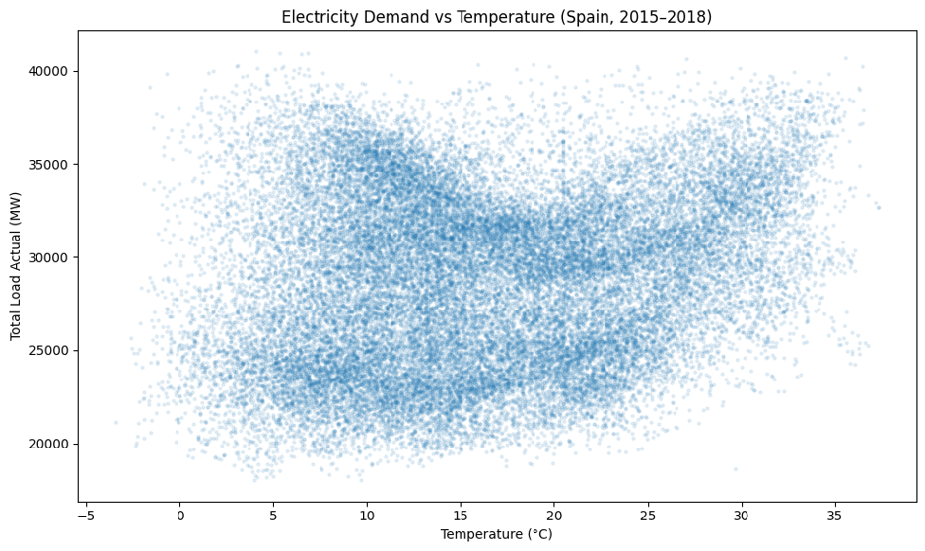Figure 2. Hourly demand against population-weighted national temperature, 2015–2018 (Cell 27).
The hourly profile (Cell 28) is much cleaner. Demand troughs in the early hours, climbs steeply through the morning, holds a broad plateau across the working day with a mid-afternoon dip, and peaks again in the evening. The gap between the overnight minimum and the daytime plateau is on the order of 8,000 MW larger than any temperature effect estimated later in this report, which sets the scale for everything that follows
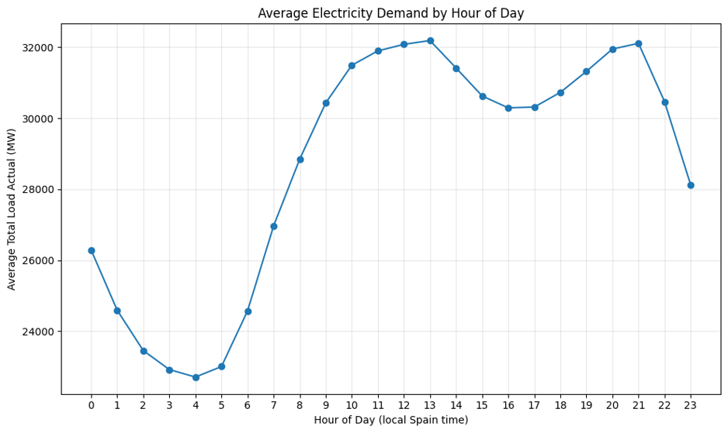Figure 3. Average demand by hour of local Spanish time (Cell 28).

The full series (Cell 29) shows annual cycles with winter and summer peaks, shoulder-season troughs, and a visible downward drift in level across the four years. Sharp single-hour dips recur at intervals, consistent with public holidays, which are not among the model features.
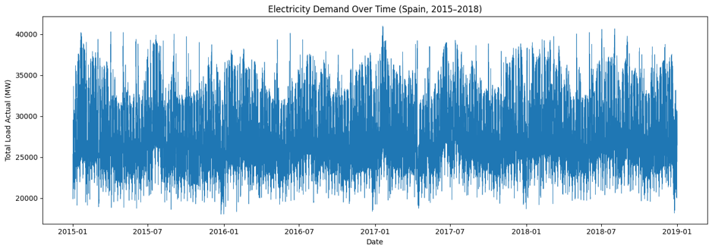Figure 4. National demand over the full period (Cell 29).

The correlation heatmap (Cell 30) states the modelling problem before any model is fitted: the three demand-history features correlate with the target at 0.95 or above, while temperature correlates at only 0.06. A linear correlation is the wrong summary for a V-shaped relationship, because the rising and falling arms cancel, which is precisely why the degree-day transformation of Cell 44 was needed rather than raw temperature.
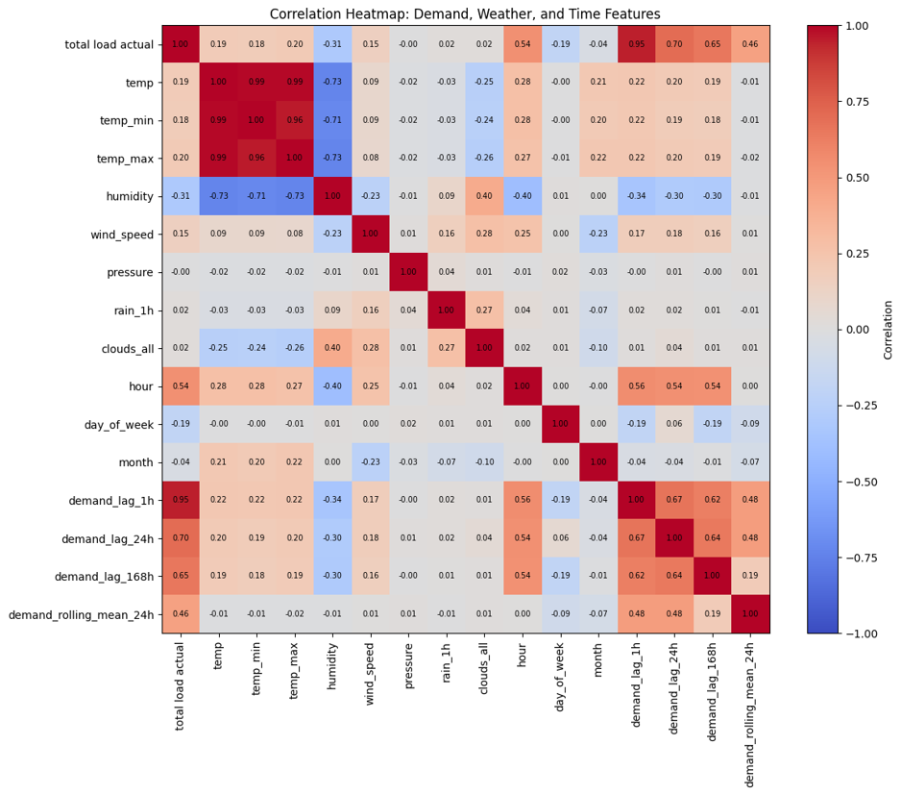Figure 5. Correlations among demand, weather and calendar features (Cell 30).

Distributions (Cell 31) show temperature roughly symmetric and centred in the middle teens, and demand approximately normal around 28,000 MW with a slight right skew. Monthly and seasonal averages (Cell 32) show the two-peaked annual pattern, highest in winter with a secondary summer peak and lowest in the shoulder months.
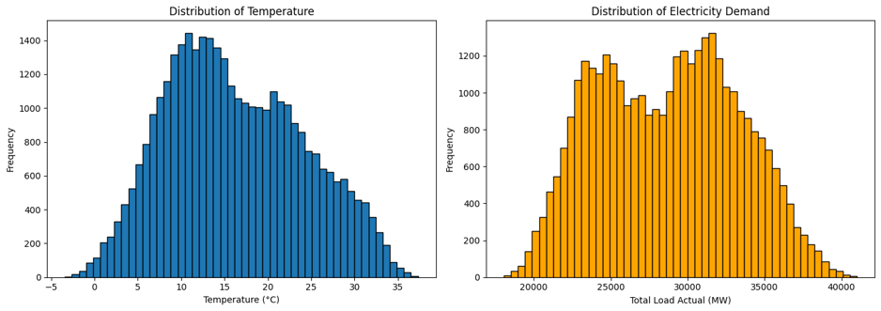Figure 6. Distributions of national temperature and demand (Cell 31).

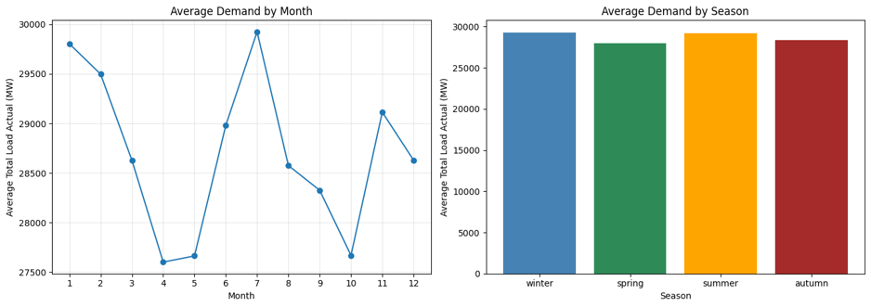Figure 7. Average demand by month and by season (Cell 32).

3.2 E1- Forecasting model performance (Cells 35, 37)
Naive persistence achieved an MAE of 1,076 MW and R² of 0.903 on the test year, confirming how much of hour-ahead demand the previous hour alone explains.
Table 5. Forecasting model performance on the 2018 test set (Cells 35, 37)
Model | MAE (MW) | RMSE (MW) | R²
Baseline (naive persistence) | 1,076.29 | 1,438.34 | 0.9034
Linear regression | 975.75 | 1,295.33 | 0.9216
Random forest | 355.44 | 577.05 | 0.9844
Gradient boosting | 397.10 | 611.37 | 0.9825

Linear regression barely improved on persistence, cutting MAE by about 9%. Both tree ensembles reduced MAE to roughly a third of the baseline. The random forest was strongest, at 355 MW against a mean demand near 28,500 MW, an error of about 1.2%. Gradient boosting was close enough that the gap should not be read as a ranking of the methods.

3.3 E2 - Error diagnostics (Cells 38–41)
The actual-versus-predicted scatter (Cell 38) sits tightly along the diagonal from roughly 18,000 to 40,000 MW with no curvature or fan shape. Over the first two weeks of the test year (Cell 39) the predicted series tracks the daily cycle closely, including the weekday-to-weekend transition.
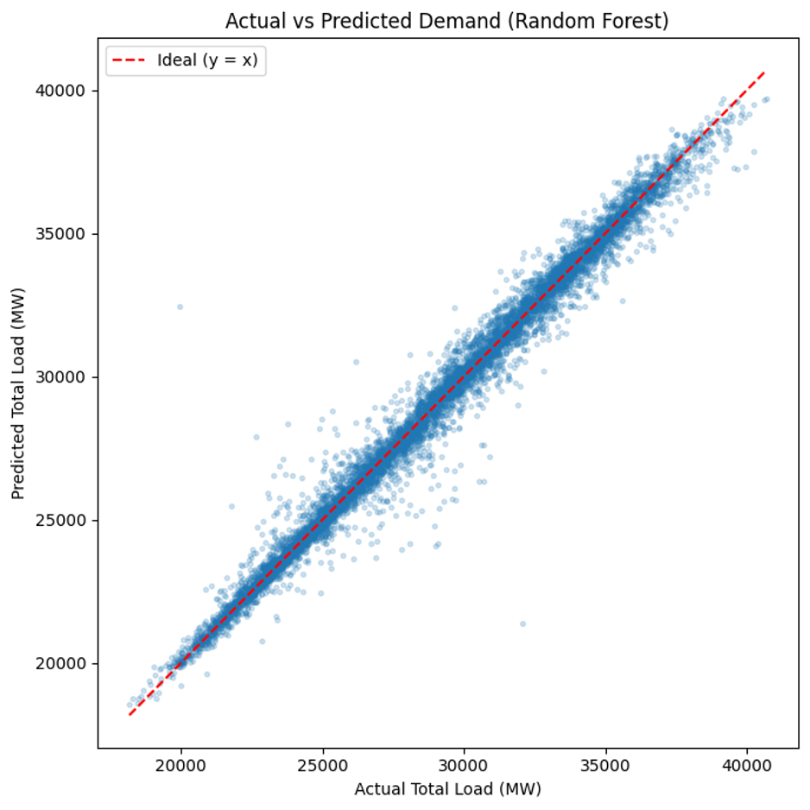Figure 8. Actual against predicted demand, random forest, 2018 test set (Cell 38).
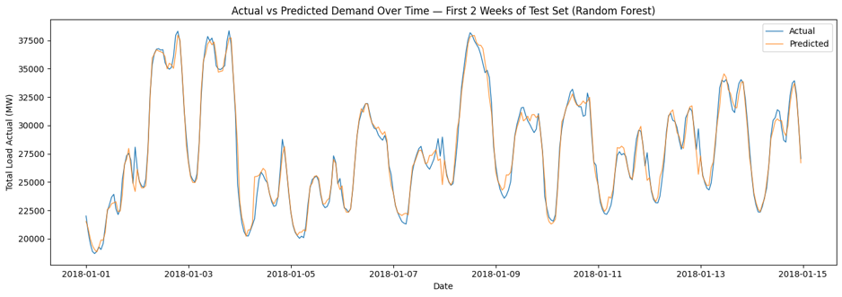Figure 9. Actual and predicted demand over the first two weeks of 2018 (Cell 39).

Residuals (Cell 40) have a mean of −13 MW and a standard deviation of 577 MW. The mean is negligible against the spread, so the model is not systematically biased, and the distribution is close to symmetric about zero. The residuals-against-predicted panel shows no strong pattern across most of the range, with mild widening at both extremes.
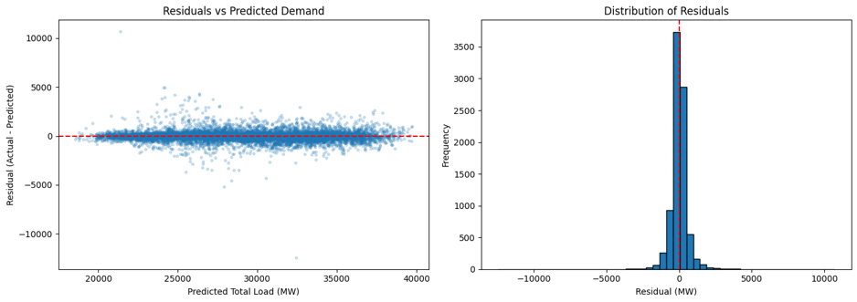Figure 10. Residual diagnostics for the random forest (Cell 40).

Two residuals stand well outside the rest, at roughly +10,700 MW and −12,500 MW, and identifying them is informative rather than merely tidy.
Table 6. The five largest absolute residuals, random forest (Cell 41)
Timestamp (UTC) | Actual (MW) | Predicted (MW) | Residual (MW)
2018-05-06 10:00 | 19,964 | 32,441 | −12,477
2018-05-06 11:00 | 32,090 | 21,380 | +10,710
2018-01-31 23:00 | 22,657 | 27,883 | −5,226
2018-09-30 22:00 | 29,001 | 24,076 | +4,925
2018-10-06 22:00 | 29,100 | 24,152 | +4,948

The two largest are adjacent hours on the same Sunday morning: a drop to 19,964 MW followed immediately by a jump to 32,090 MW. A genuine 12,000 MW swing within one hour on a Sunday morning is not physically plausible for a national system, and the adjacent-hour structure is what a mis-recorded or transposed pair of readings looks like. The notebook raises a public holiday as an alternative, but the pattern points more strongly to a recording error. Both hours were left in the data, so every reported metric includes them. The remaining three largest residuals cluster at 22:00–23:00, which suggests the models handle the evening ramp less well than the rest of the day.

3.4 E3 - Feature importance in the forecasting model (Cells 42–43)
This subsection is the pivot of the whole analysis. Applying feature attribution to the best forecasting model shows that its accuracy does not come from the variable of interest.
Table 7. Random forest feature importance, forecasting model (Cell 42)
Feature | Importance
demand_lag_1h | 0.9072
hour | 0.0747
demand_lag_24h | 0.0030
temp | 0.0027
demand_rolling_mean_24h | 0.0022
demand_rolling_std_24h | 0.0022
humidity | 0.0014
demand_lag_168h | 0.0012
wind_speed | 0.0011
all remaining features combined | 0.0042
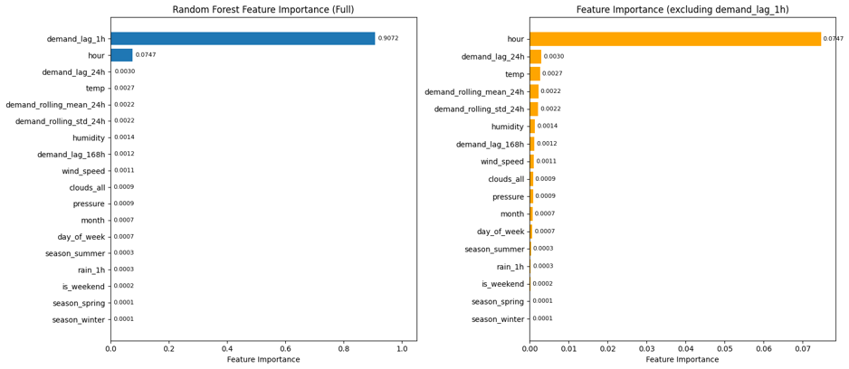Figure 11. Random forest feature importance, full scale and excluding the dominant lag feature (Cell 43).

The demand of the previous hour carries 90.7% of the importance; hour of day a further 7.5%; temperature 0.27%. The model with R² 0.984 has essentially learned that demand now resembles demand an hour ago. Asking it what happens under +3 °C would return almost nothing, not because warming has no effect but because the model has no mechanism through which temperature can act. This is the evidence on which Model A is excluded from all scenario work, and it is the reason the accuracy figures in Section 4.2 should be read as a benchmark rather than as a result.

3.5 E4 - Response model performance (Cells 45–47)
Removing the demand history cost most of the accuracy, as expected.
Table 8. Forecasting specification against response specification (Cell 45)
Specification | MAE (MW) | RMSE (MW) | R² | Valid for counterfactuals
A: with demand lags | 355.4 | 577.1 | 0.984 | No
B: weather and calendar only | 2,054.8 | 2,839.8 | 0.623 | Yes

MAE rose from 355 MW to 2,055 MW and R² fell from 0.984 to 0.623. The lower number is the honest one for this project. Model B still explains 62% of hourly national demand from weather and the calendar alone, which is reasonable for a model with no knowledge of recent load, and it is the only one of the two whose predictions move coherently when temperature is changed.
The linear version (Cell 46) performed almost identically MAE 2,134 MW, RMSE 2,826 MW, R² 0.627 with directly readable coefficients: +104.6 MW per degree above 18 °C and +78.7 MW per degree below. The asymmetry is consistent with cooling being almost entirely electric in Spain while heating is only partly so.
Permutation importance for Model B (Cell 47), measured on the test set rather than in training, ranks hour of day far above everything else: shuffling it raises MAE by 2,388 MW. Day of week adds 280 MW and the weekend flag 163 MW. The temperature group follows, with temperature at 81 MW, hdd at 51 MW and cdd at 41 MW. Cloud cover came out at −5.8 MW, meaning shuffling it marginally improved predictions, which is the signature of a feature carrying no usable information.
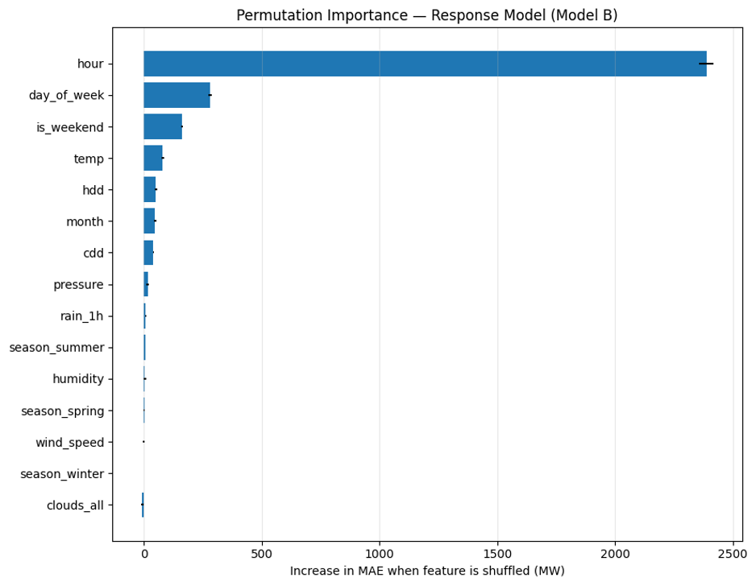Figure 12. Permutation importance for the response model, measured on the test set (Cell 47).

Temperature therefore matters, but as a second-order driver behind the daily and weekly activity rhythm. Scenario effects of a few hundred megawatts are real, and small next to a 2,400 MW hour-of-day effect.

3.6 E5 - The temperature response curve (Cell 48)
Sweeping temperature across its observed range recovers the V that the raw scatter obscured. Mean predicted demand is lowest at 19.0 °C, at 27,799 MW, rising to 29,043 MW at the coldest end of the training range (−4 °C) and 30,000 MW at the hottest (37 °C).
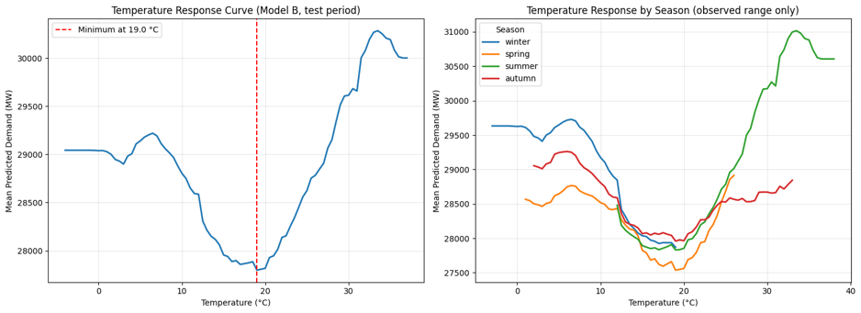Figure 13. Temperature response curve overall and by season, response model (Cell 48).

The per-season panel is the more informative one. Each curve, restricted to the temperatures that season actually saw, has the same broad shape at a different level, and the summer curve rises more steeply above about 25 °C than any other season reaches. That the seasonal curves do not coincide means season carries something beyond temperature holiday patterns, industrial scheduling, daylight hours which is the collinearity that Cell 53 was written to bound

3.7 E6 - Scenario results (Cells 49–50)
Applied to the random forest response model, uniform warming produced very small annual mean changes: +16.8 MW under +1 °C, +44.2 MW under +2 °C, +61.6 MW under +3 °C, or 0.06% to 0.22% of baseline. Taken alone those numbers would suggest warming barely affects Spanish demand. The seasonal decomposition shows why that reading is wrong.
Table 9. Mean change in predicted demand by season, random forest response model (Cell 50)
Season | +1 °C (MW) | +2 °C (MW) | +3 °C (MW) | +3 °C (%)
Winter | −140.2 | −303.1 | −491.7 | −1.68
Spring | −57.9 | −91.5 | −106.5 | −0.38
Summer | +272.7 | +578.3 | +845.5 | +2.93
Autumn | −10.9 | −14.8 | −13.5 | −0.05
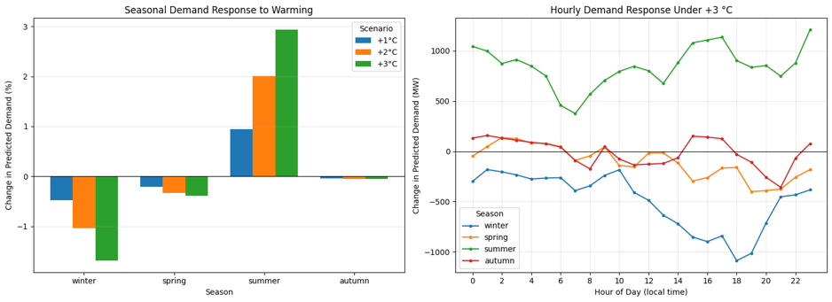Figure 14. Seasonal and hourly demand response to warming, random forest response model (Cell 50).

Summer demand rises 845 MW under +3 °C while winter falls 492 MW. The annual mean is small because these move oppositely and largely cancel, not because nothing happens. The hourly panel puts the summer increase in the later part of the day, with the largest single-hour effect of 1,211 MW at hour 23. That specific hour warrants caution: the interaction model of Cell 59 places peak cooling sensitivity in the afternoon, so the two specifications agree on the seasonal pattern and disagree on where within the day the effect lands.

3.8 E7 - Robustness of the scenario result (Cells 52–54)

3.8.1 Extrapolation and Modeling Choices
Cell 52 quantified the extrapolation problem. Training temperatures ran from −3.4 °C to 36.8 °C, test from −2.1 °C to 37.3 °C. Under +1 °C, 18 test hours (0.21%) exceed the training maximum; under +2 °C, 32 hours (0.37%); under +3 °C, 45 hours (0.51%). Because a random forest returns the boundary value beyond its range, the effect in those hours is understated, making the forest estimates a lower bound. The share is small, but they are the hottest hours, which is where the cooling response is steepest one reason the linear specification was preferred.
Cell 53 ran two sensitivity checks. Dropping month and season moved R² only from 0.6233 to 0.6248 but cut the +3 °C effect from +61.6 MW to +39.4 MW, confirming that the calendar variables absorb part of the temperature signal and that the annual-mean estimate is sensitive to how that shared variance is allocated. Varying the balance point had almost no effect: at 16, 18 and 20 °C the +3 °C change came out at +61.8, +62.2 and +61.7 MW with R² stable at 0.623, so the choice of 18 °C is not driving the result.

3.8.2 Four-way Specification Comparison
The figure below collages the two comparisons that matter for specification choice: the seasonal +3 °C effect from each of the four response models, and their test-set fit. The point of setting them side by side is that the left panel varies by a factor of three while the right panel is almost flat.
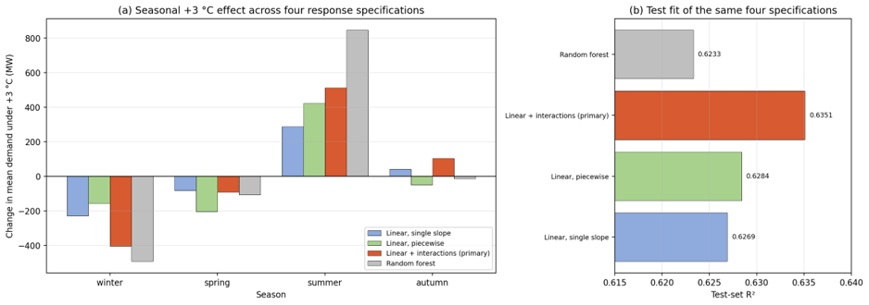Figure 15. Comparison across four response specifications: (a) seasonal effect under +3 °C, (b) test-set R². All four specifications fit the data almost equally well while disagreeing substantially on the scenario effect (Cells 45, 46, 58, 59).
Table 10. Test-set fit of all four response specifications (Cells 45, 46, 58, 59)
Specification | R² | MAE (MW)
Random forest | 0.6233 | 2,054.8
Linear, single slope | 0.6269 | 2,134.4
Linear, piecewise bands | 0.6284 | 2,127.3
Linear + time-of-day interactions | 0.6351 | 2,096.9

All four land within 0.012 of each other in R², while their +3 °C summer estimates range from +287 to +846 MW and their winter estimates from −156 to −492 MW. Test fit cannot discriminate between them. This is why Cell 60 justified the selection on interpretability, extrapolation behaviour and mechanism, and why the report carries the forest results forward as a robustness check rather than discarding them.

3.8.3 Piecewise Degree Bands
The piecewise model gave a marginally better fit than the single-slope linear model, R² 0.6284 against 0.6269. Its band coefficients are only partly interpretable.
Table 11. Estimated demand sensitivity within each temperature band (Cell 58)
Band | MW per °C within band
Cooling 18–22 °C | −29.2
Cooling 22–26 °C | +120.9
Cooling 26–30 °C | +102.5
Cooling above 30 °C | +353.5
Heating 18–14 °C | +113.3
Heating 14–10 °C | +145.0
Heating 10–6 °C | +9.8
Heating below 6 °C | −35.6

The headline pattern is credible and matches physical expectation: cooling sensitivity above 30 °C, at +354 MW/°C, is roughly three times the 22–26 °C band, which is what air conditioning load doing in extreme heat should look like. But two coefficients carry the wrong sign. The 18–22 °C cooling band at −29.2 MW/°C and the below-6 °C heating band at −35.6 MW/°C and neither can be read literally. These are collinearity artefacts: the bands overlap heavily with the month dummies, and the mildest and coldest bands contain the fewest hours, so their coefficients are poorly identified. The steepening factor printed in Cell 58 as −12.1× follows from dividing by the negative baseline band and should be disregarded; the meaningful comparison is between the 22–26 and above-30 bands.
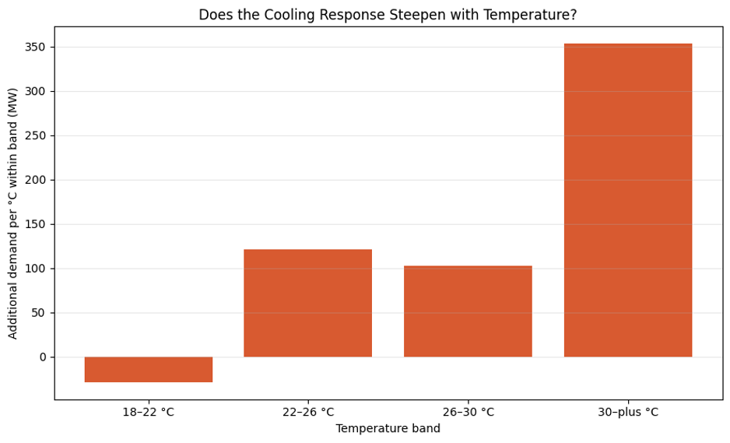Figure 16. Estimated cooling sensitivity by temperature band (Cell 58).

3.8.4 Time of day interactions
The interaction model gave the best fit of the four, R² 0.6351 and MAE 2,097 MW, a gain of +0.0082 in R² over the single-slope model, and the most informative coefficients.
Table 12. Temperature sensitivity by time of day, MW per °C (Cell 59)
Time block | Cooling (above 18 °C) | Heating (below 18 °C)
Night (00:00–07:00) | +201.8 | +3.2
Morning (08:00–13:00) | +176.2 | +133.5
Afternoon (14:00–19:00) | +205.8 | +326.0
Evening (20:00–23:00) | +119.0 | +158.8

The heating column is the striking one. Overnight heating sensitivity is 3.2 MW/°C, effectively zero, rising to 326 MW/°C in the afternoon a hundredfold variation. Spanish buildings are largely not heated electrically overnight, and the response appears when they are occupied. Cooling sensitivity is far flatter, between 119 and 206 MW/°C, consistent with air conditioning and refrigeration running on thermostats rather than schedules and continuing through the night in hot weather. The evening cooling figure being lowest of the four is unexpected and sits awkwardly against Cell 50, which placed the largest summer effect at hour 23; Section 5.3 returns to this.
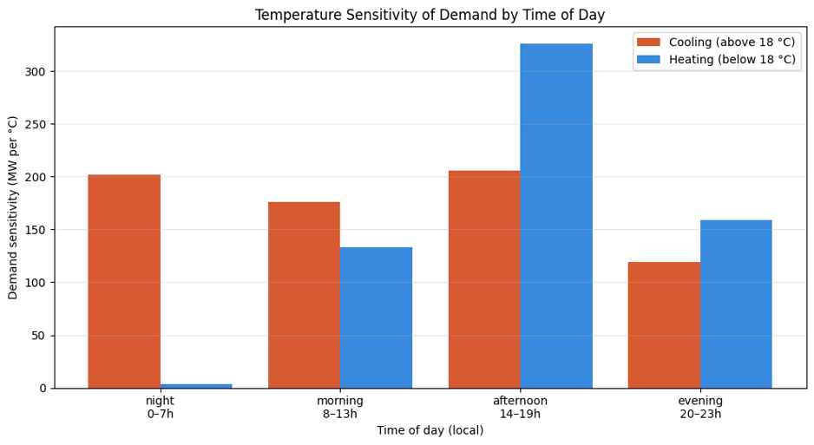Figure 17. Cooling and heating sensitivity by time of day (Cell 59).

3.9 Learning curves (Cell 62)
Both response models were evaluated with TimeSeriesSplit across five training sizes, which trains on an earlier block and validates on the block immediately after rather than shuffling.

Table 13. Learning curve endpoints at full training size (Cell 62)
Model | Training MAE (MW) | Validation MAE (MW) | Gap (MW)
Linear + interactions (primary) | 2,081.3 | 2,818.9 | 737.6
Random forest | 1,145.1 | 2,161.2 | 1,016.1

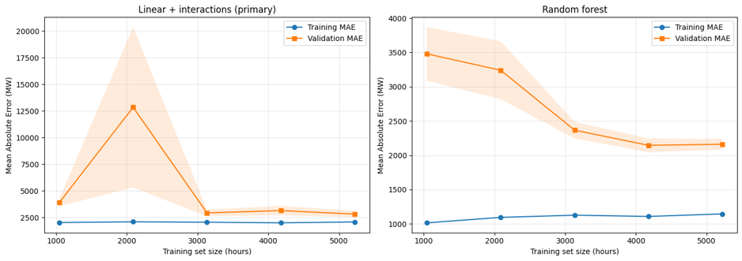Figure 18. Learning curves under TimeSeriesSplit for both response models (Cell 62).

The linear model's training and validation curves sit close together, gap 738 MW, so it is not overfitting; its error is dominated by what the specification cannot represent rather than by memorisation. The forest fits training data considerably better at 1,145 MW but validates at 2,161 MW, a gap of 1,016 MW, and its validation curve is still falling gently at the largest training size, so it would likely benefit from more data in a way the linear model would not.
One feature of the left panel needs stating rather than smoothing over. The linear model's validation MAE spikes to roughly 12,800 MW at a training size near 2,100 hours, with a very wide band across folds, before returning to about 2,900 MW at larger sizes. A block of 2,100 hours covers under three months, so some hour, day-of-week or month dummy is present in validation but absent or nearly absent in training, leaving its coefficient unconstrained. This is an artefact of one-hot encoding on a short training block rather than instability at the sizes actually used, but the curve should not be read as a smooth function at its left end.

3.10 E8 - Uncertainty,Scenario classification and the redistribution result (Cells 61,63–65)
Re-running the scenarios with the interaction model as primary gave seasonal effects in the same direction as the forest but smaller: under +3 °C, summer +512 MW, winter −404 MW, spring −91 MW, autumn +103 MW, annual mean +32.2 MW. The bootstrap over training days then attached intervals.

Table 14. Seasonal scenario effects with 95% confidence intervals from 300 training refits (Cell 61)
Season | Scenario | Mean change (MW) | 95% CI lower | 95% CI upper | Excludes zero
Winter | +1 °C | −140.00 | −201.81 | −83.27 | Yes
Spring | +1 °C | −47.44 | −101.16 | +3.22 | No
Summer | +1 °C | +165.79 | +111.10 | +216.14 | Yes
Autumn | +1 °C | +19.66 | −29.58 | +67.82 | No
Winter | +2 °C | −275.73 | −398.75 | −162.99 | Yes
Spring | +2 °C | −78.11 | −185.49 | +22.91 | No
Summer | +2 °C | +336.87 | +226.99 | +437.78 | Yes
Autumn | +2 °C | +54.22 | −44.36 | +151.13 | No
Winter | +3 °C | −404.48 | −587.75 | −236.83 | Yes
Spring | +3 °C | −90.82 | −250.45 | +60.13 | No
Summer | +3 °C | +512.34 | +346.78 | +664.01 | Yes
Autumn | +3 °C | +103.21 | −43.71 | +251.13 | No

The annual mean intervals all contain zero: +0.19 MW [−49.77, +47.35] under +1 °C, +10.72 MW [−88.66, +104.34] under +2 °C, +32.20 MW [−116.06, +174.60] under +3 °C. Summer and winter seasonal intervals exclude zero at every level; spring and autumn never do.
The interval-width comparison in Cell 61 deserves a note. For summer, hour-resampling gave widths of 109.7, 219.1 and 334.1 MW across the three scenarios and the refit method gave 105.0, 210.8 and 317.2 MW nearly the same. That similarity is coincidence, not validation: the two designs measure different quantities, and the forest’s jumpy per-hour effects happened to produce comparable width by accident. The refit intervals are the defensible ones.
Cell 63 classified each season and scenario by whether its interval excludes zero, rather than by a fixed megawatt threshold. An arbitrary cutoff would make "no detectable change" nearly unreachable and would label effects smaller than the model’s own error as findings.
Table 15. Classification of each season and warming scenario (Cell 63)
Season | +1 °C | +2 °C | +3 °C
Winter | Lower demand | Lower demand | Lower demand
Spring | No detectable change | No detectable change | No detectable change
Summer | Higher demand | Higher demand | Higher demand
Autumn | No detectable change | No detectable change | No detectable change
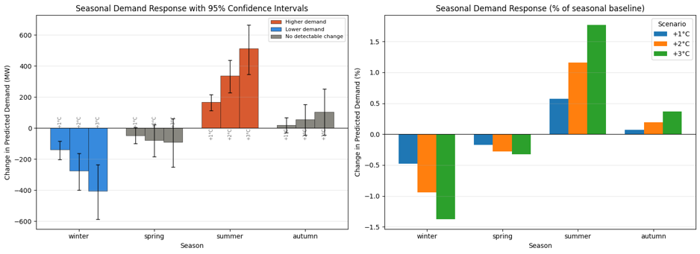Figure 19. Seasonal demand response with 95% confidence intervals, in MW and as a percentage of seasonal baseline (Cell 64).

Of the twelve season-scenario combinations, six are not detectable, three show lower demand and three higher. As a percentage of each season’s own baseline, the +3 °C effects are +1.77% in summer and −1.38% in winter. Cell 65 then set the annual and seasonal results side by side, which is the central result.
Table 16. Annual net effect against gross seasonal movement (Cell 65)
Scenario | Annual mean (MW) | 95% CI | Detectable | Increases (MW) | Decreases (MW) | Gross movement (MW)
+1 °C | +0.2 | [−49.8, +47.3] | No | +185.4 | −187.4 | 372.9
+2 °C | +10.7 | [−88.7, +104.3] | No | +391.1 | −353.8 | 744.9
+3 °C | +32.2 | [−116.1, +174.6] | No | +615.5 | −495.3 | 1,110.8

Under +3 °C the annual mean change is +32 MW and not distinguishable from zero, while gross seasonal movement is 1,111 MW roughly 35 times larger. The two figures are not in conflict; together they are the finding.

3.11 Emission factor and CO₂ impact (Cells 55-57, 66–67)
Applying the derived factors to the hourly generation data gives a total direct fossil CO₂ of approximately 237.6 Mt across the four years, about 59.4 Mt per year, and an implied average factor of 0.236 kg CO₂/kWh, ranging 0.225 to 0.249 when the IPCC low and high carbon contents are substituted. Fossil generation was non-zero in every hour of the four years, so there was no hour in which demand was met without combustion.
The marginal factor from the differencing regression (Cell 56) is 0.207 kg CO₂/kWh from 35,005 consecutive hourly pairs. Through-origin and with-intercept fits gave the same slope to three decimals, and the intercept was 99 kg/h, negligible against typical hourly changes, supporting the through-origin specification. The R² of the difference regression was 0.348 low, but expected, since hour-to-hour emission changes depend on which units are dispatched, not on demand alone.
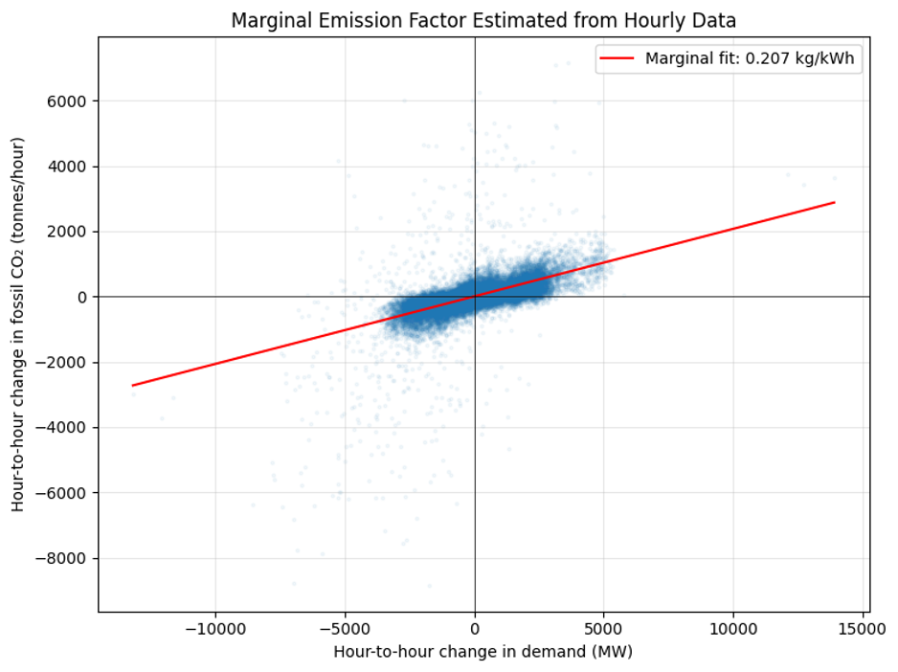Figure 20. Hour-to-hour change in fossil CO₂ against hour-to-hour change in demand (Cell 56).

The marginal factor is 12% below the average of 0.236, and below even the low end of the average’s range, so the gap between marginal and average exceeds the uncertainty in the average itself. That makes the distinction a real feature of the Spanish system rather than an artefact of the factor assumptions. The decomposition shows why.
Table 17. Which sources follow demand: MW of generation per MW of demand change (Cell 57)
Source | Slope | Mean output (MW) | Share of response
Hydro water reservoir | 0.295 | 2,604.5 | 47.7%
Fossil gas | 0.227 | 5,622.5 | 36.7%
Fossil hard coal | 0.111 | 4,256.0 | 17.9%
Solar | 0.069 | 1,432.7 | 11.1%
Hydro run-of-river | 0.013 | 972.1 | 2.2%
Fossil brown coal/lignite | 0.012 | 448.2 | 2.0%
Nuclear | 0.006 | 6,263.9 | 1.0%
Fossil oil | 0.003 | 298.3 | 0.5%
Wind onshore | −0.008 | 5,466.0 | −1.3%
Hydro pumped storage consumption | −0.112 | 475.7 | −18.2%

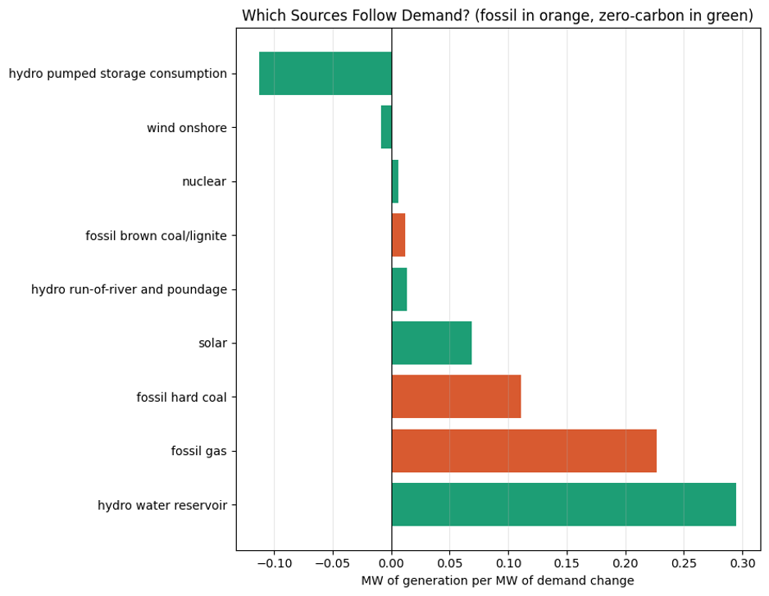Figure 21. Generation response to demand change by source; fossil in orange, zero-carbon in green (Cell 57).

Reservoir hydro is the largest single responder at roughly 48% of the marginal response, ahead of gas at 37% and hard coal at 18%. Fossil slopes sum to 0.353 against 0.265 for zero-carbon sources, so about 57% of the marginal response is fossil. Because a substantial share comes from hydro, which emits nothing directly, the marginal factor sits below the fleet average. Multiplying the decomposed slopes by their emission factors reproduced 0.207 kg/kWh, matching the Cell 56 regression exactly two independent routes agreeing.
The pumped storage term needs care. Its slope of −0.112 is a consumption column, so a negative slope means pumping falls when demand rises, which is physically sensible, but it enters the sum with the same sign convention as generation. The slopes total 0.619 rather than 1.0, leaving about 38% of the marginal response unaccounted for; cross-border interconnector flows, absent from this dataset, are the most likely explanation.
Applying the marginal factor to the seasonal demand changes over the actual hour counts of the test year (winter 2,159, spring 2,207, summer 2,206, autumn 2,185 hours) gives the seasonal emission estimates below.
Table 18. Estimated seasonal CO₂ change under warming, marginal factor 0.207 kg/kWh (Cell 66)
Season | Scenario | Energy change (GWh) | CO₂ (t) | CO₂ low (t) | CO₂ high (t)
Winter | +1 °C | −302.3 | −62,444 | −90,009 | −37,140
Spring | +1 °C | −104.7 | −21,631 | −46,122 | +1,467
Summer | +1 °C | +365.7 | +75,554 | +50,630 | +98,500
Autumn | +1 °C | +42.9 | +8,873 | −13,354 | +30,614
Winter | +3 °C | −873.3 | −180,405 | −262,145 | −105,631
Spring | +3 °C | −200.4 | −41,410 | −114,190 | +27,414
Summer | +3 °C | +1,130.2 | +233,487 | +158,035 | +302,607
Autumn | +3 °C | +225.5 | +46,586 | −19,730 | +113,358

The +2 °C rows follow the same pattern and sit between the two sets shown. Netting the seasons gives annual figures of +351 t under +1 °C, +19,400 t under +2 °C and +58,258 t under +3 °C.
The net annual figures should not be reported as established increases. They inherit the annual confidence interval, which contains zero at all three levels. The defensible statement is that under +3 °C the model predicts a redistribution of emissions roughly +233,000 tonnes in summer and −180,000 tonnes in winter with a net annual change not statistically distinguishable from zero at the 95% level. The seasonal figures are the result; the net is a null result.
Table 19. Sensitivity of the +3 °C CO₂ result to the emission factor (Cell 67)
Factor | kg CO₂/kWh | Summer (t) | Net annual (t)
Marginal, estimated from data | 0.207 | +233,487 | +58,258
Average, central IPCC factors | 0.236 | +267,135 | +66,654
Average, IPCC low factors | 0.225 | +254,110 | +63,404
Average, IPCC high factors | 0.249 | +281,686 | +70,284

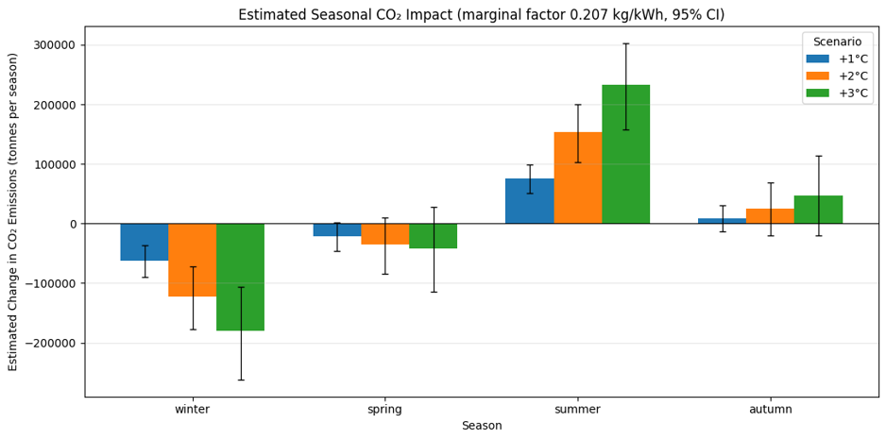Figure 22. Estimated seasonal CO₂ impact with 95% confidence intervals (Cell 67).

The net annual estimate ranges across 12,026 tonnes, about 21% of the +58,258 t central estimate material but not dominant. The structure of that spread is worth reading carefully: substituting the IPCC low and high carbon contents moves the average factor only from 0.225 to 0.249, a band of ±5%, so most of the range comes from the marginal-versus-average distinction rather than from uncertainty in the inventory factors. Since the marginal factor is the correct one for a scenario question, +58,258 t is the appropriate figure, and the main residual uncertainty in the CO₂ result sits in the demand estimate rather than the emission factor.
One part of the factor uncertainty is not captured by this band, and it is not small. The low and high columns vary only the IPCC fuel carbon content, holding plant efficiencies fixed. For gas the IPCC range spans 0.391 to 0.420 kg/kWh, about ±3.6%, whereas moving the assumed CCGT efficiency from 0.50 to 0.45 would move the factor to roughly 0.449, about +11%. The efficiency assumption is the larger lever, and it is the one without a published range attached to it.

4.Conclusion

4.1 Summary and key findings
This work estimated the response of Spanish hourly national electricity demand to temperature from four years of data, and applied that response to uniform warming of +1 to +3 °C. Two weather datasets and one national generation and load dataset were cleaned, reconciled to a common UTC hourly index, and merged into 35,028 usable hours; five city weather series were combined into one population-weighted national series. Models were trained on 2015–2017 and evaluated on 2018.
The central methodological finding is that predictive accuracy and counterfactual validity pull in opposite directions here. A forecasting model with demand lags reached R² 0.984 and MAE 355 MW but placed 90.7% of its feature importance on the previous hour’s demand and 0.27% on temperature, making it structurally incapable of answering the research question. A response model built from weather and calendar features alone reached R² 0.635 and MAE 2,097 MW and was used for all scenario results.
The substantive findings are these. Demand is minimised at 19.0 °C, with cooling sensitivity of +104.6 MW/°C above the balance point against heating sensitivity of +78.7 MW/°C below it. That sensitivity is strongly time-dependent and asymmetrically so: heating ranges from 3.2 MW/°C overnight to 326.0 MW/°C in the afternoon, tracking building occupancy, while cooling stays between 119 and 206 MW/°C, tracking thermostats. The cooling response steepens to +353.5 MW/°C above 30 °C, roughly three times its value in the 22–26 °C band.
Under +3 °C, summer demand rises by 512 MW and winter demand falls by 404 MW, both with 95% intervals excluding zero, while spring and autumn show no detectable change at any warming level. The annual mean change of +32 MW has an interval of [−116, +175] containing zero. Gross seasonal movement is 1,111 MW against that net of 32 MW. The same structure carries into emissions: using a marginal emission factor of 0.207 kg CO₂/kWh estimated from the hourly record by two independent and agreeing routes, the +3 °C scenario implies roughly +233,000 tonnes in summer and −180,000 tonnes in winter, netting to a figure not distinguishable from zero.
The conclusion is therefore that warming changes when Spain uses electricity considerably more than how much it uses over a year, and that this matters because the infrastructure is sized by the former and the annual figure conceals it. The marginal emission factor sits 12% below the fleet average because roughly 48% of the marginal response comes from reservoir hydro, so the carbon consequence of an increment of Spanish demand is smaller than an average-intensity calculation would give.

4.2 Future Direction
Four extensions follow directly from the limitations and are ordered by the ratio of value to effort.
Model peak load rather than seasonal mean. This is the largest gap between what the analysis measures and what the argument in Section 5.1 requires. The data supports the hourly panel of Cell 50 and the time-of-day coefficients of Cell 59 both point at it but estimating the change in the annual maximum needs care in the extreme tail, where the model is least constrained and where Cell 52 showed the forest cannot extrapolate at all.
Replace the uniform shift with downscaled projections. Season-specific and hour-specific temperature shifts from a published regional climate projection for Spain would turn a bounded sensitivity analysis into something closer to a projection, and would capture that warming is stronger in extremes than in means which matters given the steepening above 30 °C.
Add a Spanish public holiday calendar and attach a range to plant efficiencies. Both are cheap. The first should reduce residual variance directly and may sharpen the intervals; the second closes the one remaining gap in the emission-factor uncertainty, and given that efficiency is the larger lever for gas, it should be propagated alongside the IPCC carbon-content range rather than held fixed.
Model demand response is evolving rather than fixed. The most substantial extension, and the one that would change the numbers most. Estimating the response on rolling windows would show whether the cooling slope is already trending upward across 2015–2018 as air conditioning penetration grows, which would indicate how far the fixed-system estimate understates the response at the time horizons where +3 °C is relevant.
A fifth possibility is spatial. Rather than collapsing five cities into one national series before modelling, fitting the response per city and aggregating afterwards would respect the nonlinearity of the degree-day transformation, and would allow regional differences in the response to emerge instead of being averaged away.

