PROJECT REPORT
Weather-Driven Electricity Demand in Spain:
Machine Learning Models for Forecasting and
Counterfactual Warming Scenarios
Group # [GROUP NUMBER]
Name | Student ID
[Member 1 Name] | [ID]
[Member 2 Name] | [ID]
[Member 3 Name] | [ID]
[Member 4 Name] | [ID]

[Course Code] — [Course Title]
[Department]
[University Name]
31 August 2026

Abstract
This project investigates how ambient weather conditions drive hourly electricity demand in Spain, and uses the estimated relationship to ask a counterfactual question: what would happen to national demand, and to the carbon emissions associated with meeting it, under uniform warming of +1, +2 and +3 °C? Four years of hourly load and generation data from the Spanish transmission operator were merged with hourly weather observations from the country's five largest cities, producing an integrated dataset of 35,028 hourly records spanning 2015–2018.
Two distinct classes of model were built for two distinct purposes. A forecasting model, which is permitted to use recent demand history, achieved a test-set R² of 0.9844 and a mean absolute error of 355 MW (1.2% of mean load) using a Random Forest regressor — a 67% error reduction against a naive persistence baseline. A separate response model, deliberately restricted to weather and calendar inputs so that it remains valid under counterfactual intervention, achieved R² = 0.6351 using a linear specification with heating- and cooling-degree terms interacted with time of day.
The response model recovers a U-shaped demand–temperature relationship minimised at 19.0 °C, with a cooling response that steepens sharply above 30 °C (353 MW per °C, against a national mean load of approximately 28,700 MW). Applying warming scenarios to the 2018 test year and quantifying uncertainty by a day-block bootstrap over 300 model refits, we find that warming produces a statistically detectable seasonal redistribution of demand rather than a change in annual totals: under +3 °C summer demand rises by +512 MW (95% CI [+347, +664]) while winter demand falls by −404 MW (95% CI [−588, −237]), yet the annual mean change of +32 MW is not distinguishable from zero (95% CI [−116, +175]). A marginal emission factor of 0.206 kg CO₂/kWh, estimated directly from the generation data by a first-difference regression, translates this into approximately +233 kt CO₂ in summer against −180 kt CO₂ in winter. Because generation and network capacity are sized by peak rather than average demand, a null result in the annual total does not imply a null result for the system.

Table of Contents
(In Word: right-click the table below and choose “Update Field” to populate the contents and page numbers. This line can then be deleted.)

1. Introduction

1.1 Background and motivation
Electricity demand is unusual among economic quantities in that it must be balanced against supply continuously and almost instantaneously. Storage remains a small fraction of system capacity, so the grid operator must match generation to consumption in real time, and must have provisioned enough dispatchable capacity in advance to do so on the single worst hour of the year. This makes the drivers of demand, and in particular its extremes, a question of direct operational and planning consequence.
Weather is one of the strongest of those drivers. Below some comfort threshold, households and businesses consume electricity for heating; above it, they consume electricity for cooling. The resulting relationship between temperature and demand is not monotonic but U-shaped, and the two arms of the U need not be symmetric — they depend on the prevailing heating technology mix, the penetration of air conditioning, building stock, and behavioural patterns that themselves vary by hour of the day.
Spain is a particularly informative case. It spans a wide climatic range, from the temperate Atlantic north to the semi-arid south, it has substantial and growing air-conditioning penetration, and its heating demand is met by a mixture of electricity, natural gas and other fuels, so the electrical heating response is real but muted relative to the cooling response. It also has a generation mix in which the marginal unit varies considerably — hydro reservoirs, combined-cycle gas and coal all participate in following load — which means the carbon consequence of an extra megawatt-hour of demand is not obvious a priori and must itself be estimated.

1.2 Problem statement
The core difficulty this project confronts is that the two questions one naturally wants to ask of such data require different models, and conflating them produces results that look excellent and mean nothing.
The first question is predictive: given everything we know at time t, what will demand be? The best answer uses recent demand history, because demand is highly autocorrelated — last hour's load is an extraordinarily good predictor of this hour's load.
The second question is causal-counterfactual: if temperatures were uniformly warmer, what would demand be? A model that uses lagged demand cannot answer this. Under a warming intervention the lagged demand values would themselves change, but the model has no mechanism to update them; it would hold them fixed at their observed values and thereby absorb almost the entire temperature effect into a stale autoregressive term. The scenario result would be a near-zero artefact of the model structure, not a finding about the world.
This project therefore constructs and evaluates both model classes separately, states explicitly which is valid for which purpose, and uses only the second for scenario analysis.

1.3 Objectives
- Integrate hourly electricity load and generation data for Spain with hourly multi-city weather observations, resolving the timestamp, duplication and spatial-resolution mismatches between the two sources.
- Engineer a feature set capturing calendar structure, autoregressive demand structure, and the physically motivated heating- and cooling-degree transformations of temperature.
- Build and compare regression models for short-horizon demand forecasting, benchmarked against a naive persistence baseline.
- Build a separate weather-and-calendar-only response model, compare four specifications for it, and select a primary specification on stated criteria.
- Estimate the demand response to uniform warming of +1, +2 and +3 °C, with confidence intervals that reflect uncertainty in the fitted model rather than only sampling noise.
- Classify each season/scenario combination as a detectable increase, a detectable decrease, or no detectable change, using a statistical rather than arbitrary decision rule.
- Estimate the CO₂ consequence of the projected demand changes using an emission factor derived from the generation data itself, and test the sensitivity of that estimate to the choice of factor.

1.4 Organisation of this report
Section 2 documents the data sources, cleaning decisions, feature construction, model specifications, scenario mechanics and uncertainty quantification. Section 3 presents the experimental results in the order they were produced, from exploratory analysis through forecasting performance to scenario classification and emissions. Section 4 states the principal findings, discusses their interpretation for grid planning, and sets out the limitations of the analysis.

2. Methodology

2.1 Data sources
Two public hourly datasets covering the same four-year window were used.
Electricity data. Hourly generation by source, day-ahead forecasts, actual and forecast total load, and day-ahead and actual prices for Spain, as published by the transmission system operator (Red Eléctrica de España) and redistributed via the ENTSO-E transparency platform. Raw dimensions: 35,064 rows × 29 columns, covering 1 January 2015 00:00 to 31 December 2018 23:00 local time. The target variable throughout is total load actual, in megawatts.
Weather data. Hourly observations for the five largest Spanish cities — Madrid, Barcelona, Valencia, Seville and Bilbao — comprising temperature, minimum and maximum temperature, atmospheric pressure, relative humidity, wind speed and direction, one- and three-hour rainfall, three-hour snowfall, cloud cover, and a categorical weather-condition code. Raw dimensions: 178,396 rows × 17 columns. Temperatures are supplied in Kelvin.
Both datasets were accessed programmatically from their hosted CSV locations, so the notebook is reproducible without local data files.

2.2 Data inspection and quality assessment
Before any transformation, both tables were profiled for shape, dtypes, null counts, timestamp coverage, duplication and sampling regularity. This established four facts that determined the cleaning strategy:
- Timestamps in both files are ISO-8601 strings carrying a UTC offset that switches between +01:00 and +02:00 across the year, because Spain observes daylight saving time. Parsing these naively yields a mixed-offset object column that cannot be compared or joined correctly.
- The weather table is not one row per hour. Grouping by timestamp gave five rows for 32,514 timestamps — one per city, as expected — but six for 2,114 timestamps, seven for 366, and up to ten for five timestamps.
- The electricity table has no duplicate rows, but does have sparse missing values: two columns (generation hydro pumped storage aggregated and forecast wind offshore eday ahead) are entirely empty, the target has 36 missing entries, and most generation and forecast columns have 18–19 missing entries each.
- One city name, " Barcelona", carries a leading space, which would silently create a sixth spurious city under any grouping operation.

2.3 Weather data cleaning
Timestamp standardisation. Both timestamp columns were parsed with utc=True, converting every value to a single unambiguous UTC instant. All joins, sorting and lag construction are performed in UTC; local Spanish time is reintroduced later only for extracting calendar features, where it is the behaviourally correct clock.
City-name normalisation. Whitespace was stripped from city_name, confirming exactly five distinct cities.
Diagnosing the surplus rows. The over-count was investigated rather than assumed. Grouping by (city, timestamp) and counting distinct values of each field showed that in every multi-row group the numerical measurements — temperature, pressure, humidity, wind speed, wind direction, rainfall, cloud cover — were identical, and only the categorical weather-condition fields differed. The surplus rows are therefore not conflicting measurements or DST artefacts but multiple simultaneous condition labels for the same physical observation (for example rain and mist recorded together).
Deduplication. Twenty-one fully identical rows were removed first (178,396 → 178,375). The remaining multi-row groups were collapsed to one row per (city, timestamp) by taking the first value of each numeric field — valid precisely because those values were proven identical — while concatenating the unique categorical labels so no information was silently discarded. This removed a further 3,055 rows, yielding exactly 175,320 rows = 5 × 35,064, i.e. a complete, gap-free hourly panel for five cities.
Unit conversion and column pruning. Temperatures were converted from Kelvin to Celsius; the Kelvin originals were then dropped so that two unit systems could not both reach the model. The four categorical weather-condition columns were dropped, on the grounds that their information content is largely redundant with the numeric cloud-cover, rainfall and humidity fields already present, and that one-hot encoding a concatenated multi-label string would generate a large and sparse feature block for little expected gain.

2.4 Electricity data cleaning
The two entirely empty columns were dropped. The 36 rows with a missing target were deleted rather than imputed: imputing a target contaminates evaluation, because the model would be scored against a value that the imputation procedure — not the world — supplied. For the generation and forecast predictors, whose gaps are of the order of 0.05% and occur as isolated single hours, a forward fill was applied; over a one-hour gap in a smooth hourly series this is a low-risk interpolation. The cleaned table has 35,028 rows × 28 columns with no remaining missing values.

2.5 Population-weighted spatial aggregation
The target is a single national load series, so the five city-level weather series must be reduced to one national series. A simple unweighted mean would give Bilbao (population ≈ 345,000) the same influence as Madrid (≈ 3.2 million), even though Madrid represents an order of magnitude more electricity consumers.
Each numeric weather variable was therefore aggregated as a population-weighted mean across the five cities, with weights equal to city population:
x̄ₜ = Σ_c ( w_c · x_{c,t} ) / Σ_c w_c , where w_c = population of city c
using approximate 2018 municipal populations from Spain's national statistics register: Madrid 3,223,000; Barcelona 1,620,000; Valencia 791,000; Seville 689,000; Bilbao 345,000. The result is a single Spain-wide hourly weather series of 35,064 rows.

2.6 Dataset integration
The national weather series was inner-joined to the cleaned electricity table on the UTC timestamp. The join produced 35,028 rows — exactly the electricity row count — with zero electricity timestamps unmatched, zero duplicated timestamps, and no missing values introduced. The 36 weather timestamps that found no partner correspond precisely to the rows deleted for a missing target. The merged analysis table has 39 columns.
Generation-by-source columns were retained in the merged table even though they are not demand predictors, because the emissions analysis requires them.

2.7 Feature engineering

2.7.1 Calendar features
Hour of day, day of week, month, a weekend indicator and a meteorological season label were extracted after converting the UTC index to Europe/Madrid local time. This matters: demand patterns follow the local clock — morning activity, the Spanish evening peak, working-week routines — and extracting them from UTC would shift every feature by one hour for part of the year and two hours for the rest, blurring exactly the structure the features exist to capture.

2.7.2 Autoregressive features
Five features summarise recent demand history: demand one hour, one day and one week earlier (the latter two aligning the same hour and, for the weekly lag, the same weekday), plus the rolling mean and standard deviation of the preceding 24 hours.
Leakage was prevented structurally. The frame was sorted chronologically before any shift. The rolling statistics apply shift(1) before the rolling window, so the window closes at t−1 and never includes the current hour — a rolling mean computed without that shift would include the target itself and would be a partial copy of it.

2.7.3 Degree-day features
For the response models, temperature was additionally transformed into heating and cooling degrees about a balance point T_b:
CDD_t = max(T_t − T_b, 0) (cooling degrees)
HDD_t = max(T_b − T_t, 0) (heating degrees)
with T_b = 18 °C, the international convention for degree-day accounting. This is the transformation that allows a linear model to represent a V- or U-shaped response: the two arms receive separate coefficients, so the fitted function is piecewise linear with a kink at the balance point rather than a single straight line. The sensitivity of the results to T_b is tested in Section 3.15.

2.8 Chronological train/test split
The data were split by time, not at random: training on 2015–2017 and testing on 2018. Random splitting a time series is invalid here for two reasons. It would train on future observations to predict past ones, and — more damagingly — with lag features present, a randomly held-out hour's neighbours would sit in the training set, so the model would effectively have been shown the answer.
The split yields 26,271 training rows and 8,757 test rows (25.0% of the data). Rows with missing lag features were dropped after the split and independently within each partition, so that the 168 unavoidable missing rows at the very start of the series (from the weekly lookback) are charged to the training set alone and do not consume test observations. Final shapes: 26,103 training rows, 8,757 test rows.

2.9 A two-model design
Two model families were built, distinguished by what they are allowed to see.
Model A — forecasting. Inputs: same-hour weather, calendar features, and the five autoregressive demand features. Purpose: short-horizon operational prediction. Not valid for counterfactual scenarios, for the reason given in Section 1.2.
Model B — response. Inputs: weather and calendar features only, with no demand history of any kind. Purpose: to estimate the demand response to weather, so that weather can be intervened upon. Model B is necessarily far less accurate than Model A, and that is expected rather than a defect — it is solving a harder problem with strictly less information.

2.10 Model A specifications
Four models were compared:
- Naive persistence baseline: predict this hour equal to last hour. Any model that cannot beat this has learned nothing of value.
- Linear Regression: fully interpretable, but structurally unable to represent the U-shaped temperature response.
- Random Forest Regressor: 200 trees, max_depth=15. Captures non-linearity and feature interactions by construction.
- Gradient Boosting Regressor: 200 estimators, max_depth=4, learning rate 0.1. Sequential error-correcting trees.
The single categorical feature (season) was one-hot encoded with drop_first=True; encoding categories were established on the training partition and the test matrix was reindexed to the training columns, so no category unseen in training can appear at test time. temp_min and temp_max were excluded after the correlation analysis showed them to be near-collinear with temp (r ≈ 0.96–0.99), contributing multicollinearity without information.

2.11 Model B specifications
Four specifications were compared on the same test set:
- Random Forest response model. 300 trees, min_samples_leaf=5. The leaf-size floor is deliberate: with singleton leaves the forest memorises individual hours and its predictions become jagged step functions, which injects numerical noise directly into scenario differences.
- Linear HDD/CDD model. Cooling and heating degrees, humidity and wind speed, plus one-hot encoded hour, day of week and month. The one-hot encoding is essential here: left as integers, a linear model would read hour 23 as "23 times as much of something" as hour 1, which is meaningless. Tree models are indifferent to this; linear models are not.
- Piecewise degree-band model. Rather than one cooling slope, the temperature range is divided into bands (18–22, 22–26, 26–30, 30+ °C for cooling; 18–14, 14–10, 10–6, below 6 °C for heating) and each band receives its own coefficient. Each hour contributes its degrees to whichever bands it spans, so a 24 °C hour contributes 4 degrees to the 18–22 band and 2 to the 22–26 band. Each coefficient is then MW per °C within that band, which directly tests whether the response is convex.
- Linear model with time-of-day interactions. CDD and HDD are interacted with four time blocks — night (0–7h), morning (8–13h), afternoon (14–19h), evening (20–23h). Four blocks rather than 24 hourly interactions keeps every cell well populated and avoids the collinearity that destabilises band coefficients. Each block coefficient is a deviation from the main effect, so the cooling slope in a block is the main effect plus that block's deviation.

2.12 Counterfactual scenario construction
A scenario is implemented by rebuilding the entire design matrix from a shifted temperature series, T' = T + Δ, for Δ ∈ {1, 2, 3} °C, and re-predicting.
The critical detail is that CDD and HDD are recomputed from the shifted temperature rather than carried over. Shifting temperature while leaving the degree-day columns at their original values would produce a design matrix that is internally inconsistent — claiming a warmer hour with unchanged cooling load — and the scenario would be meaningless. This was verified programmatically: comparing the baseline and +1 °C matrices column-by-column confirmed that exactly three columns differ (temp, cdd, hdd) and all calendar and other weather columns are bit-identical.
Scenario effects are reported as the mean difference between scenario and baseline predictions, computed pointwise over the 8,757 test hours and then averaged, overall and within each season.

2.13 Uncertainty quantification
Two bootstrap schemes were used, and the distinction between them is one of the methodological findings of the project.
Scheme 1 (hour resampling). The initial approach resampled which test hours the scenario effect is averaged over, in blocks of whole days rather than individual hours. Day blocks are necessary because hourly demand is strongly autocorrelated: resampling individual hours would treat 8,757 observations as independent when the effective sample size is closer to 365, and would produce intervals that are far too narrow.
Scheme 2 (coefficient uncertainty — primary). Scheme 1 captures the wrong quantity. It measures uncertainty in which hours we averaged, but the dominant uncertainty is in the fitted coefficients themselves: a cooling slope estimated from four years of data would have come out differently given a different four years, and the scenario effect inherits that. For a linear model the per-hour effect is a fixed function of the coefficients, so within a season it is nearly constant across hours and Scheme 1 collapses to a spuriously tight interval.
The primary intervals therefore resample whole training days with replacement, refit the model on each resample, and recompute the scenario effect. Three hundred refits were performed. The spread across refits is the coefficient uncertainty, and the reported 95% intervals are the 2.5th and 97.5th percentiles of that distribution.

2.14 Statistical classification rule
Each season/scenario pair was classified by its confidence interval rather than by an arbitrary magnitude threshold:
Condition | Classification
95% CI contains zero | No detectable change
95% CI lies entirely above zero | Higher demand
95% CI lies entirely below zero | Lower demand

An absolute MW cutoff was rejected because it makes "no change" essentially unreachable — a small threshold labels effects far below the model's own error as real findings.

2.15 Emissions accounting
Hourly fossil CO₂. Direct combustion emissions were computed per hour by multiplying each fossil generation column by a fuel-specific emission factor and summing. Nuclear, hydro, wind, solar and geothermal were assigned zero direct combustion emissions; biomass and waste were also treated as zero, following the conventional IPCC treatment of biogenic carbon, which is a defensible but contested choice and is flagged in the limitations.
Average versus marginal factors. Dividing total fossil CO₂ by total load gives the average carbon intensity of the system. This is the wrong quantity for a scenario question. When demand rises by one megawatt-hour, it is not supplied by the average generator but by whichever unit is on the margin. The relevant quantity is the marginal emission factor.
Estimating the marginal factor. Following the marginal-emission-factor literature (Hawkes 2010; Siler-Evans, Azevedo & Morgan 2012), the marginal factor was estimated by regressing the hour-to-hour change in fossil CO₂ on the hour-to-hour change in total load:
Δ CO₂_t = β · Δ L_t + ε_t , where Δ X_t = X_t − X_{t−1}
The slope β answers exactly the question "when demand rises by one MWh, how much additional CO₂ is emitted?". Working in first differences also removes slowly-moving confounders — fuel prices, capacity additions, seasonal patterns — because they barely change from one hour to the next. Only genuinely consecutive hour pairs were used, and the regression was fitted through the origin (zero change in demand should imply zero change in emissions), with an intercept-inclusive fit retained as a diagnostic.
Independent cross-check. The same differencing logic was applied to every generation source separately, giving each source's MW response per MW of demand change. Recombining these slopes with their fuel emission factors reconstructs the marginal factor by a completely different route, providing an internal consistency check.
Converting to tonnes. For a mean demand change in MW sustained over H hours with factor f in kg/kWh, emissions in tonnes are (mean ΔMW) × H × f — the MWh-to-kWh and kg-to-tonne conversions cancel.

2.16 Validation diagnostics
Learning curves were computed for the primary and Random Forest specifications using TimeSeriesSplit with four folds. Ordinary k-fold cross-validation was avoided because it trains on future data to predict the past; TimeSeriesSplit always trains on an earlier block and validates on the block immediately following. The curves were computed on the training period only, so that the 2018 test set played no part in any internal validation decision.

3. Experimental Results and Findings

3.1 Data preparation outcomes
Table 1 traces the row counts through the pipeline. The key validation is that weather cleaning lands on exactly 5 × 35,064 = 175,320 rows, confirming a complete hourly panel with no gaps and no residual duplication, and that the merge preserves the full electricity row count without introducing duplicates or nulls.
Table 1. Row counts through the data preparation pipeline.
Stage | Operation | Rows | Change
Weather, raw | — | 178,396 | —
Weather | Remove exact duplicates | 178,375 | −21
Weather | Collapse city/timestamp groups | 175,320 | −3,055
Weather | Population-weighted aggregation | 35,064 | −140,256
Electricity, raw | — | 35,064 | —
Electricity | Drop 2 empty columns | 35,064 | 0
Electricity | Drop rows with missing target | 35,028 | −36
Merged | Inner join on UTC timestamp | 35,028 | 0
Train | 2015–2017, lag rows dropped | 26,103 | −168
Test | 2018 | 8,757 | 0

3.2 Exploratory data analysis
The temperature–demand relationship is U-shaped. Figure 1 plots all 35,028 hourly observations of demand against population-weighted national temperature. Demand is elevated at both temperature extremes and lowest in the mid-range, which is the signature of heating demand at the cold end and cooling demand at the warm end. The implication for modelling is immediate: any model restricted to a monotonic function of temperature is structurally misspecified.
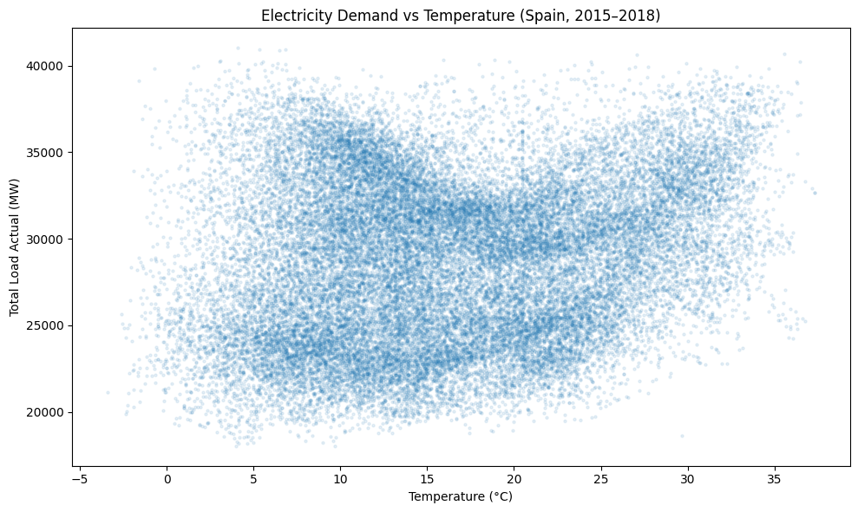
Figure 1. Hourly electricity demand against population-weighted national temperature, Spain 2015–2018. The U-shape reflects electric heating at low temperatures and cooling at high temperatures.
The daily profile is the dominant cycle. Figure 2 shows mean demand by local hour. Demand troughs in the small hours, climbs through the morning, and reaches its maximum in the evening — the characteristic Spanish load shape, with its late peak reflecting national daily routines. The peak-to-trough range within a day is large relative to the seasonal range, which anticipates the finding that hour of day is the single most important predictor in the response model.
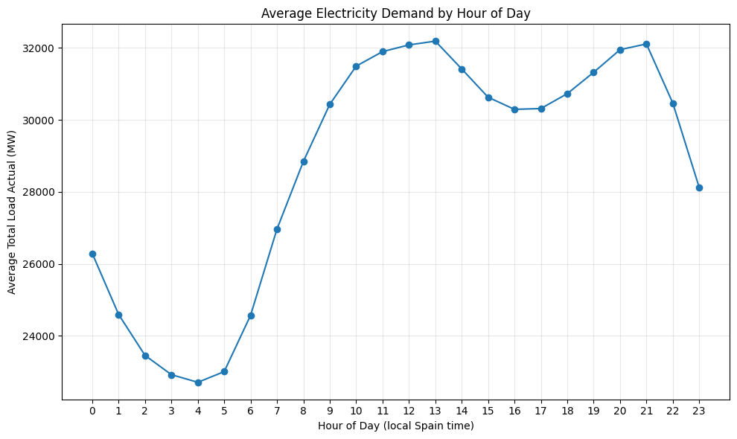
Figure 2. Mean demand by hour of day (local Spanish time).
Multiple superimposed periodicities. The full series (Figure 3) shows a strong annual cycle with winter and summer maxima and shoulder-season minima, superimposed weekly structure, and no pronounced multi-year trend over this short window. Figure 4 confirms the bimodal seasonal pattern: monthly means peak in winter and again in summer, with the seasonal aggregation showing winter highest, summer second, and spring and autumn lowest.
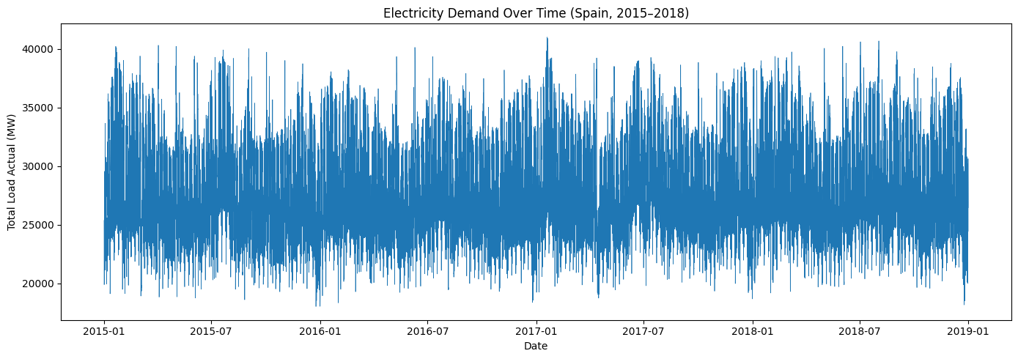
Figure 3. Hourly electricity demand over the full record, 2015–2018.
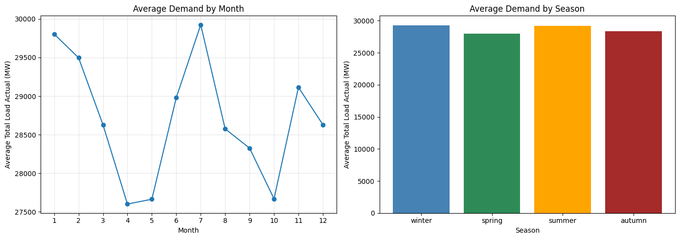
Figure 4. Mean demand by month (left) and by meteorological season (right).
Correlation structure. The heatmap (Figure 5) shows the lag features correlating with the target far more strongly than any weather variable, which is exactly why they must be excluded from the response model. It also shows temp, temp_min and temp_max to be mutually near-collinear, motivating the retention of temp alone. Notably, temperature's linear correlation with demand is weak — an artefact of the U-shape, in which the cold and warm arms have opposite slopes and largely cancel under a linear measure. This is a concrete demonstration that a low Pearson correlation does not imply an unimportant variable.
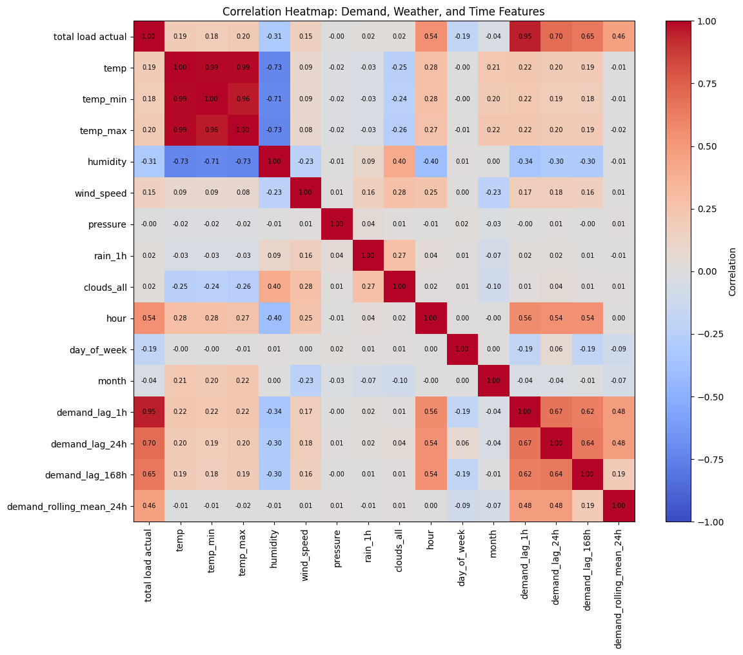
Figure 5. Correlation heatmap of demand, weather and time features.

3.3 Model A: forecasting performance
Table 2 reports test-set performance for the 2018 holdout year. All three fitted models beat the persistence baseline, but the tree ensembles do so decisively.
Table 2. Model A test-set performance (2018 holdout, n = 8,757).
Model | MAE (MW) | MSE | RMSE (MW) | R²
Baseline (naive persistence) | 1,076.29 | 2.0688 × 10⁶ | 1,438.34 | 0.9034
Linear Regression | 975.75 | 1.6779 × 10⁶ | 1,295.33 | 0.9216
Random Forest | 355.44 | 3.3299 × 10⁵ | 577.05 | 0.9844
Gradient Boosting | 397.10 | 3.7378 × 10⁵ | 611.37 | 0.9825

Three observations follow.
First, the baseline is already strong (R² = 0.903), which is a property of the problem rather than the method: hourly demand is so autocorrelated that "the same as last hour" is a good guess. Reporting R² alone against no baseline would badly overstate any model's achievement here.
Second, Linear Regression improves on persistence only modestly (MAE −9.3%), consistent with the EDA prediction that a linear functional form cannot represent the U-shaped temperature response.
Third, the Random Forest reduces MAE by 67.0% against the baseline and by 63.6% against Linear Regression, reaching 355 MW — approximately 1.2% of mean national load. Gradient Boosting performs comparably but slightly worse on every metric at these hyperparameters. The Random Forest was therefore carried forward as the Model A representative.
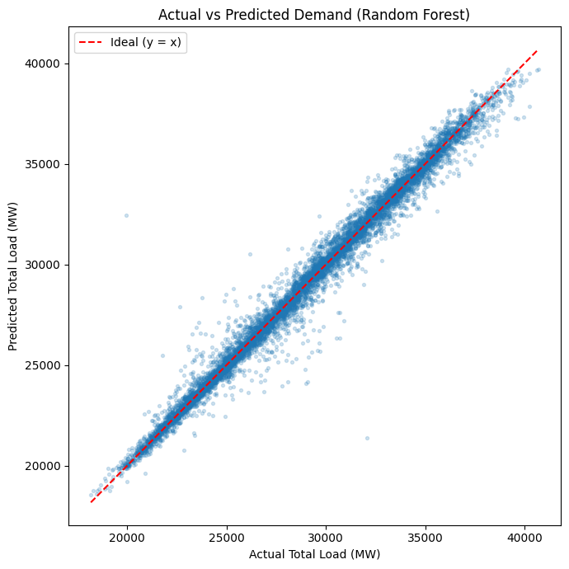
Figure 6. Actual versus predicted demand, Random Forest, 2018 test set. Points cluster tightly on the identity line across the full range.
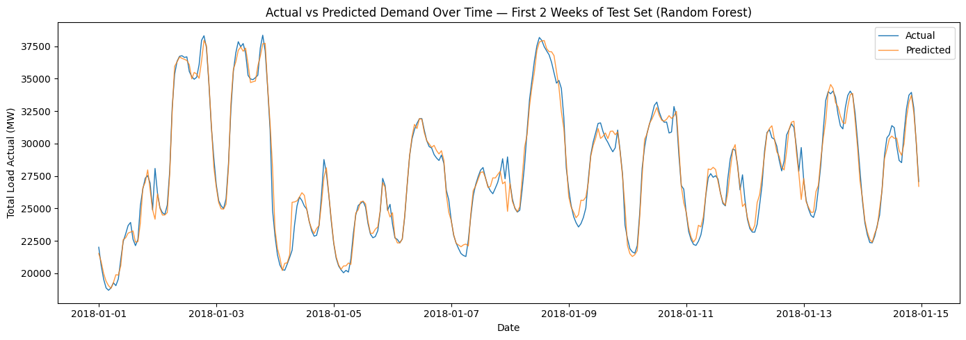
Figure 7. Actual and predicted demand over the first two weeks of the test set. The model tracks both the daily cycle and the weekday/weekend transition.

3.4 Error diagnostics
Residuals are approximately symmetric and centred near zero (mean −13.2 MW, standard deviation 576.9 MW), with no systematic pattern against the fitted values across most of the range (Figure 8). Two features deserve comment.
Mild heteroscedasticity is visible: residual spread grows somewhat at higher predicted demand, which is expected when errors scale with the level of the series.
Two extreme residuals dominate the tails. Inspecting the five largest absolute residuals identified an adjacent pair of hours:
Table 3. Five largest absolute residuals, Random Forest, 2018 test set.
Timestamp (UTC) | Actual (MW) | Predicted (MW) | Residual (MW)
2018-05-06 10:00 | 19,964 | 32,441 | −12,477
2018-05-06 11:00 | 32,090 | 21,380 | +10,710
2018-01-31 23:00 | 22,657 | 27,883 | −5,226
2018-09-30 22:00 | 29,001 | 24,076 | +4,925
2018-10-06 22:00 | 29,100 | 24,152 | +4,948

The two largest errors are consecutive hours on the same Sunday morning with residuals of nearly equal magnitude and opposite sign. A genuine demand event would not reverse itself within one hour in this way. The pattern is far more consistent with a data-recording fault — two hourly values transposed or mis-stamped in the source series — and the model's large errors are then a correct response to corrupted inputs rather than a modelling failure. The remaining large residuals cluster on late-evening hours and 31 January, plausibly reflecting holiday or special-day effects that a model knowing only hour, weekday and month cannot anticipate. A Spanish public-holiday calendar is an obvious extension.
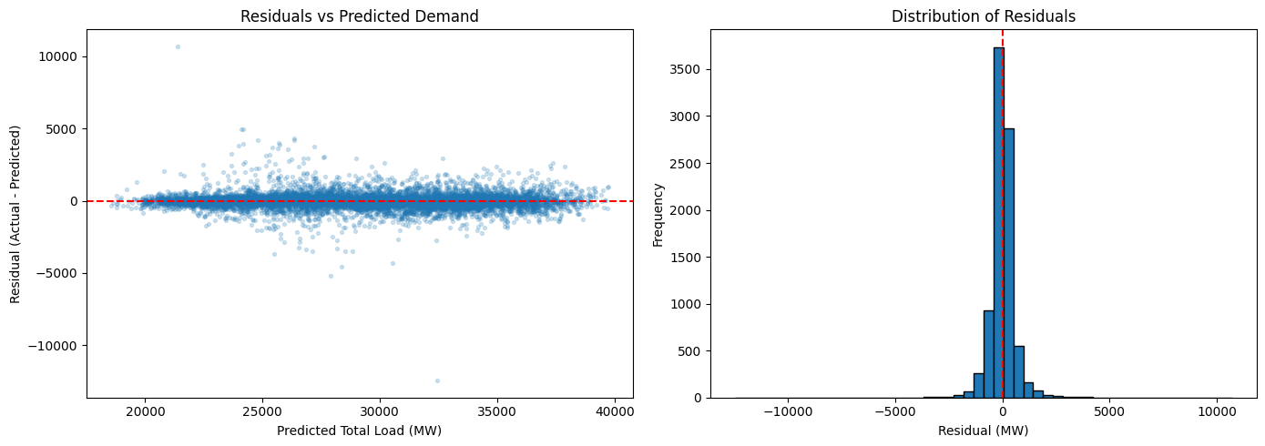
Figure 8. Residuals against predicted demand (left) and residual distribution (right), Random Forest, 2018 test set.

3.5 Feature attribution in Model A
Random Forest importances are overwhelmingly concentrated: demand_lag_1h accounts for 0.9072 of total importance and hour for 0.0747, together 98.2% of the total. Every other feature, temperature included (0.0027), is marginal.
Table 4. Random Forest feature importances, Model A (top 12 of 18).
Feature | Importance | Feature | Importance
demand_lag_1h | 0.9072 | humidity | 0.0014
hour | 0.0747 | demand_lag_168h | 0.0012
demand_lag_24h | 0.0030 | wind_speed | 0.0011
temp | 0.0027 | clouds_all | 0.0009
demand_rolling_mean_24h | 0.0022 | pressure | 0.0009
demand_rolling_std_24h | 0.0022 | month | 0.0007

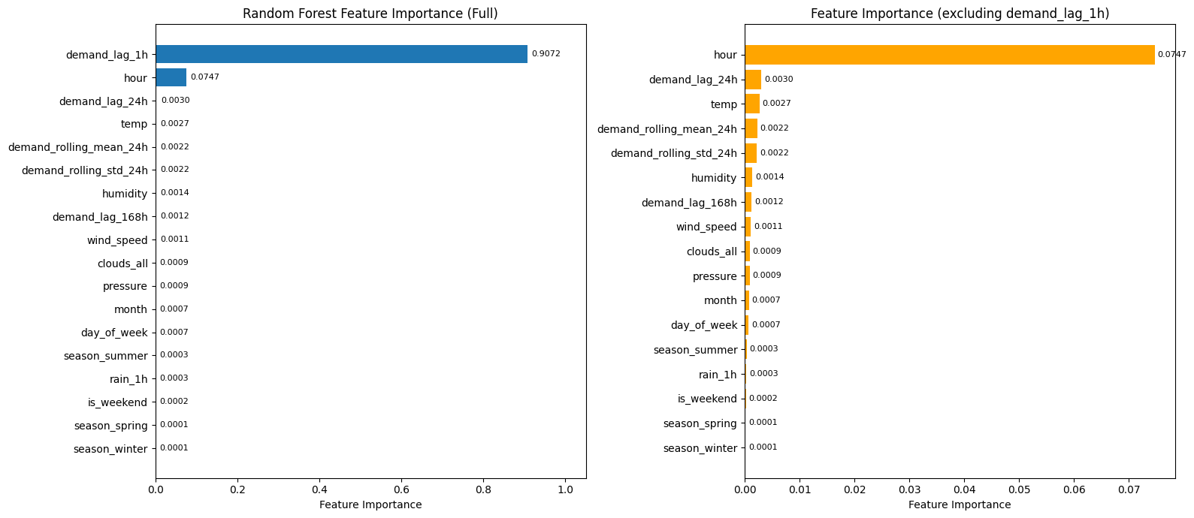
Figure 9. Random Forest feature importance, full scale (left) and with the dominant lag term removed to make the remainder legible (right).
This result is the empirical justification for the two-model design. Model A is accurate because it has learned, essentially, to propagate the previous hour forward with a time-of-day correction. Its near-zero weight on temperature is not evidence that temperature does not matter — it is evidence that temperature's influence is already embedded in the lagged demand value. Using this model for a warming scenario would hold the lag fixed and return an almost null effect by construction.

3.6 Model B: response model comparison
Removing all demand history costs a great deal of accuracy, as it must. Table 5 compares the four Model B specifications with Model A on the same test set.
Table 5. Model comparison on the 2018 test set. Only Model B specifications are valid for counterfactual scenarios.
Model | Inputs | MAE (MW) | R² | Valid for scenarios?
A: Random Forest (forecasting) | Weather + calendar + lags | 355.4 | 0.9844 | No
B1: Random Forest response | Weather + calendar | 2,054.8 | 0.6233 | Yes
B2: Linear, single HDD/CDD slope | Weather + calendar | 2,134.4 | 0.6269 | Yes
B3: Linear, piecewise bands | Weather + calendar | 2,127.3 | 0.6284 | Yes
B4: Linear + time-of-day interactions | Weather + calendar | 2,096.9 | 0.6351 | Yes

The gap between R² = 0.98 and R² = 0.63 is the value of knowing recent demand, and it is substantial. What remains — 63% of variance explained by weather and calendar alone — is nonetheless a meaningful signal, and it is the only signal that can be legitimately intervened upon.
Specification B4 was selected as primary on four grounds:
- Best test R² (0.6351) and lowest MAE among the valid models.
- Interpretability: its coefficients are directly readable as MW per °C by time of day.
- Extrapolation capability. A Random Forest predicts by averaging training observations and therefore cannot extrapolate: for any temperature above the training maximum it returns the value it learned at the maximum. A linear model can. Under +3 °C, 0.51% of test hours (45 hours) exceed the training maximum of 36.8 °C, and for those hours the forest systematically understates the effect.
- Mechanism. Heating and cooling sensitivity plausibly depend on building occupancy, which varies by time of day — so the interaction encodes a defensible physical hypothesis rather than an arbitrary flexibility.
Permutation importance on the test set (Figure 10) ranks hour far above everything else (a 2,388 MW increase in MAE when shuffled), followed by day_of_week (280 MW), is_weekend (163 MW), temp (81 MW), hdd (51 MW), month (48 MW) and cdd (41 MW). Permutation importance is preferred here over built-in tree importance because it is measured on held-out data and is not biased toward high-cardinality features.
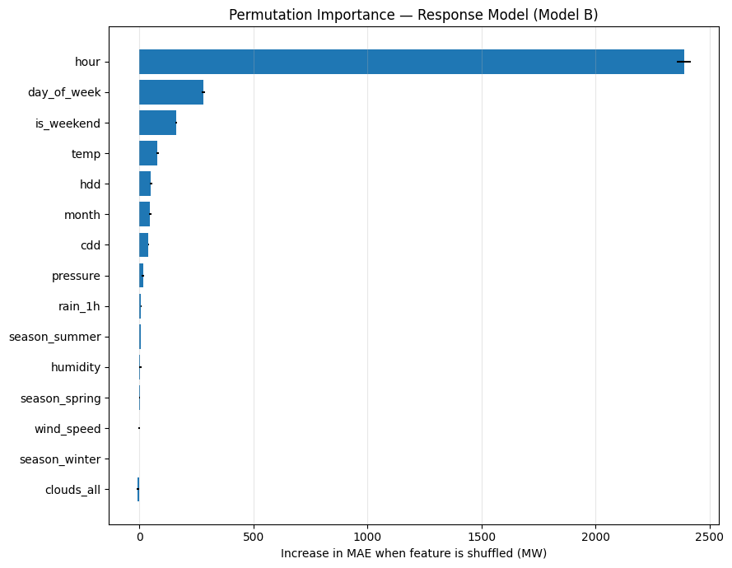
Figure 10. Permutation importance for the Random Forest response model, measured on the test set as the increase in MAE when each feature is shuffled.

3.7 The temperature response function
Holding all calendar and non-temperature weather features at their observed values and sweeping temperature across its observed range recovers the partial dependence of demand on temperature (Figure 11). The curve is clearly U-shaped and is minimised at 19.0 °C — close to, and independently supportive of, the 18 °C balance point assumed in the degree-day construction.
Mean predicted demand at the coldest observed temperature (−4 °C) is 29,043 MW; at the minimum, 27,799 MW; and at the hottest (37 °C), 30,000 MW. The cooling arm therefore rises further above the minimum (2,201 MW) than the heating arm does (1,244 MW), i.e. the response is asymmetric in favour of cooling. The seasonal panel shows the same minimum located consistently near 18–20 °C in every season, with the summer curve rising most steeply at high temperatures.
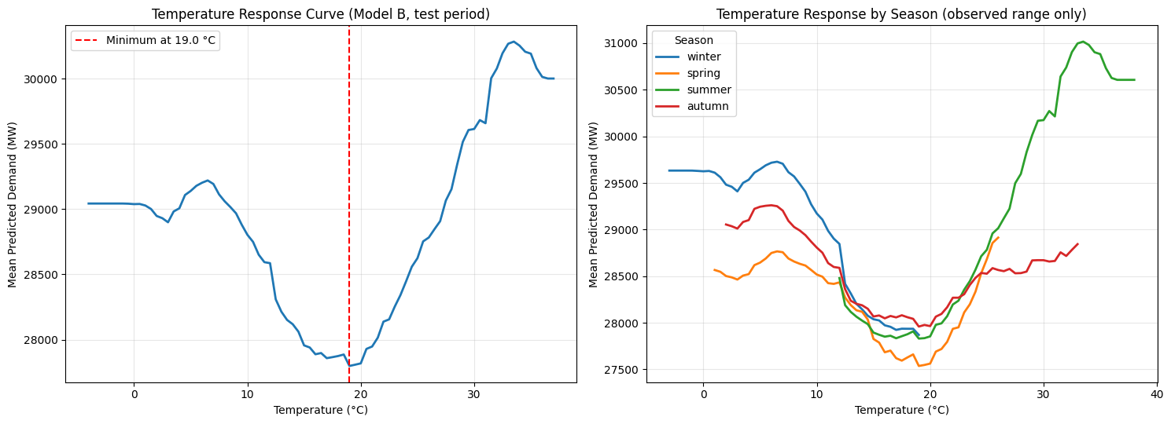
Figure 11. Temperature response curve from the response model: overall (left) and by season within each season's own observed range (right).
The linear single-slope specification quantifies the two arms directly:
Response arm | Sensitivity
Cooling response (above 18 °C) | +104.6 MW per °C
Heating response (below 18 °C) | +78.7 MW per °C

The cooling response is roughly a third larger than the heating response, consistent with cooling in Spain being almost entirely electric while heating is substantially met by gas and other fuels.

3.8 Non-linearity: the cooling response steepens
The piecewise band model tests whether a single cooling slope is adequate. It is not. Table 6 gives the fitted MW per °C within each band.
Table 6. Piecewise degree-band coefficients (MW per °C within band).
Cooling band | MW/°C | Heating band | MW/°C
18–22 °C | −29.2 | 18–14 °C | +113.3
22–26 °C | +120.9 | 14–10 °C | +145.0
26–30 °C | +102.5 | 10–6 °C | +9.8
30 °C and above | +353.5 | below 6 °C | −35.6

The cooling response is strongly convex. It is flat to slightly negative in the 18–22 °C band — unsurprising, since this straddles the comfort zone where neither heating nor cooling is much used — and then rises to 353.5 MW per °C above 30 °C, roughly three times the 22–26 °C slope (Figure 12).
This is the most operationally consequential result in the report. It means the average temperature sensitivity substantially understates the sensitivity in exactly the conditions that determine peak capacity requirements. A warming scenario that shifts a summer afternoon from 29 °C to 32 °C moves demand along the steepest part of the response function.
The heating bands are less well behaved: the two extreme cold bands give small and negative coefficients. With few observations at those temperatures in a country as warm as Spain, and with strong collinearity between adjacent bands, these coefficients should not be over-interpreted. This instability is part of the reason specification B4, which uses a single HDD term with time-of-day interactions rather than cold bands, was preferred.
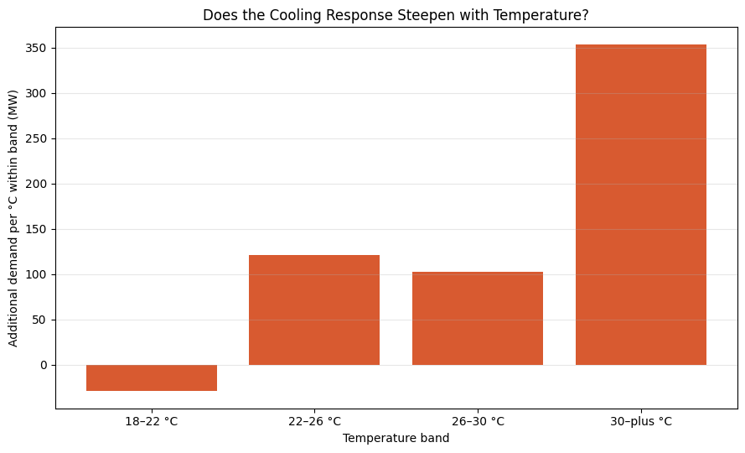
Figure 12. Additional demand per °C within each cooling band. The response steepens sharply above 30 °C.

3.9 Time-of-day heterogeneity
Interacting the degree-day terms with time blocks improves R² by +0.0082 over the single-slope model and reveals that the two responses have quite different daily shapes (Table 7, Figure 13).
Table 7. Temperature sensitivity by time of day (MW per °C).
Time block (local) | Cooling (above 18 °C) | Heating (below 18 °C)
Night (0–7h) | 201.8 | 3.2
Morning (8–13h) | 176.2 | 133.5
Afternoon (14–19h) | 205.8 | 326.0
Evening (20–23h) | 119.0 | 158.8

The cooling response is substantial at all hours, including overnight (201.8 MW per °C) — consistent with air conditioning left running through hot nights, which is behaviourally plausible and matters for baseload rather than only peak provision. The heating response, by contrast, is essentially absent overnight (3.2 MW per °C) and peaks in the afternoon (326.0 MW per °C), consistent with heating being driven by occupancy: buildings that are empty or whose occupants are asleep are not heated electrically to the same degree.
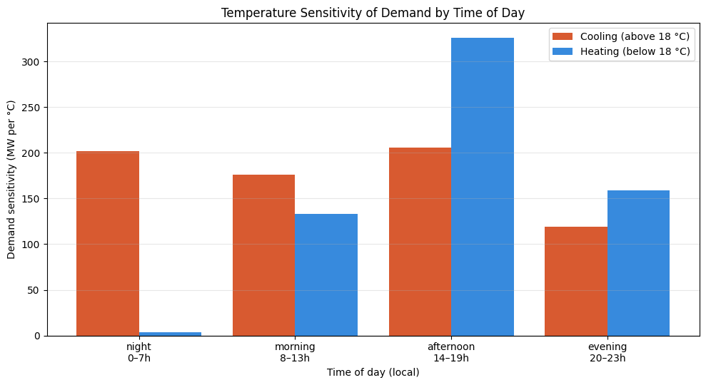
Figure 13. Cooling and heating sensitivity of demand by time of day.

3.10 Warming scenario effects
Table 8 gives the primary results: mean change in predicted demand under each warming scenario, with 95% confidence intervals from 300 model refits on day-resampled training data (Section 2.13).
Table 8. Change in predicted demand under uniform warming, primary model (linear + time-of-day interactions). Intervals are 95% bootstrap intervals over 300 refits.
Scope | Scenario | Mean Δ (MW) | 95% CI lower | 95% CI upper | CI excludes 0?
Annual | +1 °C | +0.19 | −49.77 | +47.35 | No
Annual | +2 °C | +10.72 | −88.66 | +104.34 | No
Annual | +3 °C | +32.20 | −116.06 | +174.60 | No
Winter | +1 °C | −140.00 | −201.81 | −83.27 | Yes
Winter | +2 °C | −275.73 | −398.75 | −162.99 | Yes
Winter | +3 °C | −404.48 | −587.75 | −236.83 | Yes
Spring | +1 °C | −47.44 | −101.16 | +3.22 | No
Spring | +2 °C | −78.11 | −185.49 | +22.91 | No
Spring | +3 °C | −90.82 | −250.45 | +60.13 | No
Summer | +1 °C | +165.79 | +111.10 | +216.14 | Yes
Summer | +2 °C | +336.87 | +226.99 | +437.78 | Yes
Summer | +3 °C | +512.34 | +346.78 | +664.01 | Yes
Autumn | +1 °C | +19.66 | −29.58 | +67.82 | No
Autumn | +2 °C | +54.22 | −44.36 | +151.13 | No
Autumn | +3 °C | +103.21 | −43.71 | +251.13 | No

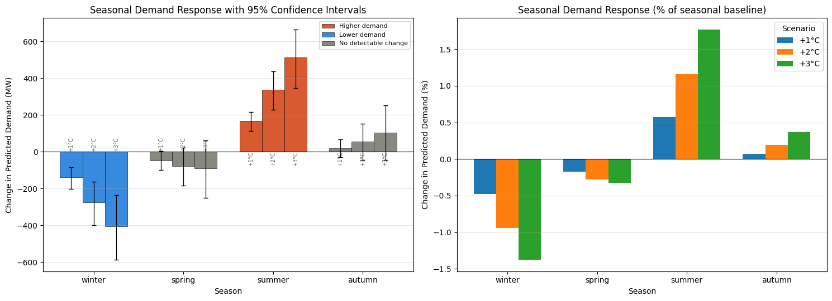
Figure 14. Seasonal demand response to warming with 95% confidence intervals (left) and as a percentage of each season's baseline demand (right). Colour encodes the statistical classification.
The pattern is consistent across all three warming levels and roughly linear in the warming increment: summer demand rises, winter demand falls, spring and autumn move too little to distinguish from zero, and the annual mean change is small and statistically indistinguishable from zero at every warming level.
In percentage terms the effects are modest but not negligible: under +3 °C, summer demand rises 1.77% and winter demand falls 1.38% relative to their respective seasonal baselines.

3.11 Scenario classification
Applying the confidence-interval decision rule gives the classification grid in Table 9.
Table 9. Classification of each season/scenario combination.
Season | +1 °C | +2 °C | +3 °C
Winter | Lower demand | Lower demand | Lower demand
Spring | No detectable change | No detectable change | No detectable change
Summer | Higher demand | Higher demand | Higher demand
Autumn | No detectable change | No detectable change | No detectable change

Of the twelve season/scenario cells, three are classified as higher demand, three as lower demand, and six as no detectable change. The classification is entirely stable across warming levels, which is reassuring: the sign and detectability of the effect do not depend on which scenario is chosen, only its magnitude.

3.12 The redistribution finding
Table 10 decomposes the annual null result.
Table 10. Annual net change versus gross seasonal movement (MW).
Scenario | Annual net | Seasonal increases | Seasonal decreases | Gross movement
+1 °C | +0.2 | +185.4 | −187.4 | 372.9
+2 °C | +10.7 | +391.1 | −353.8 | 744.9
+3 °C | +32.2 | +615.5 | −495.3 | 1,110.8

The annual mean and the seasonal means are not in conflict — their relationship is the finding. Under +3 °C, 1,111 MW of demand moves between seasons while the annual total shifts by only 32 MW, a quantity the confidence interval cannot distinguish from zero. Warming changes when Spain uses electricity far more than how much it uses over a year.
This distinction matters because generation and network capacity are sized by peak demand, not by annual energy. A redistribution toward summer, concentrated in the hours when the cooling response is steepest, increases required firm capacity even when annual consumption is unchanged. An analysis that reported only the annual figure would have concluded, incorrectly, that warming is immaterial to the Spanish grid.

3.13 Emission factors
Total direct fossil CO₂ over the full record is 236.7 Mt, implying an average carbon intensity of 0.236 kg CO₂/kWh. Three of the seven fossil generation columns (oil shale, peat, coal-derived gas) are present in the schema but identically zero throughout, and no hour in the record has zero fossil generation.
The first-difference regression, fitted on 35,005 consecutive hour pairs, gives a marginal factor of 0.206 kg CO₂/kWh. The fit through the origin and the fit with a free intercept agree to three decimal places, and the intercept is small (98 kg/h) relative to typical hourly CO₂ changes, indicating that emissions do not drift materially independently of demand. The R² of 0.348 is unremarkable and expected — individual hourly changes are noisy even when the average relationship is well identified.
The marginal factor is 13% below the average factor, which is informative in itself: the units that follow load in Spain are on average cleaner than the fleet as a whole, because hydro reservoirs participate heavily in load-following.
The source-by-source decomposition (Table 11, Figure 15) makes this concrete.
Table 11. Marginal dispatch decomposition: MW response per MW of demand change, by generation source.
Source | MW per MW Δ demand | Mean output (MW) | Share of response (%)
Hydro water reservoir | 0.295 | 2,604.5 | 47.7
Fossil gas | 0.227 | 5,622.5 | 36.7
Fossil hard coal | 0.111 | 4,256.0 | 17.9
Solar | 0.069 | 1,432.7 | 11.1
Hydro run-of-river | 0.013 | 972.1 | 2.2
Fossil brown coal | 0.012 | 448.2 | 2.0
Nuclear | 0.006 | 6,263.9 | 1.0
Fossil oil | 0.003 | 298.3 | 0.5
Wind onshore | −0.008 | 5,466.0 | −1.3
Hydro pumped storage (consumption) | −0.112 | 475.7 | −18.2

Three points stand out. Hydro reservoirs are the largest single component of the marginal response (47.7%), which is why the marginal factor falls below the average. Nuclear contributes almost nothing (0.006) despite having the largest mean output in the fleet, correctly identifying it as baseload that does not follow demand. Pumped-storage consumption has a negative slope (−0.112): when demand rises, pumping is curtailed, freeing supply — physically exactly right, and a useful validity check on the method.
Recombining the source slopes with their emission factors reconstructs a marginal factor of 0.206 kg/kWh, identical to the direct regression estimate. Two independent routes to the same number is meaningful corroboration that the estimate is not an artefact of either procedure.
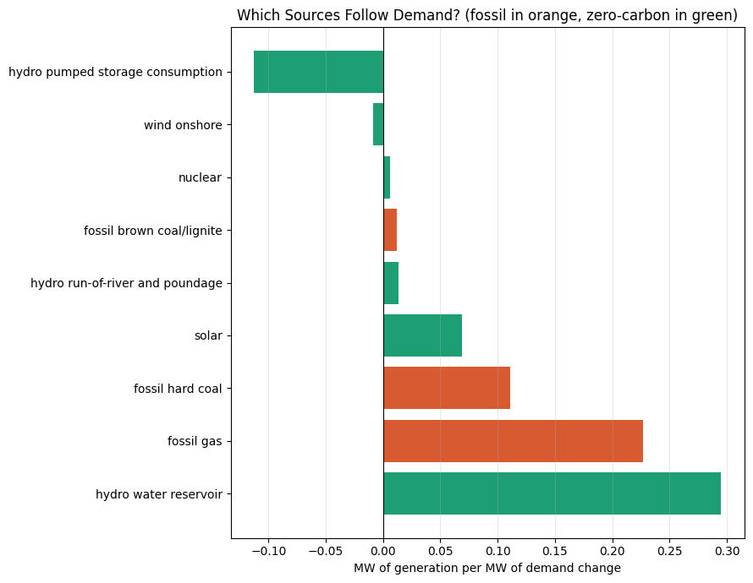
Figure 15. Marginal dispatch response by generation source.

3.14 CO₂ impact of the warming scenarios
Applying the marginal factor of 0.206 kg CO₂/kWh to the seasonal demand changes over the test-year season lengths (winter 2,159 h, spring 2,207 h, summer 2,206 h, autumn 2,185 h) gives Table 12.
Table 12. Seasonal CO₂ impact of the warming scenarios (test year). CO₂ bounds propagate the 95% demand confidence intervals.
Season | Scen. | Δ Demand (MW) | Δ Energy (GWh) | CO₂ (t) | CO₂ range (t) | Class
Winter | +1 | −140.0 | −302.3 | −62,201 | [−89,658, −36,995] | Lower
Spring | +1 | −47.4 | −104.7 | −21,546 | [−45,942, +1,461] | None
Summer | +1 | +165.8 | +365.7 | +75,259 | [+50,433, +98,115] | Higher
Autumn | +1 | +19.7 | +42.9 | +8,838 | [−13,302, +30,494] | None
Winter | +2 | −275.7 | −595.3 | −122,501 | [−177,154, −72,413] | Lower
Spring | +2 | −78.1 | −172.4 | −35,475 | [−84,239, +10,404] | None
Summer | +2 | +336.9 | +743.1 | +152,923 | [+103,041, +198,729] | Higher
Autumn | +2 | +54.2 | +118.5 | +24,378 | [−19,943, +67,952] | None
Winter | +3 | −404.5 | −873.3 | −179,701 | [−261,122, −105,218] | Lower
Spring | +3 | −90.8 | −200.4 | −41,248 | [−113,745, +27,307] | None
Summer | +3 | +512.3 | +1,130.2 | +232,576 | [+157,418, +301,426] | Higher
Autumn | +3 | +103.2 | +225.5 | +46,404 | [−19,653, +112,916] | None

The net annual figures are +350 t under +1 °C, +19,324 t under +2 °C, and +58,031 t under +3 °C. These must be reported with care. They inherit the annual demand confidence interval, which contains zero at every warming level, so the net annual figure is a null result and must not be presented as an established increase.
The defensible statement is that under +3 °C the model projects a seasonal redistribution of emissions — an increase of roughly 233 kt in summer against a decrease of roughly 180 kt in winter — with a net annual change that is not statistically distinguishable from zero at the 95% level. The seasonal figures are the result; the net is the null.

3.15 Robustness and sensitivity analysis
Five sensitivity checks were run.
1. Balance-point temperature. Setting the balance point to 16, 18 and 20 °C produced test R² of 0.6231, 0.6232 and 0.6233 and a +3 °C effect of +61.8, +62.2 and +61.7 MW respectively. The results are essentially invariant to this choice.
2. Calendar collinearity. Month and season are collinear with temperature — July is hot, but is also a holiday month with different industrial activity. Retaining them lets the model attribute genuine thermal effects to the calendar, damping the estimated response; dropping them risks the opposite. Reporting both bounds the answer. Without month and season, R² falls slightly to 0.6248 and the +3 °C annual effect falls to +39.4 MW.
3. Model specification. Table 13 compares the +3 °C seasonal effect across all four Model B specifications.
Table 13. +3 °C seasonal effect (MW) across model specifications.
Season | Linear (1 slope) | Linear (piecewise) | Linear + interact. | Random Forest
Winter | −228.1 | −156.3 | −404.5 | −491.7
Spring | −81.2 | −203.0 | −90.8 | −106.5
Summer | +286.6 | +421.9 | +512.3 | +845.5
Autumn | +41.1 | −49.7 | +103.2 | −13.5

All four specifications agree on the sign of the two large effects — summer up, winter down — and therefore on the redistribution conclusion. They disagree substantially on magnitude: the Random Forest gives a summer effect roughly three times the single-slope linear estimate. Autumn changes sign across specifications, which is consistent with its classification as no detectable change. The qualitative finding is robust; the point magnitudes should be read as specification-dependent.
4. Bootstrap scheme. For the primary model, hour-resampling and refit-based intervals happened to have similar widths (summer +3 °C: 334.1 MW versus 317.2 MW). This near-agreement is coincidental rather than reassuring — the two schemes measure different quantities, and the refit interval is the one that answers the relevant question. Under the Random Forest, hour-resampling produced intervals that appeared plausible only because the forest's per-hour effects are jagged step functions.
5. Emission factor. Table 14 shows the +3 °C result under four candidate factors.
Table 14. Sensitivity of the +3 °C CO₂ result to the emission factor.
Factor choice | kg CO₂/kWh | Summer (t) | Net annual (t)
Marginal, estimated from data | 0.206 | 232,576 | 58,031
Average, estimated from data | 0.236 | 266,197 | 66,420
National average (published) | 0.321 | 362,801 | 90,524
Gas-only upper bound | 0.490 | 553,809 | 138,183

The spread across factor choices is 80,152 t — larger than the central net estimate itself. The CO₂ conclusion is therefore more sensitive to the emission-factor assumption than to anything in the machine learning, and this should be stated plainly rather than buried.
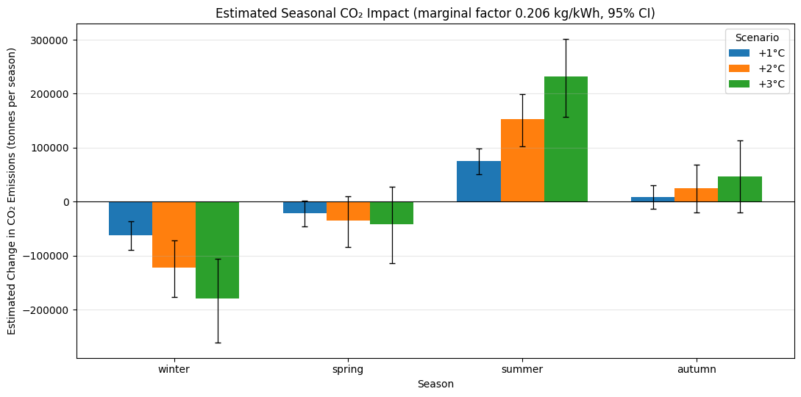
Figure 16. Seasonal CO₂ impact with uncertainty bounds under the estimated marginal emission factor.

4. Findings, Discussion and Conclusions

4.1 Principal findings
- Hourly Spanish electricity demand is highly predictable at short horizons, but almost entirely from its own recent history. A Random Forest using lagged demand achieves MAE 355 MW (R² = 0.9844), a 67% error reduction over persistence. However, 98.2% of its feature importance sits on just two features — the one-hour lag (0.907) and hour of day (0.075) — with temperature at 0.0027.
- The predictive accuracy of a model is not evidence of its validity for intervention. The most accurate model in this study is the least suitable for the project's central question, because its accuracy comes from a channel that cannot be manipulated. Excluding demand history costs 36 points of R² (0.98 → 0.64), and paying that cost is what makes the scenario analysis meaningful.
- The demand–temperature relationship is U-shaped, minimised at 19.0 °C, and asymmetric. Cooling sensitivity (+104.6 MW per °C above 18 °C) exceeds heating sensitivity (+78.7 MW per °C below it) by about a third, consistent with cooling in Spain being almost entirely electric while heating is substantially met by other fuels.
- The cooling response is strongly convex. Piecewise estimation gives −29.2 MW per °C in the 18–22 °C band rising to +353.5 MW per °C above 30 °C. Average sensitivity therefore understates sensitivity in precisely the conditions that set peak capacity requirements.
- Heating and cooling responses have different daily shapes. Cooling sensitivity is substantial even overnight (201.8 MW per °C), while heating sensitivity is near zero overnight (3.2 MW per °C) and peaks in the afternoon (326.0 MW per °C) — consistent with heating being occupancy-driven and cooling persisting through hot nights.
- Warming redistributes demand between seasons without detectably changing the annual total. Under +3 °C, summer demand rises +512 MW (95% CI [+347, +664]) and winter demand falls −404 MW (95% CI [−588, −237]), both statistically detectable, while the annual mean change of +32 MW is not (95% CI [−116, +175]). Gross seasonal movement of 1,111 MW nets to 32 MW.
- This redistribution matters even though the annual total does not move. Capacity is sized by peaks, not averages. A shift toward summer — concentrated in hours where the cooling slope is steepest — raises required firm capacity while leaving annual energy roughly unchanged. The annual null result is the least policy-relevant number in the analysis.
- Spain's marginal carbon intensity is below its average. The marginal factor of 0.206 kg CO₂/kWh, estimated by first-difference regression and confirmed independently by dispatch decomposition, is 13% below the average factor of 0.236 kg/kWh, because hydro reservoirs supply 47.7% of the marginal load-following response.
- The emissions consequence mirrors the demand result: a seasonal redistribution with a null annual net. Under +3 °C, approximately +233 kt CO₂ in summer against −180 kt CO₂ in winter, with a net annual change of +58 kt that is not distinguishable from zero at 95% confidence.
- The emissions conclusion is limited by the emission factor, not by the model. Varying the factor across four defensible choices moves the net annual estimate by 80 kt — more than the central estimate itself.

4.2 Methodological findings
Three methodological points emerged that are worth recording independently of the substantive results.
Bootstrap design must match the quantity of interest. The initial intervals resampled which test hours the effect was averaged over. For a linear model the per-hour effect is a deterministic function of the coefficients, so within a season it barely varies and the interval collapses to spurious precision (±0.1%). The dominant uncertainty is in the coefficients, which requires refitting on resampled training data. Under the Random Forest this error was concealed rather than corrected: the forest's jagged per-hour effects produced plausible-looking width by coincidence.
Weak linear correlation is not evidence of unimportance. Temperature's Pearson correlation with demand is weak, because the two arms of the U-shape have opposite slopes and cancel. Feature selection by correlation ranking would have discarded the project's central variable.
Counterfactual design matrices must be internally consistent. Shifting temperature without recomputing the degree-day terms derived from it produces a physically incoherent scenario. Verifying programmatically that exactly the intended columns change is a cheap and effective guard.

4.3 Limitations
- Emission factors require verification. The fuel-specific direct-combustion factors used to build hourly CO₂ are commonly cited central estimates and should be replaced with values verified against a primary source — IPCC AR5 Working Group III Annex III, the European Environment Agency's electricity emission factor reports, or Spain's National Inventory Report to the UNFCCC — before these figures are relied upon. Section 3.15 shows the result is materially sensitive to this choice.
- Only direct combustion emissions are counted. Lifecycle emissions of nuclear, hydro, wind and solar are non-zero but out of scope. Biomass and waste are treated as zero-carbon following conventional IPCC biogenic accounting, which is a contested convention.
- Random Forest scenarios are a lower bound. Tree ensembles cannot extrapolate. Under +3 °C, 0.51% of test hours (45 hours) exceed the training maximum of 36.8 °C, and for those hours the forest returns its boundary value, systematically understating the warming effect. This was a decisive reason for selecting a linear primary model.
- Uniform warming is a simplification. Real climate change alters the temperature distribution — shifting means, changing variance, and increasing extreme-heat frequency — rather than adding a constant to every hour. Given the convexity established in Section 3.8, a change in the upper tail would produce a larger effect than a uniform shift of the same mean magnitude, so these estimates are likely conservative.
- Adaptation and structural change are held fixed. The models are estimated on 2015–2018 behaviour and assume air-conditioning penetration, building stock, heating technology mix and electrification of end uses remain unchanged. Over any horizon on which +3 °C is realistic, all of these would change — most obviously air-conditioning adoption, which would amplify the cooling response.
- No holiday calendar. Spanish public holidays are not encoded. Several of the largest residuals in Model A are consistent with holiday effects the model cannot anticipate.
- At least one suspected data fault remains. The consecutive hours 2018-05-06 10:00 and 11:00 UTC produce large, near-equal and opposite residuals, consistent with transposed or mis-stamped source values. These were retained rather than silently removed, but they inflate reported error metrics slightly.
- Five cities represent a whole country. Population-weighted aggregation over Madrid, Barcelona, Valencia, Seville and Bilbao is a reasonable proxy for national conditions but omits substantial rural and regional variation, and the weights use municipal rather than metropolitan or catchment populations.
- Weather-condition categories were discarded. Judged largely redundant with the numeric fields, but this was not tested empirically.
- A single test year. Evaluation rests on 2018. Performance and scenario estimates would be more robust under rolling-origin evaluation across multiple test years.

4.4 Future work
The most valuable extensions, in rough order of expected return: incorporating a Spanish public-holiday calendar; replacing uniform temperature shifts with distributional scenarios drawn from downscaled climate projections, which given the established convexity should be expected to increase the estimated effect; explicit modelling of air-conditioning adoption as a time-varying elasticity; a rolling-origin evaluation over multiple test years; and estimation at regional rather than national resolution, which would allow the heterogeneous climates of the Atlantic north and the semi-arid south to be treated separately rather than averaged.

4.5 Conclusions
This project set out to characterise the weather sensitivity of Spanish electricity demand and to use it to evaluate warming scenarios. It arrives at a result whose shape is arguably more informative than a single headline number: warming does not detectably change how much electricity Spain consumes over a year, but it does detectably change when. Summer demand rises, winter demand falls, and the two largely offset in the annual mean — while the cooling response steepens sharply at exactly the temperatures and hours that determine peak capacity requirements.
Reaching that result required separating prediction from explanation. The most accurate model built here, at R² = 0.9844, would have returned a near-zero scenario effect for structural reasons having nothing to do with the climate. Discarding 36 points of R² to obtain a model that can be legitimately intervened upon was the necessary methodological cost, and recognising that trade-off is the project's central lesson.

References
Hawkes, A. D. (2010). Estimating marginal CO₂ emissions rates for national electricity systems. Energy Policy, 38(10), 5977–5987.
Siler-Evans, K., Azevedo, I. L., & Morgan, M. G. (2012). Marginal emissions factors for the U.S. electricity system. Environmental Science & Technology, 46(9), 4742–4748.
IPCC (2014). Climate Change 2014: Mitigation of Climate Change. Contribution of Working Group III to the Fifth Assessment Report, Annex III: Technology-specific cost and performance parameters. Cambridge University Press.
Breiman, L. (2001). Random forests. Machine Learning, 45(1), 5–32.
Friedman, J. H. (2001). Greedy function approximation: a gradient boosting machine. Annals of Statistics, 29(5), 1189–1232.
Pedregosa, F., et al. (2011). Scikit-learn: Machine learning in Python. Journal of Machine Learning Research, 12, 2825–2830.
ENTSO-E Transparency Platform. Hourly load and generation data for Spain, 2015–2018. Red Eléctrica de España.
OpenWeather. Historical hourly weather data for Madrid, Barcelona, Valencia, Seville and Bilbao, 2015–2018.
Instituto Nacional de Estadística (INE). Municipal Register population figures, Spain, 2018.

