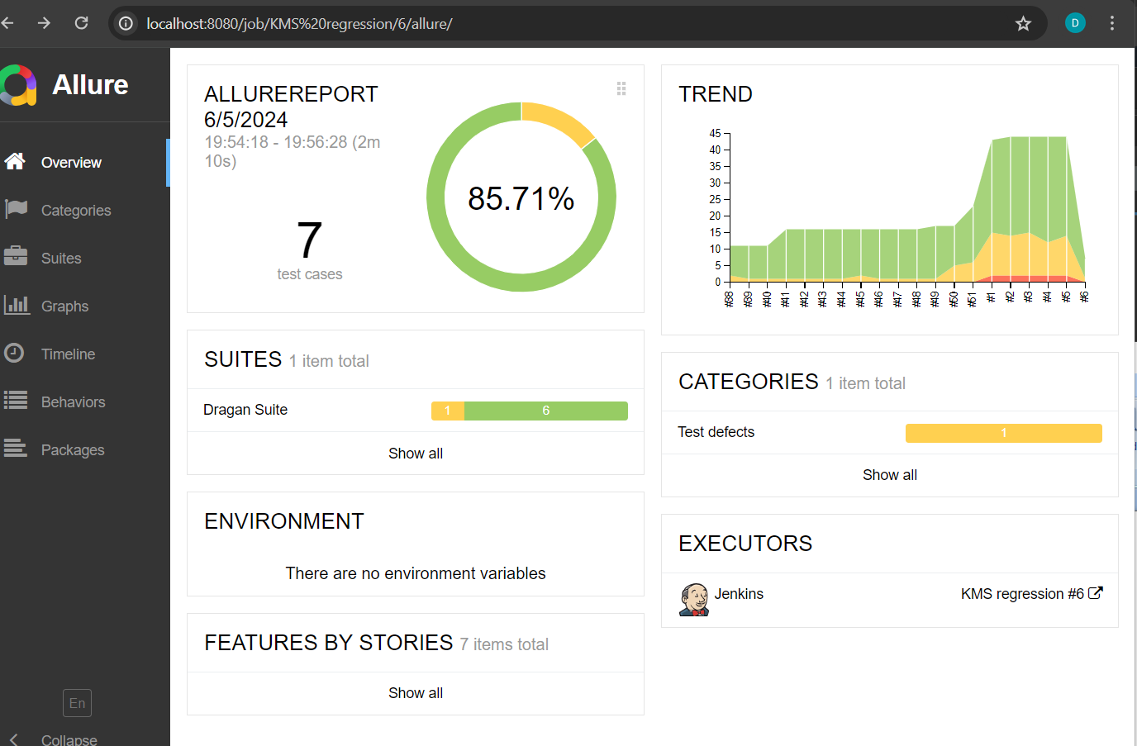

Above picture shows Allure report on Jenkins job on my local computer.

Below picture shows emailable-report

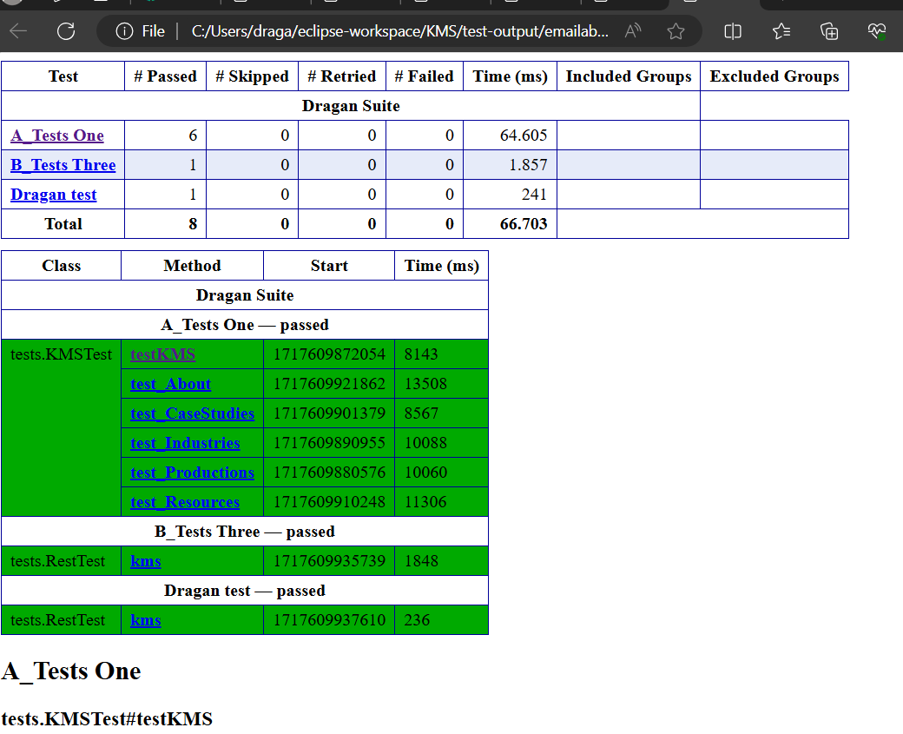

Place where is emailable report

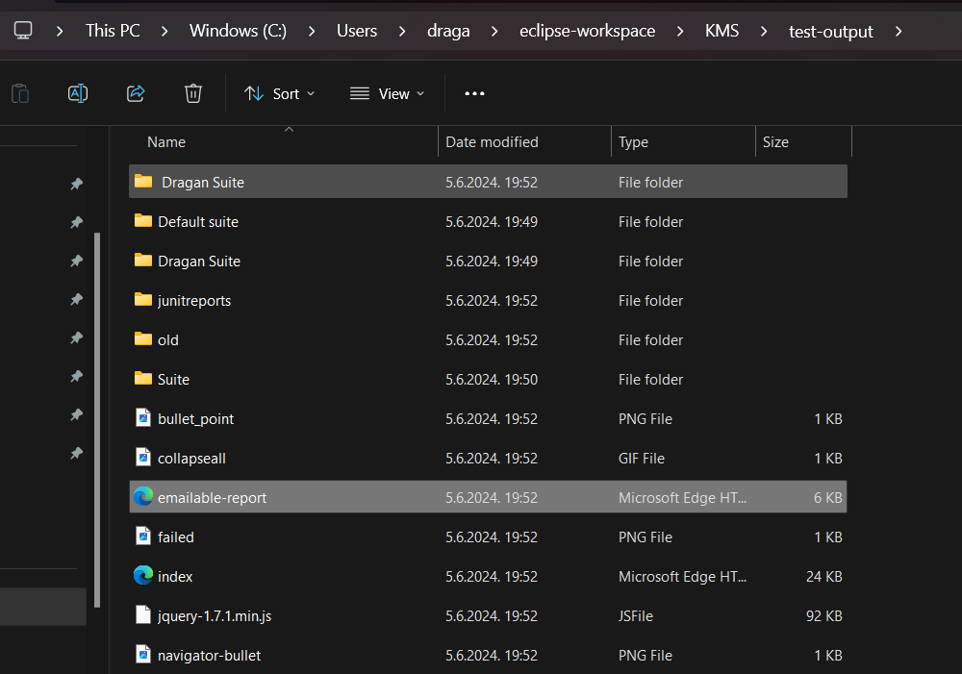

Way how to configure Jenkins.

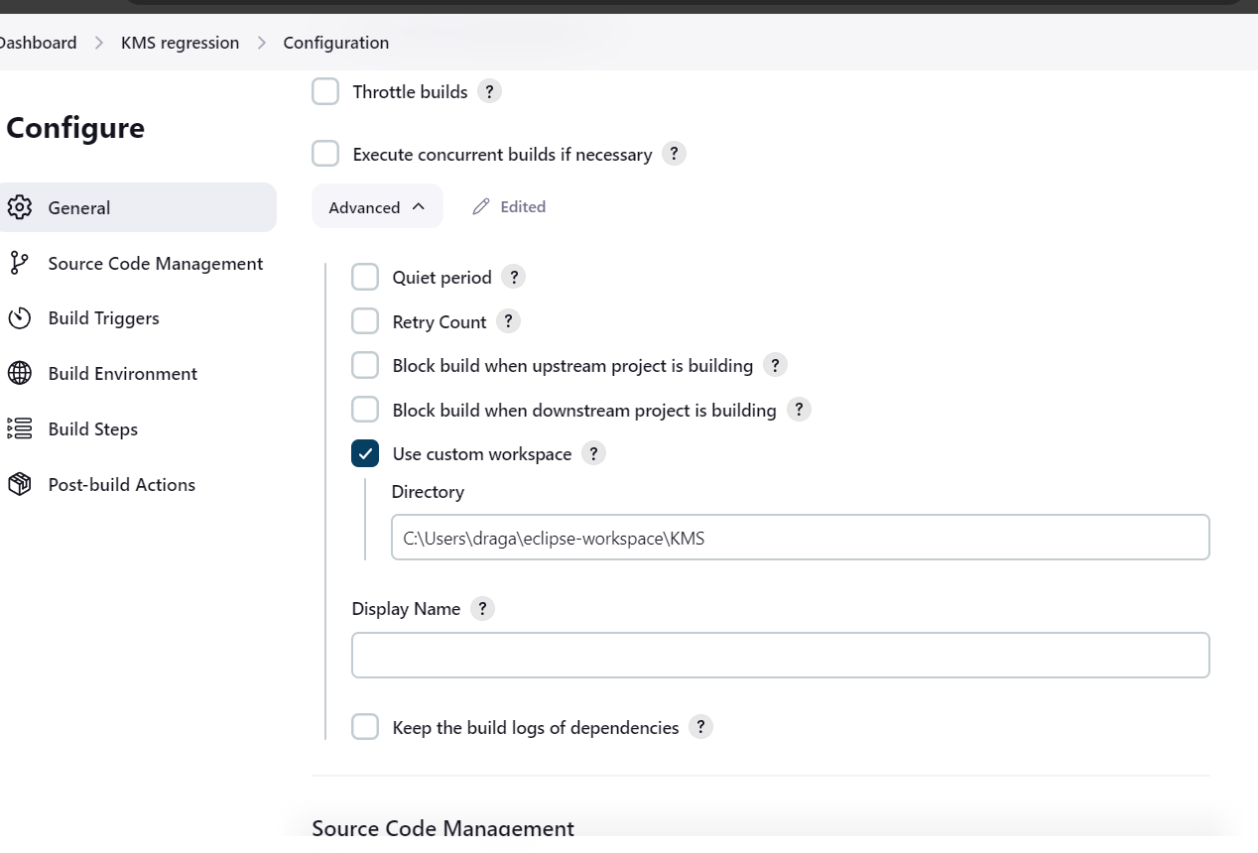

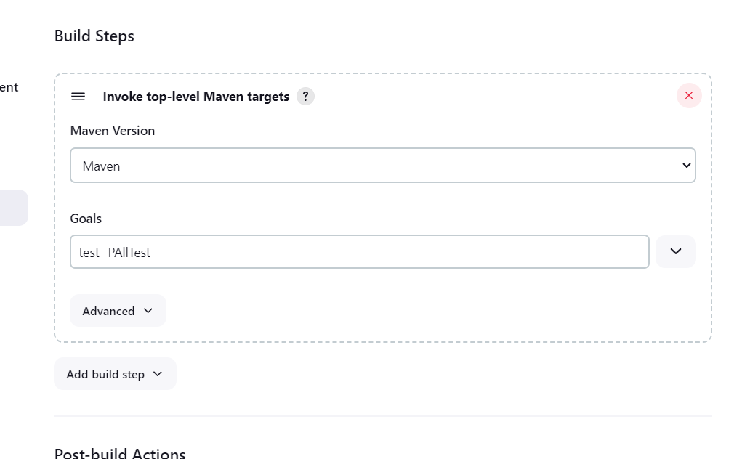

P is profile, after that we have id of profile

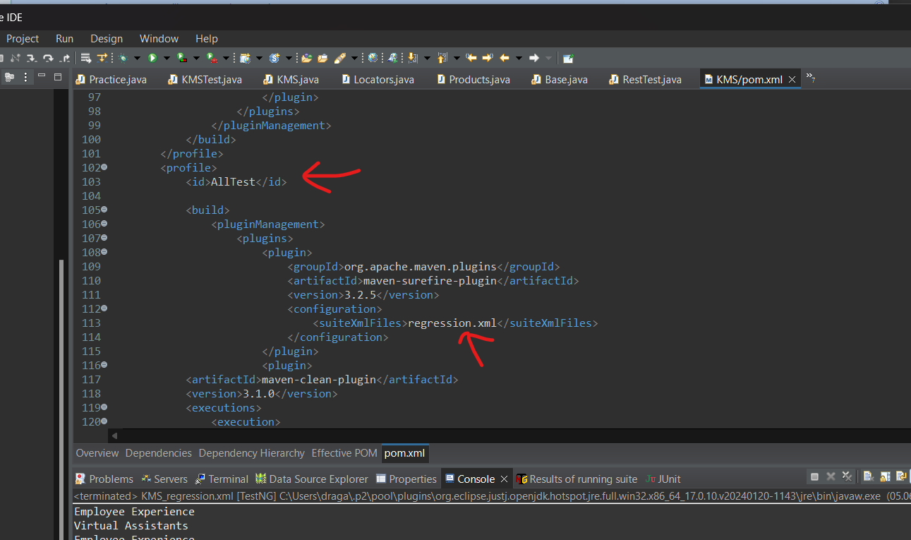

With surefire plugin I have created profiles in pom file. Using id from profiles I mapped which xml will be used for running suit. Command is mvn –P(id of profiles in my case is AllTest). If you want to run one test from Eclipse can click run button  
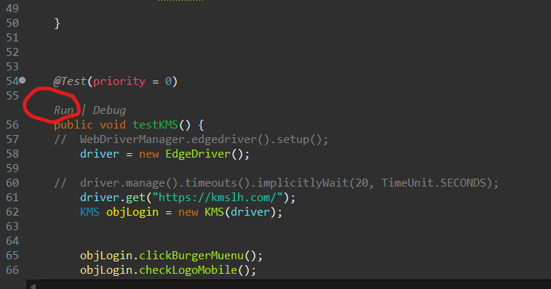

Also can right click on java file with tests for example KMSTest.java and click run as TestNG Test.  
Or we can run xml suite with right click on xml and click run as TestNG Suite.

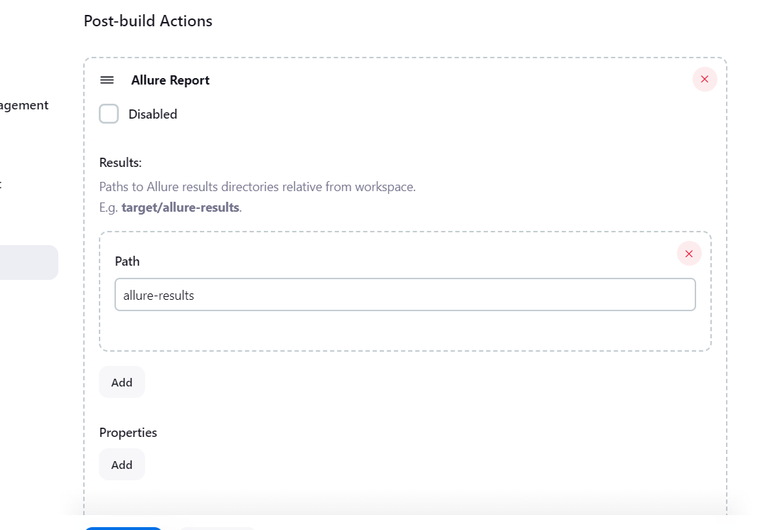

Here is visible Regression xml

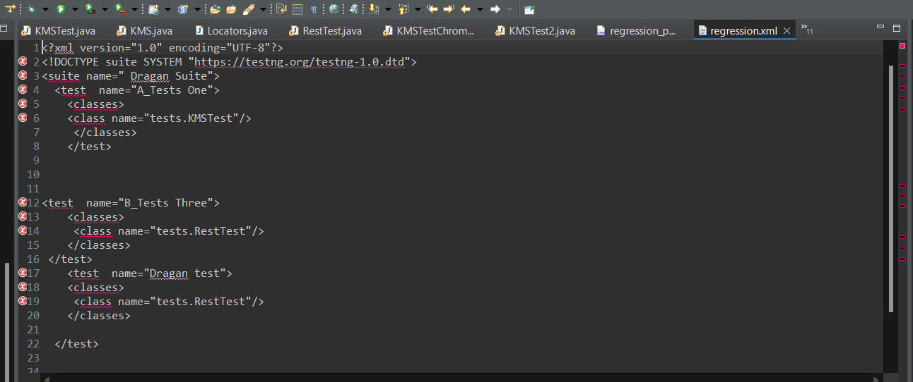

Below is smoke suite, only smoke test is in it.

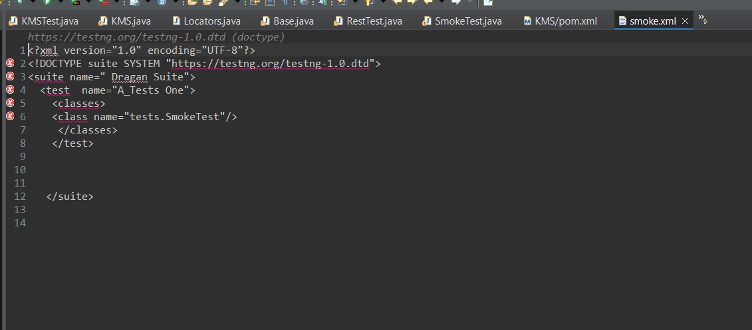

Now is example how run tests from cmd, go to project and run for example one of profiles

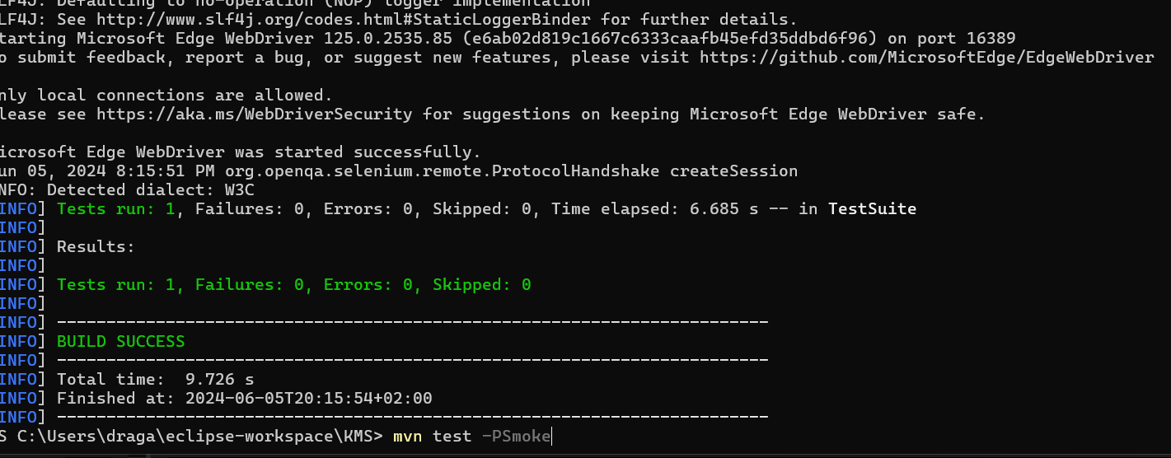

mvn test –Psmoke

for regression can use command  
mvn test –PallTest

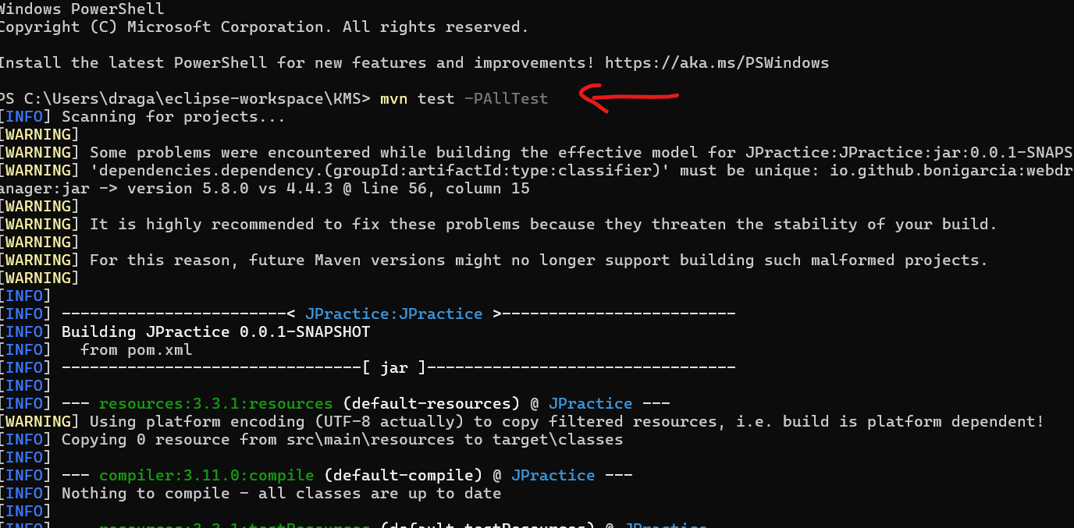

Parallel test can run with regression_parallel.xml, here we have in suite parallel =”tests”, also have thread count 5.  
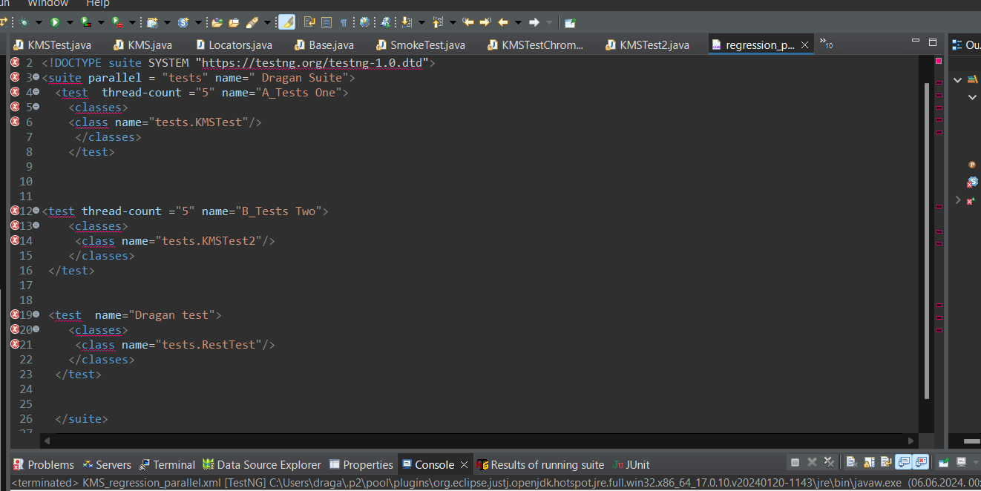

Virtual assistants and employee experience is result from api test that means that test worked parallel  
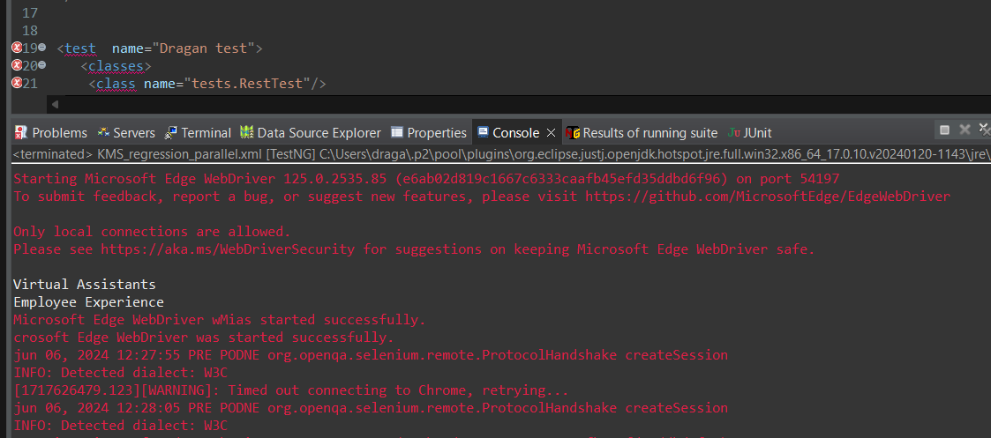

Api test is rest assured  
name is RestTest  
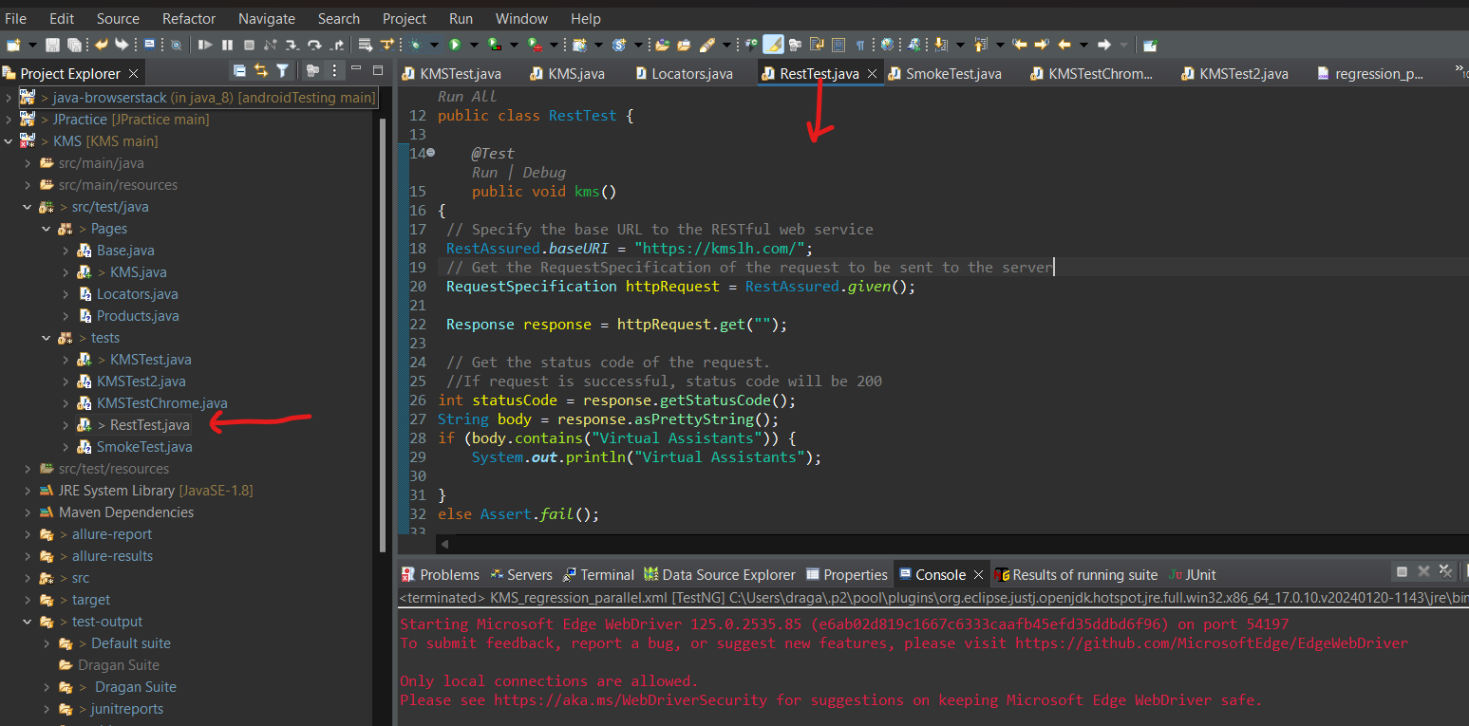

For sending email we can use tool in Jenkins. Also we can send emailable report. Also with Jenkins we can run more different jobs, smoke, regression, api and others everything with Java Selenium. Also can use IRetry Analyser for flaky tests.  
I created KMSTestChrome for running with Chrome but we can have version 114 for that. Also we can import driver exe and run on that way. I have experience in one company we disabled Chrome update on computer where we worked with Python tests. If we use driver exe and path and browser can update sometimes we need to update our driver.  
Also we can use extend reports, and have logs and screenshots

This is a Extend Report for Extendreports.java, here we implemented Extend reports for that class not in framework. In framework also can be implemented.  
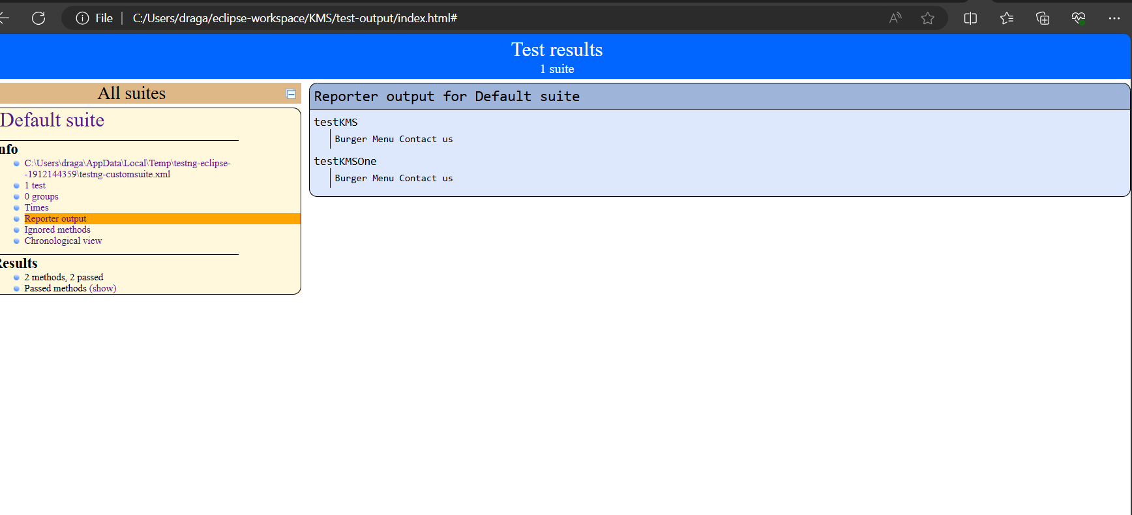

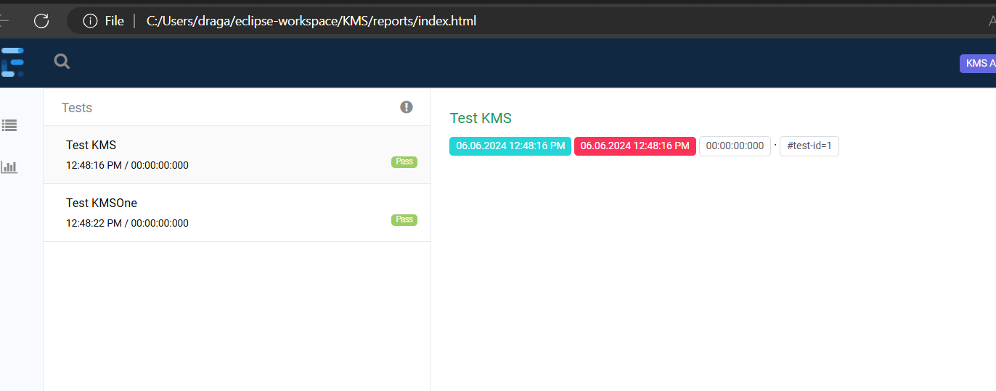

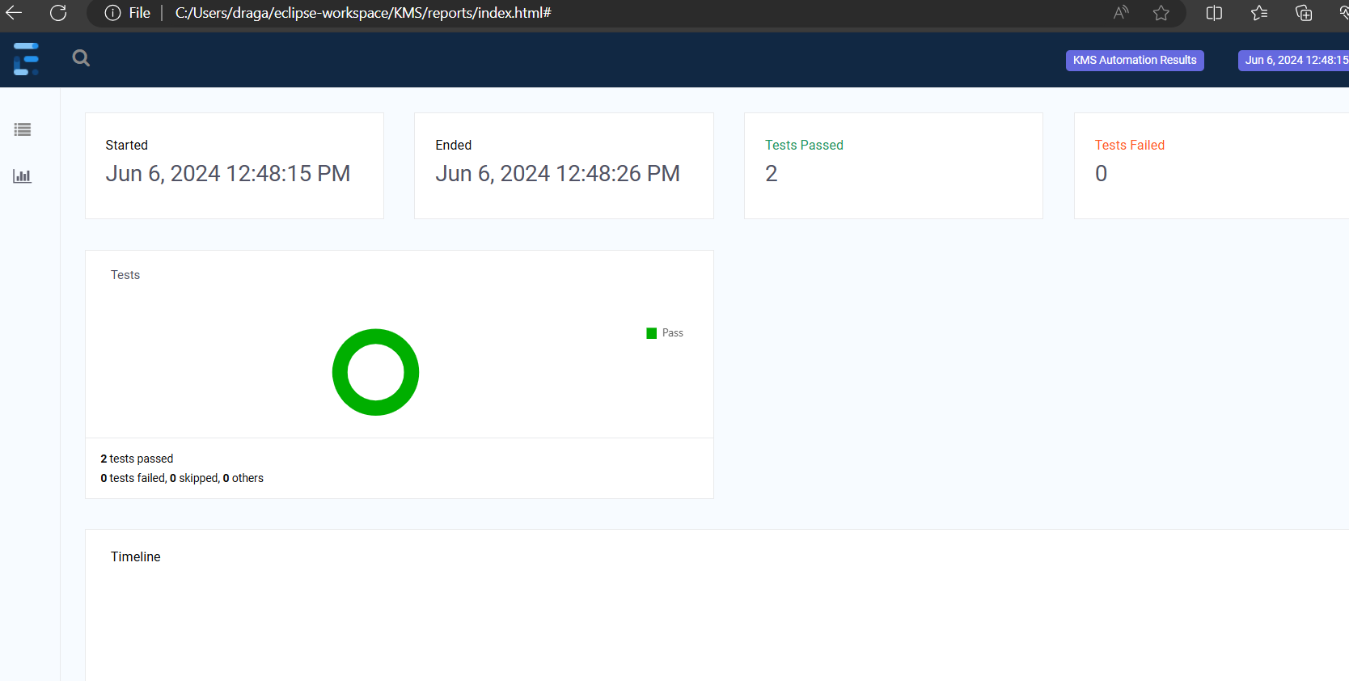

In my experience I created classes for all 5pages, but now we need only to check 4 elements and those methods are in Base class. If we need individual method for some Pages we can put that in that pages.

We can create method on that way

public boolean clickGetStarted(){

Reporter.*log*("Case Studies");

WebDriverWait wait1= new WebDriverWait(driver, 20);

try {

wait1.until(ExpectedConditions.*visibilityOfElementLocated*(locatorObj.get_started)).click();

return true;

} catch (Exception e) {

return false;

}

And call like here

public void testKMS() {

// WebDriverManager.edgedriver().setup();

driver = new EdgeDriver();

// driver.manage().timeouts().implicitlyWait(20, TimeUnit.SECONDS);

driver.get("https://kmslh.com/");

KMS obj = new KMS(driver);

driver.manage().window().maximize();

//objLogin.clickCallCenter();

//objLogin.clickCallCenter();

obj.checkLogo();

obj.checkRequestDemo();

//objLogin.checkAccessibiltyButton();

obj.checkContactUSButton();

*assertEquals*(obj.clickGetStarted(),true);

obj.checkLogo();

//objLogin.checkMainMenu();

obj.return_drv();

}

With assert we can pass or fail test. Also try and catch is good to use.