Commands used when I created envinronment

pip install pytest-playwright

pip install pytest pytest-bdd

venv\Scripts\activate

python -m pip install --upgrade pip

python -m venv venv

python -m ven v ven v

pytest --alluredir=allure-results

allure serve allure-results

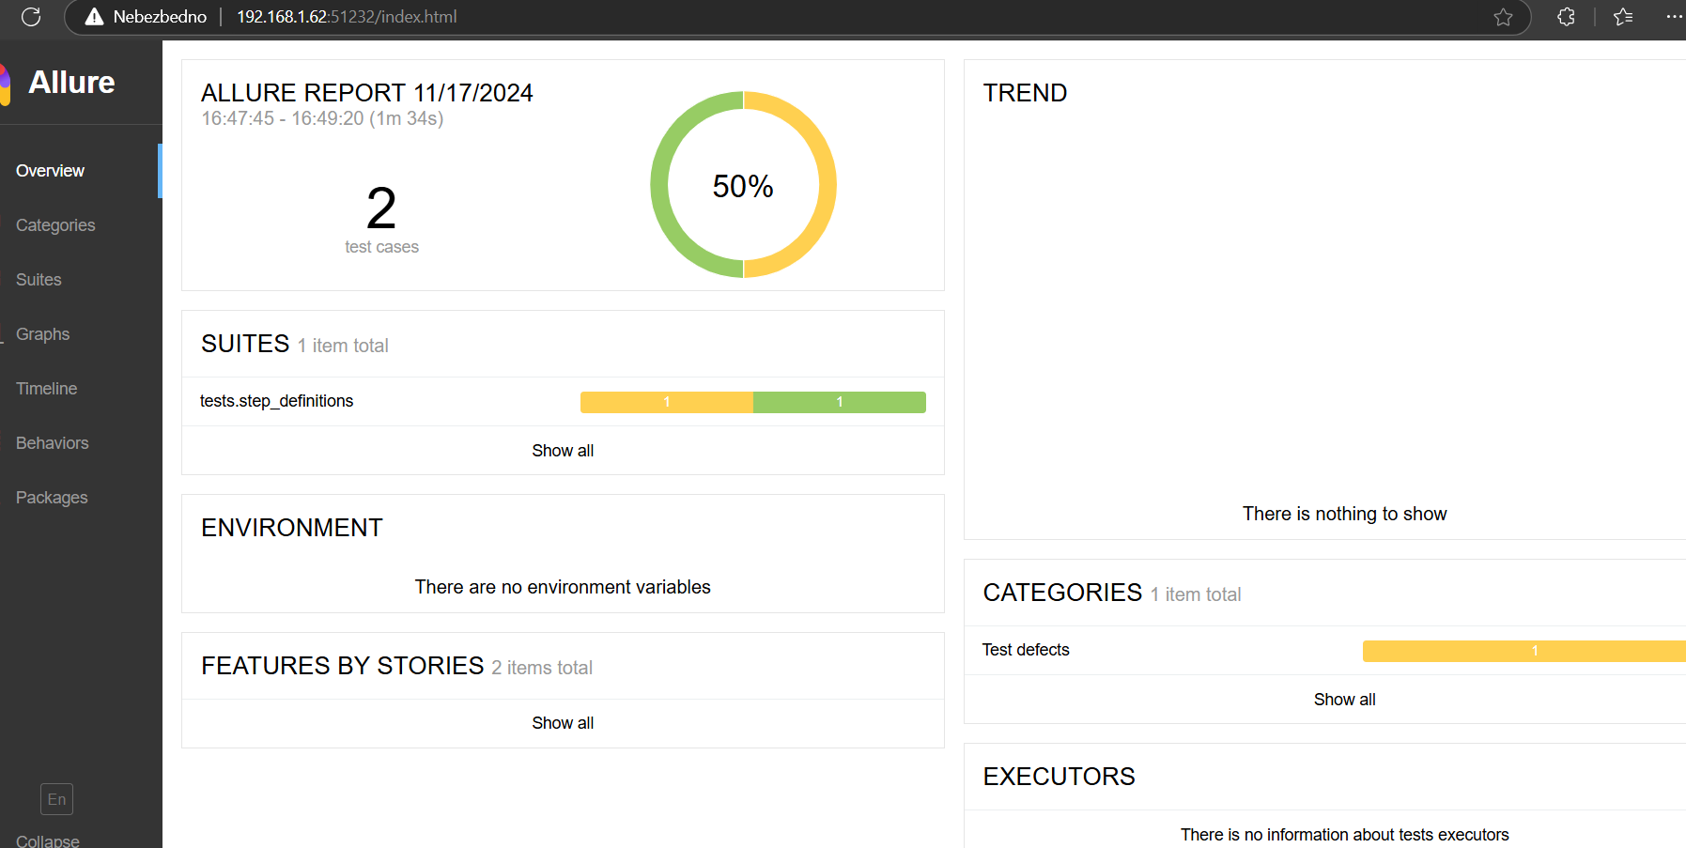

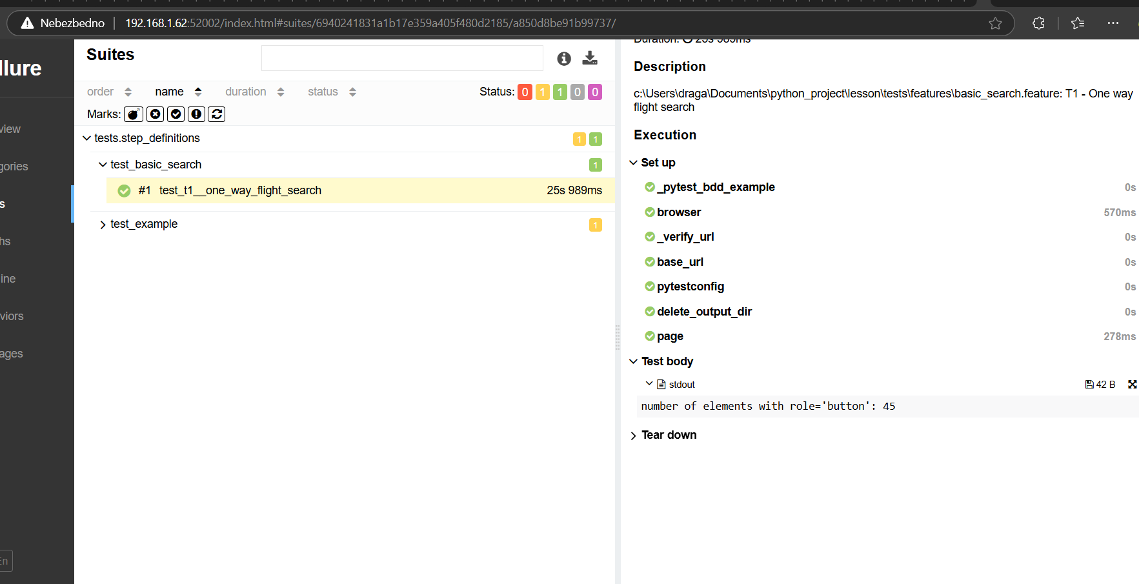

For run test use command in terminal of Studio Code:  
pytest tests/step_definitions/test_basic_search.py -v –s

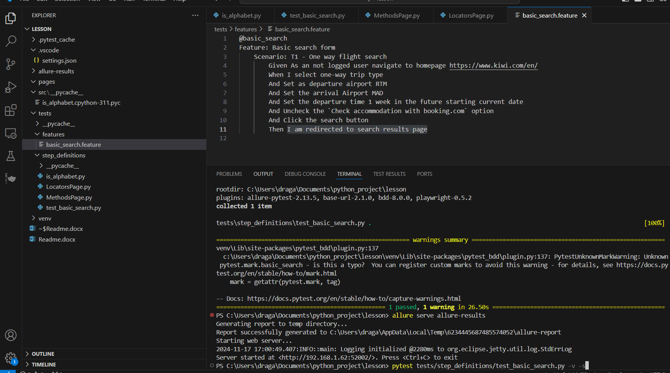

When right click on test and run result is  
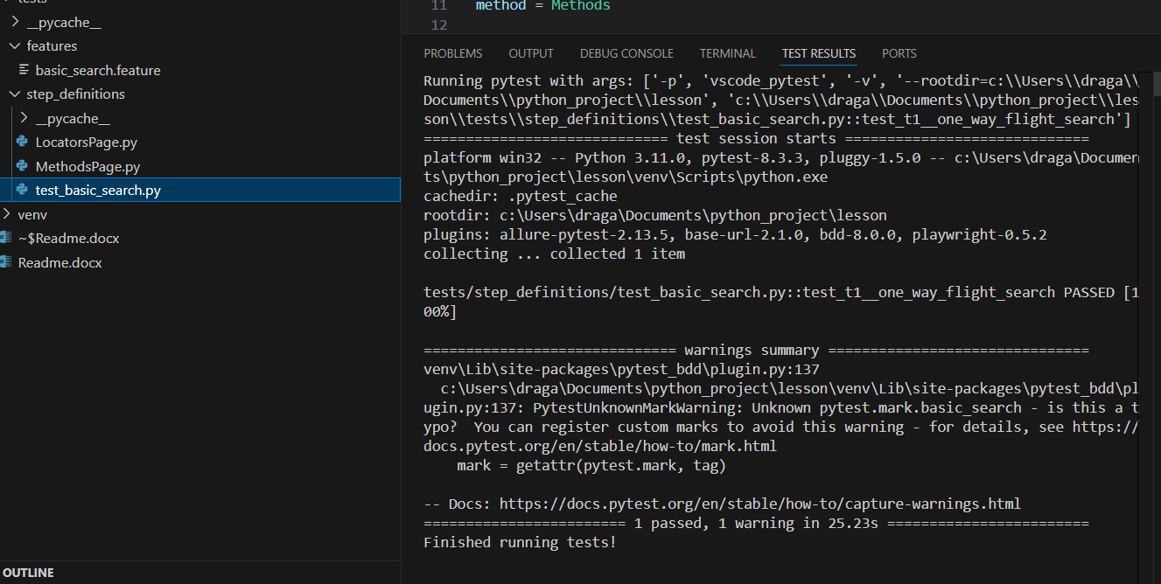  
If we have more tests in suite, we can run that test from task, with name test_basic_search.py, using command  
pytest tests/step_definitions/test_basic_search.py -v –s. Also we can use marking option in pytest and mark our test and easy run using mark.  
I needed to delete my town Belgrade on the beggining and after that import RTM and MAD. If you run test I have in code 2 sec wait reason is that you can see better results when browser will start.  
For departure time set 7 days after today I used

@when("Set the departure time 1 week in the future starting current date")

def departure_time(page):

    xpath = "//input[@name='search-outboundDate']"

    page.click(xpath)

    time.sleep(2)

    # Calculate the date one week from today

    today ="(//*[contains(text(), 'Today')])"

    div_buttons = page.locator('div[role="button"][data-test ="CalendarDay"]').element_handles()

    div_buttons_list = [div for div in div_buttons]

    print("number of elements with role='button':", len(div_buttons_list))

    counter=0

    for div in div_buttons_list:

        if (counter ==7):

            div.click()

        counter =counter +1

    time.sleep(1)

I created list of buttons in calendar, before today, buttons are disabled, after that are data-test ="CalendarDay. Way how I went to +7 is with loop   
I clicked on +7 button from today

counter=0

    for div in div_buttons_list:

        if (counter ==7):

            div.click()

        counter =counter +1

In Jenkins need to install Playwright and create free style project import path  
  
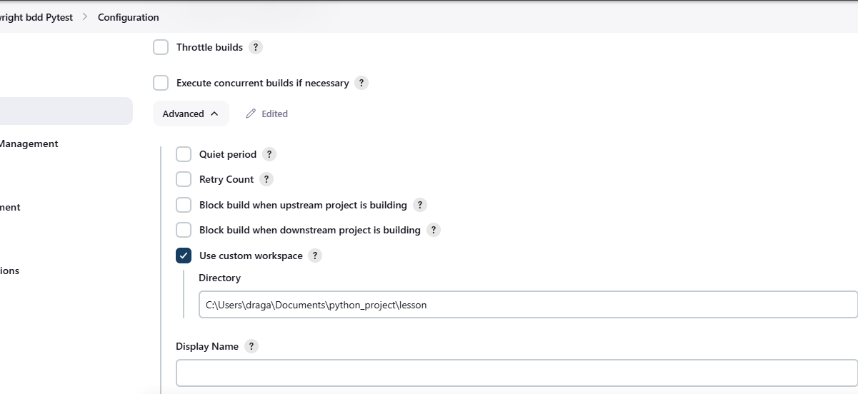

And run command   
pytest tests/step_definitions/test_basic_search.py -v -s  
  
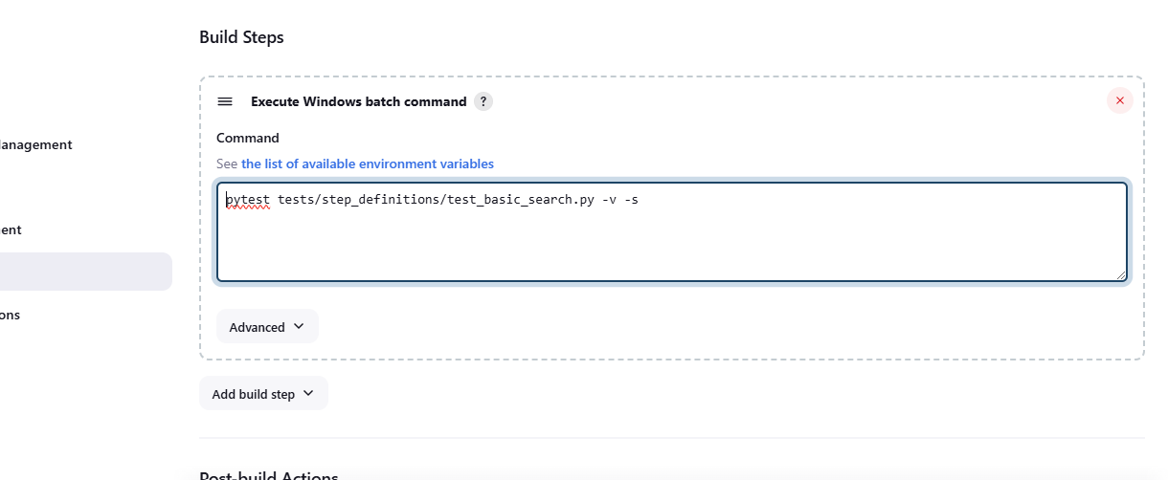

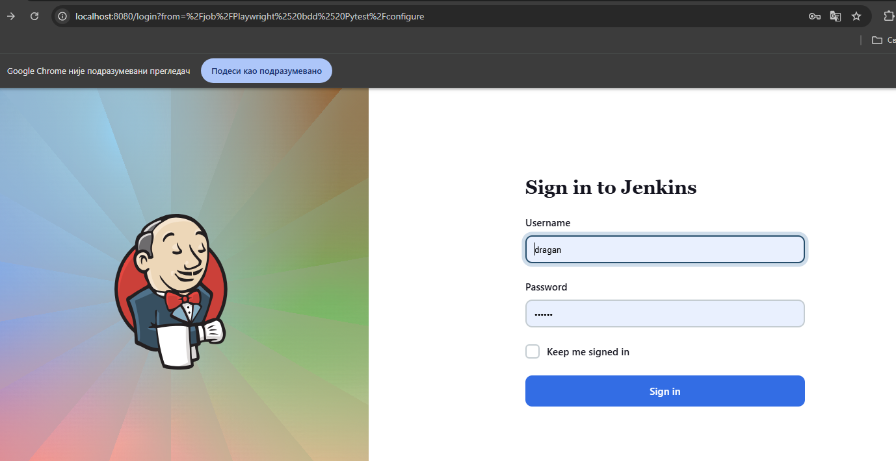

Here is visible pytest results from pytest  
some results of api test with pytest

def test_get_list_of_users():  
 url = "https://reqres.in/api/users"  
 response = requests.get(url)  
 assert response.status_code == 200  
 print(response.json())  
  
  
def test_create_new_user():  
 url = "https://reqres.in/api/users"  
 data = {  
 "name": "Paulo Oliveira",  
 "movies": ["I Love You Man", "Role Models"]  
 }  
 response = requests.post(url, data=data)  
 print(response.json())  
 assert response.status_code == 201

result in Jenkins is

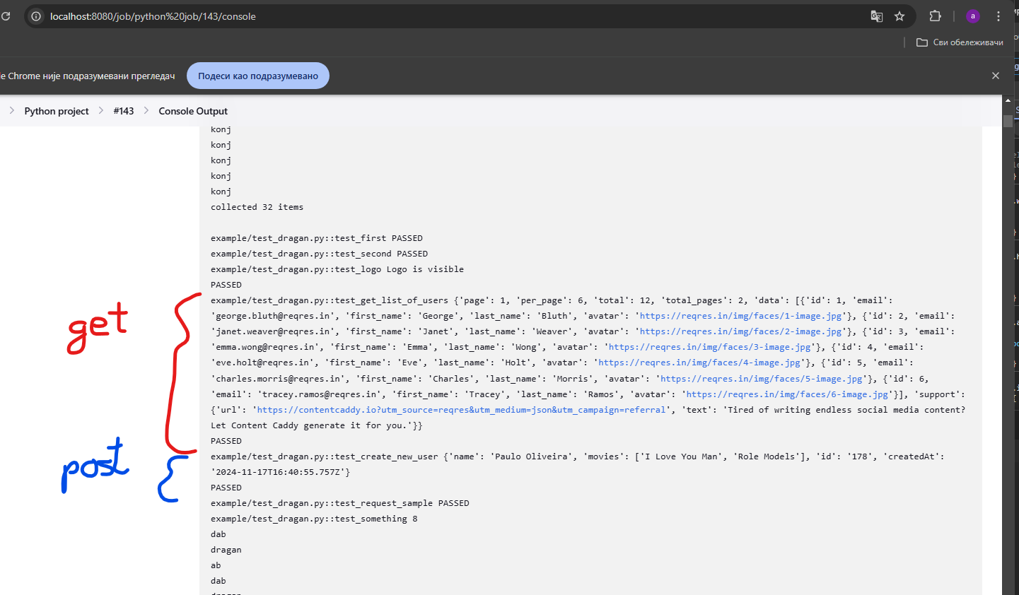

I separated locators in LocatorPage.py

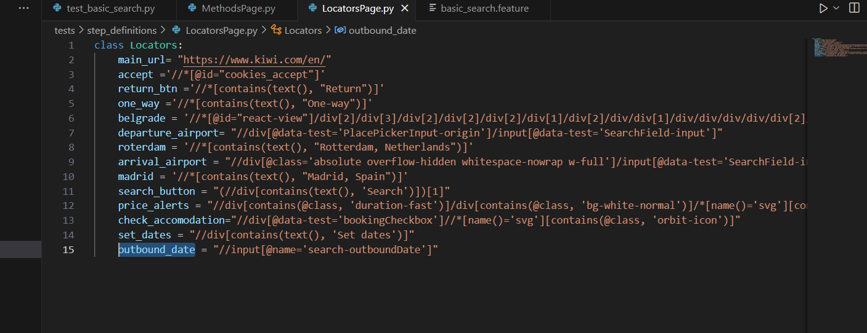

I have feature

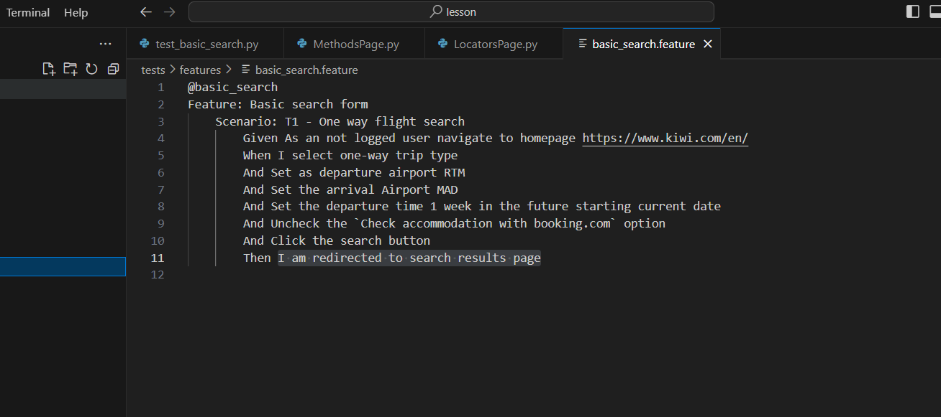

Here is test  
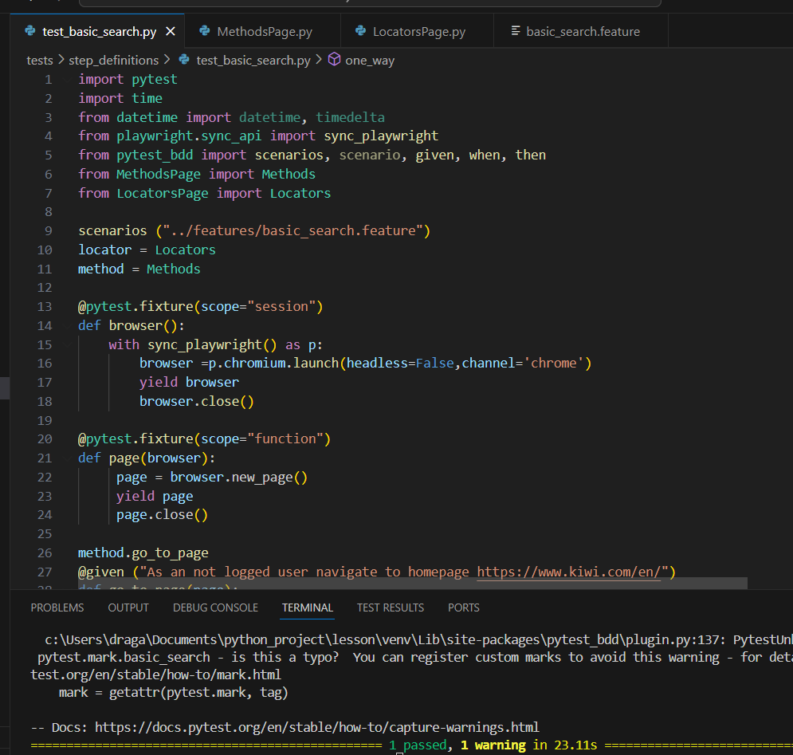

Also here is possible to click Testing and run test  
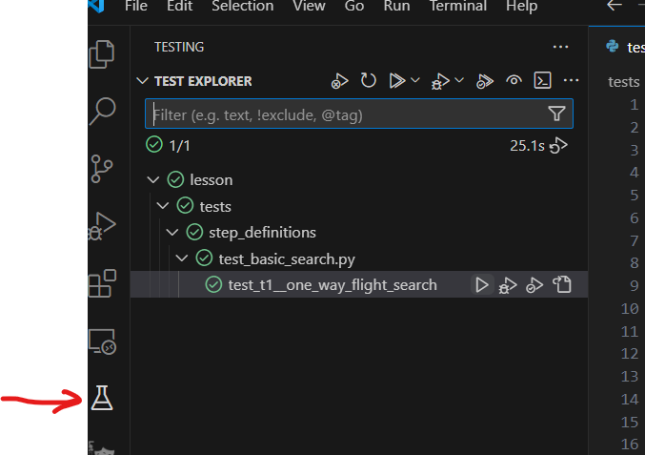

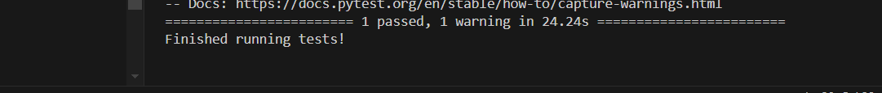

Here is yaml file from pipeline for c# bdd Specflow project on dev Azure. Pipeline is created to start bdd tests on different repository when code is changed. Similar is possible to create pipeline to start pytest tests triggered by pushing changes to repo where is code for web application.

variables:

- name: BuildParameters.solution

  value: '**\*.sln'

- name: BuildParameters.ArtifactName

  value: drop

- name: Dragan.solution

  value: '**/*.sln'

- name: buildConfiguration

  value: 'Release'

- name: buildPlatform

  value: 'Any CPU'

resources:

  pipelines:

  - pipeline: DraganDosen.BDDTesting

    source: DraganDosen.BDDTesting

    trigger:

      branches:

        include:

        - main

trigger:

  branches:

    include:

    - refs/heads/master

name: $(date:yyyyMMdd)$(rev:.r)

jobs:

- job: Job_1

  displayName: Agent job 1

  pool:

    vmImage: windows-latest

  steps:

  - checkout: self

    fetchDepth: 1

  - task: NuGetToolInstaller@0

    displayName: Use NuGet 6.6.1

    inputs:

      versionSpec: 6.6.1

  - task: NuGetCommand@2

    displayName: NuGet restore

    inputs:

      solution: $(BuildParameters.solution)

  - task: VSBuild@1

    displayName: Build solution

    inputs:

      solution: $(BuildParameters.solution)

      msbuildArgs: /p:DeployOnBuild=true /p:WebPublishMethod=Package /p:PackageAsSingleFile=true /p:SkipInvalidConfigurations=true /p:PackageLocation="$(build.artifactstagingdirectory)\\"

      platform: $(BuildPlatform)

      configuration: $(BuildConfiguration)

  - task: VSTest@2

    inputs:

     platform: '$(buildPlatform)'

     configuration: '$(buildConfiguration)'

Also we can create CI/CD with Jenkins and different tools.