For my Distributed Systems project I was asked to make Rest Application and Client. It should send all the HTTP requests (GET PUT POST DELETE). I was asked to build a server application using tomcat that responds to all of the HTTP requests. The client application will parse the response using XMLPullParser and outputs it to the GUI. The data will be taken from the HSQLDB database.

These are a few snippets of my GUI.

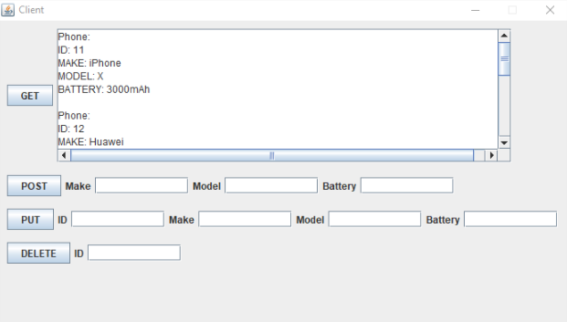

Figure 1: GUI get request

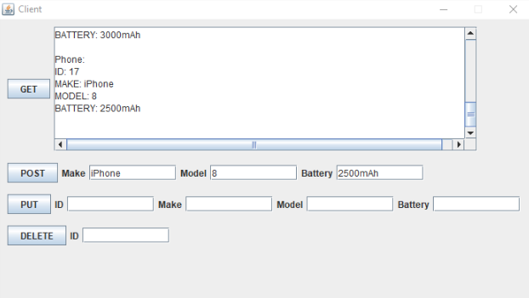

Figure 2: GUI post request

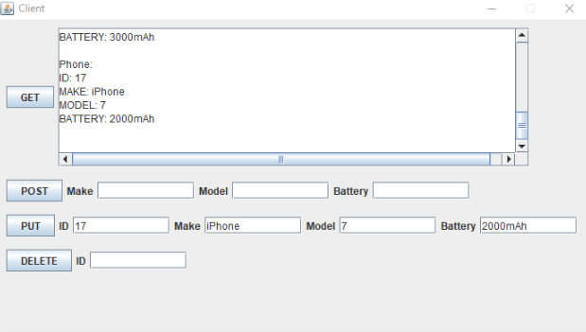

Figure 3: GUI put request on ID 17

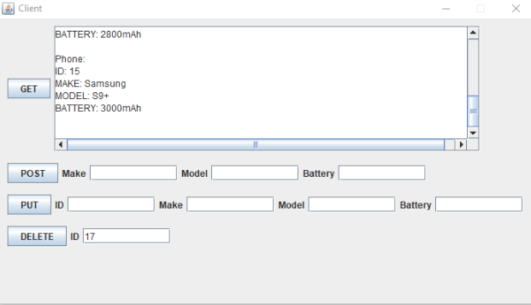

Figure 4: GUI delete request on ID 17

Here I have the HSQLDB script

drop table “public”.”phone”

create table “public”.”phone”

(

id IDENTITY PRIMARY KEY,  
 make varchar(20),  
 model varchar(20),  
 battery varchar(20)

);

INSERT INTO public.phone VALUES (‘1’, ‘Samsung’, ‘S10’, ‘3000mAh’);

INSERT INTO public.phone VALUES(‘2’, ‘iPhone’, ‘X’, ‘2500mAh’);