**Software Dev for Cloud 3**

**Student Name:** Dragana Ruzic

**AIT Student number:** A00230579

**Assignment:** ASP.NET Assignment

**Date of Submission:** 19/10/2017

Description of requirements

We were required to design & build an ASP.NET application using the drag & drop and event driven programming facilities in Visual Studio. I made an application of phones that have ids, a name, operating system, display, camera, memory, battery and price fields. It had 6 buttons: first phone which would show the first phone in the database, last phone which shows the last phone in the database, next phone with shows the next phone in the database, previous phone which shows the previous phone in the database, delete phone which deletes the phone that the user is looking at and add a phone which lets the user add a phone to the database.

This is the web form I have made.

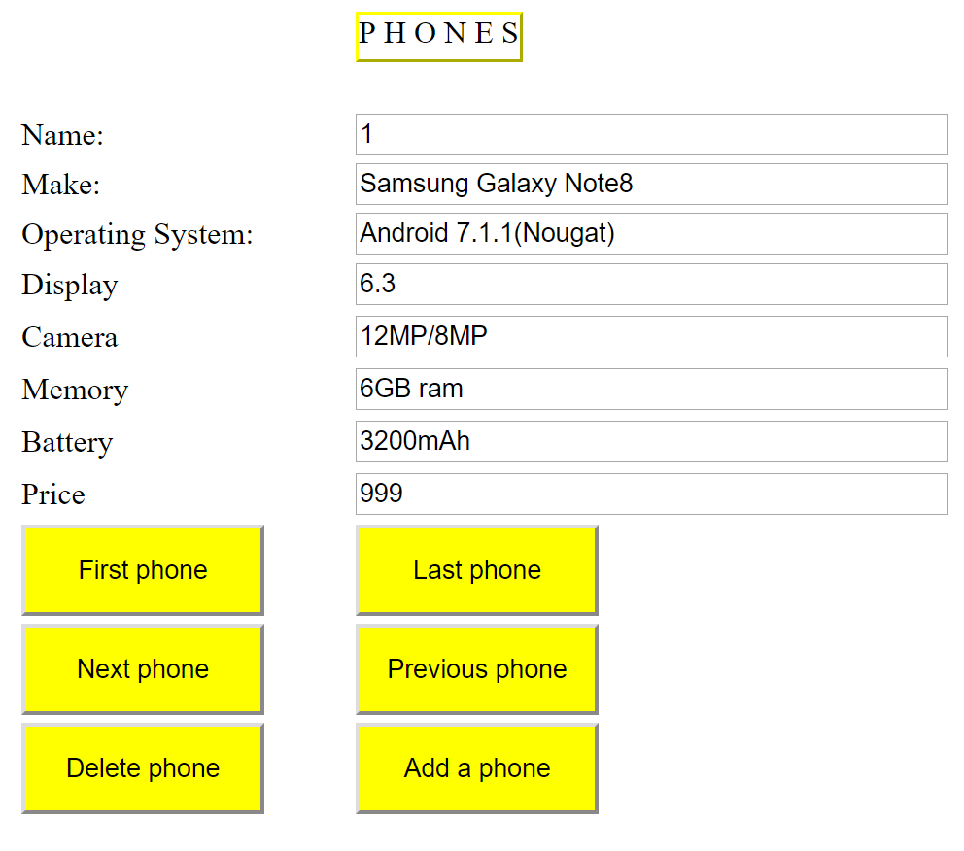

This is an example of the code for the page load. So when the form is opened the page is loaded with the first id of the details in the database. I have my count set to 1 and my max is set to 99 to match the entries in the database.

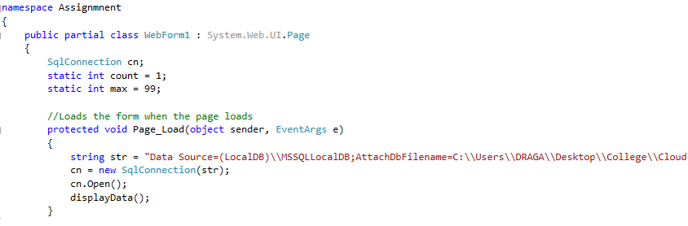

My myCount() function just counts the number of entries in the supplied values in the database.

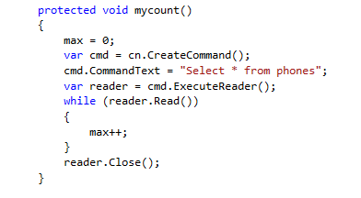

My displayData() function displays all the entries from the database into the text boxes.

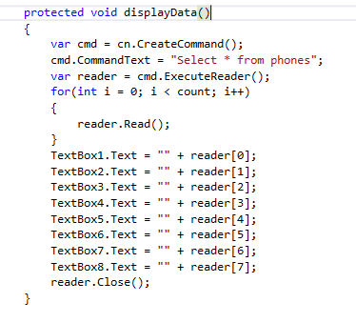

This is the code for the “First phone” button which when clicked goes through the database to find the first phone with the id listed as 1.

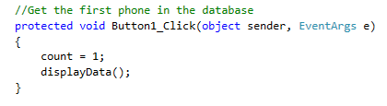

This is the code for the “Last phone” button which when clicked goes through the database to find the last phone with the id listed as 100.

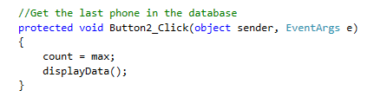

This is the code for the “Next phone” so when this button is clicked, if you are on a phone with id of 1 it will take you to the phone with id 2.

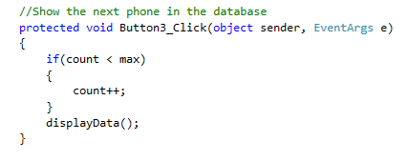

This is the code for the “Previous phone” so when this button is clicked, if you are on a phone with id of 2 it will take you to the phone with id 1.

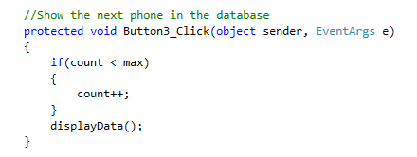

This is the code for the “Delete phone” button. It checks to see which phone the user has in the text boxes and then deletes it by its id. It executes it as a non-query because it’s not showing result it’s just deleting the phone.

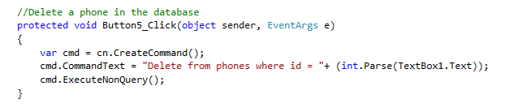

This is the code to add a phone. I needed to convert the int’s into strings and put them into the desired text boxes. The query lets the user add details into the text boxes and then it inserts them into the database.

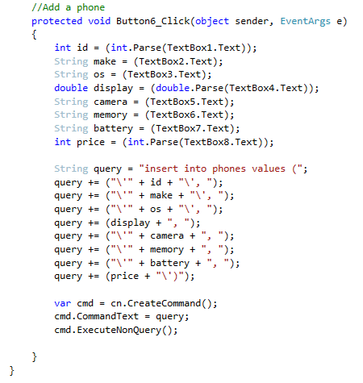

Various problems encountered during development

I kept getting an unhandled error exception when I tried to add new entries into the text boxes. I also had an error with the database where I had to re-run it every time I ran the form again.