# Retail – Errors

1. Form Return doesnt work properly. Filed ***Cash receipt number*** cannot be filled based on receipt number.

Документ.ЧекККМ.Форма.ОформлениеВозвратаДеньВДень

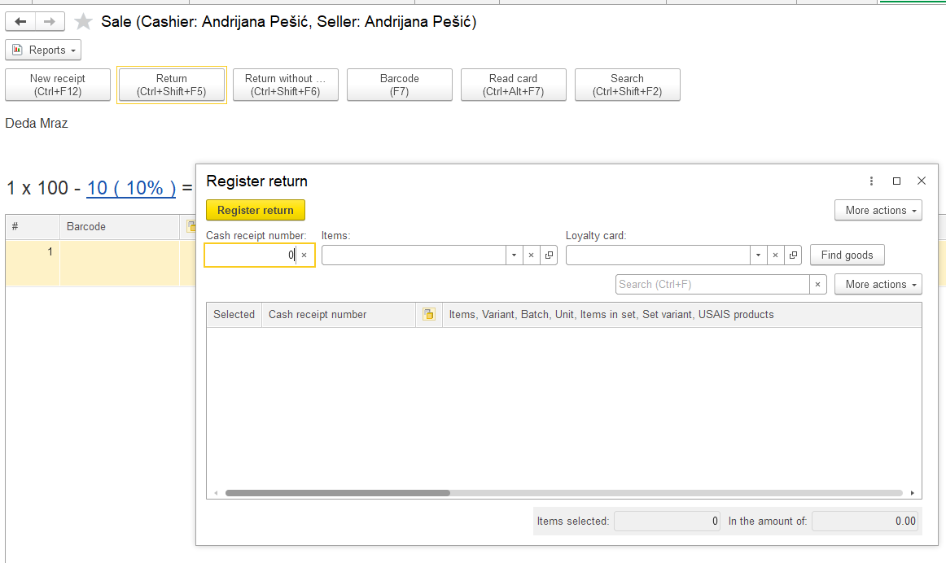

1. After paying receipt in cash, this message error appears.

Документ.ЧекККМ.Форма.ФормаДокументаРМК

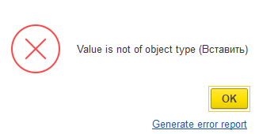

1. All receipts have same status, although they arent deffered without reservation.

ЖурналДокументов.ЧекиККМ.Форма.ФормаСписка

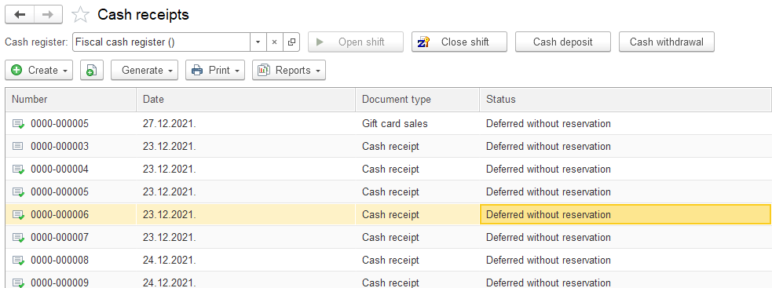

1. After closing shift Retail sales report is generated. This report should show all goods sold, but each tab is empty.

Документ.ОтчетОРозничныхПродажах.Форма.ФормаДокумента

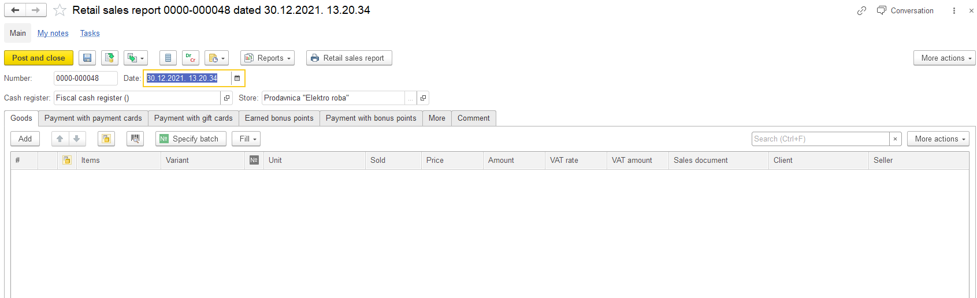

1. When set up authorization for cashier, program shows this message. How to unlock cashier workplace.

Документ.ЧекККМ.Форма.Авторизация

