3/20/2022

Peter Sheehen

0003002(L)

Task 1: Propose an updated design for your original website

Website Design

**Part 1**

**Question 1**

**Questionnaire**

Link with responses: <https://docs.google.com/spreadsheets/d/1vZXki8NMk13yf_YnwVQE4DXT2uq10Cftpmo7h8rbU40/edit?usp=sharing>

Link with form:

<https://forms.gle/yfGDNTQrRj7chWSN7>

**User Personas**

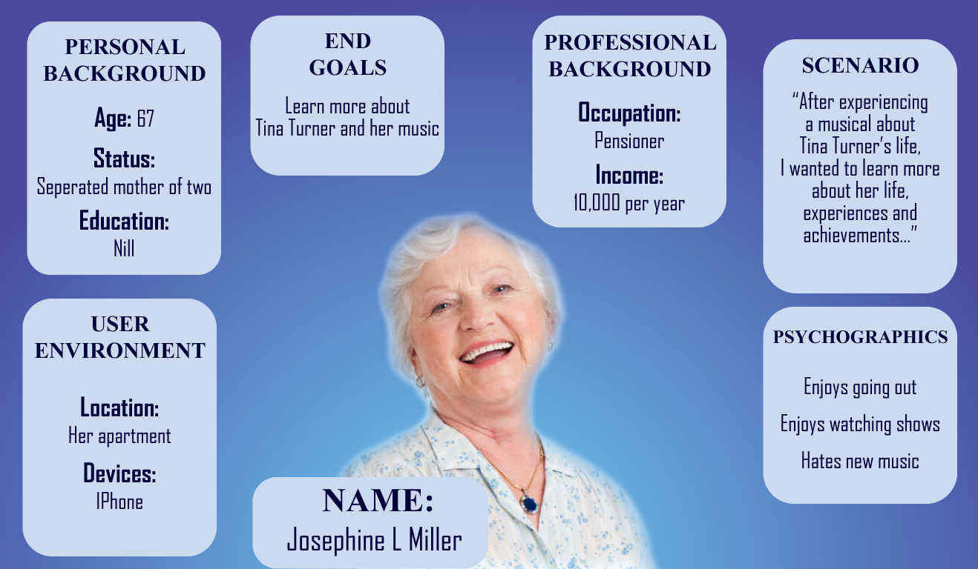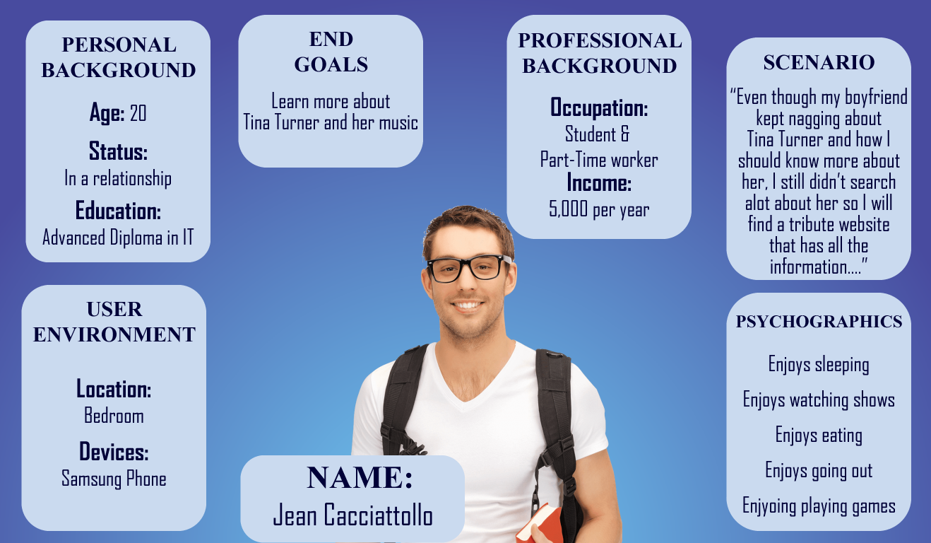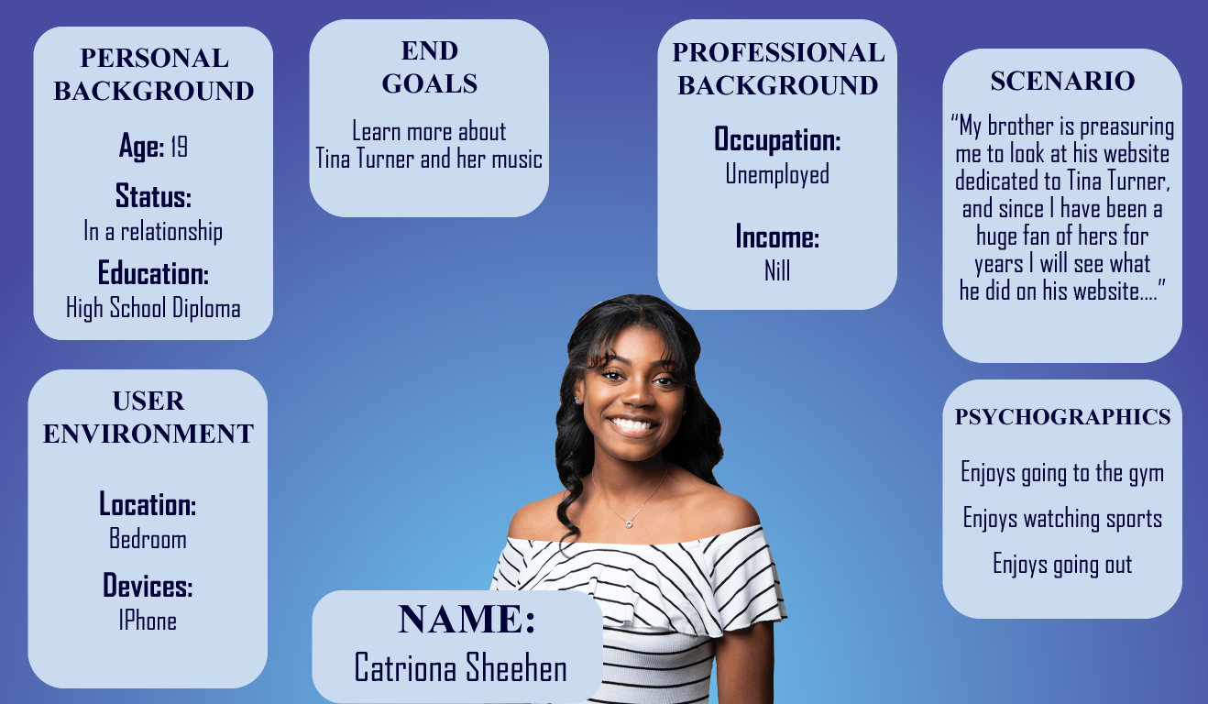

**Question 2**

|  |  |
| --- | --- |
| **Functional** | **Non-Functional** |
| The ability to click on one of her albums and listen to it | Accessibility for people with disabilities |
| The ability to increase the font size to see better | For the website to load quickly |
| Being able to use it on mobile phones without any scaling issues | Having a secure connection as well as a valid certificate |
| Having the option for a text to speech | Having a clear design as to have clear navigation |
| Being able to see past live concerts in the website |  |

**Part 2**

**Question 1**

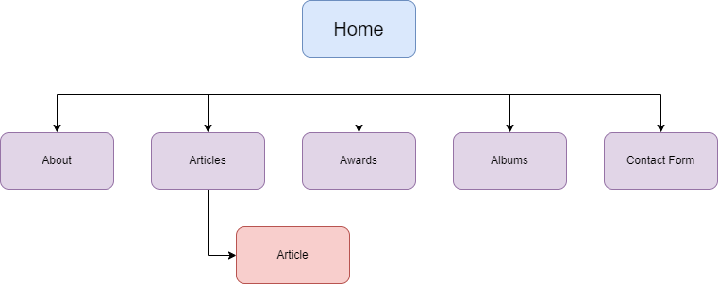

**Question 2**

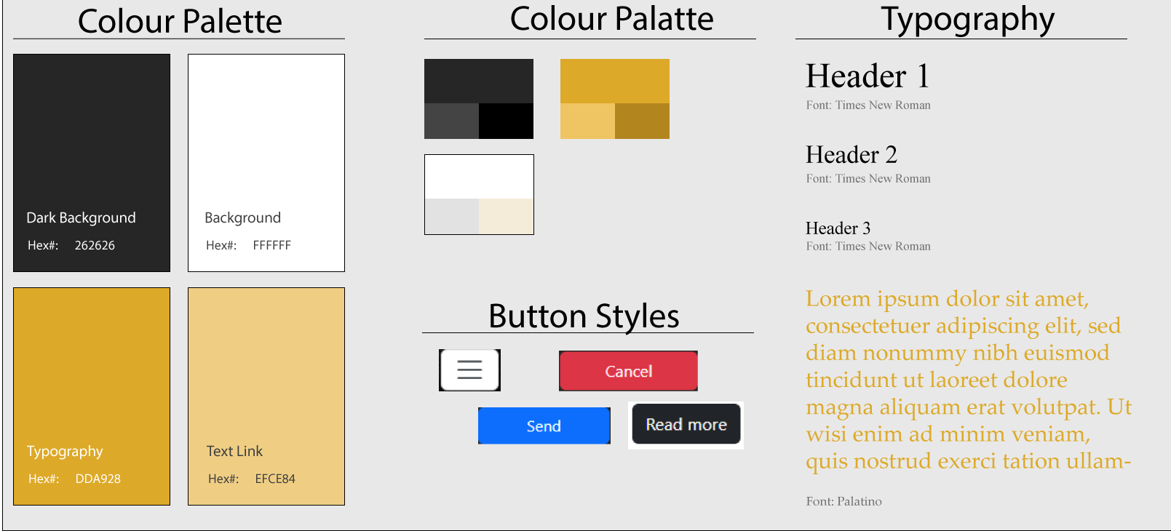

**Question 3**

**a) Low Fidelity Wireframes**

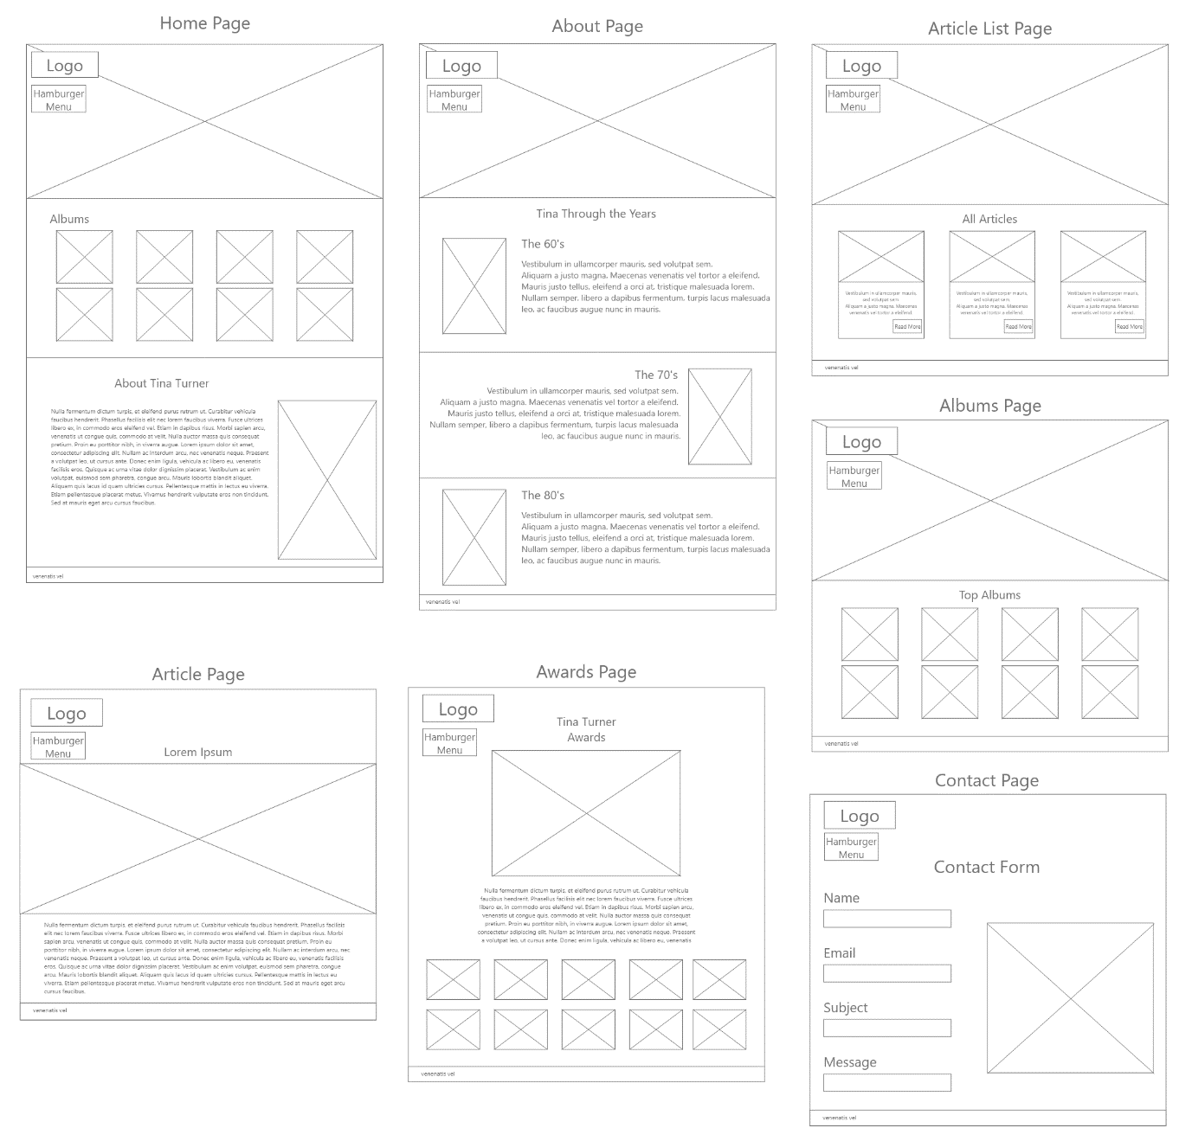

**Part 3**

1. Mention the Authoring Tool you intend to use, including any Extensions/plugins that will be used throughout the development of your website.

* The authoring tool I intend to use is vs code, mainly because it is easy to use and that was the last authoring tool we used in our Website Design unit.
  + **Live Server:** To see the progress of my work by giving me a live view of how my code is outputting.
  + **VS Code Pets:** Something to help me calm down when coding a website would be getting stressful.

1. List any Programming Languages and/or Code Frameworks you will be using and what they will be used for.
   * **HTML:** HTML will be used to create the structure and content for my website.
   * **CSS:** CSS will be used to enhance the visual appearance and layout of the web pages I created with HTML, such as adding background colour, adjust the font elements, as well as some sizes for the images and sections.