**APTECH**



**APTECH URC – APTECH COMPUTER EDUCATION**

**PATRONA PUPPY WEBSITE**

|  |  |  |  |
| --- | --- | --- | --- |
| **Center Name:** | Aptech University Road Center | | |
|  | Address: First Floor, Bell Arcade, Opposite to University of Karachi, Main University Rd, Block 1 Gulistan-e-Johar, Karachi, Karachi City, Sindh | | |
| **Instructor:** | Mr. Shahzaib SheiKh | | |
|  |  | | |
| **Batch:** | 2108-A | | |
| **Group:** | 01 | | |
| **Group members** | **Name** | | **Student ID** | |
|  | Muhammed Kashif Khan | | Student1327884 | |
|  | Muhammed Maaz Ahmed  Naveed Ahmed  Wajiha Sultan | | Student1343020  Student1343857  Student1327818 | |
|  |  | |  | |
| **Project Duration** | Start date | 8th December 2021 | | |
|  | End date | 8th January 2022 | | |

**This is to certify that**

#### **Mr./ Ms.:**

Muhammed Kashif Khan

Muhammed Maaz Ahmed

Naveed Ahmed

Wajiha Sultan

**has successfully designed & developed**

eProject: Patrona Puppy website

**Submitted by:**

Muhammed Kashif Khan

**Date of issue:** December 8th 2021

**Authorized Signature:**

TABLE OF CONTENTS

ACKNOWLEDGE 4

SYNOPSIS 4

PROBLEM DEFINITION 4

CUSTOMER'S REQUIREMENTS SPECIFICATIONS (CRS) 6

CLIENT: Patrona puppy website 6

BUSINESS/PROJECT OBJECTIVE: 6

HARDWARE/ SOFTWARE REQUIREMENTS: 6

SCOPE OF THE WORK (IN BRIEF) 8

ARCHITECTURE AND DESIGN OF THE SYSTEM 9

DIAGRAM OF THE WEBSITE 10

TASK SHEET REVIEW 1 11

SITE MAP 12

MOCK OF THE WEBSITE 13

TASK SHEET REVIEW 2 19

WEBSITE DESCRIPTION 20

JAVASCRIPT DESCRIPTION 34

TASK SHEET REVIEW 3 39

# ACKNOWLEDGE

To have a successful project, it is the continuous effort of many people.

Earliest, we would like to express our appreciation to Aptech university road center and E-Project team for giving us a great environment for studying as well as this pleasant project. This is a huge opportunity for us to explore more knowledge, build up problem solving skills and teamwork spirit.

Inside this great organization, thank for Mr. Shazaib Sheikh – our teacher, with many years’ experience of teaching, along with enthusiasm as well as rigorous in guiding the project, she is the person who helped us complete the subject to catch the schedule can achieve our goal.

Moreover, we are grateful for having the support from our family, they did create the best conditions for us to focus on the project, and put faith in the dreams we are pursuing.

The finally yet importantly, this is the efforts and curiosity of the members in our group. We have focused on starting the project very early, promoting teamwork by sharing experiences and knowledge with each other throughout the project.

# SYNOPSIS

The PATRONA puppy website is a dog’s encyclopedia website. This is the idea of a very Famous Veteran - Ms. Patrona who is fond of animals specially Dogs, Cats, Rabbits. During her serving, along with her successful career, she also had strong passion on writing books on animals and their behavior.

During those years, she had come across various type of breeds, their characteristics and behavior. With the intense interest for photography, she has a huge image gallery of the species she has discovered. Therefore, Ms. Patrona would like to share this collection to all and dog website is the first step in her plan.

This Website on Dog will help people understand more about dogs by showing all the type of dogs that Patrona discovered with more detail about location, their behavior, characteristic, etc.

# PROBLEM DEFINITION

The Web site is to be created based on the following requirements.

1. Homepage: Sharing story about Ms. Patrona website on the top, at the bottom, there is a story how she found out this breeds, her observation, etc. at the end, there is 03 more latest stories for user can choose to read.
2. The website should have a page to show all type of dogs, their characteristics, country, type, etc. It can be filter by user interest such as dog breeds, characteristic, country.
3. When user choose a dog, this dog’s information should be showed out with all detail.
4. The website should have a page to share how to care dogs, training dogs, etc.
5. There are Q&A section that allow user search regular question or asking new question. Filter and form should be used there.
6. The navigation link will be mentioned in all pages, using of Crum navigational link wherever necessary.
7. Images collection will be added in the gallery section of Dog breeds page.
8. Social sticky bar will appear in all pages so that user can share the website or any content they want.

# CUSTOMER'S REQUIREMENTS SPECIFICATIONS (CRS)

## **CLIENT:** Patrona puppy website

## ****BUSINESS/PROJECT OBJECTIVE:****

Ms. Patrona is a Famous Veteran, she would like to have a website to share her collection of dogs that have information about dog breeds, behavior, characteristic, location, etc.

We are requested to create a website with below mentioned requirement specifications.

The website is to be developed for the Windows Platform using HTML5, JavaScript and Geolocation. The site should work well in all leading browsers including Chrome, IE, and Firefox, etc.

**Input to the system:**

* Filter dog with their breeds, location, and characteristic.
* Contact input from user.

**Output from the system:**

* Displaying result of dogs that the user is filter, including images of dogs, its breeds, it can link to detail page of this dog. The detail page has full information about this dog and can go back filtered dog breeds main page.

**Process:**

* Create content for the website.
* Creating filter, data for dog breeds page.
* Validate data input from users.

**Expected delivery date:** 8 January 2022

**List of deliverables:**

* Document Word.
* User Guide.
* Source code.

## HARDWARE/ SOFTWARE REQUIREMENTS:

**For webmaster**

##### **Hardware**

* Intel Pentium 4 processor or higher
* 1 Gigabytes of RAM or higher

##### **Software**

* Windows 7 OS or higher
* Visual Studio
* Web browsers such as Chrome or Firefox that is supported by HTML5, CSS3 and JavaScript are recommended.

#### **For web users**

##### **Hardware**

* Intel Pentium 4 processor or higher
* 512 Megabytes of RAM or higher

##### **Software**

* Windows XP OS or higher
* Web browsers such as Chrome or Firefox that is supported by HTML5, CSS3 and JavaScript are recommended.

# SCOPE OF THE WORK (IN BRIEF)

After a long and detailed discussion, our group has decided to create a website contain the following webpages:

* Homepage: Showing story about Ms. Patrona website, reason she decides to create the website, her passion and story. Random showing a story path in homepage and show 03 latest stories at the bottom.
* Dog Breeds: Display all dogs of the website. Allow user to filter by dog breeds, location, and characteristic. In this website, we limit it at 36 dog breeds. It also has filter by location, characteristic, color and size. When user click on a dog, it can show all information about this dog such as breed, characteristic, location, image, etc.
* Puppy’s care: Providing article about caring dogs, dogs nutrition, etc. Many topics of tips and many article inside each topic.
* FAQ: Giving user many common Q&A to take care their dog.
* Contact: Display the address of the company, allow user to send any information they want to Patrona’s website. Allow user to give Patrona puppy a message.

# ARCHITECTURE AND DESIGN OF THE SYSTEM

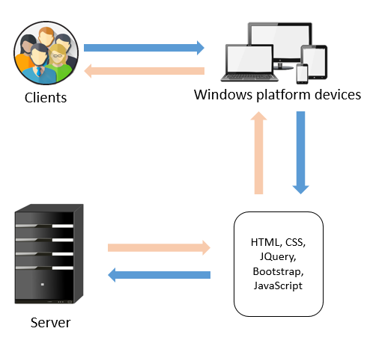

# DIAGRAM OF THE WEBSITE

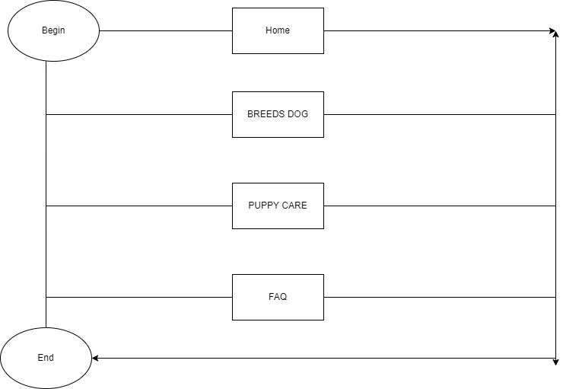

# TASK SHEET REVIEW 1

|  |  |  |  |  |  |  |  |
| --- | --- | --- | --- | --- | --- | --- | --- |
| **Project Ref. No.: eP/Advertisement Portal Management System/01** | | **Project Name** | **Activity Plan Prepared By** | **Date of Preparation of Activity Plan:** | | | |
| **Sr./No.** | **Task** | **Actual Start Date** | **Actual Days** | **Team member name** | **Status** |
| 1 | Problem statement | Patrona puppy website | Kashif | 15-Dec-21 | 1 | Kashif | Completed |
| 2 | Analysis Patrona puppy website’s requirement | 15- Dec-21 | 1 | Kashif | Completed |
| 3 | The scope of the work (in brief) | 15- Dec-21 | 1 | Maaz | Completed |
| 4 | Architecture and design of the system | 16- Dec-21 | 2 | Maaz | Completed |
| 5 | Diagram of the website | 16- Dec-21 | 2 | Naveed | Completed |
| 6 | Task Sheet | 16- Dec-21 | 2 | Wajiha | Completed |

|  |  |
| --- | --- |
| **Date:** | |
| Signature of Instructor:  **Mr. Shazaib Sheikh** | Signature of Team Leader:  **Muhammed Kashif Khan** |

TASK SHEET REVIEW 2

|  |  |  |  |  |  |  |  |
| --- | --- | --- | --- | --- | --- | --- | --- |
| **Project Ref. No.: eP/Advertisement Portal Management System/01** | | **Project Name** | **Activity Plan Prepared By** | **Date of Preparation of Activity Plan:** | | | |
| **Sr./No.** | **Task** | **Actual Start Date** | **Actual Days** | **Team member name** | **Status** |
| 1 | Site map | Patrona puppy website | Kashif | 17-Dec-20 | 1 | Maaz | Completed |
| 2 | Mock of website | 18- Dec-20 | 2 | Naveed | Completed |
| 3 | Task Sheet | 18- Dec-20 | 2 | Wajiha | Completed |

|  |  |
| --- | --- |
| **Date:** | |
| Signature of Instructor:  **Mr. Shazaib Sheikh** | Signature of Team Leader:  **Muhammed Kashif Khan** |

# WEBSITE DESCRIPTION

1. HOMEPAGE
   1. Description

This webpage displays following information: Patrona puppy introduction, latest information.

* 1. Screenshot

|  |  |
| --- | --- |
|  | ` |

1. DOG BREEDS
   1. Description

This page will show all type of dog breeds, user can search by color, character, location, size. Moreover, user can click more on See more to have more detail about a typical dog.

* 1. Screenshot

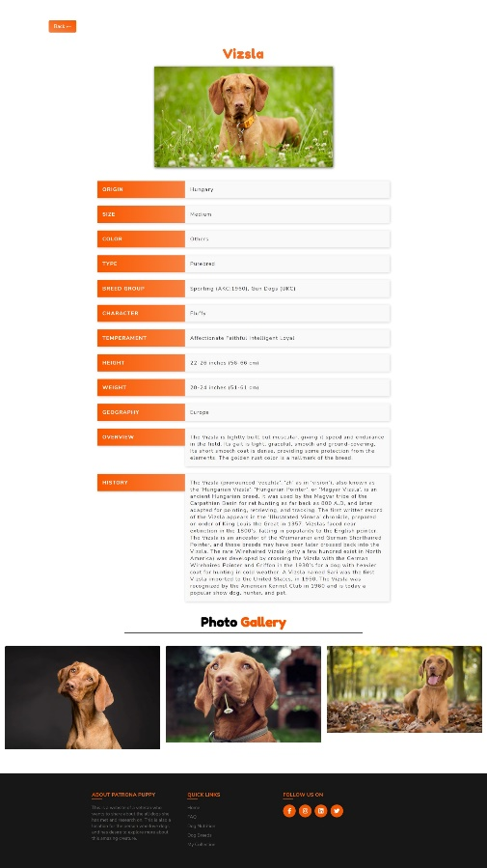

|  |  |
| --- | --- |
|  |  |

1. PUPPY CARE
   1. Description

This page will show many tips to care about the puppy, user can click more on See more to have more detail about a tips.

* 1. Screenshot

|  |  |
| --- | --- |
|  |  |
| First display of Dog Breeds page | |
|  |  |
| Main tips for user choose | Detail of each tip |

1. FQA
   1. Description

This page will show regular questions and answers about dogs.

* 1. Screenshot

|  |  |
| --- | --- |
|  |  |

# TASK SHEET REVIEW 3

|  |  |  |  |  |  |  |  |
| --- | --- | --- | --- | --- | --- | --- | --- |
| **Project Ref. No.: eP/Advertisement Portal Management System/01** | | **Project Name** | **Activity Plan Prepared By** | **Date of Preparation of Activity Plan:** | | | |
| **Sr./No.** | **Task** | **Actual Start Date** | **Actual Days** | **Team member name** | **Status** |
| 1 | Homepage | Patrona puppy website | Kashif | 8-Dec-21 | 2 | Kashif | Completed |
| 2 | Dog Breeds | 9- Dec -21 | 5 | Kashif | Completed |
| 3 | Puppy care | 15- Dec-21 | 2 | Kashif/ Maaz | Completed |
| 4 | FQA | 15- Dec-21 | 2 | Kashif/ Maaz | Completed |
| 5 | Contact | 18- Dec-21 | 2 | Kashif/ Maaz | Completed |
| 7 | JavaScript | 22- Dec-21 | 5 | Wajiha | Completed |
| 8 | User guider | 26- Dec-21 | 2 | Wajiha | Completed |
| 9 | Read me | 6-Jan-22 | 1 | Naveed | Completed |

|  |  |
| --- | --- |
| **Date:** | |
| Signature of Instructor:  **Mr. Shazaib Sheikh** | Signature of Team Leader:  **Muhammed Kashif Khan** |