# Multiple Linear Regression. In-class Exercise 4

EL-GY 6143 Intro Machine Learning. Prof. Sundeep Rangan

## Question

Complete the following cells in demo1_glucose.ipynb

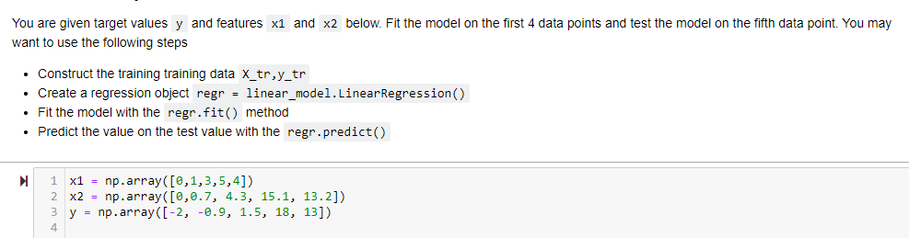

## Solution

