# Linear Classification Logistic Regression. In-class Exercise 2 Solution

EL-GY 6143 Intro Machine Learning. Prof. Sundeep Rangan

## Question

We are given the following six data points with binary labels $y_{i}∈\{0,1\}$.

|  |  |  |  |
| --- | --- | --- | --- |
| $$i$$ | $$x_{i1}$$ | $$x_{i2}$$ | $$y$$ |
| 1 | 1 | 1 | 0 |
| 2 | 1 | 3 | 0 |
| 3 | 2 | 2 | 1 |
| 4 | 2 | 3 | 1 |
| 5 | 3 | 2 | 0 |
| 6 | 4 | 1 | 1 |

1. Draw the points on a graph with different labels for each class
2. Is the data linearly separable?
3. Write a classifier for the data that makes a minimum number of errors. You must write a mathematical function describing the classifier output $\hat{y}$ in terms of $x_{1}$ and $x_{2}$. Do not just draw the boundary.
4. Write a short python function that performs the classification on a data matrix. It should output a vector of classification decisions, one for each sample.

## *Solution*

1. 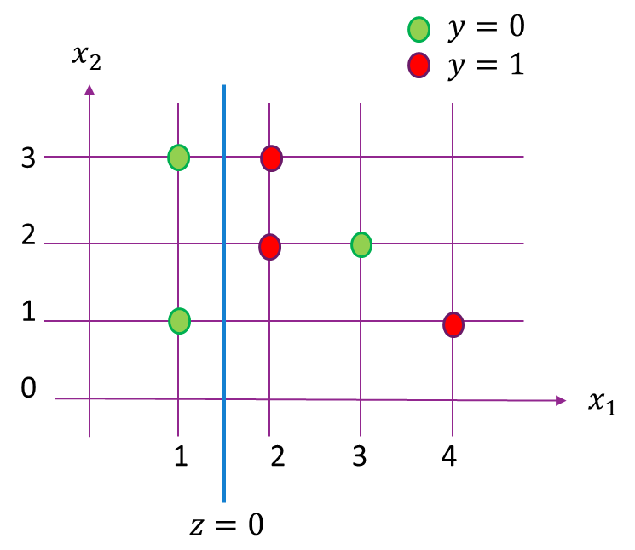The points can be graphed as on the left
2. Data is not linearly separable
3. One possible classifier is: $$\hat{y}=\left\{\begin{matrix}1 & z>0 \\ 0 & z≤0\end{matrix}\right., z=-x_{1}+1.5$$

The boundary ( $z=0)$ is shown on the graph

1. One simple python code could be as follows. Note that you need to convert from Boolean to integer.

