w DeepSeek w ChatGPT-4o mw Method of Each Title

GPT-4



14

13

5

38

12 4

2

MBFL*Ochiai*

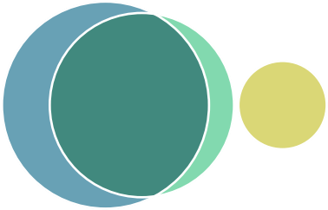

25 52 9 14

SBFL*Ochiai*

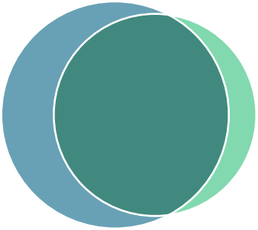

25 52 9 

GLM4

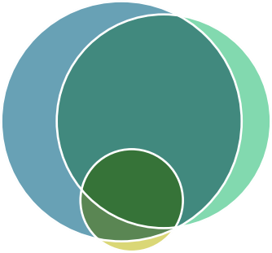22

42

9

10

3

1

MBFL*Dstar*

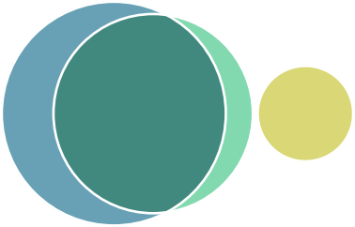

25 52 9 14

SBFL*Dstar*

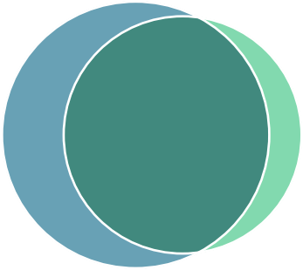

25 52 9 

LLama3



18

17

7

34

8 2 1

MBFL*Op*2

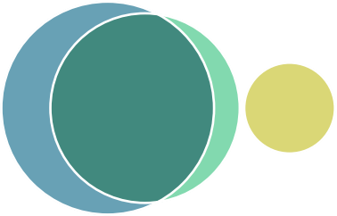

25 52 9 14

SBFL*Op*2

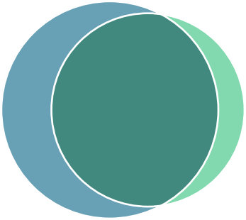

25 52 9 