The Archipelago
written by DragonCoder
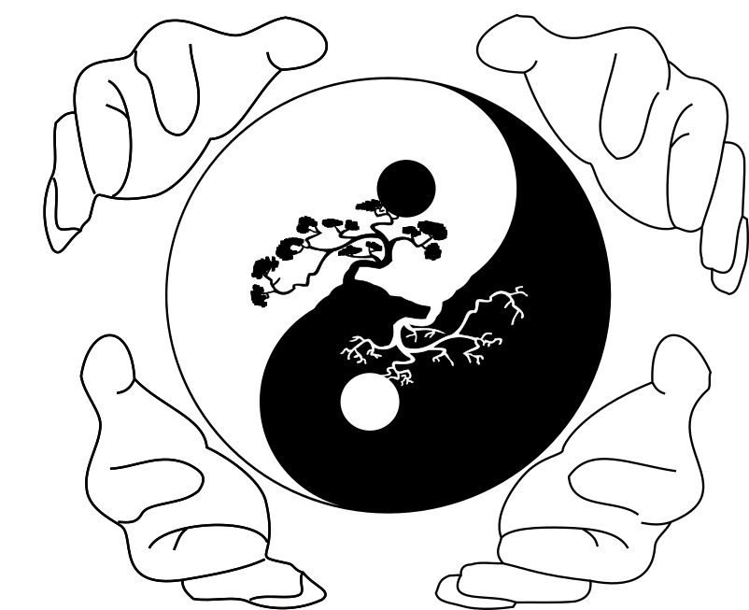
Contents
- Motivation
- Character
- Monster
- NPC
- Story
- Maps
- Systems
  - Start game
  - Make me self
  - Temple
  - Hazard games
    - Cup
    - Rokuyō

Sugoroku
    - Go

Shichi Narabe

Hanafuda
  - Offline system
  - Network system
  - Pets
  - Dungeon
  - Flower
  - Fishing
  - Ore
  - Shop
  - Quest
  - Events
    - New Year
    - National Foundation Day
    - Obon (swieto zmarlych, specjalny mistyczny boss)
    - Nanakusa no sekku (uczta 7 ziol)
    - Kiku no sekku (swieto chryzantema)
    - Plum Blossom (kwitniecie wisni)
    - Asama Onsen Taimatsu Matsuri (festiwal ognia)
    - Umi no Hi (Dzien Morza)
  - Item
    - Amulets
    - Equipment
    - Quest
    - Drop
    - Special
    - Flower
  - Chat
    - Global
    - Private
    - Translator
    - Scanner
    - Voice
  - Skills
    - Passive
    - Character
  - Mount system
  - Range
  - PvM
    - Mobs
    - Boss
    - Legendary boss
  - PvP
    - 1 vs 1
    - Couple
    - 5 vs 5
    - Temple
    - all vs all
    - Best of
      - Class
      - User
      - Temple
- Security
- Hardware
- Extra software
- Languages
- Community
Motivation
The idea for writing a game came in to my head 2 years ago. I searched a game which was interesting, have a nice story, but where is too a PvP motive. I didn’t find any interesting, then I thought, why not make your own game. I knew, that it not so easy, but I wanted try to do that. First time I have written a easy text game in a console, but I wanted more. I wanted write a game, game on a new level, which no body made, something new in gamedev and I think, that Archipelago can be so one game, when all system will be implemented. Archipelago should be a new generation game, which have not only elements of normal Role Playing Game, but too elements of multiplayer.
Character
In the game will be 5 characters, but with the time the number of characters will be possible higher. I decided to make a premium character, which someone can get, who won a game, took part in game development or something like this. The most important thing is, that all character will be balanced and not any one character will be stronger then another by maximal level and maximal equipment. We will try to balance the characters on all level, but it will really hard to do. The premium character will can be created only one time by using a special code, and this character will have extra missions, but they won’t change any thing in balance or bonus, which the character get. All characters are a japan mythological characters.

- Hachiman
According the legends Hachiman is a god with a big impetus and desire to fight. Nevertheless his inconspicuous look, he have a really powerful, which make him a dangerous opponent. Hachiman won in his life with a lot of opponents, which showed him their techniques. Much of them told, that he can use 4 elements and only handful of fighter are so powerful, that they can fight with him.

- Jimmu
Powerful fighter and conqueror of many lands. A great great great grandchild of Amaterasu, Goddess of Sun. She created for him the magic HingTai Sword, which makes him a powerful fighter. Jimmu is the last fighter, who can speak with Ardu, 3 legs raven.

- Senninowie
His story is not really known, some stories tell, that Senninowie was born in the ancient defense temple and thus he get a superhuman skills, which made him a powerful fighter and “immortal”.

- Susanno
The son of Izanagi, who was born, when she washed her nose after escaping from the Land of Darkness. Susanno is a powerful fighter, which power and cleverness overgrow a normal fighter. Susanno care out perfectly skills, which he was getting, when he was born. During a hard training he was being a master of wind and storm.

- Tsukuyomi
The fighter , who was born from a right eye of Izanangi. Tsukuyomi got the power of the moon and can control flows and outflows. The legend said, that Tsukuyomi killed the Ukemochi.rbeit benötigen Sie einen Gesundheitsausweis.
Mizuchi – water – blue dragon, which is very dangerous, he is placer on a isle, which is between 4 isles
Abumi-guchi – a furry creature formed from a stirrup of a military commander
Abura-bo – a fiery apparition from Shiga preferecture, which takes on the character of a monk
Abura-sumashi – a ghost who lives in a pass in Kumamoto prefecture
Akamataa – snake ghsot from Okinawa
Akashita – a creature who floats on the black cloud
Akateko – red hand dangling from a tree and throwing a gifted crutches
Akkorokamui – is a gigantic octopus, whiich supposedly lurks in Funka Bay in Hokkaido, his body can be to 320m big. //umiejscowienie w mokradlach, tzn mapa deba mokradla
Akuma – bad ghost
Akurojin-no-hi – spooky fire from the preferecture of Mie
Aotabo – blue monk, which kidnaps children
Ao-nyobo – woman ghost, which lurks in abandoned imperial palace
Asobibi – burning creature from Kochi prefecture
Arikura-no-baba – old woman with a magic skills
Azukiarai – a ghost who produces washed azuki beans
Ayakashi-no-ayashibi – burning creature from Ishikawa prefecture
Bake-kujira – a spooky skeleton of a whale that drifts along the coast
Basan – a large fire-breathing chicken
Byakko – white tiger west
Daidarabotchi – The evil giant responsible for creatinf terribke and at the same time beautiful terrain of Japan
Daitengu – strongest of the Tengu (boss, mystic bird from the heat)
Enenra – monster created from smoke
Eritate-goromo – tengu magics in clothes of Sojobo
Gotokuneko – cat yaoki, who breathes fire from cut bamboo
Hainu –cruel winged dog
Harionago – monster woman with the deadly spiked hair
Heike-gani – crab with a human face, ghosts of warriors from the battle of Dan-no-ura
Hibagon – Japan big foot
Hihi – monster baboon
Hinoenma – monster who takes the form of a sexy woman and seduces men (lyrics)
Hō-ō − legendary Chinese Fenghuang bird.
Ikuchi – sea vases
Isonade – sea monster with a tail covered with spikes
Itsumaden – monstrous bird, who was to see in Tiheiki
Kamaitachi – weasel with big and spicy claws
Kibagurui – nasty creature with sharp keys
Kijmunaa – tree ghost from Okinawa
Kijo – witcher and ogre
Kiyohime – a woman who turned into a snake-demon because of an unrequited love
Kyubi-no-kitsune – fox with nine tails
Kanashimi – demon who wears a mask that shows emotions lives on the top of Hiei zan
Kurage-no-hinotama – jellyfish that floats in the air like a ball of fire
Mukujara – a massive creature without face covered with hair
Nekomata – cat with a split tail
Netchku – silber, demon owl
Ningyo – Japan siren
Nowake-baba – old witches, who can attack with a hard gusts of wind
Nozuchi – species of snake inhabiting the mountains in the Japanese Archipelago
Nue – monster with a head of monkey, body of asian raccoon, legs of tiger and tail of snake
Nukekubi – monster whose breaks away from the body
Nure-onna – vase woman who appears on the bank
Ökami – creature who look like a wolf
Oni – classic japan demon who look like ogre
Onibaba - witches
onibi – fire creature
Onikuma - monstrous bear
Raijü – creature who fall on the earth in form of lightning
Ryü – japan dragon
Seiryü – azure eastern dragon
Shikome – wild woman
Shinigami – God of Death, Japanese Grim Reaper
Shiro-bozu – white ghost without face
Shiryo – ghost of a deceased person
Shishi – lion-dog, who guards the entrance to temple
Skoki – legendary demon Zhong Kui
Son Goku – king of monkeys
Suzaku – scarlet bird of the south
Taimatsumaru – tengu surrounded by fire demons [Tengu = clever demon bird]
Tamamo-no-Mae – bad nine tail fox
Tanuki – a shoeless raccoon dog
Tennin – blue creature
Tesso – The spirit of priest Raigo, who turned into a swarm of rats
Tschigumo - big spider
Tsuchinoko – legendary vase
Yamaarashi - porcupine
Yma-chichi – ghost of the mountain reminiscents monkey
Yamata no Orochi – eight-headed monster
Yama-uba – mountain witches
Yuki-onna – snow woman
Zanki – lightning demon
Zennyo Ryuo – dragon godess of rain

Yosei - fairy

Umizatou – Blind who came out of the sea and sought out travelers and for the worst fears

Sogenb – monk ghost who steals oil

Sansei – king of mountain animals //find the losted animals //buy animals

Shöjö – red hair of sea who loves alcoohol. Mission with fishes

Inugami – dog manger

Kameosa – a bottle that never dries

Kirin – a unicorn with two horns

Komainu − pair of lion-dog guarding the entrance of the temples

Numagozen – the ghost of a woman from the lake, who lost her husband in battle

Rajin – God of Ligtning //skill npc

Story
The story will be written with help of japan legends and the religion. I think, that all elements will start with 2 of most important Gods in japan religion. I think too of a mix of a japan and Chinese religion.
Map
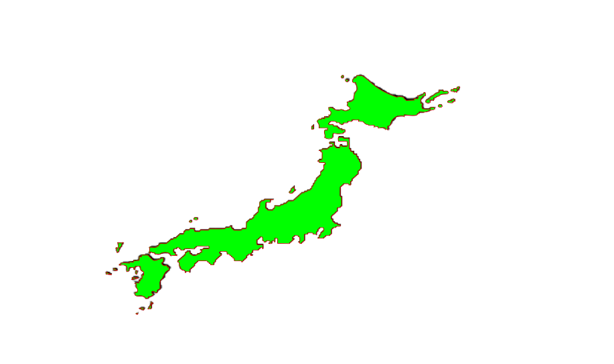
For the game I wanna use the today’s map of Japan. I think, that it will be 3 main cities, this mean 3 isles Japan or it will be only a one nation, but it can be a bad idea, because of rivalry. Japan is dream country, which have many isles and this geographical ascendancy makes Japan a excellent part of game. I wanna use more then 20 isles, which will be exp-places, cities, dungeon isle, temple isle. All exp places will be level-maps, this mean, that the character needs minimal level, but not only. I wanna make a special places, for example exp places, where only character with x killed monster can go in, but the condition can be any.

List of places and meaning of their:

Island of birth – is the start point of the game. All player will start here and then,
Dungeon Island – all NPC for the dungeon will be placed on the map
Temple Island – on this map will be places all temples. I think will be something like a circle and the player will teleport to the center
Land of Darkness – Exp place
Sikoku – one of the main prefecture
Hokkaido - prefecture
Kiusiu - prefecture
Island of fire - Exp place
Island of storm - Exp place
Island of wind - Exp place
Island of water - Exp place
Rough hills - Exp place
Monkey grove - Exp place
Wild prefecture - Exp place

Systems
  - Start game
The player will start the game on a special map in a random place. On the will be wooden boxes and one payer will can open only one box. After opening the box, player will choose his prefecture, where he/she would like to play. In the boxes will be a start equipment like a sword/staff/shoes/potions/armor
  - Make me self
I think, that it will be one of most important and hardest to implementation system. This system should give the player possibility to write his own mission, own part of the game story and help by develop the game. In the first version of the system, someone will need to check, if the mission will be compatible with the game story. In the later version I want, that the app produce not only text which will be send to us, but too the code, which can be directly implemented, if it will be possible then I will try to write the code, which will automatically write the code in the file with all another missions.
  - Temple
Temple system should make the game most interesting and should help to get a new contacts. The template system is too a system of dungeon system, PVP system this means, that the system will be a really big system. The player will can not only get level of the temple, but too a special skills, which get only user which will be in the temple, build buildings, create a NPC for ore, flowers, fishes and another one. With the temple NPC is a another story this mean, it will be 2 ways. First one: the player will sell his items for the npc ad get money, but the items will get destroy (server buys the items) and the another one, when the temple active the buy of items, and the player can sell his items and all will be paid from temple bank and then will be stored in the temple warehouse.
  - Hazard games
Hazard game system should be a system for player, this mean that the player can play with each other and make the game a little interesting. I think it will be a good distraction of a “normal” play day. It should be too possible to play with the server, but for the game algorithms I will use min-max algorithm, that the player never can win. I think a good idea will be a tax for a play.
  - Offline system
Possibility for player to offline game, but the changes will be only saved in a file, but not on the server/database.
  - Network system
Online mode of the game with possibility to play in a same network.
  - Pets
The player will get on the start a one pet, which will too get a level and skills, which be boost for the player. On the another side, it will be possibility to get a another pet, this mean, that the player can get 2 pets. The another pets will give a extra bonus and will be non exp pet.
  - Dungeon
Dungeons will be a part of the item system, pvm system, exp system, temple system. A few of item, which the player will need for games, can be only getting by the dungeons. For the temple will be a special dungeon system, where the temple will can get a items for build any build and upgrade for their NPC’s.
  - Flower
Flower system should be a part of crafting system, but too of the mission system. The flowers will be on all of maps, and the players will need to collect their. I think the best idea is, when the player get a sickle, which can be too updated and of maximal level give x% to successful getting of a flower. Potions crafting.

  - Ore
Ore system is the same system like flower system, but on the place flower come ore and on the place of sickle come pick. The ore will be needed for items upgrade, temple upgrade and for a crystal for a jewelry, which will give a boost for items.
  - Fishing
Fishing system is the same system like flower system, but on the place flower come fishes and on the place of sickle come fishing pole. The ore will be needed for temple upgrade and as a boost items.
  - Shop
Shops are part of economy, this mean, that the trade should be possibly 24h/7. To make it possibly must be written a offline shops system, that the player can open his shop and go out or do every thing, what he/she/it want.
  - Quest
Quests should be a addition or part of the game story. The user need to read the quest, if he want the all game story to know. Really important is,that the player can only one time read the quest and then he need know, what he should do. Quest are too important for a knowledge event.
  - Events
For all event should be a new look of maps, event maps, event items but too a event dungeons or maybe event games. Most of them will be a religion events.
  - Item
    - Amulets
    - Equipment
    - Quest
    - Drop
    - Special
    - Flower
  - Chat
    - Global
Global chat will be a chat, which can read all player and they can too communicate there and sell their items and another.
    - Private
Private chat between player, which should be a normal chat, which we know from a daily life.
    - Translator
Translator should be a extra option for player, which can’t speak another languages. By writing the massage, the will need to choose a languages and the massage will be translated on the server and later sent to another player.
    - Scanner
The game can be more than just a form of entertainment. I want to write a scanner which will scan the chats ad search any message of hatred and the player s will get ban.
    - Voice message
  - Skills
    - Passive
Passive skills will be all skills, which the player can only get by: killing the monster, fishing, digging ore, killing another player etc. When getting the right number of points, the skill will be increased by another point.
    - Character
All character will have his own skills, some skills will a boost skill and another one as attacker skills

  - Mount system
In the game will be a mount system. All player can get a horse skills, this mean, that the player need to make a mission and than he get a horse. The horse have too a level and as bigger the level is, then bigger the damage by hits on the horse is. If the player get a 10 level of horse, than he can use a special mounts with special bonuses. All of the mounts can get the player from a legendary bosses, events etc.
  - Range
Range system can be too named by bonus system. The players will get a range point by every mission, killing mobs, killing of player etc. and the point level determine a range name and bonuses.
  - PvM
Player vs Mobs, player need to kill monster to get a experience point.
  - PvP
    - 1 vs 1
    - Couple
    - 5 vs 5
    - Temple vs temple
    - all vs all
    - Best of
      - Class
      - User
      - Temple
Security

Almost all MMO games have problems with illegal software, which should make the game easier for the player, but it is unfair across from another player. This mean that the developer need to write anti cheat system, which will fight with the cheater. For the The Archipelago I want write 4 parts of security system, but the system will be not only the form of security against the cheater. In the game will are too GameMaster’s, which should be at the beginning a basic security system, but when the anti cheat system will be finished, they should be only a supplementary system.

- First part, the program see, if any process will injected into the game
- Second part, for the game will be written a special log system, which will save any texts, sold etc
- Third part, the AI will learn from a normal player, how see the normal game without any cheats and later the AI will search player, their don’t match in “the algorithm”. The AI will too searches anomalies and proofs the anomalies
- Fourth part, be giving the ban the system will do a screenshot of player desktop and they will be sent to us
- The player can start only 2 processes with the game on the same IP
- All ban, where as a ground was a illegal software, will be a IP_NET and IP_PC ban
- To eliminate personnel errors, should be more personnel groups. One of the group will be GameMaster’s, another one UnbanMaster’s and most important group with all right GameDeveloper
- All bans will be a IP ban, this mean, that nobody can play on the IP.
Hardware
I want do a controller. The first one which will be only a prototype should be for the hand and makes possible to steerage the character movement and usage of skills. In the next version I will concentrate on the full controller, which give me a full control by playing the game.
- There will be likely 3 controllers, both will be for the start for no commercial use
- A controller should be responsible for the control of character and using of accelerometer
- The 2nd controller should be a hand-held keyboard, it mean scarlet that will be put on the hand and has 5 buttons (1 for one finger)
- The 3rd controller is basically the same as the second controller but should be partially used as a mouse with buttons
- Apart from the basic controllers, can be use another small parts, which be connected to the body and will produce a small amount of tension, which should give the player the feeling of beeing hurt
Extra software
- Template
Template is a easy app, which help all people, which want help to write the game, or which want make a own version of game, to create new data base records.
- DragonCoderProject
Will the main app for all of my projects. In the app will be all news, and the user will can create a new account, download a game or another app, send e-mail to me, live chat etc.
- Mission
The Mission will too a Template App, this mean, that the user can write his own mission example with help of template and send to us.
- Voice recognition
Languages
As a app and game languages I chose English in the first line, then I will translate all in to Polish and German. If I will find someone, who can help me with translation in to another languages, then I will do it. For a programming languages I chose C++ with help of SFML, OpenGL and maybe Python, when I will write a AI for the game. For all community things and the DragonCoderProject app, where all can download the games etc, I will use Qt with QML, because of native programming.

Community
The main idea of a DragonCoderProject and this same with The Archipelago is very goof contact with the user of my products. The game can only exist with the players and they make up the game. The developer should be always open on user ideas and if its possible then do all to makes their happy. For the contact with the player I want make a LiveChat with the game developer, forum with most important information but too with parts for game development and ideas.

