**The End of an Era: Dr. Douglas Light Set to Retire**

Mohini Verma

Department of Biology

Lake Forest, IL 60045

Even before starting his undergraduate education at Colby College, Dr. Douglas Light had always been interested in nature and biology. He says it was his ninth-grade biology teacher that reinforced his love for biology and sparked his decision to teach. After 15 years of teaching at Lake Forest College, Dr. Light will be retiring after the 2017-2018 spring semester. He said the “decision to retire is huge; in fact, a bigger decision than I had anticipated.” When asked about his plans after retirement, Dr. Light responded that he would like to take up various hobbies, including hiking, biking, exploring, etc. as he enters this new phase in life.

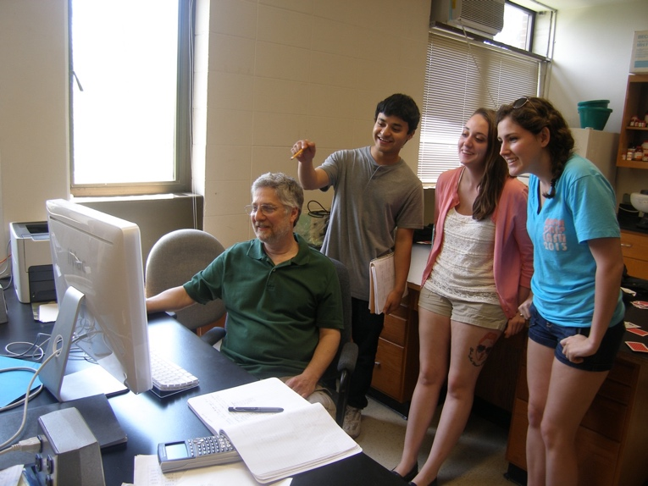

Snapshot: exciting times in the Light Lab exploring osmotic mechanisms in red blood cells (left to right: Dr. Light, Rahul Thakuri ‘17, Kayla Huber ‘16, and Rachel Grandberg ‘16)

Dr. Light discovered Lake Forest College through a job advertisement for a professor in biology. Beyond that, Dr. Light appreciated the small class sizes and liberal arts education, being that he also attended a small liberal arts college. Upon starting his adventure at Lake Forest, he set up a research lab to study cell volume regulation, taught at all levels in the curriculum, and served on several committees. In addition, Dr. Light served as Chair of the Biology Department twice during his time at LFC, as well as Chair of the Promotion & Tenure Subcommittee. Through the years, the College has also changed a bit, he says. More students are interested in health professions, and he has seen an increase in international and first-generation undergraduate students.

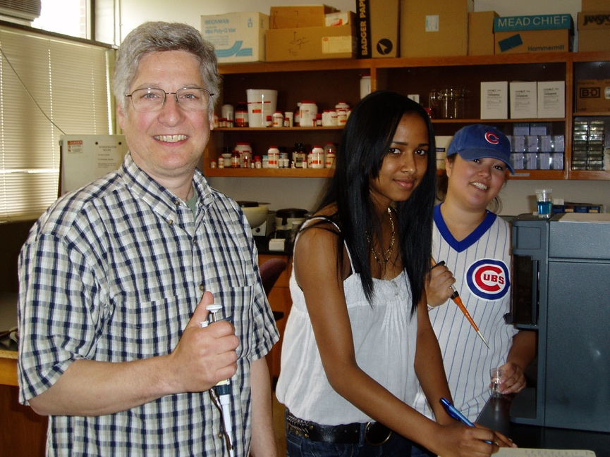

The fun continues (left to right: Dr. Light, Jordanah Evans ‘12 and Anna Naditz ‘12).

Dr. Light reflected on interactions with other faculty members in different areas of study and the ways in which they have helped him continue to grow intellectually. Dr. Light said, “one of the perks of being a professor is it allows interactions with colleagues, allowing you to learn from them.” He explained that these relationships have broadened his horizons in terms ofmusic, language, and culture. He says, “I believe that education doesn’t solely happen out of a textbook – peers are a vital asset to the quality of an education.” However, he says the biggest perk of this profession is working with students and “seeing when I have had a positive impact on a student’s college experience.”

To students wanting to pursue a similar career path, Dr. Light advises to “go in with your eyes open.” Now, the science field has changed in terms of funding being that “it is significantly harder to get funding now than when I started in this profession.” It’s important to consider other parts of the job, like advising, grading, committee work, that he says he “never realized all what my professors did when I was a college student.” On the flip side, Dr. Light said, “there are a ton of perks with this job; I get to spend my day with really smart people (students and faculty) that I can learn from, and thus I can’t help but have a positive outlook on life because of this job.”

Thank you, Dr. Light, for your dedication to your job not only as a professor but also a mentor and researcher.