Group: Sarah Stauber, Emma Juettner, Leo Carrico, Samuel Robertson

**Final Project Deliverable 3**

Goals:

In the final phase of this project, our goals were to develop a PHP interface that can be used to access our Video Store database and perform various functions, as described in the project requirements.

Implementation Process:

We began implementing our database by making a list of all the pages that we needed to include, and dividing them among ourselves to work on. We started with the login pages, and then worked our way to the subpages of the member and administrator menus. Once we were mostly done writing the PHP, we also began working on the CSS styles. We updated the SQL to create and populate our database as we worked on the PHP, since we had to make multiple changes to the database to properly implement and test the PHP interface.

Revisions to Phase 2 Specifications:

We made some changes to the SQL we submitted for Phase 2. Mainly, these were changes related to the attribute types of primary keys and text fields to avoid problems in our implementation of the database (see below).

Problems Encountered:

* We had to change several of the attribute types in our database to make some of our functions work correctly (e.g. changing primary keys for several categories from char to int and setting them to auto-increment, or making char fields longer so names wouldn’t get cut off).
* We had to restructure the way we tracked fines, eventually settling on storing a member’s total outstanding fines in a BALANCE column in the MEMBER table and storing individual fine amounts in the INVOICE_TRANSACTION table.
* We had some issues with mixed capitalization causing errors when we accessed the database on Mac computers (for some reason Windows didn’t have the same problem) so we had to change all our SQL queries to lower-case.
* We had to account for the possibility of users reloading pages that were not meant to be reloaded, for example the movie_search_target.php page, so we added statements that would direct them back to the previous page if the necessary data had not been submitted via post.

Users’ Guide:

At the main menu you can choose to either login with the administrator login or the member login.

Admin login 🡪 This takes you to the administrator login page where after login, you will have administrative functionalities.

Member login 🡪 This takes you to the member login page where you will then have member/ customer functionalities.

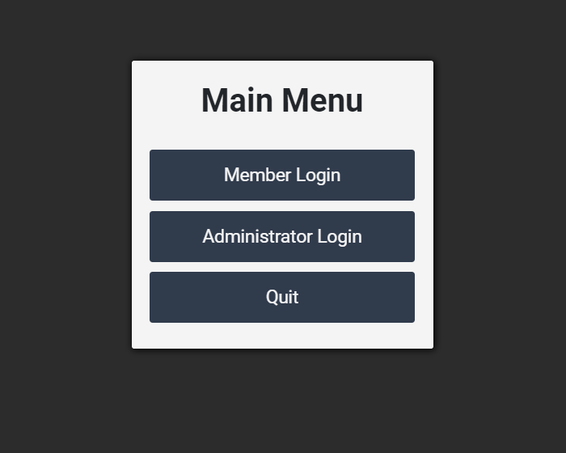

User ID 🡪 If you have already created an account, then you may input your User ID credentials here.

Password 🡪 You password going into the password slot.

Login 🡪 Once you have entered both the User ID and Password, you may successfully login by clicking the login button.

Sign Up Here 🡪 If you have not yet created an account, you can sign up with a new account here.

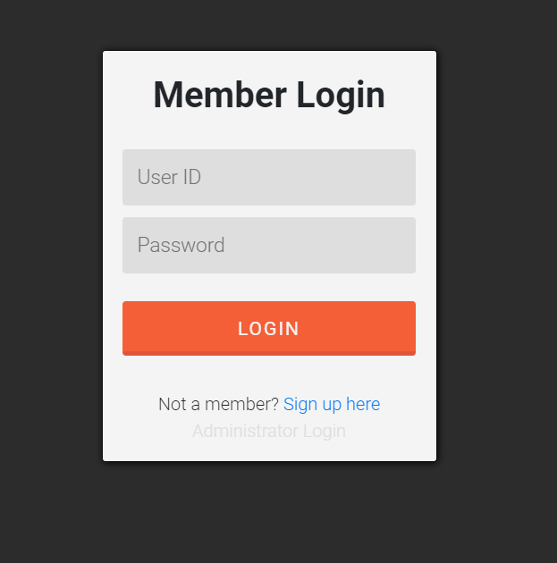

Movie Search 🡪 This will take you to were you can search movies by Title, Category, or Director.

Movie Checkout 🡪You can search movie by Title and then select the movie you would like to check out here.

Movie Return 🡪 Any movies that are currently checked out, can be returned here.

Movie Reserve 🡪 Here you can reserve movies to checkout for the future.

Movie Fines 🡪 You can see all the fines currently have.

Reserved Movies 🡪 These are a list of movies that you currently have on reserve.

Log Out 🡪 This successfully exit the program.

