Advanced Web Programming
Project 1
Jake Marshall
100087804

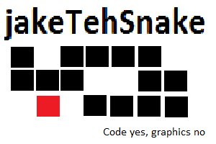

Table of Contents
Contents
Table of Contents 2
Brief Description 3
Nav bar 3

Brief Description
A mobile version of the portfolio site made in assignment 1. User is automatically redirected to this site when visiting the full site on a mobile device, and has the option to go to the full site.

Nav Bar
Current page in red

Mobile

Back button when not on home page

Separate bar when on projects/services page

Full
Table cell

Current page's cell has different class then other cells

Colour of background/text based on class

Plain text

Colours

Mobile

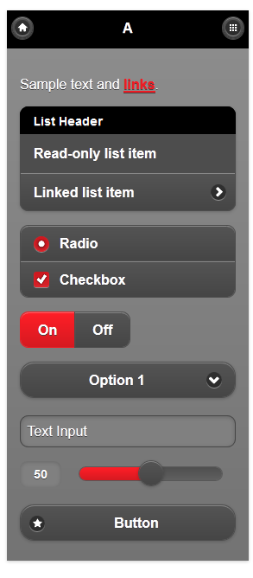
#ffffff Text

#000000 Header background

#808080 Page background

#444444 Content background

#ed1c24 Link/pressed button

Full
Red for current page text/link background on navbar

#FF2222

Blue for page background White for div background

#9999FF #FFFFFF

Typography
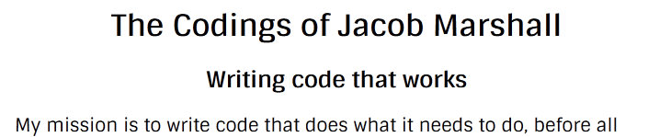

Default Size/Colour Google Webfonts “Sintony”

Wireframe

Mobile

Home
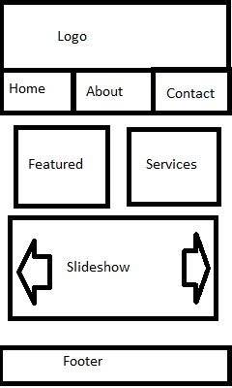

About
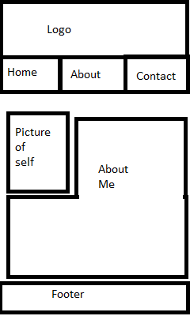

Contact
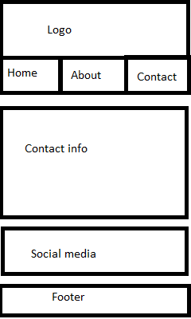

Featured work
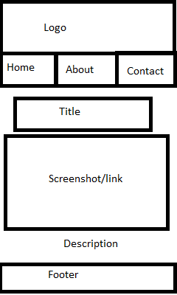

Services
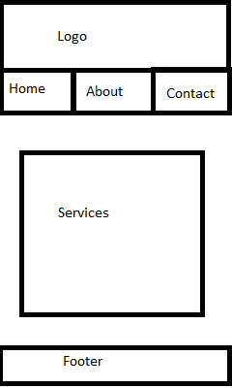

Full
Home Page

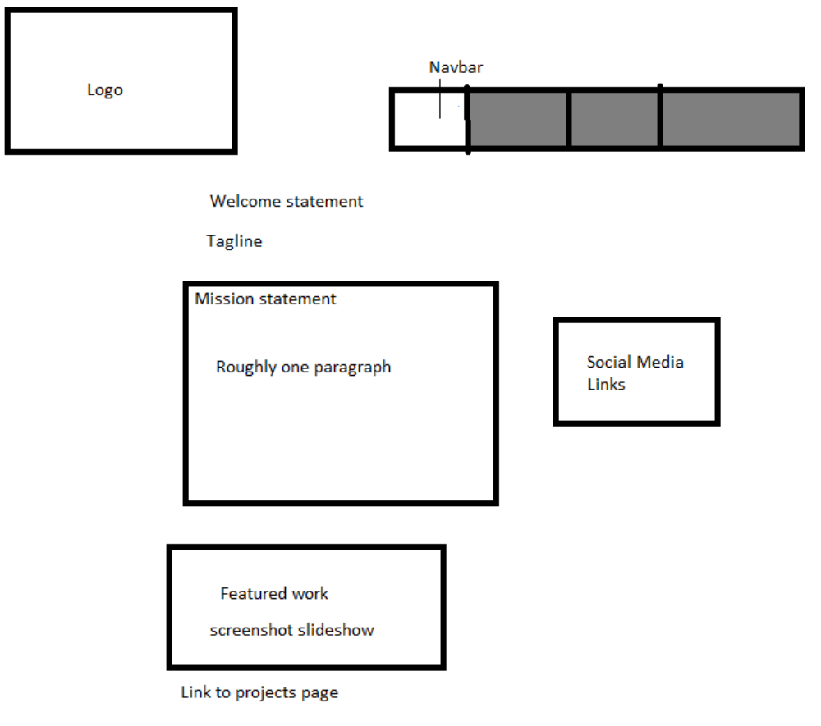

About Me
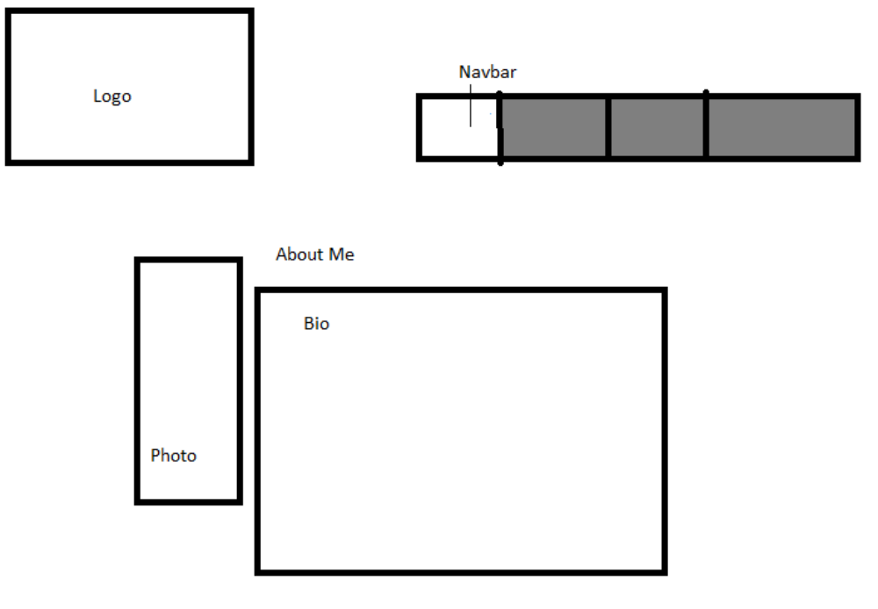

Projects

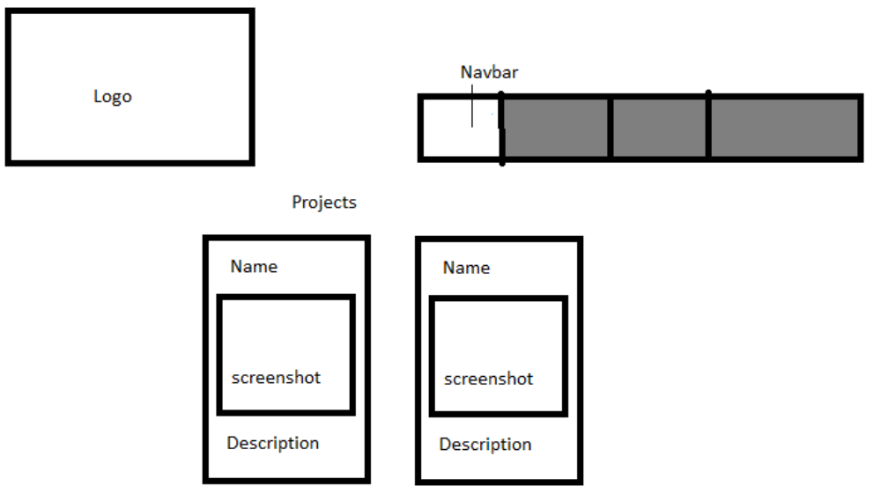

Services
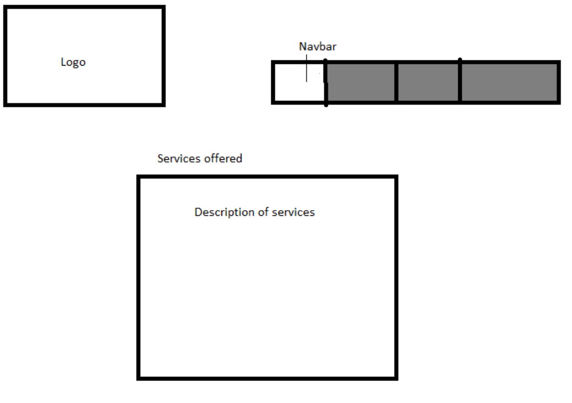

Contact

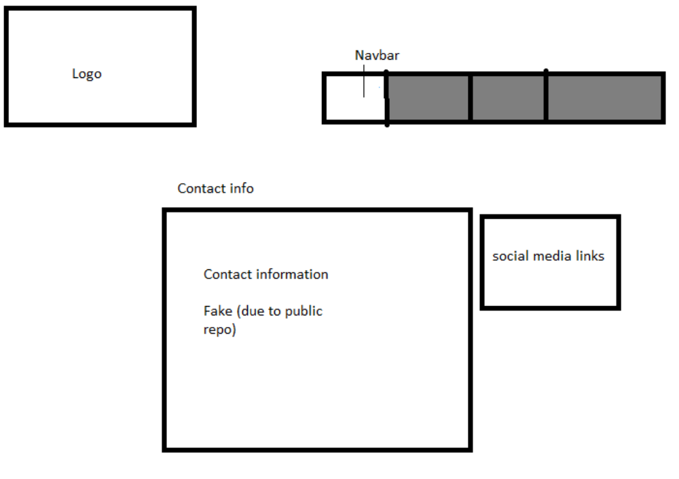

Branding

Mobile
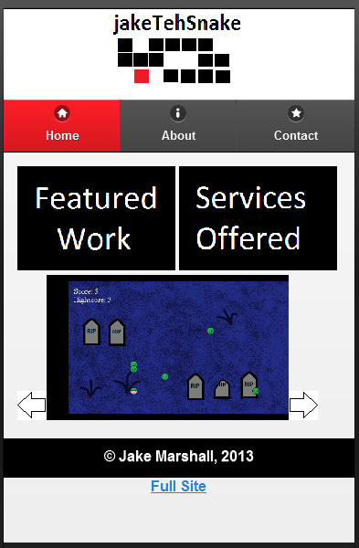

Full
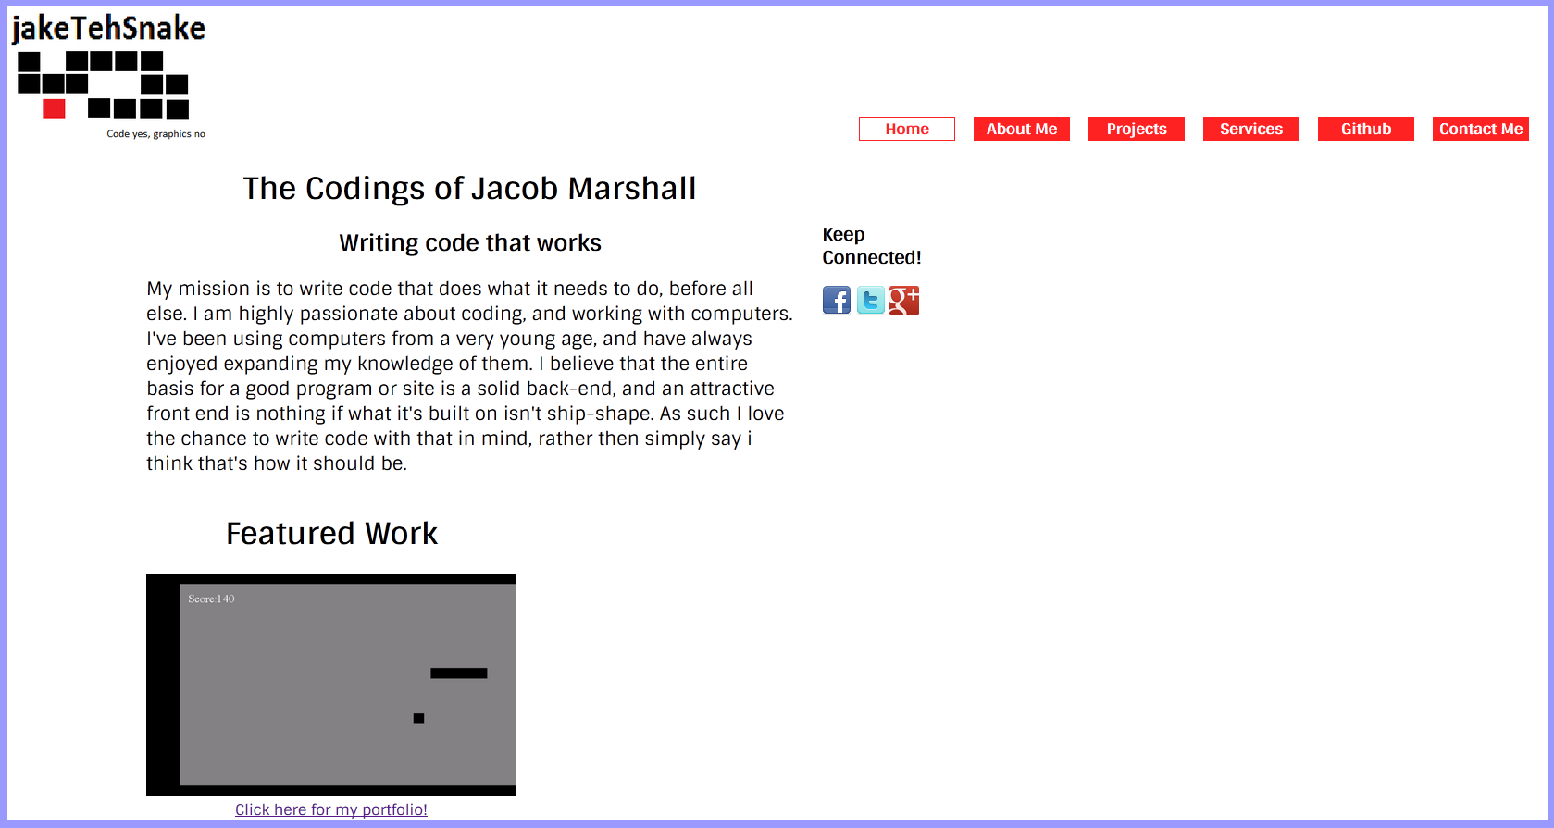

Logo
