Advanced Web Programming
Assignment 1
Jake Marshall
100087804

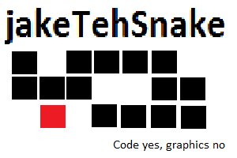

Table of Contents
Contents
Nav Bar 3
Colours 3
Typography 3
Wireframes 4
Branding 9

Nav Bar
Table cell

Current page's cell has different class then other cells

Colour of background/text based on class

Plain text

Standard text link

Colours
Red for current page text/link background on navbar

#FF2222

Blue for page background White for div background

#9999FF #FFFFFF

Typography
Arial, with sans-serif as “backup” font
Headers standard font size
Paragraph font is size 20

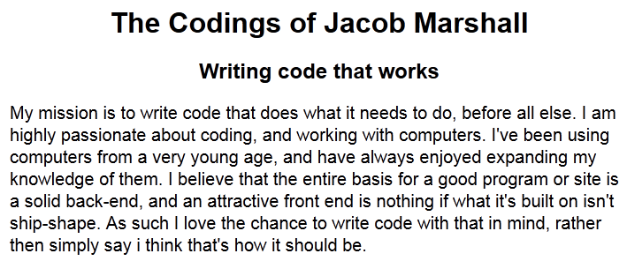Wireframes

Home Page

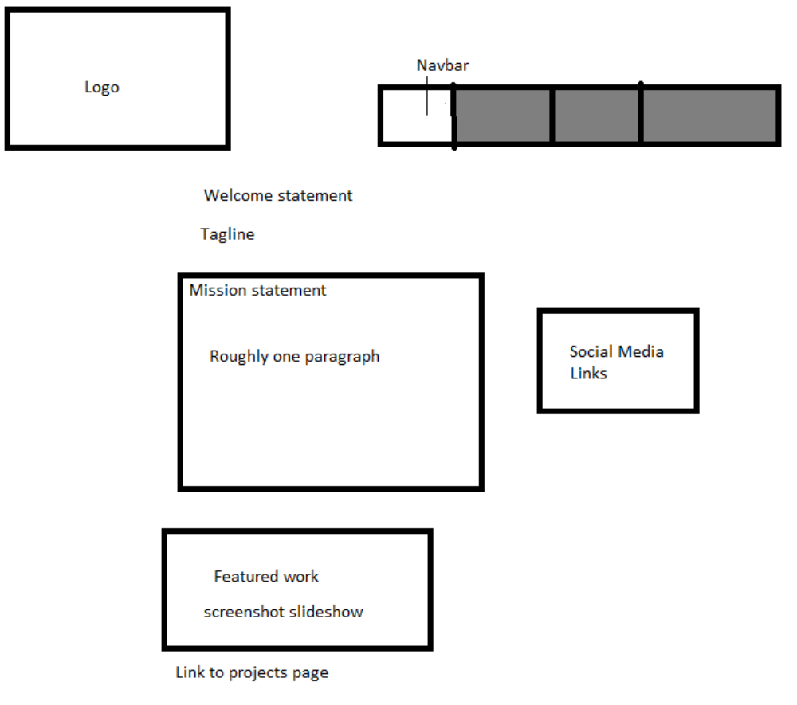

About Me
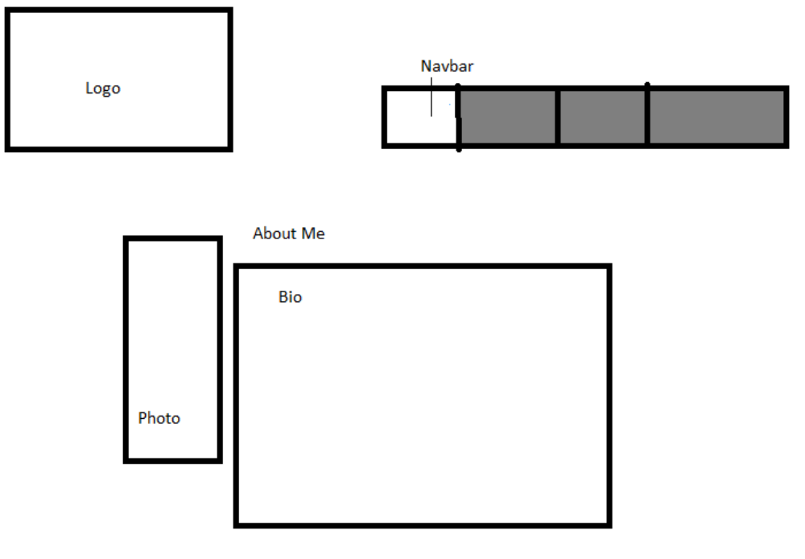

Projects

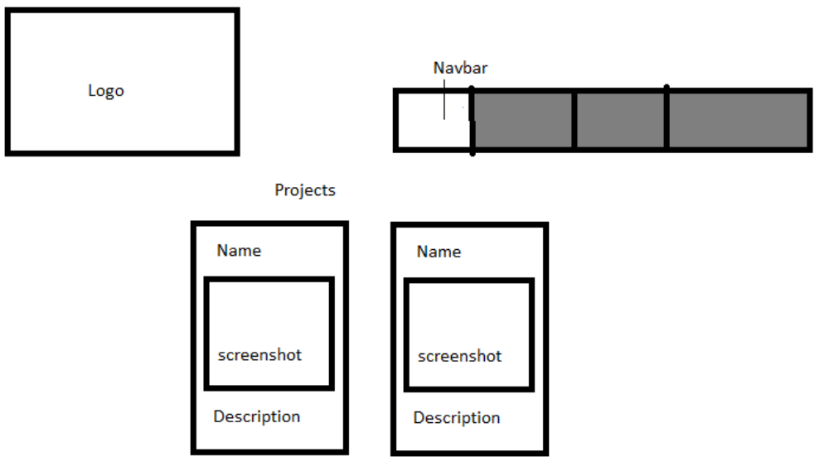

Services
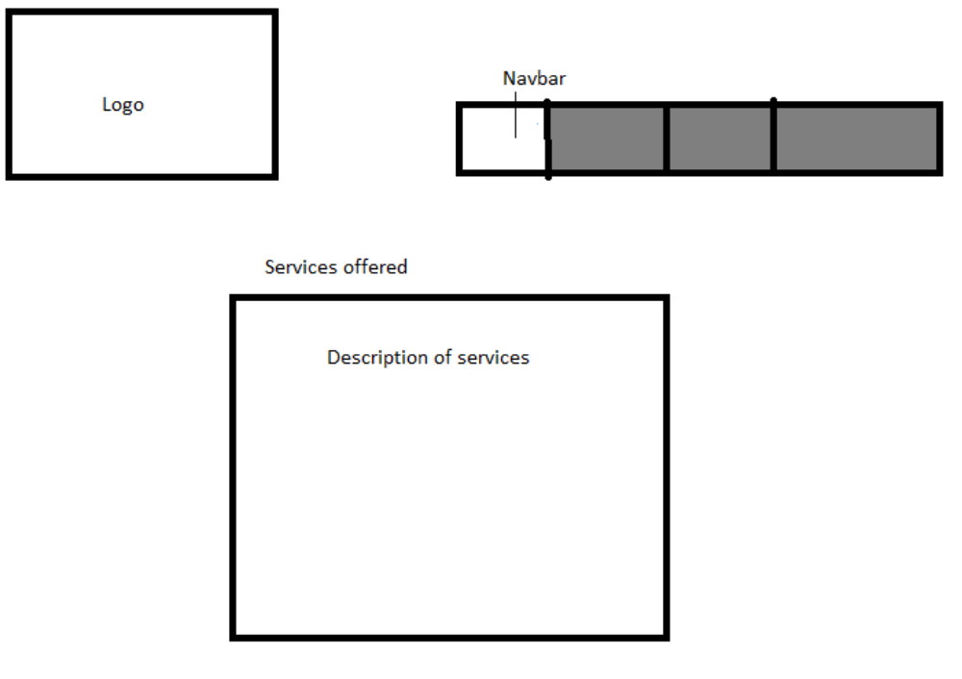

Contact

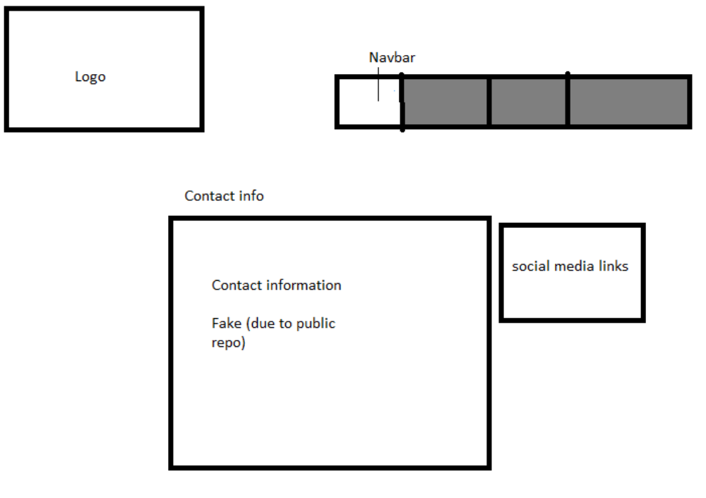

Branding
