CIS 285: Software Engineering Tools

University of Michigan – Dearborn

Winter 21 Mid-Term Exam

Time: 1 hr. 45 minutes. Total: 100 pts.

Student Name: __Andra Dobrescu__________

1. Illustrate and describe how baselines are added and removed from the project database 5 pts.
2. State differences of CVS and Git 5 pts.

>> Git

>> has distributed repo

>> much faster and works offline

>> strong merging allows git to use lots of branches

>> has a full local history

>> CVS

>> has central repo

>> much slower and works slightly less well offline

>> merging isn’t as efficient

>> does not have a full local history

1. Use Git commands and Github.com to realize the following process. Check Canvas Exam folder for AddIntegers.java initial source code.
   1. Create a new local repository
   2. Add a new AddIntegers.java to the repository
   3. Create a new gitHub repository e.g Midterm
   4. Push local to the new GitHub repository
   5. Create a local branch ‘YourName’
   6. Under ‘YourName’ branch, make whatever change in AddIntegers.java
   7. Compare the difference of the file content and then commit
   8. Push ‘YourName’ branch to GitHub
   9. Approve and merge the pull request on gitHub
   10. Synchronize local Master to gitbub

* List all the commands in the process. Your command must follow the same order as the process. 15 pts
* Copy/Paste your github repository url here (Don’t make any change to the github repository after the exam. It is a cheat if you do so) 5 pts

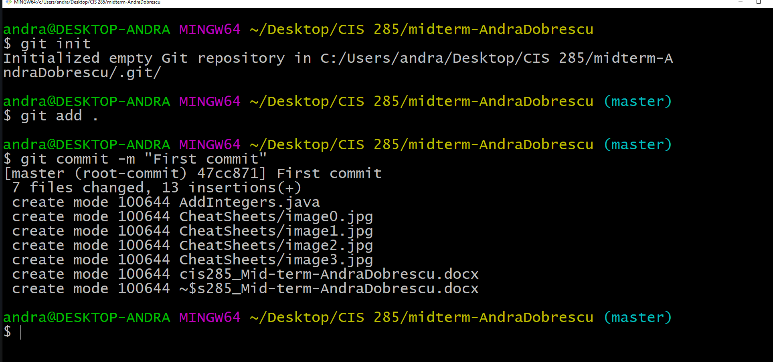

Git

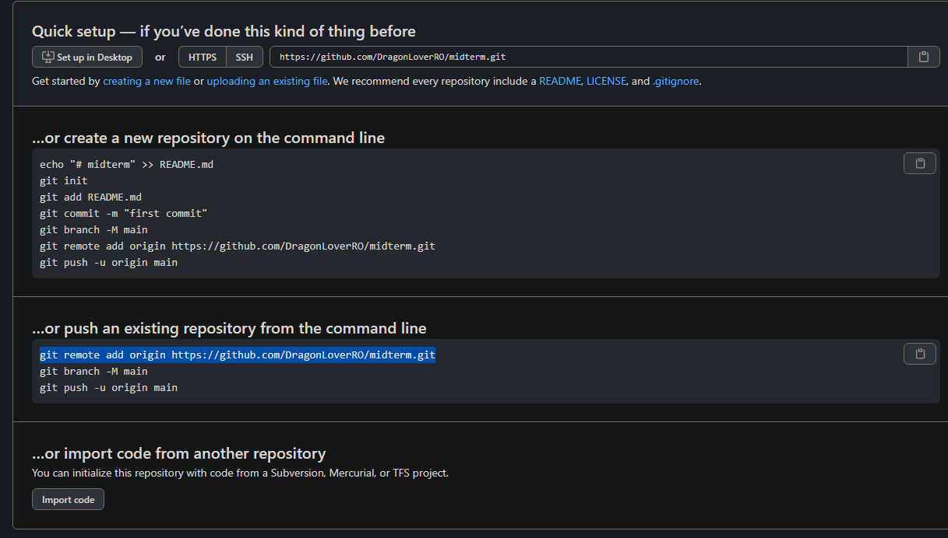

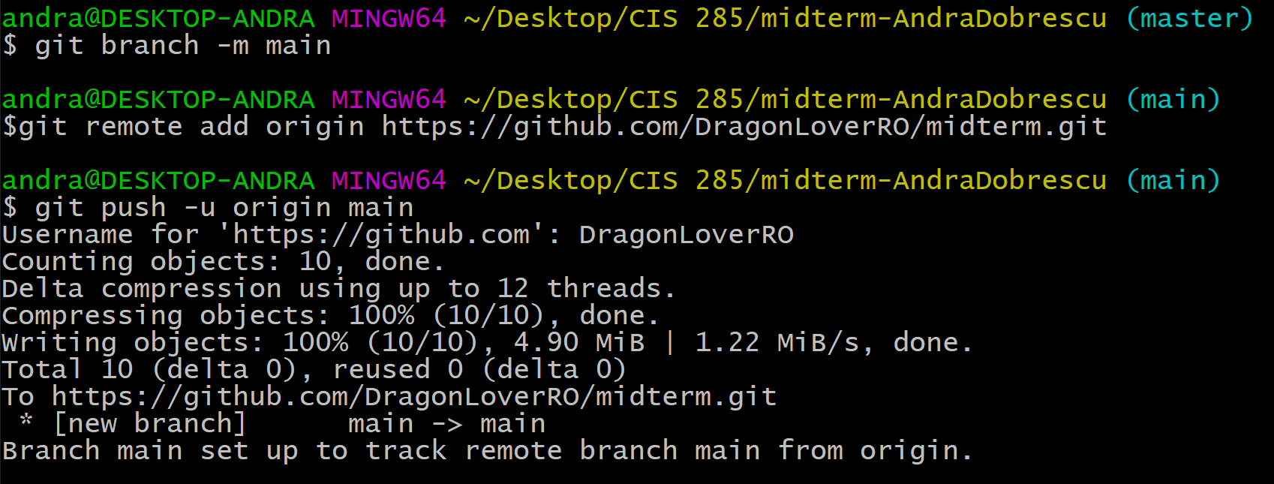

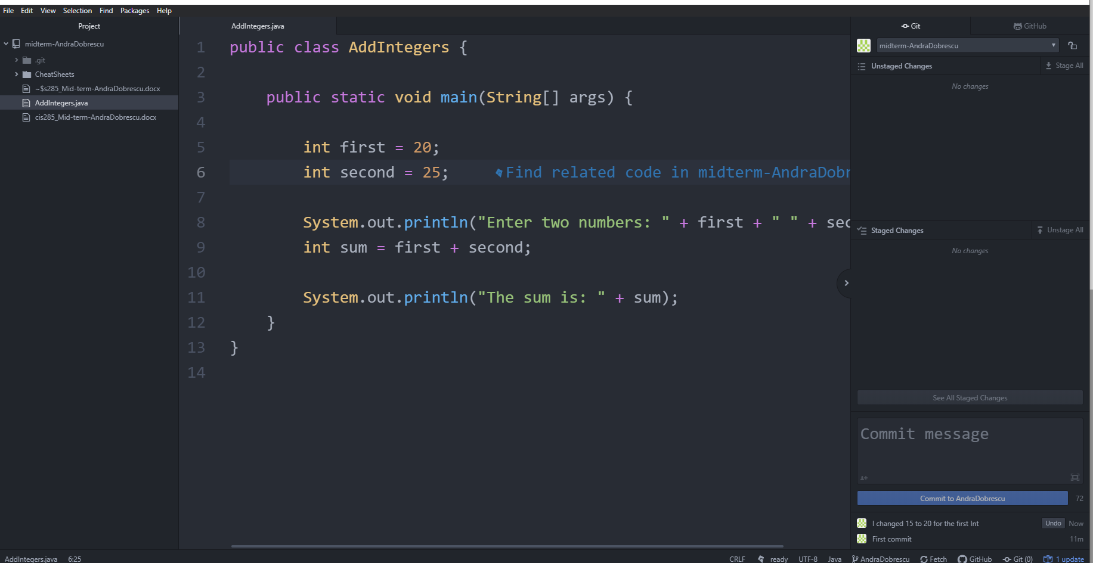

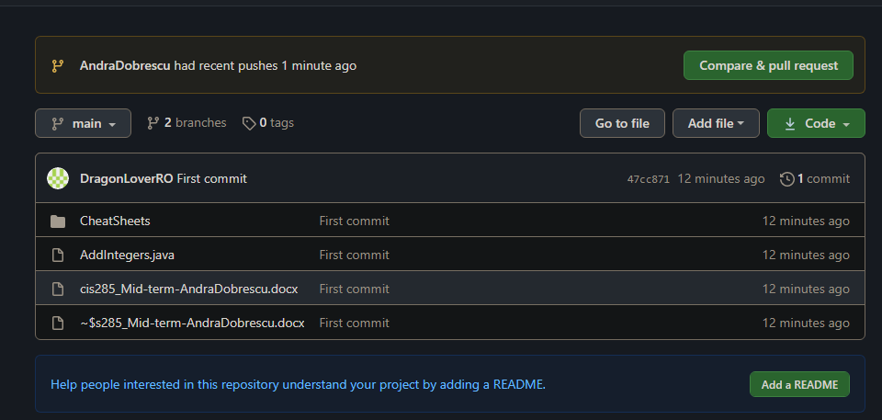

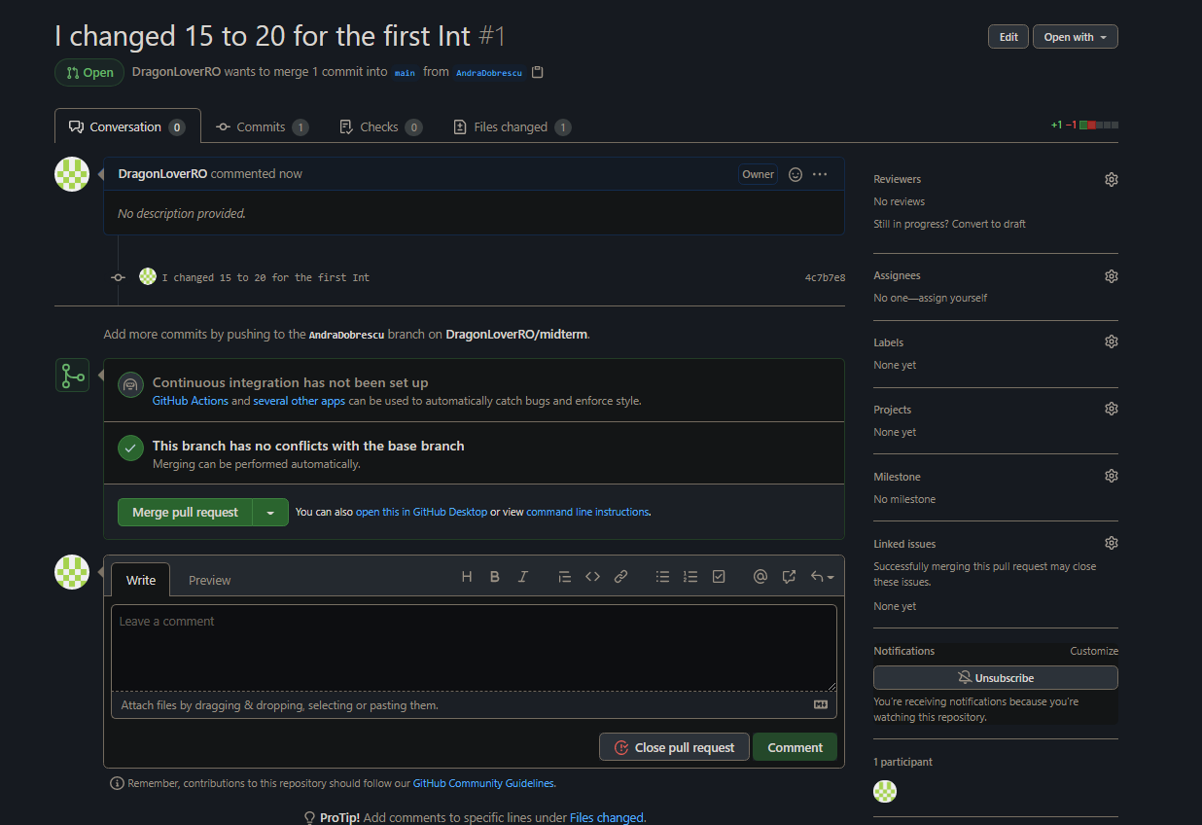

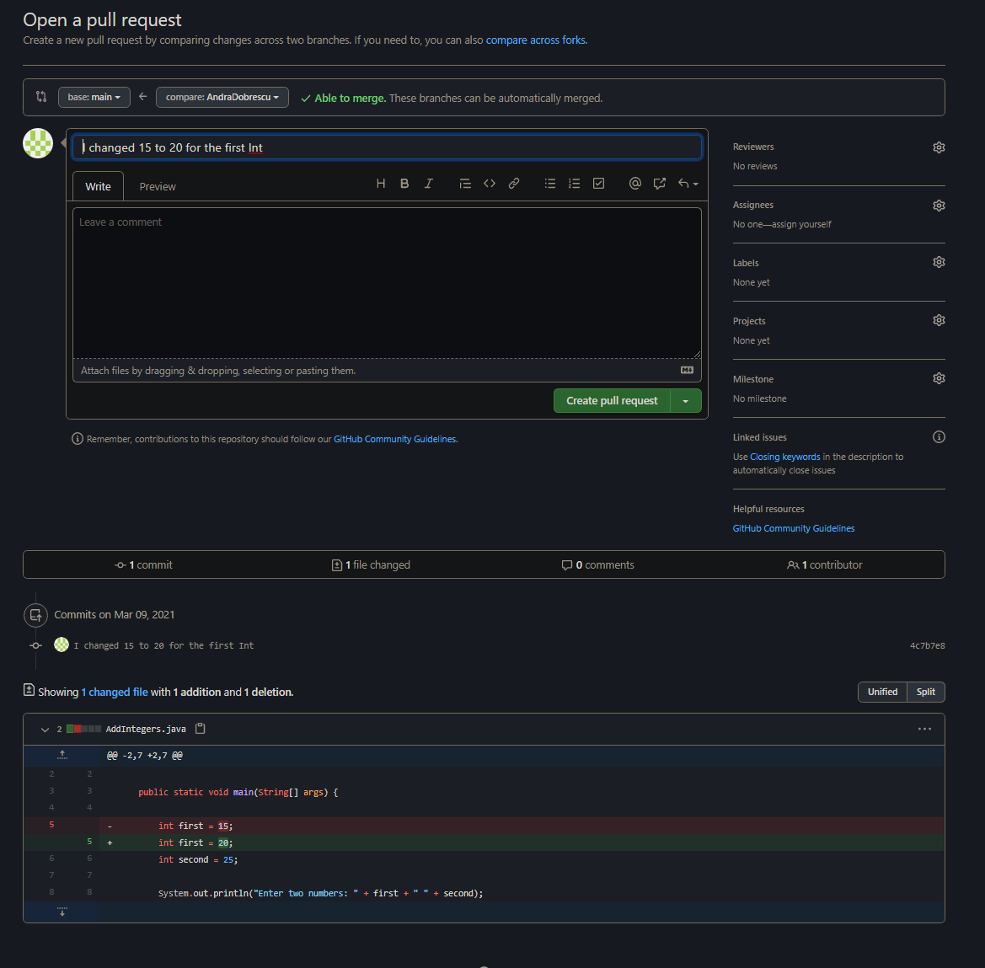

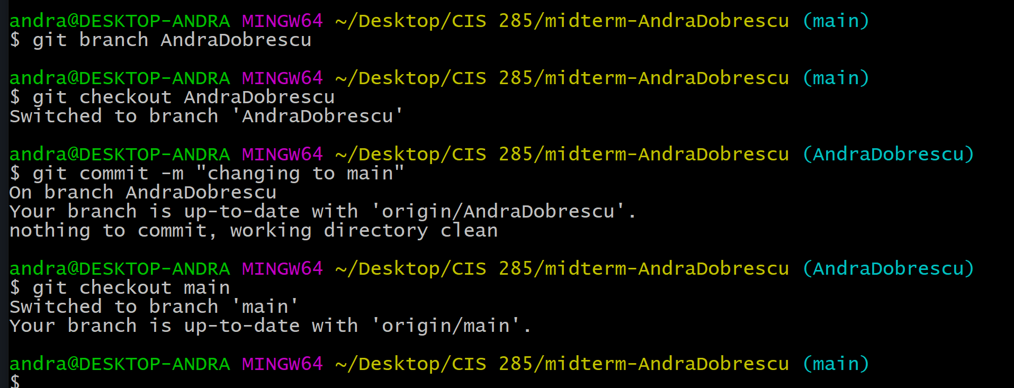

1. Continuing in question 3, Use Atom, GitHub, and Jenkins to realize the following scenario.
   1. Open Atom and Add Project Folder then navigate to AddIntegers’s folder
   2. Under local master branch, use Atom to modify AddIntegers.java (You may just change two integers’ value)
   3. In Atom, commit to local master, then push to github
   4. Connect to campus VPN and login to

<http://cis285.mooo.com:8090/>

user name: cis285

password: cis285

* 1. Create a new freestyle project with the name “YourName_AddIntegers”
  2. Config the project to connect your Midterm github repository
  3. Schedule Build Triggers to poll SCM every minute.
  4. Use the following command in Build/Execute Windows batch command

javac AddIntegers.java

java AddIntegers

* Provide screenshot of step b 3 pts
* Provide screenshot of step c 3 pts
* Provide screenshot of step f 3 pts
* Provide screenshot of step g 3 pts
* Provide screenshot of step h 3 pts
* Repeat step b and c, then have 2 successful builds in Jenkins. Provide these two Console Output screenshots (Don’t make any change to your Jenkins project after the exam. It is a cheat to do so) 10 pts

1. A marketing plan software takes salesperson’s target group in terms of income, house value, and zip code, the software search internal patron database and returns all name and address that satisfy requirement. The user can export and print the result list and statistical report of the list.
   1. Determine the number of external inputs, external outputs, external inquires, internal logical files and external interface files. 7 pts
   2. Calculate the number of unadjusted function points for the given software project.(suppose all matrix in (a) are average) 8 pts



Difficulty Values for Function Points

|  |  |  |  |
| --- | --- | --- | --- |
| Information Domain | Simple | Average | Complex |
| External Inputs | 3 | 4 | 6 |
| External Outputs | 4 | 5 | 7 |
| External Inquires | 3 | 4 | 6 |
| Internal Logical Files | 7 | 10 | 15 |
| External Interface Files | 5 | 7 | 10 |

1. >> External Inputs = 3

>> External Outputs = 2

>> Number of External Inquiries = 5

>> Number of Internal Logic Files = 1

>> Number of External Interface Files = 4

1. >> Number of unadjusted function points for the given software project for the average case is

>> (3 * 4) + (2 * 5) + (5 * 4) + (1 * 10) + (4 * 7)

>> Number of unadjusted function points for the given software project for the average case is = 80

>> = 80

1. Suppose S(Fi) = 50 in question 8. Average productivity for systems of this type is 6.8 FP/pm and burdened labor rate is $7,000 per month.
   1. Calculate function point 5pts
   2. Calculate total project cost in dollar value 5pts
   3. Calculate total estimated effort in pm 5pts
2. >> FP = [ totalCount * (.65 + .01 * 50) ]

>> FP = 80 * [.65 + .5]

>> FP = 80 * [1.15]

>> FP = 92

1. >> averageProductivity = FP/PM

>> averageProductivity = 6.8

>> laborRate = $7,000/ month

>> totalMonths = 92/6.5

>> totalMonths = 14.15

>>totalCost = 14.15 * 7,000

>>totalCost = 99,076.92

1. >> estimatedTotalEffort = FP/averageProductivity

>> estimatedTotalEffort = 92/6.8

>> estimatedTotalEffort =14 PM

1. Assume you are a software project manager and that you’ve been asked to computer earned value statistics for a small software project. At the time that you’ve been asked to do the earned value analysis, 16 tasks have been completed. However, the project schedule indicates that 18 tasks should have been completed. The following scheduling data (in person-days) are available: Compute the schedule variance, cost variance SPI, CPI, and CSI.

15 pts

|  |  |  |
| --- | --- | --- |
| Task | Planned Effort | Actual Effort |
| 1 | 13 | 12 |
| 2 | 10 | 11 |
| 3 | 15 | 18 |
| 4 | 7 | 9 |
| 5 | 9.5 | 9 |
| 6 | 18 | 20 |
| 7 | 8 | 11 |
| 8 | 4 | 5 |
| 9 | 12 | 10 |
| 10 | 5 | 3 |
| 11 | 7 | 4 |
| 12 | 14 | 14 |
| 13 | 15 | 18 |
| 14 | 9 | 12 |
| 15 | 8 | 5 |
| 16 | 7 | 8 |
| 17 | 13 |  |
| 18 | 4 |  |

>> BCWS = 178.5

>> ACWP = 169

>> BCWP = 161.5

>> SPI = BCWP/BCWS

>> SPI = .905

>> The schedule is behind

>> CPI = BCWP/ACWP

>> CPI = .955

>> The project is over budget

>> CSI = CPI * SPI

>> CSI =.864

>> The project is capable of recovery

>>CV = BCWP – ACWP

>> CV = 161.5 – 169

>> CV = -7.5

>> The project is over budget

>> SV = BCWP – BCWS

>> SV = -17

>> The project is behind schedule