**Georgia Institute of Technology**

**College of Computing**

**CS 1371 Computing for Engineers**

**Test 2 - Fall Semester 2008**

|  |  |  |  |  |  |  |  |  |  |  |  |  |  |  |  |  |  |
| --- | --- | --- | --- | --- | --- | --- | --- | --- | --- | --- | --- | --- | --- | --- | --- | --- | --- |
|  |  |  |  |  |  |  |  |  |  |  |  |  |  |  |  |  |  |
| ***0*** | ***0*** | ***0*** | ***0*** | ***0*** | ***0*** | ***0*** | ***0*** | ***0*** | **↑** Print your **T-Square username** in the spaces provided, and shade the boxes of the corresponding numbers and/or letters.  *I hereby signify that this examination paper contains my own work exclusively, and I have neither given nor received inappropriate help during the taking of this examination, in compliance with the letter and spirit of the Academic Honor Code of Georgia Tech.*  Name (print):  Signature:  TA / Section: ____________________________   |  |  |  |  |  | | --- | --- | --- | --- | --- | | **Part** | **Poss. Pts** | **Earned Pts** | **Lost Pts** | **Grader** | | **(cover)** | **-** | **-** |  |  | | **1** | **30** |  |  |  | | **2** | **30** |  |  |  | | **3** | **40** |  |  |  | | **TOTAL** | **100** |  |  |  |   *Please Note: Failure to complete this front sheet correctly will cost you 5% of your grade.*  ***Please turn off (or silence) and put away any cell phones, beepers/pagers, personal radios or music players that you have in your possession***  **Good Luck!** | | | | | | | | |
| ***1*** | ***1*** | ***1*** | ***1*** | ***1*** | ***1*** | ***1*** | ***1*** | ***1*** |
| ***2*** | ***2*** | ***2*** | ***2*** | ***2*** | ***2*** | ***2*** | ***2*** | ***2*** |
| ***3*** | ***3*** | ***3*** | ***3*** | ***3*** | ***3*** | ***3*** | ***3*** | ***3*** |
| ***4*** | ***4*** | ***4*** | ***4*** | ***4*** | ***4*** | ***4*** | ***4*** | ***4*** |
| ***5*** | ***5*** | ***5*** | ***5*** | ***5*** | ***5*** | ***5*** | ***5*** | ***5*** |
| ***6*** | ***6*** | ***6*** | ***6*** | ***6*** | ***6*** | ***6*** | ***6*** | ***6*** |
| ***7*** | ***7*** | ***7*** | ***7*** | ***7*** | ***7*** | ***7*** | ***7*** | ***7*** |
| ***8*** | ***8*** | ***8*** | ***8*** | ***8*** | ***8*** | ***8*** | ***8*** | ***8*** |
| ***9*** | ***9*** | ***9*** | ***9*** | ***9*** | ***9*** | ***9*** | ***9*** | ***9*** |
| A | A | A | A | A | A | A | A | A |
| B | B | B | B | B | B | B | B | B |
| C | C | C | C | C | C | C | C | C |
| D | D | D | D | D | D | D | D | D |
| E | E | E | E | E | E | E | E | E |
| F | F | F | F | F | F | F | F | F |
| G | G | G | G | G | G | G | G | G |
| H | H | H | H | H | H | H | H | H |
| I | I | I | I | I | I | I | I | I |
| J | J | J | J | J | J | J | J | J |
| K | K | K | K | K | K | K | K | K |
| L | L | L | L | L | L | L | L | L |
| M | M | M | M | M | M | M | M | M |
| N | N | N | N | N | N | N | N | N |
| O | O | O | O | O | O | O | O | O |
| P | P | P | P | P | P | P | P | P |
| Q | Q | Q | Q | Q | Q | Q | Q | Q |
| R | R | R | R | R | R | R | R | R |
| S | S | S | S | S | S | S | S | S |
| T | T | T | T | T | T | T | T | T |
| U | U | U | U | U | U | U | U | U |
| V | V | V | V | V | V | V | V | V |
| W | W | W | W | W | W | W | W | W |
| X | X | X | X | X | X | X | X | X |
| Y | Y | Y | Y | Y | Y | Y | Y | Y |
| Z | Z | Z | Z | Z | Z | Z | Z | Z |

Academic misconduct (including - but not limited to - examples on the list below) could result in a zero score on this examination, an “F” final grade in the course, and/or other disciplinary action:

* Failure to cooperate with or follow directions given by a proctor.
* Failure to stop writing when the allotted time is up (as reported by a proctor).
* Communication with anyone other than a proctor for ANY reason in ANY language in ANY manner.
* Sharing of ANYTHING (e.g. pencils, erasers, paper).
* Writing on paper that is not given to you by a proctor.
* Using cell phones, beepers, personal radios or music players, etc. during the exam.
* Using calculators (unless explicitly permitted) or hand-held computers during the exam.
* Using books or other reference material during the exam.
* Disruption of the exam setting.

**Reference Section**

**Reference Section:**

any(x) – checks if any of the elements of x are true

class(a) – returns the class of a

csvread(filename) – reads in file of comma separated values

csvwrite(filename, A) – writes A to .csv file

diag(m) – returns the diagonal elements of the matrix m

dlmread(filename, D) – reads in file with delimiter D

dlmwrite(filename, A, D) – writes A to file with delimiter D

double(a) – converts a to class double (numeric)

factorial(n) – returns n!

fieldnames(X) – returns an array of fieldnames

find(m) – returns the indices of the true elements of m

fopen(F, P) – opens file F with permission P

getfield(X, F) – gets value in field F of structure X

image(x) - display the image from the matrix x

imread(filename) - returns a matrix representation of an image

isa(a, b) – checks if a is of class b

length(a) – largest dimension of a

magic(n) – builds a n * n magic square

max(a) – value and index of the max value in a

mean(v) – returns the average value of v

[xx, yy] = meshgrid(x, y) – compute the plaid from the x and y vectors

mod(a, b) – the remainder when a is divided by b

ones(rows, cols) – generate a matrix filled with 1

plot(x, y, S) – plots y versus x; S specifies line style

plot3(x, y, z, S) – plots a 3-D line with S specified line style

prod(v) – compute the product of all the elements in a vector v

rand(n, m) – produces an n by m array of random numbers between 0 and 1

rmfield(S, X) – removes field X from S

sin(th) – sin of the angle in radians

size(a) – all the dimensions of a

sort(v) – arranges v in ascending numerical order

sprintf - Write formatted data to string

strcmp(a, b) – Compare strings a and b

struct(F, V, ….) – creates a structure with field F and values V

sum(v) – total all the elements in the vector v

x/y/zlabel(S) – labels x/y/z axis with string S

xlsread(filename) – reads in .xls file

xlswrite(filename, A) – write array A to .xls file

**Part 1 – Multiple Choice [30 Points]**

Using a pencil, indicate the *best* choice for each question in the box to the left of the problem. Only answer choices clearly written in the boxes will be graded.

1. The following MATLAB code is executed:

A = struct(‘Team’, ‘Duke’, ‘Win’, true);

B = fieldnames(A)

A.(B{1})(1) = ‘t’;

What is the value of A?

A. Team: ‘Duke’ B. team: ‘Duke’ C. Team: ‘tuke’

Win: 1 Win: 1 Win: 1

D. Team: ‘t’ E. Error

Win: 1

2. Which one of the commands below will create a grid of 18 graphs in a figure?

A. subplot(18)

B. subplot(3, 6, 3)

C. subplot(3, 3, 2)

D. subplot(9, 9, 5)

E. subplot(18, 8, 10)

3. **Given** that after xx, yy, and zz were defined:

mesh(xx, yy, zz)

What would the plot look like?

A. A colored surface with no lines

B. A white surface with colored lines

C. A white surface with black lines

D. A colored surface with white lines

E. None of the above

4. Given that a matrix mat was previously defined, which one of the following commands will flip the matrix left-to-right and remove all the odd rows?

A. mat=mat(1:2:end, end:-1:1)

B. mat=mat(end:-1:1, 1:2:end)

C. mat=mat(2:2:end, end:-1:1)

D. mat=mat(end:-1:1, 2:2:end)

E. None of the above.

5. A text file contains several numbers taken from an experiment. The numbers are separated by colons ( : ).

Which one of the following is the **most** appropriate function to read the text file into MATLAB?

A. dlmread

B. xlsread

C. csvread

D. colon

E. fprintf

6. Which of the following are true statements?

I. Recursion requires a wrapper function

II. Recursive functions must have a condition in which

a clone of the function is not called.

III. Iteration can be infinite while recursion cannot.

A. I only

B. II only

C. I and II

D. I and III

E. None of the above

7. **Given:**

xt = struct('Person', {'Mike', 'Greg'}, 'Class' ,'2007')

var = xt(2).Class

What is the value of var?

A. var = ''

B. var = {}

C. var = NaN

D. var = []

E. None of the above

8. **Given:**

x = 1:10;

y = linspace(21,30,11);

plot(x, y, ‘b+’)

What would the plot look like?

A. A plot of black plus signs with the given x and y values.

B. A plot of blue plus signs with the given x and y values.

C. A plot of a blue line connecting the given x and y values.

D. Error

E. None of the above

9. **Given:**

a = [1 2 3; 4 5 6; 7 8 9];

b = a(:)’;

What is the value of b?

A. [1 4 7 2 5 8 3 6 9]

B. [1 2 3 4 5 6 7 8 9]

C. [1 2 3; 4 5 6; 7 8 9]

D. [9 8 7; 6 5 4; 3 2 1]

E. Error

10. **Given:**

function ret = mine(v)

ret = 0;

if v(1)

ret = 1 + mine(v+2)

end

How many calls are made to the function, mine( ), including the initial function call that is typed into the command window: A = mine([3, 4, 5]) ?

A. 0

B. 3

C. 4

D. Infinite recursion

E. None of the above

**Part 2 – Tracing Problems [30 points]**

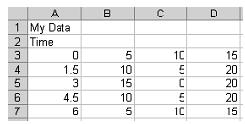**Given: data.xls**

close all

[a b c] = xlsread('data.xls');

s = ':*+o';

c = 'rgyk';

[m n] = size(a);

hold on

for z=2:n

plot(a(:,1)',a(:,z)',[c(z) s(z)])

end

title(b{1})

xlabel(b{2,1})

ylabel('Value')

axis tight

Complete the blank plot below with the data, title, labels, and axis that the above code produces. **Do not worry about indicating the color of the plot data.**

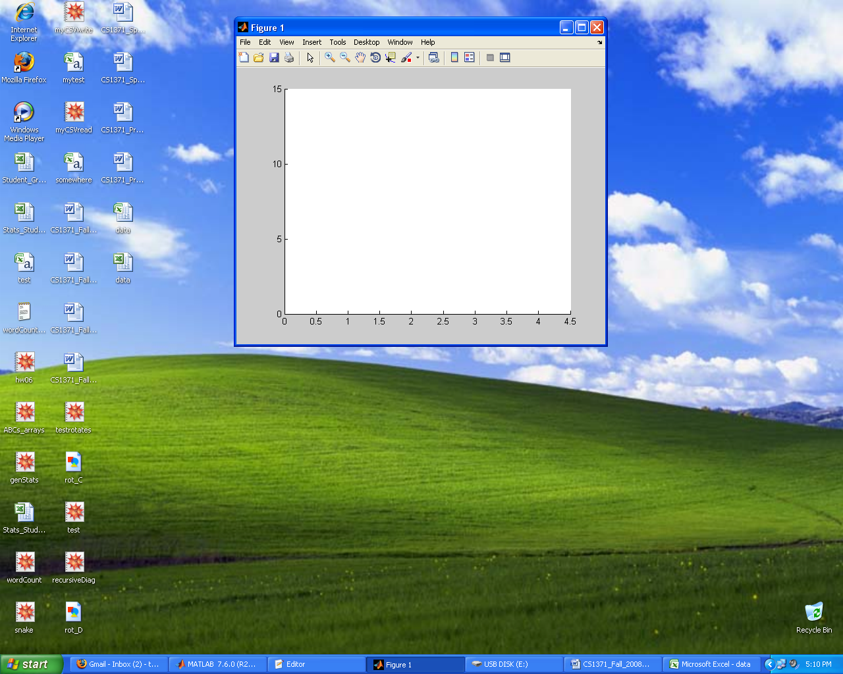

**Given:**

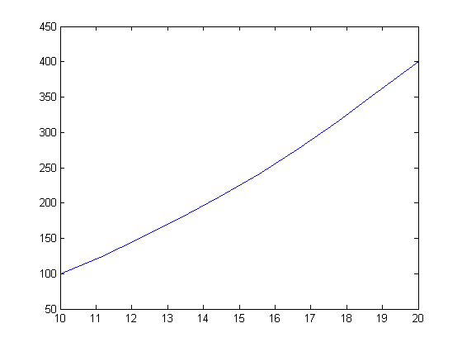u = linspace(10,20,10);

v = cos(u) + u.^2;

plot(u,v)

Then, the line is rotated around some axis to produce the following figure.

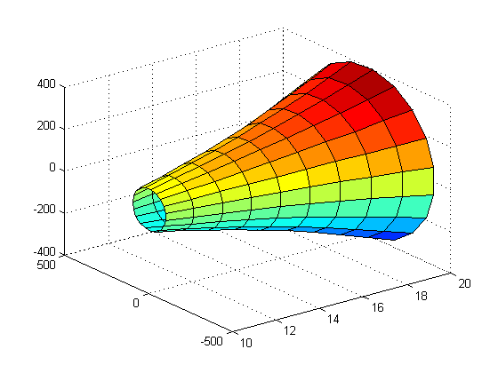

If u is mapped to the X-Axis and v is mapped to the Z-Axis, around which axis is the line rotated?

_________________________________________

What graphing command was used to produce the second figure? _________________________

Complete the code to rotate the curve around the other axis which results in a 3D surface. Make the surface smooth, label all axes, and title the figure.

th = ;

[uu tth] = meshgrid(u,th);

vv = ;

rr = ;

xx = ;

yy = ;

zz = ;

(xx,yy,zz)

;

;

;

;

;

**Part 3 – Coding Problem [40 points]**

**Choose ONE of the following two coding problems.** Check the blank next to your choice (A or B). If you decide to change your choice, clearly indicate what code you wish to be graded. If your choice is unclear, Problem B will be graded. Complete the design contract and write your code on the next page.

*You \*****MUST\**** *use recursion to receive credit.*

**A.**  Create a function called maxColumns that takes in a double array and returns a vector containing the max of each of the array’s columns.

Examples:

[ret] = maxColumns([6 4 9; 3 2 4; 1 2 8])

=> ret = [6 4 9]

*You \*****MUST\**** *use recursion to receive credit.*

**B.** Write a function called recurPlot that takes in two vectors of x and y coordinates and plots each point recursively. However, the first number of the x values will correspond with the last number in the y values, and the second number of the x values will corresponding with the second to last number in the y values, etc. You may assume the two vectors are of equal length. The points should be marked as yellow circles.

Examples:

recurPlot([1 2 3 4], [3 4 3 7])

=>

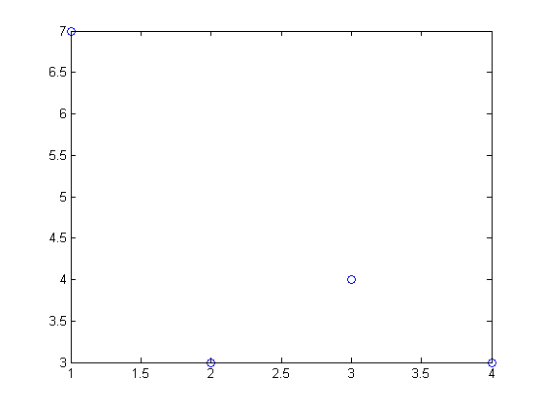**Complete the design contract for the coding problem you have selected:**

Function Name:

Inputs:

List all inputs and their classes, one per line. Not all lines may be used.

Write ‘none’ if the function does not have inputs.

Class:

Class:

Class:

Class:

Outputs:

List all outputs and their classes, one per line. Not all lines may be used.

Write ‘none’ if the function does not have outputs.

Class:

Class:

Class:

Class:

**Write your code for the Coding Problem you have selected here:**

*This page intentionally left blank for additional work.*