**Georgia Institute of Technology**

**College of Computing**

**CS 1371 Computing for Engineers**

**Test 2 - Fall Semester 2008**

|  |  |  |  |  |  |  |  |  |  |  |  |  |  |  |  |  |  |
| --- | --- | --- | --- | --- | --- | --- | --- | --- | --- | --- | --- | --- | --- | --- | --- | --- | --- |
|  |  |  |  |  |  |  |  |  |  |  |  |  |  |  |  |  |  |
| ***0*** | ***0*** | ***0*** | ***0*** | ***0*** | ***0*** | ***0*** | ***0*** | ***0*** | **↑** Print your **T-Square username** in the spaces provided, and shade the boxes of the corresponding numbers and/or letters.  *I hereby signify that this examination paper contains my own work exclusively, and I have neither given nor received inappropriate help during the taking of this examination, in compliance with the letter and spirit of the Academic Honor Code of Georgia Tech.*  Name (print):  Signature:  TA / Section: ____________________________   |  |  |  |  |  | | --- | --- | --- | --- | --- | | **Part** | **Poss. Pts** | **Earned Pts** | **Lost Pts** | **Grader** | | **(cover)** | **-** | **-** |  |  | | **1** | **30** |  |  |  | | **2** | **30** |  |  |  | | **3** | **40** |  |  |  | | **TOTAL** | **100** |  |  |  |   *Please Note: Failure to complete this front sheet correctly will cost you 5% of your grade.*  ***Please turn off (or silence) and put away any cell phones, beepers/pagers, personal radios or music players that you have in your possession***  **Good Luck!** | | | | | | | | |
| ***1*** | ***1*** | ***1*** | ***1*** | ***1*** | ***1*** | ***1*** | ***1*** | ***1*** |
| ***2*** | ***2*** | ***2*** | ***2*** | ***2*** | ***2*** | ***2*** | ***2*** | ***2*** |
| ***3*** | ***3*** | ***3*** | ***3*** | ***3*** | ***3*** | ***3*** | ***3*** | ***3*** |
| ***4*** | ***4*** | ***4*** | ***4*** | ***4*** | ***4*** | ***4*** | ***4*** | ***4*** |
| ***5*** | ***5*** | ***5*** | ***5*** | ***5*** | ***5*** | ***5*** | ***5*** | ***5*** |
| ***6*** | ***6*** | ***6*** | ***6*** | ***6*** | ***6*** | ***6*** | ***6*** | ***6*** |
| ***7*** | ***7*** | ***7*** | ***7*** | ***7*** | ***7*** | ***7*** | ***7*** | ***7*** |
| ***8*** | ***8*** | ***8*** | ***8*** | ***8*** | ***8*** | ***8*** | ***8*** | ***8*** |
| ***9*** | ***9*** | ***9*** | ***9*** | ***9*** | ***9*** | ***9*** | ***9*** | ***9*** |
| A | A | A | A | A | A | A | A | A |
| B | B | B | B | B | B | B | B | B |
| C | C | C | C | C | C | C | C | C |
| D | D | D | D | D | D | D | D | D |
| E | E | E | E | E | E | E | E | E |
| F | F | F | F | F | F | F | F | F |
| G | G | G | G | G | G | G | G | G |
| H | H | H | H | H | H | H | H | H |
| I | I | I | I | I | I | I | I | I |
| J | J | J | J | J | J | J | J | J |
| K | K | K | K | K | K | K | K | K |
| L | L | L | L | L | L | L | L | L |
| M | M | M | M | M | M | M | M | M |
| N | N | N | N | N | N | N | N | N |
| O | O | O | O | O | O | O | O | O |
| P | P | P | P | P | P | P | P | P |
| Q | Q | Q | Q | Q | Q | Q | Q | Q |
| R | R | R | R | R | R | R | R | R |
| S | S | S | S | S | S | S | S | S |
| T | T | T | T | T | T | T | T | T |
| U | U | U | U | U | U | U | U | U |
| V | V | V | V | V | V | V | V | V |
| W | W | W | W | W | W | W | W | W |
| X | X | X | X | X | X | X | X | X |
| Y | Y | Y | Y | Y | Y | Y | Y | Y |
| Z | Z | Z | Z | Z | Z | Z | Z | Z |

Academic misconduct (including - but not limited to - examples on the list below) could result in a zero score on this examination, an “F” final grade in the course, and/or other disciplinary action:

* Failure to cooperate with or follow directions given by a proctor.
* Failure to stop writing when the allotted time is up (as reported by a proctor).
* Communication with anyone other than a proctor for ANY reason in ANY language in ANY manner.
* Sharing of ANYTHING (e.g. pencils, erasers, paper).
* Writing on paper that is not given to you by a proctor.
* Using cell phones, beepers, personal radios or music players, etc. during the exam.
* Using calculators (unless explicitly permitted) or hand-held computers during the exam.
* Using books or other reference material during the exam.
* Disruption of the exam setting.

**Reference Section**

**Reference Section:**

any(x) – checks if any of the elements of x are true

class(a) – returns the class of a

csvread(filename) – reads in file of comma separated values

csvwrite(filename, A) – writes A to .csv file

diag(m) – returns the diagonal elements of the matrix m

dlmread(filename, D) – reads in file with delimiter D

dlmwrite(filename, A, D) – writes A to file with delimiter D

double(a) – converts a to class double (numeric)

factorial(n) – returns n!

fieldnames(X) – returns an array of fieldnames

find(m) – returns the indices of the true elements of m

fopen(F, P) – opens file F with permission P

getfield(X, F) – gets value in field F of structure X

image(x) - display the image from the matrix x

imread(filename) - returns a matrix representation of an image

isa(a, b) – checks if a is of class b

length(a) – largest dimension of a

magic(n) – builds a n * n magic square

max(a) – value and index of the max value in a

mean(v) – returns the average value of v

mesh(x, y, z) – plots a 3-D surface

[xx, yy] = meshgrid(x, y) – compute the plaid from the x and y vectors

mod(a, b) – the remainder when a is divided by b

ones(rows, cols) – generate a matrix filled with 1

plot(x, y, S) – plots y versus x; S specifies line style

plot3(x, y, z, S) – plots a 3-D line with S specified line style

prod(v) – compute the product of all the elements in a vector v

rand(n, m) – produces an n by m array of random numbers between 0 and 1

rmfield(S, X) – removes field X from S

sin(th) – sin of the angle in radians

size(a) – all the dimensions of a

sort(v) – arranges v in ascending numerical order

sprintf - Write formatted data to string

strcmp(a, b) – Compare strings a and b

struct(F, V, ….) – creates a structure with field F and values V

subplot(M, N, X) – creates a figure with M x N individual plots

sum(v) – total all the elements in the vector v

surf(x, y, z) – plots a 3-D surface

x/y/zlabel(S) – labels x/y/z axis with string S

xlsread(filename) – reads in .xls file

xlswrite(filename, A) – write array A to .xls file

**Part 1 – Multiple Choice [30 Points]**

Using a pencil, indicate the *best* choice for each question in the box to the left of the problem. Only answer choices clearly written in the boxes will be graded.

1. **Given:**

Person.Name = ‘Adam’;

Person.Age = 20;

Which of the following are valid ways to change the Age field of Person to 21?

I. Person.(‘Age’) = 21

II. Person.Age = 21

III. setfield(Person, ‘Age’, 21)

A. I and III only

B. II only

C. I and II only

D. II and III only

E. I, II, and III

2. You wish to plot x1 vs. y1 and x2 vs. y2 on the same figure in MATLAB. Which of the following conditions are always required to produce such a plot? You can assume x1, x2, y1, and y2 have been defined.

I. length(x2) == length(y2)

II. length(x1) == length(x2)

III. length(y1) == length(x1)

IV. The hold on function must be used.

A. II only

B. I and III only

C. I, III, and IV only

D. I, II, and III only

E. I, II, III, and IV

3. **Given:**

x = 1:4;

y = [1, 3, 6];

[xx, yy] = meshgrid(x, y)

What is the value of yy?

A. 1 3 6 B. 1 2 3 4 C. 1 1 1 1 D. 1 1 1

1 3 6 1 2 3 4 3 3 3 3 2 2 2

1 3 6 1 2 3 4 6 6 6 6 3 3 3

1 3 6 4 4 4

E. Error: x and y must be the same length.

4. **Given:**

arr = [52 5 39 20; 20 19 71 48; 33 8 38 31]

sum_of_arr = sum(arr)

res = length(sum_of_arr)

What is the value of res?

A. 1

B. 2

C. 3

D. 4

E. [3, 4]

5. Suppose inventory.xls looks like this:

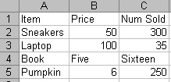

The following code is run in MATLAB:

[num, txt, raw] = xlsread(‘inventory.xls’);

What will be the value of num?

A. [50, 300; B. [50, 300; C. [50, 300; D. [50, 300;

100, 35; 100, 35; 100, 35; 100, 35]

6, 250] NaN, NaN; ‘’, ‘’;

6, 250] 6, 250]

E. None of the above.

6. Which one of the following is \***not\*** true about recursion and iteration?

A. Only iteration can run infinitely

B. Only iteration can occur in a script; recursion requires the use of a function.

C. Recursion requires a termination condition.

D. Only recursion can be used to solve for numbers from the Fibonacci sequence.

E. All of the above are true.

8. **Given:**

x = linspace(1, 100);

y = x.^ 3 + 3.*x;

Which one of the following will plot the points (x,y) with black circles?

A. plot(x, y, ‘ko’)

B. plot(x, y, ‘bo’)

C. plot(x, y)

D. plot(x, y, ‘bc’)

E. plot(x, y, ‘kc’)

7. **Given:**

Player.Name = ‘Dwyer’;

Player.Num_Touchdowns = 4;

Which of the following are valid ways to remove the Name field of Player?

I. Player.Name = [];

II. Player = rmfield(Player, ‘Name’);

III. Player = setfield(Player, ‘Name’, [])

A. II and III only

B. I and III only

C. III only

D. II only

E. I and II only

9. Which of the following commands plot a curve/surface?

I. mesh

II. meshgrid

III. surf

IV. plot3

A. I, II, and III only

B. I and III only

C. IV only

D. I, III, and IV only

E. I, II, III, and IV

10. **Given:**

A = [3 6 -1; 0 0 2; 9 0 4];

B = [1 2 3; 4 5 6];

C = [5 7; 0 0; -3 -1];

Which of the following commands will **not** result in an error?

I. [A, B, C]

II. [A, B]

III. [C, A]

IV. [C; B]

A. I, II, and IV

B. II only

C. III only

D. I, II, III, and IV

E. I and II

**Part 2 – Tracing Problems [30 points]**

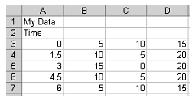**Given: data.xls**

close all

[a b c] = xlsread('data.xls');

s = ':*+o';

c = 'rgyk';

[m n] = size(a);

hold on

for z=2:n

plot(a(:,1)',a(:,z)',[c(z) s(z)])

end

title(b{1})

xlabel(b{2,1})

ylabel('Value')

axis tight

Complete the blank plot below with the data, title, labels, and axis that the above code produces. **Do not worry about indicating the color of the plot data.**

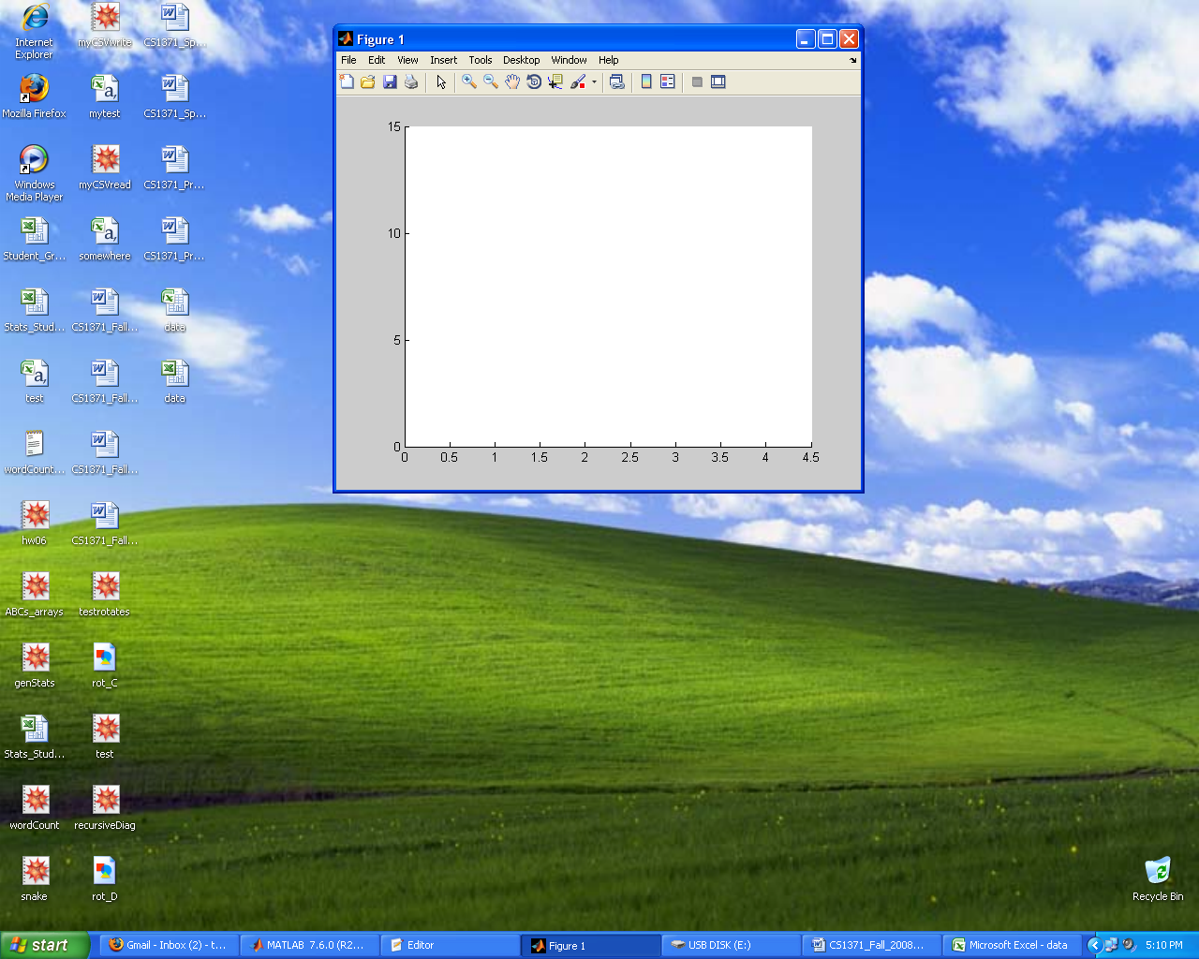

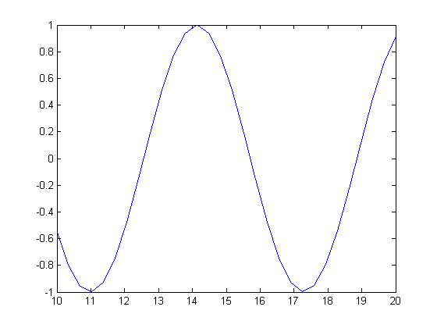**Given:**

u = linspace(10,20,30);

v = sin(u);

plot(u,v)

Then, the line is rotated around some axis to produce the following figure.

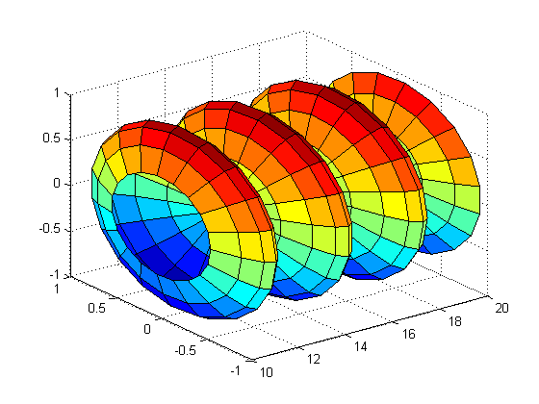

If u is mapped to the X-Axis and v is mapped to the Z-Axis, around which axis is the line rotated?

_________________________________________

What graphing command was used to produce this figure? ________________________

Please fill in the code to rotate the line around the other axis. Make the surface smooth, and label all axes.

th =_____________________;

[uu tth] = meshgrid(u,th);

vv = ____________________;

rr = ____________________;

xx = ____________________;

yy = rr.*sin(tth);

zz = ____________________ ;

_______(xx,yy,zz)

__________________________

__________________________

__________________________

__________________________

**Part 3 – Coding Problem [40 points]**

**Choose ONE of the following two coding problems.** Check the blank next to your choice (A or B). If you decide to change your choice, clearly indicate what code you wish to be graded. If your choice is unclear, Problem B will be graded. Complete the design contract and write your code on the next page.

*You \*****MUST\**** *use recursion to receive credit.*

**A.** Write a function called middleNums that takes in a matrix and returns the middle numbers inside of that matrix. Note that the middle numbers of a matrix can either be a 2x2 matrix or a single number. You may assume you will always be given matrix of 2x2 or larger.

Examples:

ret = middleNums([1,2,3,4; 5,6,7,8; 9,10,11,12])

=> ret = [6,7]

*You \*****MUST\**** *use recursion to receive credit.*

**B.** Write a function called runningMean which takes in a vector of doubles and returns the cumulative running average of the vector. Assume the length of the inputted vector is greater than 0. Computing the cumulative running average of 1:5 means:

(1 + 2) / 2 = 1.5

(1.5 + 3) / 2 = 2.25

(2.25 + 4) / 2 = 3.125

(3.125 + 5) / 2 = 4.0625

Example:

ret = runningMean(1:5)

=> ret = 4.0625

**Complete the design contract for the coding problem you have selected:**

Function Name:

Inputs:

List all inputs and their classes, one per line. Not all lines may be used.

Write ‘none’ if the function does not have inputs.

Class:

Class:

Class:

Class:

Outputs:

List all outputs and their classes, one per line. Not all lines may be used.

Write ‘none’ if the function does not have outputs.

Class:

Class:

Class:

Class:

**Write your code for the Coding Problem you have selected here:**

*This page intentionally left blank for additional work.*