**Georgia Institute of Technology**

**College of Computing**

**CS 1371 Computing for Engineers**

**Test 3 - Fall Semester 2008**

|  |  |  |  |  |  |  |  |  |  |  |  |  |  |  |  |  |  |
| --- | --- | --- | --- | --- | --- | --- | --- | --- | --- | --- | --- | --- | --- | --- | --- | --- | --- |
|  |  |  |  |  |  |  |  |  |  |  |  |  |  |  |  |  |  |
| ***0*** | ***0*** | ***0*** | ***0*** | ***0*** | ***0*** | ***0*** | ***0*** | ***0*** | **↑** Print your **T-Square username** in the spaces provided, and shade the boxes of the corresponding numbers and/or letters.  *I hereby signify that this examination paper contains my own work exclusively, and I have neither given nor received inappropriate help during the taking of this examination, in compliance with the letter and spirit of the Academic Honor Code of Georgia Tech.*  Name (print):  Signature:  TA / Section: ____________________________   |  |  |  |  |  | | --- | --- | --- | --- | --- | | **Part** | **Poss. Pts** | **Earned Pts** | **Lost Pts** | **Grader** | | **(cover)** | **-** | **-** |  |  | | **1** | **30** |  |  |  | | **2** | **25** |  |  |  | | **3** | **30** |  |  |  | | **4** | **15** |  |  |  | | **TOTAL** | **100** |  |  |  |   *Please Note: Failure to complete this front sheet correctly will cost you 5% of your grade.*  ***Please turn off (or silence) and put away any cell phones, beepers/pagers, personal radios or music players that you have in your possession***  **Good Luck!** | | | | | | | | |
| ***1*** | ***1*** | ***1*** | ***1*** | ***1*** | ***1*** | ***1*** | ***1*** | ***1*** |
| ***2*** | ***2*** | ***2*** | ***2*** | ***2*** | ***2*** | ***2*** | ***2*** | ***2*** |
| ***3*** | ***3*** | ***3*** | ***3*** | ***3*** | ***3*** | ***3*** | ***3*** | ***3*** |
| ***4*** | ***4*** | ***4*** | ***4*** | ***4*** | ***4*** | ***4*** | ***4*** | ***4*** |
| ***5*** | ***5*** | ***5*** | ***5*** | ***5*** | ***5*** | ***5*** | ***5*** | ***5*** |
| ***6*** | ***6*** | ***6*** | ***6*** | ***6*** | ***6*** | ***6*** | ***6*** | ***6*** |
| ***7*** | ***7*** | ***7*** | ***7*** | ***7*** | ***7*** | ***7*** | ***7*** | ***7*** |
| ***8*** | ***8*** | ***8*** | ***8*** | ***8*** | ***8*** | ***8*** | ***8*** | ***8*** |
| ***9*** | ***9*** | ***9*** | ***9*** | ***9*** | ***9*** | ***9*** | ***9*** | ***9*** |
| A | A | A | A | A | A | A | A | A |
| B | B | B | B | B | B | B | B | B |
| C | C | C | C | C | C | C | C | C |
| D | D | D | D | D | D | D | D | D |
| E | E | E | E | E | E | E | E | E |
| F | F | F | F | F | F | F | F | F |
| G | G | G | G | G | G | G | G | G |
| H | H | H | H | H | H | H | H | H |
| I | I | I | I | I | I | I | I | I |
| J | J | J | J | J | J | J | J | J |
| K | K | K | K | K | K | K | K | K |
| L | L | L | L | L | L | L | L | L |
| M | M | M | M | M | M | M | M | M |
| N | N | N | N | N | N | N | N | N |
| O | O | O | O | O | O | O | O | O |
| P | P | P | P | P | P | P | P | P |
| Q | Q | Q | Q | Q | Q | Q | Q | Q |
| R | R | R | R | R | R | R | R | R |
| S | S | S | S | S | S | S | S | S |
| T | T | T | T | T | T | T | T | T |
| U | U | U | U | U | U | U | U | U |
| V | V | V | V | V | V | V | V | V |
| W | W | W | W | W | W | W | W | W |
| X | X | X | X | X | X | X | X | X |
| Y | Y | Y | Y | Y | Y | Y | Y | Y |
| Z | Z | Z | Z | Z | Z | Z | Z | Z |

Academic misconduct (including - but not limited to - examples on the list below) could result in a zero score on this examination, an “F” final grade in the course, and/or other disciplinary action:

* Failure to cooperate with or follow directions given by a proctor.
* Failure to stop writing when the allotted time is up (as reported by a proctor).
* Communication with anyone other than a proctor for ANY reason in ANY language in ANY manner.
* Sharing of ANYTHING (e.g. pencils, erasers, paper).
* Writing on paper that is not given to you by a proctor.
* Using cell phones, beepers, personal radios or music players, etc. during the exam.
* Using calculators (unless explicitly permitted) or hand-held computers during the exam.
* Using books or other reference material during the exam.
* Disruption of the exam setting.

**Reference Section**

**Reference Section:**

any(x) – checks if any of the elements of x are true

class(a) – returns the class of a

csvread(filename) – reads in file of comma separated values

csvwrite(filename, A) – writes A to .csv file

cumsum(x) – returns a vector which is the cumulative sum of x

cumtrapz(x,y) – returns a vector which is the cumulative integral of y over the domain x

double(a) – converts a to class double (numeric)

factorial(n) – returns n!

fft(d) – returns the Fast Fourier Transform of the signal data d

fieldnames(X) – returns an array of fieldnames

find(m) – returns the indices of the true elements of m

fopen(F, P) – opens file F with permission P

getfield(X, F) – gets value in field F of structure X

image(x) - display the image from the matrix x

imread(filename) - returns a matrix representation of an image

isa(a, b) – checks if a is of class b

length(a) – largest dimension of a

magic(n) – builds a n * n magic square

max(a) – value and index of the max value in a

mean(v) – returns the average value of v

[xx, yy] = meshgrid(x, y) – compute the plaid from the x and y vectors

mod(a, b) – the remainder when a is divided by b

ones(rows, cols) – generate a matrix filled with 1

plot(x, y, S) – plots y versus x; S specifies line style

plot3(x, y, z, S) – plots a 3-D line with S specified line style

prod(v) – compute the product of all the elements in a vector v

rand(n, m) – produces an n by m array of random numbers between 0 and 1

rmfield(S, X) – removes field X from S

sin(th) – sin of the angle in radians

size(a) – all the dimensions of a

sort(v) – arranges v in ascending numerical order

sound(y,fs) – plays a sound

sprintf - Write formatted data to string

strcmp(a, b) – Compare strings a and b

struct(F, V, ….) – creates a structure with field F and values V

sum(v) – total all the elements in the vector v

wavrite(y,fs,filename) – writes a sound to a .wav file

x/y/zlabel(S) – labels x/y/z axis with string S

xlsread(filename) – reads in .xls file

xlswrite(filename, A) – write array A to .xls file

**Part 1 – Multiple Choice [30 Points]**

Using a pencil, indicate the *best* choice for each question in the box to the left of the problem. **Only answer choices clearly written in the boxes will be graded.**

1. Which one of the following is the big(O) of merge sort?

A. N2

B. log(N2)

C. log(N)

D. N2*log(N)

E. None of the above

2. Which one of the following is the range of values that can be stored by the uint8 datatype?

A. 1 to 256

B. 1 to 255

C. 0 to 1

D. 0 to 256

E. 0 to 255

3. **Given:**

x = linspace(1,10,100)

y= x.^3

y1 = diff(y)./diff(x)

Which one of the following will plot the second derivative of y with respect to x?

A. plot(x(2:end), diff(y1)./diff(x(2:end)))

B. plot(x(3:end), diff(y1)./diff(x(2:end)))

C. plot(x(3:end), diff(diff(y))./diff(x))

D. plot(x(2:end), diff(y1(2:end))./diff(x(2:end)))  
E. plot(x, diff(y1)./diff(x(2:end)))

4. **Given:**

img = imread('car.jpg');

img = double(img);

num = uint8((img(:,:,1)+img(:,:,2)+img(:,:,3))/3);

img2(:, :, 1) = num;

img2(:, :, 2) = num;

img2(:, :, 3) = num;

Which one of the following best describes the effect on img?

A. img is a black and white image

B. img is a grayscale image

C. img is 1/3 times smaller than the img2

D. img2 is the negative of img

E. None of the above

5. If the sampling frequency is 8000 samples/second of a sound, which one of the following represents the amount of time between consecutive samples?

A. 1 second

B. 8000 seconds

C. 1/4000 seconds

D. 1/8000 seconds

E. The answer cannot be determined from the information provided

6. **Given the following sorting algorithm:**

Compare the 1st two elements of the vector. If out of order, exchange them to put in order. Move down one element, compare the 2nd and 3rd elements, exchange if necessary. Continue until end of vector. Pass through the vector again, exchanging as necessary. Repeat until a pass is made with no exchange.

Which one of the following sorting methods does it best describe?

A. Bubble sort

B. Merge sort

C. Insertion sort

D. Quick sort

E. None of the above

7. **Given:**

out = polyfit(x, y, n);

Assume x, y, and n have been previously defined.

Which one of the following must be true about x and n for polyfit to find a unique polynomial for the given set of data?

A. length(x) == n

B. length(x) > n

C. length(x) < n

D. length(x) < n - 1

E. n may be any integer and x is a vector of x-coordinates

8. **Given:**

BF = imread('blackfriday.jpg');

[R C L] = size(BF);

BF(:,:,:) = BF(:,C:-1:1,:);

What occurs to the image stored in variable BF?  
 A. Flips image upside down

B. Flips image left to right

C. Rotates image 180 degrees

D. Image is unchanged

E. Error

9. **Given:**

[note, Fs] = wavread(‘sound.wav’);

half = 2^(1/12);

N = length(note);

Which one of the following will raise the pitch of note by 5 half steps?

A. note(round(linspace(1, N, half*5)))

B. note(round(linspace(1, N, half^5)))

C. note(round(linspace(1, N, (half^5)*N)))

D. note(round(linspace(1, 5*half, N)))

E. note(round(linspace(1, N, N/(half^5))))

10. **Given:**

[x fs] = wavread('annoyingsound.wav');

L = length(x);

Which one of the following is the time duration, in seconds, for the annoyingsound.wav?

A. fs * L / (L + 1)

B. fs / L

C. L / fs

D. L * fs

E. fs * L / (fs + 1)

**Part 2 – Tracing and Algorithms[30 points]**

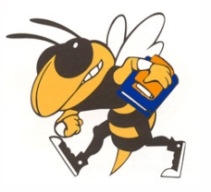

**Problem A.** For each code snippet below, write the letter of the

image or plot it would produce. Only answers in the boxes next

to the code snippets will be graded. **Given:**‘buzz.jpg’ image 🡪

‘buzz.jpg’

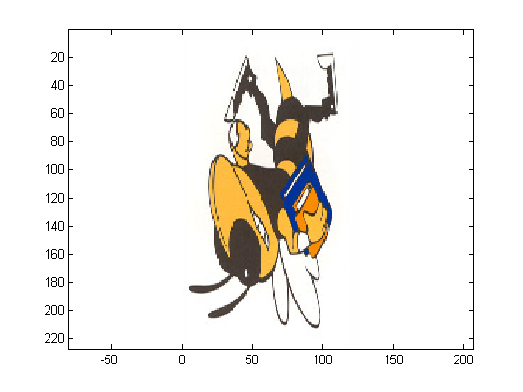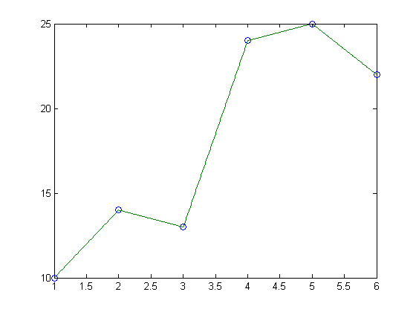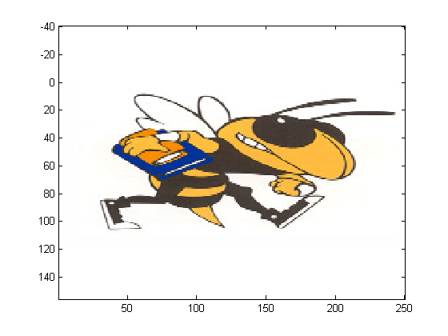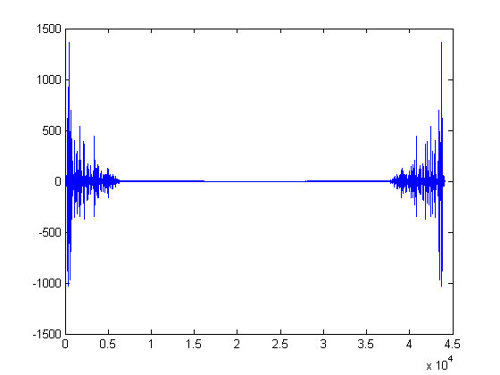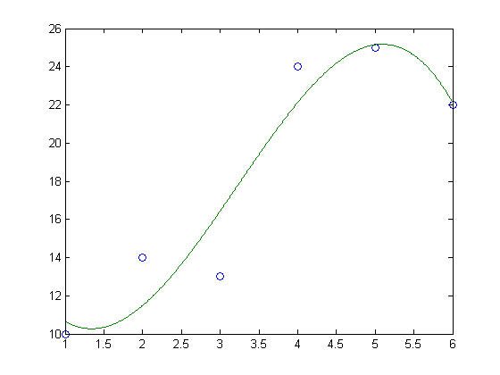

C

A

B

H

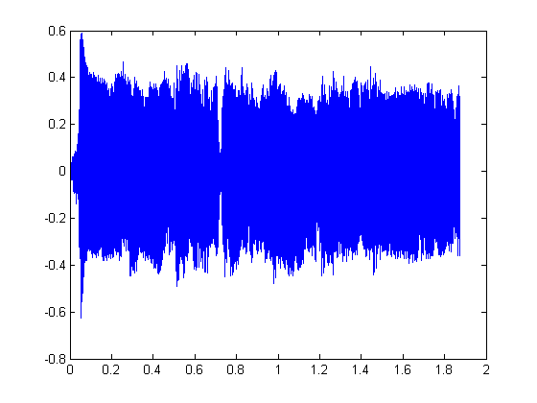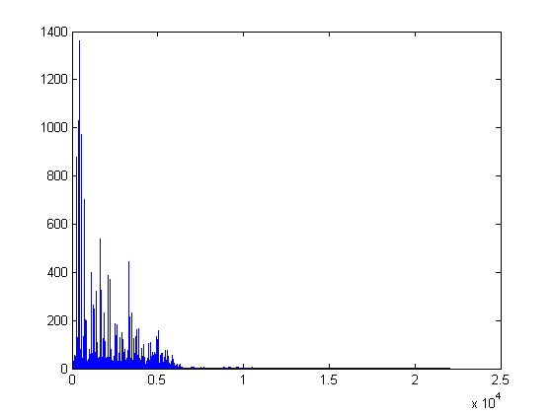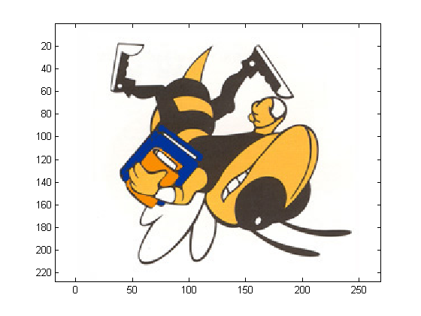

E

D

F

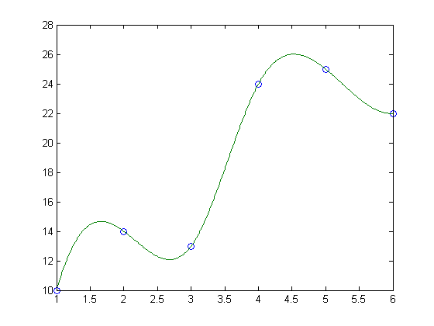

I

G

4.

5.

3.

1.

|  |  |
| --- | --- |
| [a b] = wavread('music.wav');  y = real(fft(a));  c = 1/b;  d = length(a)*c;  e = 1/d;  x = [1:length(a)].*e;  plot(x,y) | y = [10 14 13 24 25 22];  2.  x = 1:length(y);  c = 1:.01:length(y);  a = polyfit(x,y,3);  b = polyval(a,c);  plot(x,y,'o',c,b,'-') |
| y = [10 14 13 24 25 22];  x = 1:length(y);  c = 1:.01:length(y);  b = interp1(x,y,c);  plot(x,y,'o',c,b,'-') | A = imread('buzz.jpg');  A = A(1:2:end,end:-1:1,:);  image(A)  axis equal |
| A = imread('buzz.jpg');  A = A(end:-1:1,1:2:end,:)  image(A)  axis equal | [a b] = wavread('music.wav');  6.  c = length(a)/b;  d = 1/b;  plot(d:d:c,a) |

**Problem B.** Answer the questions below using the given sorting code.

**Given:**

function crazysort(from, to)

if from<to

p = helper(from,to);

crazysort(from,p);

crazysort(p+1,to);

end

function lower = helper(from, to)

global b

pivot = b(from);

i = from – 1;

j = to + 1;

while i<j

i = i + 1;

while b(i)< pivot

i = i +1;

end

j= j – 1;

while b(j) > pivot

j = j -1;

end

if i<j

temp = b(i);

b(i) = b(j);

b(j) = temp;

end

end

lower = j;

1. Which sorting algorithm does the above code implement?

2. What is the theoretical computational efficiency of this algorithm? **Part 3 – Short-Coding Problems [30 points]**

You must complete **ALL** of the following coding questions. Your code should not exceed 7 lines for any individual question. These are NOT functions. A function header is **NOT** necessary.

1. Given an image, ‘peace.jpg’, rotate the image clockwise 90 degrees and display the image.
2. Given the vector coef which is the coefficients of a polynomial, calculate dcoef which are the coefficients of the continuous derivative (using the Power Rule) of the original polynomial.
3. Given a recording of a C-Note played on a piano, ‘piano.wav’, read in the file and swap the first and second halves of the sound. After swapping, reverse the sound and decrease its amplitude by one-half. Write the modified sound back to the original file.**Part 4 – Sorting**

Sort the following vector using the **merge sort** algorithm. Write out the vector at each major step in the algorithm.

[ 14, 6, 5, 16, 15, 2, 20, 1 ]