**Georgia Institute of Technology**

**College of Computing**

**CS 1371 Computing for Engineers**

**Test 3 - Fall Semester 2008**

|  |  |  |  |  |  |  |  |  |  |  |  |  |  |  |  |  |  |
| --- | --- | --- | --- | --- | --- | --- | --- | --- | --- | --- | --- | --- | --- | --- | --- | --- | --- |
|  |  |  |  |  |  |  |  |  |  |  |  |  |  |  |  |  |  |
| ***0*** | ***0*** | ***0*** | ***0*** | ***0*** | ***0*** | ***0*** | ***0*** | ***0*** | **↑** Print your **T-Square username** in the spaces provided, and shade the boxes of the corresponding numbers and/or letters.  *I hereby signify that this examination paper contains my own work exclusively, and I have neither given nor received inappropriate help during the taking of this examination, in compliance with the letter and spirit of the Academic Honor Code of Georgia Tech.*  Name (print):  Signature:  TA / Section: ____________________________   |  |  |  |  |  | | --- | --- | --- | --- | --- | | **Part** | **Poss. Pts** | **Earned Pts** | **Lost Pts** | **Grader** | | **(cover)** | **-** | **-** |  |  | | **1** | **30** |  |  |  | | **2** | **25** |  |  |  | | **3** | **30** |  |  |  | | **4** | **15** |  |  |  | | **TOTAL** | **100** |  |  |  |   *Please Note: Failure to complete this front sheet correctly will cost you 5% of your grade.*  ***Please turn off (or silence) and put away any cell phones, beepers/pagers, personal radios or music players that you have in your possession***  **Good Luck!** | | | | | | | | |
| ***1*** | ***1*** | ***1*** | ***1*** | ***1*** | ***1*** | ***1*** | ***1*** | ***1*** |
| ***2*** | ***2*** | ***2*** | ***2*** | ***2*** | ***2*** | ***2*** | ***2*** | ***2*** |
| ***3*** | ***3*** | ***3*** | ***3*** | ***3*** | ***3*** | ***3*** | ***3*** | ***3*** |
| ***4*** | ***4*** | ***4*** | ***4*** | ***4*** | ***4*** | ***4*** | ***4*** | ***4*** |
| ***5*** | ***5*** | ***5*** | ***5*** | ***5*** | ***5*** | ***5*** | ***5*** | ***5*** |
| ***6*** | ***6*** | ***6*** | ***6*** | ***6*** | ***6*** | ***6*** | ***6*** | ***6*** |
| ***7*** | ***7*** | ***7*** | ***7*** | ***7*** | ***7*** | ***7*** | ***7*** | ***7*** |
| ***8*** | ***8*** | ***8*** | ***8*** | ***8*** | ***8*** | ***8*** | ***8*** | ***8*** |
| ***9*** | ***9*** | ***9*** | ***9*** | ***9*** | ***9*** | ***9*** | ***9*** | ***9*** |
| A | A | A | A | A | A | A | A | A |
| B | B | B | B | B | B | B | B | B |
| C | C | C | C | C | C | C | C | C |
| D | D | D | D | D | D | D | D | D |
| E | E | E | E | E | E | E | E | E |
| F | F | F | F | F | F | F | F | F |
| G | G | G | G | G | G | G | G | G |
| H | H | H | H | H | H | H | H | H |
| I | I | I | I | I | I | I | I | I |
| J | J | J | J | J | J | J | J | J |
| K | K | K | K | K | K | K | K | K |
| L | L | L | L | L | L | L | L | L |
| M | M | M | M | M | M | M | M | M |
| N | N | N | N | N | N | N | N | N |
| O | O | O | O | O | O | O | O | O |
| P | P | P | P | P | P | P | P | P |
| Q | Q | Q | Q | Q | Q | Q | Q | Q |
| R | R | R | R | R | R | R | R | R |
| S | S | S | S | S | S | S | S | S |
| T | T | T | T | T | T | T | T | T |
| U | U | U | U | U | U | U | U | U |
| V | V | V | V | V | V | V | V | V |
| W | W | W | W | W | W | W | W | W |
| X | X | X | X | X | X | X | X | X |
| Y | Y | Y | Y | Y | Y | Y | Y | Y |
| Z | Z | Z | Z | Z | Z | Z | Z | Z |

Academic misconduct (including - but not limited to - examples on the list below) could result in a zero score on this examination, an “F” final grade in the course, and/or other disciplinary action:

* Failure to cooperate with or follow directions given by a proctor.
* Failure to stop writing when the allotted time is up (as reported by a proctor).
* Communication with anyone other than a proctor for ANY reason in ANY language in ANY manner.
* Sharing of ANYTHING (e.g. pencils, erasers, paper).
* Writing on paper that is not given to you by a proctor.
* Using cell phones, beepers, personal radios or music players, etc. during the exam.
* Using calculators (unless explicitly permitted) or hand-held computers during the exam.
* Using books or other reference material during the exam.
* Disruption of the exam setting.

**Reference Section**

**Reference Section:**

any(x) – checks if any of the elements of x are true

class(a) – returns the class of a

csvread(filename) – reads in file of comma separated values

csvwrite(filename, A) – writes A to .csv file

cumsum(x) – returns a vector which is the cumulative sum of x

cumtrapz(x,y) – returns a vector which is the cumulative integral of y over the domain x

double(a) – converts a to class double (numeric)

factorial(n) – returns n!

fft(d) – returns the Fast Fourier Transform of the signal data d

fieldnames(X) – returns an array of fieldnames

find(m) – returns the indices of the true elements of m

fopen(F, P) – opens file F with permission P

getfield(X, F) – gets value in field F of structure X

image(x) - display the image from the matrix x

imread(filename) - returns a matrix representation of an image

isa(a, b) – checks if a is of class b

length(a) – largest dimension of a

magic(n) – builds a n * n magic square

max(a) – value and index of the max value in a

mean(v) – returns the average value of v

[xx, yy] = meshgrid(x, y) – compute the plaid from the x and y vectors

mod(a, b) – the remainder when a is divided by b

ones(rows, cols) – generate a matrix filled with 1

plot(x, y, S) – plots y versus x; S specifies line style

plot3(x, y, z, S) – plots a 3-D line with S specified line style

prod(v) – compute the product of all the elements in a vector v

rand(n, m) – produces an n by m array of random numbers between 0 and 1

rmfield(S, X) – removes field X from S

sin(th) – sin of the angle in radians

size(a) – all the dimensions of a

sort(v) – arranges v in ascending numerical order

sound(y,fs) – plays a sound

sprintf - Write formatted data to string

strcmp(a, b) – Compare strings a and b

struct(F, V, ….) – creates a structure with field F and values V

sum(v) – total all the elements in the vector v

wavrite(y,fs,filename) – writes a sound to a .wav file

x/y/zlabel(S) – labels x/y/z axis with string S

xlsread(filename) – reads in .xls file

xlswrite(filename, A) – write array A to .xls file

**Part 1 – Multiple Choice [30 Points]**

Using a pencil, indicate the *best* choice for each question in the box to the left of the problem. **Only answer choices clearly written in the boxes will be graded.**

1. **Given the following beginning of a sorting algorithm:**

Pick a value in the vector. Partition the other elements into two sets, one with values less than the value (on the “left”) and one with values greater than or equal to the value (on the “right”). Do the same process for each of those two sets. Continue until each set is of length 1 or 0. Recombine.

Which one of the following sorting methods does it best describe?

A. Bubble sort

B. Bucket sort

C. Insertion sort

D. Quick sort

E. Merge sort

2. **Given:**

mat = imread(‘pic.jpg’);

mat = mat(1:2:end, end:-1:1,[3 2 1])

In which of the following ways has the original pic.jpg been changed?

I. The image was shrunk in half vertically

II. The image was flipped left-to-right

III. The red and blue layers were swapped

A. I only

B. I and II only

C. I and III only

D. II and III only

E. I, II, and III

3. **Given:**

x = 1:3;

y = 2.*x.^2 + 3.*x + 1;

vec1 = trapz(x, y);

vec2 = cumtrapz(x, y);

Which one of the following is equal to vec1?

A. vec2(2:end)

B. vec2(1)

C. vec2(end)

D. cumsum(vec2)

E. sum(vec2)

4. **Given:**

[note fs] = wavread(‘piano.wav’);

N = length(note);

newNote = 0.5 * note(round(linspace(1,N,N/2)));

Which of the following best describe the difference(s) between note and newNote if they are played at the same sampling frequency using sound?

I. newNote will be a higher pitch than note

II. newNote will be a lower pitch than note

III. newNote will be played at a lower volume than note

IV. newNote will be played at a higher volume than note

A. I and III only

B. I and IV only

C. II and III only

D. II and IV only

E. III only

5. Which one of the following is true about Big O and sorting algorithms?

A. Big O specifies the time spent to sort a set of numbers

B. Big O for bubble and merge sort is O(N log N)

C. Big O for insertion sort is O(N log N)

D. Each sorting algorithm only has one Big O associated with it

E. None of the above

6. Given that the data vector of a sound file has 4800 samples and plays for 12 seconds, what is the sampling frequency (in Hz)?

A. 40 Hz

B. 1/400 Hz

C. 57600 Hz

D. 400 Hz

E. 1/40 Hz

7. **Given:**

BF = imread('photo.jpg');

[R C L] = size(BF);

BF(:,:,:) = BF(:,C:-1:1,:);

What occurs to the image stored in variable BF?  
 A. Flips image upside down

B. Flips image left to right

C. Rotates image 180 degrees

D. Image is unchanged

E. Error

8. Which one of the following sorting algorithms substantially decreases in efficiency if the input vector is previously sorted?

A. Merge sort

B. Insertion sort

C. Quick sort

D. Bubble sort

E. Both A and C

9. Which one of the following will return the value 5?

A. length(diff([1 7 4 9 5]))

B. length(polyfit([1 3 6], [2 5 9], 5))

C. length(polyval([1 3 5 9 5], [6 9 5 2 1]))

D. diff([1 5])

E. None of the above

10. Given a sampling frequency, Fs, which one of the following will store a vector of 3 seconds of silence in silence?

A. silence = zeros(Fs*3,1)

B. silence = zeros(1, Fs/3)

C. silence = zeros (Fs/3,1)

D. silence = [0, 0, 0];

E. None of the above

**Part 2 – Tracing and Algorithms[30 points]**

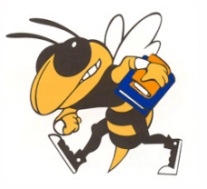

**Problem A.** For each code snippet below, write the letter of the

image or plot it would produce. Only answers in the boxes next

to the code snippets will be graded. **Given:**‘buzz.jpg’ image 🡪

‘buzz.jpg’

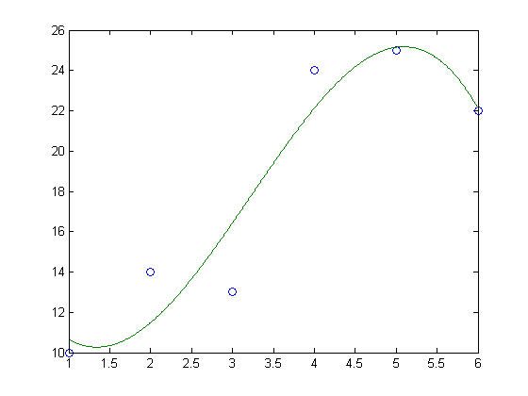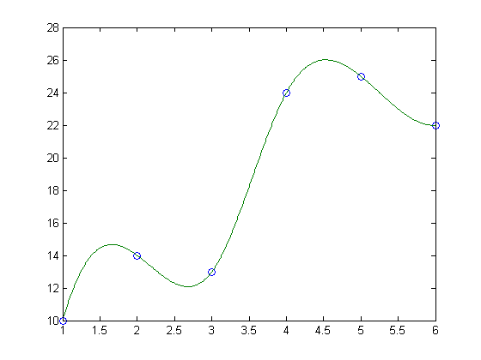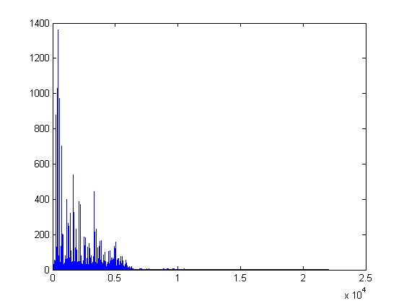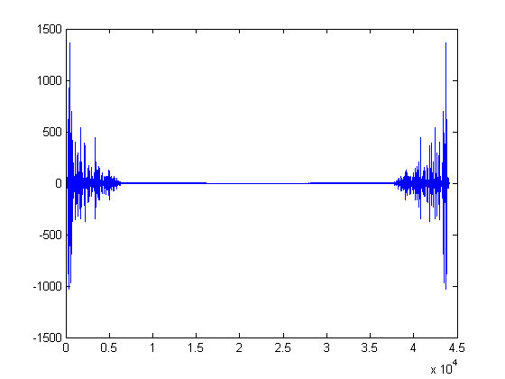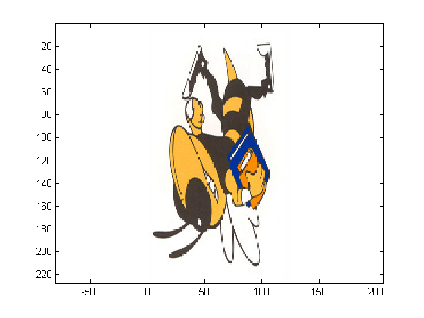

C

A

B

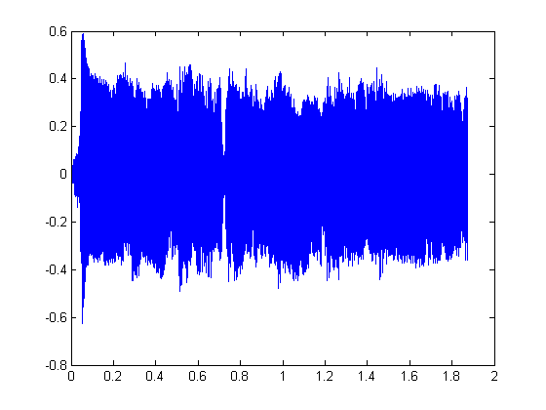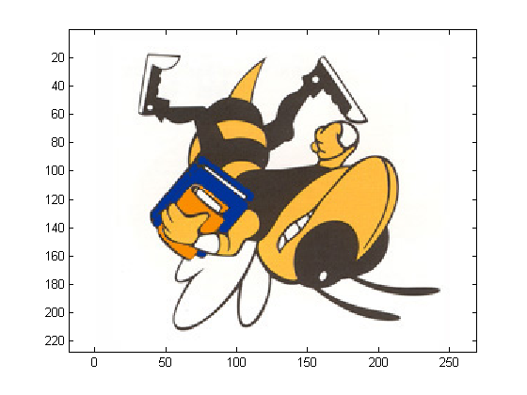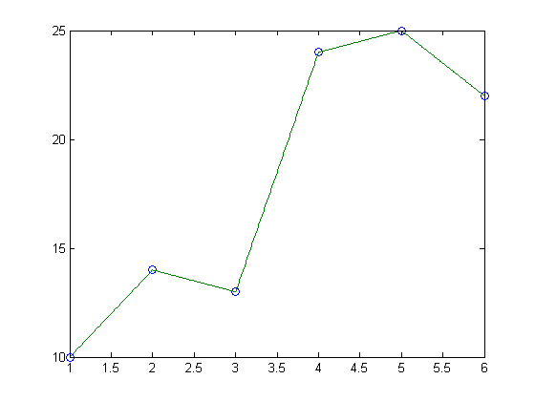

E

D

F

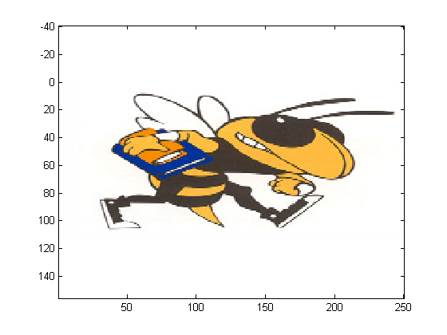

G

I

H

4.

5.

3.

1.

|  |  |
| --- | --- |
| [a b] = wavread('music.wav');  y = real(fft(a));  c = 1/b;  d = length(a)*c;  e = 1/d;  x = [1:length(a)].*e;  plot(x,y) | y = [10 14 13 24 25 22];  2.  x = 1:length(y);  c = 1:.01:length(y);  a = polyfit(x,y,3);  b = polyval(a,c);  plot(x,y,'o',c,b,'-') |
| y = [10 14 13 24 25 22];  x = 1:length(y);  c = 1:.01:length(y);  b = interp1(x,y,c);  plot(x,y,'o',c,b,'-') | A = imread('buzz.jpg');  A = A(1:2:end,end:-1:1,:);  image(A)  axis equal |
| A = imread('buzz.jpg');  A = A(end:-1:1,1:2:end,:)  image(A)  axis equal | [a b] = wavread('music.wav');  6.  c = length(a)/b;  d = 1/b;  plot(d:d:c,a) |

**Problem B.** Answer the questions below using the given sorting code.

**Given:**

function b = crazysort(a)

b = a;

sz = length(a);

if sz > 1

szb2 = floor(sz / 2);

first = crazysort(a(1:szb2));

second = crazysort(a(szb2+1:sz));

b = helper(first,second);

end

function b = helper(first,second)

i1 = 1;

i2 = 1;

out = 1;

while (i1 <= length(first)) & (i2 <= length(second))

if first(i1) < second(i2)

b(out) = first(i1);

i1 = i1 + 1;

else

b(out) = second(i2);

i2 = i2 + 1;

end

out = out + 1;

end

while i1 <= length(first)

b(out) = first(i1);

i1 = i1 + 1;

out = out + 1;

end

while i2 <= length(second)

b(out) = second(i2);

i2 = i2 + 1;

out = out + 1;

end

1. Which sorting algorithm does the above code implement?

2. What is the theoretical computational efficiency of this algorithm? **Part 3 – Short-Coding Problems [30 points]**

You must complete **ALL** of the following coding questions. Your code should not exceed 10 lines for any individual question. These are NOT functions. A function header is **NOT** necessary.

1. Given an image matrix img, convert it into the negative image and store this in negimg.
2. Given a vector x and a vector y, find the ***highest* order** polynomial best-fit curve which is ***unique***. Evaluate new y-coordinates (store in ynew) using the new x-coordinates, xnew, in that polynomial.
3. Given a sound file, ‘song.wav’, make a plot of the Fast Fourier Transform of the sound where the x-axis is the correct frequency domain and the y-axis is the absolute value of the energy as determined by the FFT.

**NOTE:** If you run out of room, use the back of the test.**Part 4 – Sorting**

Sort the following vector using the **quick sort** algorithm. Write out the vector at each major step in the algorithm.

[ 7, 4, 9, 16, 13, 3, 5, 18]