Michael Peterson Due 8/30
Project 1 (2.15)
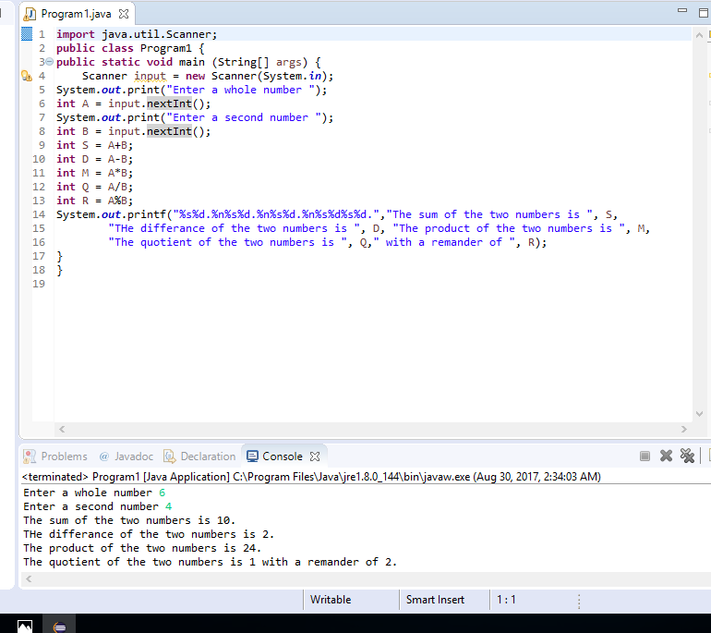
Program 2 (2.16)
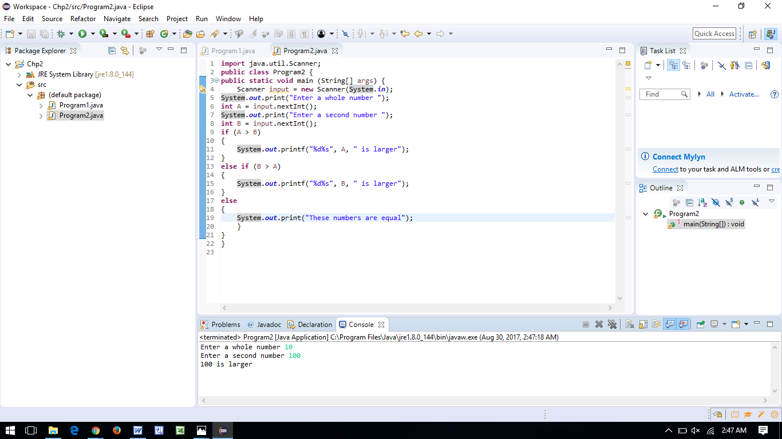
Run 1 (B >A)
Run 2 (A > B)
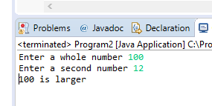
Run 3 (A = B)
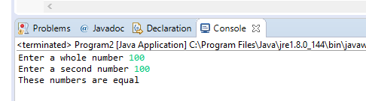
Program 3 (2.26)
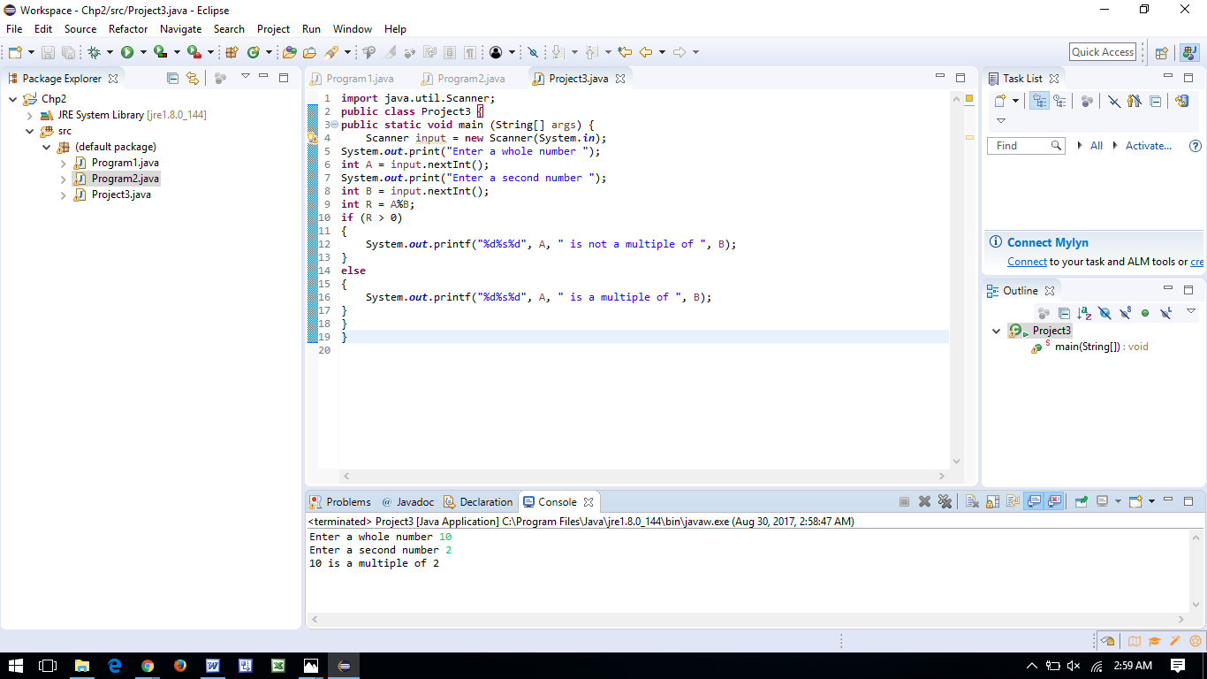
Run 1 (Is a multiple)
Run 2 (is not a multiple)
