Micheal Peterson
CHP 5 class work

5.7
a) 7.5
b) 7.0
c) 0.0
d) 0.0
e) 6.4
f) -14.0

5.8
Program:
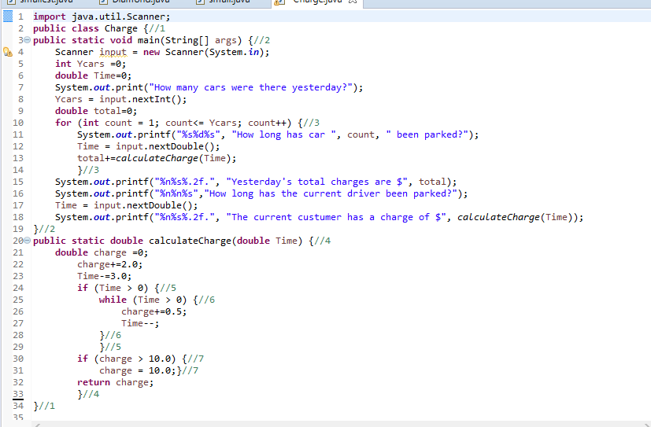
Run through:
