DesktBud: C++ Project

By: Shouh Yann Mo

ID: 59090029

UML Class Diagram:

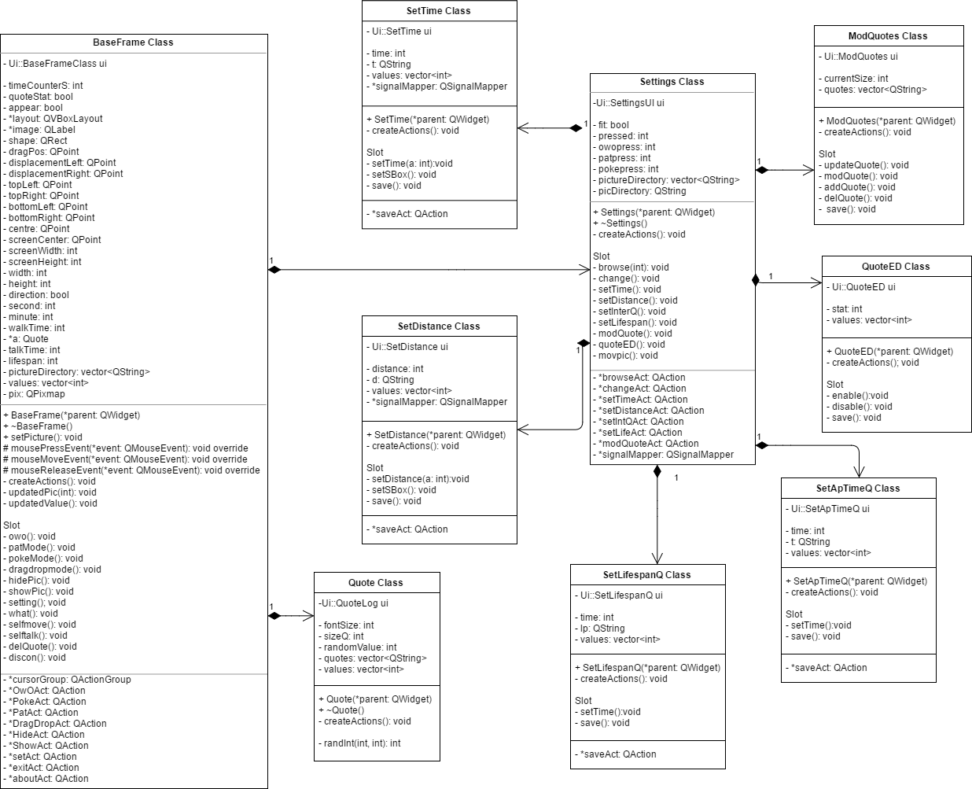



DesktBud

Object-Oriented Programming Project

Shouh Yann Mo, 59090029

KMITL, International College, Thailand